A Brief Report Focusing on:

The Reasons Why I have Chosen Construction
As A Sector To Work In.

Prepared For:
R. Thomas

Prepared By:
S. Joseph (2113608)

Date Completed:
03/11/22
Table of Content

Page Number
1. Executive Summary 3
2. Terms of Reference 3
3. Procedure 3
4. Findings 4
5. Conclusion 6
6. References 7
7. Appendices 9

- Executive Summary
This report aims to clearly describe and analyze the reasons for choosing construction as a sector to pursue, by uncovering personal motives and influences on such a decision made. Furthermore, an overview of the research done before entering this profession will be presented. The report will then conclude by examining the benefits of this sector and the prospective role to be engaged after completion of this degree.

- Terms of Reference

  - The focus of this report is:
    - To discuss my reason for pursuing the built environment.
    - To examine the research conducted before hand of entering the sector as well as disclose any influences and motives behind the undertaking.
    - This report is to be handed in between the 31st of October 2022 and the 2nd of November 2022.

- Procedure

  - This section includes research sources as well as methods of which that research will be presented.
    - Research sources presented throughout this report will consist of mainly websites and literature and can be found in the bibliography. Figures and photos will also be included and are listed as appendices.
    - An event which brought about the opportunity to pursue the sector also provides a strong background for research.

- Findings

  - The subsector of construction I am currently pursuing is Civil Engineering. At the time of this report, I am a Level 4 Civil Engineer student enrolled at the University of Wales Trinity St. David under a scholarship offered by King Charles, who was, Prince Charles at the time of my enrollment. Also, I am an international student from Saint Vincent and the Grenadines, by which this opportunity came about as a solution to a volcanic eruption which occurred on the main island. Affected mainly, were the homes and farmlands of occupants which resided directly in the pathway of the inevitable lahars and pyroclastic flow on the northern end of the island.

  - Having found out about the opportunity when it was first listed, I viewed the options and made the best decision in relation to an already existing personal interest for design and creative works. Although, Quantity surveying was also listed, “The professional quantity surveyor (PQS) is the client’s cost consultant and cost manager for the building process.” Towey, (2012). Whereas “When a new structure of a civil engineering nature is required, the civil engineer is engaged to design a scheme and write a specification for a scope of works with due concern for public protection and the environment.” Towey, (2012). Based on those definitions, I begun deeper research into the Civil Engineering sector and given that Civil Engineering supports the idea of planning, designing, and managing construction projects, having a degree as well as the expertise in this field will justify the purpose of the scholarship and in return benefit my homeland by reinvesting all which was learnt into the construction sector.

  - My research began by overviewing the course outlook on the University’s page and reviewing the modules that were listed over the three-year program. Two of which stood out to me were Professional Skills and Health & Safety in Construction and The Management of Sustainable Construction.

  - Although seen as a benefit to our tourism, being an island located in a tropical climate comes with the unfortunate hazardous hurricanes, rising seas and high winds. According to the National Oceanic and Atmospheric Association (NOAA), the hurricane season begins June 1st and ends November 30th (2018). On October 30th, 2010, Hurricane Tomas ravaged the island of St. Vincent and the Grenadines. The Caribbean Disaster Emergency Management Agency (CDEMA) reported that there was significant damage to houses including over 300 homes having roof and other structural damage. Over 1000 citizens were displaced from their homes and placed in shelters (2010). Professional Skills and Health & Safety in Construction enables me as a professional to identify the effects of which these hazards may have on infrastructure as well as provide an insight on how to completely avoid or minimize environmental and human harm (Great Britain. Health And Safety Commission, 2013). Poor engineering on the roofing of homes is deemed hazardous to the inhabitants and surrounding occupants. Many homes on the island were built ignoring these health and safety measures and the outcome after hurricanes can be seen in the appendix as Appendix 1.

  - Furthermore, St. Vincent and the Grenadines is known for its rich greenery and beautiful marine life. The Fauna and Flora of the island are under protection, yet each year tourists and negligent inhabitants may find themselves damaging and destroying them. The idea of sustainable construction on the island should be a regular practice for as long as the finance is available by the government or willing investors. Green buildings are becoming a major aspect in the world today and can be seen amongst brand giants such as Apple and Google. Specifically, Apple’s corporate headquarters “Apple Park”, in Cupertino, California, has succeeded at becoming a 2.8 million–square–foot (260,000 square meters) building which, because of green sustainability being a focus during planning, has disturbed only 20% of the site and currently lays amid 7,000 plum, apple, cherry, and apricot trees. (Kibert, 2016). The St. Vincent and the Grenadines Environment Fund (SVGEF) has stated that over the last decade the energy consumption on the island has risen drastically. Unfortunately, the majority of that energy, some 80%, is non-renewable energy whereas the remainder is renewable hydro-power (SVGEF). Utilizing sustainable construction can allow preservation of natural rivers and springs to enable hydroelectricity across the island.

- Conclusion
Pursuing Civil Engineering directs me in the correct path to begin impacting my homelands construction sector in a positive way by enabling sustainable and safety practices. To combat the adverse effects of nature on the island’s infrastructure, I sought to learn more about construction practices which assures and maximizes efficient protection to not only inhabitants but also worker thereby choosing civil engineering. Without professional practice, I fear my homeland will not move forward in the sector and more will be at harm. “We shape our buildings, thereafter they shape us.” Winston Churchill, (1943)

- References

  - Great Britain. Health And Safety Commission (2013). Managing health and safety in construction : Construction (Design and Management) Regulations 2007 : approved code of practice. Norwich: Hse Books.

  - Kibert, C.J. (2016). Sustainable Construction: Green Building Design and Delivery, 4th Edition. [online] John Wiley & Sons. Available at: https://www.wiley.com/en-us/Sustainable+Construction%3A+Green+Building+Design+and+Delivery%2C+4th+Edition-p-9781119055174.

  - Metal, M. (2022). Are Metal Roofs Hurricane Proof? [online] blog.mcelroymetal.com. Available at: https://blog.mcelroymetal.com/metal-roofing-and-siding/are-metal-roofs-hurricane-proof.

  - National Hurricane Center and Central Pacific Hurricane Center (2018). Tropical Cyclone Climatology. [online] Noaa.gov. Available at: https://www.nhc.noaa.gov/climo/ [Accessed 3 Nov. 2022].

  - St. Vincent and the Grenadines Environmental Fund. (n.d.). St. Vincent & the Grenadines Fund - Sustainability. [online] Available at: https://www.svgef.org/areas-of-interest/sustainability/ [Accessed 2022].

  - Team, G.C. (2021). Civil Engineer Job Description: Salary & Qualifications. [online] Go Construct. Available at: https://www.goconstruct.org/construction-careers/what-jobs-are-right-for-me/civil-engineer/ [Accessed 2022].

  - Towey, D. (2012). Construction Quantity Surveying. John Wiley & Sons.

  - Wong, M. (2021). Hurricane Elsa: Close to 200 houses damaged in St Vincent | Loop Caribbean News. [online] Loop News. Available at: https://caribbean.loopnews.com/content/hurricane-elsa-close-200-houses-damaged-st-vincent [Accessed 2022].

  - www.cdema.org. (n.d.). Situation Report #2 Hurricane Tomas severely impacts Saint Lucia and caused damage to Saint Vincent and the Grenadines and Barbados (as at 2:00 p.m.) - CDEMA. [online] Available at: https://www.cdema.org/index.php?option=com_content&view=article&id=820:situation-report-2-hurricane-tomas-severely-impacts-saint-lucia-and-caused-damage-to-saint-vincent-and-the-grenadines-and-barbados-as-at-200-pm&catid=39:situation-reports&Itemid=347 [Accessed 2022].

  - www.uwtsd.ac.uk. (n.d.). Civil Engineering (BSc, HND, HNC) | UWTSD. [online] Available at: https://www.uwtsd.ac.uk/bsc-civil-engineering/ [Accessed 2022].

  - UK Parliament (2019). Churchill and the Commons Chamber. [online] UK Parliament. Available at: https://www.parliament.uk/about/living-heritage/building/palace/architecture/palacestructure/churchill/.

- Appendices

  - Appendix 1
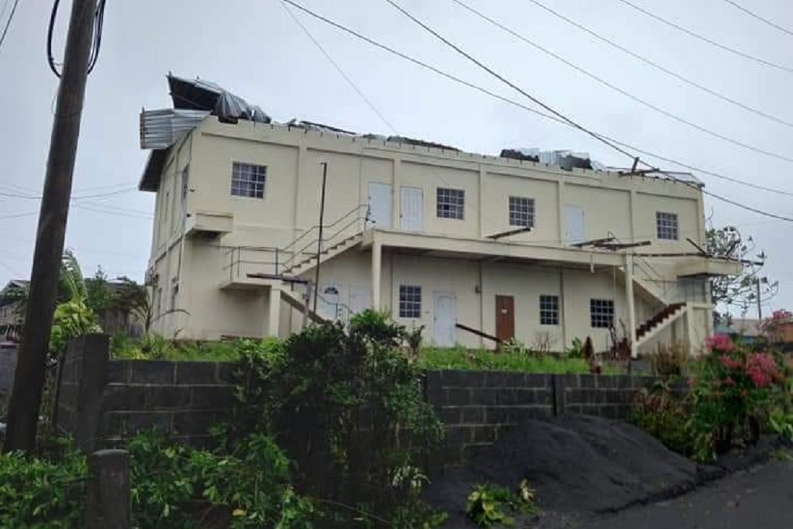
The following picture shows the extent of damage done on a police station located at the northern end of the island because of Hurricane Elsa.

Source: Loop Caribbean News (2021)

