To what extent would green roofs improve the quality of urban water runoff compared to traditional roofs in Wales?
-Urban areas in Wales face immediate uncertainty with flooding and surface water pollution
-Green roofs slow down the flow of rainwater by stopping it at the source, reducing the runoff volume, absorbing pollutants through natural filtration
-The research for green roofs runoff quality is under researched, this research project would be able to fill gaps
-In September 2025, Wales experienced 174% of its average September precipitation, putting major stress and strain on the drainage systems (Met Office, 2025). An example of this is the flash flood in Swansea in September 2025, causing flooding in Cwmbwrla and surrounding areas, causing masses of property damage and disrupting traffic (Jones, 2025)
-Its important the runoff water is of a high quality as rainwater in the UK can contain dangerous pollutants such as nitrates and forever chemicals that can damage sewerage and aquatic life, this research project will investigate if green roofs can filter these chemicals and improve the water quality.
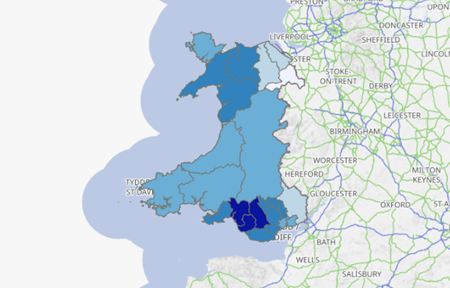
Map of rain fall in Wales
(DataMapWales, 2024)

Going to be a focus on:
The South Welsh rainfall and how it can affect traditional roofs and how a green roof would be a benefit
Focus on slowly down the rainwater with green roofs and how that is beneficial for the drains
How the green roofs filter the rainwater, helping to protect waterways and aquatic life
How this possible improved water runoff quality can be of a benefit to human life
The best plants to use with consideration for water quality, longevity and ease of maintenance

DataMapWales (2024) Annual Precipitation. Available at https://datamap.gov.wales/layers/geonode:annual_precipitation (Accessed: 30 October 2025)
Jones. B (2025) Flash-flooding leaves cars submerged under water at Swansea roundabout, ‘Wales Online’ Available at https://www.walesonline.co.uk/news/wales-news/flash-flooding-leaves-cars-submerged-32474669 Accessed 30 October 2025)
Met Office (2025) September 2025 weather stats: A regional breakdown. Available at https://www.metoffice.gov.uk/blog/2025/met-office-weather-stats-for-september-2025 (accessed: 30 October 2025)

