CRITICAL EVALUATION OF HINKLEY PROJECT

  - ASSIGMENT 1

Student Name: Stanislava Boneva
Student Number: 2028273

Programme: BA in Business Management
Module: Project Management
Module code: LCBB5005
Lecturer(s): Sadeque Shaikh, Dr Xavier Matieni

A table of contents
- Introduction..………………………………………………3
- core objectives of the project………………………………3
- timeline of the project…………………………………………4
- performance in project management of hpc project.4
- evaluation of the hpc project performance……5
  - budget…………………………………………………...6
  - why so many overruns……………………………6
  - quality stakeholders…………………………….7
  - time……………………………………………………….8
  - risk factors…………………………………………..8
- Conclusion…………………………………………………..10
- references…………………………………………………..11

- INTRODUCTION
This project presents an investigation and critical evaluation of the greatest luxurious Atomic control plant development on the planet – the Hinkley Point C of UK. It outlines the management operations and analyses the integrated techniques and performance which lead to the decline in major factors of project sustainability and resilience – budget, quality stakeholders, risk factors and time. The main focus of the work is to compare the initial plan and the drawbacks of the undertaken actions which result in enormous overruns and delays.
The major background setting is oriented toward the whole idea behind the project and how it became almost impossible to realize it. Hinkley Point C highlights the importance of building a nuclear plant in Somerset that is efficient and has both economic and social significance expressed within the creation of jobs, growth to the economy levels and supply of low-carbon electricity for a wide range of homes.
- Core objectives of the project
The Hinkley Point C project has various dimensions of objectives which are considered to be essential both for the community it is affecting directly and the country:
- The first one is the economic one. In terms of it, the government and the EDF Energy company are aiming to create thousands of jobs and thus to minimize the unemployment gap (EDF Energy, 2015). Through the beginning of the project in 2006 a lot of job and apprenticeship opportunities as well as education programmes have emerged which are entirely devoted to the mission of making the individual professionally educated and prepared for the further work challenges.
- Another major objective of the project is the financial one. The provision of financial security for future generations in terms of reducing people’s expenses is one of the complex goals to be attained (EDF Energy, 2015). Minimization of consumers costs is a way of ensuring the income stability of the nation and the overall balance in the economy.
- According to the statistical data, as a whole, the basis of the ground upon the project bases its performance is circled around the idea to contribute more than 1 billion pounds to the local community during the construction phase and around 40 million each year during the phase of functioning (Hinkley Point Realisation Plan, 2018).

- Timeline of the project:
The history behind the realisation of this project is a long one and dates to 2005 when the idea has been announced in public and later in 2008 the shareholder company EDF purchased UK energy for more than 12 billion pounds (the Guardian, 2016). During the years which follow after that, many awareness has been risen and the idea of nuclear safety has taken a major place within the government strategies. According to the statistics from the article in the Guardian (2016), in 2013 the UK government together with EDF stated that there would be a strike price for power which was stated to be 92.50/MWH pounds.
After so many years which have passed by from the initiation of the project idea, in 2015 the HPC took a 2 billion loan to finance the construction and in the same year a three times bigger investment from a China NP group had been made (EDF Energy, 2015). The debt and the investor’s contribution prove the tendency that many people believed this project was sustainable and very optimal.
Another theoretical review of the concepts portrays that in 2016 the HPC project has achieved some kind of success and acceptance as the government has declared that it agrees with the initiation and the construction of the plant.
- Performance in Project management of HPC project
In recent years, there have been numerous delays and upcoming repercussions for the project continuation due to various reasons. The first problem emerged a couple of years ago, when according to an interview by EDF given to BBC (2022), the nuclear power station operation would be delayed with one year and a cost of additional three billion pounds. However, from the management levels of the company ensure that this negative impact will not affect the consumers and they will not be burdened with additional taxes. After this disturbance, the global Covid-19 pandemic emerged and deteriorated the normal functionality of supply chains by creating disturbances across the networks of firms. The instability and the non-resilience from the lockdowns which remained present for a long time produced a net loss of more than seventeen billion euros which shook up the project entirely. Later, the negative effects from the Russia-Ukraine war additionally worsened the operation and created a risk of further delays and increasing costs (Hernandez, 2023).

- Evaluation of the HPC project performance
The sequence of unexpected events and the current progress of the project open an opportunity to review and assess the overall performance up to now. Therefore, in order to critically review and evaluate the project, a focus on four main components of project sustainability and robustness will be reviewed in-depth:
  - Budget
When laying the foundations of a future megaproject, one of the most essential pillars is the budget and its initial forecast. In the statistical representation of NS Energy Staff Writer (2022), the production costs in the beginning of the project were calculated to be around twenty billion pounds. The costs are explicitly revealed and shown on Diagram 1, where a breakdown of the expenses is systemized and it is seen that apart from the construction cost, others like operating, controlling, maintaining, decommissioning and waste funds are added to the basket (MSC, 2022). This is an extensive amount of money that is why the project is assessed to be the most expensive one in this field of study.
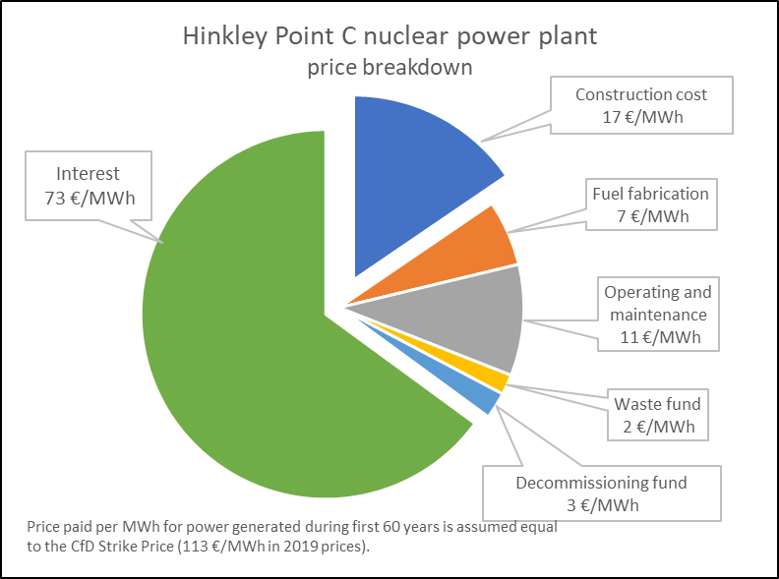
Diagram 1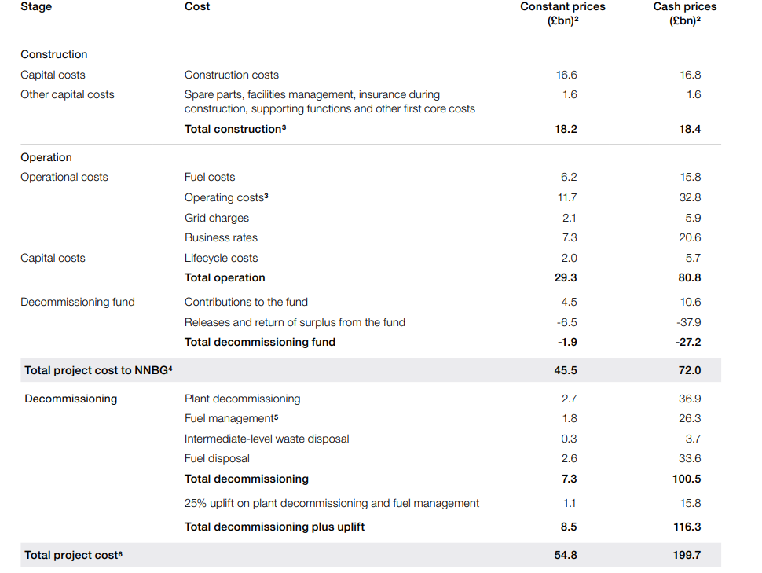

Source: MSC, 2020
Later, during the years, the costs have been continuously revised and changed. Although the building of the plant is entirely financed by its investors, the NNB Generation Company has presumed that the final total cost of the project will be around 45 billion pounds over the whole lifetime (National Audit Office, 2017). With both the Covid-19 crisis and the war situation, the steady rise in costs has hit frightening levels. But why have the project management leaders been unable to remain alternative pathways to settle down this crisis and why so many overruns have been happening? The answer to this question is given in the next part of the critical evaluation.
  - Why such overruns and delays?
Following and analysing the audits of Hinkley Project, a trend appears – for the constant increase in costs of the project are responsible the British regulatory requirements and restrictions as well as the inability of the staff to derive the resolving point to this issue (M.F, 2016). Due to criticism from various sides, the company insisted on continuing the research.
Although the organisation was not stopped by the slight disturbances, the situation has been worsening since then. The rise in expenses is directly proportional to the declines in the returns on the projects (from 9% to 8.2%) (the Guardian, 2017). From a macro-economic perspective, such situations are prerequisite for exacerbating economic and social setting and inability to fulfil the promised objectives.
In the opinion of the investors in the project, “such cost increase of 10% isn’t horrific” (Reuters, 2019). The real issue behind this situation is not the rising cost or the decreasing returns, but the inefficient position of the project on the market and the inability to offset the disastrous market repercussions on the overall outcome.
  - Quality Stakeholders
Important and inevitable part of the evaluation of a project is integration of the quality stakeholders. For such massive projects, costs are related to different stakeholders and also affect millions of other people (Flyvbjerg, 2014). A short list of the most involved private and public shareholders is presented (EDF, 2022):
- Investors – they have the main role in shaping the project proposition and in assisting the building of the plant; they have declared that even in the situation of disturbances , their role will be defending and they will support the project continuation (Reuters, 2019);
- Contractors – several companies such as Rolls-Royce, AMEC and AREEVA are responsible for the provision of equipment and nuclear supply systems;
- Government and regulatory bodies – they have posed some regulatory practices during the pandemic, but after this they have applied other practices to relieve and open the door to nuclear development;
- Residents/customers/ consumers/ local businesses – they are not currently affected by the emerging costs as the EDF company’s director has assured that the financial burdens will be undertaken by the organisations within the project, not the people.

  - Time
Timing is essential for project management as any delay within the scheduled activities will create disturbances in the planning, outcomes and costs of the overall project. The following project has been in a great risk of continuing delays. The biggest issue about is , is that it loses its competitiveness on the global market where other new nuclear power projects are emerging and trying to offer the same (National Audit Office, 2017).
The first date for the initiation of the generation of electricity has been planned to happen by 2020, but after a couple of delays it has turned out to be in 2025 or 2027 (EDF, 2022). Those alterations have provoked a bed tendency – of steady delays and constant uprising prices and costs. This outlines a perfect chance for alternative competitive companies to take advantage and conquer the market.
Despite the numerous rumours about further time delays of the project, the EDF spokesman refutes these accusations in 2023 and states the time schedule remains as before and follows the objective of turning energy efficient programmes into action and not losing any time in this (West Somerset Free Press, 2023). Through an in-advance arrangement with the government, the project will try to float out of the water and compensate for its huge losses.
  - Risk factors
Risk organisation is one of the hardest tasks in development running as it requires advanced and researched planning tools and risk analysis methods in order to assess the performance (Boateng et al, 2015). However, in such international large projects, risks are underestimated and this leads to the common and big cost overruns.
Risks can be conditionally divided into several categories:
- Risks emerging during the construction phase – The construction of these plants has been delayed year after year. The cause for this is rooted within the incompetence and inability of the risk management staff team to integrate high-digitalized technology which coordinates the sides within this phase, and which foresees the development of the production processes (National Audit office, 2017). NNBG company has installed some systems in order to track the construction phase performance and the costs and has detected that there are tremendous quality issues which at the end lead to the delays (EDF, 2022). A recommendation of how to resolve such a problem is to implement transferrable-skills programmes and self-actualizing initiatives which will be flexible and will act as guiding lines for the staff for future situations.
- Risks emerging during the operational phase – As long as the operational phase is on its way, the risk of overspending in this phase without possessing the ability to remain functioning and stable is very big (
- Risks emerging during the final phase – the decommissioning waste is another issue which might create many leading risks due to the threatening of the taxpayers to repay some of the taxes (National Audit Office, 2017). That is why, there is a decommissioning programme as an alternative for the consumers that they will not repay the expenses, but the fund will do it through the generated returns.

- Conclusion
There are many current challenges within establishing a fair operational process and minimization of the expense’s practices. On one hand, the project is threatened to fail as the costs are constantly emerging, there is no monitoring activity and there is an insecurity provoked by various factors. On the other hand, the management team are not taking the necessary approaches to establish quality standards of protection against cost crisis and fast recovery from such disturbances.
In such a scenario, several recommendations might be given. The project management team and the strategic team are the responsible figures who might engage professionals to assess the losses and to plan carefully how to proceed. Only through a careful examination of the role of each factor within the pyramid of operation and retrieval of the details behind the failure of the development can this project emerge again and become more competitive than before.

- References:

BBC (2022). Hinkley Point C delayed by a year as cost goes up by £3bn. BBC News. [online] 20 May. Available at: https://www.bbc.com/news/uk-england-somerset-61519609.

EDF warns UK nuclear plant could cost extra $3.6 billion, see more delays. (2019). Reuters. [online] 25 Sep. Available at: https://www.reuters.com/article/us-britain-nuclear-hinkley-edf-idUSKBN1WA0T0 [Accessed 30 March. 2023].
EDF Energy. (2015). Hinkley Point C. [online] Available at: https://www.edfenergy.com/energy/nuclear-new-build-projects/hinkley-point-c.

Flyvbjerg, B. 2014. What You Should Know About Megaprojects and Why: An Overview. Project Management Journal 45(2) 6-19.

Hernandez, A. (2023). Cost of EDF’s new UK nuclear project rises to $40 billion. Reuters. [online] 20 Feb. Available at: https://www.reuters.com/business/energy/cost-edfs-new-uk-nuclear-project-soars-40-bln-2023-02-20/.
HINKLEY POINT C WIDER BENEFITS REALISATION PLAN. (2018). Available at: https://assets.publishing.service.gov.uk/government/uploads/system/uploads/attachment_data/file/725960/HPC_Benefits_Realisation_Plan.pdf.
‌

M.F. on 30th J. 2016 in and power, N. (2016). What’s wrong with Hinkley Point C? – Yorkshire Campaign for Nuclear Disarmament. [online] Available at: https://yorkshirecnd.org.uk/whats-wrong-hinkley-point-c/ [Accessed 4 Apr. 2023].

MSc, J. van D. (2020). The Hinkley Point C case: is nuclear energy expensive? [online] Medium. Available at: https://medium.com/generation-atomic/the-hinkley-point-c-case-is-nuclear-energy-expensive-f89b1aa05c27.
National Audit Office. (2017). Hinkley Point C. Report. Department for Business, Energy & Industrial Strategy. SESSION 2017-18. Available at: https://www.nao.org.uk/wp-content/uploads/2017/06/Hinkley-Point-C.pdf

NS Energy Staff Writer. (2022). EDF announces revised costs for Hinkley Point C nuclear power plant. [online] Available at: https://www.nsenergybusiness.com/news/edf-revises-up-cost-estimate-for-hinkley-point-c/

Smyth, Hedley & Lecoeuvre, Laurence & Philippe, Vaesken. (2017). Co-creation of value and the project context: Towards application on the case of Hinkley Point C Nuclear Power Station. International Journal of Project Management. 36. 10.1016/j.ijproman.2017.04.013.
the Guardian. (2017). Hinkley Point C is £1.5bn over budget and a year behind schedule, EDF admits. [online] Available at: https://www.theguardian.com/uk-news/2017/jul/03/hinkley-point-c-is-22bn-over-budget-and-a-year-behind-schedule-edf-admits.
the Guardian. (2016). Hinkley Point C timeline: all the key moments. [online] Available at: https://www.theguardian.com/environment/2016/jul/28/hinkley-point-c-timeline-all-the-key-moments.
Turner, R., R. Zolin. 2012. Forecasting Success on Large Projects: Developing Reliable Scales to Predict Multiple Perspectives by Multiple Stakeholders Over Multiple Time Frames. Project Management Journal 43(5) 87-99.

West Somerset Free Press. (2023). Hinkley Point C nuclear power station ‘on schedule’ despite delay claim | wsfp.co.uk. [online] Available at: https://www.wsfp.co.uk/news/hinkley-c-on-schedule-despite-new-delay-claim-after-new-agreement-586884

