KEY QUESTIONS

- What are the core materials?
- How / where was it made?
- Who made it?
- What function did it have?
- How might it have been considered?
- Who used it?
- How was it discarded?
- How was it recovered?
- Where was it taken?
- Where is it now?

OBJECT BIOGRAPHY REPORT
Q Drew
HPAR4011
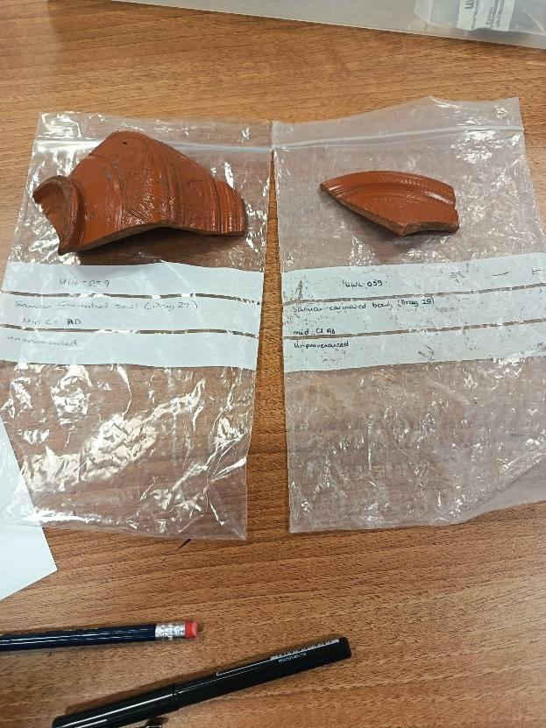
UWL-059
Samian cerinated bowl (DRAG 29)
Mid c1 AD
Unprovenanced

Index:
- location of artifact
1.1 UWL / UWTSD Carmarthen Teaching collection
2. background detail
2.1 Samian
Samian production / Samian economy
Include maps
2.2 Roman
Date / time frame
2.3 decoration
Describe / compare /
Use images / sketches
3. form
3.1 size / dimensions – known / estimate
3.2 fabric description
3.3 colour
4. condition
4.1 breaks / wear / abrasion
5. construction
5.1 production / distribution

Bibliography / Reference list
Appendices

