‌
BA BUSINESS MANAGEMENT
Assignment -2
Module name- Marketing Fundamental
Module code-LCBB4004
Lecturer- Tushara Balendran
Name-Navjot Kaur
Student ID-2214338
Title- Internal and external analysis of Samsung company
Submitted on 13th of January 2023

INTRODUCTION - In this report ,writer will shed light on the internal and external analysis of Samsung company. Also, this report will relate the macro environment and microenvironment to Samsung company and its merits and demerits. Another focus of this report on the marketing mix strategy of the company . Moreover, the impact of pandemic on the business globally.
DEFINITION OF MARKETING - . - The term "marketing" refers to the actions a company takes to promote the acquisition or consumption of a commodity. Delivering goods to clients or other businesses involves marketing efforts like sales and promotion. On occasion, affiliates will handle a company's marketing.(TWIN,A)

MAIN STAGES OF MARKETING PROCESS; There are five main steps of the marketing process, as shown in the diagram situational analysis, objectives, developing a strategy ,implementation, and adjusting the strategy.

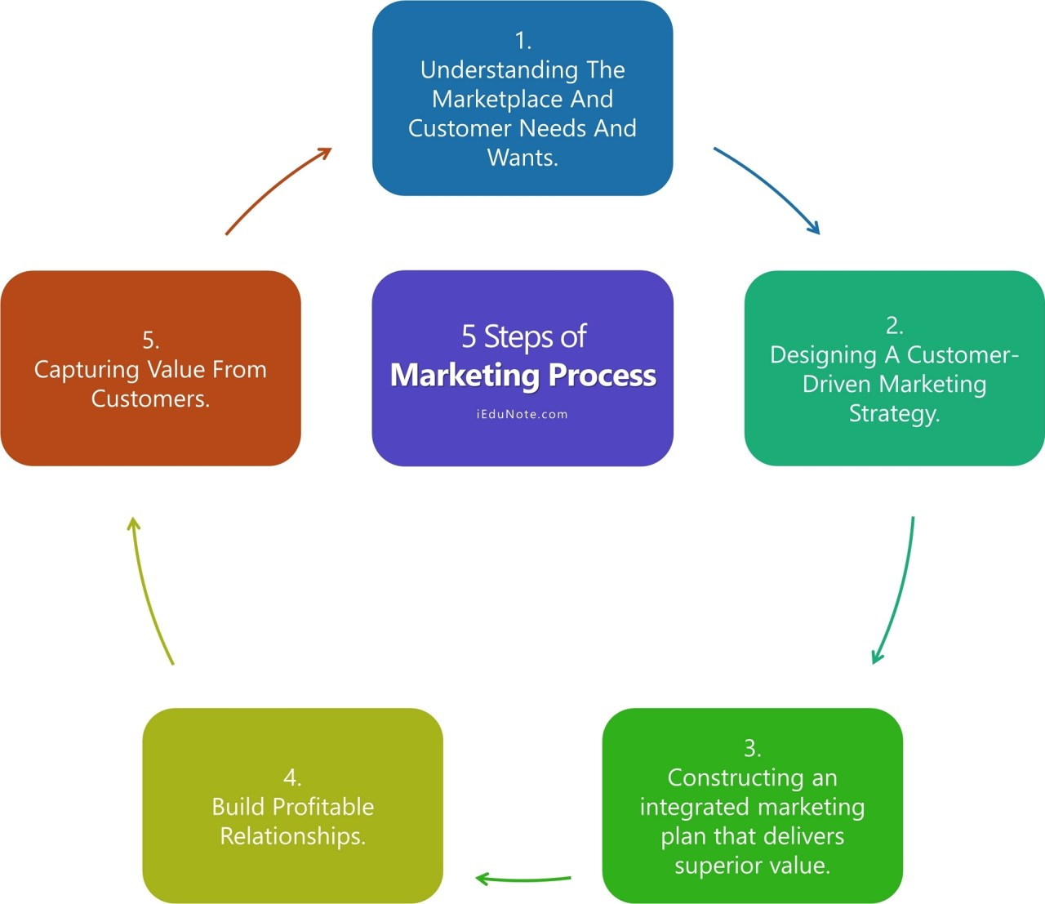
SITUATIONAL ANALYSIS : In order to . produce and promote goods that are in line with consumer demands ,desires and expectations and to develop customer relationships that are good in value ,it is reproving to comprehend their needs and expectations. In the long run ,this boosts the company customer equity (IEDUNOTE,2020)

OBJECTIVES: In this the centre of attention choosing the clients to serve, determining the target market, determining clients to serve, and picking a marketing strategy can all assist you in assessing how to best serve your clients when creating a market plan.
.(IEDUNOTE,2020)
STRATEGY: The business's sales promotion outlines the types of customers this should target and the benefits it will offer them. The marketer then develops integrated marketing plans that will give the desired value to the target customers. (IEDUNOTE,2020)
IMPLEMENTATION: Implementing your marketing strategy is the process of turning it into reality. It offers details on the steps and resources needed to implement your promotional campaigns.
CONTROL: Management is responsible for monitoring how well the strategy is being carried out. He can do this by getting input and, if necessary, taking remedial action, which entails managing . iEduNote (2020).
IMPACT OF COVID -19 ON COMPANIES:
According to( www.worldbank.org, n.d) The pandemic, which has present for almost a year, has had an effect on every sector of the global economy and nation. But even inside countries and businesses, performances have widely varied. One- fourth of the businesses saw a 50% decline in its sales. An average of 27%less was spent on sales. Business altered payroll during outbreak by reducing hours, increasing wages, and providing staff time off .People began doing business online .The majority of people time was spent on social networking sites, which started to have impact on their health. As a result. During the pandemic, people live unhealthy lifestyles. Small enterprises and developing countries endure great hardship. The largest obstacle to getting assistance, according to 50%of firms is ignorance .Many businesses were temporarily shut down due to epidemic. However, a large number of people suffered during epidemic because they were unemployed. As, a result covid 19 has a significant impact on enterprise all around the world.

PESTLE ANALYSIS OF SAMSUNG COMPANY
PESTLE DIAGRAM IS GIVEN BELOW :

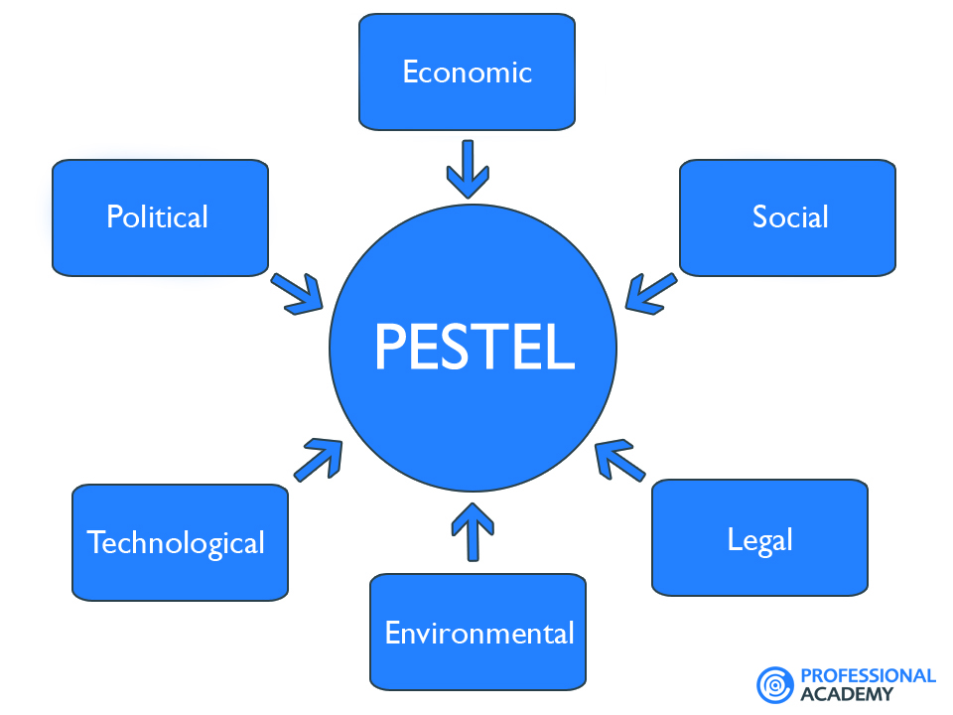

POLITICAL FACTORS: It is both favourable and unfavourable for the company Samsung . Samsung can be said to be operating in regions where strategic factors are innocuous in the bulk of the markets in which it operates because there are minor annoyances in some international markets, like India. The firm has recently had to take into account not only the political instability but also the danger of war would break out on the Korean Peninsula due to the animosity between South Korea and North Korea. . It has thus faced significant political difficulties in its own country. Furthermore, Samsung faces political pressure in a number of countries in Africa and Latin America where the political environment is unstable and prone to multiple changes in governing institutions. It is advantageous since, of course, there is currently little cause for anxiety given that the company has largely brought the political instability into view in its corporate strategy. Juneja, P. (2015)
ECONOMIC FACTORS :. Since many economies in the world population have opened up, Samsung may now be able to expand its global footprint, making this component very crucial. The current economic downturn has drastically decreased consumer buying power in many numerous sectors, raising questions about this aspect of the situation and motivating Samsung to search for profitable business prospects in emerging regions. Keeping in mind that Samsung works in a dynamic and uncertain macroeconomic environment has necessitated the corporation's need to modify its business strategy is crucial. The one saving grace for the corporation has been that it has expanded into developing and emerging economies which now has allowed it to successfully adjust to the diminishing consumer spending power in industrialised countries. Samsung has begun an aggressive push into emerging markets to make up for lost revenue from the developed world. ( Juneja, P. (2015)
SOCIAL FACTORS: It is both favourable and unfavourable for the company. Favorable because Samsung is primarily a South Korean Chaebol and is a family-owned multinational. This suggests that, although having a worldwide presence, the corporation is still essentially Korean. Its multinational companies have several facets as a result, one of which is adjusting to the environmental circumstances. In other words, because Samsung is a worldwide company that also has to act locally, it had to embrace a global strategy in many rising nations. Samsung also has to adapt its products to the quickly changing preferences of consumers in the various markets where it competes. It is viewed as a negative aspect for the Samsung corporation. (Juneja, P. (2015)
TECHNOLOGICAL FACTORS :This is favourable for the Samsung company. Because Samsung is one of the world's most creative businesses. This suggests that the company has an advantage when it comes to utilising technology and promoting innovation for a long-term competitive advantage. As a result, the company has become concerned with remaining at the forefront of innovative solutions, as well as with beating its rivals and competitors to market by releasing its newest items first. Nevertheless, as we shall probably understand, this has also resulted in the corporation copying the illustrious Apple's design process while taking shortcuts, which has drawn legal and regulatory notice and caused issues for the business. (Juneja, P. (2015)
. LEGAL FACTORS: . These are unfavourable because Samsung has paid a price for allegedly imitating Apple's iPod touch, resulting in a result, the company has lost support from the public for its business processes and customer opinion. It is unclear how the company would negotiate the legal minefield it finds itself in in developed markets as a consequence of the various litigations. ( Juneja, P. (2015)
ENVIRONMENTAL FACTORS . Given the growth of the ethical customer, who expects companies to source and produce their goods in an environmentally and socially accountable manner, Samsung must be aware of the need to develop its products to meet the needs the ethical consumer. This implies that it must take care to avoid compromising the wages paid to the individuals who create the final product or the working conditions. It is favourable because Samsung is doing well on environmental conditions.( Juneja, P. (2015)

SWOT ANALYSIS OF SAMSUNG

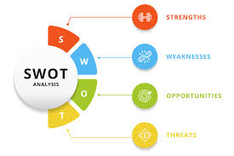

STRENGTH: The Samsung SWOT analysis highlights the strength that is beneficial for the expansion of the organisation. Edrawsoft. (n.d.).
- . The business is well-known in the smartphone industry. For a very long time, Samsung has controlled the market. Apple's sales volume is 13.7%, while Samsung's is 18.5%, according to Gartner.
- Samsung is recognised for its top-notch and innovative research and development efforts. In such a harsh business, it offers a diverse range of goods and has improved its level of innovation to remain competitive. For instance, as a result of this, Samsung won 36, CES awards in 2018.
- The state-of-the-art appliances are eco-friendly. It enhanced the brand's standing. On the EPA's 2016 Green Energy Partner List, Samsung is regarded as the ninth-best company.
WEAKNESS: Like other businesses, this one has certain strengths, but also some drawbacks. With the aid of analysis, one may rapidly spot the shortcomings and flaws, and then remove the obstruction. Edrawsoft. (n.d.).
- . The US market accounted for 70.8% of sales for both Apple and Samsung, although Samsung is a corporation that is heavily dependent on the US market alone, which creates difficulties. The reason for this is that Android's sales would suffer if this market experienced a recession. On the other contrary, it's important to keep in mind that Samsung has a poor market presence in Asia.
- .Even the brand itself has shipped some defective goods, which has made customers less confident.
- Samsung has seen a drop in its smartphone sales since 2017.
OPPORTUNITIES: Samsung notes a few opportunities for corporate growth
- Samsung has unveiled the newest air conditioning goods, known as the "Triple Protection Proposition," which can provide them a competitive advantage.
- . The brand needs to diversify through this conquer the markets in Asia and Europe. Another factor that will aid in the company's growth, particularly in the Asian as well as European markets, is acquisition.
- In order to thrive in this fiercely competitive market, the brand has developed cutting-edge innovation and cutting-edge products like foldable phones.
- The company also has a 5G and 6G network capacity. Once more, it may permit corporate investment. Edrawsoft. (n.d.).
THREATS: The business has experienced many threats and continues to do so. To create a strategy that would aid in the overall economic growth and development of the company, it is vital to recognise these factors. As a result, the following risks are connected to the company:
- A dispute over patent infringement has involved the corporation.
- The competition has continually increased thanks to other well-known firms like Apple, Oppo, or Huawei.
- The brand is also subject to political and legal threats. Due to limitations brought on by local regulations that differ, the company has operational difficulties.
- Samsung used counterfeit versions of other brands for the phone. The Galaxy S7 Edge is one of the copied smartphone models. Edrawsoft. (n.d.).

Benefits and drawbacks of the SWOT analysis are listed below:
MERITS
- Problem area The Swot can be used with a team, individual, or organisational unit. A number of the organisation's objectives can also be supported by the analysis. The . A merger, partnership, or the outsourcing of a functional head, for example, can all be evaluated using a SWOT analysis of the brand or firm in question. An additional use for a SWOT analysis is to evaluate a certain supply source, business practise, market characteristics, or the development of a particular technology. ( Nordmeyer, B. (2019)

- Neutrality of Applications: Defining a target and engaging in a roundtable discussion to uncover internal and external elements that are advantageous and detrimental to achieving the objective are the first steps in conducting a SWOT analysis. This methodology is used regardless of whether the study supports procedures for company growth, product development, long term planning, opportunity analysis, or competitive analysis. ( Nordmeyer, B. (2019)

- Regarding Data: . For a SWOT analysis, it is required to combine qualitative and numerical data from several sources. Access to a variety of data from many sources boosts enterprise-level policy-making and planning improves decision-making, improves communication, and helps to coordinate operations. ( Nordmeyer, B. (2019)
DISADVANTAGES( Nordmeyer, B. (2019)
- No weighing factors: . Strengths, flaws, opportunities, and threats are compiled into four separate lists as the outcomes of a SWOT analysis. However, the tool does not provide a means of evaluating the relative weights of various elements inside a given list. It might consequently be challenging to determine the actual effect of any one ingredient also on target.
- Subjective Analysis: . For business operations to have a real impact on a company's success, they must be grounded on reliable, timely, and comparable data. SWOT data collection and analysis does, however, require a stage of the screening process that reflects the bias of the individuals who acquire the data and participate in the table discussion. Additionally, the data utilized for the SWOT analysis may soon become dated.
- Ambiguity. Using the one-dimensional model that the SWOT analysis creates, each component of a problem is categorised as a benefit, susceptibility, potential, or threat. In light of this, it seems as though each quality only has one impact on the issue under consideration. The same factor, though, could both a strengths and a weakness. The following is a paraphrase of the following: But without a lot of sales, it can be challenging to compete on pricing because of the expenses of running high-visibility facilities. ( Nordmeyer, B. (2019)

SEGMENTATION, TARGETING, AND PLACEMENT OF SAMSUNG
segmentation, targeting, and placement are a series of steps done out in a specific order on Samsung. The cornerstones of Samsung's marketing strategy are those. the division of a population into distinct groups based on similar traits. Finding certain demographic groups that will purchase goods and services is the practise of targeting. The final phase in positioning is selecting the marketing approach that is most appropriate for the target clientele.
Samsung's market segment
Samsung supports a number of market sectors simultaneously by providing a wide range of service and product packages. For instance, corporate Samsung SMART Signage displays are available in a variety of sizes, home screens, and functionalities, as well as a variety of price points. With a variety of financial resources, Samsung thus meets the demands and desires of its customers. It is well known that Samsung regularly plagiarises Apple's design concepts, functions, and marketing practices. Several Samsung products, notably mobile image sensors, now have a poor turnover rate. On the other hand, some goods were created in anticipation of greater upcoming sales.
Samsung has a big and diverse product line-up. Approximately six design centres, more than 50 industrial bases dispersed across many sites, more than 30 Research and development facilities, and other components make up an organisation. Samsung offers a wide range of products, so consumers with multiple stakeholders, incomes and preferences can discover a product they enjoy. The company's goods are renowned for their exceptional quality and longevity. Additionally, throughout time, Samsung's products did more than just reflect the market; they also established trends. .( Edrawsoft.(n.d.)

TARGETING OF SAMSUNG
All across the world, Samsung products are offered for sale in a variety of nations. The business employs a variety of sales strategies to connect with a wide spectrum of clients. Samsung has played a pro-active role in sales and service agreements that are directly related to business sales. The concurrent marketing of Samsung's products is assisted by distributors. Regional, national, and local distributors are all available for the business. Distributorship privileges might vary significantly amongst distributors.
Any Samsung product, or only a specific class of items, may be promoted to the public by a distributor. Depending on the distributor's size, level of competence, and operational region, this varies. Samsung also offers its goods through big-box stores as well as smaller ones. Reliance Digital, Chroma, and other companies are more examples. .( Edrawsoft.(n.d.)

Samsung's positioning
Any business could change its direction with a strong positioning plan. Positioning might be quite good in shaping consumers' impressions of a brand. Samsung's positioning approach is quite standard for a technological corporation. Samsung employs placement strategies that take the competitors into account. The business continually adopts cutting-edge technologies to help maintain a level playing field. Samsung stays up to date and keeps its place as the leading manufacturer among other strong companies thanks to the new functions, a new choice, and other advancements.( Edrawsoft.(n.d.)

SAMSUNG'S "4PS" ADVERTISING STRATEGY
It includes the four Ps—product, pricing, place, and promotion—which are viewed as a single entity and are especially useful for marketing communication integration. Samsung's marketing mix is one of the primary factors contributing to its success. The company would not even be able to operate without these blend components. (HowandWhat.net, 2021)


The product strategy of Samsung
Samsung manufactures a broad range of goods. They include air conditioners, cell phones, tablets, audio/video gear, electronic items, watches, televisions, and sound equipment. They also include washing machines, home appliances, refrigerator, vacuum cleaners, and usb drives (Samsung, 2021).
Products from Samsung are developed in worldwide design studios and made across the entire globe. The company operates several research and development centres throughout the globe where it develops new goods. A select group of customers are given the chance to test out new products and offer feedback when they are first launched by the business. Sales are boosted when clients understand that they might suggest the service to others.( HowandWhat.net(2021).
PRICING STRATEGYOF SAMSUNG:
The company applies the price-skimming method whenever it introduces a new device with cutting-edge technology. Because of this, it generates significant revenue. In an effort to increase sales and gain market share, when competing companies begin to develop products that are exact replicas of those currently available, the price of that particular product is decreased.
Samsung also provides reasonable pricing for a handful of its additional products, such as its air conditioning units, televisions, and refrigerators. Due to fierce competition on the market from various other brands that provide equivalent products, this has happened. However, when prices are competitive, profits might occasionally be lower.( HowandWhat.net(2021).
PROMOTION AND PLACE STRATEGY OF SAMSUNG
Several different market channels are used by Samsung to distribute its products. Service dealers manage the company's significant accounts. Major retailers are also recipients of the company's product offerings. Customers can browse the merchandise in the shops and choose the items they want. It's worth noted that Samsung sometimes distributes its products through a lone distributor in a particular area. On Android's website, customers can choose and order products. Now they have the freedom to shop whenever they want and at their own pace. Through its website, the company can also reach clients who do not have easier access to a distributor or storefront for Galaxy.( HowandWhat.net(2021).
RECOMMENDATIONS
- The effective use of social value to accomplish commercial objectives could be a crucial element for Samsung's to get achievement with digital marketing. Social currency is characterised by a customer's level of brand involvement and tendency to share information with others. Samsung must have to increased its social media presence in an effort to enable users and brand enthusiasts to share their peers and family about their Android experiences.
- Companies like Samsung must address the needs and interests of the diverse population segments that their products are aimed at. This indicates that they have social media accounts on all of the main social networks. On all major social media platforms, including Instagram, Twitter, YouTube, and Instagram, Samsung have need to do a good job of maintaining a strong presence. Samsung must offer incredibly attentive and dedicated contact centre teams through its specialised social media pages.
CONCLUSION
Any internal and external study of Samsung corporation discussing this report .A corporation can develop achieve success in the market place by employing the right strategy or by using analytical rules and company get success in the market. Using the Pestel and Swot Analysis identify opportunities and risk in the market. Additionally, mentioned above are the advantages and disadvantages of Swot analysis . This segmentation, positioning and targeting of the Samsung as well as Marketing Mix and its component are also briefly examined in the report. Also, recommendations provided for Samsung to get success in the business.

REFERENCES
Twin, A. (2021). Marketing in Business: Strategies and Types Explained. [online] Investopedia. Available at: https://www.investopedia.com/terms/m/marketing.asp.[ACCESSED ON 13 DECEMBER 2022]

iEduNote (2020). Marketing Process: 5 Steps of Marketing Process. [online] iEduNote.com. Available at: https://www.iedunote.com/marketing-process
[ACCESSED ON 13 DEC 2022]

Juneja, P. (2015). PESTLE Analysis of Samsung. [online] Managementstudyguide.com. Available at: https://www.managementstudyguide.com/pestle-analysis-of-samsung.htm
[ACCESSED ON 15 DEC 2022]

NordmeyBAer, B. (2019). Advantages & Disadvantages of SWOT Analysis. [online] Chron.com. Available at: https://smallbusiness.chron.com/advantages-amp-disadvantages-swot-analysis-41398.html.
[ACCESSED ON 15 DEC 2022]

Edrawsoft. (n.d.). Samsung SWOT Analysis | EdrawMax Online. [online] Available at: https://www.edrawmax.com/article/samsung-swot-analysis.html [ACCESSED ON 15 DEC 2022]

HowandWhat.net(2021).Marketing mix of Samsung (4Ps of Samsung ).[online]
Howandwhat. Available at: https://www.howandwhat.net/marketing-mix-samsung/ . [ACCESSED ON 25 DEC 2022]

Edrawsoft. (n.d.). Samsung Segmentation, Targeting and positioning.[online] Available at: https://www.edrawmind.com/article/samung-segmentation-targeting-positioning.html.
[ACCESSED ON 26 DEC 2022]

The World Bank (2021). How COVID-19 is Affecting Companies Around the World. [online] World Bank. Available at: https://www.worldbank.org/en/news/infographic/2021/02/17/how-covid-19is-affecting-companies-around-the-world.

‌

