Marketing Fundamentals Analysis and Evaluation
LCBB4004 - Tushara Balendran
Radu Claudiu Pintea - 1921951

Table of Contents
Introduction 3
Processes and stages of marketing including the role of the marketing mix: 4
Situational analysis of Volkswagen: 6
Porters 5 Forces Model: 8
SWOT analysis for Volkswagen: 9
Conclusion 10
Reference 11

Introduction
The marketing process is the set of analysis of the organisation which helps to analysis the marketing activities of the organisation. The marketing process helps the organisation to set the mission, vision, objectives of the marketing and introduce the new policies in the marketing activities. The marketing activities help to develop the new strategy and product various by applying methods and models of the organisation. The marketing process includes the mission, situational analysis, marketing mix, marketing implementation and controls (Heinze, 2020). In the situational analysis develop to market segmentation, target market and positioning of the markets.

Processes and stages of marketing including the role of the marketing mix:
Marketing is the activities to promote the buying and selling of the organisation and increase the power of the company to maintain the marketing development of the organisation. To set the strategy of marketing, Volkswagen introduces the development of the marketing strategy to improve the selling of the company.
According to Philip Kotler (2018), the marketing process is the set of the stage which helps to establish the marketing activities of the organisation and fulfil the mission, objective by marketing strategy analysis as well as implementation and controls. The analysis of the marketing process is given below to develop the strategic analysis and marketing mix.
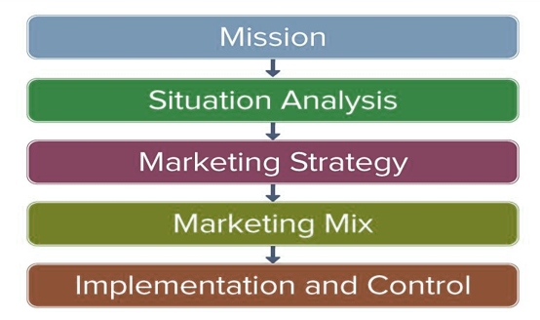
Figure: Marketing process (Chaffey, 2019)
Mission: The mission of the organisation is the setting plan that will be developed by the functional organisation of the company. The multinational organisation set a different mission for the different functional department and helps to identify the future activities of the company. The mission of the marketing function of Volkswagen is to increase the sale of the new brand of the company and vision is applied for every function Mobility for everyone. The marketing department of Volkswagen ensures the consumer relationships and accelerate the amount of sale (Kirova, 2017).
Situational analysis: situational analysis is the set of process in which the functional department analysis the situation to develop the strategy and reach to the consumers. The situational analysis for the marketing function of Volkswagen helps to develop the analytical ability for making good relationships of the problem for the situation.
Marketing strategy: The strategy is the activities by which the organisation compete with the competitors by the game plan and set the strategy based on their competitors’ ability. Volkswagen set the marketing strategy against Toyota and Nissan to improve the market condition and sales of the automobile. The cheap manufacturer of the automobile is the Toyota and the Volkswagen need to develop the marketing strategy to connect the consumers.
Marketing Mix: there are 7Ps of marketing mix which helps to evaluate and analyze the marketing activities of the organisation. The marketing mix (product, price, place, promotion, people, process and physical evidence) which helps to market analysis of any types of company. Volkswagen analysis marketing mix to enter into the new markets or making the strategy of marketing (Martin, 2017).
- Product: The physical attribute of the organisation for sale to make profits and maximize wealth. The product based on the customer requirement and quality helps the organisation to sustain in the markets and satisfy the consumers. The product analysis of the company assists the marketing to set the strategy and process. ‘
- Price: To become the market leader and compete with the large organisation, the organisation need to set proper pricing strategy and improve the business of the company. There are various type of pricing strategies like skimming pricing, premium pricing and penetration pricing. The Volkswagen set the premium pricing because the company set the market focus on upper-level consumers.
- Place: the distribution channel of the organisation that helps to provide the product to the consumers. The distribution channel of Volkswagen (Volkswagen- regional dealers- country dealers- agents- final consumers) which directly helps the consumers to buy the product or service.
- Promotion: the main function of the marketing department which promote the brand by sale promotion, direct selling, sponsorship and advertisement. Now Volkswagen advertises the product both online and offline to engage the consumer for buying the products.
- People: The internal stakeholders of the company (Employees) who are engaged in the production of the quality automobile that assist the marketing function to compete with the competitors and helps to maintain customer relationships.
- Process: the process of Volkswagen is very artificial and the company use robots and artificial intelligence to produce the automobile and collecting the information from the consumer by using online and internets.
- Physical evidence: the components of the marketing mix which helps to identify the physical environment which develops to make the physical design of the shop or showroom. The outlet of Volkswagen is very gorgeous and aesthetic which attract the consumers to buy the brand of products.
Implementation and control: The last steps of marketing strategy development and analysis which helps to implement the strategy of the organisation and control which is unnecessary to uproot from the strategy. After implementing the marketing strategy, the company need to evaluate and analyze the problem of the strategy and monitors this strategy regularly.

Situational analysis of Volkswagen:
Marketing analysis includes some important steps which help to analysis the marketing of the organisation. The analysis is the market segmentation, target marketing, product positioning and optimal marketing mix. The strategy of Volkswagen helps to differentiate the market based on product development and improve the leadership of the markets.
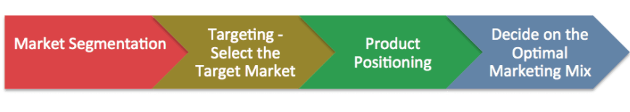Market segmentation: The young, single and professional at the age of 18-24 years who are engaged in developing the marketing strategy of the organisation. The consumers who are regarded the car as their status, the organisation should develop the model with high feature and technology enable to enter these markets. The market segmentation of Volkswagen is the singe, married couple with children, young at the age of 15-24, the consumer who priority for high speed and the better run engine should be monitored and control for the competition of the company (Chaffey, 2019).
Target market: The target markets for Volkswagen is the gorgeous and affluent person who spent money for status as the purchase of the car.
Demographic | - At the age of 30 to 40  - Affluent families  - Two or more children  - 1+ children between 5 to 15  - Household income 100000 dollar  - College or university degree
Psychographic | - Interest on technology  - Enjoy typical parenting activities  - Contemporary test and youthful attitude  - Part of a community individuals
Figure: Target market for Volkswagen (Author)
The target market is the important marketing tools that select the target of the consumer who is the prospective to purchase the product or service. The target markets for Volkswagen depends on the demographic and psychographic behaviours of the consumers and their activities in the organisational development(Morgan 2019).
The positioning of Volkswagen: The market position according to Wilkinson (2018), is the process of establishing the identity of the image for product or service that perceived the certain ways of consumers. Volkswagen position its product by the brand and its attractive features of the products or service.

Porters 5 Forces Model:
The porter’s five force model is the analytical tools that use to evaluate the competitive environment of the organisation. The porter’s five force model is used to analyst the threats of entry, potential new entrants, threats of substitute, and powers of suppliers and buyers.

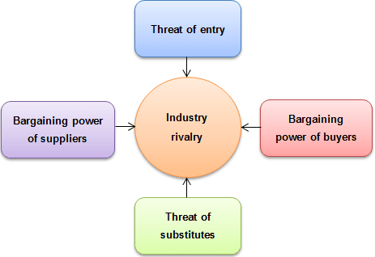
Figure: porter’s five force model
Threats of new entry: The threats for the Volkswagen for the new arrival in the market is very low as the company establish an image to the market that helps to sustain in the markets. The threats for the new organisation to continue the business activities but Volkswagen is the old and big which continue to compete with the old organisation (Brinkman 2019).
Bargaining power of suppliers: The bargaining power of supplier is the ability of the supplier to switch one organisation to another which increase threats for the company to stay in the competition (Quinn, 2019).
Bargaining powers of buyer: the bargaining power of buyer is very high as there are numbers of big players in the automobile industry that are Toyota, Audi, Nissan, BMW in which the consumer can easily sift to change the buying behaviours.
Threats of substitute: the threats for the organisation to bargain with substitute and develop the product or service. The bargaining powers of substitute define the alternative products in the market which need to analyse to decide on marketing (Sahaf, 2019).

SWOT analysis for Volkswagen:
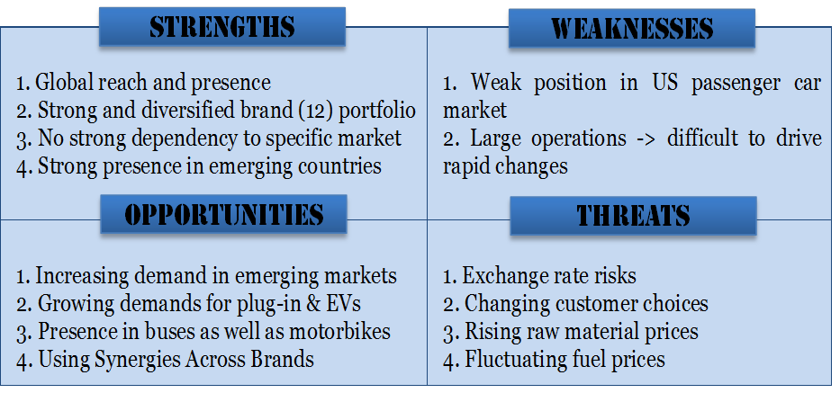
Figure: SWOT analysis for Volkswagen
The strength, weakness, opportunity and threats for Volkswagen should be analysed to provide the information about the strategic option of the company.
Strength: Volkswagen is the reputed brand in the world which provide the product and has a strong supply chain around 117 countries. The organisation has a strong and diversified brand portfolio and specific market around the world.
Weakness: The American markets of Volkswagen are not so good and it is the main weakness of the company and recent tesla the big player in the American markets. The large operation of the company drives to need changes in the organisation.
Opportunity: purchasing powers of the consumer are rapidly changing and improve the life standard of the people who developed to cope with the situation of the organisation. Volkswagen tries to present the auto bike industry to diversify the organisational portfolio (Blundel, 2019).
Threats: The threats for the company is the rapid spread of Covit-19 and fluctuating oil pricing of the world; the exchange rate risk of company demotivate the development and rising risk.

Conclusion
After analysis the market segmentation, target markets, positioning and analysis the marketing mix as well as porter 5 force to competition analysis and marketing problem evaluation, I learn about the competitive position of the Volkswagen. The automobile industry faced challenged and risk by the competition of the organisation and find the relationships of the organisation. The competitive analysis of the organisation develops to increase the condition of Volkswagen to sustain in the markets.

Reference
Heinze, A., Fletcher, G., Rashid, T. and Cruz, A. eds., 2020. Digital and social media marketing: a results-driven approach. Routledge.
Kirova, V., 2017. Exploring the role of strategic marketing department. Journal of Marketing Development and Competitiveness, 11(2).
Martin, K.D. and Murphy, P.E., 2017. The role of data privacy in marketing. Journal of the Academy of Marketing Science, 45(2), pp.135-155.
Morgan, N.A., Whitler, K.A., Feng, H. and Chari, S., 2019. Research in marketing strategy. Journal of the Academy of Marketing Science, 47(1), pp.4-29.
Quinn, L., Dibb, S., Simkin, L., Canhoto, A. and Analogbei, M., 2016. Troubled waters: the transformation of marketing in a digital world. European Journal of Marketing.
Sahaf, M.A., 2019. Strategic marketing: making decisions for strategic advantage. PHI Learning Pvt. Ltd..
Blundel, R., Lockett, N., & Wang, C. 2015. Exploring entrepreneurship. Sage.
Brinkman, J., Navarro, I., & Harper, D. 2018. Unlocking the business environment. Routledge.
Chaffey, D., & Ellis-Chadwick, F. 2019. Digital marketing. Pearson UK.
Hillson, D., & Murray-Webster, R. 2017. Understanding and managing risk attitude. Routledge.

