Silver Athenian Tetradrachm, 450 BC - 430 BC
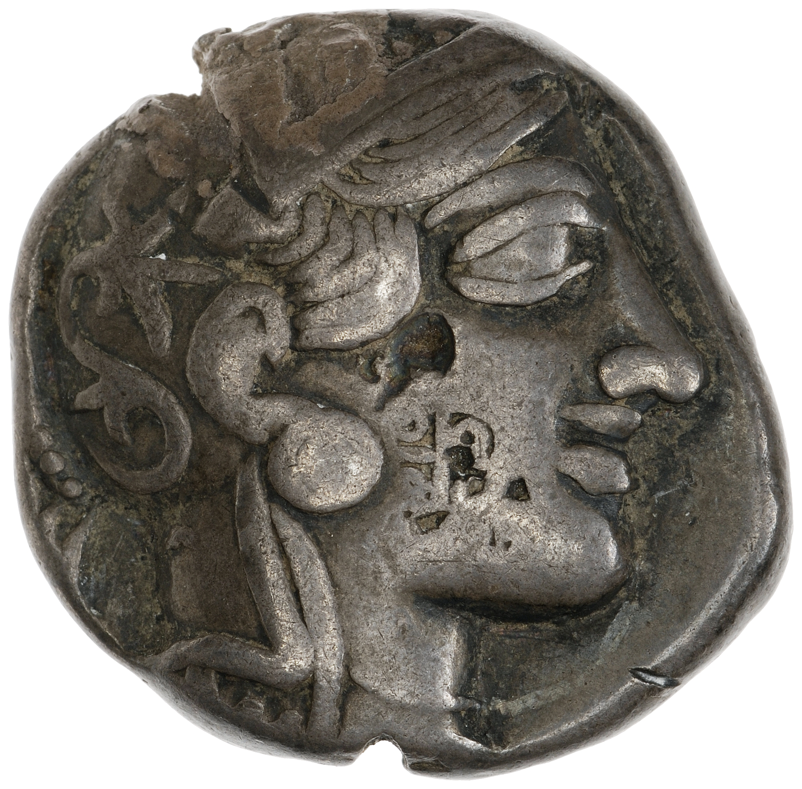
The Silver Tetradrachm was minted from the years 450-430 BC in the region of Attica, and It weighs in at around 16.57g (American Numismatic Society, 2015). This specific type of Tetradrachm is very common in archaeology and we have an abundance of these coins that have survive into the present day (American Numismatic Society, 2015). The imagery on the coin is probably some of the most recognisable when it comes to Greek coins. However, despite its recognisable iconography, Greek Coinage, in particular Athenian, has been described by Roman numismatist, T. V. Buttrey, as the "most boring ever produced” (T. V. Buttrey, 1979). This is due to that fact the designs of the coins never change drastically since their appearances in the archaic period (I. Carradice, 1995, p32). Also, unlike Roman coins, the Greeks didn’t change their designs frequently which meant that the symbols weren’t used as propaganda to the same extent Roman coins were, like the Aegypto Capta coin (I. Carradice, 2010). However, M. Thompson states that although Greek coins may be dull, they “are unique in that they have something to say about the three aspects of…[Athenian life]…Athenian architecture, sculpture and topography.” (M. Thompson, 1982).
Figure 2:Obverse of Silver Athenian Tetradrachm, 450 BC - 430 BC, http://numismatics.org/collection/0000.999.9884?lang=en
Athenian Silver coins were some of the most prized within the Classical period as Athens was one of the wealthiest Polies at the time. It got its wealth via many factors, but the main three being:
- Its large Silver deposits in the mines of Laurion
- Its large Navy built with the silver that was coming from Laurion
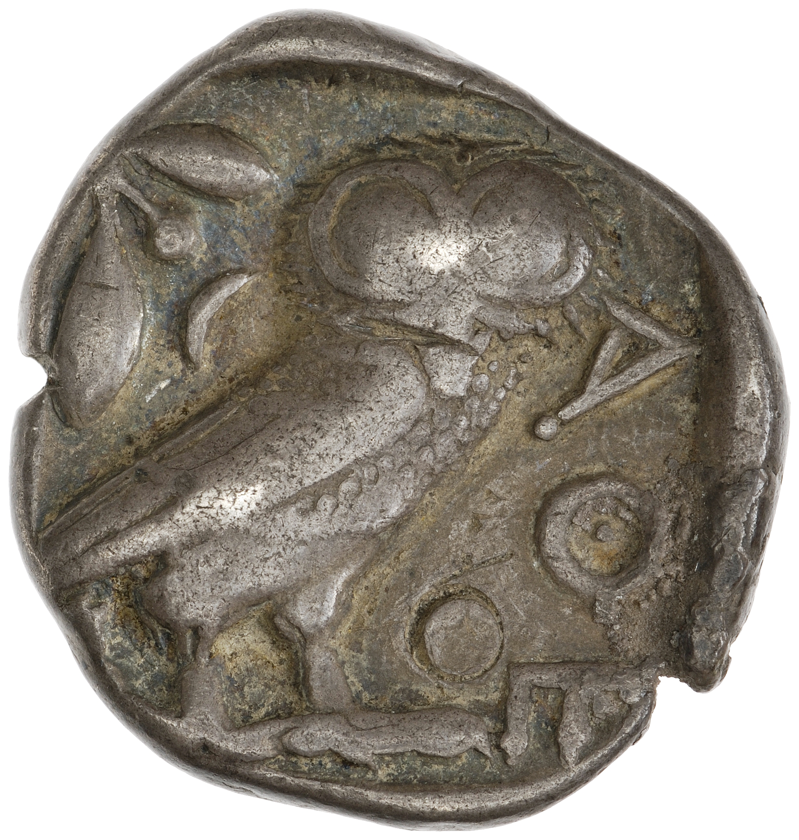
- Tribute in Silver coinage from member Polies of the Deleon League which was collected using its big powerful Navy (Thucydides, 1954, Book 2. Chapter 13. Section 3).
The imagery on the coin consists of a side profile image of the Goddess Athene on the obverse, while on the reverse is an image of an Athenian Owl with a couple of Olive branches (American Numismatic Society, 2015). The image on the obverse side of the coin is of Athene, who is the goddess of wisdom, military strategy and philosophy (V. Ions, 1978). Athene is also the patron goddess of Athens, hence the cities name, after she won it in a competition with Poseidon. (V. Ions, 1978, p103). We can tell that the coin is from the period 431-421 BC, due to the shape and decoration of Athene’s helmet and face. The laurel wreath round her head was introduced after the victory of Greek Polies in the Persian wars as Laurel leaves are a sign of victory (I. Carradice, 2010). Also, Athene’s appearance is still very Archaic (big nose and eyes), this appearance changes after Athens defeat in the Peloponnesian War (J. Boardman, 1991). Therefore, we can pinpoint the age of the coin due to stylistic changes. On the reverse side of the coin, the imagery is of the symbols that represent Athene and to the gifts that she gave the Athenians to try and win a competition with Poseidon to become Patron Goddess of Athens. In the myth, she was supposedly to have gifted the Athenians olives as they could be harvested and used more practical compared to Seahorses, which is what Poseidon gifted them (V. Ions, 1978, p103). The Owl is a symbol of Athene, which has the connotations wisdom, justice and philosophy (V. Ions, 1978). The Owl is also associated with Athens, as the city is named in tribute to the Goddess Athene which so happens to share the symbol of the Owl (V. Ions, 1978). Therefore, both share the same symbol. Also, the inscription on the coin reading ‘AOE’, is an abbreviated version of the word ΑOΕΝΑΙΟΝ, which in translation means “of the Athenians”. Therefore, we can firmly assume that this coin comes from Attica. (I. Carradice, 2010).
Figure 2:Reverse of Silver Athenian Tetradrachm, 450 BC - 430 BC, http://numismatics.org/collection/0000.999.9884?lang=en
References:
American Numismatic Society (2015), ‘Silver Athenian Tetradrachm, 450 BC - 430 BC’, Available at: http://numismatics.org/collection/0000.999.9884?lang=en (First accessed 16th January 2020)

I. Carradice (1995), ‘Greek Coins’, United Kingdom, British Museum Press, pp 32

J. Boardman (1991), ‘The Oxford history of the classical world’, Oxford, Oxford University Press.

M. Thompson (1982), ‘Reflections on the Athenian Imperial Coinage, Hesperia Supplements, Vol. 20, Studies in Athenian Architecture, Sculpture and Topography’, pp. 163-171+220, The American School of Classical Studies at Athens, https://www.jstor.org/stable/1353957 , Accessed: 16-01-2020 14:55 UTC

V. Ions (1978), ‘The Worlds Mythology in Colour’, London, The Hamlyn publishing Group, p103

Thucydides (1954), ‘History of the Peloponnesian War’, London, Penguin Group, Book 2. Chapter 13. Section 3

T. V. Buttrey (1979), ‘The Athenian Currency Law of 375/4 B.C.,Essays in Honor of Margaret Thompson’, Greek Numismatics and Archaeology
Silver Athenian Tetradrachm, 450 BC - 430 BC. 0000.999.9884, American Numismatic Society, United States of America, http://numismatics.org/collection/0000.999.9884?lang=en
First accessed 16th January 2020

