Digital Skills and Research Methods
ASSIGNMENT
CLASS: BMSW4003

ACADEMIC REPORT

STUDENT NAME: CADMIEL OPRESCU
STUDENT NUMBER: 2133523
LECTURER: SUNETH FERNANDO

Contents

Introduction 3
Research Background 3
Aims and Objectives of This Research 4
Aims of This Research 4
Literature Review – Virtual Learning Environment 4
Method 6
Research Approach 6
Data Collection 6
Sampling method 6
Method of their analysis 6
Ethical considerations 6
Analysis and Discussion 7
Conclusion 13
References 14
Appendix ...……………………………………………………………………………………16

Introduction
One of the more modern innovations in the contemporary educational environment is the addition of virtual learning environment which is also known as VLE. In this particular research project, a comprehensive questionnaire survey has been undertaken based on quantitative research method which will analyse the impact of virtual learning environment in different perspectives on the students of the University of Wales Trinity. In this particular research project, the author has identified the research background, has provided an overview of the literature review which is also used as secondary data in this project and combined a number of statistical tools to demonstrate the analyses and findings that can be communicated to the audience. The author has also carefully conducted the research survey so that every ethical consideration available is taken seriously so that no action causes a breach of the connection and interpretation of the data. The concept of a virtual learning environment is linked to the advent of the Covid 19 pandemic all throughout the research project which will be considered a key factor in simulating the importance of VLE from the perspective of both students and teachers.

Research Background
Research topic
The main subject topic of the research project is, the impact of a virtual learning environment on the learning experiences of students who belong to the University of Wales trinity of the Saint David London campus.
Background
The impact of COVID-19 on University going students has been mostly characterised as lingering and unforeseen. The past 12 months might have ended on a good note, especially with the rising vaccination rates, outdoor graduations of students and the recuperation of academic commitments from educational institutions, however, especially in the UK, the return to the educational institutions was perhaps the most challenging stint ever faced by the students as well as the educators (Sahu, 2020). According to McKinsey, one particular analysis reveals that the impact of the pandemic on the university-going students learning was pretty significant which left them five months behind on average in terms of their major subject and four months behind in terms of academic reading when D school year end it for them (Marinoni et al., 2020). The fallout of the pandemic is therefore apprehended to create a lasting impact which might threaten the prospect of this generation by constructing opportunities that may stretch into their adulthood. As a result, the impact on the total UK economy could see a shark full of around £100 million each year until the undergraduates of educational institutions do not enter the workforce (Chaturvedi et al., 2021).
In order to combat the lingering impact of the COVID-19 pandemic on the education of the skin of university-going students, many educators felt that a virtual learning environment should be introduced in order to get them on the road to academic commitments and personal development opportunities programs. This has been particularly the case for the senior and junior year students who have engaged in assignment submission, presentation, thesis paper and research project submission (Tadese and Muluye, 2020).

Aims and Objectives of This Research

Aims of This Research
The main aim of the research is to investigate the impact of a virtual learning environment on the university’s academic students in the short and long term.
Objectives
- The research purposes investigate what the positive and negative impacts of the virtual learning environment.
- The research aims at finding out the collective alignment and competency of the students in the reception to integrate virtual learning environments as their core learning platforms.
- The research also makes some recommendations to improve the learning platform of the virtual learning environment.

Literature Review – Virtual Learning Environment
Open referred to as the state of learning and teaching tools, the virtual learning environment is characterised and designed with a view to enhancing the learning experience of the student's by incorporating tools like the computer and the environmental Internet (De Lange et al., 2003). There are some principal components of a virtual learning environment package that may exclusively include curriculum mapping, online support for both the student and the instructors, Internet links that connect the curriculum resources residing outside, student tracking, electronic communication and many more (Orey and Rosa, 2018). Curriculum mapping is referred to as a conceptualised framework which can segment the academic curriculum activities into several sections so that both the teachers and the designers of curriculum activities can assign and assess them (Lacka et al., 2021). On the other hand, student tracking is generally a process of collaborating with a performance review of students even if they are not present in a physical environment. There is a lot of electronic communication which are related to a virtual learning environment (Ernest et al., 2013). They are, with publishing, interactive chat programs and platforms, electronic mail, discussion group, discussion threads and many more (Rashid et al., 2021). Electronic communication is one of the key ingredients of combining the physical element of academic curriculum processes and the material ones. Online discussions have added a new dimension to how the relationship between the instructor and the students should be formed. Here, the instructors provide both formative and summative feedback to the students so that they can incorporate the feedback to their own learning. Students also provide feedback on the teaching method of the teachers and instructors so that they can also reciprocate the allotted feedback from the students. In this particular process, an interactive relationship between the instructor and the students is formed (Dutton et al., 2004).
A virtual learning environment also allows the teacher and the students to have their unique identity numbers. Therefore, both the teachers and the students are enabled to see each other’s activities. This has the potential to create a massive form of accountability and transparency from both ends. This is why, according to mini research, a virtual learning environment can help educational institutions effectively track the transparency and accountability of teachers and students. However, in some cases, the teacher has some more leverage and operational tools, as expected, than the students (Hassan et al., 2019). For example, the teacher has the additional service right to create a student performance review as well as they can also modify the current content in the curriculum. This is how, in the virtual learning environment, the teacher can make assessments on the academic performance as well as personal development programs of the students. Some of the most recognised virtual learning environment software packages include Lotus, morning space, blackboard and COSE.

Method

Research Approach
In this particular research project, both quantitative and qualitative methods will be used. The quantitative method will be used to interpret the reactions of the students. The qualitative method would be used by producing a literature review on the concept of the virtual learning environment.

Data Collection
The report will collect both primary data in secondary data. Four primary data, the research project will use the responses from a survey questionnaire. For secondary data, the research will use a literature review by contacting A to Matic analysis of the virtual learning environment.

Sampling method
By using the random sampling method, the survey researcher has selected a total of 10 students who will be participating in the questionnaire.

Method of their analysis
The responses to the questionnaire will be used in the form of some statistical tools including ratio analysis, percentage analyses and graphical representation.

Ethical considerations
The name and ID numbers of the students will not be published to the University authority to maintain the integrity of the research project.

Analysis and Discussion
Question 1
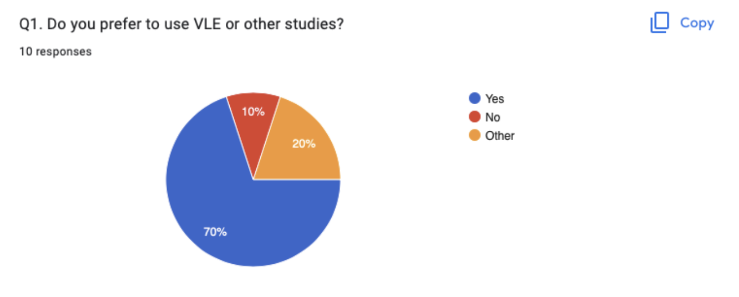
The first question asked to the respondents was if they prefer to use a virtual learning environment or other studies. In response to the question, seven respondents said that they prefer to use the virtual learning environment. One respondent said that he does not want to use a virtual learning environment. Finally, two students say that they prefer to use another study platform. The answer only shows that around 70% of the students prefer to use virtual learning environment.
Question 2
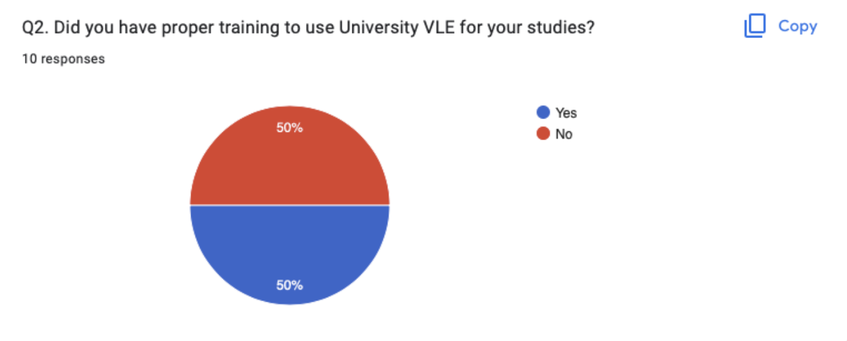

The second question was if the respondents had proper training to use the University virtual learning environment for their respective studies. In response to this question, the respondents were equally divided between the answers. 50% of the students said that, they did have proper training to use University virtual learning environment for their studies. On the other hand, 50% of the rest of the students said that, they did not have proper training to use the University virtual learning environment for their studies. The answers go on to show that, there is an equal distribution of opinion on this particular regard.
Question 3
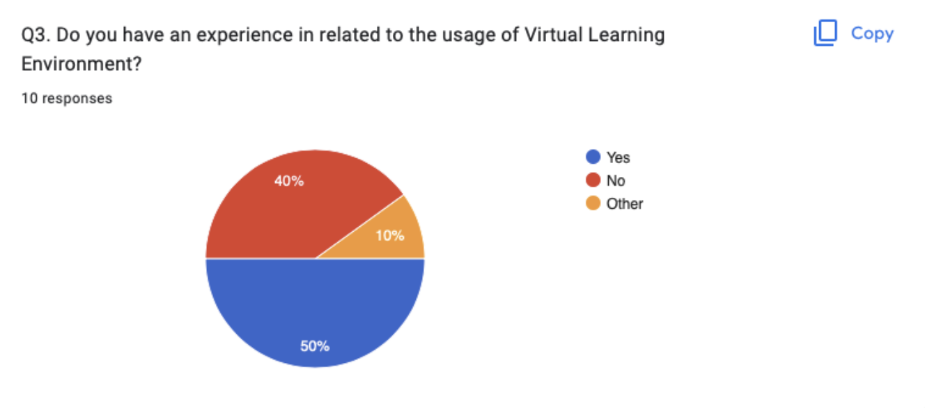

The third question was about if the students had an experience in relation to the application of a virtual learning environment. In this particular case, most of the students, 5 to be exact, answer that they indeed had an experience in relation to the application of a virtual learning environment. 40% of the student said that they did not have any experience in relation to the application of a virtual learning environment. Finally, only one student chose the other option. It can be inferred from the answer to the question that, the most student has an experience in relation to the usage of virtual learning environment but it should be improved nearby.

Question 4
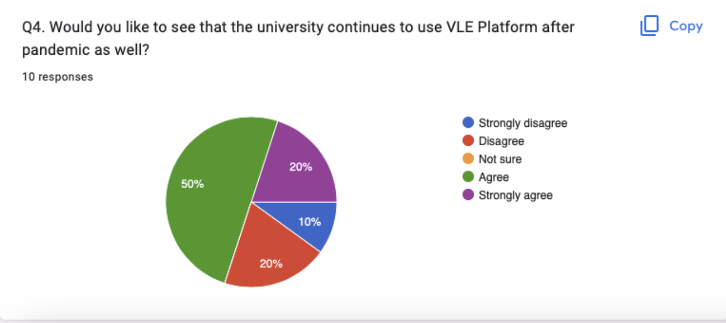

The first question was about if the students liked to see the university continuing the application of the virtual learning environment platform even after the end of the pandemic as well. In response to the question, 50% of the students agreed with the statement whereas another 20% strongly agreed with this statement. This goes on to show that, around 70 students out of the 10, reacted positively to this particular question. On the other hand, 10% of the students strongly disagreed with the retention of a virtual learning environment platform after the pandemic whereas another 20% only disagreed with the notion of assisting with the VLE Platform.

Question 5
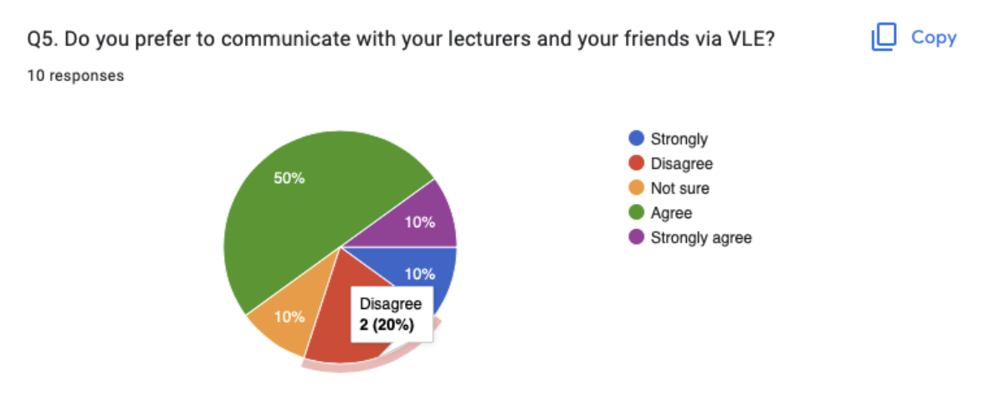

The next question enquired the students if they preferred to communicate with their lectures and their friends via the platform of the virtual learning environment. Reacting to this particular question, 50% of the students agreed whereas 10% of the students strongly agreed. This goes on to show that, the students relatively were in the majority positively reacting to the question which asked them about their communication preferences with lectures and friends. 10% of the students however were unsure of the application of VLE. The rest of the 30% of the students were split between the disagree and the strongly disagree section.
Question 6:
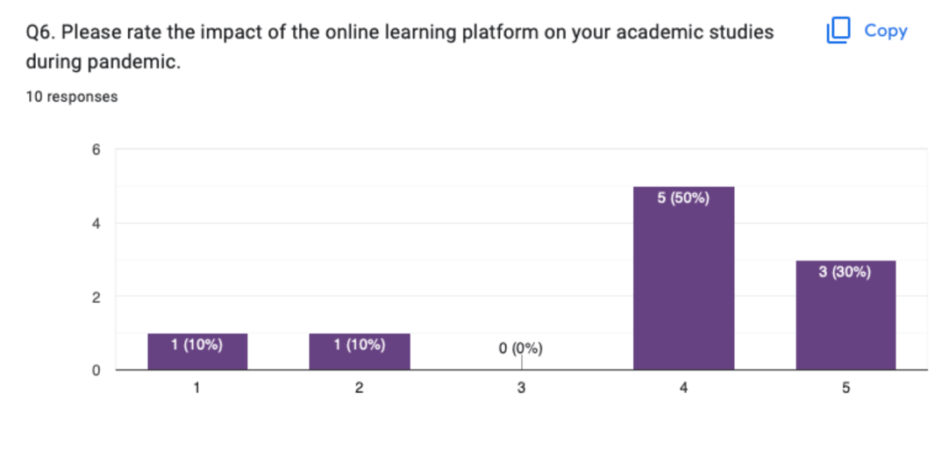

The next question asked the students about the impact of the online learning platform virtual learning environment on their academic studies during the pandemic. Around 50% of the students rated the value platform with a point of four and another 30% of the students read it virtual learning environment as three. Therefore, the majority of the students highly rated the existence of a virtual learning platform as an education platform during the pandemic.

Question 7
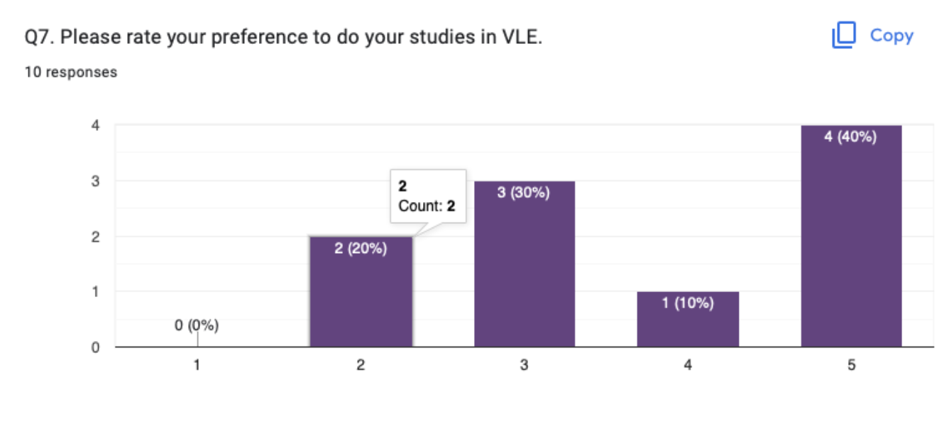
When the students were asked to read the preferences to engage in their studies via the virtual learning environment that from, 4 students rated five whereas one student rated the platform four. However, three students raided platform three and two students read it the platform two. In the end, it can be said that the preference of the students in doing their studies in the virtual learning platform was fairly high.
Question 8

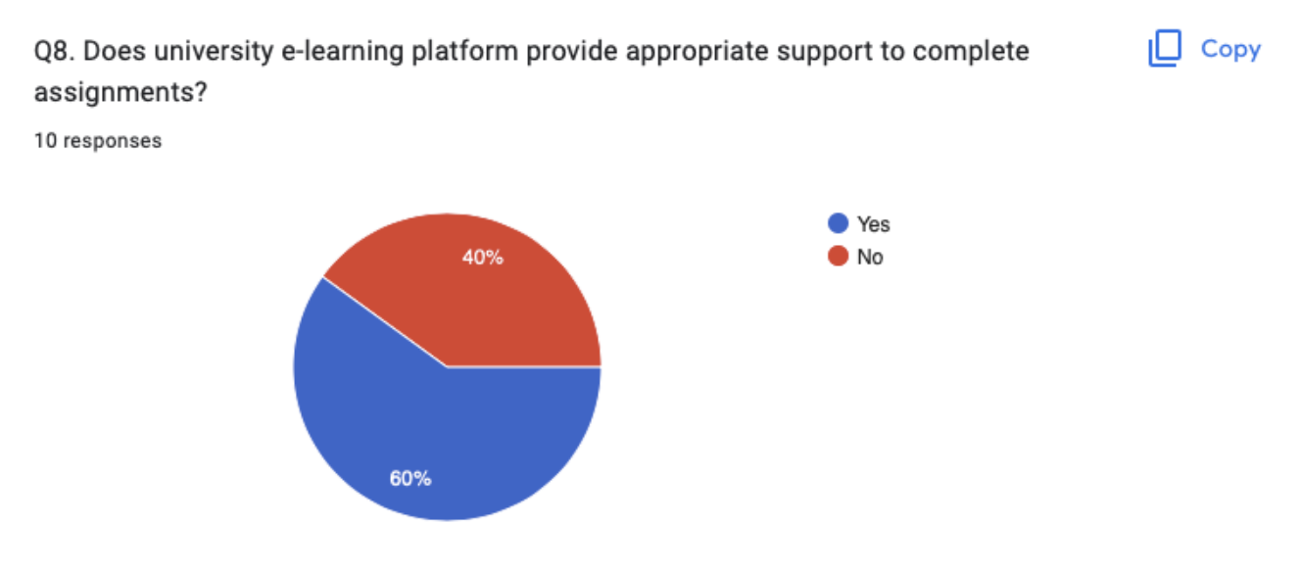
In reply to the next question, 60% of the respondents said that the university does provide appropriate support to complete assignments to the students via the electronic learning platform. However, another 40% of the students also said the negative to the same question. This goes on to show that come in the University needs to work more to increase its support so that the students are fully equipped with the application of the electronic learning platform
Question 9
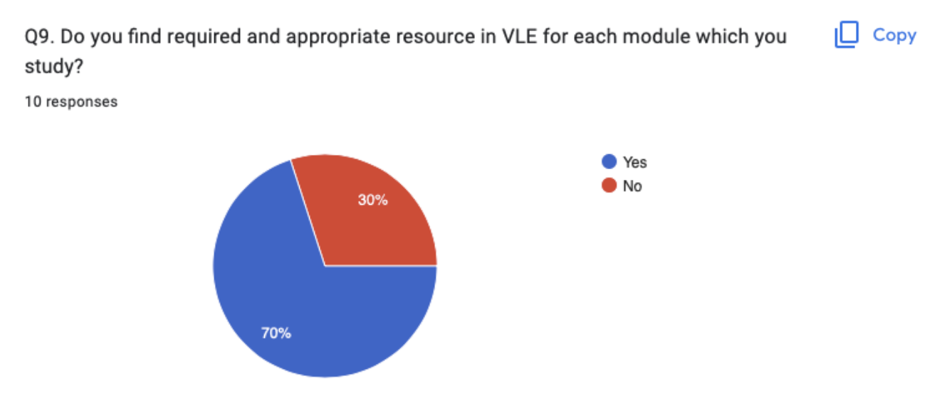
In response to the question of whether the students found their records and appropriate resources in the virtual learning environment for each of the modules, 70% of the students replied in the affirmative whereas 30% of the students replied in the negative.
Question 10
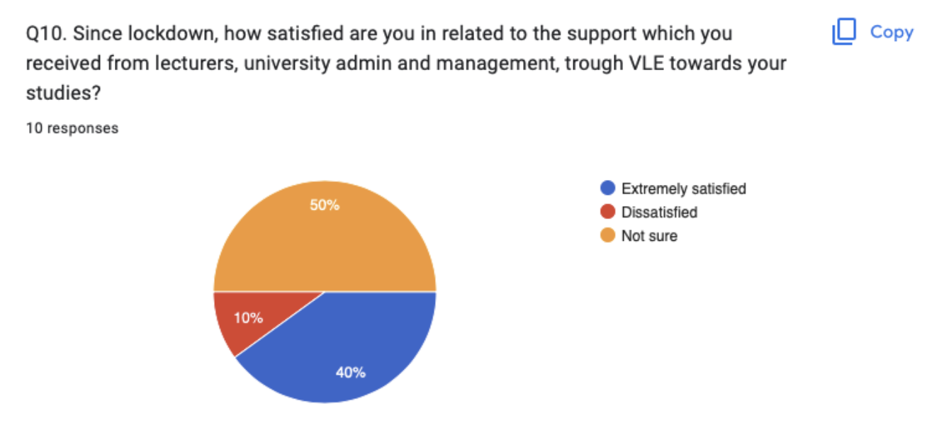
The final question was about the level of satisfaction of the students in regard to the virtual learning environment in form of lectures, university admin and management. This question produced an unfavourable response for the universities in 50% of the students were not sure about the support. 40% of the respondents however replied in positive and another 10% said that they were not satisfied at all.

Conclusion
The research project shows that, the student of the University are mostly positive when it comes to the potential of virtual learning environment as an alternative to the physical classes and lectures. However, the last few questions also showed that, the support they received from the University and management panel were not satisfactory enough in some levels. Regardless, there is ample opportunities for the University management to increase their support by providing training and development programs to the student so that they are better equipped with this learning platform.

References
Chaturvedi, K., Vishwakarma, D.K. and Singh, N., 2021. COVID-19 and its impact on education, social life and mental health of students: A survey. Children and youth services review, 121, p.105866.
De Lange, P., Suwardy, T. and Mavondo, F., 2003. Integrating a virtual learning environment into an introductory accounting course: determinants of student motivation. Accounting Education, 12(1), pp.1-14.
Dutton, W.H., HOPE CHEONG, P.A.U.L.I.N.E. and Park, A., 2004. An ecology of constraints on e‐learning in higher education: The case of a virtual learning environment. Prometheus, 22(2), pp.131-149.
Ernest, P., Guitert Catasús, M., Hampel, R., Heiser, S., Hopkins, J., Murphy, L. and Stickler, U., 2013. Online teacher development: Collaborating in a virtual learning environment. Computer assisted language learning, 26(4), pp.311-333.
Hassan, S.U., Waheed, H., Aljohani, N.R., Ali, M., Ventura, S. and Herrera, F., 2019. Virtual learning environment to predict withdrawal by leveraging deep learning. International Journal of Intelligent Systems, 34(8), pp.1935-1952.
Lacka, E., Wong, T.C. and Haddoud, M.Y., 2021. Can digital technologies improve students' efficiency? Exploring the role of Virtual Learning Environment and Social Media use in Higher Education. Computers & Education, 163, p.104099.
Marinoni, G., Van’t Land, H. and Jensen, T., 2020. The impact of Covid-19 on higher education around the world. IAU global survey report, 23.
Orey, D.C. and Rosa, M., 2018. Developing a mathematical modelling course in a virtual learning environment. ZDM, 50(1), pp.173-185.
Rashid, A.H.A., Shukor, N.A., Tasir, Z. and Na, K.S., 2021. Teachers' Perceptions and Readiness toward the Implementation of Virtual Learning Environment. International journal of evaluation and research in education, 10(1), pp.209-214.
Sahu, P., 2020. Closure of universities due to coronavirus disease 2019 (COVID-19): impact on education and mental health of students and academic staff. Cureus, 12(4).
Tadesse, S. and Muluye, W., 2020. The impact of COVID-19 pandemic on education system in developing countries: a review. Open Journal of Social Sciences, 8(10), pp.159-170.

Appendix


