

University of Wales Trinity Saint David
MSc Cybersecurity and Digital Forensics
ACCA7031 — Digital Forensics Analysis
The Current State of Digital Forensics, and a Case Investigation into
Suspected Exfiltration of Proprietary Technical Information
Prepared by: TASSAVAR Ahemad kureshi
Student ID: 2530068
Lecturer: Dr. Mohamed Ghanem

Table of Contents
Table of Contents 1
PART A — TASK 1: THE CURRENT STATE OF DIGITAL FORENSICS 1
Introduction 1
Current State of the Field and Forensic Tools 1
Digital Forensics and Cybersecurity (DFIR) 1
Emerging Trends 1
Key Challenges 1
National and International Job Market 1
Conclusion and Recommendations 1
Task 1 References 1
PART B — TASK 2: DIGITAL FORENSICS CASE INVESTIGATION 1
Case Background and Summary 1
Investigation Scope and Objectives 1
Evidence Inventory 1
Evidence Integrity and Chain of Custody 1
Evidence Acquisition and Hash Verification 1
Communication Analysis 1
WhatsApp, 21/08/2024 1
WhatsApp, 29/08/2024 (low-relevance content) 1
WhatsApp, 20/11/2024 1
WhatsApp, 31/01/2025 (morning) 1
Facebook, 31/01/2025, 12:47–12:53 1
Call log and contacts (Huawei) 1
Samsung Galaxy A13: independent travel corroboration 1
Chronological Timeline 1
Call and Email Correlation 1
File and Metadata Analysis 1
Suspect Analysis 1
Peter Dover (“Emma” persona), Huawei P Smart 2019 1
Joe, Samsung Galaxy A13 1
Norman, Nokia C2 2nd Edition 1
Vanessa 1
Ulefone Note 14 (unidentified owner) 1
Critical Evaluation of Findings 1
Evidence Limitations 1
Conclusion 1
Recommendations 1
Personal and Technical Reflection 1
Task 2 References 1

PART A — TASK 1: THE CURRENT STATE OF DIGITAL FORENSICS

Introduction
Digital forensics is the use of scientific methods to identify, protect, collect, examine and present electronic evidence, while keeping its integrity and value as proof [1], [2]. The field has grown from simple disk analysis into a formal discipline guided by international standards (ISO/IEC 27037, 27042; NIST SP 800-86). It now covers not just criminal cases but also corporate incident response and civil disputes. The large growth in data, and new anti-forensic tools, are testing existing methods [3], [4]. This report reviews current forensic tools, the link with cybersecurity incident response, new trends, key problems, and job market growth.

Current State of the Field and Forensic Tools
The tools market has two main types: costly commercial suites for businesses, such as Cellebrite UFED, and cheaper open-source tools; courts have tended to favour the commercial suites because open-source tools lack a standard validation framework for legal acceptance [14]. Cellebrite UFED is the most common tool for mobile extraction because it supports many devices. However, its closed-source code makes it hard to check its accuracy against standards such as NIST SP 800-101 Rev. 1 [5], [6]. Magnet AXIOM combines disk, mobile and cloud data using AI, but its methods are also not fully open to review.
EnCase (OpenText) is still used in court but is hard to learn and costly. FTK processes data quickly but can crash on very large files. X-Ways gives detailed control but takes more time to use. Autopsy, based on The Sleuth Kit, is the best-known free tool. Because its code is open, it answers some of the criticism aimed at paid, closed tools [4], though it lacks business support. Table 1 compares these tools. No single tool is perfect, so examiners often use more than one together.
Table 1. Comparative Overview of Leading Digital Forensic Tools
Tool | Purpose | Key Features | Strengths | Limitations
Cellebrite UFED | Mobile acquisition | Physical/logical extraction, chip-off, cloud tokens | Broad device support | Closed-source; costly
Magnet AXIOM | Disk/mobile/cloud examination | Unified timeline, AI media triage | Intuitive; strong cloud/IoT | Opaque parsers; resource-heavy
EnCase (OpenText) | Enterprise forensics & eDiscovery | EnScript, court-validated reports | Strong legal pedigree | Steep learning curve; costly
FTK (Exterro) | Disk/data indexing | Distributed processing, KFF hashing | Fast on multi-core | Unstable on huge datasets
X-Ways Forensics | Low-level disk analysis | Hex-level control, disk cloning | Lightweight; granular | Weak automation/GUI
Autopsy | Open-source forensic suite | Sleuth Kit backend, plug-ins | Free; auditable code | Weaker enterprise support

Digital Forensics and Cybersecurity (DFIR)
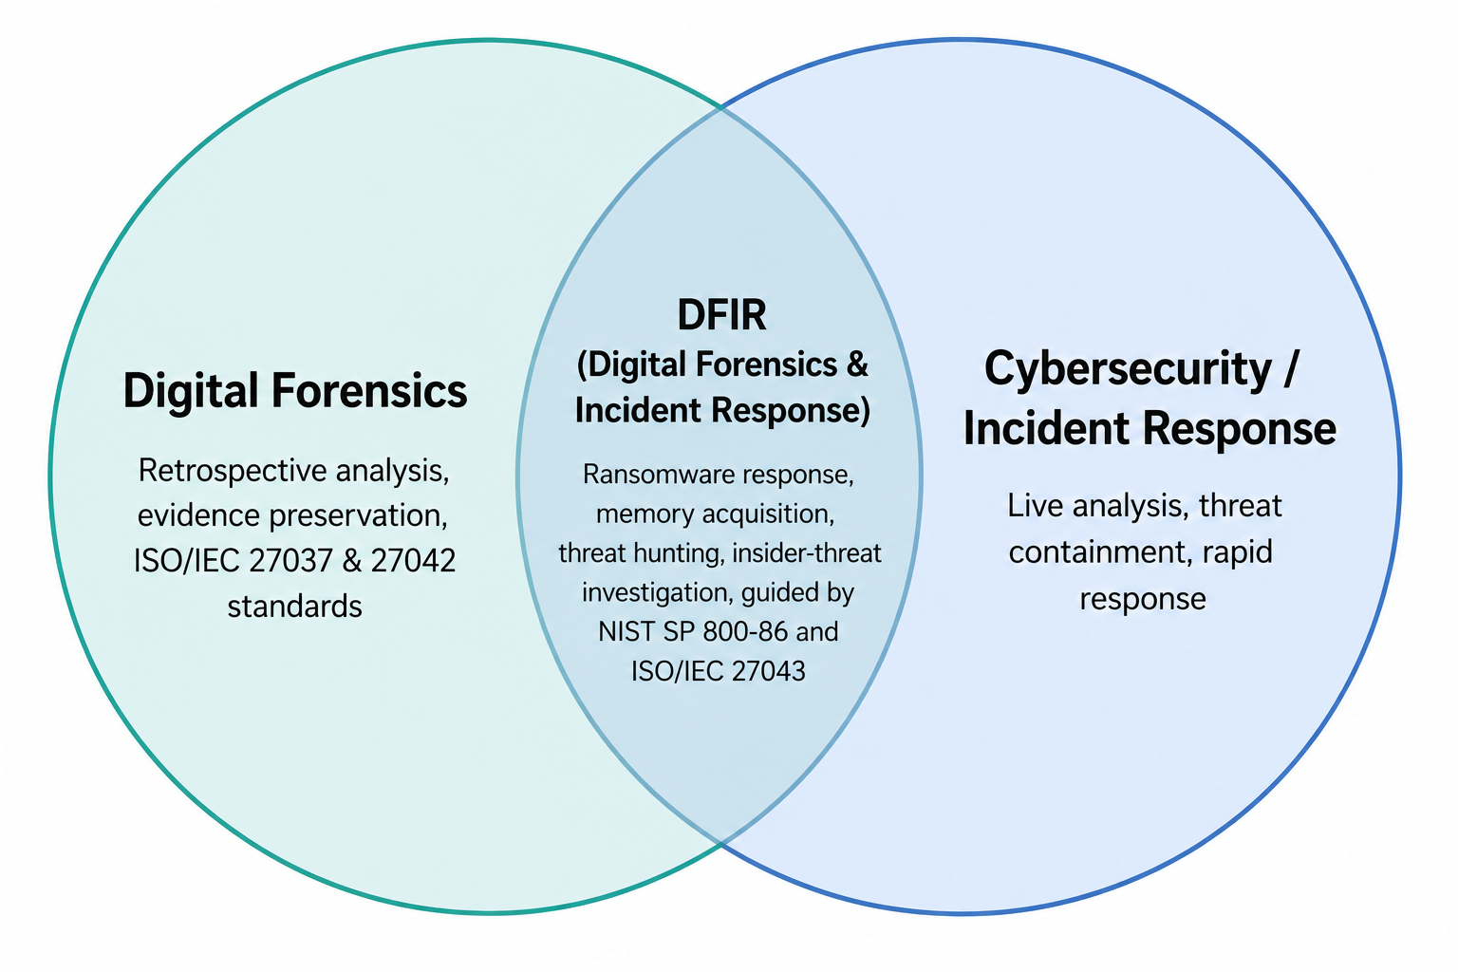
Figure 1. Overlap between Digital Forensics and Cybersecurity / Incident Response (DFIR)
Digital forensics and cybersecurity now overlap so much that they are often called Digital Forensics and Incident Response (DFIR). Traditional forensics looks back at what happened, but incident response must act quickly, often on live systems. NIST SP 800-86 treats forensic methods as part of incident response [1]. This overlap is clearest in ransomware cases, where responders must stop the attack, collect memory evidence, and later rebuild the timeline. Threat hunting also uses forensic methods early, to find hidden insider threats. ENISA reports that ransomware and supply-chain attacks remain the top threats, showing why organisations need forensic-ready systems [7]. Insider-threat cases need the same care, but within stricter privacy and employment laws. ISO/IEC 27043:2015 gives a shared process for both areas [8].

Emerging Trends
Several new trends are changing forensic work. AI and machine learning help sort evidence and spot unusual activity, but their decisions are hard to explain in court, and recent work shows AI/ML now supports most stages of the DFIR workflow, from triage to attribution [13]. Cloud forensics matters more as data moves to cloud providers, which adds legal and access problems compared with normal disk imaging [9]. Internet-of-Things forensics is growing because of smart-home and vehicle data, but different device systems need different collection methods. Memory forensics is important again because modern malware often leaves no trace on disk. Blockchain forensics tracks cryptocurrency crime through transaction records, though anonymous accounts make it hard to identify people. These trends point to forensic work becoming more distributed and closer to real time.

Key Challenges
Strong encryption often blocks access to data without the owner's help. Anti-forensic methods, such as changing timestamps, deleting files, and hiding data, are now easy for non-experts to use, making evidence incomplete [4]. Data stored across countries creates legal problems, since getting permission to access it can take longer than the case allows [2]. New AI tools can create fake evidence, so examiners must check where evidence came from, not just how it looks. The amount of data on each device keeps growing, so automatic sorting is now needed to manage cases without losing accuracy [3].

National and International Job Market
There are not enough digital forensic and DFIR experts to meet demand. The (ISC)² Workforce Study found a large skills gap, with forensic and incident response roles among the hardest to fill [10]. In the UK, police forensic teams compete with private firms for skilled staff, which is pushing up pay. Large companies, under pressure from data breach laws, are building their own DFIR teams and looking for skills in mobile and cloud analysis, memory forensics, automation, and malware analysis, along with certificates such as SANS/GIAC, EnCE and Cellebrite. Demand is expected to grow further as INTERPOL pushes for shared lab standards worldwide, and as IoT, cloud and AI evidence become more common [11].

Conclusion and Recommendations
Digital forensics has grown from a narrow, disk-based task into a wide field linked to cybersecurity, cloud management and legal compliance. No single tool is best for everything, so good practice depends on checking results across tools and following recognised standards [2], [12]. The link with DFIR reflects real operational needs, driven by ransomware and insider threats. Ongoing problems such as encryption, legal borders and growing data volumes show that good tools alone are not enough, and that staffing and legal cooperation matter too. Labs should use tested AI tools for sorting evidence, organisations should keep forensic-ready logs, and practitioners should gain recognised certificates while following ISO and NIST guidance.

Task 1 References
[1] K. Kent, S. Chevalier, T. Grance, and H. Dang, “Guide to Integrating Forensic Techniques into Incident Response,” NIST Special Publication 800-86, Gaithersburg, MD, USA, Aug. 2006.
[2] ISO/IEC 27037:2012, Information Technology — Security Techniques — Guidelines for Identification, Collection, Acquisition and Preservation of Digital Evidence, ISO, Geneva, Switzerland, 2012.
[3] D. Quick and K.-K. R. Choo, “Impacts of increasing volume of digital forensic data: A survey and future research challenges,” Digital Investigation, vol. 11, no. 4, pp. 273–294, 2014.
[4] S. L. Garfinkel, “Digital forensics research: The next 10 years,” Digital Investigation, vol. 7, pp. S64–S73, 2010.
[5] E. Casey, Digital Evidence and Computer Crime: Forensic Science, Computers and the Internet, 3rd ed. San Diego, CA, USA: Academic Press, 2011.
[6] R. Ayers, S. Brothers, and W. Jansen, “Guidelines on Mobile Device Forensics,” NIST Special Publication 800-101 Rev. 1, 2014.
[7] European Union Agency for Cybersecurity (ENISA), “ENISA Threat Landscape 2023,” ENISA, 2023.
[8] ISO/IEC 27043:2015, Information Technology — Security Techniques — Incident Investigation Principles and Processes, ISO, Geneva, Switzerland, 2015.
[9] National Institute of Standards and Technology, “NIST Cloud Computing Forensic Science Challenges,” NISTIR 8006 (Draft), U.S. Dept. of Commerce, 2014.
[10] (ISC)², “ISC2 Cybersecurity Workforce Study 2023,” International Information System Security Certification Consortium, 2023.
[11] International Criminal Police Organization (INTERPOL), “Global Guidelines for Digital Forensics Laboratories,” INTERPOL, Lyon, France, 2019.
[12] ISO/IEC 27042:2015, Information Technology — Security Techniques — Guidelines for the Analysis and Interpretation of Digital Evidence, ISO, Geneva, Switzerland, 2015.
[13] D. Dunsin, M. C. Ghanem, K. Ouazzane, and V. Vassilev, "A comprehensive analysis of the role of artificial intelligence and machine learning in modern digital forensics and incident response," Forensic Science International: Digital Investigation, vol. 48, 301675, 2024.
[14] I. Ismail and K. A. Zainol Ariffin, "The admissibility of digital evidence from open-source forensic tools: Development of a framework for legal acceptance," PLOS ONE, 2025.

PART B — TASK 2: DIGITAL FORENSICS CASE INVESTIGATION

Case Background and Summary
This investigation concerns an alleged corporate IP compromise. Evidence from a Huawei P Smart 2019 (owner: Peter Dover) references material belonging to “ABC technologies” and an “AI-based Neuro product”, with a “blueprint” and financial figures. Four devices were submitted: a Samsung Galaxy A13 linked to “Joe” (intermediary), the Huawei (persona “Emma”), a Nokia C2 linked to “Norman” (buyer-side), and an unattributed Ulefone Note 14.
No “Vanessa”, “NexGen Circuits” or “QT-AI-2025” appears in the evidence. The analysis is confined to the four Cellebrite extractions, and where material does not evidence something this is stated as “Not Available in the Evidence”.
Examiner Name: Tassvar; Date: August 2026; Location: United Kingdom.

Investigation Scope and Objectives
The objectives were to:
(1) Acquire all submitted devices forensically;
(2) Preserve integrity through SHA-256 validation;
(3) Recover communications, contacts, calls, location and account data; and
(4) Correlate artefacts across devices into a corroborated timeline.

Evidence Inventory
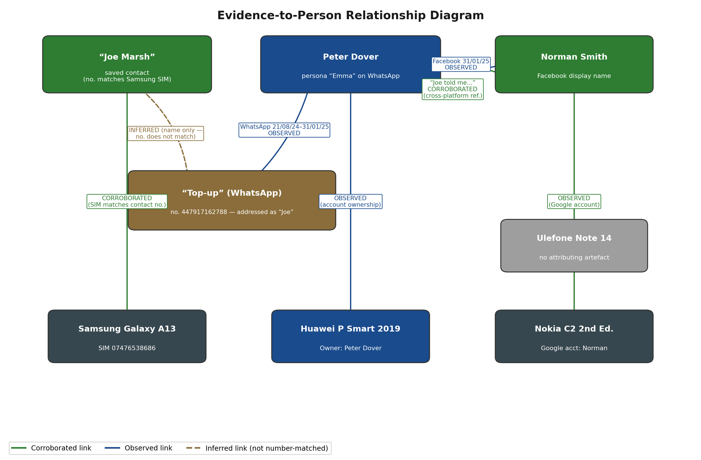
Figure 2. Evidence-to-Person Relationship Diagram — Devices, Contacts and Confidence Levels

Table 2. Evidence Inventory
Evidence Item | Person/Device | Evidence Type | Relevant Detail
Samsung Galaxy A13 (SM-A137F) | Joe (intermediary) | Device extraction | Android 14; SIM 07476538686
Huawei P Smart 2019 (POT-LX1) | Peter Dover / “Emma” persona | Device extraction; chats; email; location | Android 10; account dovp59@gmail.com
Nokia C2 2nd Edition | Norman | Device extraction | Android 11; Google account registered to “Norman”
Ulefone Note 14 | Not identified | Device extraction | Android 12; no attributing artefact recovered
WhatsApp chat, 21/08/2024 | “Emma” / “Joe” | Communication | References “ABC technologies” / “AI based Neuro product”
WhatsApp chat, 31/01/2025 | “Emma” / “Joe” | Communication | “5M secured”, offshore reference
Facebook chat, 31/01/2025 | Peter Dover / Norman Smith | Communication | “5M offshore”, 48-hour deadline
Call log (15 entries) | Huawei | Call records | Mostly “Not answered”, 17–19 Aug 2024
Contacts | Huawei | Contact list | “Aj Worcester Boi”, “Joe Marsh”
Glasgow rail ticket photo | Samsung | Media gallery | Bought 29/08/2024, travel 31/08/2024,Blairhill→Glasgow
Manchester rail ticket screenshot | Samsung | Media gallery | Captured 22/11/2024,Wigan→Manchester
Email inbox (dovp59@gmail.com) | Peter Dover / Huawei | Account evidence | 71 items; largely automated notifications
Location record | dovp59@gmail.com / Huawei | Geolocation | 1601 Willow Road, Menlo Park, CA; 25/01/2025 17:14:09

Evidence Integrity and Chain of Custody
All four extractions were hash-verified in Cellebrite Physical Analyzer, each returning “Verified” (OBSERVED). Handling followed ACPO principles [1] and ISO/IEC 27037 [2].
Examiner: TASSAVAR; Case Identifier: m34cz1; Evidence Number: 0212, recorded at acquisition. Crime Type was logged as “Other”, and Department and Location were left blank (Not Available). This limits proof of unbroken custody but not the technical integrity confirmed by hashing.

Evidence Acquisition and Hash Verification
Acquisition used Cellebrite Physical Analyzer (v7.73.0.11) and Cellebrite UFED (v7.76.0.24, Educational) [4], [5], following NIST SP 800-101 Rev. 1 [3]. Only Cellebrite was used; no second tool cross-verified the extractions. Table 3 gives the SHA-256 values, extraction type and window per device, all “Verified” (OBSERVED).
Table 3. Device Acquisition and Hash Verification
Device | Extraction Type | Start | End | SHA-256 | Status
Samsung Galaxy A13 | File System [Android Backup] | 28/10/2025 11:57 | 28/10/2025 12:36 | 0e585c4f...a3195 | Verified
Huawei P Smart 2019 | File System [Android ADB] | 28/10/2025 16:12 | 28/10/2025 16:53 | d5193dbf...7e31f | Verified
Nokia C2 2nd Edition | File System [Android Backup] | 28/10/2025 16:01 | 28/10/2025 16:03 | a693656c...e13ab | Verified
Ulefone Note 14 | File System [Android Backup] | 28/10/2025 11:25:18 | 28/10/2025 11:27:40 | 630724e2...7befd | Verified
Full SHA-256 values (unabbreviated):
- Samsung: 0e585c4fe8160254253be515a16ff94b7fdf88b248b67d45cfdef8753a9a3195;
- Huawei: d5193dbf8246c09fdde73be8558343985ab24a2e1c142e4d64e16e2b6507e31f;
- Nokia: a693656c260e339069756be8005346e97033d0ccf2f79add56cd69c9eade13ab;
- Ulefone: 630724e2f8863adb9c4f7df1ab645e56c19a832d546fe7ab55b0cebf8ea7befd.
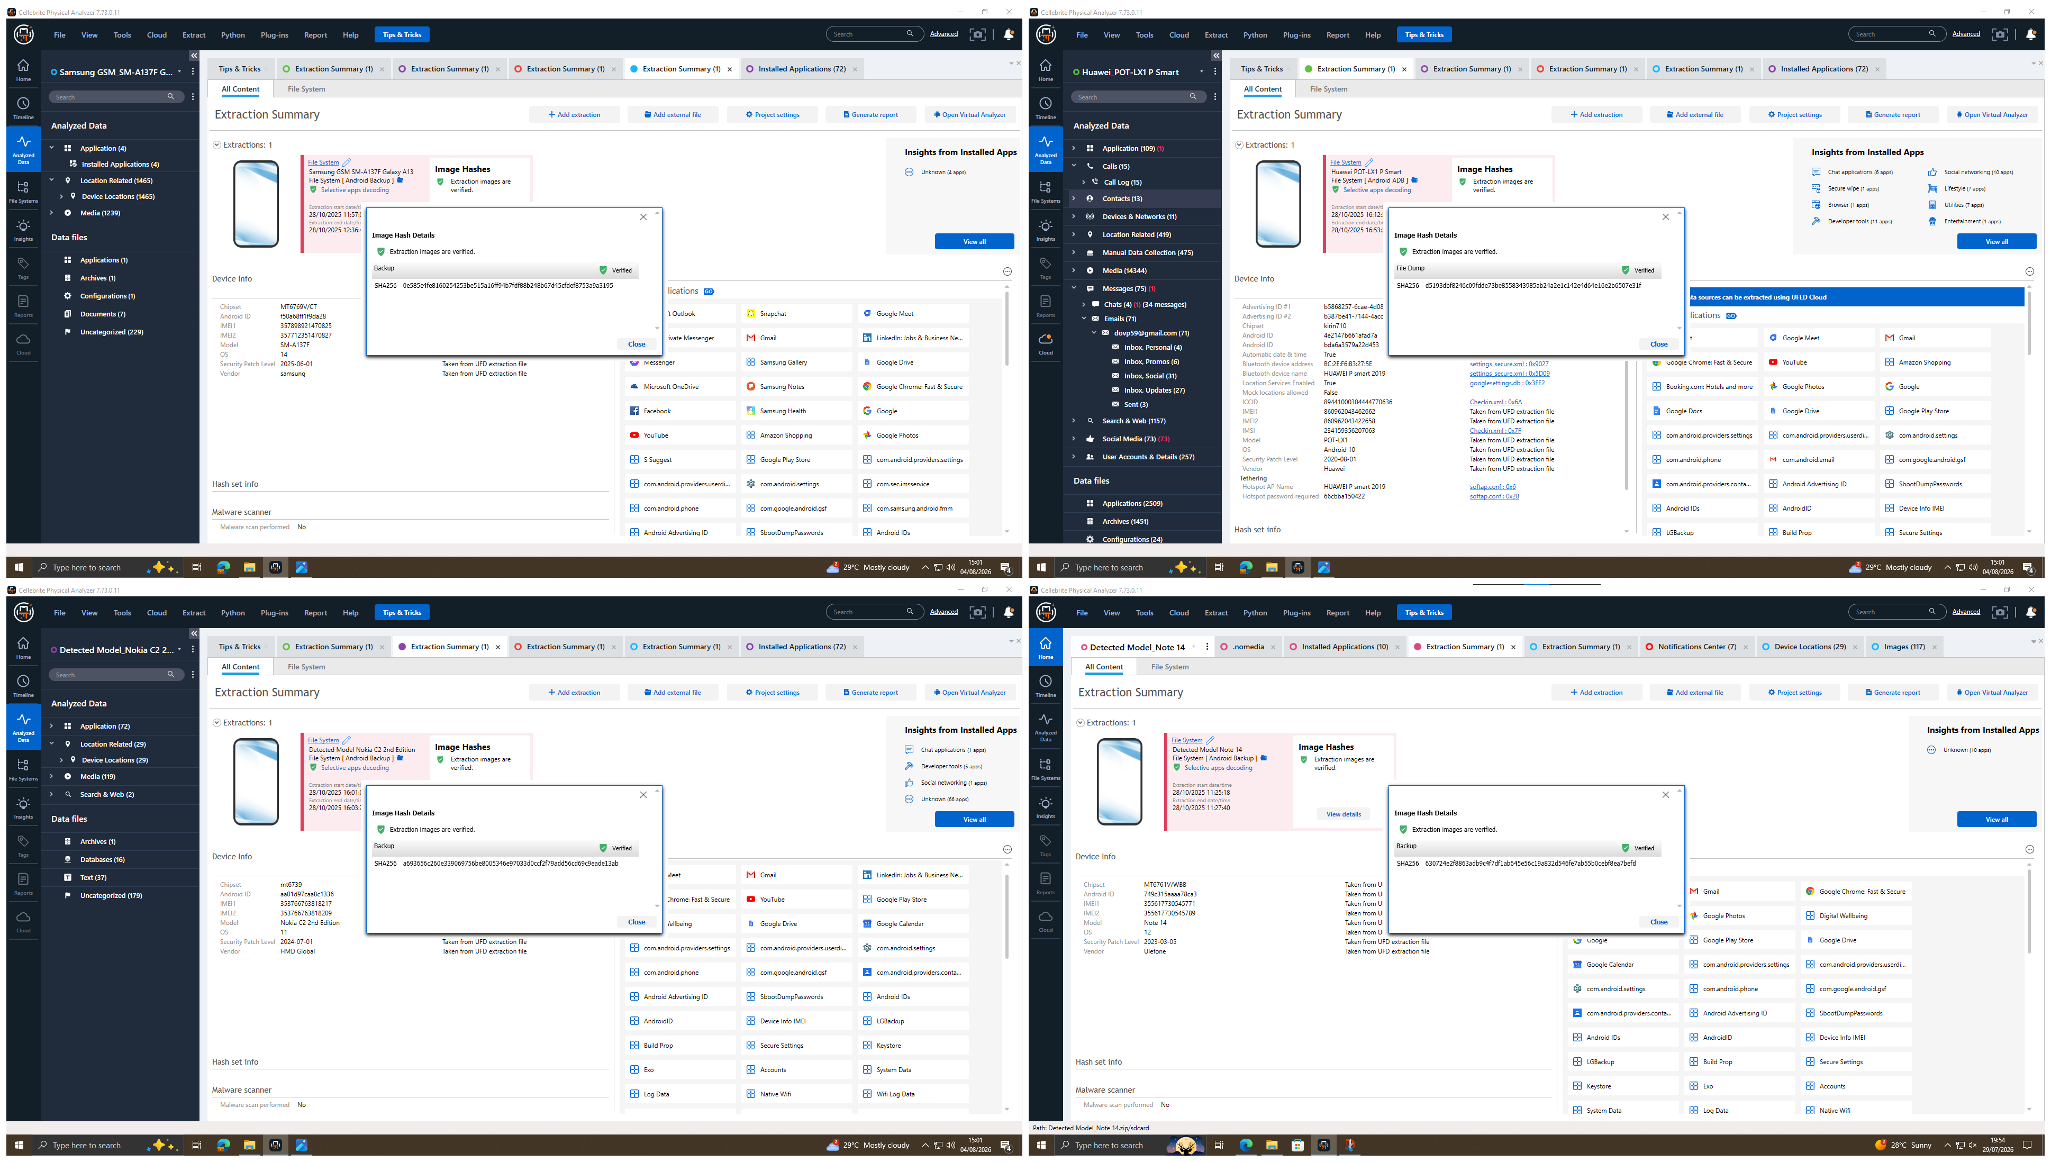
Figure 3. SHA-256 Image Hash Verification — Samsung Galaxy A13, Huawei P Smart 2019, Nokia C2 2nd Edition,Ulefone Note 14 (clockwise from top-left)

Communication Analysis
All four extractions were searched across every communication platform present: WhatsApp, Facebook Messenger, Instagram, SMS, email and call records. Instagram was installed on none of the devices, and no Instagram messages or SMS were recovered (Not Available in the Evidence). The substantive material is a WhatsApp thread (21/08/2024 to 31/01/2025) and a Facebook thread (31/01/2025), both from the Huawei.

WhatsApp, 21/08/2024
The owner (Peter Dover, persona “Emma”) tells a contact saved as “Top-up”: “I have access to some highly valuable information from ABC technologies… I’m thinking about selling it” (09:58). The contact replies “That’s serious stuff Emma”, is addressed as “Joe”, reports meeting clients at a hotel, and agrees to keep it “under wraps” (OBSERVED). This is the earliest evidence of intent to disclose.
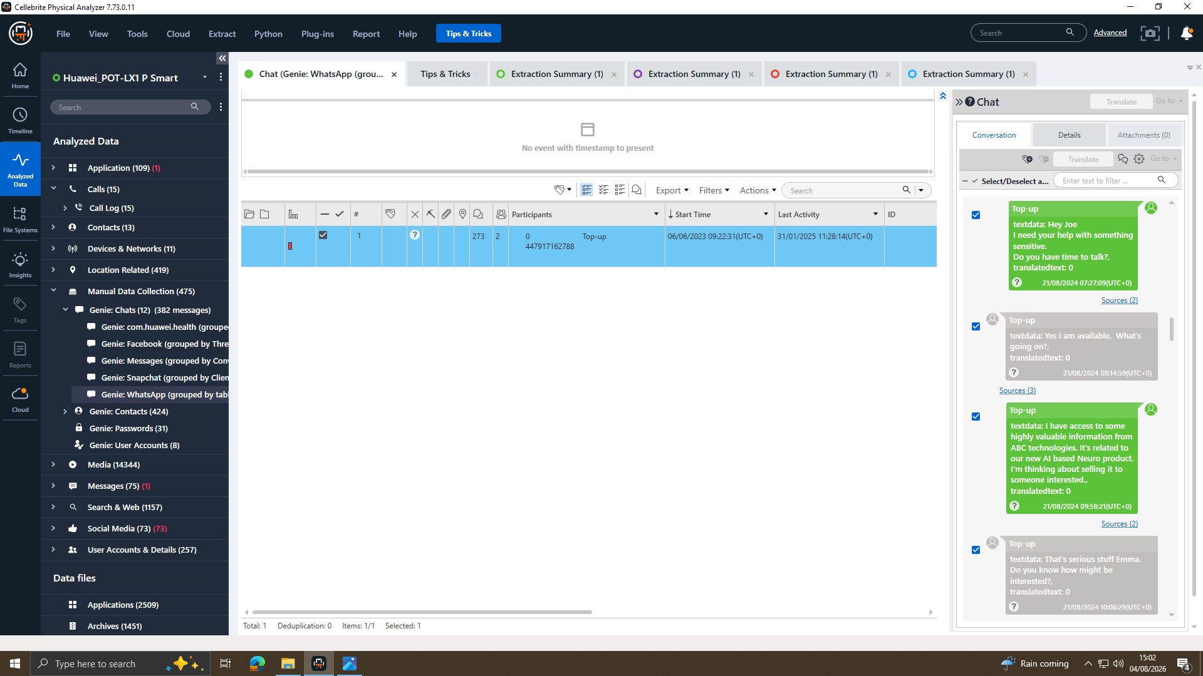
Figure 4. WhatsApp Chat Extract, 21/08/2024 (Huawei P Smart 2019

WhatsApp, 29/08/2024 (low-relevance content)
On 29/08/2024 “Top-up” says he is “flying to Glasgow to meet a contact”, but the thread then carries unrelated promotional content with no reply (OBSERVED). Treated as low-relevance and not relied upon.

WhatsApp, 20/11/2024
The owner presses for progress (“Any update on the offers?”). The contact replies “Final talks about it. Meeting the client this week at Manchester” (OBSERVED). This is the first named buyer-side meeting location.

WhatsApp, 31/01/2025 (morning)
The owner opens “Need to move fast”; the contact reports “Met the guy again… wants better numbers”, and on the offshore arrangement replies “He’s good with it. 5M secured” (OBSERVED), establishing a third party, a likely buyer, unnamed here.
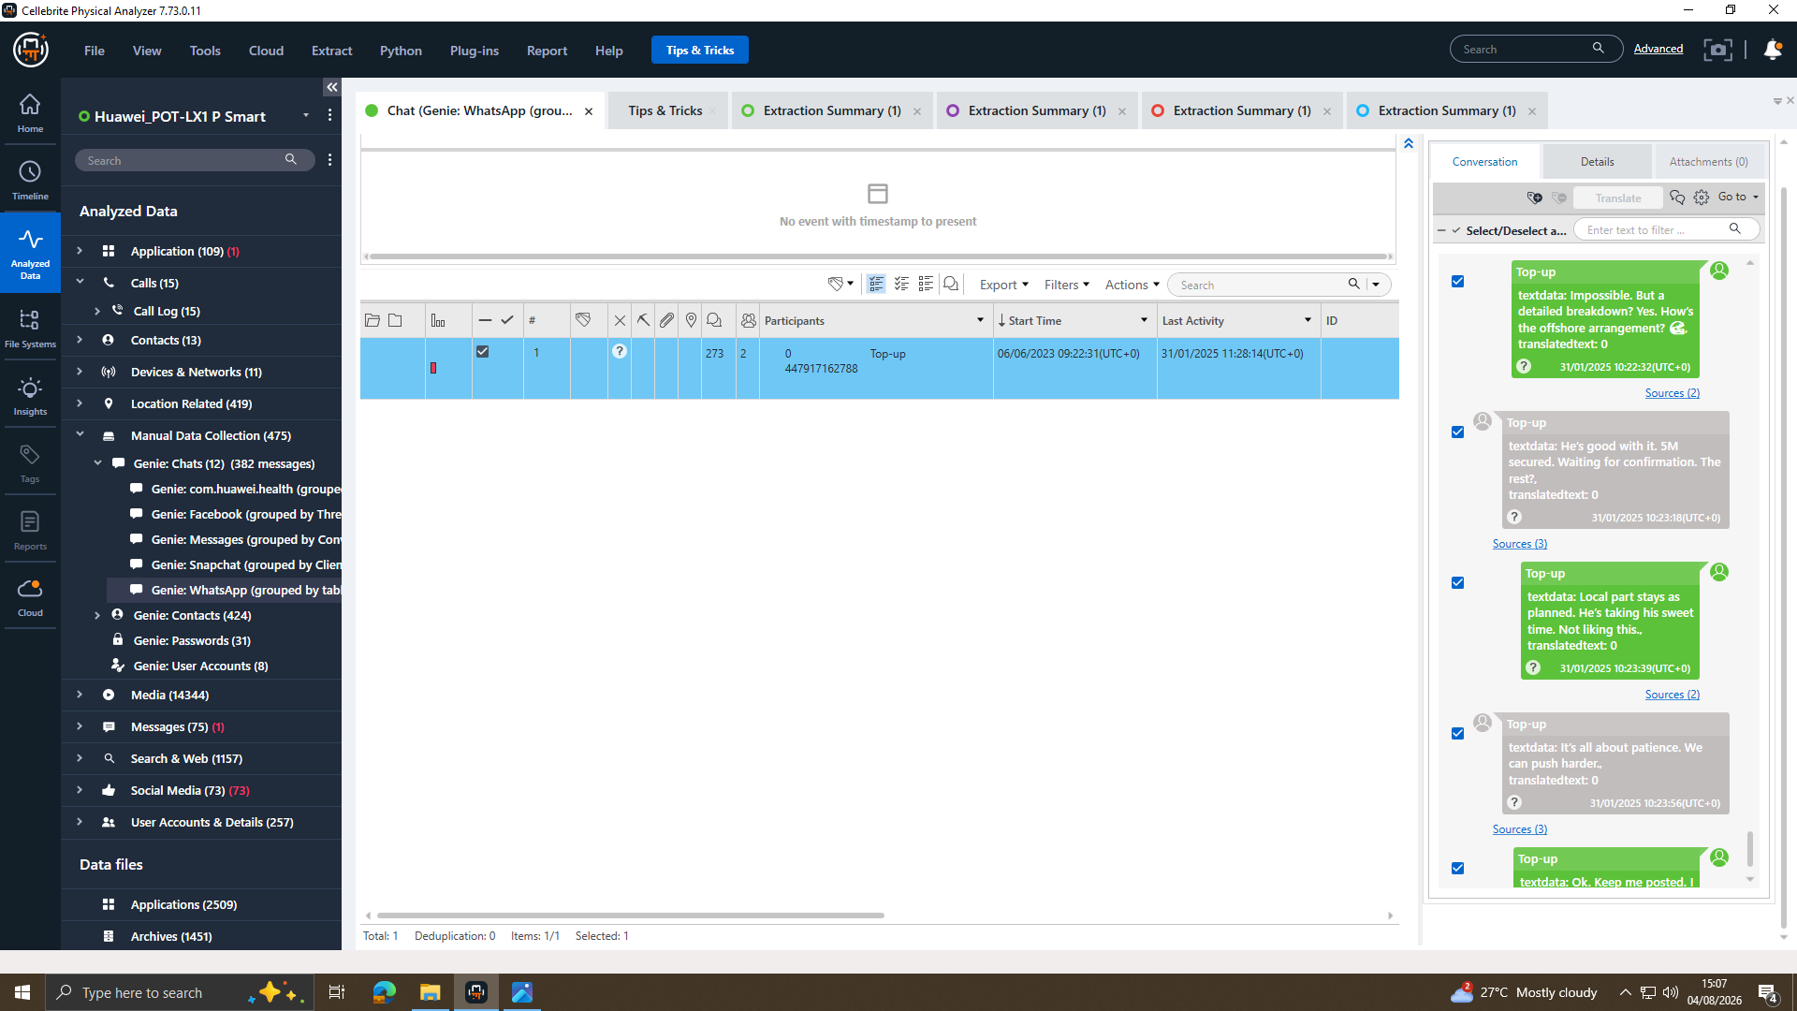
Figure 5. WhatsApp Chat Extract, 31/01/2025 (Huawei P Smart 2019)

Facebook, 31/01/2025, 12:47–12:53
A chat between “Peter Dover” and “Norman Smith” opens “Norman, Joe told me u r ready to proceed” (12:47). This is the only artefact naming “Joe” outside WhatsApp (CORROBORATED). Norman asks for the “Blueprint in chunks”, terms are agreed (“First part releases, and 5M offshore reflects”), and Peter Dover replies “Watch ur inbox in 48 hrs” (OBSERVED). Norman is likely “the guy” referenced that morning (INFERRED).
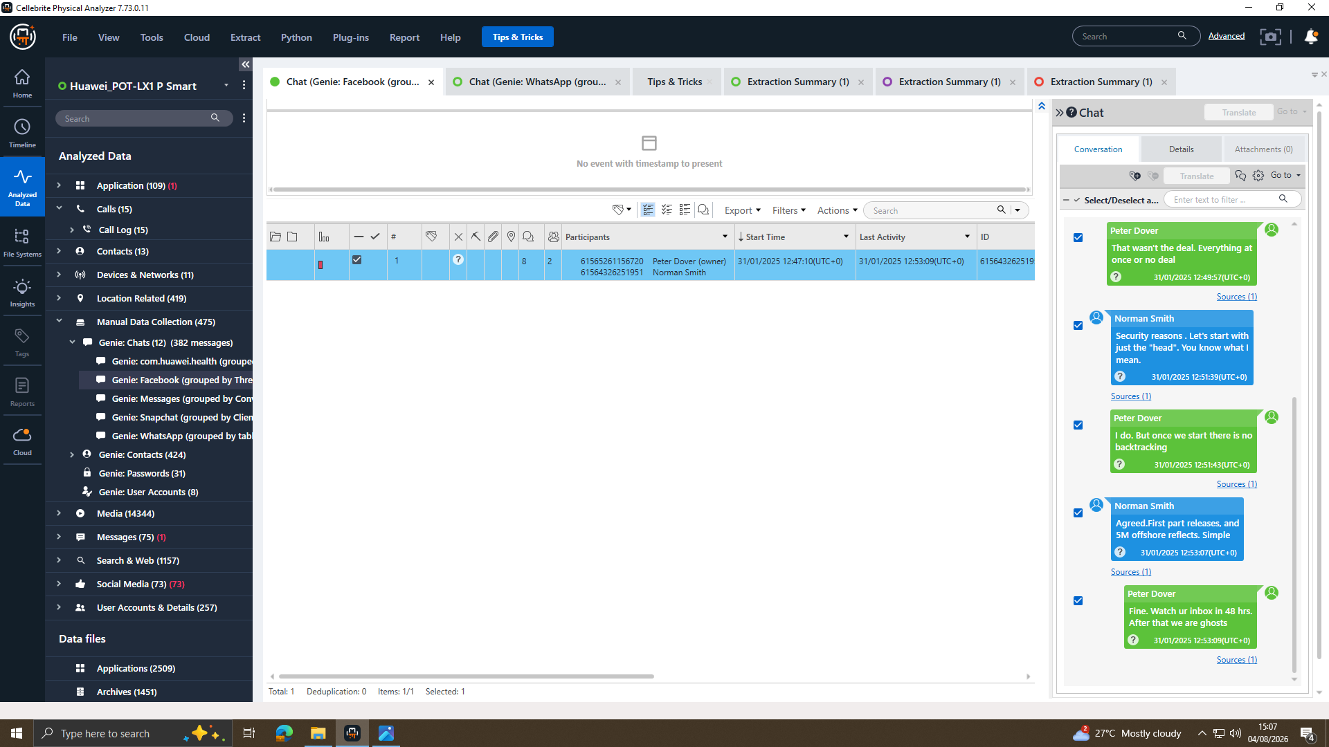
Figure 6. Facebook Chat Extract, 31/01/2025 — Peter Dover / Norman Smith (Huawei P Smart 2019

Call log and contacts (Huawei)
Call records were extracted and cross-referenced across all four devices. Only the Huawei held entries for the period: 15 calls, mostly unanswered, with repeated contact to “SA No.” across 17–19 August 2024 (OBSERVED). Each was checked against the WhatsApp and Facebook timeline, and none coincides with a messaging event, so the calls cannot be tied to the negotiation (UNRESOLVED). This is a documented negative result. “SA No.” matches neither “Top-up” nor “Joe Marsh”, though “Joe Marsh” is saved with a number matching the Samsung SIM (CORROBORATED).
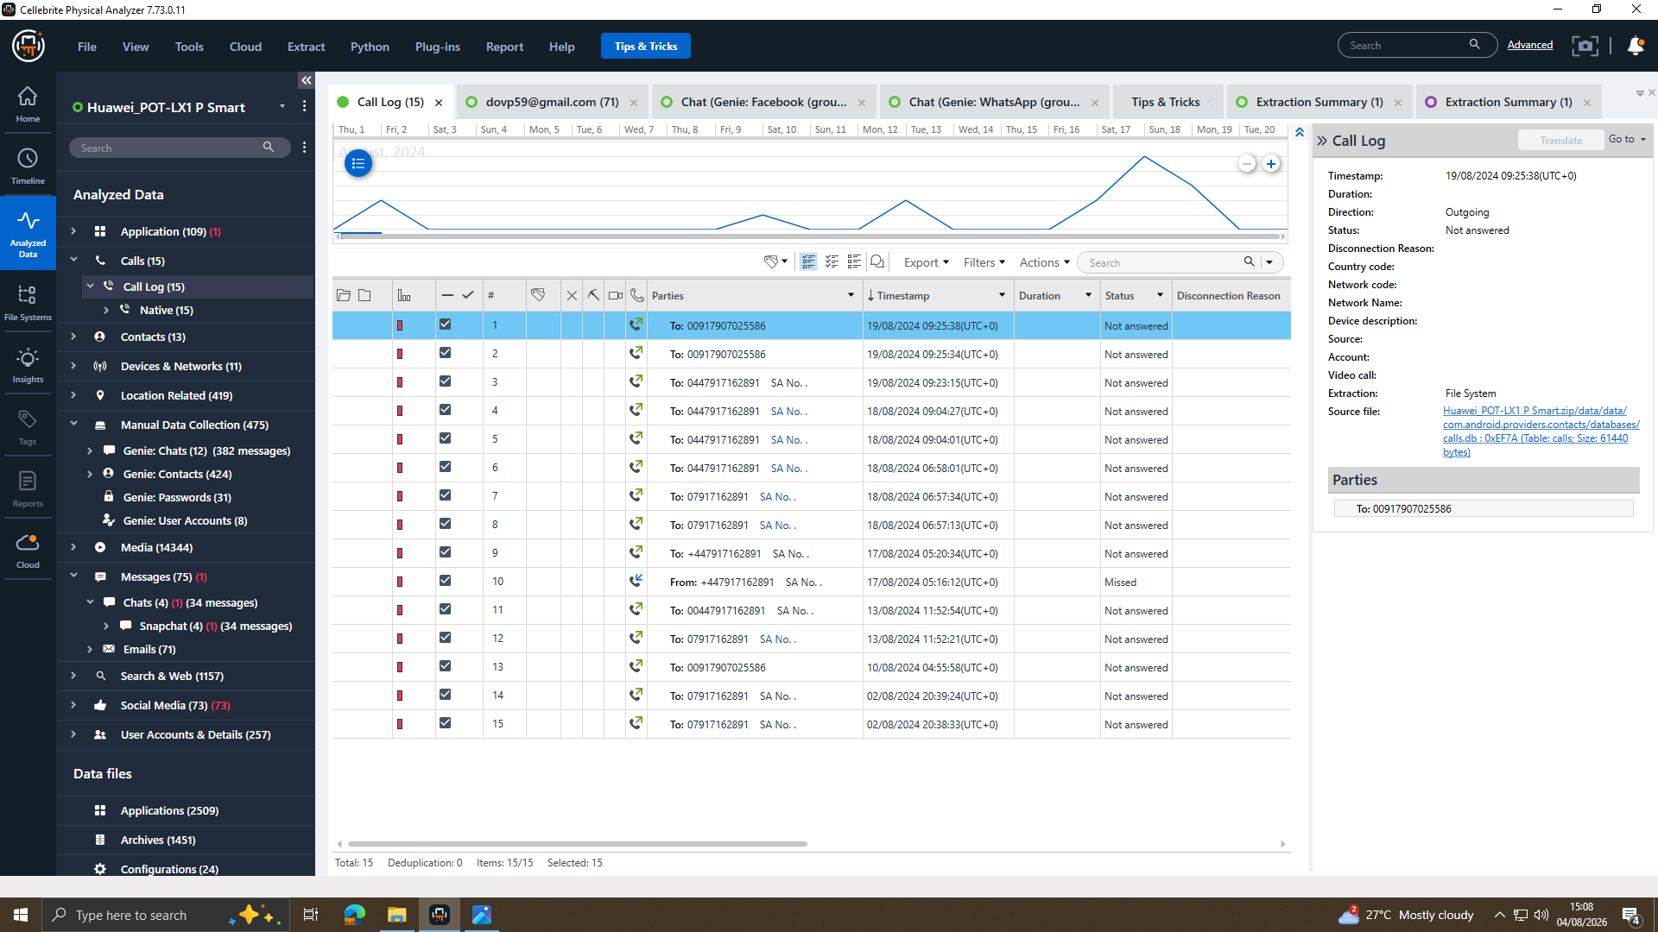
Figure 7. Call Log — Huawei P Smart 2019 (15 entries)
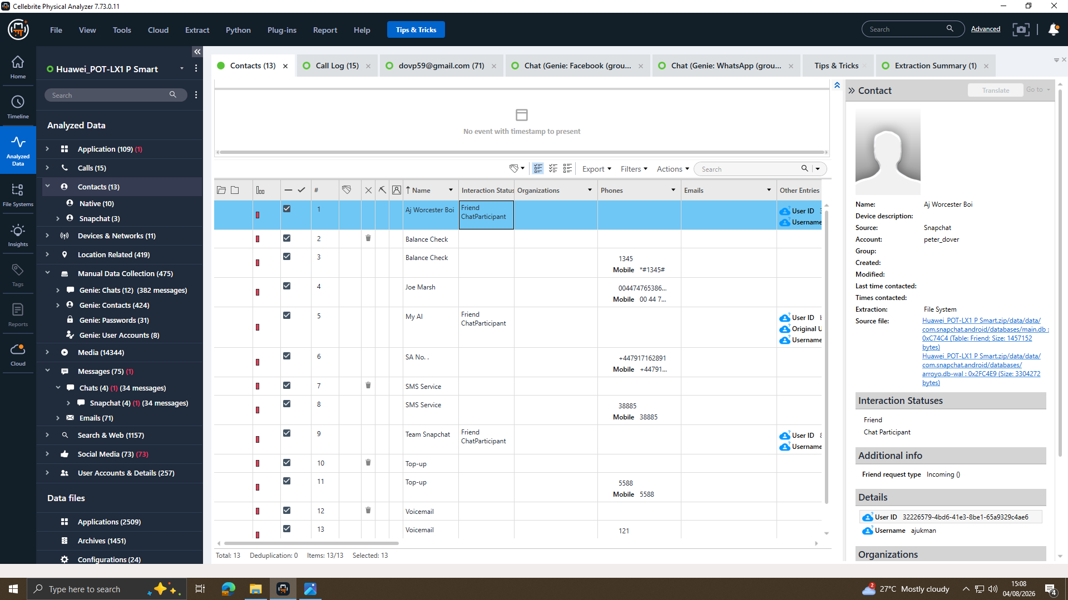
Figure 8. Contacts — Huawei P Smart 2019, showing “Joe Marsh” and “SA No.” entries

Samsung Galaxy A13: independent travel corroboration
The Samsung gallery holds two corroborating items. A rail ticket bought at Glasgow Queen Street (29/08/2024) matches the Glasgow travel message (CORROBORATED), although it is a short local journey rather than the flight described. A Wigan to Manchester screenshot (22/11/2024) matches the Manchester message (CORROBORATED). Both support that travel occurred, not who was met.
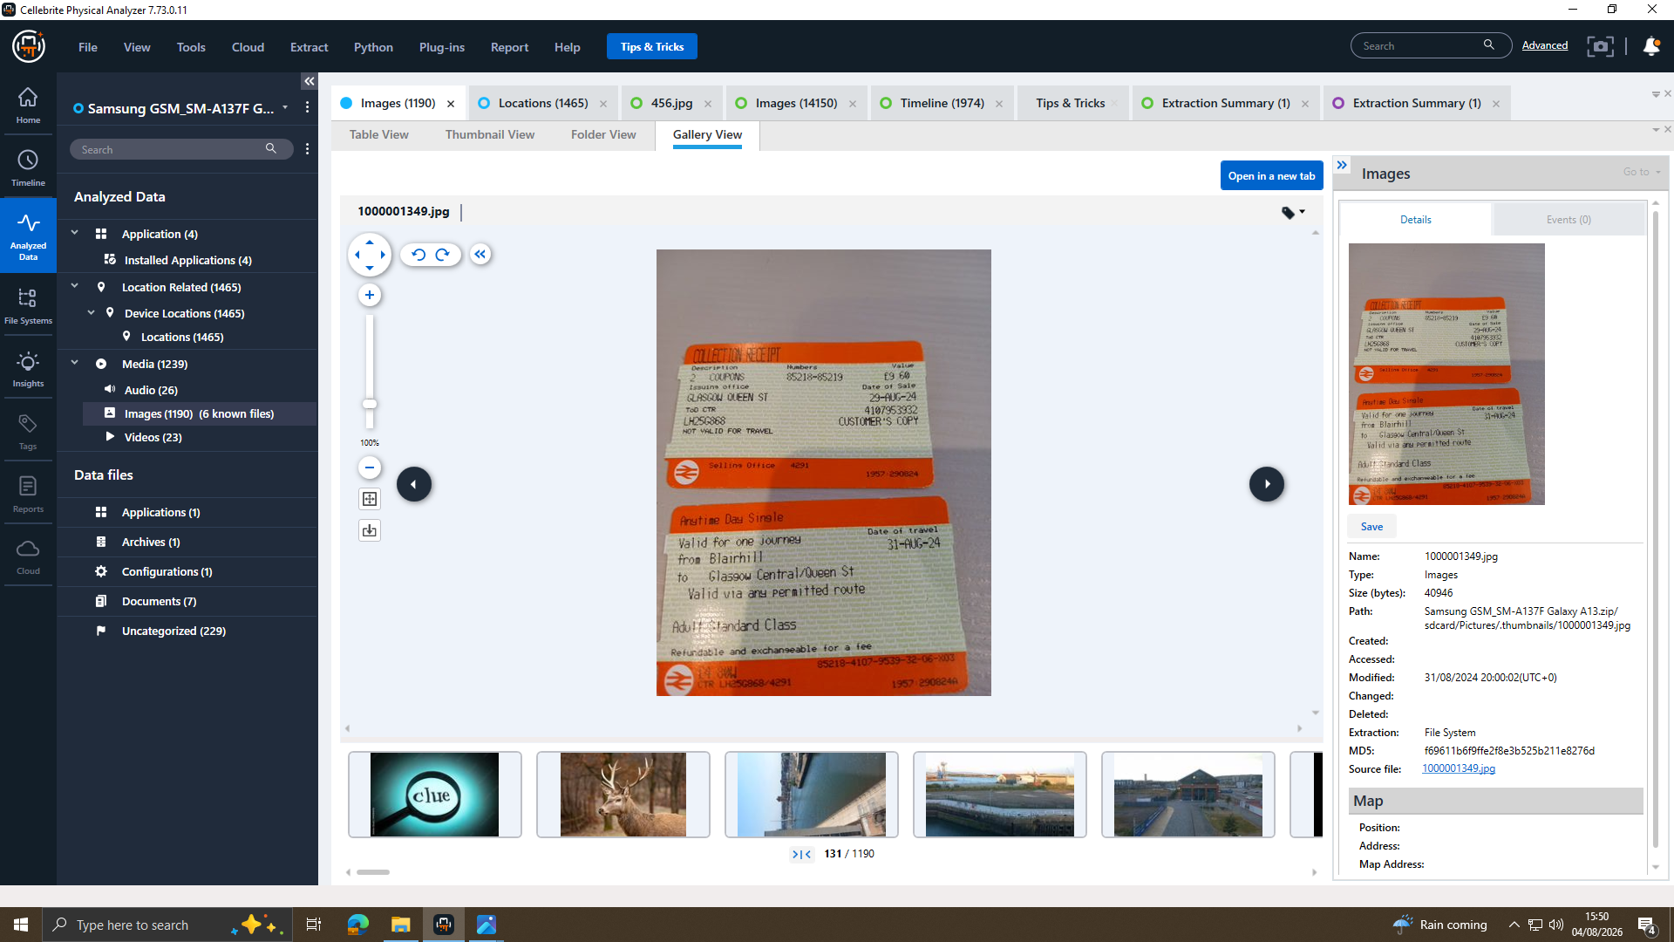
Figure 9. Samsung Galaxy A13 Gallery — Glasgow Rail Ticket Photograph (purchased 29/08/2024, travel 31/08/2024
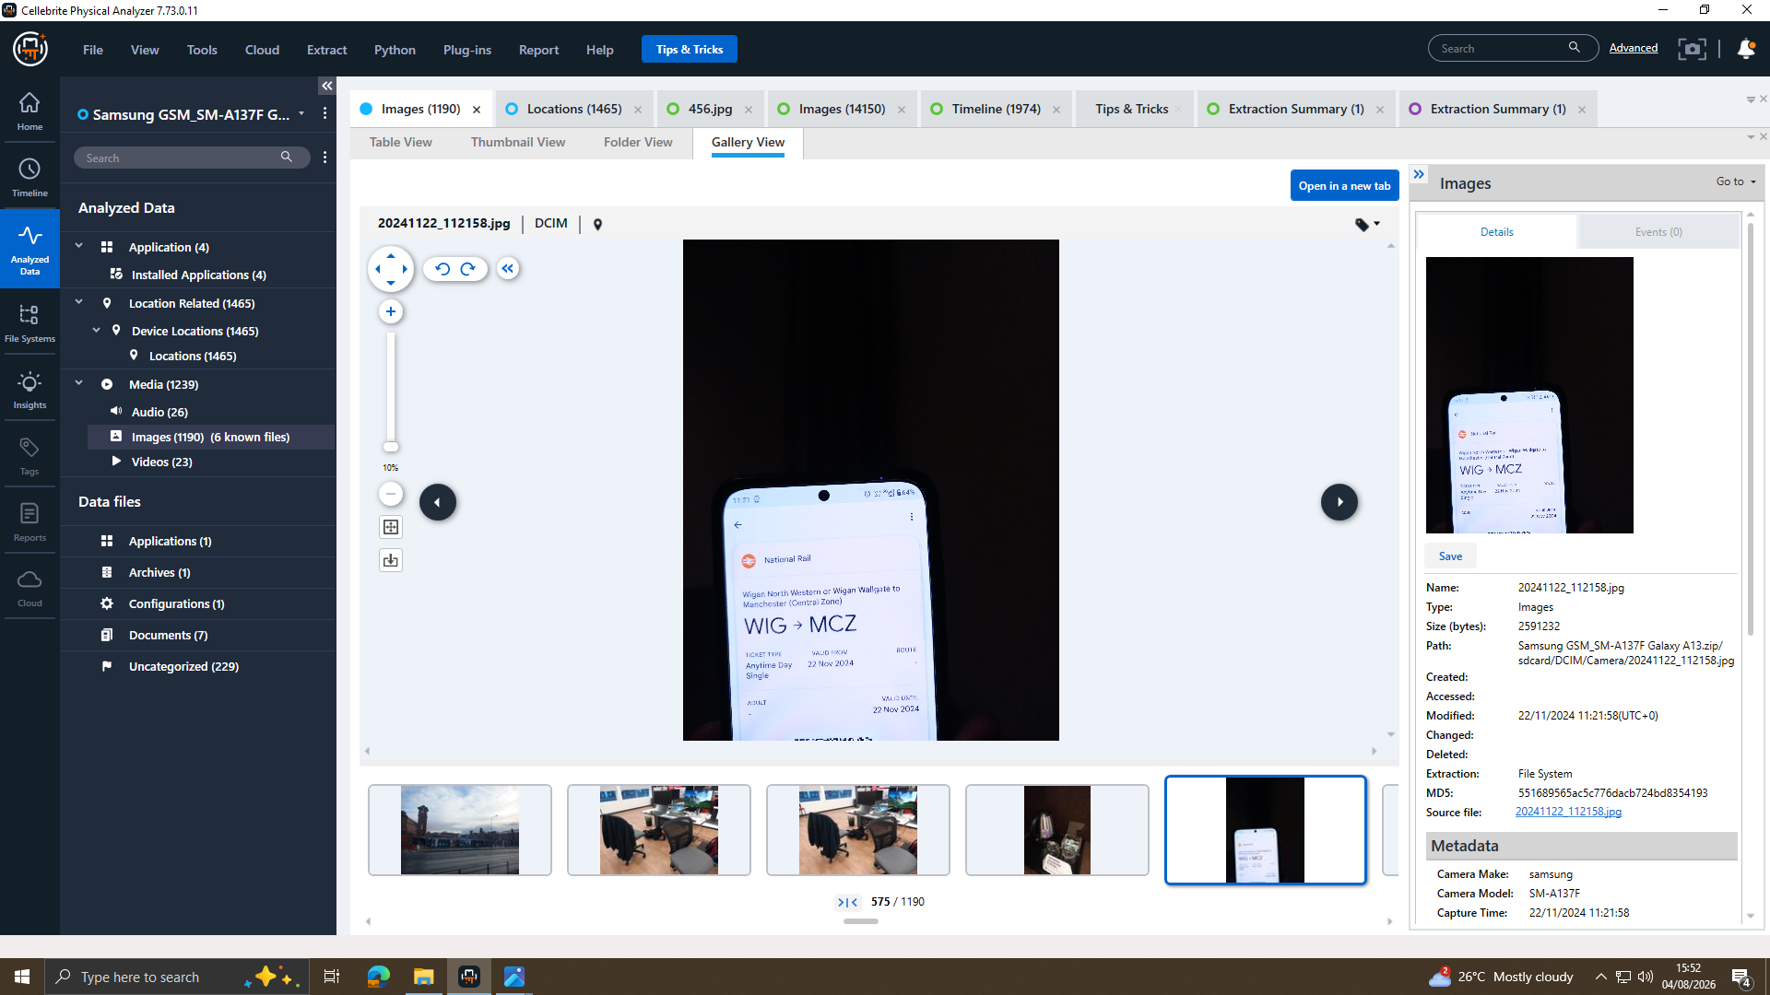
Figure 10. Samsung Galaxy A13 Gallery — Manchester Rail Ticket Screenshot (captured 22/11/2024)
A large volume of Samsung and Nokia location entries came from a racing-game app with a fixed longitude. These are simulated rather than genuine GPS positions and are excluded. Nokia images and a Wi-Fi cookie show general activity unrelated to the negotiation.

Chronological Timeline
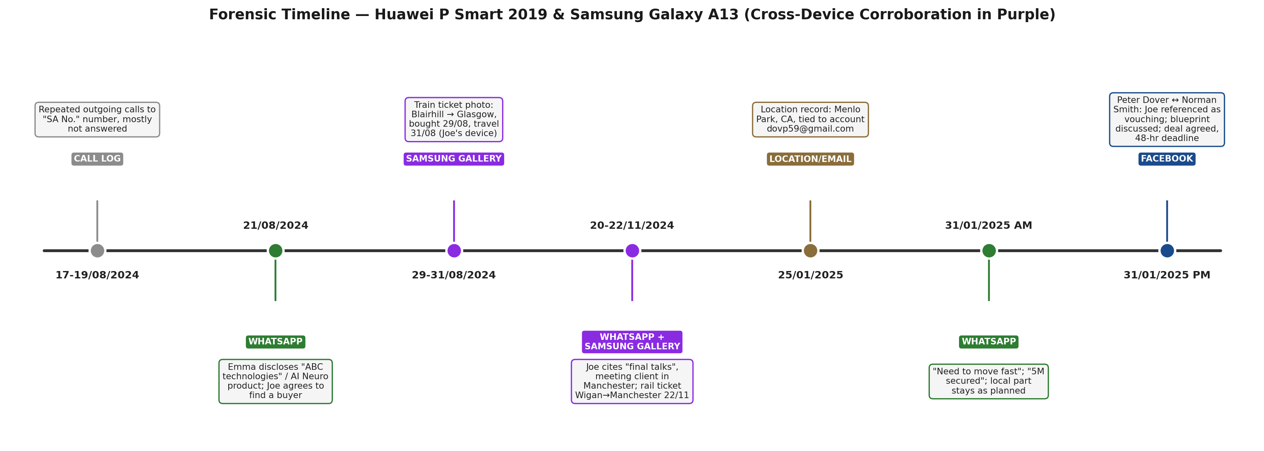
Figure 11. Forensic Timeline Diagram — Huawei P Smart 2019 & Samsung Galaxy A13 (cross-device corroboration highlighted)
Table 4. Forensic Timeline
Date/Time | Source | Person(s) | Event | Confidence
17–19/08/2024 | Call log, Huawei | Owner / “SA No.” number | Repeated outgoing calls, mostly not answered | OBSERVED
21/08/2024, 07:27–14:05 | WhatsApp, Huawei | “Emma” / “Joe” (Top-up) | Owner discloses possession of “ABC technologies” material; contact agrees to seek a buyer, meeting clients at a hotel | OBSERVED
29–31/08/2024 | Gallery, Samsung | Joe (Samsung owner) | Rail ticket photo:Blairhill → Glasgow, bought 29/08, travel 31/08 | CORROBORATED (cross-device)
20–22/11/2024 | WhatsApp, Huawei + Gallery, Samsung | “Emma” / “Joe” (Top-up) | Contact cites “final talks”, meeting client in Manchester; rail ticketWigan→Manchester captured 22/11 | CORROBORATED (cross-device)
25/01/2025, 17:14:09 | Location & Email, Huawei | Peter Dover (account owner) | Location record: Menlo Park, CA, tied to account dovp59@gmail.com | OBSERVED (single record — see §2.6.8)
31/01/2025, 10:15–10:39 | WhatsApp, Huawei | “Emma” / “Joe” (Top-up) | “Need to move fast”; “5M secured”; local part stays as planned | OBSERVED
31/01/2025, 12:47–12:53 | Facebook, Huawei | Peter Dover / Norman Smith | Joe referenced as vouching for Norman; blueprint discussed; deal agreed with 48-hour deadline | OBSERVED; link to WhatsApp thread INFERRED

Call and Email Correlation
The Facebook exchange was cross-checked against the device’s native “Genie” timeline; timestamps matched, confirming the chat as device-native and not edited after acquisition (CORROBORATED).
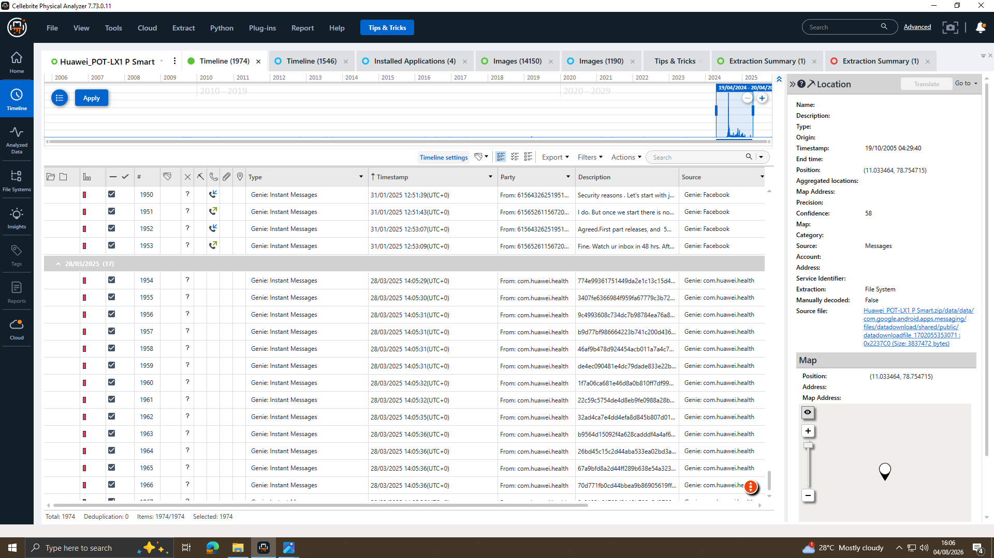
Figure 12. Genie Platform Timeline — Facebook Instant Messages Matching the 31/01/2025 Chat Timestamps
The Gmail account dovp59@gmail.com was reviewed in full for exchanges relating to sample or file transfer. The recovered items are routine service and marketing notifications, with no message discussing the material, no attachment, and no correspondence with any party named in the chats (Not Available). The location record and Gmail entry share one timestamp and source file, so they are one record in two views rather than independent corroboration (OBSERVED). The negotiation ran over WhatsApp and Facebook only, consistent with avoiding a corporate audit trail (INFERRED).
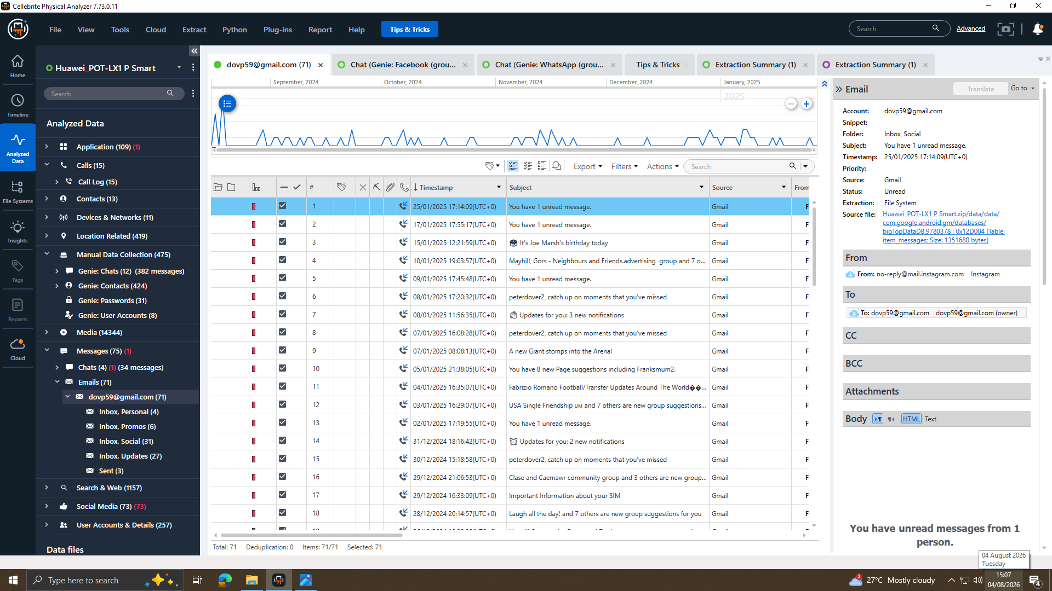
Figure 13. Email Inbox — dovp59@gmail.com (Huawei P Smart 2019)
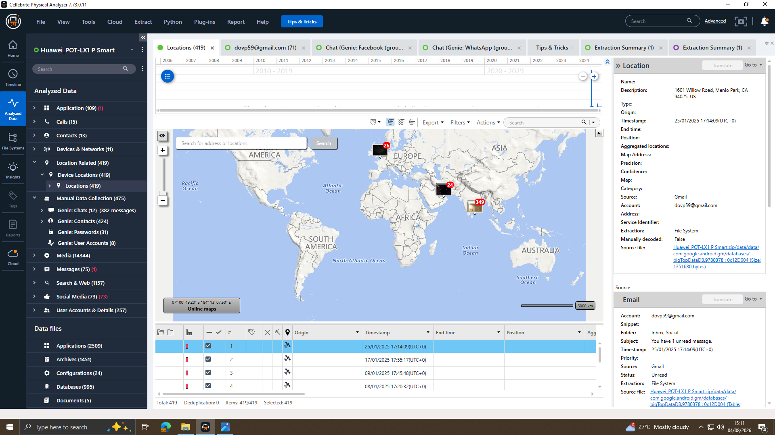
Figure 14. Location Record — 1601 Willow Road, Menlo Park, CA, tied to account dovp59@gmail.com

File and Metadata Analysis
The file systems and media stores of all four extractions were examined for documents, CAD drawings, PDFs and attachments relating to the alleged material. None was recovered and the email attachments field is empty (Not Available). Metadata analysis was applied to the artefacts that did exist: the Samsung gallery images carry creation timestamps of 29/08/2024 and 22/11/2024, each within days of the meetings described in the WhatsApp thread, which is what allows them to corroborate that travel (CORROBORATED). “Blueprint” appears in the Facebook chat text only, so no conclusion is drawn on whether a file existed or was transferred.

Suspect Analysis

Peter Dover (“Emma” persona), Huawei P Smart 2019
Owner of the device holding all substantive chat, email and location evidence. The evidence shows he originated and sustained a proposed disclosure of the material for reward, agreeing terms and a deadline with Norman Smith. No artefact shows the material was transferred, and attribution rests on account ownership rather than biometrics.

Joe, Samsung Galaxy A13
The Samsung SIM identifies “Joe Marsh” as the Samsung owner (CORROBORATED), while the link to the WhatsApp contact “Top-up” remains INFERRED from name usage alone. The Samsung rail tickets match the meetings described (CORROBORATED, cross-device), supporting that the trips occurred though not proving the identities are the same.

Norman, Nokia C2 2nd Edition
Attributed via a Google account registered to “Norman”. The Facebook chat shows him negotiating price and staged delivery with Peter Dover, who treats him as vouched for by “Joe”. This supports Norman as buyer-side. No Nokia-side chat extraction exists, so this stays UNRESOLVED.

Vanessa
No contact, account, message, call record or other artefact referring to “Vanessa” or “NexGen Circuits” appears anywhere in the supplied evidence. Not Available in the Evidence.

Ulefone Note 14 (unidentified owner)
Forensically acquired and hash-verified, but no account, contact or communication artefact identifying an associated person was recovered. Not Available in the Evidence.

Critical Evaluation of Findings
Three items carry the most weight: the WhatsApp thread naming the material and the meetings; the Facebook negotiation, where Peter Dover cites “Joe” as vouching for Norman; and the Samsung rail tickets, which are the only cross-device corroboration. Confidence that a sustained negotiation took place is CORROBORATED. Confidence that any transfer occurred is NOT AVAILABLE. Remaining gaps are set out under Evidence Limitations.

Evidence Limitations
Limitations: (1) the “Top-up” number does not match “Joe Marsh” or the Samsung SIM, leaving the intermediary’s identity unresolved; (2) the Ulefone Note 14 is unattributed; (3) no file artefact substantiates the “blueprint”; (4) the location and Gmail records derive from one database entry; (5) part of the WhatsApp thread (29/08/2024) is unrelated bulk content, excluded. These constrain conclusions about conduct but not acquisition integrity.

Conclusion
The evidence establishes a sustained negotiation (21/08/2024 to 31/01/2025) between the Huawei owner (Peter Dover, persona “Emma”) and a contact addressed as “Joe”, concerning “ABC technologies” and an “AI based Neuro product”. Samsung rail tickets corroborate that contact’s travel. On 31/01/2025 a Facebook negotiation with Norman Smith agreed a “5M” offshore arrangement and a 48-hour deadline. No evidence shows a file was transferred. The findings support further investigation, not a determination of guilt.

Recommendations
It is recommended that:
(1) the Samsung and Nokia chat and call records be examined against “Top-up”;
(2) chain-of-custody documentation be completed;
(3) financial records be sought, with authorisation, to test the “5M” references;
(4) cloud and file-system searches be run for the “blueprint”; and
(5) the matter be referred to law enforcement under the Computer Misuse Act 1990, the Theft Act 1968 as amended by the Fraud Act 2006, and the Trade Secrets (Enforcement, etc.) Regulations 2018.

Personal and Technical Reflection
This investigation strengthened my skills in mobile acquisition, hash verification, and reading Cellebrite output critically rather than at face value. The main lesson was separating what the evidence shows from what it appears to suggest. Tagging findings as OBSERVED, CORROBORATED, INFERRED or UNRESOLVED forced me to distinguish a documented fact, such as a matching SIM, from a plausible but unproven inference. The hardest part was the location data, which looked like corroboration until I traced it to a game app writing fixed coordinates. I also learned the limits of using one tool, and would add a second such as FTK Imager in future.

Mobile Forensic Acquisition Demonstration
Prior to processing the case evidence, the acquisition workflow was demonstrated on the examiner's own test device using Cellebrite UFED. Figures 15-17 show the case-details entry, the selection of content types for extraction, and the completed extraction summary.
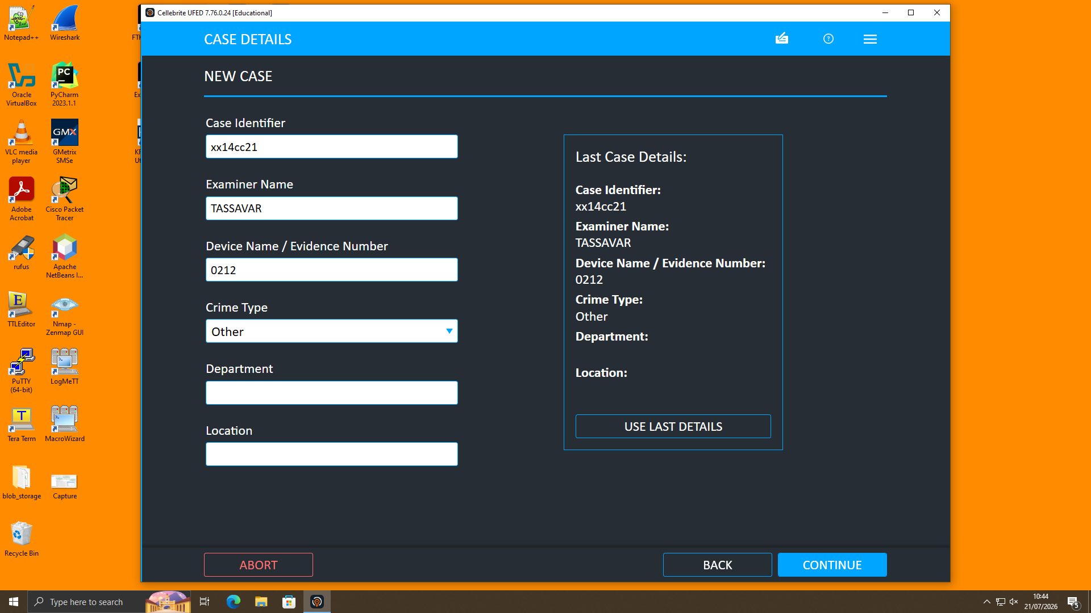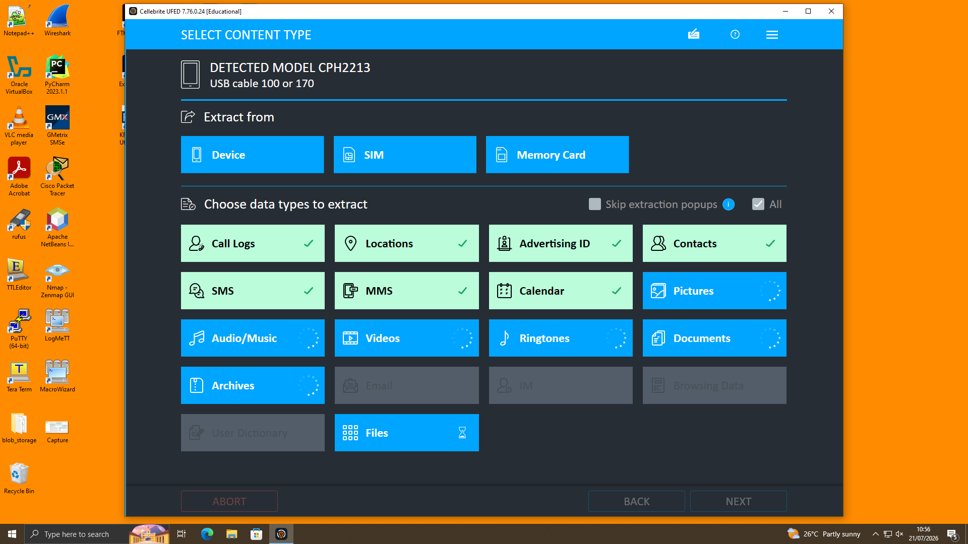
Figure 15. Cellebrite UFED — New Case Details Entry Figure 16. Content Type Selection for Extraction

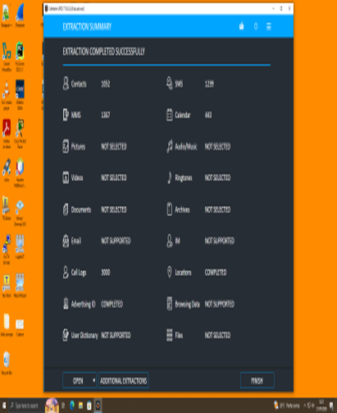
Figure 17. Cellebrite UFED — Extraction Summary, Completed Successfully (Examiner Test Device)

Task 2 References
[1] Association of Chief Police Officers (ACPO), Good Practice Guide for Digital Evidence, Version 5, London, U.K.: ACPO, 2012.
[2] ISO/IEC 27037:2012, Information Technology — Security Techniques — Guidelines for Identification, Collection, Acquisition and Preservation of Digital Evidence, ISO, Geneva, Switzerland, 2012.
[3] National Institute of Standards and Technology, SP 800-101 Rev. 1: Guidelines on Mobile Device Forensics, Gaithersburg, MD, USA, 2014.
[4] Cellebrite, Cellebrite Physical Analyzer (Version 7.73.0.11) [Computer software], 2026.
[5] Cellebrite, Cellebrite UFED (Version 7.76.0.24, Educational) [Computer software], 2026.

