Subject— Strategic Management
Code —LCMB7003
Professor—Amare Desta
Name- Vishal Choudhary
Student id- 2412600
Title: Strategic Market Entry and Expansion of Dyson Ltd into India: A Comprehensive Analysis

Table of Contents
1. Selection of Organisation and Target Market 3
1.1 Introduction to Dyson Ltd 3
1.2 Reasons why the Dyson Ltd was chosen. 3
1.3 Introduction to the Indian Market. 4
1.4 Reason as to why India will be used as a Target Market. 5
2. Comprehensive Strategic Analysis 6
2.1 Macro-Environmental Analysis of India (PESTLE) 6
2.2 Industry and Competitive Analysis (Porter’s Five Forces) 7
2.3 National Competitive Advantage (Porter’s Diamond Model – India) 8
2.4 Internal Resource Analysis of Dyson Ltd (VRIO Framework) 9
2.5 Portfolio Analysis of Dyson (BCG Matrix) 10
3. Strategy Formulation and Strategy Development. 11
Table 3.1: Ansoff Matrix for Dyson India 12
3.2 Competitive Strategy Using Porter’s Generic Strategies 13
Table 3.2: Porter’s Generic Strategy for Dyson India 13
3.3 Market Entry Strategy for India 13
Evaluation of Market Entry Modes 13
Recommended Strategy: Wholly Owned Subsidiary 14
3.4 CSR, ESG and Sustainability Strategy 14
3.5 Risk Analysis and Mitigation 15
4. Dyson India Balanced scorecard Performance Evaluation Framework. 16
4.1 Balanced Scorecard for Dyson India Expansion 16
4.2 Financial Perspective 17
4.3 Customer Perspective 18
4.4 Internal Business Process Perspective. 18
4.5 Learning and Growth Perspective. 19
4.6 Balanced Scorecard Strategy Value and Limitations. 19
5. Critical Discussion 20
6. Conclusion 21
References 23

1. Selection of Organisation and Target Market

1.1 Introduction to Dyson Ltd
Dyson Ltd is a British multinational technology firm which was established in 1991 by Sir James Dyson. Dyson is a globally renowned company based on the United Kingdom, which is innovative in its approach to product design and engineering. The company first caught the eye of the global community when it invented the bagless vacuum cleaner and thereafter has invested in variety of products with air purifiers, bladeless fans, hair care products, lighting, and hand dryers following it (Dyson, 2024). Dyson markets itself as a luxury technology brand that delivers on high-quality technology, innovative design and excellent performance.
Dyson has a highly differentiated business model that is informed by a constant research and development investment. In contrast to the conventional manufacturers of appliances, Dyson is striving at addressing domestic issues by the use of proprietary motor, aerodynamic and digital control technologies (Dyson, 2024).
Dyson is all about the performance excellence, innovation, as well as design differentiation. Dyson products have been marketed as technologically developed, strong, and good quality products that are more effective than the ordinary ones (Dyson, 2025). Dyson is a highly global company with presence in more than 65 nations in Europe, Asia, the Americas and Middle East. Its manufacturing operations are focused in Southeast Asia, whereby it has large facilities in Malaysia and Singapore.
Dyson product portfolio is dedicated to high quality electrical products. The major ones are vacuum cleaners, hair dryers and stylers, air treatment products, hand dryers and lighting systems. Dyson is guided by the premium pricing strategy, as its technology is highly developed, brand positioning, and leadership in innovation.

1.2 Reasons why the Dyson Ltd was chosen.
Dyson will be a suitable organisation to analyse the global expansion based on a number of strategic advantages. To begin with, the company has an effective international brand which is accompanied by technological innovation, performance reliability and high quality. This high brand equity helps Dyson to enter new markets with instant credibility and customer confidence especially in high-end consumer electronics and household appliance segment (Dyson, 2025).
Second, the business model of Dyson is very scalable and innovation-oriented. The business has a vertically integrated research, design, and product engineering which enable it to quickly adapt and launch new technologies without being heavily reliant on outside innovation partners. Such dominance of proprietary technology gives Dyson a sustained competitive edge and enables it to always differentiate in global markets.
Third, Dyson has a lot of experience in global expansion, specifically in Asia. The company has been able to lead in the market in China, South Korea, Japan and other economies in the Asia-Pacific region (Bencic, 2016). This shows that it can culture its premium product offerings to diverse cultures, price-sensitive and highly competitive markets. These experiences create a lot of strategic uncertainty in the entry of another complex emerging market like India.
Lastly, the rising interest in sustainability and energy efficiency at Dyson is in line with the changing regulatory and consumer demands in the emerging economies (The Open University, 2019). The issue of air quality, hygiene and energy saving is the growing concern of governments and consumers in urban areas. The strategically sound logic of air cleaning, high-performance motors, and the lifecycle of products is what makes Dyson more relevant and strategically valid in the new markets in the long term.

1.3 Introduction to the Indian Market.
India is one of the emerging economies in the world that is very large and growth rate is high. India has more than 1.4 billion population and with a robust economic growth, growing urbanisation and rising disposable income, it presents a huge consumer base (George, 2023). Within the last twenty years, the Indian economy has shifted to services, manufacturing and technology based industry though it was an agriculture based economy. The business environment and industrial capability of the country have also been enhanced further in the government initiatives like Make in India and digitalisation reforms.
The increasing incomes, urbanization of housing and modernization of the lifestyle has led to a rise in the rate of the Indian consumer electronics and home appliances market (Mohanty, 2021). The market is growing to demand high quality home appliances and is especially growing in the metropolitan cities including Mumbai, Delhi, Bengaluru, and Hyderabad. An increasing population of middle and upper-middle classes, as well as their exposure to international brands and online shopping websites, is leading to the uptake of technologically sophisticated domestic products.
It is also due to the urban residential development trends which are facilitating the growth of the appliance demand. In large cities, supports of high-rise apartment buildings, gated communities, and smart home ideas are becoming widespread (Mohanty, 2021). These changes lead to the need to be able to clean their homes using vacuum cleaners, purify the air, take care of their hair, and use home appliances that are compact but still deliver high functionality. Also, in most Indian cities, air pollution has greatly raised the level of consumer awareness when it comes to the quality of indoor air, which boosts demand in sophisticated purification technologies.
The lifestyle of the Indian consumer is changing at a fast rate. A younger technology-sensitive generation is becoming more conscious of convenience, hygiene, product performance as well as brand identity (Das et al., 2022). The increased use of e-commerce platforms, mobile payments and omnichannel retailing has transformed the purchasing behaviour enabling the premium global brands to reach Indian consumers more easily than it was in the past decades. The social media impact, online advertisement and aspirational consumption are also another factor that adds to the increased acceptance of high quality lifestyle products.
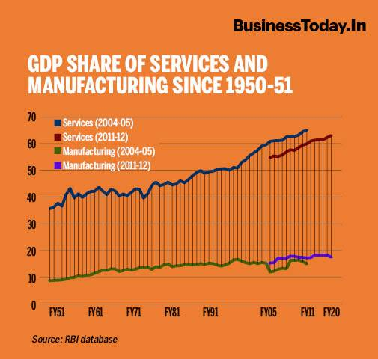
Figure 1: Rebooting the Economy of India
Source: (Mohanty, 2021)

1.4 Reason as to why India will be used as a Target Market.
India has a very high potential of market growth of Dyson in the long-term. The high rate of urbanisation, income, and lifestyle preference shift favor the increased demand of high-tech household products. With the growing levels of disposable incomes, more consumers are ready to spend on high-quality appliances that have better performances, durability, and energy efficiency (Olsthoorn et al., 2023). The aspirational segment of consumers is well matched by Dyson premium positioning.
One of the large sources of demand is the growth of the middle and higher middle classes in India. The young workers, two-income families and city families are actively demanding to have products which improve their hygiene, convenience and indoor air quality. This segment is especially appropriate in regards to Dyson vacuum cleaners, cordless products, and air purifiers because people are becoming more concerned about dust, pollution, and allergens in urban households.
The level of air pollution in large cities of India is one of the greatest in the world, so there is a high natural need in the development of the advanced technologies of air purification (Yadav et al., 2021). Dyson is technologically leading in the air treatment products, and this is a major strength in entering the market. Moreover, the increase in interest of wellness, cleanliness and living smart in India is supporting the product-market fit of Dyson.
India also has an excellent strategic significance on the world manufacturing and distribution network. As the infrastructure, logistics growth, and Indian government incentives to develop electronic production increase, India has prospects not only as a consumer market but also as a future production and sourcing location (Wandhe, 2024). Making a firm foothold in India would consolidate the presence of Dyson in South Asia and facilitate its expansion in the region in the long term.
Organised premium appliance retail is not well developed as in the developed economies though Indian market is very competitive, and price sensitive. This will give Dyson a strategic chance to position itself as the chosen high-end technology appliance brand when the mass competitive saturation has not set in. Through the right localisation strategy, pricing structure, and digital-first market entry strategy, India is a high reward, and strategic expansion market in the international market that Dyson should enter.

2. Comprehensive Strategic Analysis

2.1 Macro-Environmental Analysis of India (PESTLE)
The PESTLE framework is applied to evaluate the key macro-environmental factors shaping Dyson’s market entry and long-term success in India (Ormston, 2025).
Table 1: PESTLE Analysis for Dyson in India
Factor | Key Conditions in India | Strategic Implications for Dyson
Political | Stable democratic system, pro-business reforms, “Make in India” initiative, strong FDI inflows in retail and manufacturing. | Encourages long-term foreign investment and potential future manufacturing localisation.
Economic | High GDP growth rate, expanding middle class, inflationary pressures, currency volatility. | Rising consumer spending enables premium sales, though price sensitivity remains high.
Social | Rapid urbanisation, health and hygiene awareness, pollution concerns, young demographic profile. | Strong demand for air purifiers, vacuum cleaners, and premium personal care appliances.
Technological | Advanced digital payment systems, strong mobile internet penetration, rapid e-commerce growth. | Enables direct-to-consumer sales, omnichannel strategies, and digital marketing effectiveness.
Legal | Evolving consumer protection laws, product safety standards, import duties on electronics. | Compliance costs and import tariffs may affect pricing strategy.
Environmental | Severe urban air pollution, climate change concerns, growing sustainability regulations. | Strengthens demand for Dyson’s air treatment products and energy-efficient appliances.
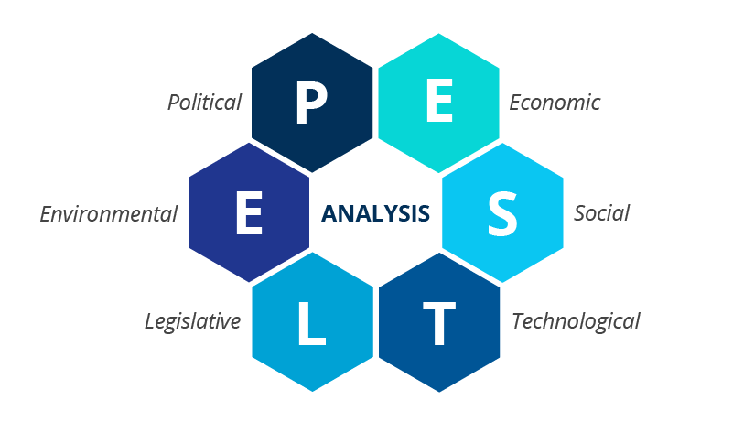
Figure 2: PESTLE Analysis
Source: (Ormston, 2025)

2.2 Industry and Competitive Analysis (Porter’s Five Forces)
Porter’s Five Forces model is applied to evaluate competitive intensity within the Indian premium appliance and consumer electronics industry (The Strategy Institute, 2024).
Table 2: Porter’s Five Forces for Dyson in India
Force | Intensity | Industry Conditions | Strategic Impact on Dyson
Threat of New Entrants | Moderate | High capital investment, strong branding required, but rising online-only brands lower entry barriers. | Dyson’s premium brand offers moderate protection.
Buyer Bargaining Power | High | Price sensitivity remains significant despite income growth. | Pressures Dyson to justify premium pricing through performance and branding.
Supplier Bargaining Power | Low to Moderate | Global component sourcing, multiple electronics suppliers. | Limited supplier dominance strengthens cost control.
Threat of Substitutes | High | Traditional brooms, low-cost local vacuum brands, and service-based cleaning. | Requires sustained product differentiation and brand education.
Competitive Rivalry | High | Strong competition from Philips, Panasonic, Xiaomi, Samsung, and Indian brands. | Requires aggressive brand positioning and continuous innovation.
The strategic analysis shows that India has a high growth but very competitive external environment to Dyson. Although the macro-environmental conditions are ideal in favor of the demand of premium appliance technology, there is a high competition, price sensitivity by buyers, and substitute threats are a great challenge in terms of strategy (Mahboobi Renani et al., 2021). Nevertheless, the brand reputation, technological advantage, and online retailing strengths give Dyson a good strategic absorption to sustain the entry and the long-term market positioning.
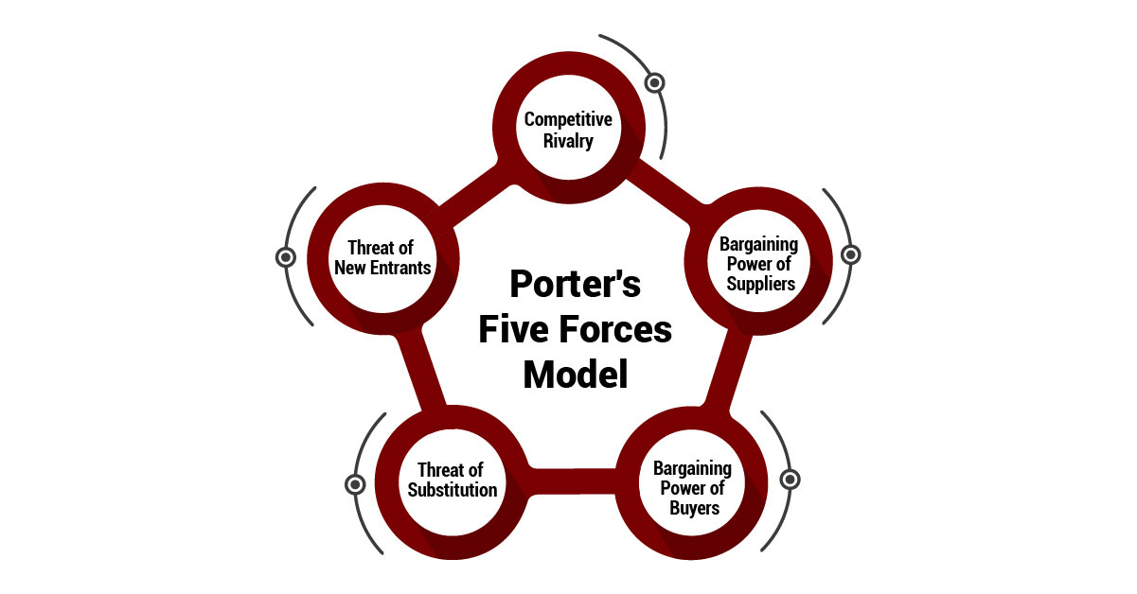
Figure 3: Porter’s Five Forces Model
Source: (The Strategy Institute, 2024)

2.3 National Competitive Advantage (Porter’s Diamond Model – India)
Diamond Element | India’s National Conditions | Strategic Implications for Dyson
Factor Conditions | Large pool of low- to semi-skilled labour, growing engineering talent, expanding electronics manufacturing ecosystem, improving digital infrastructure. | Enables potential future local assembly or manufacturing to reduce import costs and improve supply chain speed.
Demand Conditions | Rapidly expanding urban middle and upper-middle class, rising health, hygiene, and air-quality awareness, growing demand for premium home appliances. | Creates strong domestic demand for Dyson’s air purifiers, vacuum cleaners, and personal care devices.
Related & Supporting Industries | Strong IT sector, expanding logistics and warehousing, active electronics component suppliers, fast-growing e-commerce platforms. | Supports Dyson’s omnichannel strategy and efficient nationwide distribution.
Firm Strategy, Structure & Rivalry | Highly competitive consumer electronics market with both global and strong domestic brands; aggressive pricing and innovation cycles. | Forces Dyson to maintain continuous innovation, strong branding, and premium differentiation to sustain competitiveness.
Strategic Interpretation:
Urbanisation and health awareness in India provide good demand side benefits to Dyson. Although factor conditions are working in favor of the local production, stiff competition makes Dyson stick to the innovation-based rather than price-based competitiveness strategy (Creately, 2024).
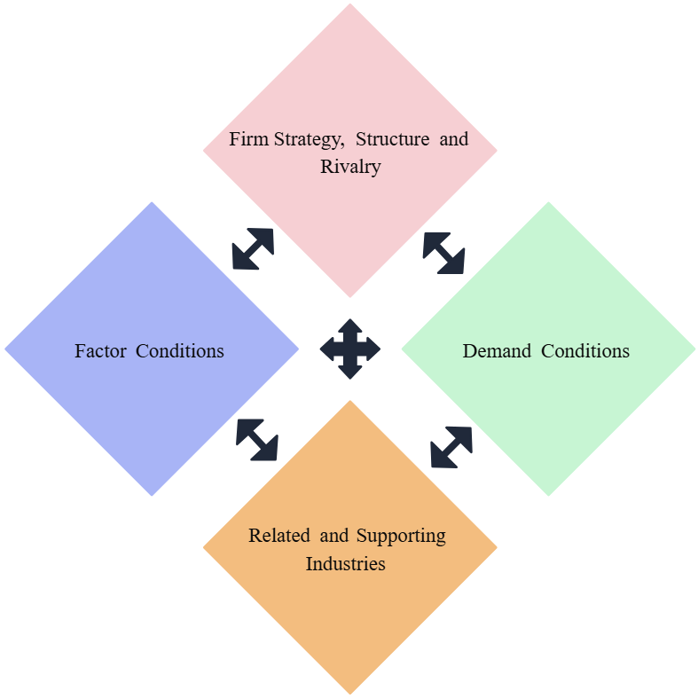
Figure 4: Porter’s Diamond Model
Source: (Creately, 2024)

2.4 Internal Resource Analysis of Dyson Ltd (VRIO Framework)
Key Resource / Capability | Valuable (V) | Rare (R) | Inimitable (I) | Organised to Exploit (O) | Strategic Implication
Global Brand Reputation | Yes | Yes | Yes | Yes | Sustained competitive advantage through premium brand trust and customer loyalty.
Proprietary Motor & Airflow Technology | Yes | Yes | Yes | Yes | Core sustained competitive advantage based on patented engineering capabilities.
R&D and Innovation Capability | Yes | Yes | Yes | Yes | Sustained competitive advantage enabling continuous premium technology leadership.
Premium Pricing Power | Yes | Moderate | Moderate | Yes | Temporary to sustained advantage through brand-based differentiation.
Sustainability & Energy-Efficient Design | Yes | Moderate | Moderate | Yes | Competitive advantage aligned with environmental regulations and consumer preferences.
Strategic Interpretation:
The VRIO analysis authenticates the fact that Dyson enjoys various sources of sustained competitive advantage especially due to its proprietary technology andвеctors of innovation intensity as well as a robust brand image (Bruno, 2025). This is a hard to replicate resource which makes these resources very strong in the premium position of Dyson in India.
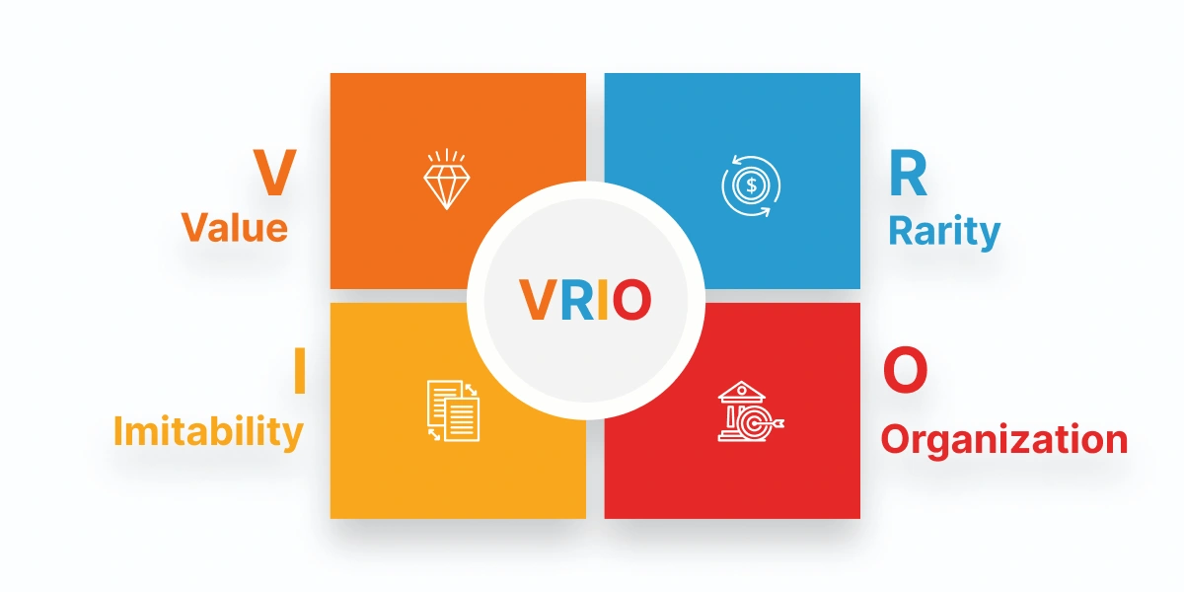
Figure 5: VRIO Framework
Source: (Bruno, 2025)

2.5 Portfolio Analysis of Dyson (BCG Matrix)
BCG Category | Dyson Product Segments | Market Growth | Market Share | Strategic Implication
Cash Cows | Vacuum cleaners (corded and cordless models) | Moderate | High | Generate stable revenue and fund new product innovations and market expansion.
Stars | Air purifiers, hair dryers, and multi-styling devices | High | High | Require continuous investment but offer strong growth and market leadership potential.
Question Marks | Smart home integration products and advanced environmental sensors | High | Low | High-growth but uncertain success; require strategic investment and market testing.
Dogs | Older-generation lighting products and low-demand appliance accessories | Low | Low | Limited strategic importance; suitable for product discontinuation or redesign.
Strategic Interpretation:
The portfolio of Dyson is well-balanced with Stars and Cash Cows that implies the high growth--oriented and financially sound product mix. Question Marks demonstrates a potential to become more innovative in the future, whereas Dogs should be rationalised to become more efficient in portfolios.
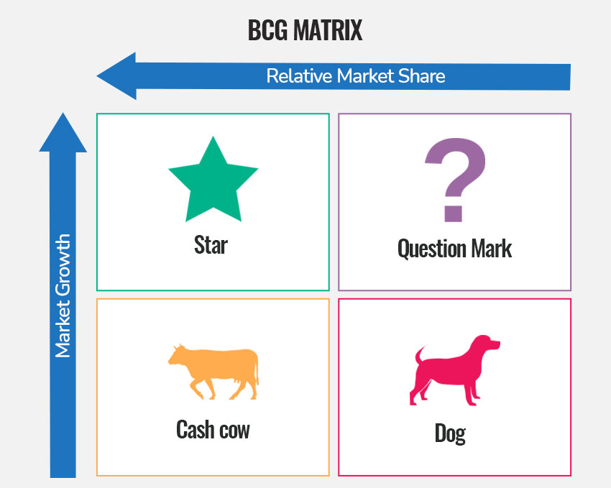
Figure 6: BCG Matrix
Source: (Speakingnerd, 2021)

3. Strategy Formulation and Strategy Development.
The Ansoff Matrix offers an opportunity to assess a business strategy and determine the most effective growth strategy (Dudovskiy, 2023).
The Dyson strategic growth opportunities are analysed to assess them using the Ansoff Matrix, using existing and new products and markets. In the case of Dyson expansion in India, the four strategic directions are all taken into account, with market development being the best primary growth direction.

Table 3.1: Ansoff Matrix for Dyson India
Strategy | Application to Dyson | Risk Level | Strategic Evaluation
Market Penetration | Increasing sales of existing Dyson products in current global markets. | Low | Not applicable to India as a new major expansion market.
Market Development | Introducing Dyson’s existing product portfolio into the Indian market. | Moderate | Most suitable strategy as it reduces product risk while capturing a high-growth market.
Product Development | Launch of new technology variants tailored for Indian conditions. | Moderate to High | Suitable in later stages after brand establishment.
Diversification | Entry into unrelated product or service sectors. | High | Not recommended due to high uncertainty and strategic misalignment.
Strategic Justification for Market Development
The best approach that Dyson should use in India is market development since the company already has a product portfolio that is successful and technologically enhanced globally. India is a potential premium market that is not well served yet is rapidly expanding (Tandel and Aithal, 2025). Introducing the current vacuum cleaners, air purifiers and personal care devices of Dyson means that Dyson does not have to face the high uncertainty of introducing absolutely new categories of products. The strategy enables the brand presence to be built fast, existing R&D investments to be utilized effectively, and revenue to be realized at a faster rate. When the market becomes mature then selective product development can be done with the help of localisation and adjustment.
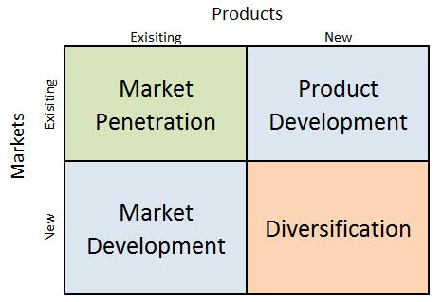
Figure 7: Ansoff Matrix
Source: (Dudovskiy, 2023)

3.2 Competitive Strategy Using Porter’s Generic Strategies

Table 3.2: Porter’s Generic Strategy for Dyson India
Strategic Element | Application in India | Strategic Benefit
Differentiation | Patented motor technology, advanced filtration, premium industrial design. | Creates strong brand distinction and reduces direct price competition.
Standardisation | Core technology platforms, global brand identity, engineering design. | Ensures R&D efficiency and consistent product quality.
Local Adaptation | Product usage education, filters adapted for Indian dust and pollution levels, service models. | Improves customer relevance and market acceptance.
Premium Value Proposition | Superior performance, durability, innovation, health benefits. | Supports premium price positioning and customer trust.
In India, Dyson does not compete on the basis of high cost leadership because of high cost of manufacture, importation duties and its high brand positioning (Dieffenbacher, 2024). Rather, it uses the technology-led differentiation strategy where the customers can afford to pay more money to get better performance, improved air quality, and durability. Standardisation helps in supporting global efficiency, whereas limited localisation helps to guarantee product-market fit.
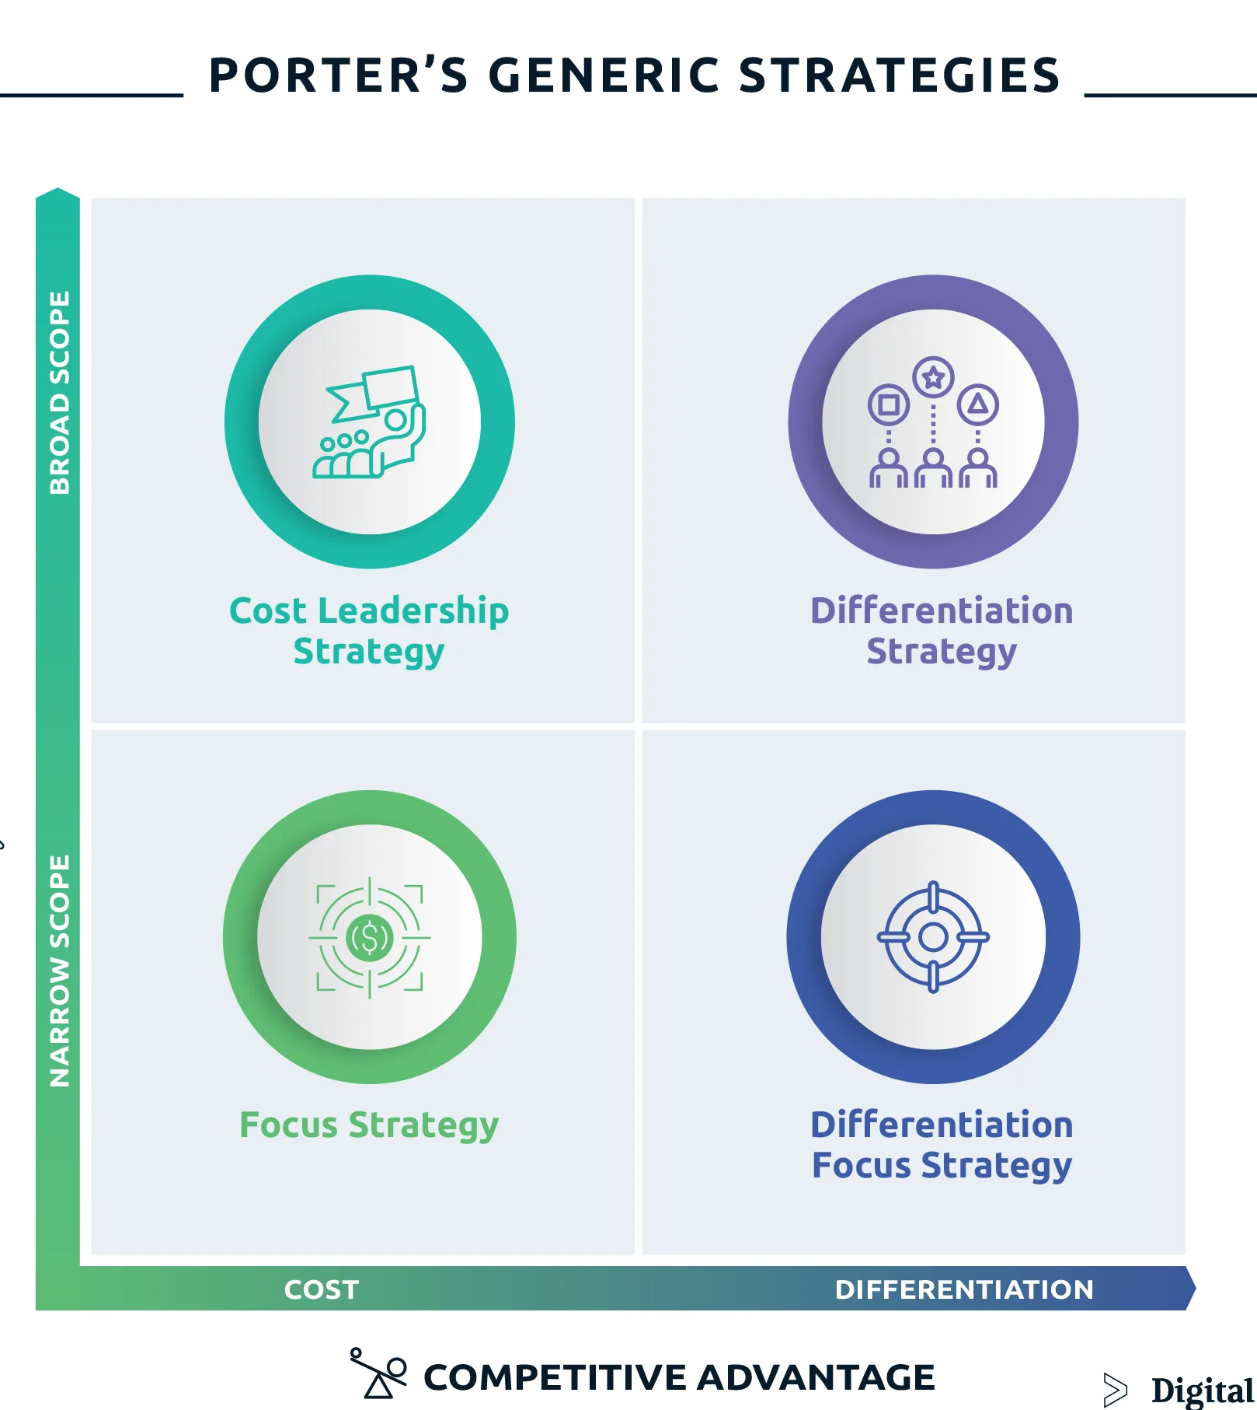
Figure 8: Porter’s Generic Strategy
Source: (Dieffenbacher, 2024)

3.3 Market Entry Strategy for India

Evaluation of Market Entry Modes
Entry Mode | Advantages | Limitations
Exporting | Low capital requirement, quick market entry. | High import duties, limited market control, weak physical presence.
Franchising | Faster expansion, reduced capital risk, local market knowledge. | Weak control over quality, service standards, and brand experience.
Joint Venture | Shared investment risk, local regulatory expertise. | Strategic conflicts, shared profits, slower decision-making.
Wholly Owned Subsidiary | Full control, strong brand protection, long-term profit retention. | High investment cost, greater exposure to financial risk.

Recommended Strategy: Wholly Owned Subsidiary
The most effective entry mode that can be adopted by Dyson in India is a wholly owned subsidiary (Giles, 2022). This arrangement allows Dyson to have complete oversight of brand management, pricing strategy, intellectual property, customer experience and service quality. It also guarantees total strategic conformity to international standards and sustainability initiatives.
Entry Mode Justification
Control wise, complete ownership will guarantee an excellent safeguard of proprietary technologies and guarantee worldwide uniformity of service (Giles, 2022). On the risk factor, even though capital exposure is high, the long term consumption growth and economic stability in India lowers market uncertainty. The profitability point of view is that when fully owned, Dyson does not have to divide returns with partners as any future revenues belong to it. This maximises shareholder value in the long term and helps reinvest back into the local operation, after sales infrastructure and digital platforms.
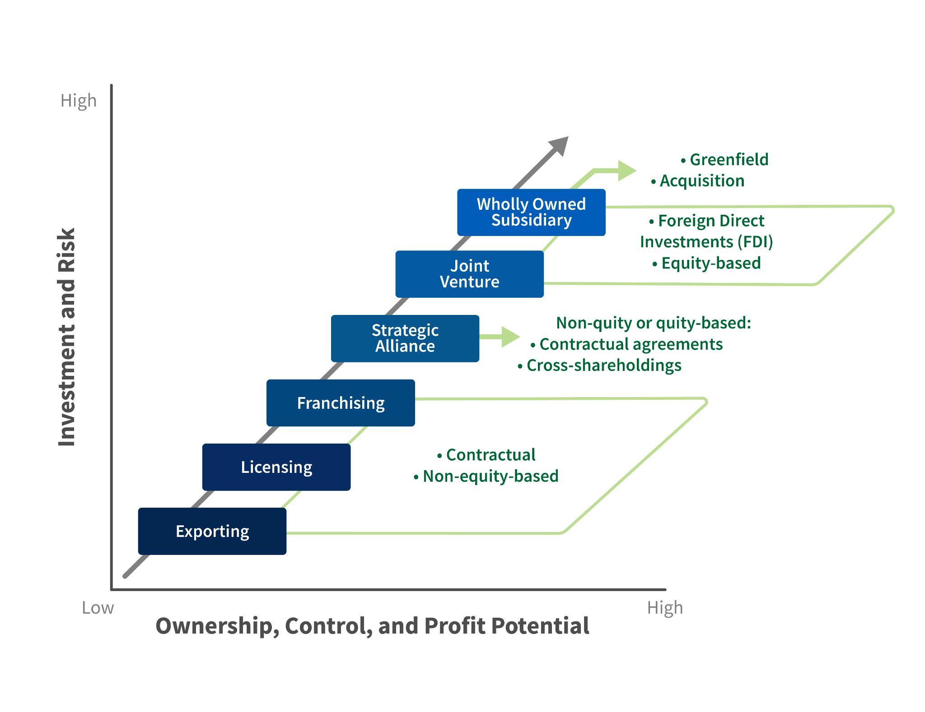
Figure 9: Market Entry Modes
Source: (Giles, 2022)

3.4 CSR, ESG and Sustainability Strategy
Table 3.3: CSR and ESG Strategy for Dyson India
CSR Dimension | Strategic Actions | Expected Impact
Sustainable Production | Use of energy-efficient motors, reduced material waste. | Lower carbon footprint and improved regulatory compliance.
Circular Economy | Extended product durability, recycling programmes for electronic waste. | Supports India’s e-waste regulations and enhances brand reputation.
Community Development | Employment generation, technical skills training, service workforce development. | Enhances local economic development and social goodwill.
Environmental Innovation | Promotion of air purification technologies in high-pollution cities. | Improves public health awareness and brand relevance.
Dyson’s air purification technologies are particularly aligned with India’s severe air pollution challenges. By positioning its products as both consumer appliances and health protection solutions, Dyson strengthens its ESG reputation while expanding its addressable market.

3.5 Risk Analysis and Mitigation
Risk Category | Nature of Risk | Mitigation Strategy
Political & Regulatory Risk | Changes in import tariffs, product certification delays. | Long-term regulatory monitoring, phased investment, local compliance teams.
Currency & Inflation Risk | Rupee depreciation increasing import costs. | Partial local sourcing, currency hedging, flexible pricing strategy.
Cultural & Consumer Behaviour Risk | Low awareness of premium appliance benefits. | Product demonstrations, influencer education, digital marketing campaigns.
Supply Chain Risk | Dependence on overseas manufacturing. | Multi-country sourcing strategy, inventory buffering.
Competitive Risk | Aggressive pricing by global and domestic brands. | Heavy branding investment, continuous product innovation, superior service quality.
Summary
The strategic formulation of Dyson in the Indian market revolves around two pillars of market development growth strategy, which is backed by market competitive strategy of differentiation and subsidiary entry mode that is wholly owned. Long term stability and brand legitimacy are also helped by integrated sustainability programs and well-organized risk mitigation programs. Such a strategic alliance will enable Dyson to create a robust premium market niche, sustain a high level of profitability, and develop a platform that can be scaled to grow in India in the long-run.

4. Dyson India Balanced scorecard Performance Evaluation Framework.
The Balanced Scorecard (BSC) framework is embraced in order to measure the success of strategic expansion by Dyson into the Indian market. The BSC is a holistic performance measurement technique, which includes financial and non-financial measurements in four major dimensions, including Financial, Customer, Internal Business Processes, and Learning and Growth (The Strategy Institute, 2024a). The given framework is especially suitable in the context of Dyson expansion into India because this firm is involved in one of the most innovative and high-end industries where profitability is not the only measure of the long-term success but brand equity, operational efficiency, workforce capacity, and technological innovation.

4.1 Balanced Scorecard for Dyson India Expansion
Table 4: Balanced Scorecard KPIs for Dyson India
Perspective | Strategic Objectives | Key Performance Indicators (KPIs) | Target Outcomes
Financial | Achieve profitable growth and return on investment | Revenue growth rate, Market contribution margin, Return on Investment (ROI) | Positive ROI within 3–5 years, steady annual revenue growth
Customer | Build premium brand awareness and customer loyalty | Brand awareness index, Customer satisfaction score, Repeat purchase rate, Market share | Strong brand recognition in metro cities, high customer retention
Internal Processes | Optimise supply chain and service efficiency | Inventory turnover, Order fulfilment cycle time, After-sales service efficiency | Reduced delivery time, high service reliability
Learning & Growth | Build skilled workforce, innovation, and digital capability | Employee training hours, Innovation pipeline, Digital sales contribution | Strong technical competencies, rising digital-driven sales
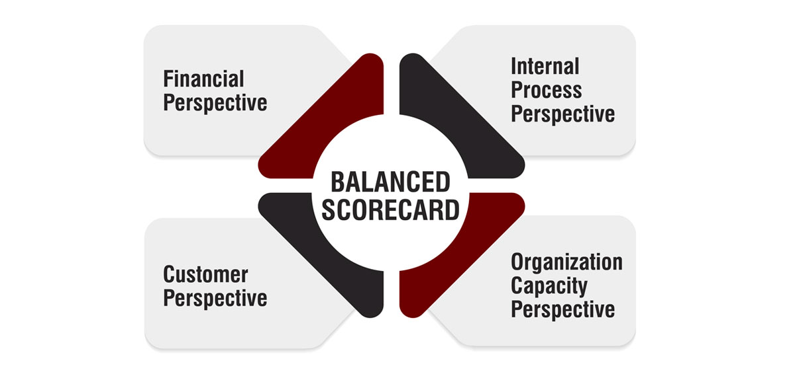
Figure 10: Balanced Scorecard
Source: (The Strategy Institute, 2024a)

4.2 Financial Perspective
The financial lens is based on the capacity of Dyson in gaining sustainability in its profits in India and the high capital investment in premium market entry (Damodar, 2021). The most important indicator in the first years of the expansion is the growth in revenue, which indicates that the market is already accepting the premium products offered by Dyson like vacuum cleaners, air purifiers and hair hair tools. As India has a growing number of middle and upper-middle-class population, the increase in revenues is bound to pick up slowly once the brand gains critical visibility in the big metropolis cities.
The ability of the Dyson investment in logistics infrastructure, marketing, local service network, and and possible future assembly facility to produce a satisfactory financial payoff is measured by Return on Investment (ROI) (Bayraktar et al., 2025). It would be a successful establishment in the market to achieve a positive ROI within a three-to-five years period. The contribution margin in the market also indicates how efficient Dyson has been in its premium pricing strategy to offset its operating costs and reinvestment. Dyson has a very price-sensitive environment and balancing between importation price, prices of supply chain and promotional discounting will be necessary to keep Dyson in a healthy margin.

4.3 Customer Perspective
The customer view will gauge the ability of Dyson to position itself as a high-quality and reliable brand of appliances in India. One of the first indicators used in the early market entry stage is brand awareness since Dyson is yet to build a mass image outside of the elite urban areas (Gerhardt et al., 2021). A high brand awareness using digital campaign, influencer marketing, experience retail shops, and product demonstrations is critical in informing consumers on the differentiated value proposition by Dyson.
The level of customer satisfaction and loyalty is determined by the repeat purchase rates, online reviews, service feedback score. Since the products of Dyson are sold at the high-end segment, the quality of after-sales service, warranty service, and product reliability are critical in maintaining customer reliability (de la Cruz González, 2023). Market share also indicates how Dyson is able to gain an increasing market share in the high-end appliances sector of India despite the stiff competition of multinational and local brands. Good performance in metropolitan cities like Delhi, Mumbai, Bengaluru and Hyderabad would be an indicator of good early market penetration.

4.4 Internal Business Process Perspective.
The internal business process view determines the effectiveness of Dyson in terms of its supply chain, sales, and service activities in the Indian market. The inventory turnover is a vital gauge because of the expensive nature of the Dyson products and the potential dangers of overinventory in a market that is easily affected by price changes (Kelka, 2024). A higher inventory turnover indicates a high demand forecasting, good logistics, and good retail coordination.
The order fulfilment cycle time is the metric of the speed of delivery and the capability of Dyson to provide customers with increasing demands of speed and quality service, especially in the channels which are e-commerce oriented (Al-Masa’fah et al., 2025). Moreover, post sales service is crucial in maintaining the high premium image of Dyson. The indicators, including the response time of the services, the availability of the technicians, and the success rates on the first-time repair directly impact the customer satisfaction and loyalty to the brand. The long-term operational success of Dyson will require streamlining warehousing, the last-mile delivery, and covering the whole country with services.

4.5 Learning and Growth Perspective.
The learning and growth approach is concerned with the long-term ability development of Dyson in India based on the skill of employees, innovation, and digital transformation. The Employee training hours are used to measure the investment in technical expertise, product knowledge, customer service excellence and leadership development (Yertas, 2024). A well-trained workforce is needed to support the differentiation strategy of Dyson, which is highly technology-based.
The performance of innovation is gauged by the frequencies of new product launches, technological improvements and innovation to suit the conditions of India, including the level of dust, air pollution and lead variations (Luo and Zhao, 2024). The digitization aptitude is determined by the proportion of online sales to all sales, utilization of mobile applications, and marketing efficiency based on data usage. Since India is extensively adopting digital, the success of Dyson will highly rely on how it can incorporate the physical stores and online shopping in an integration of an omnichannel customer experience.

4.6 Balanced Scorecard Strategy Value and Limitations.
The Balanced Scorecard offers Dyson with a powerful and proactive model of tracking its India growth in totality. The BSC provides financial performance to be connected with customer loyalty, internal efficiency, and employee capability, which guarantees the long-term strategic capability building that supports the short-term profitability (Samsuden et al., 2024). This concerns Dyson in particular where large startup investment and premium price can only be supported by brand equity and service quality.
The BSC, however, also has its limitations. It highly depends on quality data gathering and successful management interpretation. The danger also exists that by being overly preoccupied with measurable indicators, it might become an oversight to the qualitative aspect of the brand emotion, cultural acceptance, and informal market conditions. The Balanced Scorecard is a very appropriate performance management tool, despite these constraints, that can steer the long-term growth and strategic success of Dyson in the Indian market.

5. Critical Discussion
The presence of good macroeconomic fundamentals, the high pace of urbanisation and the increased demand of high-end household technologies are factors that can justify the viability of the entry of Dyson into the Indian market. The growing population of middle and upper-middle income earners together with rising health consciousness and deteriorating air quality in urban areas of India are significant natural sources of demand of Dyson air purifiers, vacuum cleaners, and personal care products (Sharma et al., 2025). The accessibility of markets is also increased by the fast pace of e-commerce and online payment which enables Dyson to expand beyond the physical retail constraints. The possibility of market entry is however limited by high importation taxes, bureaucratic compliance of regulatory requirements as well as inconsistency in infrastructure across states which can impede an early growth and influence pricing competitiveness.
Competitive sustainability of the differentiation-based strategy adopted by Dyson in India is good though it needs constant innovation and investment in branding (Parkman, 2023). Compared to the mass-market manufacturers of appliances, Dyson does not strive to compete at the price point but in terms of performance, design, and technological excellence. This approach would be highly applicable to aspirational urban shoppers who correlate a high-quality brand with lifestyle improvement, hygiene, and wellness. Nevertheless, there are still the issues of high buyer bargaining power and price sensitivity. Philips, Xiaomi, LG, and Eureka Forbes among other domestic and multinational companies are competitors who operate in the aggressive discounting market and may destroy the perceived value (Moon, 2022). To remain ahead, Dyson should continue to offer better performance and provide outstanding after sales support and enhance emotional brand attachment by providing education based marketing.
In terms of strategic risk and long-term reward, the India expansion can be seen as a high-reward, but high-investment opportunity of Dyson. The main risks are the currency volatility, dependence on imports, regulatory delays and resistance to premium pricing by the culture (Umeaduma and Dugbartey, 2023). However, such short-term risks are offset against tremendous long-term returns in the form of having one of the fastest-growing consumer markets in the world, long-term revenue potential, possible future local manufacturing, and solid regional branding throughout South Asia. The strategic rewards in the long term are obviously a lot higher than the operational and financial costs as long as market entry is a gradual and well-calculated process.
The credibility of the strategic frameworks employed in this paper, such as the PESTLE, Porters Five Forces, VRIO, BCG Matrix, Ansoff Matrix, and the Balanced Scorecard are normally good in facilitating systematic strategic arguments. It is effective that these models make complex conditions in the market simpler and help in systematic decision making. Nevertheless, they are also limited to some extent. The majority of these instruments remain fixed and fail to fully reflect the pace of digital disruption, behavioural change and informal sector competition that define the Indian market. Moreover, the models make rational market behaviour assumptions and could be deficient in emotion-driven brand drivers and cultural consumption patterns.
The success of Dyson in other emerging markets like China and Southeast Asia gives the confidence of its India strategy. Dyson experienced the same challenges in these markets that pertained to price sensitivities, high local competition and regulations. Dyson has become a well-known brand with constant revenue increase through innovation-based differentiation, integration into the omnichannel of retailing and investing in the quality of its services. The above precedents suggest that, although India is a complex country, Dyson has the strategic, technological, and operational potentials that it can use to realize long-term success.

6. Conclusion
This report has provided a detailed strategic analysis of the expansion plan of Dyson Ltd into Indian market by utilizing some of the key strategic management theories such as PESTLE, Porters Five Forces, VRIO, BCG Matrix, Ansoff Matrix, and Balanced Scorecard. The macro-environmental analysis has verified that India presents a dynamic and high-growth environment that is typified by high rates of urbanisation, rising income levels, ability to be health conscious, and excellent digital infrastructure. The industry analysis also indicated that there is a competitive but opportunity rich market of premium appliances with innovation, branding and quality of service being the major source of competitive advantage.
On the internal capabilities analysis, both the VRIO analysis and the BCG analysis revealed that Dyson has highly strategic capacities in the form of proprietary technology, intensive research and development capability, a premium brand reputation, and a product portfolio focused on growth. Through these resources, Dyson has a sustained competitive advantage and can easily apply differentiation strategy in India. The Ansoff Matrix rationalized market development as the most suitable growth strategy which enables Dyson to apply its existing product pool in a new high growth geographical market. The suggested entry mode, which is a wholly owned subsidiary, aids in control of the long-term strategic management, protection of intellectual property, and retention of profits.
The Balanced Scorecard framework offered a framework of integrated performance evaluation system that connected financial achievement with customer satisfaction, work efficiency, employee competence and innovation performance. This serves to make sure that the expansion of Dyson is being controlled both in the short-run profitability metrics and the ability to grow in the long-run. The presence of CSR, ESG, and sustainability programs only confirms that the growth strategy of Dyson is consistent with the environmental focus in India, the issues of the population health, and its regulatory demands.
On balance, India is proved to be one of the most appropriate countries where Dyson can launch its international business because of the high consumer rate, the long-term consumption rate, the aggravating air quality issues, and the rise of the premium-quality lifestyle technologies acceptance. Although the expansion presents tremendous threats of price sensitivity, reliance on imports and regulatory complexity, these threats can be mitigated by making gradual investments, development of local service infrastructure, well-developed systems of compliance, and localisation planning over a long period of time.
The last suggestion is that Dyson must execute its expansion in India under the differentiation-based approach with wholly owned subsidiary with the support of robust digital integration, service quality, and innovation based on sustainability. The strategic pathway is anticipated to provide a long-term competitive advantage, profitability and excellent brand domination in the Indian high-end appliance market which is experiencing growth.

References
Al-Masa’fah, W., Abushaikha, I. and Bwaliez, O.M., 2025. Exploring the role of additive manufacturing in the prosthetic supply chain: qualitative evidence. The TQM Journal, 37(7), pp.1963-1991. https://dspace.lib.cranfield.ac.uk/bitstreams/bfca632c-1b21-473e-aba2-b385836db0db/download
Bayraktar, E., Zaim, S., Gudelek, M. and Golgeci, I., 2025. Global logistics efficiency after COVID-19: a cross-country analysis using the logistics performance index. International Journal of Logistics Research and Applications, pp.1-32. https://www.tandfonline.com/doi/pdf/10.1080/13675567.2025.2540863
Bencic, E. (2016). China boosts Dyson’s global growth to record level - Appliance Retailer. [online] Appliance Retailer. Available at: https://www.applianceretailer.com.au/china-boosts-dysons-global-growth/.
Bruno, V.R. (2025). A Complete Guide to the VRIO Framework in 2025. [online] Edstellar.com. Available at: https://www.edstellar.com/blog/vrio-framework.
Creately (2024). Porter’s Diamond Model | Creately. [online] creately.com. Available at: https://creately.com/diagram/example/Ec1LwCuMShz/porters-diamond-model.
Damodar, S.K., 2021. A comparative study of corporate sustainability, strategic corporate social responsibility and market value creation among companies operating in India. https://research.utwente.nl/files/267714982/Thesis_S_Kumar_Damodar.pdf
Das, D., Sarkar, A. and Debroy, A., 2022. Impact of COVID‐19 on changing consumer behaviour: Lessons from an emerging economy. International journal of consumer studies, 46(3), pp.692-715. https://pmc.ncbi.nlm.nih.gov/articles/PMC9111418/pdf/IJCS-46-692.pdf
de la Cruz González, B., 2023. Feasibility assessment of manufacturer-controlled spare parts manufacturing using AM technology. https://repository.tudelft.nl/file/File_b4bfc844-f17a-4417-ad9d-b3042c2e24cc
Dieffenbacher, S. (2024). Porter’s Generic Strategies: Cost Leadership, Differentiation and Focus. [online] Digital Leadership. Available at: https://digitalleadership.com/blog/porters-generic-strategies/.
Dudovskiy, J. (2023). Apple Ansoff Matrix - Research-Methodology. [online] Research-Methodology. Available at: https://research-methodology.net/apple-ansoff-matrix-2/.
Dyson (2024). Dyson vacuum cleaners, hair dryers and stylers, fans, humidifiers, hand dryers and lighting | Dyson. [online] Dyson.com. Available at: https://www.dyson.com/en.
Dyson (2025). About Dyson. [online] Dyson.com. Available at: https://www.lb.dyson.com/en-LB/Community/AboutDyson.aspx.
George, A.S., 2023. Evaluating India's economic growth: challenges and opportunities on the path to 5 trillion dollars. Partners Universal International Innovation Journal, 1(6), pp.85-109. https://puiij.com/index.php/research/article/download/108/80
Gerhardt, V.J., Siluk, J.C.M., de Freitas Michelin, C., Junior, A.L.N. and da Veiga, C.P., 2021. Impact of market development indicators on company performance. IEEE Engineering Management Review, 50(1), pp.65-84. https://www.researchgate.net/profile/Vinicius-Gerhardt/publication/357010221_Impact_of_market_development_indicators_on_company_performance/links/624460a221077329f2e289ee/Impact-of-Market-Development-Indicators-on-Company-Performance.pdf
Giles, A. (2022). International Entry Modes. ecampusontario.pressbooks.pub. [online] Available at: https://ecampusontario.pressbooks.pub/globalmarketing/chapter/6-1-international-entry-modes/.
Kelka, H., 2024. Supply chain resilience: navigating disruptions through strategic inventory management. https://www.theseus.fi/bitstream/handle/10024/858213/Kelka_Heaven.pdf?sequence=2
Luo, Q. and Zhao, X., 2024. Intellectual property protection intensity and regional technological innovation structure: Based on the perspective of economic complexity theory. Heliyon, 10(21). https://www.cell.com/heliyon/fulltext/S2405-8440(24)15995-6?uuid=uuid%3Affb9aa4c-eb20-4b75-a264-446e6623e6b8
Mahboobi Renani, E.S., Amiri Aghdaie, S.F., Mohammad Shafiee, M. and Ansari, A., 2021. Developing a scale for brand competitive positioning: a study in the home appliance industry. Journal of Modelling in Management, 16(2), pp.558-578. https://www.academia.edu/download/65753998/Developing_a_scale_for_brand.pdf
Mohanty, P. (2021). Rebooting Economy 58: The untold story of India’s services sector. [online] Business Today. Available at: https://www.businesstoday.in/opinion/columns/story/indian-economy-the-untold-story-of-indias-services-sector-despite-being-main-driver-of-countrys-growth-story-284311-2021-01-13.
Moon, H.C., 2022. Global business strategy: Asian perspective. World Scientific. https://www.worldscientific.com/doi/pdf/10.1142/9789811236587_0001
Olsthoorn, M., Schleich, J., Guetlein, M.C., Durand, A. and Faure, C., 2023. Beyond energy efficiency: Do consumers care about life-cycle properties of household appliances?. Energy Policy, 174, p.113430. https://www.sciencedirect.com/science/article/am/pii/S0301421523000150
Ormston, A. (2025). PESTLE Analysis: A Guide to Understanding Market Influences. [online] B2B International. Available at: https://www.b2binternational.com/2025/04/03/pestle-analysis/.
Parkman, I., 2023. Raising the ceiling: the impact of design-based differentiation on product pricing. https://dl.designresearchsociety.org/cgi/viewcontent.cgi?article=1035&context=iasdr
Samsuden, N.S., Kohar, U.H., Khatib, S.F. and Abbas, A.F., 2024. Digital Capabilities and Business Performance: A Systematic Literature Review. Sustainability (2071-1050), 16(24). https://www.mdpi.com/2071-1050/16/24/11108
Sharma, J.L., Dubey, P.K. and Sharma, M., 2025. Assessing the Economic Impact of Climate Change on the Indian Middle Class. The Lumbini Journal of Business and Economics, 12(2), pp.42-58. https://nepjol.info/index.php/ljbe/article/download/77407/59345
Speakingnerd (2021). Assessment of BCG Matrix, its need and application. [online] SpeakingNerd. Available at: https://speakingnerd.com/strategy/strategy-models/bcg-matrix.
Tandel, K. and Aithal, P.S., 2025. Technological Strategy of Apple in India: Business Challenges and Growth Opportunities. Poornaprajna International Journal of Teaching & Research Case Studies (PIJTRCS), 2(2), pp.259-291. https://poornaprajnapublication.com/index.php/pijtrcs/article/download/137/113
The Open University (2019). Dyson; Why Asia? | OU News. [online] Open.ac.uk. Available at: https://www.open.ac.uk/blogs/news/business-law/business/dyson-why-asia/.
The Strategy Institute (2024a). A Comprehensive Guide to Implementing the Balanced Scorecard Framework. [online] www.thestrategyinstitute.org. Available at: https://www.thestrategyinstitute.org/insights/a-comprehensive-guide-to-implementing-the-balanced-scorecard-framework.
The Strategy Institute (2024b). Porter’s five forces: The ultimate competitive strategy blueprint. [online] www.thestrategyinstitute.org. Available at: https://www.thestrategyinstitute.org/insights/porters-five-forces-the-ultimate-competitive-strategy-blueprint.
Umeaduma, C.M.G. and Dugbartey, A.N., 2023. Effect of exchange rate volatility on export competitiveness and national trade balances in emerging markets. International Journal Computation Applied Technology Research, 12(11), pp.57-71. https://www.researchgate.net/profile/Chidimma-Umeaduma/publication/390244423_Effect_of_Exchange_Rate_Volatility_on_Export_Competitiveness_and_National_Trade_Balances_in_Emerging_Markets/links/67e5b9019f2308642191313a/Effect-of-Exchange-Rate-Volatility-on-Export-Competitiveness-and-National-Trade-Balances-in-Emerging-Markets.pdf
Wandhe, D.P., 2024. An overview on production linked incentive (PLI) scheme by the government of India. Available at SSRN 4693578. https://papers.ssrn.com/sol3/Delivery.cfm?abstractid=4693578
Yadav, D., Joshi, S.M., Gour, M., Singh, M. and Singh, R.K., 2021. Air pollution scenario in India and assessment of air purification technologies. In Advances in interdisciplinary engineering: Select proceedings of FLAME 2020 (pp. 265-280). Singapore: Springer Singapore. https://www.researchgate.net/profile/Ahmad-Adam-5/publication/350830366_Economic_Implication_and_Impact_of_Climate_Change_on_Net_Zero_Energy_Building_NZEB/links/625bd91a709c5c2adb82be04/Economic-Implication-and-Impact-of-Climate-Change-on-Net-Zero-Energy-Building-NZEB.pdf#page=285
Yertas, M., 2024. The Role of Training and Continuous Development in Improving Employee Productivity and its Impact on Company Financial Performance. Atestasi: Jurnal Ilmiah Akuntansi, 7(2), pp.1362-1379. https://jurnal.feb-umi.id/index.php/ATESTASI/article/download/1047/748

