New Build Dwelling:
Technical Report With Drawings
Module: ACBA4001
Ayesha Williams

Contents

Introduction………………………………………………………………………………. .3
Technical Report- …………………………………………………………………………3-8

Section 1 –………………………………………………………………………………....3-6
i) Ground Floor Construction - Detailing And Junction With External Wall
ii) First Floor Construction - Detailing And Junction With External Wall And Restraints
iii) Eaves Detailing And Roof Covering – Weathering, Fixing And Laps
iv) Main Roof Structure – Construction, Detailing And Fixing

Section 2 –…………………………………………………………………………………6-7
i) Specified Roof Structure And Finish – Advantages & Disadvantages
ii) Alterative Roof Structure Method – Advantages & Disadvantages

Section 3 –………………………………………………………………………………….7-8
i) Offsite Construction
ii) Categories Of Offsite Construction

Conclusion…………………………………………………………………………………8
References…………………………………………………………………………………9

Introduction-
In this technical report, some of the key important construction details required for timber frame buildings will be addressed. This report will include hand drawn, proportionate and annotated sections and sketches which meet with the current building regulations for a domestic new build. Also, detailed in this report is the advantages and disadvantages of a specified roof structure and an example of an alternative method of roof structure detailing its advantages and disadvantages. The final part of the report will outline the construction method of offside construction.

Section 1-
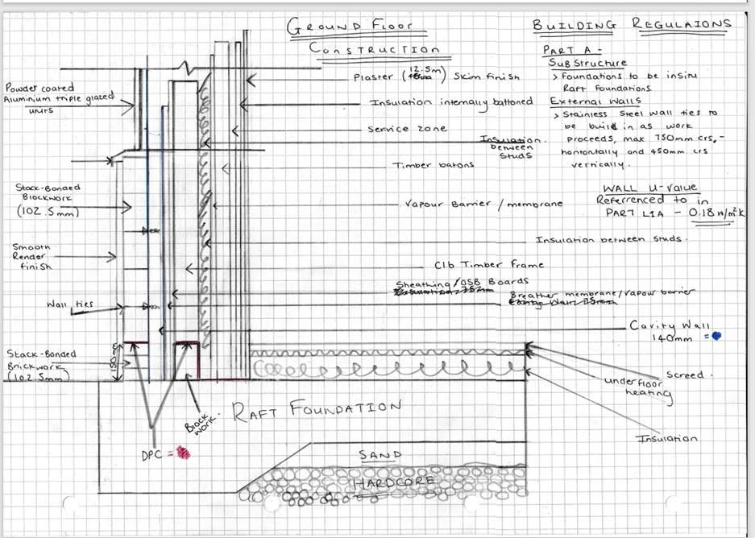
i) Ground Floor Construction - Detailing And Junction With External Wall

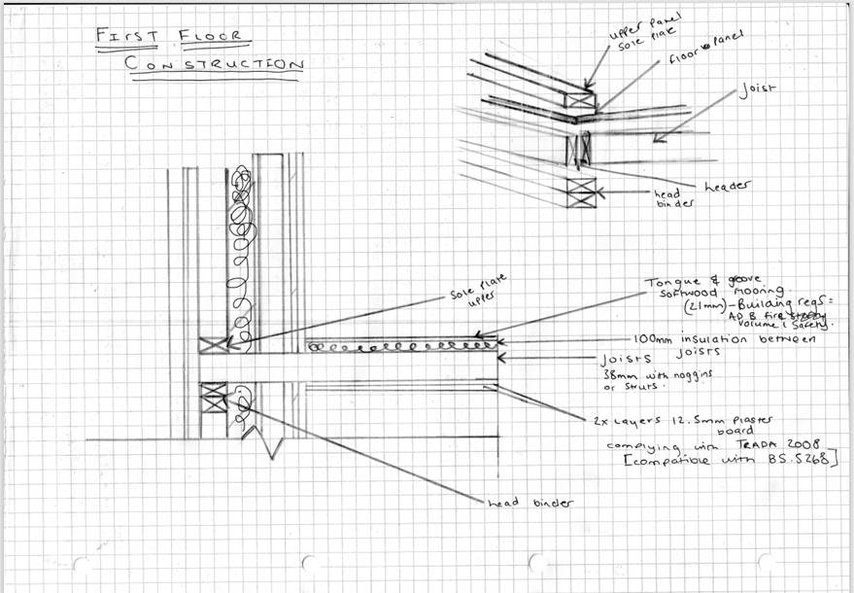
ii) First Floor Construction - Detailing And Junction With External Wall And Restraints

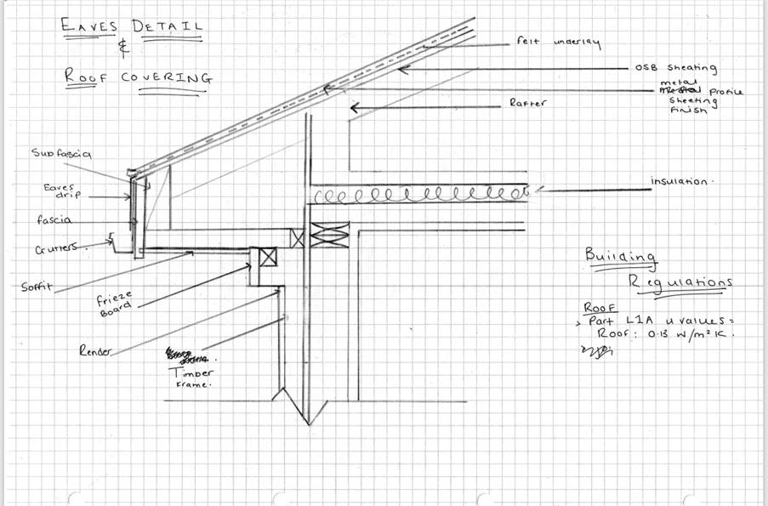
iii) Eaves Detailing And Roof Covering – Weathering, Fixing And Laps

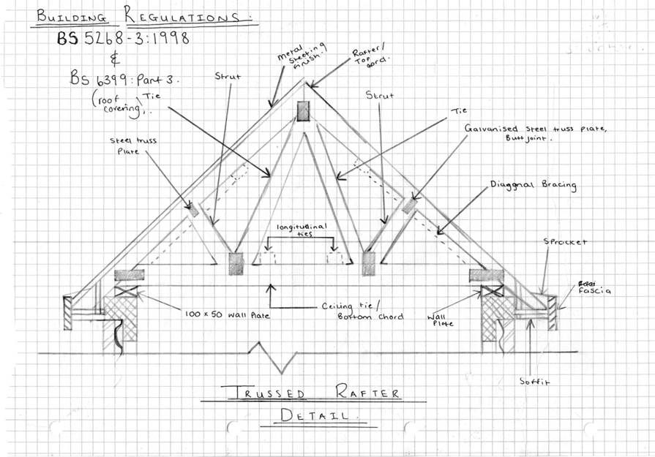
iv) Main Roof Structure – Construction, Detailing And Fixing

Section 2 –
i) Specified Roof Structure And Finish – Advantages & Disadvantages
Given the specified roof structure of a “trussed rafter with a metal profile sheeting finished on OSB boards”, this roof structure has both advantages and disadvantages. As opposed to a traditional pitched roof, trussed rafters utilize significantly less timber, around "40% less wood" (McFadden, N.D). Trussed rafters are made from a sustainable material and can be much cheaper compared to traditional steel frames. There are a number of disadvantages to using trussed rafters, these disadvantages include a timber material can be subject to rot which can attract pests which can cause major issues. it must be noted that using timber it does need to be treated for both fire resistance and rot resistance to prevent the trussed rafters from failing after a number of years (McFadden, N.D).

ii) Alterative Roof Structure Method – Advantages & Disadvantages
An alternative roof structure compared to the one detailed already, would be ‘The Mansard or Gambrel Roof'. Using this alternative roof structure would provide its users with a double pitched roof, this would enable further adequate space within the roof structure itself for room space or storage. The use of this alternative roof structure would allow for dormers providing extra comfort if the user were to make use of this additional space for extra rooms. There are some disadvantages to having a Gambrel roof. It can be prone to uneven wear due to the shape of the roof, Precipitation falls onto the top part of the flat roof and can stay there, as there is no valley or draining to allow the weather to drain from the flat roof. A further advantage to using this structure would be the use of fewer materials due to the lack of beams and columns needed, although, with its shape in mind, a disadvantage can be found within the height of this structure, especially during windy weather as the structure can become very vulnerable (Crawford, N.D)

Section 3-
i) Offsite Construction
In short, offsite construction means designing, developing, engineering, and pre-assembling the fundamentals and components of a construction project in a factory setting. All these elements will be installed together at their intended site location (Kier , 2020).

ii) Four Main Categories Of Offsite Construction
There are four main categories of ‘Offsite Construction'. These four categories can be considered as the following;
Ø Panelised Systems
These systems can come in three different styles. Firstly, panelised systems can come in a ‘Open’ form, which that’s the panel has been mechanically made so that each panel can be fitted together on site (Structural Timber Association, N.D). These open panelised systems normally form internal and external walls and any additional materials such as insulation and services can be installed onsite. Panelised systems can also be found in the form of ‘Closed’ panelised systems which is when the whole panel is made within a factory environment which has all materials already built in such as all insulation boards, services zones etc (Design Buildings Wiki, 2021). The final of the panelised systems is ‘SIPs’ which is shortened for ‘Structural insulated panels’ again similar to ‘Closed’ Panelised systems however SIPs are mechanically made with high performance construction. SIPs are normally constructed with exterior and interior sheathing filled with a form core. Panelised systems can be used in relation to this project, for example to form single load bearing walls internally or externally.

Ø Volumetric Systems
Volumetric systems are three dimensional ways of offsite construction. This can be accomplished in a number of ways, however most frequently is the use of “stacking and/or adjoining factory-finished modules to create a broadly ‘finished’ building” (Foot Anstey, 2020). In regards to using this form of Offsite construction for this project, it would be good to use for the assembly of bathrooms or fully furnished usable spaces to speed up the build.
Ø Sub-assemblies and Components
Sub-assemblies and Components are single elements used for the construction of the building these can be in the form of pre-assembled fixtures such as roofs and pre-fabricated chimney stacks. This form of offsite construction is commonly used to add new elements onto existing features (HLN GROUP, 2019). For use on this project, it would be wise to use this form for adding dormers onto the existing properties or pre manufactured staircases and doors.

Ø Hybrid Systems
This form of offsite construction is the combination of both volumetric and panellised systems which create a fully fitted sole building. These hybrid systems help with having units being installed with final finishes (K, N.D.). For this project, using Hybrid Systems would be beneficial if the client was to install fully finished rooms such as a wet room.

Conclusion
To summarize, the drawings in this technical report should help the client understand the building's entirety in the requested sections. The drawings included in this report have detailed the components of each section as well as the building regulations. Offsite construction which has also been detailed in this report explains to the clients offsite construction and how it can be used to benefit this project in relation to the build as well as explaining the four main categories of, offsite construction.

References
Crawford, K., N.D. Gambrel Roof: Advantages and Disadvantages. [Online]
Available at: https://farmfoodfamily.com/gambrel-roof/
[Accessed 2022 April 23].
Design Buildings Wiki, 2021. Closed panel system. [Online]
Available at: https://www.designingbuildings.co.uk/wiki/Closed_panel_system
[Accessed 2022 April 25].
Foot Anstey, 2020. What is volumetric construction?. [Online]
Available at: https://www.footanstey.com/our-insights/articles-news/what-is-volumetric-construction/
[Accessed 2022 April 25].
HLN GROUP, 2019. modern methods construction. [Online]
Available at: https://www.hlnengineering.co.uk/modern-methods-construction-mmc/#:~:text=Sub%2DAssemblies%20and%20Components,other%20modern%20methods%20of%20construction.
[Accessed 2022 April 25].
Kier , 2020. Offsite and Modern Methods Of Construction. [Online]
Available at: https://www.kier.co.uk/media/3011/brochure-offsite-mmc-brochure-2020-digital.pdf
[Accessed 2022 April 23].
K, N. S., N.D. What is offsite construction. [Online]
Available at: https://theconstructor.org/building/offsite-construction-features-methods/38319/
[Accessed 2022 April 25].
McFadden, D., N.D. Advantages and Disadvantages of a Timber Truss Roof. [Online]
Available at: https://homesteady.com/12568608/the-disadvantages-of-steel-beams
[Accessed 2022 April 23].
Structural Timber Association, N.D. TIMBER FRAME. [Online]
Available at: https://www.structuraltimber.co.uk/timber-systems/timber-frame
[Accessed 2022 April 25].

