Student Name: Jack Rowland

P Number: 1701980

Programme of Study: BA Illustration

Module: Independent Inquiry (ADAD6001)

Title: How have real-world circumstances shaped the topical evolution of Illustration?

Submitted in partial fulfilment of the requirements for the degree of BA (Hons) University of Wales Trinity Saint David, Swansea

Table of Contents

Introduction 1
Chapter 1 – Prehistory 2
Chapter 2 – Ancient History 3
Chapter 3 – The Middle Ages 4
Chapter 4 – The Renaissance 5
Chapter 5 – The 18th Century 6
Chapter 6 – The 19th Century 7
Chapter 7 – The 20th Century 7
Conclusion 9
Bibliography 10

Word Count: 3051

Introduction

The aim behind this independent inquiry is to create a body of suitable research by examining reliable sources in order to put together a personal and critical evaluation of my chosen topic: how have real-world circumstances shaped the topical evolution of Illustration? Another aim would be to keep away from specific art movements such as Romanticism or Surrealism as these topics can lead down paths towards the changes within Fine Art as opposed to Illustration.

The purpose within this inquiry is to explore political and social challenges such as living conditions, war and the overall development of civilization as a whole and show how the practice of illustration has transformed and adapted throughout each of the different time periods in order to accommodate itself with these changes.

The first chapter of this inquiry will be based upon the prehistoric age and the subject matter of humanities earliest cave paintings. The second chapter of the inquiry will be based around how the arts since developed in the age of Ancient Rome and how they became more personal to ourselves as civilization grew. The third chapter of this inquiry will be based upon the Middle Ages and how to the purpose of illustration began to touch upon reportage. The fourth chapter of the inquiry will be based around The Renaissance and how illustration began to part from religious themes. The fifth chapter of this inquiry will be based upon the Industrial Revolution and the use of illustration within the news.
The sixth chapter of the inquiry will be based around the 19th Century and the increasing demand for illustration. The seventh and final chapter of this inquiry will be on the 20th century and what illustration had become in that period.

In relation to today, the topical evolution of Illustration is important to be discussed as it allows us to have a greater understanding of where humanities greatest artistic achievements have originated from, as well as recognise the growth of our culture and advancement in technology. This links to my personal practice and career aspirations as I like my work to act as a means to go off the beaten track and create something weird and abnormal, sometimes to create a suggestion to the natural chaos of real life, which is the main driving force of the changes within illustration’s subject matter or topic.

Chapter 1 – Prehistory

The Prehistoric Age refers to the era of human history that existed before the invention of written records, as well as the beginning of the first present-day Homo sapiens.

During this time period, humans would rely upon a hunter-gatherer lifestyle and follow the migration of big-game animals in order to maintain a steady income of food and resources. For refuge, these nomadic hunters would choose to settle under rudimentary shelters or within the protection of caves.

Evidence from as early as 40,000 B.C. shows us that these hunters would create models of humans and fauna out of harvested animal bones, as well as illuminate the walls of their caves by using natural pigmentation, engraving directly into the rock face, or by using the contours of the tunnel walls to make their artwork appear more three-dimensional.

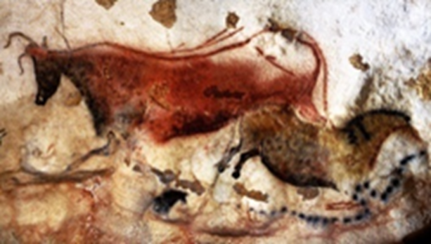

Red Cow & First Chinese Horse - Photograph N. Aujoulat (2003) © MCC-CNP

The first ever recorded example of Illustration that still survives is among a series of cave paintings found in Lascaux, France which date back to 15,000 B.C. The main subject matter of these paintings appears to be the artists themselves and their relation the animals that they would rely upon for survival. By looking at this series of artwork, we can see that the imagery documents important events that would have happened in the artist’s life, such as the sighting of a bison shedding its winter fur, a hunting party tracking the heard, or a member of the tribe suffering from an injury.

Curators of these caves speculate that the images may serve a ritualistic purpose, and that by illustrating their prey, it may be more powerless when it is time for the tribe to attack, thereby securing a more bountiful hunt. It can also be considered that during this age where there was no written language, this kind of illustrative story-telling would have most likely been used as a device of communication between pre-historic people.

While it is widely considered that these cave systems are the birthplace of humanities artistic expression, the precursor to the Homo sapien, Homo erectus had already made supposedly purposeless patterns on artifacts previously, as found in Bilzingsleben, Germany. In comparison to these artifacts however, we can now see art was beginning to convey a narrative using sequential imagery.

Chapter 2 – Ancient History

Ancient History refers to the beginning of recorded human history around 4,000 B.C which spanned for around 5,000 years until the fall of the Roman Empire. During this time period, the first civilizations came into being, and the practice of art and illustration became more and more understood. As the Roman Empire expanded, Roman culture drew many artistic influences from the civilizations they were conquering, particularly the Ancient Greeks and the Ancient Egyptians, with many Greek artwork only surviving today through Roman copies.

Roman artists would mainly produce art with the intention of honouring their pantheon of Gods, as well as their political and royal leaders. The richest Romans in particular would also decorate the inside of their homes with landscape and still life paintings, as well as artwork important figures and mythological scenes, in order to maintain the illusion of great cultural knowledge to their guests. Most Roman artwork took the form of paintings, mosaics and sculptures with busts of their ancestry being especially popular. All of which were made with the intention of having the utmost level of beauty. Mosaics would adorn the walls of public buildings and certain homes and would often feature things from every day Roman life, such as food, clothes or gladiator contests.
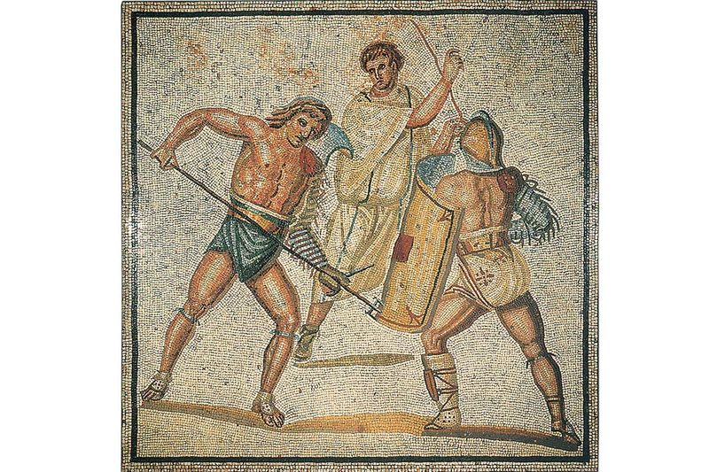

3rd Century Roman Villa Nennig Mosaic Floor, Detailed Battle of Gladiators, © Stiftung Saarländischer Kulturbesitz

This photograph is of a 3rd Century Roman floor mosaic found within the Roman villa in Nennig, Germany. The subject matter of this mosaic would be a gladiator sports event that would have been a popular pastime to go and spectate in Roman life. In this mosaic we can see an artist’s impression of a retiarius gladiator wielding a trident while fighting to the death with a secutor gladiator, which could have been an important spectacle at a local arena, or an entirely fictional event created for aesthetic purposes. Roman mosaics such as this were generally created in order to get a feel for who the buyer is and what they held in high regard. As they were also adapted into the Roman home, mosaic art would also be used as a measure of how much wealth the home-owner had and would act as a symbol of their status towards guests.

Chapter 3 – The Middle Ages

The Middle Ages was an era which took place after the fall of Rome with the early Renaissance on the horizon. During this period, although most art work was produced around religious themes and displayed within churches and monasteries to spread the Christian faith, the incessant occurrence of war, disease, famine as well as the lack of medicine and technology made death commonplace within everyday life, and imagery of death and the afterlife was prevalent throughout illuminated manuscripts, woodcuts and paintings. With the printing press having not yet been invented, every book had to be written and decorated by hand. These were known as illuminated manuscripts and could be in the form of any document that was complimented with decorative borders, letters, and small illustrations and scenes which are known as miniatures.
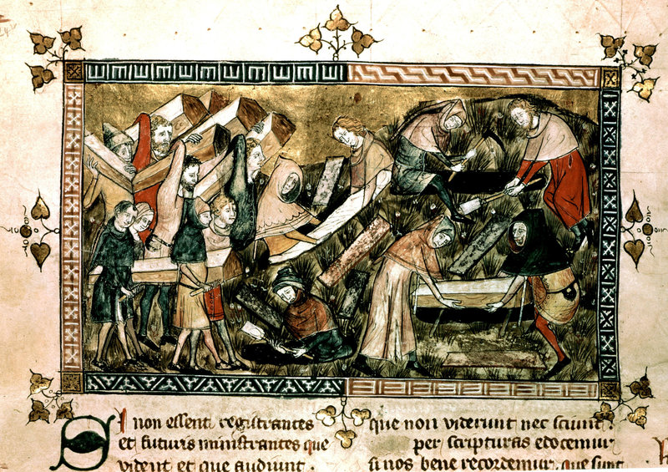

The plague in Tournai. Detail of a miniature from "The Chronicles of Gilles Li Muisis" (1272 - 1352), abbot of the monastery of St. Martin of the Righteous.

This particular miniature was drawn between 1272 – 1352 and remains one of the earliest depictions of the Black Death. The subject matter we can see depicted in this piece would be the social ruin that ensued when coping with mass death during the Black Death, which devastated Europe from 1347 onwards. As well as this the Christian belief of an afterlife and to honour the dead with an acceptable burial is also apparent. By looking at the artwork we can make out an artist’s impression of an event during the bubonic plague. We see a scene of despair, as people carry the coffins of those that they have lost to the illness into their graves to be buried respectfully. By looking at this painting we can begin to understand how artwork was evolving to act as commentary on social blights.

This particular miniature was created in order to document the effects the plague had on society specifically in Tournai, and perhaps to serve as visual reportage from an age long before the invention of the camera, so that the event can be looked back upon with a visual reference in the future. As well as this, not many people during this era would have been able to read or write, so it would have been necessary to convey important information through imagery.

Chapter 4 – The Renaissance

The Renaissance, meaning “Rebirth”, was the period following the Middle Ages, lasting from the fourteenth to the sixteenth century. After the hindrance of plague and war, the Renaissance was a time of growing prosperity and political stability. Just as in the Middle Ages, European artwork continued to approach religious themes predominantly, however there was also a new interest in portraiture and the desire to capture subjects as realistically as possible. With this new interest, great progress was made in terms of the understanding of human anatomy within the visual arts, and paintings became more realistic than ever before. The main mediums of illustration during this time period would have been, fresco, egg tempera as well as oil paints.
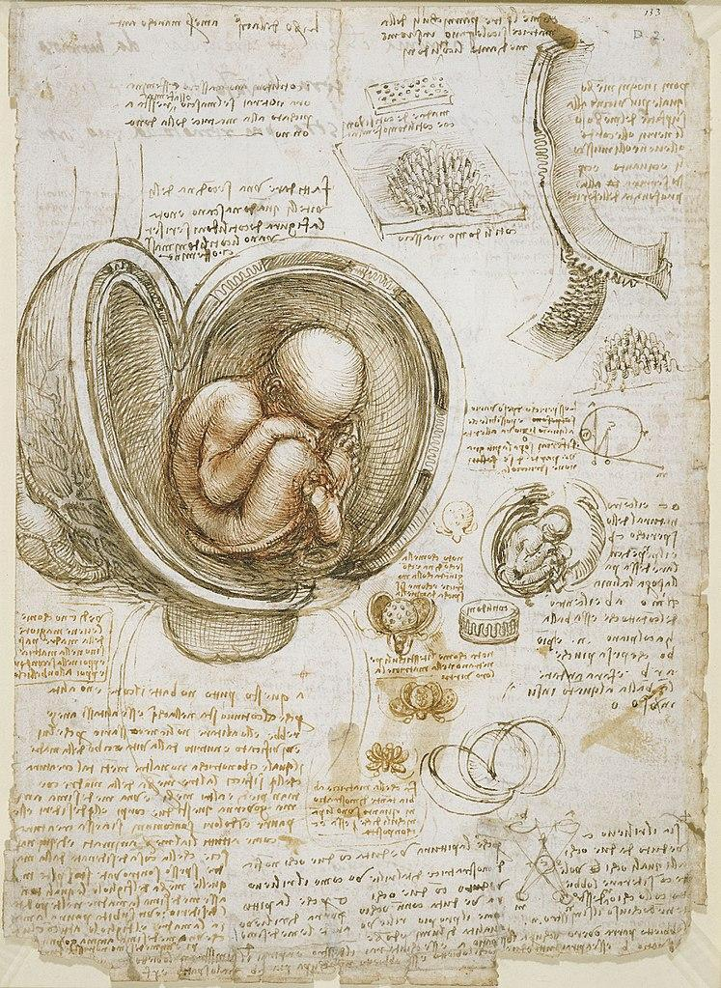

Studies of the Foetus in the Womb. (1510 – 1513) by Leonardo da Vinci

The diagrams within this piece were sketched by Leonardo da Vinci, a Renaissance Master of arts and science, and are estimated to date back to 1510 – 1513. By looking at this image, we can make out a page from a sketchbook showing us an illustrated study of a foetus curled up inside of the womb, surrounded by smaller sketches of human anatomy, as well as paragraphs of information.

These images would have most definitely been drafted from real life dissections, a procedure that for a non-physician would have been illegal. However, by disregarding any normal artistic and moral values, Da Vinci's findings made progress within how scientists and artists conducted their research of the human anatomy.

As most illustrations during this period would have traditionally been commissioned to address a religious context such as Botticelli’s “The Birth of Venus”, or Michelangelo’s painting of the Sistine Chapel Ceiling, these Da Vinci’ images would have been educational or scholarly in nature. As 16th Century doctors would not have the technology of X-rays or photographs to capture ailments, injuries or procedures, they would have illustrators commissioned to create diagrams for them in order to teach new students or make scientific progress. This teaches us as to how illustration had somewhat moved on from depicting a narrative or an emotion but now was being used for educational purposes.

Chapter 5 – The 18th Century

The 18th Century marked the genesis of the industrial revolution and illustration began to draw its attention to political and social circumstances. The industrial revolution began at around 1760 and during this period, people abandoned agricultural work to find new jobs in the mechanical cities. With the influx of new employment within factories rising, so did the demand for reading material, with workers wanting entertainment as well as newspapers and magazines to stay on top of current affairs. There was so much popular demand that the development of printing technology was boosted, and more papers were published and distributed. This new boom meant that Illustration became a common occurrence within everyday life.

As the streets of cities became packed for work, the social classes clashed, and newspapers adopted political cartoons and satire as readers took pleasure in having their political viewpoint verified through humorous illustrations. Satire was also well received by the people as illustrators were at liberty to mock politicians and political news in such a way that they could get away with it. Prints soon became mass-produced around the world and would be illustrated using etchings and engravings that would be incorporated into books, as well as wood engraving or woodcuts that would be used to finish the front pages of newspapers.

Chapter 6 – The 19th Century

The 19th century saw sudden changes in the sense of society and technology. This would be due to the Industrial Revolution in the 18th Century as well as the rapid growth of commercial business and low quality of life that came with it. The 19th Century also saw the rise of the United States as a powerful nation.

As the machine age continued to grow massively, both adults and children had to work unrealistically long hours in strenuous and sometimes life-threatening jobs, which despite the distress it caused, acted as a catalyst for large changes within Illustration. With new money coming in, there was a new demand for illustrated children’s novels as for the first time, the middle class could now buy publications for their children, as well as themselves. This new target market inspired illustrators in ways that were never before seen.

Chapter 7 – The 20th Century

In the 20th Century, thanks the ongoing development of technology, illustrative publications similar to what we have seen in the 18th and 19th century continued to be successful as there were new and improved methods of printing and distribution and illustrated books could be enjoyed by the masses.

By this time publishers thought that the use of illustrations was essential in order to sell copies. When catalogues would make continuous sales, the illustrators in turn had their work promoted and thus the money would keep moving and illustration was established as its own business, which advanced along with the publishing industry. Amazingly, because of this, illustrations were everywhere. They emerged onto every cover of every commercial magazine, as well as in the form of fiction, advertisements and even calendars.

In the year 1914, the beginning of World War 1 caused great ramifications to everyone including artists, whether that be through conscripted military service that was put into effect in the United States in 1917, or by working to create posters designed to promote the military and help the war effort.

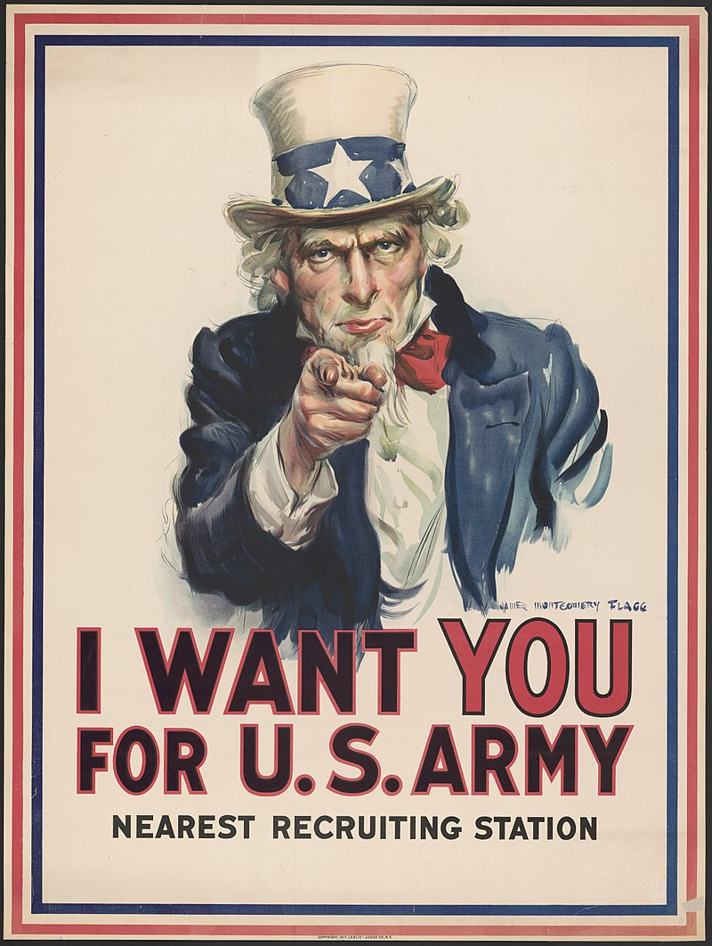

Uncle Sam Recruiting Poster by James Montgomery Flagg, 1917

This painting of Uncle Sam was created as a poster to persuade people into joining up for recruitment during the First World War. It was created in 1917 by James Montgomery Flagg and even today, it is one of the most reproduced posters of all time. By looking at the image, we can see Uncle Sam, the personification of America and its values, pointing towards the viewer along with the quote "I want you for U.S. Army". This may be in order to make the average American citizen feel as though they are special and can make a difference in the war as if they can save the country.

At the end of World War 1, came a decade known as the roaring 20s. After such hardship from the war, the roaring 20s became a time of personal expression with new fashion and music such as jazz. Artist during this time period word mainly to go against what was conventional and attempted to make progress in society by challenging their viewers with art relating to human rights and sexuality. Then in 1929, disaster struck yet again when the stock markets crashed, and the United States was plunged into what we know refer as the ‘Great Depression’. With America in a dire economic deficit, the illustration industry of course suffered with it.

However, with technological advances, people could enjoy other forms of escapism other than reading, such as listening to the radio or visiting a movie theatre, which was a business that was rapidly expanding, and the film industry of course needed illustrators to storyboard and conceptualise the ideas of the filmmaker. Animators such as Walt Disney also moved from creating short cartoon animations, to begin drawing entire feature-length movies.

In the 1950s, once the Second World War had ended, photography was beginning to eclipse illustration in advertisements and so illustration had to get creative in order to stay current. Luckily the production of movies also began to take place in full effect, with posters being the only cost-effective method of advertising new releases.

Thanks to popular culture, comic books resonated with more and more people, and consumers started playing fantasy board game and video games that were industries that relied on illustration to thrive.

Suddenly, in the 1980s, there was another milestone in information technology with the invention of the desktop computer. The computer completely revolutionised the way in which designers and illustrators would work forever and forced these artists to learn new software and digital process in order to create their work digitally.

Soon, it became necessary for illustrators to create online portfolios and websites to showcase their work to potential clients as we do today. The digital era had dawned and illustration continued to thrive.

Conclusion

In conclusion, real-world circumstances have absolutely shaped the topical evolution of Illustration. We know this because from looking at each figure of evidence, we can see how through the development of society and technology, similarly to how humans have adapted and overcame hardships, illustration has too. We can see how since the dawn of time; humans have always had a desire to tell stories and convey or document ideas visually. We as a race have overtime changed our illustrative subject matter from the animals we would hunt to survive, to the animals that we animate in cartoons. From the impact of war, we have created imagery to empower ourselves, and we have created visual commentaries that have stood the test of time that we can still learn from today.

Bibliography

Reference Images

http://www.bradshawfoundation.com/lascaux/
https://www.visitsaarland.co.uk/Media/Attractions/Roman-Villa-Nennig
http://supotnitskiy.ru/stat/stat8.htm
https://upload.wikimedia.org/wikipedia/commons/6/63/Leonardo_da_Vinci_-_Studies_of_the_foetus_in_the_womb.jpg
https://commons.wikimedia.org/wiki/File:Unclesamwantyou.jpg

Resources

https://www.khanacademy.org/humanities/prehistoric-art/paleolithic-art/a/paleolithic-art-an-introduction
https://www.metmuseum.org/toah/hd/preh/hd_preh.htm
https://www.artsy.net/gene/prehistoric-art
http://www.visual-arts-cork.com/prehistoric-art.htm
http://www.arthistoryarchive.com/arthistory/prehistoricart/
https://en.wikipedia.org/wiki/Ancient_art
https://www.khanacademy.org/humanities/ancient-art-civilizations/roman/beginners-guide-rome/a/introduction-to-ancient-roman-art
https://www.invaluable.com/blog/roman-mosaics/
https://blogs.getty.edu/iris/a-brief-introduction-to-roman-mosaics/
http://www.medieval-life-and-times.info/medieval-art/
https://www.bl.uk/the-middle-ages
https://www.khanacademy.org/partner-content/getty-museum/getty-manuscripts/a/what-is-an-illuminated-manuscript
https://www.ducksters.com/history/renaissance_art.php
http://www.visual-arts-cork.com/renaissance-art.htm
https://www.rockwell-center.org/essays-illustration/childrens-book-illustrators-golden-age-illustration/
https://americanart.si.edu/art/highlights/19th-century
https://www.mayfairgallery.com/blog/19th-century-european-painting-styles-movements
https://www.widewalls.ch/1920s-art/
https://www.huffpost.com/entry/art-activism-1930s-today_b_1098260
https://www.enotes.com/homework-help/what-impact-did-conditions-1930s-have-arts-what-466263
https://www.widewalls.ch/50s-posters/

