DS 1 Template

My Screenshots/Photos

Screenshot/Photo 1
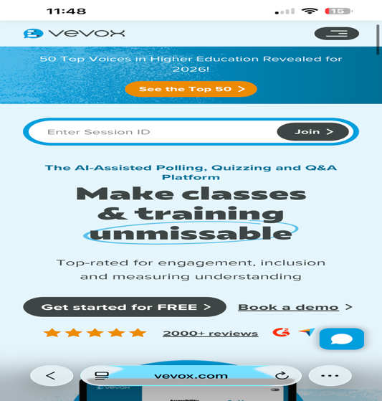
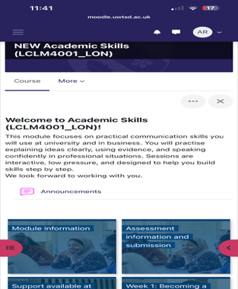
Learning how to access and use moodle correctly.

Learning how to use vevox where I can answer questions anonymously. (screenshot 2)

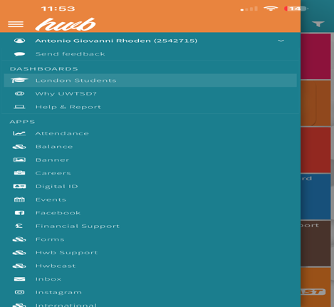

Learning how to correctly use the Hub and access everything I need. (Screenshot 3)


Gained knowledge about LinkedIn Learning. (Screenshot 4)

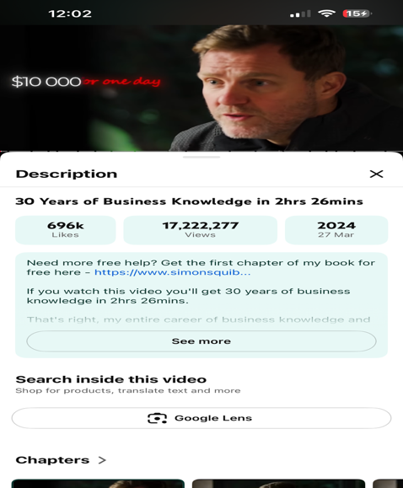
Watching Educational videos on YouTube about business.(screenshot 5)

I use digital tools to complete assignments, research information, communicate with lecturers and classmates, and manage my studies.
- I feel confident when I use my smartphone, browse the internet, send emails, and create documents.
- I want to improve my skills in using different software, creating presentations, and working more efficiently with digital technology.
- I often use these tools: Microsoft Word, email, online learning platforms, search engines, and ChatGPT.
- I sometimes feel nervous about using unfamiliar software or making mistakes when learning new digital systems.
- I hope this module will help me develop my digital skills, build my confidence, and learn how to use technology more effectively in my studies and future career.
Digital skills are important for me because they help me succeed at university, stay organised, communicate effectively, and prepare for future employment opportunities.

