Lewys Thorne
UWTSD – 2214464
Lecturer – Rob Goodson
Analysis and simulation of a centrifugal clutch
Stress analysis and dynamics – ACMA5010

Contents
1. Introduction 2
1.1 How the Centrifugal Clutch works 3
1.1.1 How the Centrifugal clutch operates according to the diagram 4
1.2 Material Choices for Centrifugal Clutches 4
1.3 Applications and operating conditions for a centrifugal clutch 5
1.4 Advantages of the Centrifugal Clutch 6
1.5 Disadvantages of the centrifugal clutch 6
1.6 Electromagnetic clutches in automation. 7
2. Task 2 8
2.1 What is the diameter of the outer drum? 8
2.2 Determine the Engagement speed of the centrifugal clutch. 9
2.3 Radial force when the driving shaft is rotating at a speed of 550 RPM. 10
2.4 Torque transmitted at 550RPM. 11
2.5 Transmitted torque compared with RPM values ranging from 450-700. 11
2.6 Coefficient of 0.3, 0.35 and 0.40 13
2.7 Angular acceleration of the drum to achieve maximum possible torque. 14
3. Conclusion 14
4. References 15

Introduction

There has been massive development of clutch mechanisms in mechanical engineering over the past century, with massive breakthroughs in the field of electromagnetic and centrifugal clutches. Electromagnetic clutches are a more recent development in manufacturing processes, whereas centrifugal clutches have been in the forefront of engineering for smaller applications like small motor equipment for a considerable amount of time. This report will explore the historical aspects of the centrifugal clutch, internal workings, material concerns, applications, benefits and present relevance.
The report will continue by looking at the internal mechanisms of the centrifugal clutch with specific values attached to them. From here a series of answers will be given for the calculations of certain aspect of the clutch, such as the engagement speed, radial force and transmitted torque created by the clutch when there are different coefficients of friction applied.

How the Centrifugal Clutch works
Usually located between the engine's flywheel and the gearbox system, the centrifugal clutch is a clutch mechanism that uses centrifugal force to connect the engine's driving shaft to the gearbox shaft. It functions more efficiently at higher speeds and serves as the main means of connecting the engine and gearbox shafts (Testbook, 2023).
The Automotives Global (2019) explains that when the engine speed reaches a specific RPM, it generates enough centrifugal force inside the clutch which results in clutch engagement. When the RPM is lower, the clutch will disconnect itself to stop the power transmission of the system.
The centrifugal clutch has developed a lot over the recent century, some of the developments include the material advancements which were incorporated to reduce the wear and slipping when in the engagement process. Lighter materials such as aluminium and carbon have been used to allow for lighter weight applications such as go kart racing. Lastly, the material advancements have allowed manufacturers to create centrifugal clutches which are more compact and light weight which is especially important for handheld tool such as chainsaws (Yadav et al., 2022).

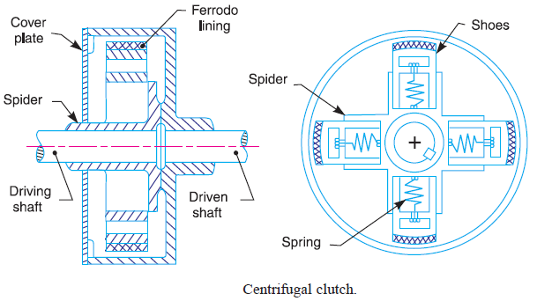

(Figure 1 – Diagram of a Centrifugal clutch)
Above is a diagram of a centrifugal clutch. There are a few key components included in the diagram, these are the clutch shoes, the outer drum, the springs and the driving/driven shaft.

How the Centrifugal clutch operates according to the diagram
In Idle State
When there is a low RPM on the driving shaft the springs will keep the clutch shoes retracted, away from the inner surface of the drum.
Acceleration
When the engines RPM increases, the centrifugal force will begin to act on the clutch shoes, causing them to extend towards the inner surface of the drum.
Engagement
When the RPM is continuously increased, the centrifugal force will cause the clutch shoes to contact the inner part of the drum. When the clutch is fully engaged, the power transmission is at its maximum, it is here that there is direct connection between the driving and driven component.
Disengagement
This is when the engines’ RPM decreases. When this happens, the centrifugal force being applied to the shoes lessens, causing the springs to pull the shoes back towards the centre of the clutch. At this point the mechanical connection between the driving and driven component is no longer present. The engine will still be able to run, however there will be no power transmission to the driven component, so the system will be able to coast
(Norton, 2014, pp.960–966)

Material Choices for Centrifugal Clutches
A centrifugal clutch's component material selection is influenced by several variables, including the intended use, anticipated load, operating environment, and financial limitations. The materials are chosen with cost-effectiveness in mind, balancing the requirements for strength, wear resistance, and heat resistance.
Each component within the centrifugal clutch system will have a specific material requirement. For example, the clutch shoes will make direct contact with the inside of the drum when the RPM of the system is high enough. Thus, the clutch shoe should be made from a high friction and rough material so that it can properly engage with the inside of the drum for an efficient mechanical connection. Steel, or ceramic compounds are typical materials for the linings of brake shoes (O’Keefe, n.d.).
The clutch drum which is the outer part of the centrifugal clutch will be made from a durable and strong material such as steel or aluminium alloys.
Typically, the springs which are required to push the clutch shoes outwards towards the inner part of the drum are made of high strength steel. The reason for this is due to the materials’ high yield strength and fatigue resistance which is required when the spring undergoes constant loading as the system increases/decreases in RPM.

The spider’s material would likely be steel, however, depending on the application, the spider may be made from aluminium or cast iron. An aluminium spider will allow for a lightweight assembly compared to steel which may be required in racing applications. A cast iron spider may be used in industrial applications where high levels of resistance to wear, and high strength are required (Budynas and Nisbett, 2019, pp.860–864).

Applications and operating conditions for a centrifugal clutch

Typically, centrifugal clutches are built into machinery that has high-speed rotating components powered by smaller engines. They are found in a wide range of applications, ranging from landscaping equipment to mining equipment. Although the centrifugal clutch has many applications, it is not suitable for every type of job. Centrifugal clutches are not commonly used in applications which involve the transfer of high torque as they are liable to slip if the driving load is too large. Furthermore, centrifugal clutches are also not advised when the application requires a high reliability of disengagement (Team, 2021).
Some typical applications for the centrifugal clutch are as follows:
- Go Karts
- Lawnmowers
- Scooters/Mopeds
- Chainsaws
- Farm Machinery
- Small industrial machinery
- Construction equipment
(Testbook, 2023)
Operating Conditions
As the centrifugal clutch is used in a wide range of applications, it is important that it can withstand the potential conditions it may face. For example, the difference in temperature conditions. Some centrifugal clutches may be used in industries where extremely high temperatures are used, whereas they may also be used in outdoor equipment such as farming machinery where the temperature is very low. A chainsaw is turned on and off frequently when being used, this means that the centrifugal clutch should be able to withstand the multiple engagements and disengagements without wearing. Lastly, a crucial factor to consider is the load applied to the driving component. Centrifugal clutches are frequently employed in situations involving fluctuating loads. Effective power transmission, efficiency, and resistance to excessive wear and sliding are all crucial requirements for the clutch.

Advantages of the Centrifugal Clutch

There are many advantages to the centrifugal clutch, some of these include:
- Ease of use
- Portability
- Automatic operation
- Stalling
- Maintenance
The centrifugal clutch is typically used in small applications such as the chainsaw, lawnmower or go kart. This is due to its ease of use which is due to automatic operation. As there is no manual clutch operation, the operator will find it easier to use the equipment due to there being no manual pedal or lever. Centrifugal clutches are typically lighter than other clutches which is beneficial for applications which are handheld such as the chainsaw. Auto Mechanic School, (2022) states that: “it helps to prevent the engine from stalling”. Due to the operation being automatic, the chance of stalling at low speeds is prevented, compared to that of a manual clutch. As it is minimising the chance of stalling, the operational safety of the equipment increases. Lastly, the centrifugal clutch requires low maintenance compared to other clutch types, which is incredibly beneficial to the application as users would be reluctant to buy equipment which needed regular maintenance (Testbook, 2023)

Disadvantages of the centrifugal clutch

Although there are many advantages to using the centrifugal clutch, there are also some disadvantages where this type of clutch would not be beneficial to the application. Engineer Know, (2021) believes that slippage is one disadvantage when the application involves heavy duty work. This would be during the engagement process. When the shoes engage with the inner part of the drum, there may be some slippage which generates heat and reduces efficiency of the system which can contribute to wear over time. The next disadvantage is the lack of manual control can be non-beneficial for some applications. As the clutch is designed for automatic engagement/disengagement based on the rpm, the lack of manual control could be non-beneficial for applications which require precise control over power transmission. Lastly, centrifugal clutches are generally only used in small equipment, as they are not advantageous in large complex machinery (Adenwala, 2020).

Electromagnetic clutches in automation.

For current automated industrial processes, electromagnetic clutches offer instantaneous, electronically controlled engagement and disengagement, increasing safety, decreasing wear and tear, and improving operating efficiency (oguraindustrial, 2016). Typical applications that electromagnetic clutches are used in include:
- Motion control
- Conveyors
- Machine Tools
- Automated assembly lines
- Material Handling
Electromagnetic clutches are used in motion control systems such as CNC machines and robotics. The clutch ensures quick and accurate positioning of different components. The electromagnetic clutch is used in conveyors because of the precise engagement and disengagement which ultimately manages the transfer of materials along production lines. The electromagnetic clutch is also used in textile manufacturing. The clutch is used to accurately manage the winding, feeding and tensioning in the process, this in turn increases productivity and overall quality of production. Lastly, electromagnetic clutches are used in material handling. Applications in which these clutches are used can include hoists and cranes as the clutch can be used with controlled lifting/lowering of heavy loads (www.mecholic.com, n.d.)

Task 2

Figure () – Diagram of centrifugal clutch from assessment specification.

What is the diameter of the outer drum?

Centre of mass of each shoe is at a radius of 95mm from the shaft centre.
95mm
95 x 2 (total length) = 190mm
There is a clearance of 9mm on either side of the outside of the shoes and the inner part of the outer drum. As it is either side, we multiply 9mm by 2
9 x 2 = 18mm
Finally, the thickness of the outer drum is 4mm all the way round. To get the total diameter of the drum, we multiply the thickness by two (both sides).
4 x 2 = 8mm
Adding up all these numbers will give the total diameter of the drum:
Total diameter of the drum = 190 + 18 + 8 = 216mm or 216${x10}^{-3}$m

Determine the Engagement speed of the centrifugal clutch.

Centripetal force (F_{C}) = mω²r
Spring force (F_{s}) = Kx
F_{C} = F_{s}
Therefore:
mω²r = Kx
Where:
m = mass of the shoes
ω = Angular velocity
r = total radius of shoes from the shaft centre
K = Spring stiffness
x = Total clearance

mω²r = Kx
ω² = $\frac{Kx}{mr}$
K = 7.5kN/m = 7500N/m
x = 0.009m
m = 275g = 0.275kg
r = 104mm = 0.104m
Therefore:
ω² = $\frac{7500 x 0.009}{0.275 x 0.104}$
ω² = 2360.14

ω = $\sqrt{2360.14}$
ω = 48.58 rad/s

To convert rad/s to rpm, the following equation is used:
RPM = ω x $\frac{60}{2π}$

RPM = 48.58 x $\frac{60}{2π}$
RPM = 463.90
RPM to the nearest whole number = 464 rpm.

Radial force when the driving shaft is rotating at a speed of 550 RPM.

Centripetal force (F_{C}) = mω²r
Spring Stiffness (F_{s}) = Kx

550rpm converted to rad/s using the following equation:
$\frac{550x2π}{60}$ = 57.5958 rad/s
F_{C} = 0.275 x 57.5958² x 0.104 = 94.87N

F_{s} = Kx
F_{s} = 7500 x 0.009
F_{s} = 67.5

F_{c} – F_{s} = 94.87 – 67.5
The radial force acting on the clutch face (one shoe) = 27.37N
The radial force acting on the clutch face for the system (4 shoes) = 27.37 x 4 = 109.48N

Torque transmitted at 550RPM.

Torque ($τ$) = Fr
F = $μ x Radial Force$
F = 0.35 x 109.48 = 38.32N
$τ$ = 38.32 x 0.104
$τ$ = 3.99Nm

Transmitted torque compared with RPM values ranging from 450-700.

450 rpm
First, convert the speed from RPM to Rad/s using the equation:
ω = $\frac{RPM x 2π}{60}$
Therefore:
ω = $\frac{450 x 2π}{60}$ = 47.124 rad/s
Work out the radial force at proposed rpm (like in part 2.3)
Calculate F_{c}
F_{c} = 0.275 x 47.124² x 0.104
F_{c} = 63.511N
Calculate F_{s}
F_{s} = Kx
F_{s} = 7500 x 0.009
F_{s} = 67.5
F_{c} – F_{s} = 63.511 – 67.5 = -3.988N
Multiply by 4 for the whole system
-3.988 x 4 = -15.955
radial force at 450 rpm = -15.955N

Transmitted Torque
$τ$= Fr
F = $μ x Radial Force$
F = 0.35 x -15.955 = -5.58N
$τ$ = -5.58 x 0.104
$τ$ = -0.581Nm

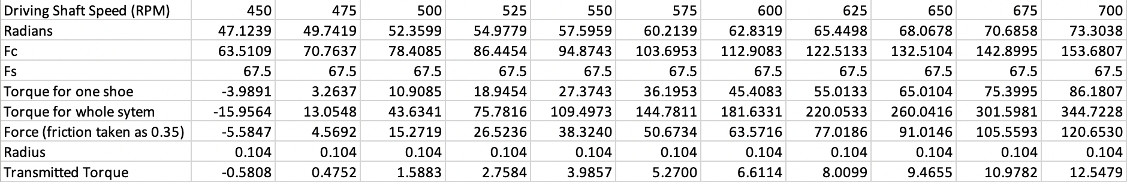
The above workings out were then performed for every rpm value, from 450-700 in 25rpm increments. The table and graph below show the results:

Coefficient of 0.3, 0.35 and 0.40

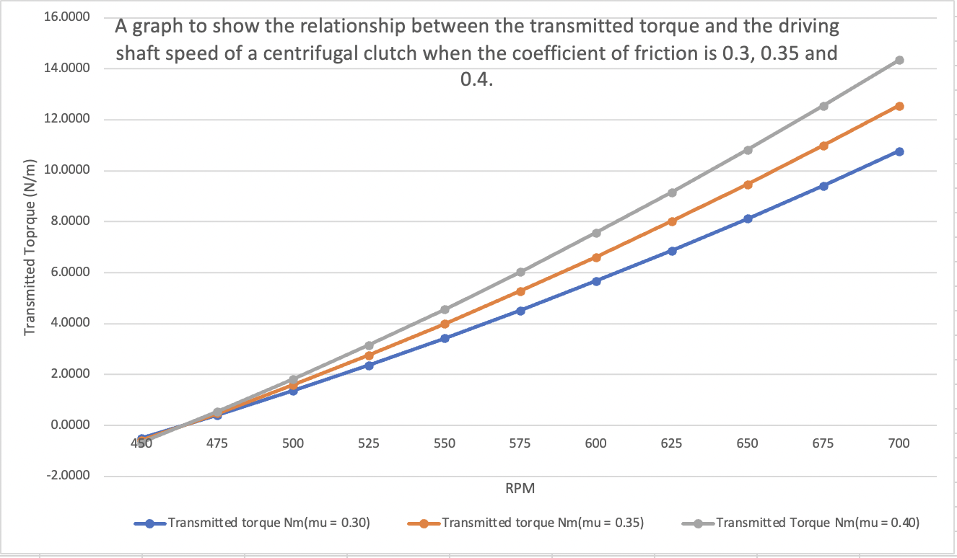
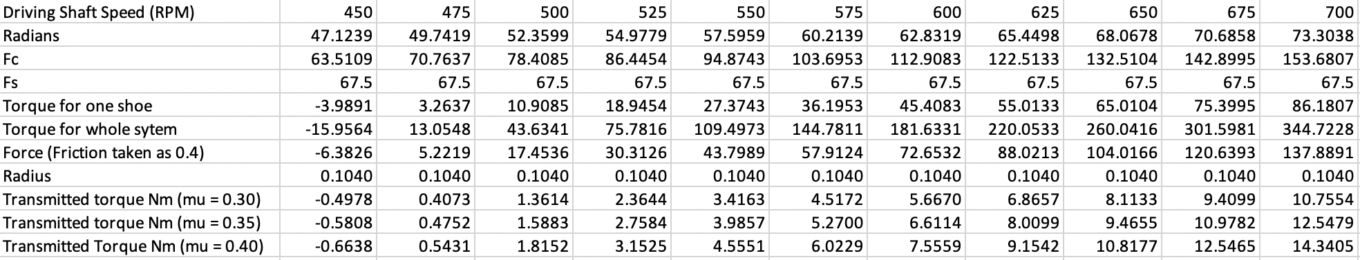
Below is a table and graph illustrating the transmitted torque when the coefficient of friction is 0.30, 0.35 and 0.4.

The graph above shows three trendlines, each for the different coefficients of friction (0.3, 0.35 and 0.4). We can see that all three trendlines show the same pattern curvature. The trendlines are all showing an increasing at an increasing rate curve. The graph shows that when the RPM is at 450rpm, all three coefficients of frictions have a similar transmitted torque value to each other. As the RPM increases, the transmitted torque also increases for all three coefficients of frictions. However, the grey trendline (coefficient of friction = 0.40) shows that as the RPM increases, the transmitted torque increases at a higher rate than the coefficients 0.3 and 0.35. The coefficient of friction 0.35 has a higher transmitted torque than the coefficient of friction 0.3 when at the same RPM, but not as much as the 0.4 trendline. We can conclude from this that as the coefficient of friction increases and the RPM increases, the higher torque is transmitted.

Angular acceleration of the drum to achieve maximum possible torque.

Angular Acceleration ($α$) = $\frac{Torque(T)}{Moment of inertia(Ι)}$
Maximum transmitted torque from the graph = 14.3405N/m
Moment of inertia = $\frac{1}{2}$ x mr²
m = 750g = 0.75Kg
r = 108mm (0.108m taken from 2.1)

Moment of inertia = $\frac{1}{2}$ x 0.75 x 0.108²
Moment of inertia = 4.374x10⁻³ Kg/m²

Angular acceleration = $\frac{14.3405}{0.004374}$
Angular Acceleration = 3278.58 rad/s

Conclusion

To conclude this report, the centrifugal clutch has been a massive part of engineering technology for the past century, and it is still improving currently by looking into more advancements such as weight and material usage for applications which require light weight technology, such as a go kart. More advanced clutches have also been created (electromagnetic clutch) to improve manufacturing processes such as the precision movement in CNC machines. Common errors such as slipping and wear in centrifugal clutches have been minimised in new technologies and new clutches which reinforces the point that research and development will greatly improve production and quality within a manufacturing process.

References
Adenwala, N. (2020). Centrifugal Clutch: Parts, Working, Advantages, Disadvantages & Applications [PDF]. [online] Design | Engineering. Available at: https://dizz.com/centrifugal-clutch/ [Accessed 5 Nov. 2023].
Auto Mechanic School (2022). Centrifugal Clutch – Working Principle, Main Parts Advantages and Disadvantages. [online] www.youtube.com. Available at: https://www.youtube.com/watch?v=bxFkzWyGc4Q [Accessed 5 Nov. 2023].
Budynas, R. and Nisbett, K. (2019). Shigley’s Mechanical Engineering Design. [online] McGraw-Hill Science/Engineering/Math, pp.860–864. Available at: https://ia903102.us.archive.org/33/items/MechanicalEngineeringDesign9th/Mechanical%20Engineering%20Design%209th.pdf [Accessed 4 Nov. 2023].
Engineer Know (2021). Centrifugal clutch Working Advantage and Disadvantage Explained. [online] www.youtube.com. Available at: https://www.youtube.com/watch?v=-NZ_Lr9KUBQ [Accessed 5 Nov. 2023].
Norton, R.L. (2014). Machine design : Nn integrated approach. 4th ed. [online] Boston: Prentice Hall, pp.960–966. Available at: https://mmsallaboutmetallurgy.com/wp-content/uploads/2019/02/machine-design.pdf.pdf [Accessed 4 Nov. 2023].
O’Keefe, P.J. (n.d.). Clutch Shoe | Engineering Expert Witness Blog. [online] Engineering Expert Witness Blog. Available at: http://www.engineeringexpert.net/Engineering-Expert-Witness-Blog/tag/clutch-shoe [Accessed 4 Nov. 2023].
oguraindustrial (2016). Electromagnetic Clutches - How they work. [online] www.youtube.com. Available at: https://www.youtube.com/watch?v=5SuqyE_bXqo [Accessed 9 Feb. 2022].
Team, T.B. (2021). The Importance of Centrifugal Clutches in Engines. [online] BLM Automatic Clutch. Available at: https://www.blm-cm.com/blog/centrifugal-clutches-engines/#:~:text=Centrifugal%20clutches%20are%20integral%20to [Accessed 5 Nov. 2023].
Testbook. (2023). Centrifugal Clutch- Diagram, Working, Advantages and Applications. [online] Available at: https://testbook.com/mechanical-engineering/centrifugal-clutch [Accessed 5 Nov. 2023].
The Automotives Global (2019). How Centrifugal clutch Works? [online] www.youtube.com. Available at: https://www.youtube.com/watch?v=HrmWNBwHBQ0 [Accessed 4 Nov. 2023].
www.mecholic.com. (n.d.). Electromagnetic Clutch Working, Applications, Advantages and Disadvantages | Mecholic. [online] Available at: https://www.mecholic.com/2016/01/electromagnetic-clutch-working-application-advantages.html.
Yadav, P., Kumar, A., Choudhary, N., Singh, S. and Gupta, P. (2022). Design and Analysis of Compliant Centrifugal Clutch. Design and Analysis of Compliant Centrifugal Clutch, [online] 8(12). Available at: https://ijirt.org/master/publishedpaper/IJIRT155041_PAPER.pdf.

