

Evaluating and Comparing the Performance of Routing Protocols (OSPF, RIP, EIGRP) on Network Devices

by
ZEYU XIE
Supervisor: MUNYARADZI NICHOLAS MURIRA

Project submitted as part of the requirements for the award of
BSc Computing (Computer Networks and Cybersecurity)

November 2025

CONTENT
CHAPTER1 3
1.1 INTRODUCTION 3
1.2 AIM 4
1.3 OBJECTIVES 4
1.4 CONCLUSION 5
CHAPTER 2 6
2.1 INTRODUCTION 6
2.2 A Critical Analysis of Existing Research 9
2.3 CONCLUSION 10
CHAPTER 3 12
3.1 INTRODUCTION 12
3.2 Research Onion 12
3.3 Research Philosophy - Positivism 13
3.4 Research Approach - Deductive Approach 13
3.5 Research Strategy - Experiment 14
3.6 Research Choice - Quantitative Method 14
3.7 Time Horizon - Cross-Sectional 15
3.8 Techniques and Procedures - Data Collection Methods 15
3.9 Evaluation Criteria 16
3.10 Universality of Experiment 17
3.11 CONCLUSION 18
CHAPTER 4 19
4.1 INTRODUCTION 19
4.2 Experimental Requirements 19
4.3 Network Topology Design 21
4.4 Implementation and Experimental Procedure 23
4.5 Testing Methods and Metrics 24
4.6 CONCLUSION 24
CHAPTER 5 26
EVALUATION 26
5.1 INTRODUCTION 26
5.2 Baseline Connectivity and Latency Results 26
5.3 Path Selection Results 29
5.4 Link Failure and Convergence Results 34
5.5 Internal Protocol Behaviour 39
5.6 CONCLUSION 45
CHAPTER 6 46
CONCLUSIONS AND RECOMMENDATIONS 46
CHAPTER 7 47
REFLECTION 47
CHAPTER 8 49
REFERENCE 49
CHAPTER 9 51
BIBLIOGRAPHY 51
APPENDICES 52

CHAPTER1

1.1 INTRODUCTION

In modern internet architecture, the Transmission Control Protocol (TCP/IP) serves as the core engine driving the operation of global internet and enterprise networks. Its primary goal is to achieve seamless interconnection between heterogeneous networks, thereby providing universal and reliable communication capabilities for diverse network architectures. Undeniably, the value of network interconnection lies in transcending geographical boundaries, enabling hosts in different networks to establish communication connections [1]. Most networks employ a layered protocol architecture, where each layer serves the upper layers while abstracting the implementation details of underlying protocols. To ensure accurate and efficient data packet forwarding across the network, the routing function at the network layer is essential. This layer plays a central role in both datagram transmission and path selection.[1]

In the network architecture, the Internet consists of interconnected subnets (Autonomous Systems, AS) linked by backbone links. The IP protocol ensures data packet forwarding between these autonomous systems. Regardless of network location, devices rely on various routing protocols to guarantee reliable data transmission from source nodes to destination nodes [2]. The router acquires network topology data via routing protocols, evaluates multiple potential paths, and selects the optimal route based on optimization principles (routing protocols are customizable, with path priorities adjustable through configuration commands). Significant differences among routing protocols in path calculation mechanisms, convergence speed, and scalability may lead to varying impacts on overall network performance.

For large enterprise networks[4], selecting appropriate dynamic routing protocols (such as OSPF, EIGRP, or RIP) is critical for enhancing performance, improving reliability, and supporting future scalability. As organizations expand or network environments evolve (e.g., changes in link configurations, department consolidations, or growing service demands), network topologies often require continuous adjustments. In such scenarios, optimizing routing mechanisms, reducing network latency, increasing throughput, minimizing packet loss, and preventing bottlenecks and single points of failure have become core requirements in enterprise network design and maintenance. For instance, adopting more efficient routing protocols or implementing rational topologies (such as mesh architectures[5]) can maintain communication through backup paths during link failures, ensuring the continuity of critical business services. [3].

This experiment is a test and analysis experiment for network routing protocol.

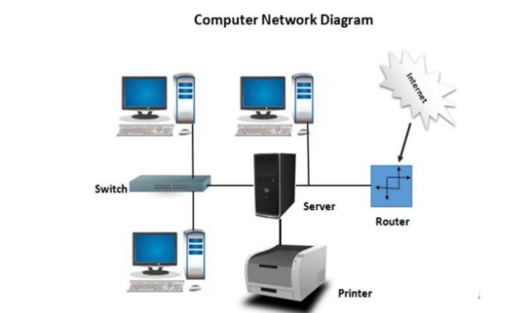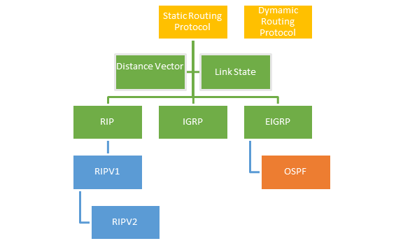
*Figure1: What’s networking[4] *Figure2: Routing protocol[5]

1.2 AIM
The aim of this project is to simulate a large-scale enterprise network environment to evaluate and compare the performance of different routing protocols, analysing their efficiency, time performance, and cost implications to support informed enterprise network design and routing strategy optimisation.

1.3 OBJECTIVES
The five objectives for this report are:
1. Conduct a structured literature review of routing protocols and network simulation tools (including GNS3 and Huawei eNSP) to identify key performance metrics, comparison criteria, and existing research gaps relevant to enterprise network environments.
2. Identify and justify an appropriate research methodology for the project, selecting suitable experimental and analytical approaches to ensure reliable comparison of routing protocols within a simulated enterprise network environment.
3. Design and implement a representative enterprise network simulation using tools such as GNS3 and/or Huawei eNSP, configuring and testing at least two routing protocols based on defined performance criteria.
4. Capturing and analyses network performance data using tools such as Wireshark, evaluating measurable metrics including latency, throughput, and convergence time to enable objective comparison of routing protocols.
5. Evaluate and interpret the findings by comparing protocol performance alongside estimated deployment and operational costs and produce justified recommendations for enterprise network architecture and routing strategy optimisation.

1.4 CONCLUSION

This chapter introduces the background of the experiment, its purpose, and the research subjects.

In Chapter 2, "Research and Literature Review", I will study relevant literature on routing protocols, network simulation tools, and the indicators used.

The 3rd chapter will be the "Methodology section", where the experiment will be designed using the "Research Onion" method to ensure the reproducibility and reliability of the experiment.

In the Chapter 4,"design and implementation section", I will present the network topology and device configurations on the two simulation platforms, including correct network address allocation and routing protocols, etc. After the topology can operate normally, I will use network protocol analyser (Wireshark and Npcap) for caught, testing and data collection.

Chapter 5 is the "Evaluation" section, where I will compare the experimental results of Chapter 4, compare the device data under different platforms, and draw conclusions.

Chapter 6 will combine the results of the previous two chapters and the actual equipment costs to provide some reference suggestions for the company to choose brands and equipment.

Chapter 7 will be personal "Reflection". I will review all the efforts related to the project throughout the year, summarize the new knowledge I have learned and the points that are helpful for personal improvement.

Chapters 8 and 9 will present reference resources, Gantt charts, and some tools I used to help me learn in IEEE format.

CHAPTER 2
RESEARCH & REVIEW OF LITERATURE

2.1 INTRODUCTION
This chapter will validate the research rationale and theoretical framework of the study within computer network disciplines through systematic analysis of literature on network topology. The literature review begins with fundamental theories of network topology and routing, then examines the characteristics of RIP, OSPF, and EIGRP. It compares existing performance evaluations of these protocols and extends to emerging intelligent technologies in network performance optimization. Finally, the chapter critically assesses limitations in prior research to highlight the necessity and contributions of this study.

2.1.1 Overview of Interior Gateway Protocol

Before analyzing the references, the author will briefly explain the concepts of RIP, OSPF, and EIGRP routing protocols to help readers better understand the research. Understanding the principles and characteristics of these protocols enables a fair evaluation of their performance.

RIP (Routing Information Protocol)

The Routing Information Protocol (RIP) is designed to assist routers in determining the optimal path for transmitting data packets within a network. It uses the number of hops as its routing metric, and due to its limited scalability, it is mainly used in small to medium-sized networks. [8]

The “packet count” indicator refers to the number of routers that a data packet must pass through before reaching its destination. [8]

OSPF (Open Shortest Path First)

Open Shortest Path First (OSPF) is a link-state Interior Gateway Protocol (IGP) developed by the Internet Engineering Task Force (IETF) to provide efficient routing within an Autonomous System (AS). OSPF uses the Shortest Path First (SPF) algorithm, developed by Dijkstra, to determine the best route to each destination.[9]

EIGRP (Enhanced Interior Gateway Routing Protocol)

Enhanced Interior Gateway Routing Protocol (EIGRP) is an advanced distance-vector routing protocol that uses characteristics of both distance-vector and link-state protocols, making it a hybrid routing protocol.[10]

2.1.2 Network Topology and Its Influence on Routing

Network topology serves as the foundational infrastructure for routing protocols. As demonstrated by Liu and Liu (2014) [6], it not only governs the physical and logical interconnections among network nodes but also directly impacts routing efficiency, reliability, and congestion behaviour.[6]

The paper divides the common network topology into eight categories: point-to-point, bus, star, ring, mesh, tree, hybrid, and daisy chain.[6]

For instance ：
- The star and bus topology are used in traditional LAN, which are simple and easy to deploy, but have weak fault tolerance.[6] [11]
- Mesh and hybrid topologies provide multi-path redundancy, making them more suitable for large enterprise networks as they maintain communication continuity through alternative paths when links fail. [6]

Liu's literature analysis reveals that the redundant path feature in mesh architectures enables dynamic routing protocols like OSPF and EIGRP to fully leverage multipath advantages, achieving faster convergence and higher path selection efficiency.[9][10] In contrast, RIP's reliance on hop count and periodic updates makes it unsuitable for complex topologies or large-scale networks.[10]

2.1.3 Performance Research and Comparison of RIP, OSPF and EIGRP

Ioan & Gavril [2], in their research paper “Network Performance Evaluation for RIP, OSPF and EIGRP Routing Protocols”. Using “Opnet” Simulator conducted a systematic evaluation of the performance of these three protocols under different network scales, traffic pressures, and topological conditions.

The literature indicates that in terms of convergence speed, due to the different principles of various routing protocols, it is manifested as follows: EIGRP > OSPF > RIP (speed from fast to slow)[2][11]
EIGRP achieved peak throughput across all test scenarios due to its precise comprehensive metrics and superior path selection, while OSPF demonstrated stable performance and RIP recorded the lowest throughput. EIGRP's rapid fault detection capability also resulted in the lowest packet loss rate, whereas RIP's high packet loss rate stemmed from frequent routing inconsistencies during convergence[2][11]. In latency performance, OSPF outperformed all protocols by enabling rapid adaptation to network changes, achieving optimal load balancing and bandwidth utilization with minimal latency[2]; EIGRP follows closely behind, while RIP experiences the highest latency due to sub-optimal path selection and slow convergence.

In conclusion, the study conclusively demonstrates that EIGRP is optimal for enterprise networks requiring high performance and rapid response, OSPF is better suited for large-scale and complex scenarios, while RIP is more appropriate for smaller networks.
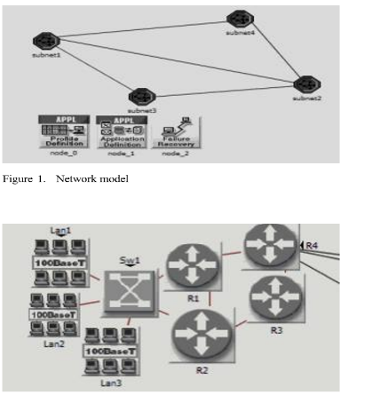
Figure3: Opnet Simulator[2]

2.1.4 Comparison of Routing Protocol Performance

In their paper “RIP vs. OSPF Routing Protocols: Which One Is the Best for a Real-Time Computer Network”, Majid & Fuada[7] conducted a systematic study of two common internal gateway routing protocols—RIP and OSPF. The research aimed to compare their performance across various network scales and real-time environments, while further exploring how protocol design mechanisms influence actual network performance.[7]

The author constructed a testing environment using the GNS3 and ENSP simulation platforms to evaluate protocol performance from multiple perspectives, including convergence time, end-to-end latency, throughput, packet loss rate, real-time application performance (such as VoIP and video transmission), and shortest path selection efficiency. The research findings clearly demonstrate significant differences between OSPF and RIP in path selection mechanisms and overall network performance. [7][13] OSPF calculates path costs based on link bandwidth, enabling it to more accurately identify optimal paths in complex topologies. In contrast, RIP, which relies solely on hop count as a routing metric, tends to select logically shortest but sub-optimal paths in practice, making it more prone to sub-optimal routing. Performance data further supports this: OSPF's average end-to-end latency is significantly lower than RIP's (83ms vs. 177ms)[7]，and it can update the routing table quickly when the link state changes, while RIP's periodic update mechanism causes the response lag in dynamic environment.[7][12]

Furthermore, a key finding of this study is that implementation variations across different emulation platforms affect protocol performance. For instance, ENSP demonstrates significantly lower average latency than GNS3 (94ms versus 329ms)[5]，The results show that the internal mechanism of the simulation tool and the equipment model have a non-negligible effect on the experimental results. In the shortest path test, OSPF consistently chooses the better path in ‘traceroute’ experiment, while RIP often has the phenomenon of detouring due to the hop limit.[13]

Overall, this study not only demonstrates OSPF's significant superiority over RIP in real-time scenarios, but also highlights how the simulation platform itself can influence experimental outcomes. This provides a theoretical basis for the project to adopt multi-platform or more precise simulation methods. Furthermore, it emphasizes that RIP's performance is unsuitable for large-scale or high-real-time-network environments due to better alternatives. Additionally, the implementation differences of experimental platforms (such as GNS3 and ENSP) can significantly affect test data, suggesting that researchers should carefully select tools and account for platform biases when conducting network simulation tests.

2.2 A Critical Analysis of Existing Research

Although the performance of RIP, OSPF and EIGRP are analysed in the existing literature, there are still some limitations and superficiality.

First, the study “RIP vs. OSPF: Which One Is the Best for a Real-Time Computer Network?” primarily compares the two protocols, RIP and OSPF, and draws conclusions about their performance differences across various simulation platforms. However, the research scope is limited, with test data mainly obtained through basic network tests and ‘traceroute’ commands like ‘Ping’ and ‘traceroute’, without in-depth analysis of metrics such as throughput and packet loss rate. Additionally, while the study highlights significant latency differences between ENSP and GNS3, [7]it fails to explain the underlying causes of platform variations, such as differences in device models, configuration methods, or internal implementation mechanisms. This, to some extent, affects the rigor of the conclusions.

Secondly，While the paper “Network Performance Evaluation for RIP, OSPF and EIGRP” provides a comprehensive comparison of the three protocols, its experimental topology is limited to small and medium-sized networks. It fails to address the complex hierarchical structures, multi-region OSPF designs, and traffic pattern variations in large enterprise networks. [9][10]Furthermore, although the study highlights EIGRP's advantages, it does not evaluate its applicability in cross-vendor environments, which compromises the generalization of the conclusions and makes it difficult to provide actionable recommendations for enterprises.[2]

Finally, “A Study on Topology in Computer Network” underscores the critical role of topology in network performance. However, its analysis primarily focuses on classifying and describing topological structures, without establishing connections between topological complexity and the performance of specific routing protocols. [6]Moreover, some of the examples analysed, such as the bus topology, are no longer relevant to current applications.

2.3 CONCLUSION

This chapter provides a comprehensive review of research in three mainstream routing protocols—RIP, OSPF, and EIGRP—while examining how network topology impacts protocol performance. Studies indicate that RIP, despite its simplicity and ease of configuration, is better suited for small or simple networks due to its basic metric mechanism, slow convergence, and limited path selection capabilities.[7] OSPF, on the other hand, excels in path selection accuracy, convergence speed, and network scalability, making it the preferred choice for large enterprise networks.[9] EIGRP, while offering the best performance in convergence time and throughput, faces practical deployment challenges due to its limitations in cross-vendor environments and significant dependence on device types.[10]

Furthermore, literature comparisons reveal that different simulation platforms (e.g., GNS3 and ENSP) exhibit protocol implementation differences, which significantly affect experimental outcomes. Therefore, when conducting network protocol performance research, the selection of simulation tools and consistency of experimental environments are critical to ensuring result reliability. Additionally, existing studies still fall short in experimental scale, metric scope, and depth of cross-protocol comparisons, particularly lacking experimental designs for real-world enterprise network architectures and multi-perspective analytical recommendations.

CHAPTER 3
RESARCH METHODOLOGY

3.1 INTRODUCTION

This chapter explains the research methodology adopted to investigate and compare the performance of RIP, OSPF, and EIGRP routing protocols within a simulated network environment. To ensure a structured and academically justified research design, the methodology is developed using the Research Onion (Figure 4) framework proposed by Saunders et al., which provides a clear step-by-step approach to selecting appropriate research methods.

Using this framework, the chapter examines each relevant layer of the research process, including research philosophy, research approach, strategy, methodological choice, time horizon, and data collection techniques. Since the project focuses on measurable network performance indicators such as latency, convergence time, packet loss, and route efficiency, a quantitative experimental methodology is considered the most appropriate.

The chapter also discusses how the selected methods contribute to the validity, reliability, and overall credibility of the study, providing a strong foundation for the implementation and testing stages presented in the following chapter.

3.2 Research Onion
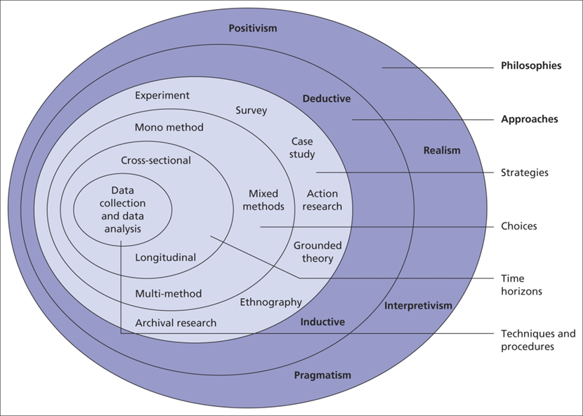

Introduction
As this research is an experimental project, it focuses on constructing controlled topologies through network simulation environments to collect quantitative performance metrics under different routing protocols. The chapter concludes by introducing how data collection and analysis are conducted using the Research Onion model, ensuring the reproducibility of the research process, the verifiability and authenticity of experimental results, and the scientific and rational nature of the experimental methods. It also explains the tools (GNS3, HUAWEI eNSP) and hardware selected for this project.
Figure 4: research onion[14]

3.3 Research Philosophy - Positivism

Concept and Reasons
This study will adopt positivism as the research philosophy, which means that the author will design hypotheses and test them and understand the behaviour of network protocol through measurable and verifiable data.

The philosophical approach was adopted because routing protocol performance metrics—such as latency, throughput, and convergence time—are objective and quantifiable, making them ideal for empirical analysis, even in a virtual network environment. Moreover, the positivist methodological framework permits leveraging established experimental findings.

The limitation is that experiment ignores real-world affecting network deployment. Project will happen with simulator. Not considering the actual physical elements. For example, deployment spaces and lab room’s temperature.

It will be expected that the experiment acknowledges this limitation by restricting conclusions to controlled environments while recommending real-world validation in future work.

3.4 Research Approach - Deductive Approach

Concept and Reasons
This research will employ the deductive method, which involves deriving testable hypotheses from known theories and verifying them through experiments. In essence, it begins with the given experimental hypotheses and then tests their validity through specific experiments. This approach not only provides a reference for designing experiments to achieve the research goals, but also directly links theory with empirical verification. If the hypothesis is proven correct, it is regarded as a success; otherwise, the experimental results will be presented along with the actual findings.

Based on the literature review, the following hypotheses are formulated
- Hypothesis 1: The average delay of OSPF will be significantly lower than that of RIP.
- Hypothesis 2: EIGRP achieves convergence faster than OSPF and RIP.
- Hypothesis 3: OSPF and EIGRP are more likely to select optimal paths, whereas RIP tends to produce suboptimal paths.

All experiments were designed to test or refute these hypotheses.

3.5 Research Strategy - Experiment

Concept and Reasons
This study mainly adopts the experimental research method as the core quantitative analysis tool, and conducts quantitative exploration based on standardized experimental procedures.
During the implementation of the experiment, this research will actively manipulate and regulate the core independent variables, systematically observing the actual effects and changing patterns of variable changes on the dependent variables; at the same time, through random allocation, the experimental group and the control group are reasonably divided to effectively eliminate the influence of irrelevant interfering factors, thereby accurately clarifying the internal logic between variables and establishing the causal relationship between different routing protocols and network performance indicators. This study takes three main dynamic routing protocols, namely RIP, OSPF, and EIGRP, as the core independent variables, and focuses on data monitoring and analysis of key performance indicators in network operation, including network transmission delay, data throughput, network convergence time, and data packet loss rate as the four core dependent variables.
Compared with other research methods, the experimental research method has significant application advantages. On the one hand, it can achieve a high degree of control over various experimental variables, minimizing experimental errors caused by external environments; on the other hand, it can complete precise horizontal comparisons of the performance of different routing protocols under a unified experimental environment and configuration standards, clearly and intuitively presenting the differences in the operation of each protocol; in addition, standardized experimental steps and parameter settings can ensure the standardization and uniformity of the overall experimental operation, effectively improving the reproducibility of the research experiment, and further enhancing the scientific, objectivity, and reference value of the current research results.

3.6 Research Choice - Quantitative Method

Concept and Reasons
This research adopts a quantitative research method, as it focuses on collecting and analysing numerical data derived from network performance tests.
Quantitative data is essential in this context because routing protocol performance must be evaluated using measurable indicators rather than subjective judgment. The use of numerical metrics enables precise comparison and statistical analysis. Because data sources are more abundant. The results which are more credible because they can be cross-platform validated.

3.7 Time Horizon - Cross-Sectional

Concept and Reasons
This study will adopt a cross-sectional design, as it aims to compare protocol differences without requiring long-term dynamic monitoring. Performance metrics such as latency, convergence, and packet loss can be obtained and replicated within a short timeframe.

3.8 Techniques and Procedures - Data Collection Methods

This research will rely on professional network command and simulation tools to complete the collection and recording of all experimental data. The research will use a test tool based on the ICMP protocol to accurately measure network transmission delay, thereby capturing the data round-trip transmission delay under different routing protocol environments. At the same time, professional traffic generation tools will be used to continuously monitor the network data transmission process, and real-time statistics and recording of throughput-related data will be conducted to objectively reflect the data carrying and transmission capacity of the link.

Regarding the measurement of network convergence time, this research will simulate fault scenarios such as link interruption and link recovery artificially, observe the route updates and the stability speed of the entire network after the network topology changes of RIP, OSPF, and EIGRP, and thereby complete the quantitative evaluation of convergence performance. The overall data collection scheme has significant advantages. The test commands and analysis tools used throughout the experiment are all industry-standard tools in the network field, with standardized and unified operation procedures, which can effectively ensure the replicability and reproducibility of the experimental process and research results.

Simultaneously, the experimental data output by various tools are presented in quantitative numerical form, the results are clear and intuitive, and are convenient for subsequent horizontal comparison, data analysis, and result discussion. It should be noted that this research still has certain limitations. Due to the constraints of the performance parameters and operation mechanism of the tools, there may be minor errors in the measurement process, which will have a certain impact on the measurement accuracy.

To reduce the negative impact of this limitation, this research will take corresponding mitigation and optimization measures. By combining multiple test tools for cross-detection and conducting multiple repeated experiments and multiple parallel tests, the experimental data will be mutually verified to minimize the measurement deviation caused by a single tool and improve the accuracy, reliability, and rigor of the final experimental data.

3.9 Evaluation Criteria

The comprehensive performance of the routing protocol will be comprehensively and systematically evaluated based on four core quantitative indicators, to objectively compare the operational performance and adaptation differences of RIP, OSPF and EIGRP, three dynamic routing protocols, under the same network environment.

Firstly, the latency[15] is measured in milliseconds and is mainly used to measure the total duration for a data packet to travel from the sending end to the receiving end. It can directly reflect the transmission time during the data forwarding process and the network response efficiency and is a key indicator for evaluating the smoothness of network communication.

Secondly, the throughput[16] is measured in megabits per second (Mbps), which reflects the total amount of data transmitted over the network link within a given period. It effectively demonstrates the overall network operation efficiency and the actual utilization level of link bandwidth resources, and directly reflects the data forwarding capability of the routing protocol in high-load scenarios.

Furthermore, the routing convergence[17] is uniformly measured in seconds. It specifically refers to the duration required for all network routing devices to complete the update of routing information, synchronization of routing tables, and restoration of stable operation after a network topology change, link failure, or device status alteration. This fully demonstrates the adaptive adjustment capability and fault-tolerant ability of the network architecture in the face of sudden changes.

Finally, the packet loss rate[18] is presented in percentage form, representing the proportion of lost packets during the transmission process out of the total sent packets. It directly reflects the integrity and stability of the data transmission process and is an important reference for evaluating the data forwarding quality of the routing protocol and the reliability of network communication.
By conducting a comprehensive analysis based on the above four multi-dimensional performance criteria, it is possible to conduct a comprehensive, objective, and three-dimensional assessment of the overall operational performance of different routing protocols, clearly compare the advantages and disadvantages of each protocol, and thereby provide solid and comprehensive quantitative support for the experimental analysis and research conclusions of this study.

3.10 Universality of Experiment

This experiment takes the large-scale enterprise-level network topology as the simulation modeling background, simulating the network architecture characteristics and traffic operating environment in the daily operations of large enterprises. Consequently, the various experimental results and performance patterns obtained in this research can be well adapted and applied to enterprise network scenarios of medium and large scales.

The conclusions drawn from this research have strong practical reference value and feasibility and can provide practical theoretical basis and reference for the routing protocol planning, network architecture establishment, and actual project deployment of mainstream manufacturers such as Cisco, Huawei, and Juniper. It helps enterprises optimize network configuration and improve the overall network operation quality.

Meanwhile, the various performance change trends presented in the experiment are not limited by the network scale. They are universal and consistent in different topology scales and networking environments, further enhancing the universality and promotion significance of the research conclusions.

Experiment has retained complete and detailed process records from environment setup, parameter configuration, test execution to data collection and analysis. The content is standardized and complete and can be consulted and traced at any time. This not only ensures the transparency and rigor of the research process but also facilitates subsequent researchers to replicate the experiment, conduct further exploration and comparative analysis.

3.11 CONCLUSION

Based on the objectives of this experimental test, combined with the regulations of "Research Onion" on the experimental process, predictions and risk assessments were made.

The methodology provides a solid foundation for the design and implementation phase presented in the next chapter, where the experimental setup and procedures will be described in detail.

CHAPTER 4
DESIGN & IMPLEMENTATION

4.1 INTRODUCTION

This chapter will elaborate on the implementation process and experimental setup used to evaluate the performance of the RIP, OSPF and EIGRP routing protocols. I will design and configure a network topology that meets the experimental requirements in GNS3 and eNSP and provide a controllable testing environment.

At the same time, this chapter will describe the network architecture, device configuration, protocol deployment, and the testing process used to generate comparable performance data. Protocol traffic is captured using Wireshark and the routing behavior during normal operation as well as under simulated network failure conditions is analyzed.

The purpose of this chapter is to demonstrate how the experimental framework was constructed, to prepare for the results and evaluations presented in the subsequent chapters.

4.2 Experimental Requirements

4.2.1 Hardware Equipment

To ensure stable virtual network simulation and the simultaneous execution of multiple routers, a laptop/PC with a minimum of 16GB RAM was used. Sufficient memory allocation was necessary because several virtual routers and network appliances needed to run concurrently within GNS3 VM and Huawei eNSP environments. In addition, the processor was required to support hardware virtualisation technologies such as Intel VT-x or AMD-V to enable efficient VM performance.

4.2.2 Software System

For this experiment, multiple professional network simulation and analysis software were selected to jointly establish a complete experimental environment and complete the performance evaluation. GNS3 and its accompanying virtual machines were mainly used to build a highly realistic Cisco routing simulation environment, accurately simulating the protocol operation mechanism of Cisco devices; Huawei eNSP, combined with the virtual machine deployment method, can achieve comparative tests across multiple vendor platforms, facilitating horizontal comparison of the running characteristics and behavioural differences of routing protocols under different brand devices.

Therefore, Wireshark, as a professional packet capture tool, is responsible for capturing network data packets throughout the process and deeply analysing the protocol interaction process and traffic characteristics; Npcap provides underlying packet capture driver support for the Windows system, which is a necessary component to ensure the normal implementation of data capture by Wireshark.

All the quantitative data collected during the experiment will be uniformly sorted, statistically analysed, and archived using Microsoft Excel, and visual comparison charts will be drawn based on the software functions to intuitively present the differences in various performance indicators. The selection of overall experimental tools fully considers practicality and research needs.

This software generally has the advantages of flexible deployment, and high degree of customization, enabling the free construction of diverse network topologies, adjustment of experimental parameters, support for multiple repeated tests and variable control, and effectively ensuring the operability, repeatability, and overall rigor of this network experiment.

4.3 Network Topology Design

A consistent and controlled experimental topology was designed and implemented in both GNS3 and Huawei eNSP to ensure a fair comparison between RIP, OSPF, and EIGRP routing protocols. The use of two simulation environments was beneficial in reducing platform-specific bias and improving the credibility of the results.

The topology consists of five routers (R1–R5) and four end devices (PC1–PC4). Each edge router provides connectivity to one or more end hosts, while the internal routers form the routing backbone of the network. This structure reflects a simplified enterprise network containing access nodes, distribution paths, and core routing functions.

Multiple redundant links were intentionally included between routers to support dynamic rerouting and convergence testing. In particular, alternative paths were established between R1, R4, and R5, allowing traffic to be redirected when the primary route failed. This was an important design decision, as routing protocols cannot be effectively evaluated without topology changes or failure scenarios.

A structured IPv4 addressing scheme was adopted to simplify management and analysis. Separate subnets were assigned to each point-to-point router link and each LAN segment, enabling routing updates and path selection to be clearly identified during testing.

Following screenshot was taken from GNS3:
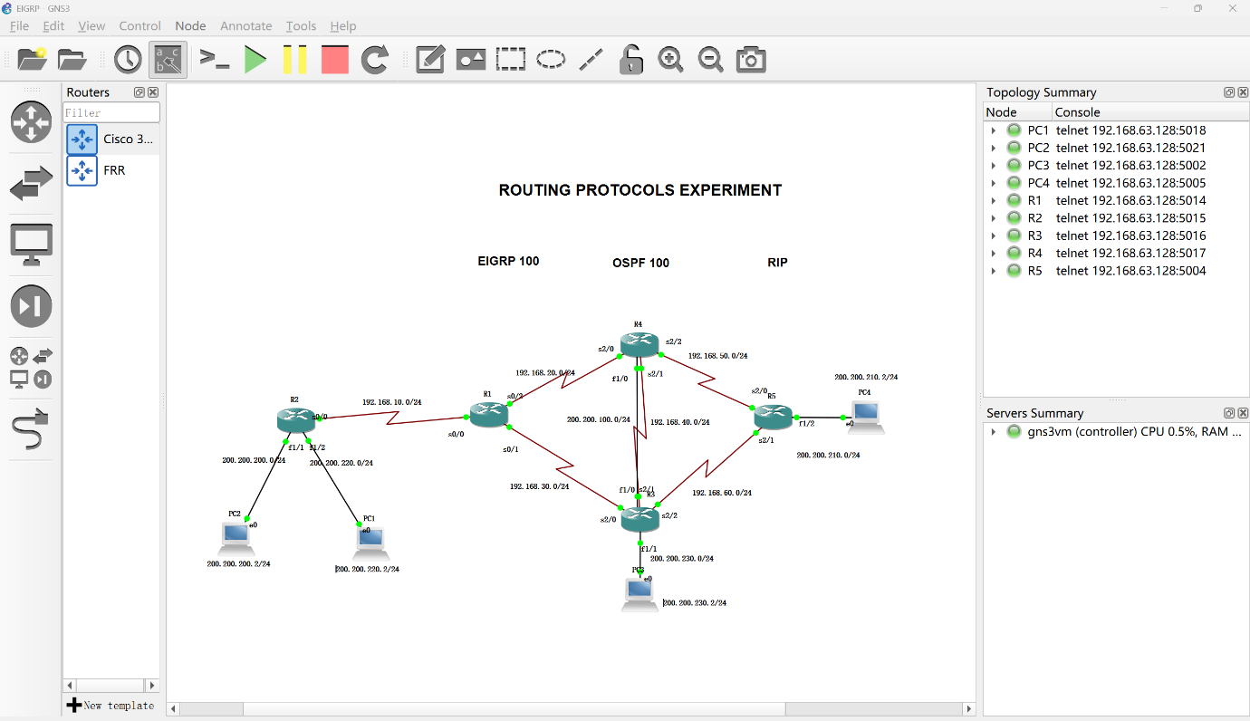
The experimental topology employs Cisco 3640 (C3640) series routers, which are simulated and run in GNS3. These are used as 5 core routing devices, R1-R5, to support the deployment and testing of dynamic routing protocols such as EIGRP, OSPF, and RIP.

The topology uses serial links to connect the routers, and the PCs are directly connected to the routers via links.

To test the convergence performance of the routing protocol under network failure scenarios, this topology has designed multiple redundant links and backup paths. Among them, multi-path redundancy is configured between R1 and R5, including two main paths: R1→R4→R5 and R1→R3→R5. At the same time, a multi-hop backup path R1→R4→R3→R5 is reserved. Between R4 and R5, a direct connection main link and a backup link via R3 are set up. In case of failure of the direct connection link between R4 and R5, the routing switch can be triggered to measure the protocol convergence time. In addition, R1 simultaneously establishes connections with R3 and R4, forming a dual-exit structure. When one of the links fails, the traffic can continue to be forwarded through the other link, thereby verifying the path switching efficiency and fault recovery capability of different routing protocols.

Following screenshot was taken from eNSP:

A case in point of Subnetting

Device | Interface | IP Address | Mask
R1 | S0/0 | 192.168.10.2 | /24

The complete addressing table is provided in Appendix.

A case in point is that R1 routing’s eigrp neighbour.

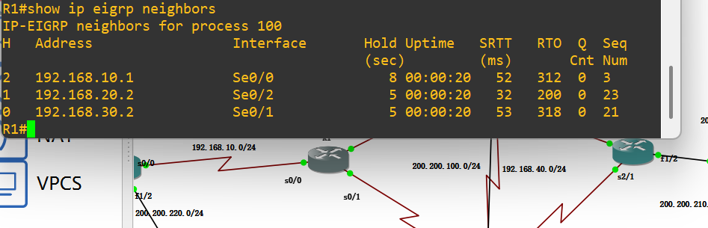
From the "show ip eigrp neighbors" command, the three neighbors (R2, R4, R3) of R1 have normal session states, and parameters such as Hold Time and SRTT are within reasonable ranges. This indicates that the neighbor relationship is stable and EIGRP has completed full network convergence.

4.4 Implementation and Experimental Procedure

Following completion of the design stage, the topology was implemented within GNS3 and replicated in Huawei eNSP. All virtual routers were instantiated and interconnected according to the planned structure. Interfaces were manually configured with IPv4 addresses, subnet masks, and activated using administrative commands.

Initial connectivity was verified through direct ping tests between adjacent devices to ensure correct Layer 3 communication before routing protocols were enabled.

Three routing protocols were then deployed separately under identical conditions.

For RIP testing, RIPv2 was configured to support classless routing, and automatic summarization was disabled where necessary. For OSPF, a single backbone area (Area 0) was adopted to reduce unnecessary complexity while maintaining realistic link-state operation. For EIGRP, a common autonomous system number was configured across all routers to establish neighbour adjacencies and exchange routing information. During the link failure test, the disconnection time for all links was 10 seconds.

After protocol deployment, verification commands were used to confirm successful operation. These included routing table inspection, neighbour relationship checks, and route advertisement confirmation.

Wireshark was integrated through the GNS3 packet capture function to allow real-time monitoring of protocol traffic. This enabled observation of hello packets, routing updates, neighbour establishment, and route recalculation during failure scenarios.

Several implementation challenges were encountered during setup, including packet capture integration issues and interface addressing inconsistencies. These were resolved through manual path configuration, software reinstallation, and repeated connectivity verification.

4.5 Testing Methods and Metrics

Latency was measured using ICMP echo requests, based on the round-trip response time between end devices. Packet loss rate was determined by conducting transmission tests and calculating the proportion of lost responses.

Convergence time was measured by intentionally disabling selected network links and recording the duration required for the network to restore stable end-to-end communication through an alternative route.

Path selection behaviour was analysed using traceroute outputs and routing table entries. Neighbour establishment and maintenance were verified through protocol-specific diagnostic commands.

In addition, Wireshark was used to capture and inspect routing protocol traffic, including hello packets, update messages, and route recalculation behaviour.

These metrics were selected because they provide a balanced and objective basis for comparing routing protocol responsiveness, stability, scalability, and forwarding performance.

4.6 CONCLUSION

This chapter presented the design and implementation of the experimental network environment used to evaluate RIP, OSPF, and EIGRP routing protocols. A consistent topology was developed and deployed in both GNS3 and Huawei eNSP to ensure fair and controlled comparison across all protocols.

The chapter also described the implementation process, including router configuration, protocol deployment, and packet capture integration. In addition, the selected testing metrics and experimental procedures were outlined, covering latency, packet loss, convergence time, path selection, and protocol behaviour analysis.

To improve the reliability of the study, standardised procedures, repeated testing, and controlled variables were applied throughout the experimentation process.

Overall, the completed environment provides a stable and repeatable platform for comparative routing analysis. The following chapter presents the experimental results, evaluates protocol performance, and discusses the findings in relation to the research objectives.

CHAPTER 5
EVALUATION

5.1 INTRODUCTION

This chapter presents the experimental results obtained by comparing the RIP, OSPF and EIGRP routing protocols. These results were obtained through experiments and analyses based on the performance indicators defined in Chapter 4, including latency, packet loss rate, convergence time, path selection behavior, and internal routing operations.
The purpose of this chapter is to determine the performance of each protocol under normal network conditions and in simulated scenarios of link failures. Subsequently, based on the research objectives and the literature reviewed in the preliminary stage of this study, the obtained results will be analyzed in depth.

5.2 Baseline Connectivity and Latency Results

GNS3:
EIGRP: PC1 and PC2 ping to PC4, respectively.
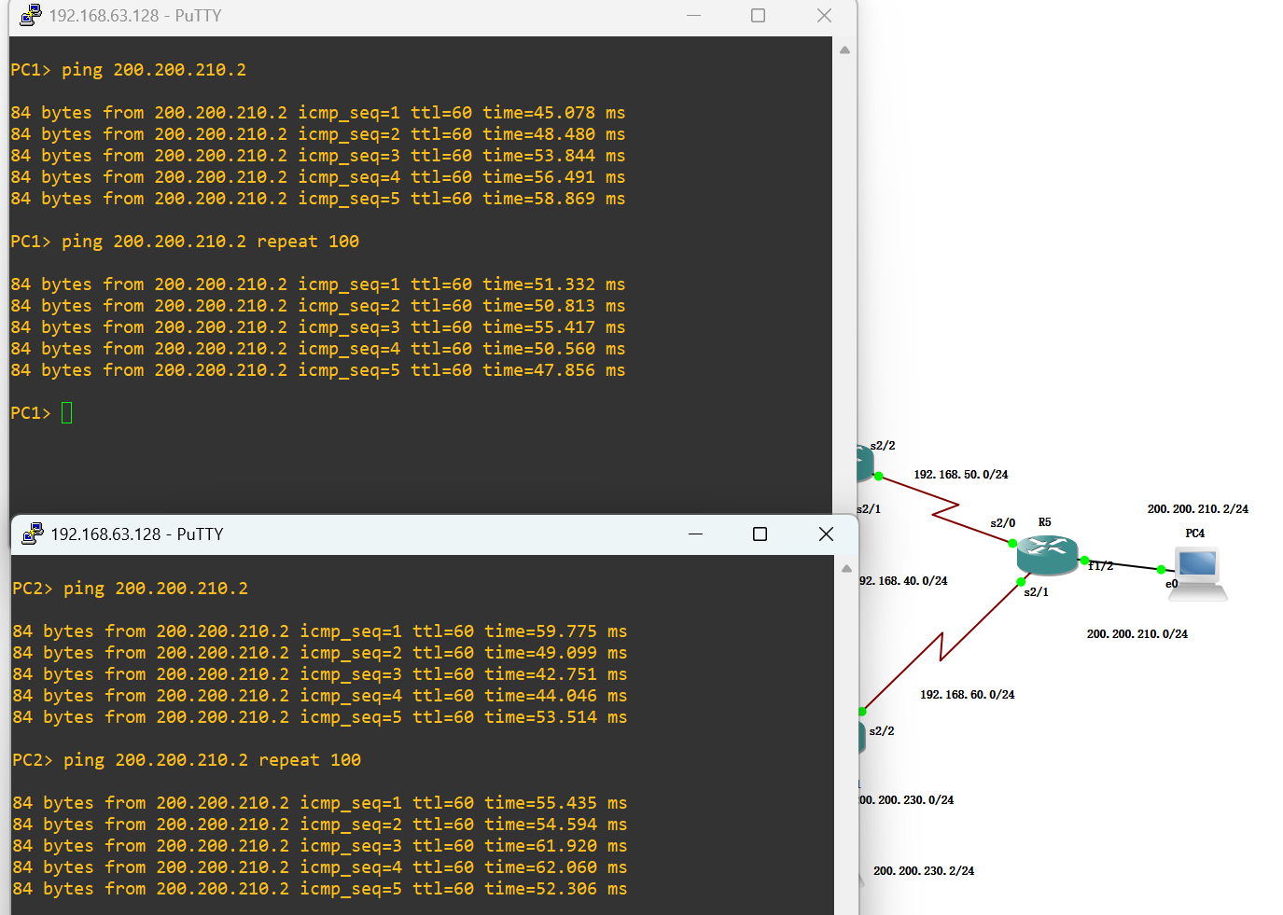
All interfaces are in an open state. ICMP scanning tests were conducted from PC1 and PC2 to PC4 (200.200.210.2) to measure the average delay and packet loss rate. The average round-trip delay recorded by PC1 was 51.87 milliseconds, with a packet loss rate of 0%, while the average delay of PC2 was 53.55 milliseconds, also without packet loss.
Both ends maintained a 100% data packet transmission success rate, which confirmed the stability of the end-to-end connection and consistent forwarding performance under normal operating conditions. The overall average delay of all test hosts was calculated as 52.71 milliseconds, with no packet loss, indicating that EIGRP can efficiently select paths and reliably transmit data.

OSPF: PC1 and PC2 ping to PC4, respectively.
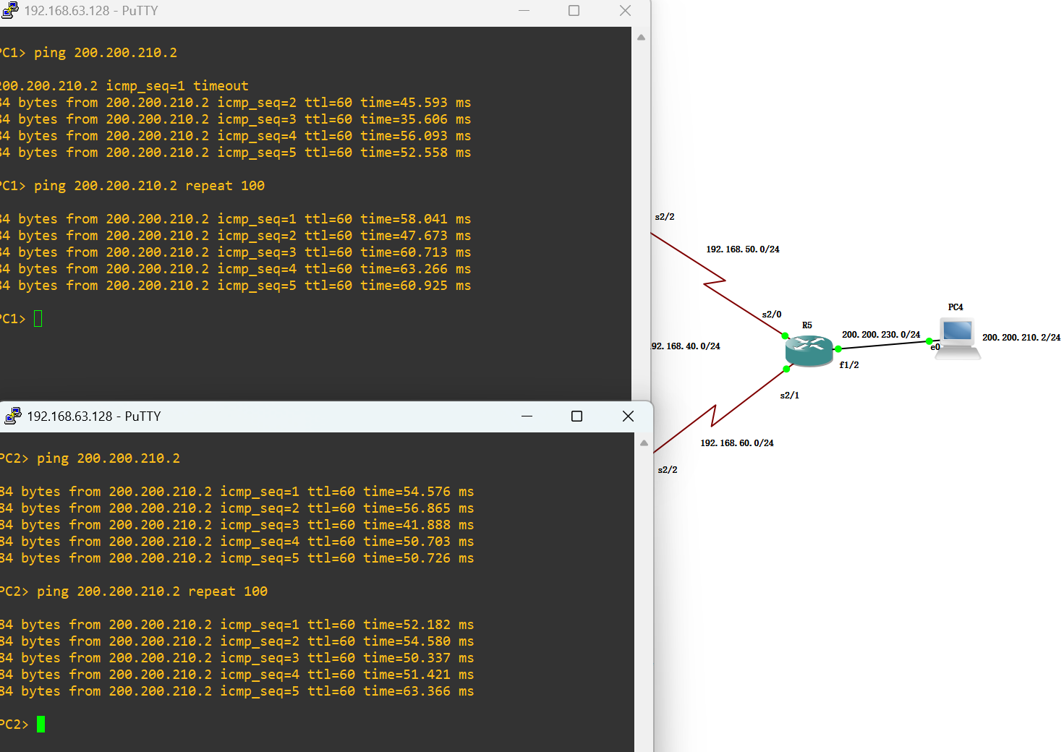

show ip ospf neighbor
show ip ospf database

RIP: PC1 and PC2 ping to PC4, respectively.
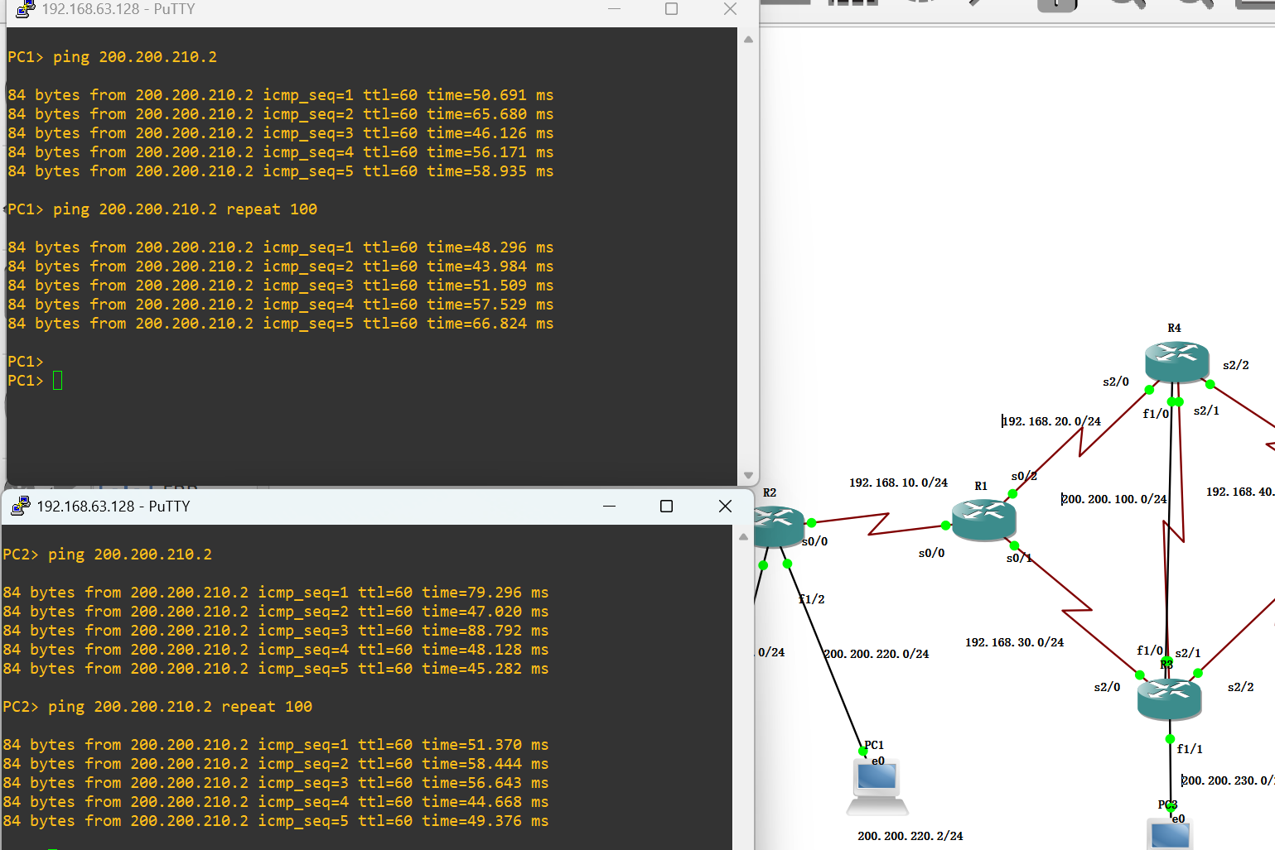

debug ip rip
show ip route rip

Protocol | Avg Latency (ms) | Packet Loss (%)
RIP | 55.74 | 0%
OSPF | 53.03 | 0%
EIGRP | 54.32 | 0%

eNSP:
EIGRP: PC1 and PC2 ping to PC4, respectively.

OSPF: PC1 and PC2 ping to PC4, respectively.

RIP: PC1 and PC2 ping to PC4, respectively.

Protocol | Avg Latency (ms) | Packet Loss (%)
RIP |  | %
OSPF |  | %
EIGRP |  | 0%

5.3 Path Selection Results

GNS3:
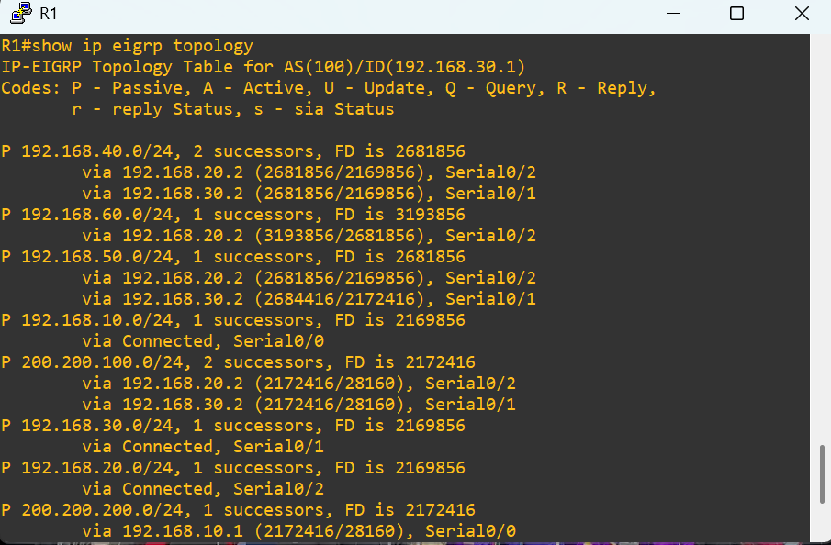
EIGRP

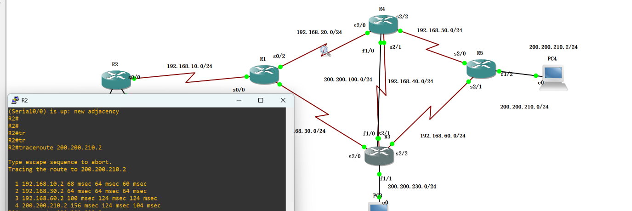
The traceroute test conducted when all interfaces were in an open state clearly demonstrated the network path selected by EIGRP under normal operating conditions.

The route from R2 to PC4 (200.200.210.2) passed through R1, R3 and R5, which confirmed that EIGRP chose the path through R3 as the preferred path based on its comprehensive indicators.

All traceroute attempts successfully reached the destination, proving that the network is fully connected in a normal state. The round-trip time at the destination was approximately 104-156ms, reflecting the normal delay level of the path and can be used as a reference value for subsequent fault switching tests. Subsequently, it can be compared with the results obtained in the link failure scenario to evaluate the convergence and fault transfer capabilities of this protocol.

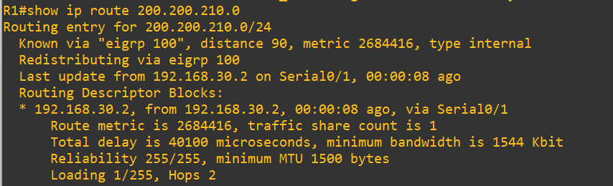
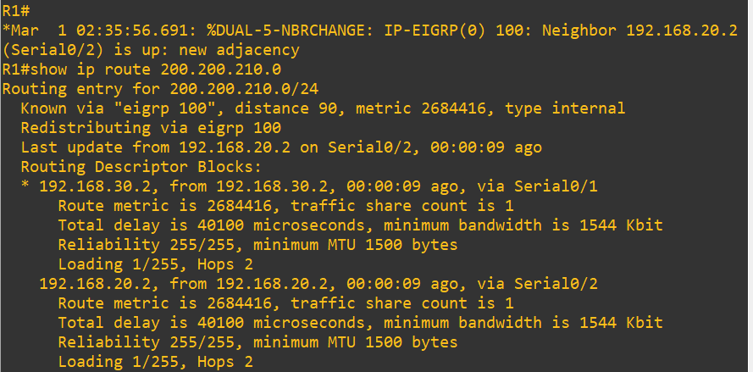
When the S0/2 port with and without the command “shutdown”

OSPF
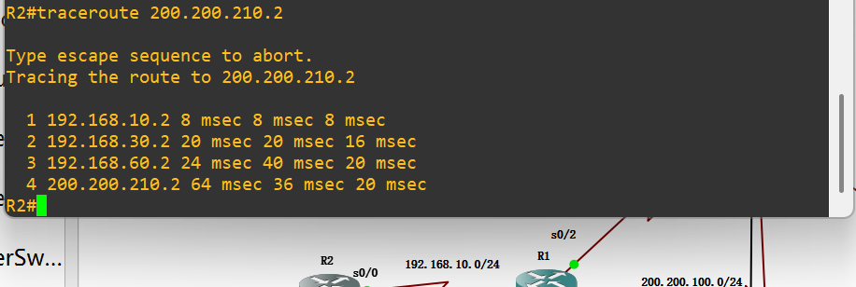
The traceroute test conducted when all interfaces were in an open state clearly demonstrated the network path selected by OSPF under normal operating conditions.

The route from R2 to PC4 (200.200.210.2) passes through R1, R3 and R5. It is confirmed that EIGRP has selected the route of R3 as the preferred route based on its comprehensive indicators.

All traceroute attempts were successfully completed to the destination, proving that the network is fully connected in a normal state. The round-trip time to the destination was approximately 20-64 milliseconds, reflecting the delay level of the path and can be used as a reference value for subsequent fault switching tests.

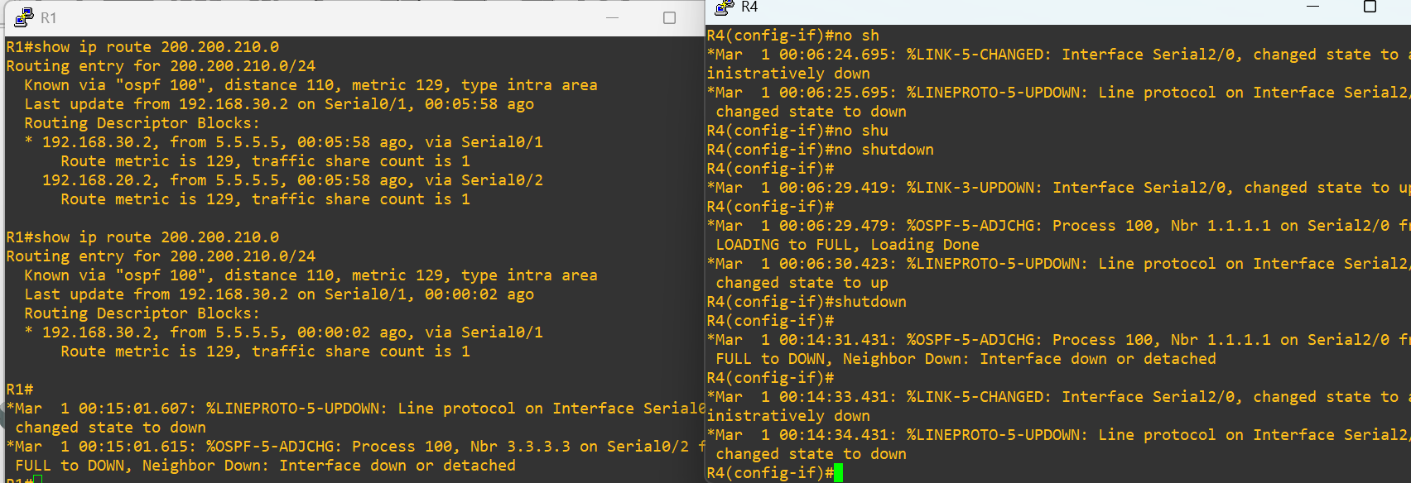
When the S2/0 port with and without the command “shutdown”

RIP
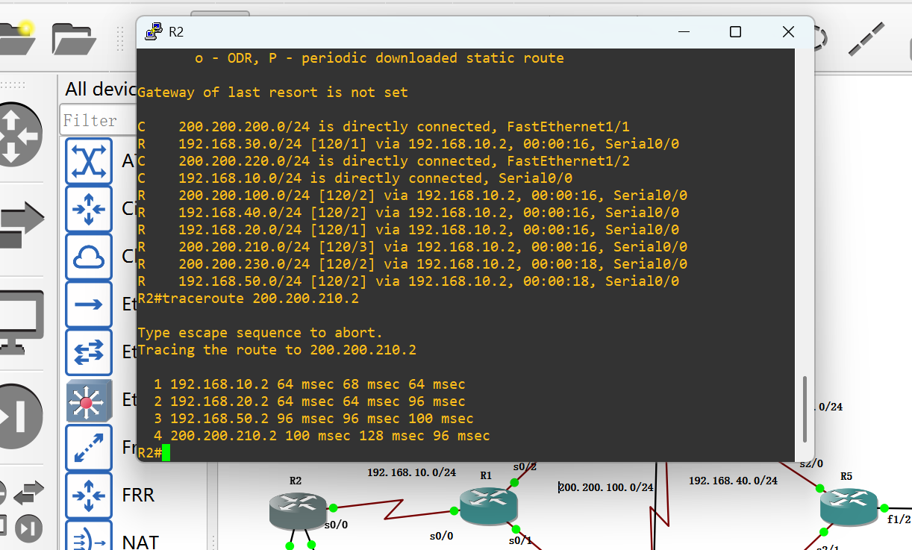
The traceroute test conducted when all interfaces were in the enabled state clearly demonstrated the network path selected by OSPF under normal operating conditions.

The path from R2 to PC4 (200.200.210.2) would pass through R1, R4, and R5. It has been confirmed that EIGRP chose the path of R4 as the preferred path based on its comprehensive indicators.

All routing traceroute attempts successfully reached the destination, indicating that the network was fully connected under normal conditions. The round-trip time to the destination was approximately 96 to 100 milliseconds, reflecting the delay level of the path and can be used as a reference value for subsequent fault switching tests.

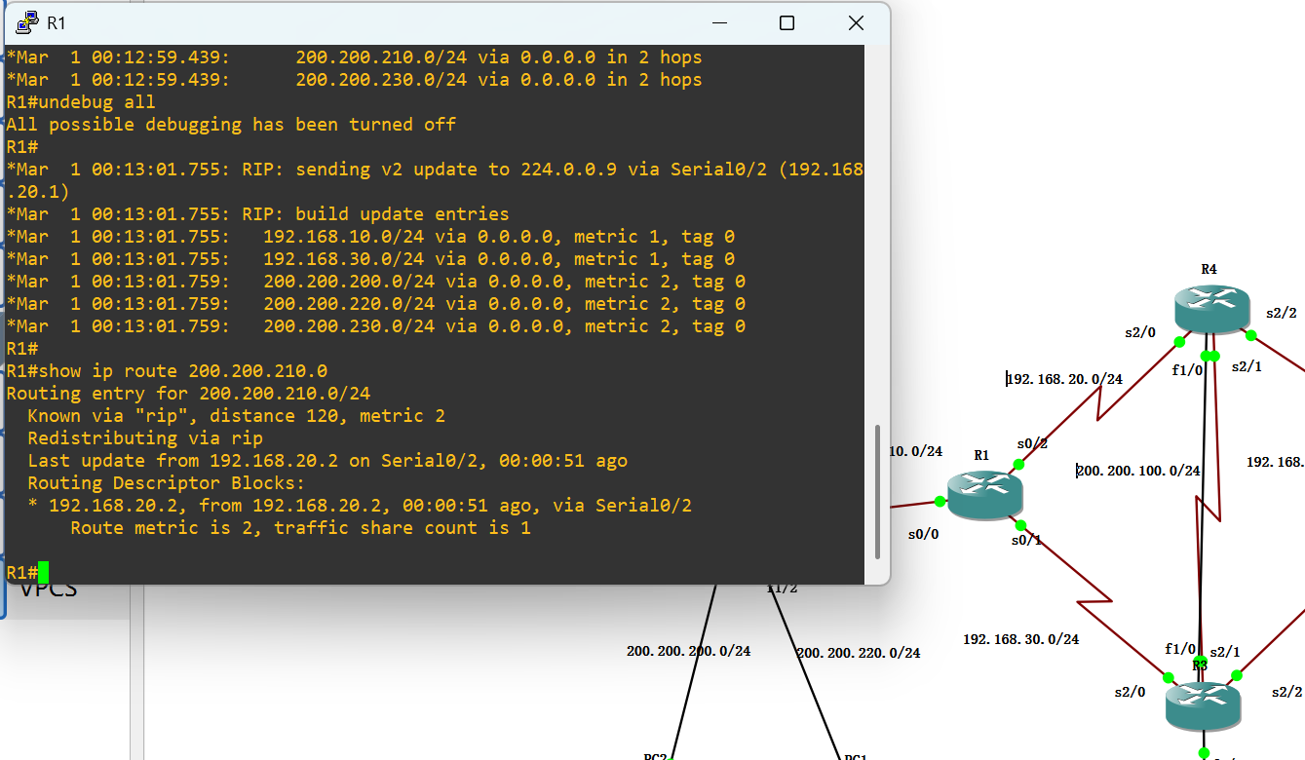

Different with the OSPF protocol and the EIGRP which support equivalent multipath routing, the RIP only installs a single path in the routing table. Even if multiple paths have the same hop count metric value, RIP will only retain the first learned routing entry and ignore subsequent routing updates. This "first-come, first-served" operation mechanism results in RIP being unable to achieve load balancing through redundant paths, which is one of the core limitations of this protocol.

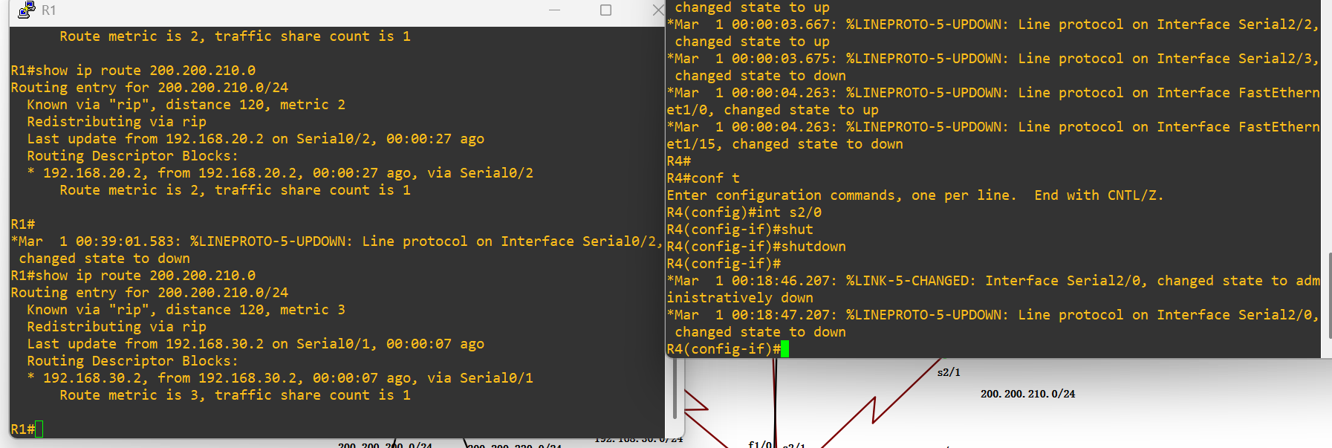
When the S0/2 port with and without the command “shutdown”

eNSP:

EIGRP
OSPF
RIP

5.4 Link Failure and Convergence Results
GNS3:

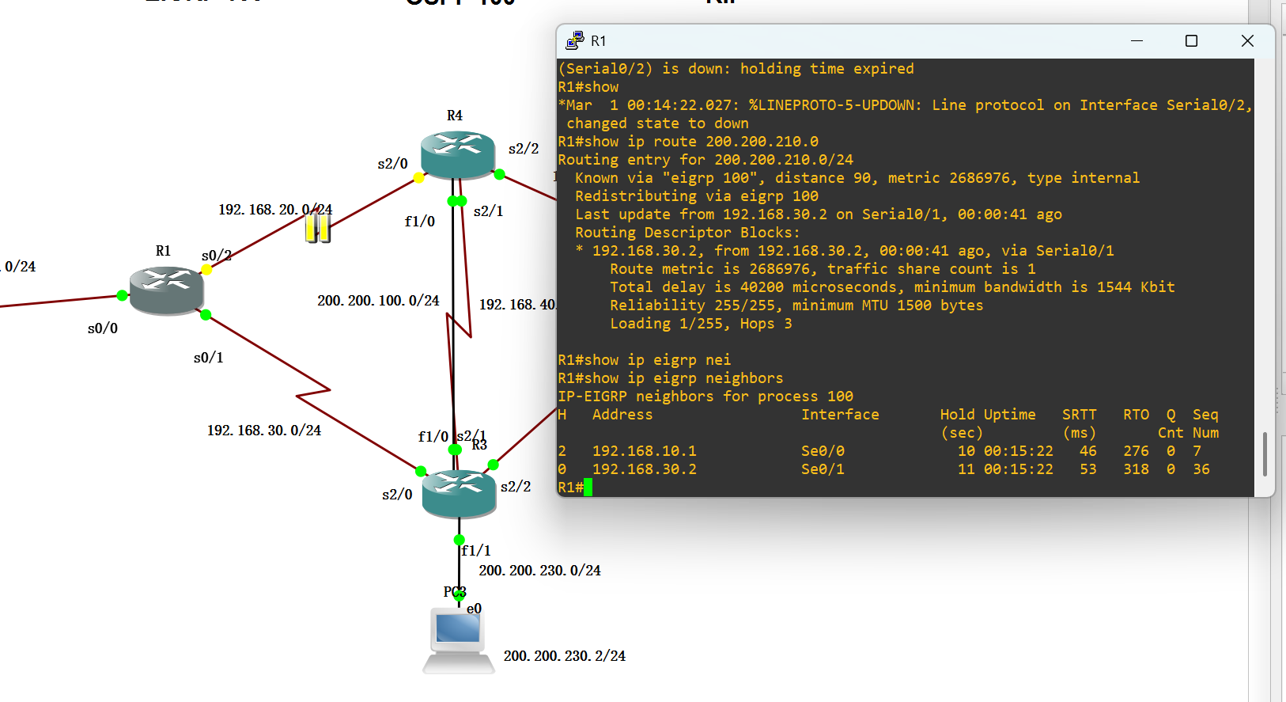
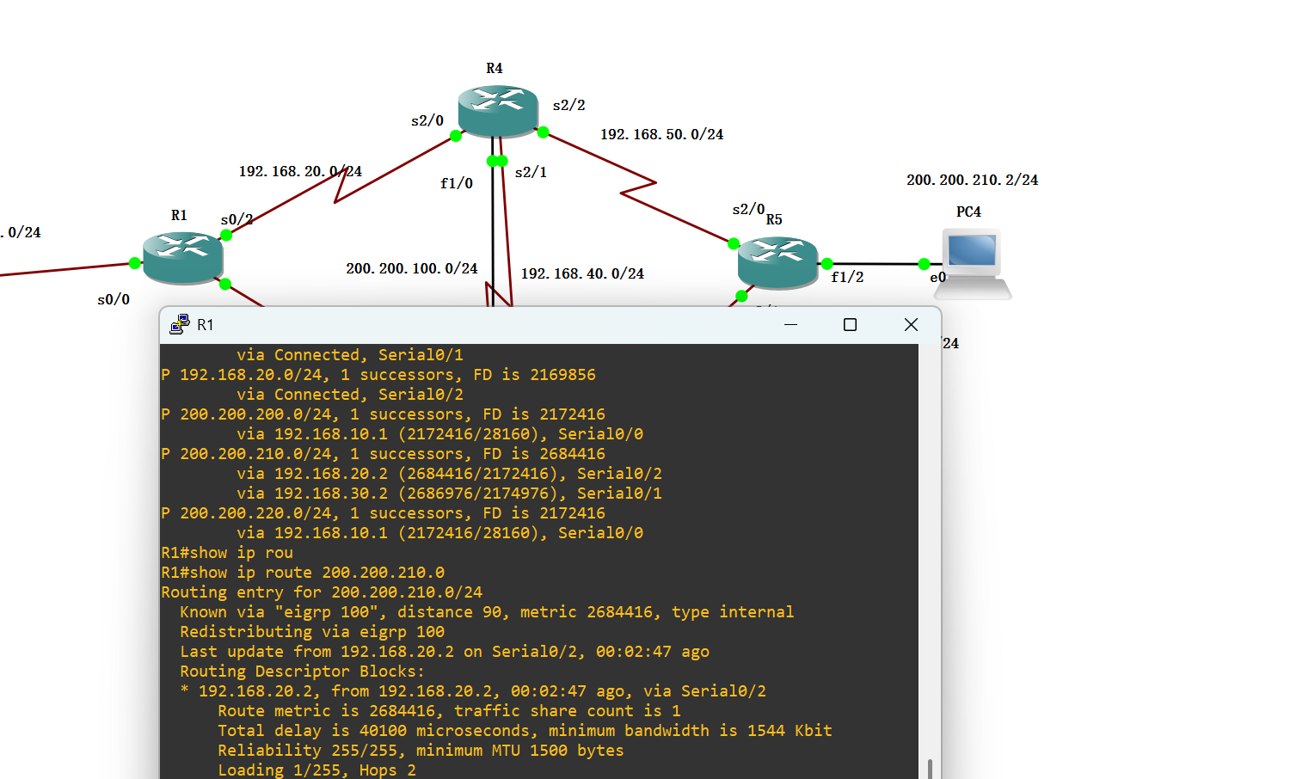
From the result of "show ip route 200.200.210.0/24", the current route next hop for this network segment (the network segment where PC4 is located) is 192.168.30.2 (R3), not the main path's 192.168.20.2 (R4), indicating that you have disabled the direct links between R1-R4, triggering a failover.
The metric value of the route has changed to 2686976, with a hop count of 3 (Hops 3), and the path is R1 → R3 → R5, which is exactly the backup path we designed previously.
At the same time, the topology table also shows that there is a feasible backup path (via R3) for 192.168.50.0/24 (the R4-R5 link), indicating that the feasible successor mechanism of EIGRP is working properly and can quickly switch in case of a main path failure.

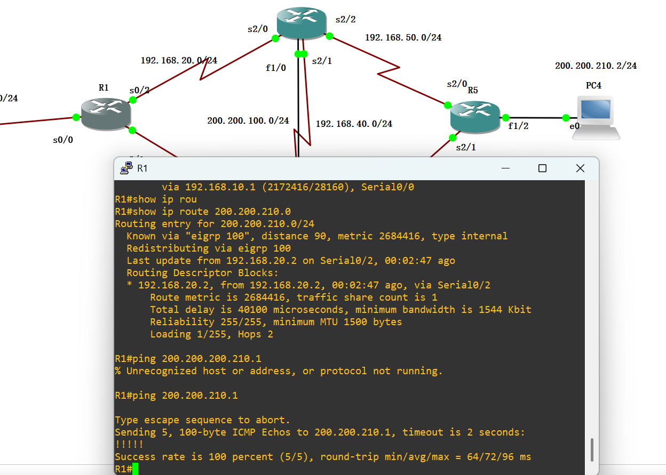
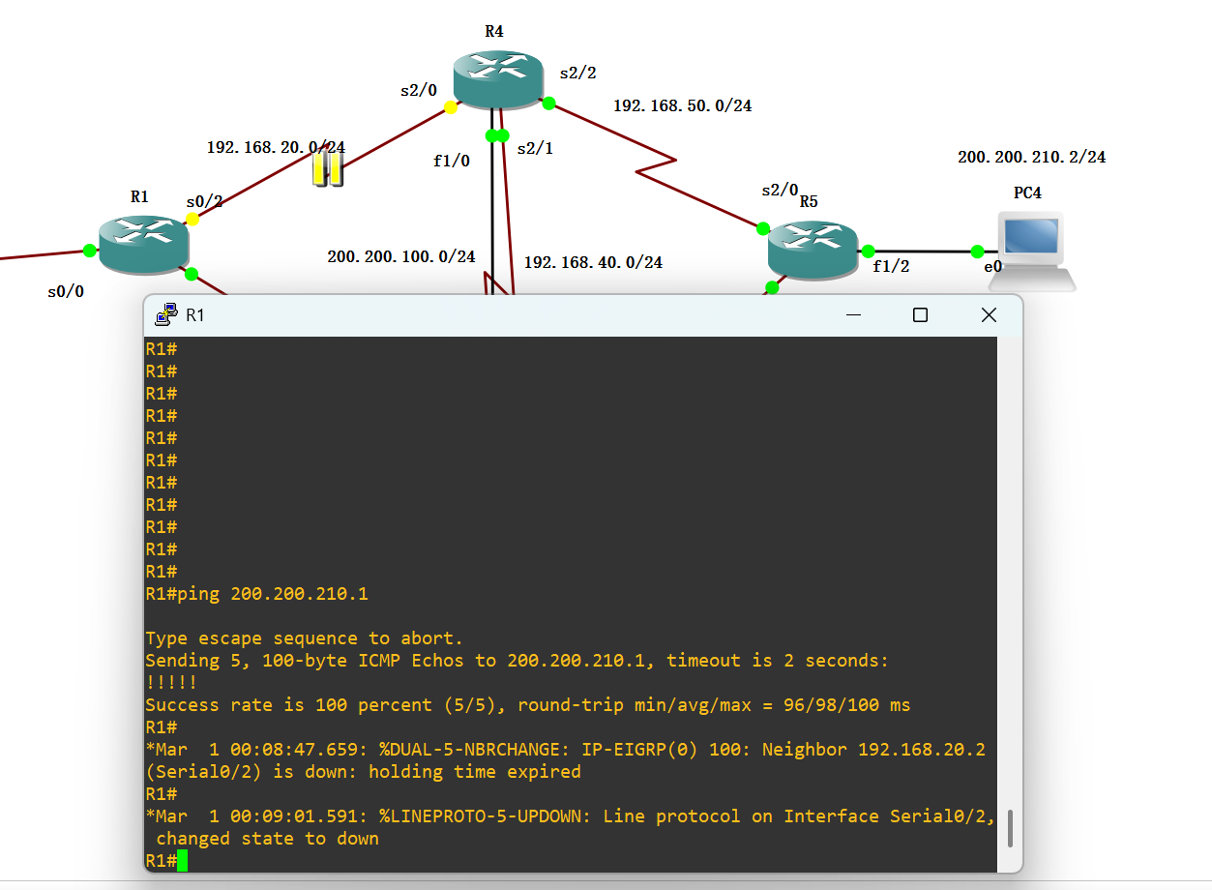

These two screenshots of EIG fully document the process of EIGRP failover and convergence testing. The primary link is R1 → R4 → R5 (R1's serial port 0/2 is directly connected to R4), and the backup link is R1 → R3 → R5. The testing method is to manually shut down the R1-R4 link and observe the route switching and connection recovery of EIGRP. This indicates that the convergence time of EIGRP is shorter than the delayed timeout interval (2 seconds), achieving fast and packet-free switching. Because the feasible successor mechanism of EIGRP is effective, the backup path is calculated and stored in advance, and there is no need to wait for the re-computation of the routes. Moreover, after the switch, the path length increases, and the round-trip delay rises from 72ms to 98ms, but remains stable, indicating that the backup path can effectively ensure the business connectivity.

The EIGRP protocol’s performance was evaluated under a controlled link failure scenario to assess its convergence speed and reliability. The test involved shutting down the serial link between R1 and R4, forcing the network to switch to the pre-configured backup path via R3.

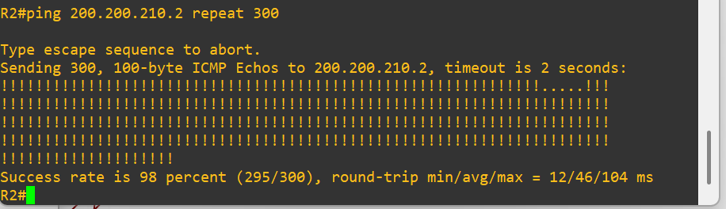
Shutting down the primary link between R2 and R1 and then restoring it. A continuous ICMP ping test with 300 packets was initiated from R2 to the destination 200.200.210.2 to record packet loss and recovery time.

The results show that EIGRP achieved a success rate of 98%, corresponding to a packet loss rate of only 2%. The brief interruption lasted approximately 2–3 seconds, confirming a fast recovery time. The average round-trip latency remained stable at 46 ms, with a maximum latency of 104 ms during the failover window.

OSPF
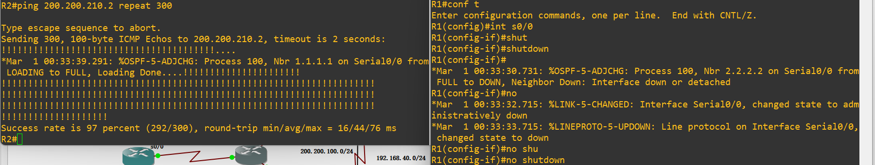

RIP
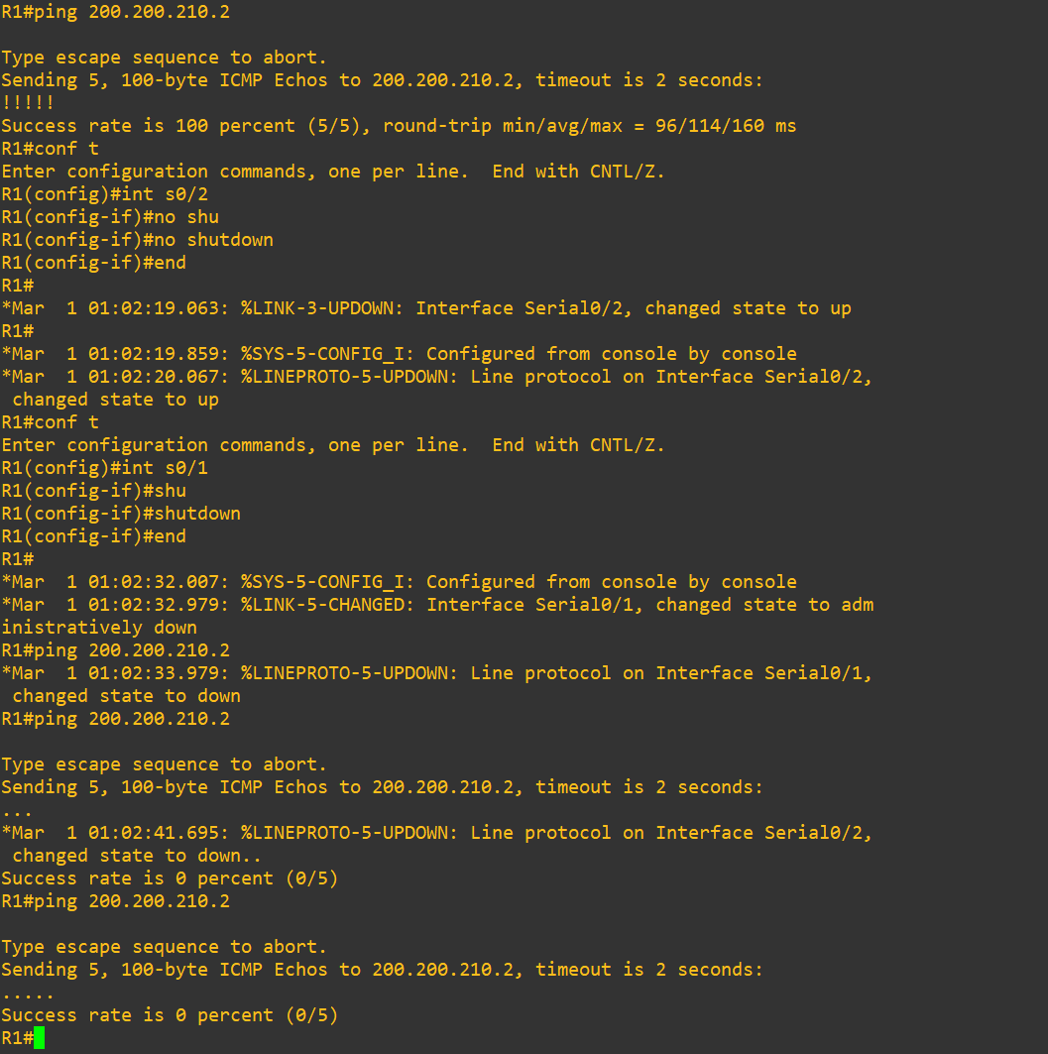
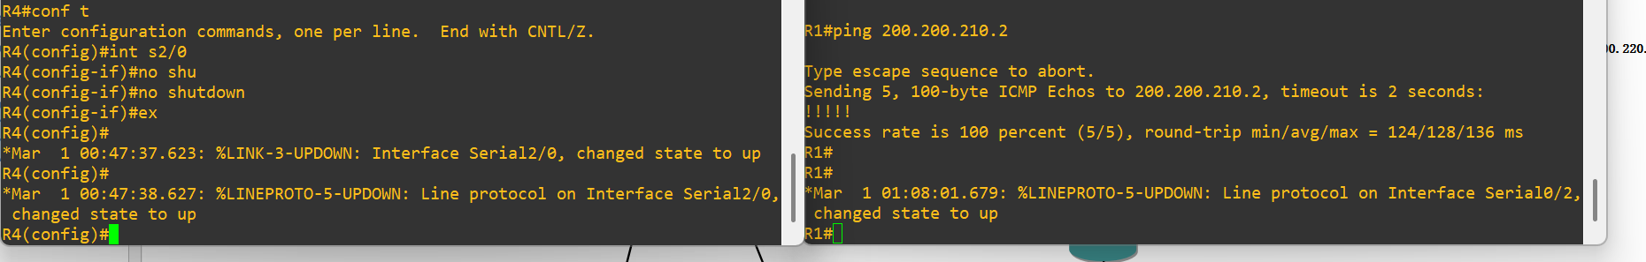
When the R1–R4 link was disabled, connectivity was maintained with no packet loss, indicating that RIP successfully redirected traffic through an alternative route.

However, when the R1–R3 link was disabled, communication to the destination network temporarily failed. This suggests that the R1–R3 path played a critical role as a backup route or that RIP required additional time to reconverge after topology change.

This behaviour highlights RIP’s dependency on limited path knowledge and slower timer-based convergence mechanisms compared with more advanced routing protocols.

5.5 Internal Protocol Behaviour

EIGRP feasible successor
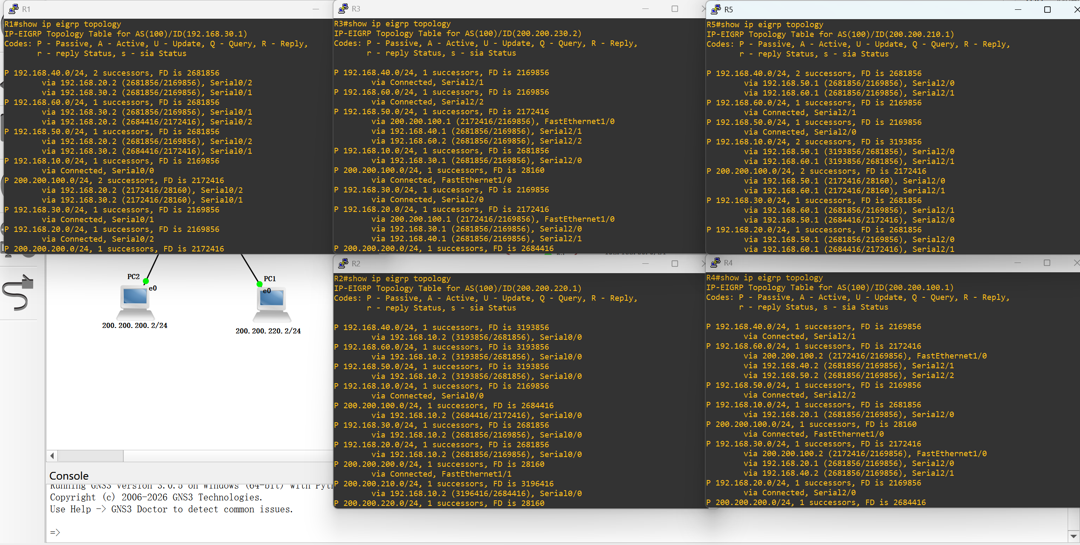
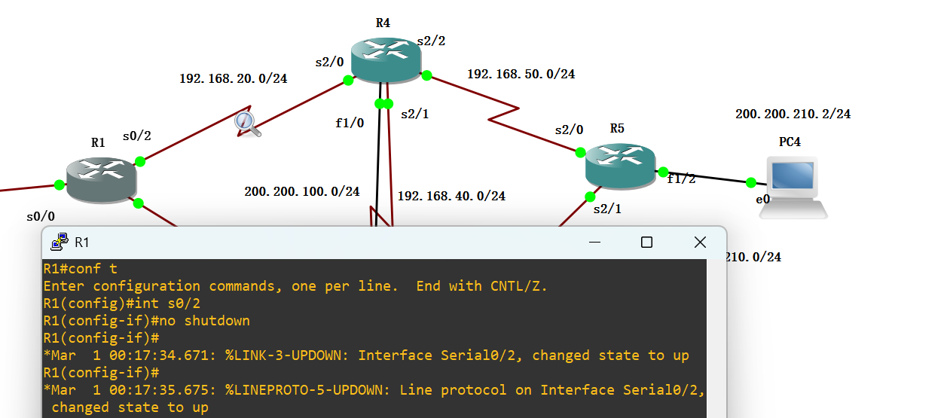

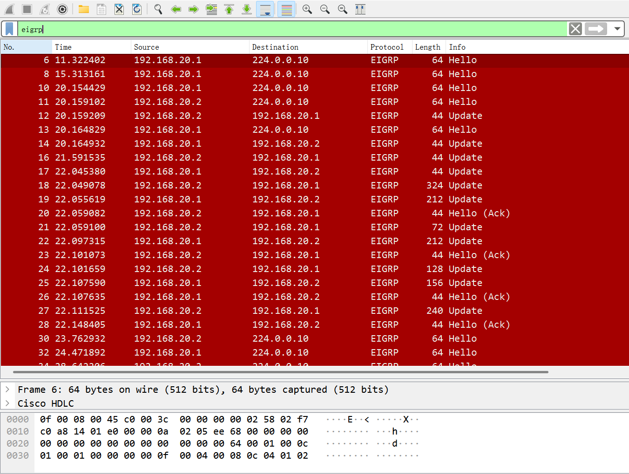

Prior to the failure, regular Hello packets were exchanged at 5-second intervals, maintaining a stable adjacency.

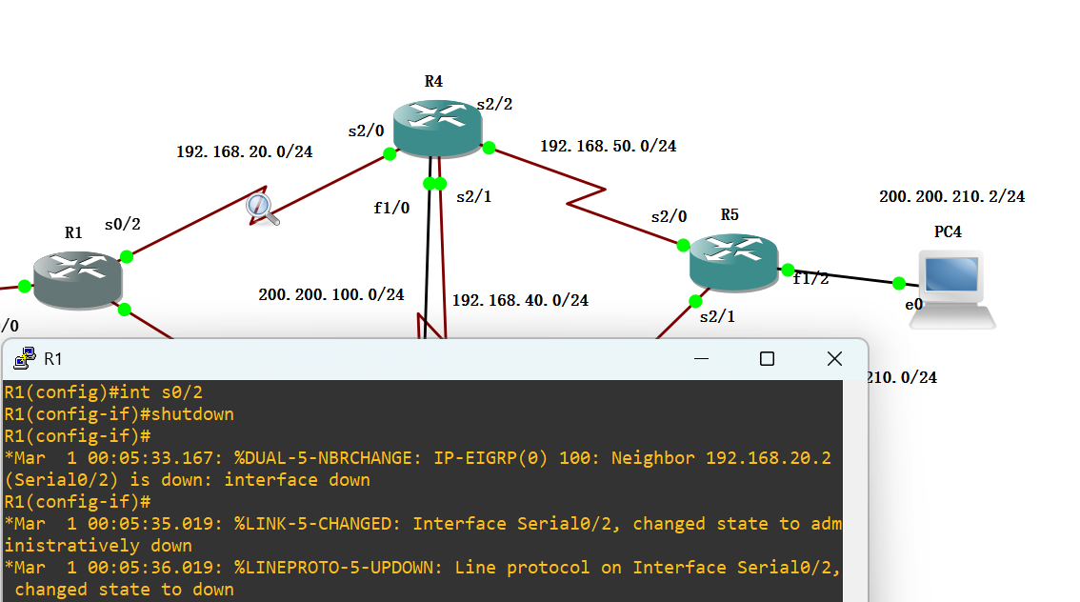
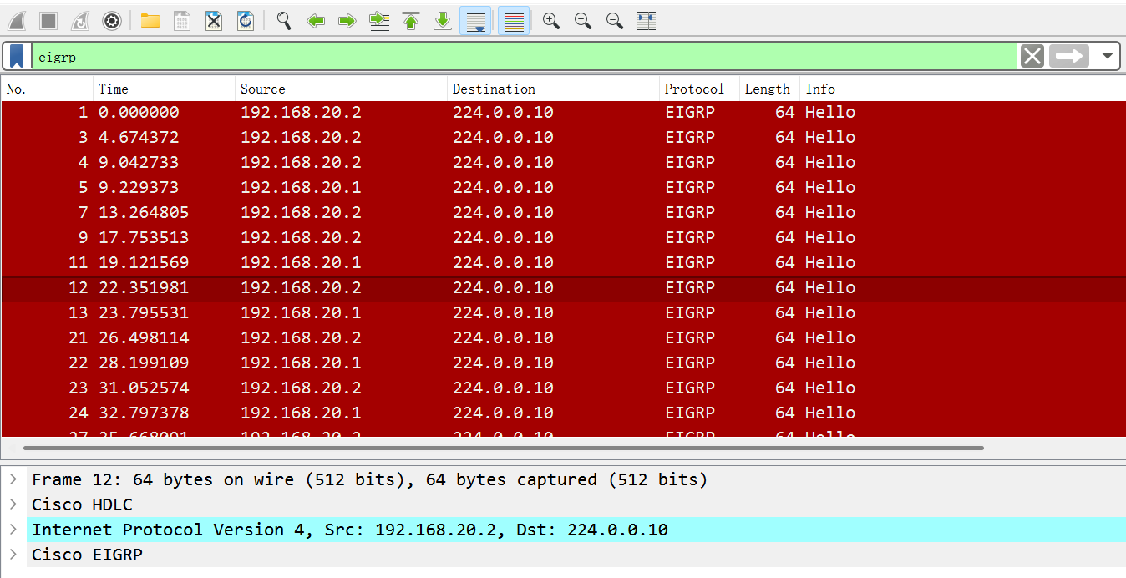
Upon the link failure, a burst of EIGRP Update packets was immediately triggered between the two routers, propagating the topology change.

OSPF LSA flood
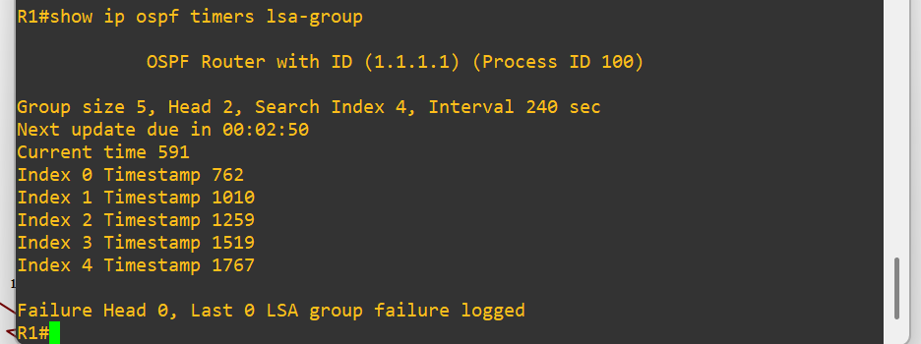
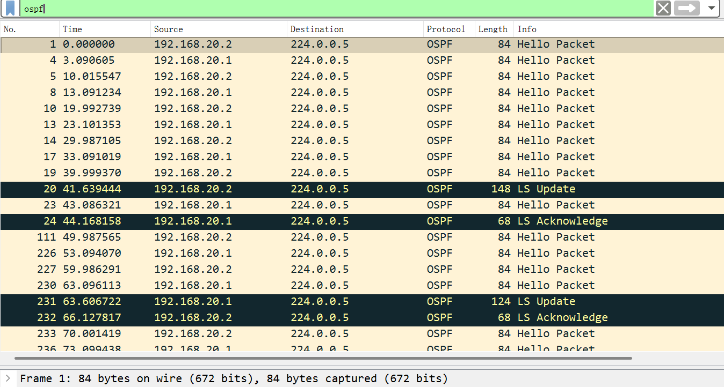
When the R1-R3 link failed, the affected router immediately sent an LS Update packet to the OSPF multicast address 224.0.0.5 to advertise the topology change. The neighboring router responded with an LS Acknowledge packet to confirm receipt.
After the link was restored, another LS Update was sent to update the network with the new topology, followed by a corresponding acknowledgment. This process confirms that OSPF relies on full topology synchronization and SPF recalculation, rather than precomputed backup paths. The total time from LSA transmission to ping recovery was approximately 7–8 seconds, which aligns with the previously measured recovery time from router logs.

RIP periodic updates slower
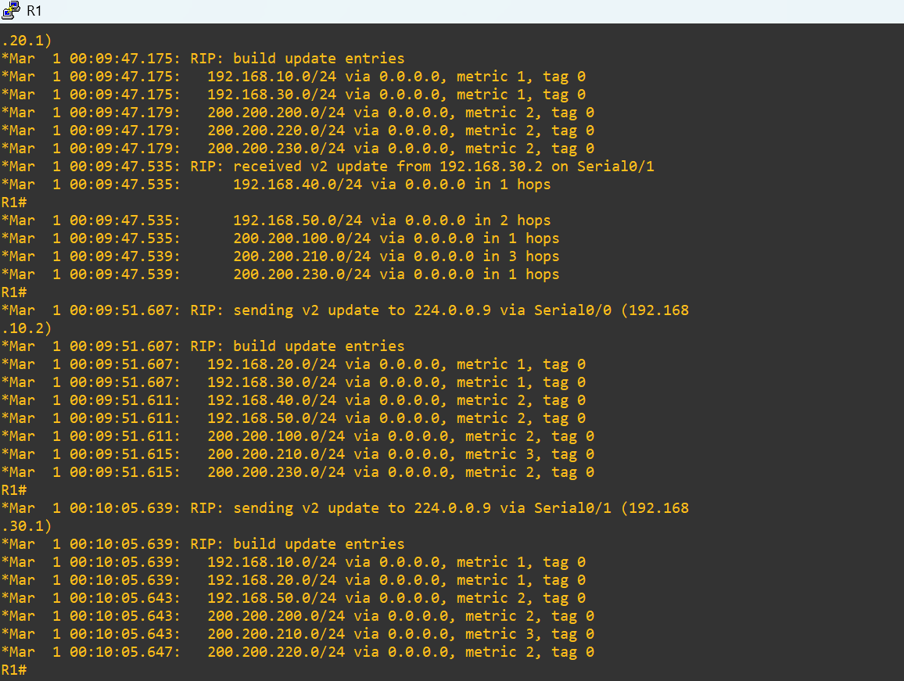

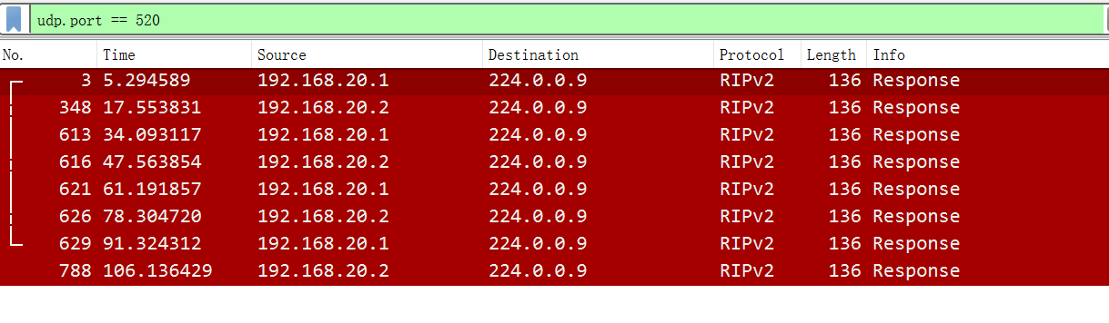
Wireshark captures from R1 showed that RIP version 2 exchanged routing information using UDP port 520 and multicast address 224.0.0.9. Update packets were observed at intervals of approximately 30 seconds, matching the default RIP timer behaviour.

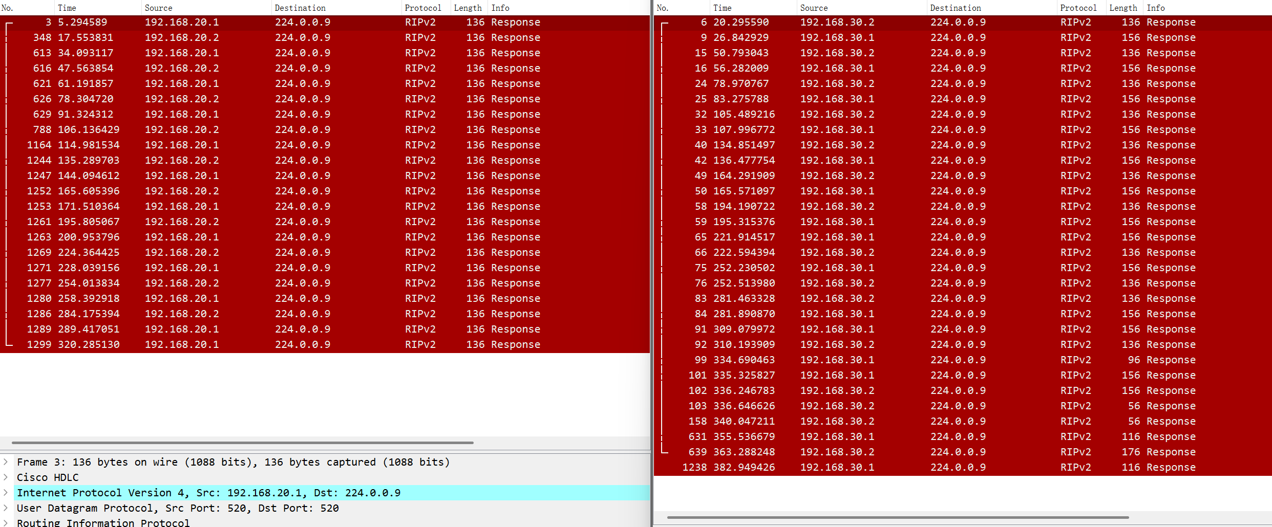
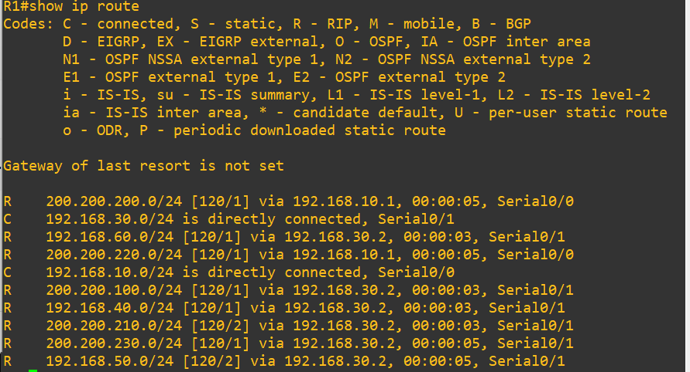
To evaluate fault tolerance, the primary link between R1 and R4 was manually disabled while traffic from R2 to the destination network (200.200.210.0/24) remained active.

Packet capture was simultaneously conducted on the failed interface and the alternative R1–R3 link. Wireshark results showed a noticeable increase in RIP update traffic on the backup path following the failure event. This indicates that RIP routers propagated topology changes and recalculated routes using triggered updates.

eNSP:

5.6 CONCLUSION

This chapter demonstrated that although all three routing protocols successfully supported end-to-end communication, significant differences were identified in efficiency and fault tolerance.

RIP was functional but slower to react to topology changes. OSPF achieved balanced enterprise-grade performance, while EIGRP produced the best overall results in convergence and route optimisation.

CHAPTER 6

CONCLUSIONS AND RECOMMENDATIONS

CHAPTER 7

REFLECTION
Looking back on this nearly one-year experimental project, in this section, I will summarize the experiences and skills I have gained by combining the practical operation skills of my major with project management aspects.
From a professional perspective, the simulation software used in this experiment is not just the Cisco Packet Tracer used in the course learning. This means it is necessary to learn the usage methods of new test simulation software, such as setting up the experimental environment and configuring commands. Although the underlying topology logic is the same. But the first problem to be solved is to determine the legality of downloading the test software, that is, whether the official version can be obtained from the official software and whether the functions in the resource can meet the expectations of the tester. Secondly, the command languages of different software are different. I not only need to clearly understand the configuration commands of different routing devices, but also need to know how to select the correct physical device before starting the configuration, such as in GNS3, how to select the correct interface model for router devices and switch devices to achieve routing functions, and which port should be selected as the correct routing port when connecting the devices. At the same time, during the experiment, troubleshooting situations occurred frequently. The most memorable one was the scenario when installing WinPcap_4_1_3. The Windows system indicated that a higher version of this type of tool had already been installed on this machine and gave the complete name, but the system did not find the tool (the software name given by the system was WinPcap_5_2_7). Since installing WinPcap is a necessary step for eNSP testing, I had to solve this problem. Through consulting relevant professionals and referring to the answers on the official website of Huawei eNSP, I found that the Npcap installed in the system conflicted with the WinPcap to be installed. Therefore, only by uninstalling Npcap could WinPcap be installed. This step took nearly a week to complete, because due to different systems and devices, there were many problems encountered by the public, and I needed to extract, match, and analyze the solutions suitable for me step by step.
Through this experiment, objectively analyzing the extracurricular gains is a rehearsal for future employment. Because in actual work, engineers will face different system or software devices. Early contact with devices closer to reality can help me adapt to learning and operation in various working environments in advance and learn more solidly. Because I can get timely help from my supervisor.
The successful completion of the project greatly exercised my self-discipline ability. Since this is an independent project completed by myself, with a longer coverage, in addition to the specific experimental direction and content, in the initial design stage, it is also necessary to divide the overall time and assign weights, that is, to formulate a planning table. As an undergraduate, how to manage one's free learning and creative time requires in-depth thinking. To find a balance between life and study and complete the specified tasks according to the set plan steps. At the same time, during this period, regular communication with the supervisor or the guiding teacher can also help students better learn how to report work progress to department managers or supervisors, so as to better carry out work in the future.
At the same time, my supervisor also taught me a lot. This not only includes his guidance on my experimental operation and thesis writing. During the guidance process, his patience and responsibility also made me realize that when someone becomes a wise person in a certain field, they will also be patient and tolerant towards new students. In the future work, when I become a senior member in the department, I will also be like him and be patient and tolerant towards new colleagues joining the company.

CHAPTER 8

REFERENCE

- Lydia Parziale, David T. Britt, Chuck Davis “TCP/IP Tutorial and Technical Overview”, ibm.com/redbooks, December 2006.

- I. Fiţigău and G. Toderean, “Network performance evaluation for RIP, OSPF and EIGRP routing protocols,” IEEE Xplore, Jun. 01, 2013. https://ieeexplore.ieee.org/document/6636217 (accessed Nov. 01, 2020).

- Andrew S. Tanenbaum, “Computer Networks 4Th Ed.”, Prentice Hall, 2003.

- https://www.facebook.com/momena.khalil, “What Are Computer Networks? Why Are Computer Networks Necessary? | Techironed,” Techironed, Dec. 12, 2023. https://techironed.com/what-are-computer-networks-why-are-computer-networks-necessary/

- “Routing Protocols Types: Static, Dynamic, IP, CISCO,” www.guru99.com. https://www.guru99.com/routing-protocol-types.html

- Q. Liu and Q. Liu, “A Study on Topology in Computer Network,” IEEE Xplore, Oct. 01, 2014. https://ieeexplore.ieee.org/document/7003481?arnumber=7003481
- Nuur Wachid Abdul Majid and S. Fuada, “RIP VS. OSPF ROUTING PROTOCOLS: WHICH ONE IS THE BEST FOR A REAL-TIME COMPUTER NETWORK?,” Jurnal SIMETRIS, vol. 11, No.1 P-ISSN 2252–4983, pp. 249–256, Apr. 2020. http://download.garuda.kemdikbud.go.id/article.php?article=1589220&val=5218&title=RIP%20VS%20OSPF%20ROUTING%20PROTOCOLS%20WHICH%20ONE%20IS%20THE%20BEST%20FOR%20A%20REAL-TIME%20COMPUTER%20NETWORK

- GeeksforGeeks, “Routing Information Protocol (RIP),” GeeksforGeeks, May 17, 2018. https://www.geeksforgeeks.org/computer-networks/routing-information-protocol-rip/
‌
- GeeksforGeeks, “Open Shortest Path First (OSPF) Protocol Fundamentals,” GeeksforGeeks, Apr. 20, 2018. https://www.geeksforgeeks.org/computer-networks/open-shortest-path-first-ospf-protocol-fundamentals/

- GeeksforGeeks, “EIGRP fundamentals,” GeeksforGeeks, Apr. 19, 2018. https://www.geeksforgeeks.org/computer-networks/eigrp-fundamentals

- GeeksforGeeks, “Difference between Star topology and Bus topology,” GeeksforGeeks, May 04, 2020. https://www.geeksforgeeks.org/computer-networks/difference-between-star-topology-and-bus-topology/

- GeeksforGeeks, “Difference between RIP and EIGRP,” GeeksforGeeks, Jun. 05, 2020. https://www.geeksforgeeks.org/computer-networks/difference-between-rip-and-eigrp/

- “RIP V/s OSPF | Differences between RIP and OSPF,” ComputerNetworkingNotes. https://www.computernetworkingnotes.com/ccna-study-guide/rip-v-s-ospf-differences-between-rip-and-ospf.html

- getitdoneex, “The Research Onion Explained: Layers, Methodology, and Application - Academic Writing Solutions,” Academic Writing Solutions, Apr. 16, 2025. https://getitdoneex.com/the-research-onion-explained-layers-methodology-and-application/

- GeeksforGeeks, “What is Latency?,” GeeksforGeeks, Sep. 2021. https://www.geeksforgeeks.org/computer-networks/what-is-latency/

- “Network throughput,” Wikipedia, Jun. 23, 2022. https://en.wikipedia.org/wiki/Network_throughput

- Wikipedia Contributors, “Convergence (routing),” Wikipedia, May 14, 2018. https://en.wikipedia.org/wiki/Convergence_(routing)

- “Packet loss,” Wikipedia, Jan. 28, 2020. https://en.wikipedia.org/wiki/Packet_loss

‌
‌

CHAPTER 9

BIBLIOGRAPHY

GANTT CHART

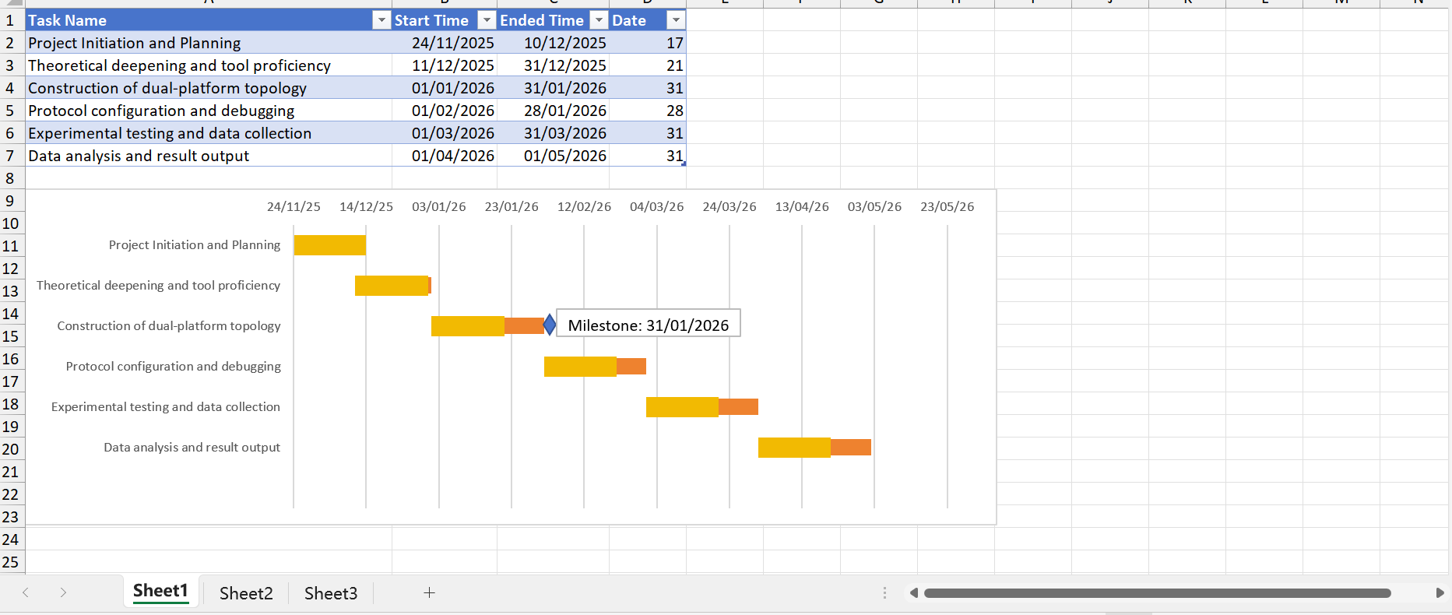

APPENDICES

Subnetting of Devices

R1 | S0/0 |  | 192.168.10.2 | 255.255.255.0
R1 | S0/1 |  | 192.168.30.1 | 255.255.255.0
R1 | S0/2 |  | 192.168.20.1 | 255.255.255.0
R2 | S0/0 |  | 192.168.10.1 | 255.255.255.0
R2 | F1/1 |  | 200.200.200.1 | 255.255.255.0
R2 | F1/2 |  | 200.200.220.1 | 255.255.255.0
R3 | S2/0 |  | 192.168.30.2 | 255.255.255.0
R3 | S2/1 |  | 192.168.40.2 | 255.255.255.0
R3 | S2/2 |  | 192.168.60.1 | 255.255.255.0
R3 | F1/0 |  | 200.200.100.2 | 255.255.255.0
R3 | F1/1 |  | 200.200.230.1 | 255.255.255.0
R4 | S2/0 |  | 192.168.20.2 | 255.255.255.0
R4 | S2/1 |  | 192.168.40.1 | 255.255.255.0
R4 | S2/2 |  | 192.168.50.1 | 255.255.255.0
R4 | F1/0 |  | 200.200.100.1 | 255.255.255.0
R5 | S2/0 |  | 192.168.50.2 | 255.255.255.0
R5 | S2/1 |  | 192.168.60.2 | 255.255.255.0
R5 | F1/2 |  | 200.200.210.1 | 255.255.255.0
PC1 | E0/0 |  | 200.200.220.2 | 255.255.255.0
PC2 | E0/0 |  | 200.200.200.2 | 255.255.255.0
PC3 | E0/0 |  | 200.200.230.2 | 255.255.255.0
PC4 | E0/0 |  | 200.200.210.2 | 255.255.255.0

