

Programme Name: Master of Business Administration
Module Code: LCMB7024
Module Title: Marketing Management
Title: Developing a New High-Performance Autonomous Electric Brand: Mercedes-EQX Autonomous
Lecturer Name: Dian Mayasari
Student Name: AYSHA SULTANA
Student ID: 2512232
Word Count: 3000
Submission Date:

Table of Contents
1. Introduction 1
2. Element 1: Segmentation, Targeting, Differentiation, and Positioning (STDP) Analysis for Mercedes-EQX Autonomous 1
2.1 Segmentation 1
2.2 Targeting 3
2.3 Differentiation 4
2.4 Positioning 5
3. Element 2: Marketing Mix for Mercedes-EQX Autonomous (4Ps) 5
3.1 Product 6
3.2 Price 6
3.3 Place 7
3.4 Promotion 8
4. Element 3: Marketing Strategy Pitch 9
5. Element 4: Reflection 10
References 12

Developing a New High-Performance Autonomous Electric Brand: Mercedes-EQX Autonomous

1. Introduction
The purpose of this portfolio is to develop a comprehensive marketing strategy for Mercedes-Benz’s new electric performance line, Mercedes-EQX Autonomous. This sub-brand will blend luxury, sustainability, and cutting-edge autonomous technology, positioning itself as the ultimate solution for consumers seeking high-performance electric vehicles with seamless self-driving capabilities. The strategy will focus on the brand’s Segmentation, Targeting, Differentiation, and Positioning (STDP), alongside an in-depth marketing mix analysis. By leveraging Mercedes-Benz's heritage of innovation and excellence, Mercedes-EQX Autonomous will redefine the future of electric mobility, offering an unparalleled driving experience in both urban and high-performance environments.

2. Element 1: Segmentation, Targeting, Differentiation, and Positioning (STDP) Analysis for Mercedes-EQX Autonomous
Mercedes-Benz, a global leader in luxury automotive manufacturing, has built its reputation on offering high-quality vehicles that blend performance, safety, and technological innovation. As the automotive industry shifts towards electrification and autonomous driving, Mercedes-Benz aims to introduce Mercedes-EQX Autonomous, a new, standalone brand dedicated to high-performance electric vehicles (EVs) with advanced autonomous driving systems. This brand concept seeks to meet the growing demand for sustainable, intelligent, and performance-driven cars, appealing to affluent consumers who prioritise luxury, technology, and innovation. This analysis of Mercedes-EQX Autonomous will focus on segmentation, targeting, differentiation, and positioning strategies, backed by insights from the evolving market trends and consumer behaviour.

2.1 Segmentation
Segmentation is crucial for identifying specific consumer groups whose needs and preferences align with the new brand offering. For Mercedes-EQX Autonomous, the segmentation will focus on demographics, psychographics, and behavioural traits, highlighting groups that value luxury, performance, and cutting-edge technology.

Demographic Segmentation:
The primary demographic target for Mercedes-EQX Autonomous consists of high-net-worth individuals (HNWIs) and upper-middle-class professionals aged 30-55, who typically have significant disposable income. According to McKinsey’s report on global luxury markets, HNWIs are among the fastest-growing consumer segments, particularly in urban metropolitan areas (McKinsey, 2020). These individuals often seek products that reflect their status, align with their values, and provide an elevated lifestyle experience. This makes them ideal for high-end electric vehicles, which offer both prestige and sustainability.

Psychographic Segmentation:
The psychographic segmentation will focus on early adopters of new technologies with a strong preference for eco-conscious luxury. Studies have shown that a growing number of affluent consumers are prioritising sustainability in their purchasing decisions, especially among younger luxury buyers. A 2020 Deloitte report on automotive trends reveals that consumers increasingly view eco-friendly features as a key consideration, especially among those aged 25-45, who are more likely to invest in electric mobility (Deloitte, 2020). For these consumers, the combination of luxury and sustainability offered by Mercedes-EQX Autonomous becomes a highly appealing proposition.

Behavioural Segmentation:
Behavioural segmentation will target those who value innovation, convenience, and performance. Mercedes-EQX Autonomous will appeal to individuals seeking advanced solutions that enhance their driving experience, such as autonomous driving systems, seamless connectivity, and driver-assistance technologies. Research by Statista (2022) shows that 60% of consumers are willing to pay a premium for vehicles with advanced driver-assistance systems (ADAS), reflecting a growing trend in the automotive market towards innovative, safe, and autonomous driving solutions.

2.2 Targeting
Given the high-performance nature and advanced technology embedded in Mercedes-EQX Autonomous, the brand will focus on three distinct target segments, each driven by their specific needs and preferences:

Affluent Professionals and Executives:
This group, aged 35-55, typically holds executive or senior roles and has substantial disposable income. They value luxury and technology but also require efficiency in their daily lives. According to a 2021 Forbes report, this demographic is increasingly adopting electric vehicles due to their performance, environmental impact, and convenience (Forbes, 2021). They would be particularly attracted to the autonomous driving features of Mercedes-EQX Autonomous, which provide seamless commuting and a luxurious driving experience.

Tech-Savvy Luxury Consumers:
Typically, younger professionals aged 30-45 are located primarily in urban centres and have an affinity for the latest technological innovations. According to the Consumer Technology Association (2021), 45% of tech-savvy consumers prioritise technology integration when purchasing high-end products, including vehicles. These individuals are inclined to seek electric vehicles with state-of-the-art autonomous systems that offer a stress-free, connected driving experience. Mercedes-EQX Autonomous offers these features through its Kortex autonomous system, which provides intelligent decision-making capabilities.

Sustainability-Conscious Luxury Consumers:
This segment includes affluent consumers who prioritise eco-friendly solutions without sacrificing luxury. Research by BMW Group (2021) reveals that sustainability is an increasingly important purchasing factor for luxury car buyers, particularly those concerned with carbon emissions and environmental impact. Mercedes-EQX Autonomous will attract these consumers by offering electric vehicles with zero emissions, thereby aligning with their ecological values while still maintaining the luxury performance they demand.

2.3 Differentiation
In the competitive luxury automotive market, Mercedes-EQX Autonomous will differentiate itself based on three core pillars: performance, autonomous driving technology, and sustainability.

Performance:
Mercedes-Benz has long been synonymous with exceptional engineering and driving performance. The Mercedes-EQX Autonomous will build on this legacy, offering electric vehicles that not only deliver outstanding speed and handling but also feature advanced electric powertrains for both efficiency and thrilling acceleration. Research by Accenture (2021) on electric vehicle performance indicates that consumers are increasingly seeking EVs that don’t just offer sustainability but also deliver performance rivaling that of traditional gas-powered vehicles.

Autonomous Driving Technology (Kortex):
The brand will distinguish itself with its proprietary autonomous system, Kortex, which will provide advanced driving automation that works flawlessly in all driving conditions. Unlike competitors like Tesla, which offer partial autonomy, Kortex will be capable of complete self-driving, enabling consumers to experience both performance and comfort during their journeys. Deloitte (2020) indicates that autonomous driving features are becoming a top priority for luxury buyers, particularly for long-distance travel and urban commuting.

Sustainability:
With the growing importance of eco-conscious consumerism, Mercedes-EQX Autonomous will capitalise on the shift towards sustainable mobility. With a 100% electric lineup, the brand will appeal to consumers seeking high-performance vehicles that also help reduce carbon emissions. The rise in demand for electric cars is supported by consumer studies indicating that luxury buyers increasingly desire eco-friendly features without compromising on luxury and performance (McKinsey, 2020).

2.4 Positioning
The positioning of Mercedes-EQX Autonomous will emphasise luxury, performance, technology, and sustainability. The brand will be positioned as the ultimate solution for discerning individuals who demand a seamless, autonomous driving experience coupled with the luxury performance Mercedes-Benz is known for.

The key messaging will highlight Mercedes-EQX's Autonomous ability to blend intelligent, Kortex-powered self-driving technology with unmatched driving dynamics, ensuring a luxurious, effortless driving experience. By combining high-performance EV technology with advanced autonomy, Mercedes-EQX Autonomous will position itself as the epitome of the future of luxury cars: performance-driven, tech-driven, and sustainably driven.

In conclusion, Mercedes-EQX Autonomous will strategically target high-net-worth individuals who value luxury, innovation, and sustainability. By differentiating itself through exceptional performance, advanced autonomous capabilities, and a commitment to sustainability, this brand will fill a gap in the high-performance electric vehicle market, offering a sophisticated, seamless solution for consumers seeking the future of mobility. Positioned as the epitome of luxury and innovation, Mercedes-EQX Autonomous will lead the way in the next phase of automotive evolution.

3. Element 2: Marketing Mix for Mercedes-EQX Autonomous (4Ps)
The Mercedes-EQX Autonomous will combine luxury, performance, sustainability, and cutting-edge technology into a full-electric vehicle that can also be solar-charged in all weather conditions. This will provide a unique blend of advanced autonomous driving features, high-performance electric powertrains, and self-sustaining energy efficiency. The following sections discuss how the 4Ps framework, Product, Price, Place, and Promotion, will be used to bring Mercedes-EQX Autonomous to market, ensuring its success while positioning it as a leader in the luxury electric vehicle industry.

3.1 Product
The Mercedes-EQX Autonomous will be a full-electric luxury vehicle that integrates advanced autonomous driving with solar self-charging capabilities, providing a truly sustainable and innovative driving experience. The inclusion of solar panels embedded in the vehicle’s roof and bodywork will allow it to self-charge in all weather conditions, providing enhanced convenience for users who may not always have access to traditional charging infrastructure. This solar charging system will not replace conventional charging but will serve as a supplementary feature, helping extend the vehicle’s range and reduce reliance on external charging stations. According to McKinsey (2020), consumer demand for electric vehicles (EVs) with sustainable features, such as solar charging, is on the rise, particularly among eco-conscious luxury buyers who value innovation and environmental responsibility.

The Kortex autonomous driving system will ensure that the vehicle provides a seamless driving experience in all weather conditions, which is an essential feature given the unpredictability of the weather. The car will be equipped with advanced sensors, cameras, and machine learning algorithms that enable it to navigate urban traffic, highways, and adverse conditions like snow, rain, and fog, ensuring driver safety and convenience at all times. The car will also feature an intuitive and luxurious interior, including high-end materials, intelligent connectivity, and customizable options to meet the specific needs of the luxury consumer. As highlighted by Accenture (2021), premium consumers are increasingly interested in luxury vehicles that combine technology, sustainability, and performance in one cohesive product.

3.2 Price
Given the advanced technology and premium features of the Mercedes-EQX Autonomous, the pricing strategy will position it as a high-end luxury electric vehicle. The base model will start at over $100,000, consistent with Mercedes-Benz’s other luxury offerings, such as the S-Class and AMG GT. The pricing reflects not only the performance and luxury associated with the brand but also the cutting-edge technology incorporated into the vehicle, such as solar self-charging and autonomous driving features. Studies by McKinsey (2020) suggest that affluent consumers are willing to pay a premium for innovative features, particularly those that offer both eco-conscious and high-performance capabilities, aligning with the Mercedes-EQX Autonomous offerings.

To appeal to a broader audience within the luxury market, Mercedes-EQX Autonomous will offer multiple trim levels, allowing consumers to customise their vehicle’s battery range, luxury features, and autonomous capabilities. This will allow for a flexible pricing structure, with higher-end models offering additional luxury features such as premium interior finishes, extended solar charging capabilities, and enhanced performance. The ability to personalise the vehicle to each consumer’s needs will ensure that the Mercedes-EQX Autonomous remains competitive while maintaining its premium status in the market.

3.3 Place
The Mercedes-EQX Autonomous will be distributed through exclusive Mercedes-Benz dealerships in major metropolitan areas where affluent professionals reside. These dealerships will offer a luxurious and personalised purchasing experience, allowing customers to interact with the brand in an environment that reflects the Mercedes-Benz ethos of performance and luxury. As digitalisation plays an increasingly significant role in the consumer purchasing journey, Mercedes-EQX Autonomous will also be available for online customisation and purchase. Through a user-friendly online platform, customers can configure their vehicle, choose from different trim levels, and schedule a test drive at their convenience. According to Statista (2021), more consumers are moving toward digital car buying and online configurators, particularly in the luxury sector, making it essential for Mercedes-EQX Autonomous to offer this channel.

In addition to physical dealerships and online platforms, the brand will have a strong international presence, focusing on markets such as North America, Europe, and Asia, where demand for luxury electric vehicles is skyrocketing. Global expansion will ensure that Mercedes-EQX Autonomous reaches key regions where consumers are eager to embrace sustainable technologies in the luxury automotive space, aligning with McKinsey’s 2020 report on the growth of the EV market in these regions.

3.4 Promotion
The promotional strategy for Mercedes-EQX Autonomous will focus on building brand awareness, generating interest in its innovative features, and creating a strong emotional connection with consumers. Given the product's luxury and high-tech nature, the promotional efforts will be centred on exclusive experiences and digital engagement.

First, digital marketing will play a key role in reaching tech-savvy consumers who are active on platforms such as Instagram, YouTube, and LinkedIn. These platforms will feature video content, influencer partnerships, and interactive campaigns that highlight the vehicle's solar self-charging capabilities, autonomous driving features, and high-performance nature. This will also include targeted advertisements aimed at consumers who have shown interest in sustainability, luxury vehicles, and advanced automotive technology.

In addition to digital marketing, experiential marketing will be a core part of the promotional strategy. Mercedes-EQX Autonomous will host exclusive launch events, test-drive opportunities, and virtual reality experiences that allow consumers to experience the vehicle’s autonomous capabilities and solar self-charging system firsthand. These events will take place in major cities where the target audience resides, giving potential buyers the chance to experience the product's innovation. According to Forbes (2021), luxury brands are increasingly relying on experiential marketing to engage with high-end consumers. This strategy will be crucial for positioning Mercedes-EQX Autonomous as an innovative leader in the luxury automotive market.

Furthermore, Mercedes-EQX Autonomous will engage in partnerships and sponsorships of green energy initiatives and sustainability-focused events, such as Formula E racing and eco-friendly tech conferences. This will help the brand reinforce its commitment to sustainability while positioning itself as a leader in luxury electric mobility. These partnerships will strengthen the brand’s reputation among eco-conscious consumers seeking high-performance vehicles that also support environmental sustainability (Deloitte, 2020).

The marketing mix for the Mercedes-EQX Autonomous is designed to showcase the vehicle’s luxury, performance, and innovative technologies, including solar self-charging and autonomous driving. The product will offer a seamless blend of eco-consciousness and high-performance, with a premium pricing strategy that reflects the brand’s luxury positioning. The distribution strategy will focus on exclusive dealerships, online sales platforms, and global expansion to ensure the brand reaches its target audience. Promotional efforts will include digital marketing, experiential events, and strategic partnerships to build awareness and engage potential customers. Through this integrated approach, Mercedes-EQX Autonomous is positioned to lead the luxury electric vehicle market, offering a sustainable, high-performance alternative for consumers seeking the future of autonomous mobility.

4. Element 3: Marketing Strategy Pitch
Mercedes-EQX Autonomous: Revolutionising Luxury Electric Mobility
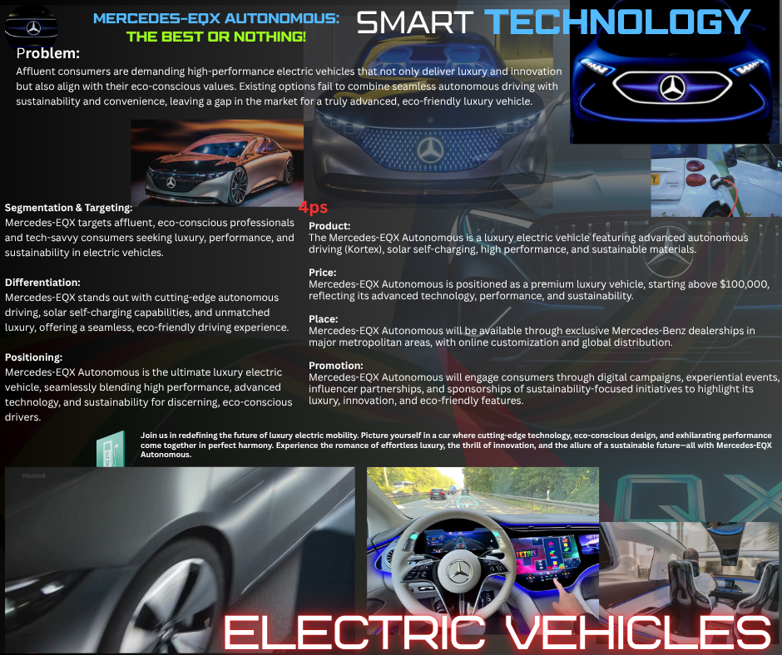
Mercedes-EQX Autonomous is the next evolution in luxury electric vehicles, combining performance, innovation, and sustainability. With Kortex, our cutting-edge autonomous driving system, we offer seamless, all-weather driving that adapts to every condition, providing an intelligent, smooth experience for our customers. This solves a critical problem in today’s market: high-end consumers demand vehicles that not only perform at the highest level but are also eco-conscious and autonomous (Deloitte, 2020).

In addition to performance, Mercedes-EQX Autonomous features solar self-charging capabilities, offering extra convenience and sustainability by allowing the vehicle to recharge in all weather conditions. This innovative system reduces dependency on external chargers, enhancing the driving experience (McKinsey, 2020).

Our premium pricing strategy positions Mercedes-EQX Autonomous as a luxury brand, offering exclusive features such as advanced AI systems and sustainable materials, making it the ideal choice for tech-savvy, environmentally conscious professionals. The luxury EV market is expanding rapidly, and Mercedes-EQX Autonomous is poised to lead this transformation (Accenture, 2021).

With a global distribution strategy and experiential marketing designed to engage potential customers, we offer an unrivalled blend of luxury, performance, and sustainability for the future of driving today. Join us as we drive the future of electric autonomous mobility.

5. Element 4: Reflection
Developing the Mercedes-EQX Autonomous brand and creating its marketing strategy was an insightful and enriching process, particularly in applying marketing theories such as the 4Ps: Product, Price, Place, and Promotion. Using these frameworks allowed me to craft a brand that combines luxury, performance, and sustainability in a competitive market.

The Product element was advantageous. The Mercedes-EQX Autonomous was designed as a full-electric luxury vehicle equipped with autonomous driving technology and solar self-charging capabilities. This innovation directly responds to the increasing demand for sustainable luxury and performance (Kotler & Keller, 2016). The integration of solar charging allows for added convenience and sustainability, addressing consumer concerns about the limitations of charging infrastructure. However, this also presented a challenge in effectively communicating the vehicle’s technological sophistication without overwhelming the audience during the pitch. Porter’s (1985) Differentiation Strategy helped focus on autonomous driving and solar charging as key differentiators, but refining these features for a broader audience was necessary.

The Price strategy focused on positioning the Mercedes-EQX Autonomous as a premium product. This approach aligns with Kotler’s (2017) concept of premium pricing, emphasising exclusivity and luxury. While this strategy is sound for targeting affluent consumers, the challenge was ensuring the price reflected the added value of innovative features such as autonomous technology and solar charging without alienating potential buyers. Pricing this vehicle while maintaining its luxury status and technology leadership was complex, but it remains justified by the vehicle’s performance and sustainable features.

The Place strategy involved using exclusive dealerships and online sales to ensure a personalised buying experience. Schindler (2012) highlights the importance of exclusive distribution for luxury products, which aligns with our decision to focus on premium urban locations and a digital platform to appeal to modern buyers. This approach ensures the vehicle remains accessible yet exclusive, reinforcing its luxury positioning.

In terms of Promotion, the strategy focused on creating a strong emotional connection with the target audience. We used experiential marketing virtual test drives, interactive experiences, and high-tech events, aligning with Keller’s (2003) model of brand resonance, which aims to build deep emotional bonds with consumers. However, balancing the technical aspects of autonomous driving with the emotional appeal of luxury was challenging. In future projects, I would invest more time in refining the narrative to create a more compelling emotional appeal while also showcasing the vehicle's advanced technology.

Reflecting on this process, I recognise that real-time consumer feedback could have improved the development of both the product and the strategy. Although focus groups and market testing were not conducted early on, they would have helped refine product features and ensure market alignment (Kotler & Keller, 2016). In future brand developments, integrating consumer insights earlier would help avoid potential disconnects between the brand concept and customer needs.

In conclusion, applying the 4Ps and strategic frameworks helped shape the Mercedes-EQX Autonomous brand, though it also exposed challenges around communicating innovation and maintaining exclusivity. Moving forward, I would emphasise consumer validation and integrate stronger brand storytelling to balance the technical and emotional aspects of the brand.

References
McKinsey & Company. (2020). "The luxury goods market: A comeback story." McKinsey & Company.
Deloitte. (2020). "2020 Global Automotive Consumer Study: The Drive for Innovation."
Accenture. (2021). "The future of electric vehicles: Automotive trends and innovation."
BMW Group. (2021). "Sustainability and luxury: Shaping the future of mobility."
Forbes. (2021). "Luxury car trends and the future of high-end automobiles."
Statista. (2022). "Advanced driver assistance systems (ADAS) in the automotive industry."
Consumer Technology Association (2021). "Consumer Trends and Technology Adoption in 2021."
Aaker, D. A. (1996). Building Strong Brands. Free Press.
Cialdini, R. B. (2006). Influence: The Psychology of Persuasion. Harper Business.
Kotler, P. (2017). Marketing Management (15th ed.). Pearson Education.
Kotler, P., & Keller, K. L. (2016). Marketing Management (15th ed.). Pearson Education.
Porter, M. E. (1980). Competitive Strategy: Techniques for Analysing Industries and Competitors. Free Press.
Schindler, R. M. (2012). Exclusive Distribution Channels: Theory and Practice. Journal of Marketing.

