University of Wales
Trinity Saint David

Subject: Approaches to Research and Academic Communication (SBPD7001)

Topic: How Internal Auditing Function can Effectively Balance the Agency Problems between Shareholders (Principal) and Management (Agent) and be Measured

Lecturer: Dr. Millissa Cheung
Student: WONG Lung Hon, Mandict (1812879)
Date: 28th August 2019

Table of Contents

1.1 Introduction 2
1.2 Abstract 3
1.3 Literature Review 4
1.3.1 Agency Theory 4
1.3.2 Agency Theory and Internal Auditor’s Roles 5
1.3.3 Internal Auditing 6
1.3.4 Balanced Scorecard 13
1.4 Conclusions 16
2.0 Research Methodology of a Selected Research Paper for Discussion 18
2.1 Introduction 18
2.3 Selected Research Paper 18
2.4 Summary 19
2.5 Discussion 21
3.0 Oral Presentation Slides 26
Reference 45

Part I

1.0 Effectiveness of Internal Auditing Function

1.1 Introduction
From a general perspective, internal auditors are constantly striving for excellence, with business acumen, technical expertise and interpersonal skills to demonstrate that internal auditing functions can drive not only the organizational governance and risk management but also provide significant value in achieving the strategic goals, value added consulting contributions.

This report consists of two parts: 1) Literature review of an interested research topic regarding effectiveness of internal auditing function; and 2) Research methodology discussion for another related research paper. In part one, there are 5 sessions, including Introduction and Abstract sessions for introducing the importance and relevance of why the research topic has been selected. The third session provides Literature Review of Internal Auditing Functions and characteristics of Balanced Scorecard and Agency Theory selected to explain the relationship between the shareholders and internal auditors and the potential measurement. The last session will cover conclusion with reflections and limitations of this research report.

For the part two of this report, a discussion on research methodology of a selected research paper will be included. A discussion of author’s application of research method of qualitative research, data collection and analysis processes and techniques and statistical analysis of reliability, validity and generalization of research findings will be addressed. It also covers the analysis of the research objective, research approach, research gaps and ethical consideration and potential effort for further research in the future as appropriate.

Internal Audit is one of the key control mechanisms of corporate governance of an organization. The challenge is that it is difficult to learn and understand everything before an every single audit engagement. The auditees or the process owners in fact are the subject matter experts not the auditors.

In this paper, I would like to apply the Agency Theory to explain the traditional value of internal auditing function bringing to the governance board and explore the contemporary view of consulting element of internal auditing contributions to the management team for the organization.

Unfortunately, auditors are always being negatively connoted and viewed as the “bad guys” or “sadists” no matter how hard the auditors strive to identify opportunities for improvement and address best practices for deficiencies found. The more the deficiencies identified during the audit assignment, the more the audited parties would treat the auditors as “bad guys” unless they drop the findings from the audit report which is totally unethical and loss of objectivity and independence as a profession.

In reality, organizations and leaders do take risks for survival in certain business opportunity circumstances. It depends on the organization’s risk tolerance and the potential risk level. Internal auditors, as internal employed staff within the organization, we can never take the responsibility for management of risk or business operations, but we should provide practical recommendations, value-added advices for the management to improve the effectiveness and efficiency of the organization’s sustainable corporate governance, sound risk management and on-going internal control processes.

Given the developments in both the field of strategy and risk management, it is imperative that internal auditors have to stay current on emerging thinking and best practices. Internal auditors need to keep themselves up-to-date not only on emerging expectations of regulators but also the changes of dynamic business environment. Nevertheless, internal auditors have to ensure required competencies are in place to fulfill future requirements.

1.2 Abstract
The research topic of this paper is “How Internal Auditing Function can Effectively Balance the Agency Problems between Shareholders (Principal) and Management (Agent) and be Measured”. I am working in accounting, finance and auditing fields, all these are related to professional services industry for more than 25 years. I have suffered from being viewed as “watch dog” or “bad guy” for a long time since I actually moved and stepped into auditing profession in 2004.

There have been many discussions about the effectiveness of internal auditing function of an organization including the effectiveness of internal control, compliance and risk management etc. I would like to apply the Agency Theory to explain the traditional value of internal auditing function bringing to the governance board and explore the contemporary view of consulting element of internal auditing contributions to the management team for the organization as a whole.

In order to collect evidences to measure the potential change of perceived values of the effectiveness of internal auditing function with this new consulting element, a well-defined Balanced Scorecard method will be proposed to measure the feedbacks of principal group (shareholders/ audit committee) and agency group (management/employees).

The objective of this paper is to address the research questions as below:
- apply Agency Theory to address the agency problems between Shareholders and Management;
- clarify the roles of Internal Auditing function between Shareholders and Management;
- adopt the Balanced Scorecard to measure the effectiveness of Internal Auditing Services provided by Shareholders/Audit Committee and Management; and
- explore the theory of Service Innovation whether it can improve the Assurance and Consulting roles of Internal Auditors.

1.3 Literature Review

1.3.1 Agency Theory
Agency theory addresses the issue of the agency problem and its solution regarding the relationships between Principal (shareholder) and Agent (management) (Jensen & Mekling, 1976; Ross, 1973). That is the problem of conflict of interest between principal and agent where management should act on the fiduciary interest to shareholders or audit committee and act responsibly in a manner consistent with their agreed agency contract.

Agency Problem
Moral hazard may arise the risk that a party has not entered into a contract in good faith or has provided misleading information Internal auditor may also assess whether there is adequate information about the agents’ misrepresentation (management) actions (Eisenhardt, 1989). Management may have an incentive to take unusual risks in a desperate attempt to earn a profit before the contract settles. Management may take advantage of shareholder with a contract which may have the opportunity to gain from acting contrary to the principles laid out by the agreement as the employed management team could make any unfavorable decision and take risks without having to suffer consequences they are not the resource provider as a shareholder (principal). Internal Auditor may provide and verify whether there is any misrepresentation actions i.e., investment and reports from management to shareholders. That’s why internal auditor will take an alignment role to balance the agency problem. Table1 below shows the comparison between the principal (shareholder) and agent (management) for illustrate why there are conflict of interests incurred.
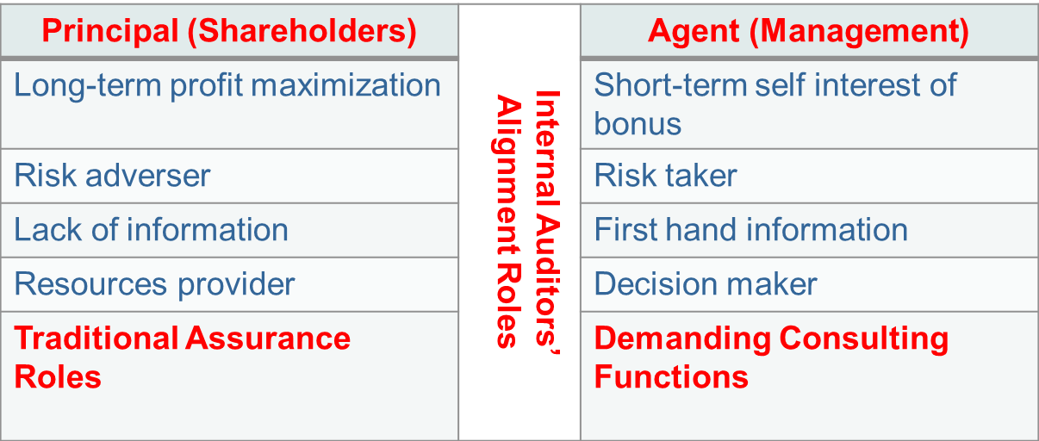
Table 1. Expectations between Principal and Agent

1.3.2 Agency Theory and Internal Auditor’s Roles
How IA can perform both assurance i.e. compliance and consulting i.e. due diligence functions effectively to balance the needs of Principal and Agent as shown in Figure 1.

Poussy and Perron (2018) advocated that internal audit function is seen as a governance supervising mechanism that addresses agency problems and balance the shareholders and management' interests by providing the audit committee with major, if not the only, the effectiveness of internal control against with management. However, Sarens and Abdolmohammadi (2011) and Barua et al. (2010) argued that there is an overlapping role among the audit committee and internal audit function, but further researches are necessary to verify such conclusion (Roussy and Perron, 2018) while Mihret deviated view from traditional agency theory that a consulting function helps to provide advisory and assurance services to both audit committee and management in term of the increase the rate of return on the overall organization’s capital.
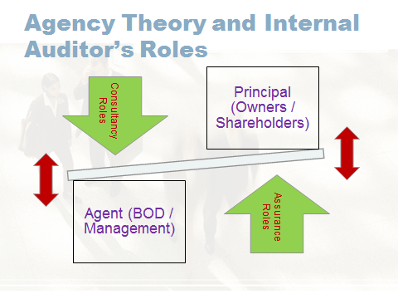
Figure 1. Balancing role of Internal Auditor

1.3.3 Internal Auditing

Internal Audit and External Audit
Some of the objectives, roles, responsibilities, and work of internal auditors and external auditors are complement each other, sometimes with similarities and even overlapping each other like both may have an in-depth analysis of the organization's transactions; they are familiar with governance, risk management, and internal control systems.

This is not surprising; each profession is based on a professional discipline and follows the standards of the discipline at work. Because of this, external auditors' professional concerns include inaccurate information and misstatements affecting the financial reports.

The IIA defines internal auditing as
“an independent objective assurance and consulting activity designed to add value and improve an organization’s operations, it helps an organization accomplish its objectives by bringing a systematic, disciplined approach to evaluate and improve the effectiveness of risk management, control, and governance processes.”

The internal audit is an internal function of the organization, but the internal auditor needs to conduct the audit engagements independently of the auditee. Internal auditors must follow IIA's International Standards for Internal Auditing Practices. Because only independence can be maintained to ensure audit effectiveness. Ideally, internal auditors should report directly to audit committee.

Internal audit can be defined as an independent activity objectively, confirmatory and consultant established to add value and repair the organization’s operations and by helping them to achieve their targets through a systematic and disciplined way to evaluate and improve the effectiveness of risk management and control processes and governance

According to the International Federation of Accountants (IFAC), an audit engagement is
“a reasonable assurance engagement in which a professional accountant in public practice expresses an opinion whether financial statements are prepared, in all material respects (or gives a true and fair view or are presented fairly, in all material respects), in accordance with an applicable financial reporting framework, such as an engagement conducted in accordance with International Standards on Auditing. This includes a Statutory Audit, which is an audit required by legislation or other regulation.”

Unlike internal auditors, external auditors are contracted third parties; not employees of the organization, so they do not have a vested interest in the organization. External auditors by definition, would not get heavily involved in the governance and risk management, especially the internal control activities of the organization because the objectives and roles of external auditing do not require external auditors to actively carry out their function through the financial year but mainly at the end of the year, so external auditors cannot provide timely advice to the organization on how to prevent risks, nor can it provide insights that will help increase organizational value.

Given the different natures and functions of internal and external audits, it is not surprising that external auditors are perceived with more confident in the work to the shareholders as they shall not undertake any interests from the engaged organization other than the disclosed professional audit fees transparently stated in the annual report of the organization. They ultimately focus on expressing an opinion on the financial condition and the fairness of representation of financial statements. The International Auditing and Assurance Standards Board (IAASB) published the International Standards on Auditing as a guide to the work of external auditors globally.

Traditional Views of Internal Audit Function
Internal audit has been continuously transformed over the years to meet the changing demands of the organizations (Munteanu & Zaharia, 2014) as shown below:
- In the 1950s, the primary task of internal auditors was to review accounting records for focusing on accounting control issues (Munteanu & Zaharia, 2014).
- In the 1960s, the role of internal auditors was led by accountants, promoting as a business supervisor and added a new role of the operational review.
- Internal auditors’ participation in corporate governance had become another new milestone in history in the 1970s.
- In 1978, the Institute of Internal Auditors (IIA) passed the "Internal Audit Professional Practice Standards", had advanced internal auditors a big step from its history as so called "organization police and watchdogs" to become an expertise of the company's internal control system and had effectively entered the foundation of risk management.
- In early 1980s, internal audit function was only being viewed as the fundamental accounting transaction auditing work (Cooper, Leung and Wong, 2006).
- In early 1990s, part of the roles of internal auditors was being focused on an independent assessment of effectiveness of internal control system and efficiency of operation of organization with lesser concern with simply safeguarding of assets and preventing and detecting fraud and errors.
- In mid 1996s, a further positively shift of internal auditor’s perception from providing an independent review of the efficient operations to an advanced view of internal audit towards advisory role as an internal consultant to senior management of the organization (Cooper et al, 1996).

So the traditional perception of internal auditing function was mainly the review of internal controls to safeguard of assets and accounting records. It was perceived as “watch dog” or “bad guy” whose role was like a nitpicker and fault detector that internal employees would not passively work with internal auditors and tell them anything unless those information were specifically being asked.

Contemporary Views of Internal Audit Function
Currently in 2000s, Van Peursem (2004) and Cooper et al. (1996) pointed out a potential problem that internal auditors must independently assess the confusion between the effectiveness of management and management's expectations. More observations by McCall (2002) with similar view that internal auditors will assume with position in the best interests of the company and is unwilling to oppose management, regardless of the consequences, which may create potential negative image of the internal audit profession (Cooper et al, 2006). Further, Goodwin (2004) identified that the use of internal audit to facilitate management training was gradually common as part of the internal auditing functions of organizations. Arena (2009) also found that mmanagement consulting elements of IA function would reduce resources used for compliance and financial based audits.

Internal auditors focus mainly on non-financial information such as governance, risk management, and internal control functions. External audit and internal audit are not competitive to each other and so do not conflict with each other; on the contrary, they complement each other and are essential for good corporate governance and should maintain communication and collaboration.

Therefore, internal audit needs to contribute to the organization on governance, risk management, and control processes, and to discuss building a good internal control system on an ongoing basis through the year. To ensure efficiency, the internal audit function is required to provide management with advice on improving both the financial and operational related work like a consultant (Head, 2009).

However, the consideration of conflict of interests between the consulting and assurance roles concurrently provided by the internal auditors of the organization would need further research efforts in the future.

Some literatures indicated that there are positively correlated supporting the professional independence which are the active assurance engagements (Gramling et al., 2004); the adequacy of the communications between the internal auditor and the audit committee (Anderson et al., 2012; the strategic components of operational activities (Gramling et al., 2004; Soh, 2011, Sarens, 2011 and Van Peursem, 2004); the independence and competence of internal auditor and audit committee (Christopher et al., 2009).

On the other hand, the involvement of operational assignments as a project manager (Arena and Azzone, 2009; Glover et al., 2008; Gramling et al., 2004); fixed salary based with company profit related performance bonus (Omar and Stewart, 2015; Schneider, 2010); a training platform for top management (Christopher et al., 2009; Messier et al., 2011); heavy involvement of senior management in internal auditing long-term plan (Christopher et al., 2009); the arm’s length relationships with senior management (Holt, 2012; Norman et al., 2010) are all negatively corrected to auditor’s professional independence.

Trusted Advisor
From the past, internal auditing focused on accounting control to the current organization-wide risk-based auditing, which is a major step forward in the internal audit profession. We can see that the coming leap of internal audit is that internal auditors strive to ensure that the strategic focus of the internal audit plan to align with the strategic priority of the organization, and to provide insights into the organization's ability to successfully achieve its strategic goals.

With a formal mechanism, it doesn’t only improve the interaction between internal auditors and management of the organization, but also help internal auditors become more visible, the knowledge structure is richer and more reasonable, and the actual situation within the organization is better understood.

To be a trusted advisor, you must have excellent business acumen, technical expertise, and interpersonal skills to be seen by stakeholders as an important enabler to drive the organization's goals. For a competent internal audit team, this means the team must be able to consistently add significant value to the organization.

During the 1990s, the increasing use of international accounting firms in consulting and assurance engagements over-shadowed the internal audit function (Cooper, Leung & Wong, 2006). Regarding the independence of internal auditors, there is still confusion between the past and the present. The definition of internal auditing makes it more complex, and internal audit includes both the expectations of the consulting and assurance roles. The internal auditor is not sure how to balance the independence of the two roles.

Internal auditors have now found that the scope of activities with addition of consulting services is broader than ever and this has brought a whole new dimension to the internal auditing profession (McCall, 2002). Internal Auditors are no longer focusing on the measurement, evaluation, and reporting on internal control effectiveness, their roles have been expanded to work with management to add value to the organization by improving the operations efficiency.
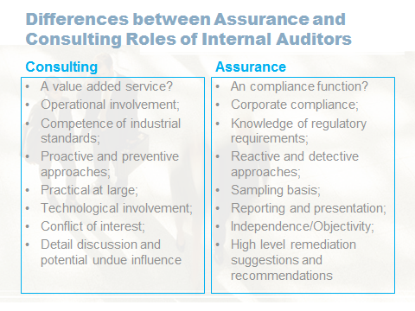
Figure 2. Key different roles between consulting and assurance of internal audit

The internal audit function should be carried out as an internal consultant within the organization. The internal auditor should remain truly independent and free from any internal conflicts that may exist with professional, well-educated, have an understanding of the business, and take a proactive attitude. That requires auditors to develop enhanced negotiation, communication and softer skills to better work with the company and develop more in-depth technical knowledge about the business itself. The audit team must be prepared to respond to risks and provide value-added, practical advice. More importantly, auditors must always keep in mind the ethical principles governing such projects, especially the need to balance counseling and independence.

In addition, the Audit Committee needs to be established to be properly informed about all the consulting services that the Internal Audit Function has provided as part of quarterly reports. The Audit Committee can then ensure that any consulting services do not compromise the independence of the Internal Audit Function, as well ensuring these value-add activities do not affect the progress of the annual internal audit plan.
Management of the Internal Audit Function must therefore build into the annual internal audit plan time for these value-add consulting services in a way that balances its assurance and consulting roles. This is fundamental at the planning stage to ensure that the Internal Audit Function does not focus on consulting services to the detriment of its core assurance function.
Management may also want the internal audit department to conduct consulting work, but seek some form of assurance that any findings will not be reported upwards or included in the overall report submitted by the internal audit department to the audit committee. In this situation, the audit assignment should be rejected as this situation may lead to internal auditing under its guarantee to investigate the reasons behind.
It is also important that consultancy services are offered to support management in their work, not to be a substitute for management’s own efforts to address the issue in question and made it clear that internal audit would never take part of any sign-off decision responsibility.

Independence of Internal Auditors
According to definition of Internal Auditing (IIA, 2017), internal auditors are no longer only performing independent and objective assurance engagements, they have to increase their roles including consulting activities for operational levels instead of corporate level in the past. With this consulting role, they may not need to report to audit committee for those particular consultation tasks but will work directly with the managers to implement the changes and assist with the related training. However, the key is that the internal auditors must maintain the independence and objectivity of the consulting task they involved without any administrative, managerial or decision-making responsibility to avoid even a potential or apparent conflict of interest aroused. As a consultant, the internal auditor can only give advice, review the control procedures and suggest changes to improve the assigned tasks with the team.

As the professional internal auditors, they should possess the related competence, experience, operational skill and knowledge necessary to add value and improvement to the organization. According to the guidelines of IIA (2017), the agreed consulting roles are by nature restricted to advice, recommendation, opinion and suggestion to a specific agreed scope of that consultation task. Therefore, the internal auditor must highly aware of their work to maintain objectivity and note assume any management decisions and responsibilities.

Positively, a consultancy work could enrich the knowledge about risk control and governance or the auditors involved who subsequently may help them to make a contribution to their audit assurance work.

Independence/Objectivity
Although internal auditors being assigned to involve functions other than internal auditing, it also means that their knowledge, skills, and contributions are being recognized and meaningful across a range of functions of the organization.

One of the primary concerns is the ability to maintain both perceived and real objectivity, while reporting lines can also lead to independence. It would very dangerous that there may have business measurement tied to performance or incentive goals of internal auditors which may likely be perceived as compromise the independence and objectivity indeed or appearance (Head, 2009).

Independence refers to the ability of internal auditing units to perform internal auditing duties in an unbiased manner. The internal audit supervisor can directly and unrestrictedly engage with high-level management and the board of directors. The requirements can be achieved through a dual reporting relationship. The threat to independence must be from individual auditors, projects, functional and institutional levels are managed.

The purpose of the consulting project must be consistent with the value, strategy and objectives of the organization. Internal auditors need to collaborate with management (Marijana & Ahmed, 2017). Internal audit is not only important for monitoring, analyzing and assessing the risk control and compliance of the organization, but also is required to provide insight on an ad hoc basis to the organization by expanding the audit scope and focusing more on collaboration and strategic engagement including technological advancement.

Technology for Internal Auditing
Of course, with a greater allocation of resources to internal audit function can improve the effectiveness of achieving the consulting and assurance roles (Gramling et al., 2004). Advanced technology support would enhance the effectiveness of audit function which helps to identify control deficiencies, manage risk and prevent potential fraud activities.

This requires audit related technology to promote the autonomous and creative spirit when applying the rules. This happens especially considering the necessity of adapting the prevention of risks with the special characters of the organization and its economic activity.

There are indeed many differences and not easy to form a synergy between internal audit and the work of the creative pioneers and innovators of the organization, internal auditors should actively participate in the response to change from the beginning.

For today's internal audit executives, one of the biggest challenges is to recognize the nature of change. Understanding the content of change and providing organizations with insights to drive change is the most valuable job. This is no longer a new topic for internal audit. Internal auditors are based on risk, providing organizations with objective confirmation, advice and insights to strengthen and protect the interests of the organization.

The direct way to avoid this dilemma is to improve the quality of the internal audit function. Internal auditors can innovate working methods and use data analytics and robotics to improve work efficiency. Internal auditing functions can help the organization to analyze the entire database by leveraging process automation software tools, rather than just sampling analysis of some samples, providing technical support for automating risk management activities.

Internal auditors will be fixed by focusing on validation efforts, maintaining close contact with stakeholders and experts, increasing investment in transformative technology training, applying new technologies at work, and providing organizations with insights into emerging risks and opportunities. Internal auditing function is a key force in helping organization to harness the trend of technology disruption.

1.3.4 Balanced Scorecard
Balanced Scorecard is a powerful Harvard Business Scholl developed management tool for strategy translation and implementation (Frigo 2002b). The Balanced Scorecard model is one of the essential frameworks for strategy execution, it can be applied to lead internal audit activities as a tool to more effectively manage the risks and connect internal audit strategy to corporate strategy. It can create a platform for risk assessment and enterprise risk management and will help develop a business strategy with effective actions for improving internal audit functions (Frigo 2002a) which aligns with Kaplan that:
Mark Frigo (2002a) has developed a clear guidelines for developing Balanced Scorecards for an internal audit strategy that will help internal auditors meet the needs of management, executives and the board and truly make their department a valuable strategic partner (Kaplan & Norton 2007).
According to the Institute of Internal Auditors (IIA), it adopted that the balanced scorecard is a strategy-focused approach including both non-financial and financial performance measures of efficiency and effectiveness.

Kaplan and Norton developed the Balanced Scorecard in 1992 and subsequently presented the ``Balanced Scorecard,'' methodology in a 1996 Harvard Business Review article entitled, ``Using the balanced scorecard as a strategic management system''. This is a more comprehensive development of the ``Balanced Scorecard'' with new additional perspectives including customers, internal business processes, and learning and growth on top of financial perspective (Ziegenfuss, 2000; Lueg, 2015). These four perspectives explained the way how to attain the strategic objectives of an organization (Ziegenfuss, 2000).

The Balanced Scorecard has been applied to evaluate and refine strategy for departmental level according to the Institute of Internal Auditors Research Foundation that Frigo (2002a) referred that Balanced Scorecard could be a good management model to standardize measures and access strategy of an internal auditing department and achieve the audit committee objectives and corporate strategies. The concept of Balanced Scorecard model can also be used to measure how well the internal audit function is performing in respect of the 4 perspectives (financial, customer, internal process and innovation) of Balanced Scorecard shown in Figure 3.

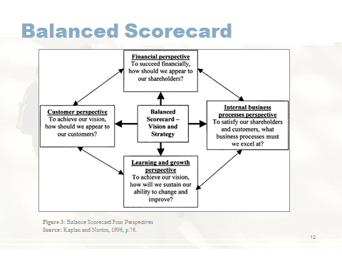

Four perspectives of Balanced Scorecard
The financial perspective here is focusing on adding value to the company and stakeholders. In this case, the cost management as internal audit department is a cost center rather than a profit generating center of a company. Carcello et al. (2005) investigated that some companies invest heavily in IA and evidenced that IA budgets control is an important dimension influencing the perception of IA effectiveness.

The customer perspective here is defined as those internal auditing department’s customers who those managers of the departments (auditees) are being audited (Soh and Martino, 2011) in this study. That measures the customer satisfaction regarding to the values that the audit engagement can deliver to the auditees. The appreciation of IA by internal customers including management and audit committee members is a crucial factor identified by Lenz & Hahn (2015).

The internal business process perspective is the improvement process of IA functions to satisfy the stakeholders and internal customers. Lenz et al. (2013) suggested that IA process is one of the key categories and the ability of the internal auditor to establish and perform proper audit processes to identify, examine and evaluate audit engagements. Soh and Martinov-Bennie (2011, p.614) viewed that it is importance of a good internal auditor’s competencies and process to be effectively collaborated with different levels in the organization and is free to voice fair and criticized opinions even in controversial situations.

The learning and innovation perspective is aimed to address how internal auditors can sustain their ability to change and improve the knowledge, skills and abilities to constantly reinvent into the IA department in respect of the company’s strategic long-term growth. Mihret et al. (2010, p.240) viewed that the continuous learning to maintain and update skills and competencies of internal auditors is closely related to IA effectiveness and meeting the expectation of auditees which is also aligning with the view of Rittenberg and Anderson (2006) that skilled and qualified internal auditors would be deemed to be highly satisfying as a professional.

The technology may provide an added value for improving the possibility to assess the transaction details by developing data analysis in more accurate and completer manners (Boţa-Avram, Popa & Ştefănescu, 2010, pp. 136-146).

The difficulty in measuring the effectiveness of internal audit function encounter various expectations, so there is no simply way in using the best model for measuring the efficiency and quantifying the effectiveness of internal audit functions (Prawitt, 2003).

1.4 Conclusions

The development of internal audit has gone through multiple stages, from control-based auditing to consulting-oriented auditing, as well as ensuring that internal auditing objectives are aligned with the organization's strategic priorities.

From a traditional view, the internal audit function is an important part of controlling the infrastructure and must be able to check any aspect of the organization operations to determine whether policies and procedures are adequate, secure, operate as expected, or whether new controls are needed to fill the gaps or correct errors (Head, 2009).

Internal auditor contemporarily can turn the role in the compliance and assurance into more consulting and strategic outcomes that not only prevent such fraud and non-compliance, but also enable the organizations to operate more efficiently. Internal auditors can be a trusted consultant to help management make informed decisions and make a significant contribution to achieving sustainable shareholder value. By all mean, internal auditors must act professionally to ensure the objective assurance and advisory function that report shareholders and the audit committee directly and independently.

Internal auditing function is a key force in helping organization to harness the trend of technology disruption. The inclusion of technology strategy and the related diagnostic tool for internal function is an evolutionary approach but it requires constant improvement to help internal auditors continue to re-evaluate its technology needs and make the necessary changes to achieve the internal auditing effectiveness for the future.

Even though internal audit will participate more in consulting roles of the organization on top of assessing the effectiveness of corporate governance with the highest efficiency, it will not be able to success without the overall support of the organization’s management and the audit committee though an effective communication channel between management, the audit committee and internal audit. The strong tone of support from senior management is extremely important for the internal audit function in facilitating the active participation of management and employees to work collaboratively together with the internal auditors for the organization. This requires senior management to establish and maintain effective internal control environment, raising risk awareness and ethical corporate culture at all levels in maintaining transparency and accountability all levels through the organizations.

Although internal auditors can never learn enough in comparing with those subject matter experts, with the aspects of independent, objective and professional practices to do our audit engagements well for both interest groups i.e. Principal and Agents.

Finally and hopefully, my wish is that we, as an auditor would no longer being negatively viewed as “Bad Guys” or “Watch Dog”. We still need to continue to work hard to continuously improve our works together with all levels of the organization. We are “On the Same Boat” we should strive to “Balance and Run the Boat” together.

Part II

2.0 Research Methodology of a Selected Research Paper for Discussion

2.1 Introduction
In this section, the research methodology of a research paper was selected for discussion. So far the literature of internal auditing functions has been investigated from an auditing point of view and it was concluded that an effective internal auditing function requires different auditing tool for each individual organization due to the fact that different organization bore some different characteristics. The key purpose of this paper written by the authors is to determine the most significant types of methods used to determine internal audit performance by using fundamental types of research.

2.3 Selected Research Paper
“Measuring and Assessment of Internal Audit’s Effectiveness”
Palfi Cristina & Bota-Avram Cristina, 2009. “Measuring and Assessment of Internal Audit’s Effectiveness”. Annals of the University of Oradea: Economic Science, 3(1), pp.784–790. Available at: http://steconomice.uoradea.ro/anale/volume/2009/v3-finances-banks-and-accountancy/132.pdf

Abstract:
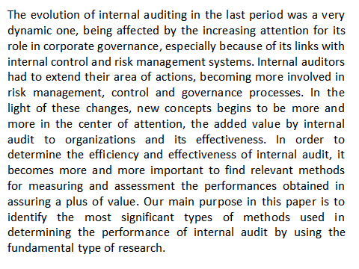
Keywords: value added, internal audit’s effectiveness, qualitative methods, quantitative methods, balanced scorecard

2.4 Summary
An easy reading research paper above is selected to analyze and discuss the research methodology applied by the authors, Palfi Cristina and Bota-Avram Cristina in 2009.

This paper firstly touched on the role of internal auditors for corporate governance regarding the internal control and risk management system and extended that the auditors have provided value added contribution to the organization in a more efficient and effective manner. In order to assess such performance, the authors had tried to identify the most remarkable performance measuring methods by using the fundamental research.

The authors had mentioned that the Institute of Internal Auditors (IIA) and the International Standards for the Professional Practice of Internal Auditor (ISPPIA) both have the similar standards for Chief Audit Executive (CAE) to be responsible to develop and maintain a quality internal control framework for the organization. That would help the internal auditors to be more valuable to their organizations and those values to be determined and assessed. As such, internal audit would get rid of the unpleasant label of “resource consumer” and become a “value creator”.

In order to measure the value of the internal auditor, the authors had also made the following assumptions as the general rules in respect of internal auditor’s contrition to the organization:
- The internal auditor should understand his responsibility to create added value for the organization;
- Internal auditors are responsible for demonstrating internal audit work to the audit committee and management; and
- Internal auditors should take active role to organize meetings on self-assessment of control for management within the organization.

The authors had applied fundamental research to gather the key findings from the related literatures. The information of speciality literature collected by documentation and observation methods was used to measure and assess the effectiveness of internal audit. Both inductive and deductive research methods were also applied in two phases:
- phase 1: a general overview of the most significant techniques; and
- phase 2: to synthesize the most applicable methods for building a relevant framework,
to assess the internal audit effectiveness.

In this paper, the information were collected from the 2007 and 2008 results of “Global Internal Audit Survey” obtained by Ernst & Young (EY), one of the Big4 CPA firms.

In 2007 survey, the data were drawn from internal audit executives of 138 key representatives in public companies around the World Business Week 1000, as well as Standard & Poor's Global 1200 companies from 24 countries, most of which are large multinational companies with revenues of more than $4 billion. The key findings were summarized as below:
- 50% of respondents did not track the value of their internal audit team;
- 13% of them evaluate internal audit value with actual cost savings;
- The most leading metrics being used in internal audit effectiveness measurement were:
  - performance against with Audit plan (89%);
  - time effort in issuing the internal audit report (72%);
  - time effort in solving reported findings (32%); and
  - role of supporting key business initiatives (23%).

Where the similar findings found in 2008 survey were:
  - time effort in solving reported findings (34%);
  - role of supporting key business initiatives (22%).

In addition, the authors also took the 2005 joint study from one of the biggest US/Canada internal audit and consulting services firm, PROTIVITY and Institute of Internal Audits about the best internal audit practices of some large multi-national organizations around the world and indicated that the key modes to assure the quality measuring and enhancing the internal auditors’ performance were:
- instituting of assurance quality of internal auditor to apply policies and procedures according to professional standards;
- realizing of internal audit quality according to the settlements of IIA standards;
- evaluation of internal audit quality perceived by external teams;
- measuring the performance through qualitative methods;
- implementing some assurance quality program;
- other instruments:
  - reports for the management in an informal manner;
  - various system for monitoring timing and quality of internal audit reports;
  - development of the new internal audit procedures; and
  - compliance of specific objectives for individual auditors.

Quantitative methods for the measurement of the effectiveness of internal audit:
- fulfilment of internal audit plan;
- time frame for issuing the final audit report;
- time frame for resolving of audit findings;
- obtainment of professional certification;
- time involvement of internal audit and administrative activities.

Qualitative methods for the assessment of performance of internal audit by mean of questionnaires and interviews with mangers and auditees of the organizations.

Finally, the authors quoted “Balanced Scorecard” as one of the most recognized model with the support of Frigo (2002)’s research paper of “A Balance Scorecard Framework for Internal Auditing Departments (Paperback)” to combine quantitative and qualitative methods to measure and assess the internal audit performance. This Balanced Scorecard model consists of 4 measuring perspectives as following:
- internal audit customers (audit committee);
- internal audit customers (management and auditees);
- internal audit process;
- innovations and capabilities.

Although the qualitative research design is not intended to prove or test the theory, it is more likely that the proposed theory will be used to merge the data being collected (Dunleavy, 2003, Grix, 2010). However, care needs to be taken to avoid from ignoring the theoretical views of previous work cited in the literature review.

2.5 Discussion
Although internal audit effectiveness has been studied intensively, the related measuring tool such as balanced scorecard has attracted less attention. Few published articles about using balanced scorecard to measure effectiveness of internal audit exist. The articles mainly used sociality literature by documentation and observation methods to develop a guideline for the measurement and assessment of internal audit effectiveness.

The difficulty in measuring the effectiveness of internal audit function encounter various expectations, so there is no simply way in looking for the best model for measuring the efficiency and quantifying the effectiveness of internal audit functions (Prawitt, 2003).

The data collection was based on the two “Global Internal Audit Surveys” done by EY in 2007 and 2008. Aiming to achieve a more convincing findings (Smith, 1975) was intended to address and reduce the potential bias and limitations by increasing the validity and reliability of the research result.

2.5.1 Ethical Consideration
In this paper, no written informed consent agreement was mentioned. Although most of the information was extracted from secondary data of EY’s survey reports in 2007 & 2008, questionnaires were mentioned as part of the data collection for the analysis purpose. The authors should not simply assume that interviews and questionnaires would not be upsetting, distressing to the respondents. As an ethical researcher, it is required to have thought through the implications so that we can justify the decisions. At least most basic level though, when choosing methodologies and methods, perhaps the best test is to ask yourself how you would personally feel if you, your family or your friends were ‘researched’ by means of them. If you have any qualms whatsoever, you need to think very carefully about applying them to anyone else (Wellington 2005, pg. 104). Research may allow for certain risks, but these risks should be predicted in advance.

2.5.2 Samples
For a proper survey study, it is important to determine an appropriate sample size which in fact depends on the true population size of company being estimated, its heterogeneity on the key characteristics being studied, the amount of sampling error willing to tolerate and of course the resources of the amount of money and time available to do the research.
In this study, the data was collected from internal audit executives of 138 key representatives in public companies around the World Business Week 1000, as well as Standard & Poor's Global 1200 companies from 24 countries, most of which are large multinational companies with revenues of more than $4 billion based on the two “Global Internal Audit Surveys” done by EY in 2007 and 2008. Of course the larger the random sample size, the more likely it can capture the diversity that exists in the true population. However those respondents were mainly those largest corporations rather than randomly selected with some SMEs involved and the survey results applied may not be the same purpose of what they originally intended i.e. to conclude that balanced scorecard is the most frequent used model to measure internal audit effectiveness.

2.5.3 Questionnaire
Since the set of questionnaires being borrowed did not go through a panel of experts to address the purpose of its research objective. It is only rather cost effective in terms of both money and time resources without any pre-testing process as they were the non-auditors rather than the expected study participant for this project of assessing the perception of effectiveness of internal auditors from auditees without the intention to get comments from test group with audit background to fine tune the questions for the purpose of a pilot testing project. So if survey was the final one without a random sample approach, generalization about a true population would not be possible. Further by making conclusion about a population using data collected form a convenience or non-representative sample may in fact be causing an unprofessional ethical result (Nardi, 2014, p.154-156) where methodological control generally depends on the principle of randomness.

2.5.4 Sampling
A non-random sampling design was adopted in this study, so that the findings may not be generalizable. One of the limitations as stated by Hanmon (2017), and Yung & Chan, 2002) that it is unknown whether the findings generalize to a larger population as that was a purposive sample of large corporations to participate in a survey about perception of effectiveness of IA function. The results may likely be limited by the intended samples gathered and subjected to the constraints of time and limited resources (Yung & Chan, 2002). So the general perception of effectiveness of IA from SME group may not be reflected in this survey. Although in practice, biased samples occur because of badly planned or ill-considered procedures and these lead to false conclusions about the population (Swift & Piff, 2005, p376). They are really relying on the concept of randomness.

2.5.5 Scale Development
A good survey relies on how those good questions are being asked, getting a representative sample and getting a good response rate (Dunifon, 2005). As per Peterson (2000, pp.45-60), he stated 5 useful criteria for constructing effective questions which are that questions should be brief, relevant, unambiguous, specific and objective (acronym as BRUSO). In this survey, the effectiveness items were divided among scales representing four constructs of theory of Balanced Scorecard. However, no reliability and validity tests were mentioned to achieve the internal consistency of a scale can also be examined with item-to-scale correlations and inter-correlations of items within a scale (DeVellis, 2003).

So it is no way to ensure that the ultimate goal of questionnaire could conclude that the balanced scorecard would be an effective measurement for the performance of internal audit with a reliable, valid and practical tool for this survey (Hanmon, 2017) i.e. Cronbach alpha reliability test for measuring the construct with a score desirably higher than 0.7 (Cronbach, 1951, Fraenkel & Wallen, 2000, p.179).

2.5.6 Standard Deviation
Standard deviation is another powerful measure of dispersion of values for interval data (Nardi, 2014, p.144) without mentioned in this paper. In the report, there was no standard deviation being mentioned or used to measure the average of response values from the mean which describes the distribution in relation to the mean, and then compare similar variables within the samples. In fact, the more dispersed the scores are from the responses of the samples (large corporations only). A low standard deviation indicates that the data points tend to be very close to the mean. A high standard deviation indicates that the data points are spread out over a large range of values. A small standard error is an indication that the sample mean is a more accurate reflection of the population mean to be measured in the survey. However, nothing was included in the report as the authors may simply adopt the secondary data directly without further analysis themselves.

2.6 Research Approaches
Research may explore, describe, or explain a topic or a phenomenon (Singleton and Straits, 1999). Explorations, descriptions, and explanations may get a clearer and broad sense, the necessary rules and procedures for research. The key to evaluating research is to assess whether the chosen method is sufficiently rigorous and appropriate for the research question, and whether the research is conceptually and theoretically grounded (Roussy and Perron, 2017). There is a need to study other choice of method other than a combination of qualitative and quantitative approach.

2.6.1 Exploratory Research:
The objective of exploratory study is to explore a phenomenon under study. It provides a more precise research problem to be investigated further. When little is known about a phenomenon or a topic, exploratory study is advised. In addition, when the subject area is new, exploratory study is used for finding main points from people who have firsthand knowledge about the topic. Literature survey and experience surveys are the two methods used for exploratory research (Emory, 1991).

2.6.2 Descriptive Research:
Descriptive studies answer questions such as who, where, when, how and what. Their objective is to describe the topic under investigation. These studies try to find out facts about a phenomenon. Any data collection method may be used in a descriptive study (Selltiz, Wrightsman, and Cook, 1976). U.S. Census data is an example of descriptive research.

2.6.3 Explanatory Research:
This type of research aims at testing relationships and revealing casual linkages about a phenomenon. It identifies cause-result relationships, if any. The objective of this kind of study is to answer ’why’ type of questions (Yin, 1989). Identification of explanatory and response variables plays a big role in this type of research. Many statistical tools, such as multivariate regression analysis, factor analysis, and variance analysis are available for this type of study. Moreover, qualitative research techniques can also be used for the explanatory research.

2.7 Structured Literature Review
Structured literature review would be recommended to use a process that through a set of rules, potentially offers less bias and more transparency of the execution and measures and techniques of validation and reliability. The structured literature review uses a set of rules that may provide less bias and higher execution transparency and give a higher degree of validity and reliability of the research results. It also gives an exposing insightful future pathway of research with the current technological advancement via internet to discover instantly as much relevant articles to researchers (Massaro et al, 2004; Roussy and Perron, 2017). Traditional literature reviews may limit the way to do proper research processes and miss certain high graded articles and more importantly the valuable contributions.

There is no single and ideal method of collecting data and the sources, a combination of research methods in applying different research techniques to address the same problems and research questions with quantitative in form of numeric data/information in a more objective manner i.e. statistical techniques and qualitative with more subjective involving personal interpretation to gain better understanding about the reasoning behind the participants' responses i.e. interviews, observations and surveys (Tashakkori & Teddlie, 2003).

Part III

3.0 Oral Presentation Slides
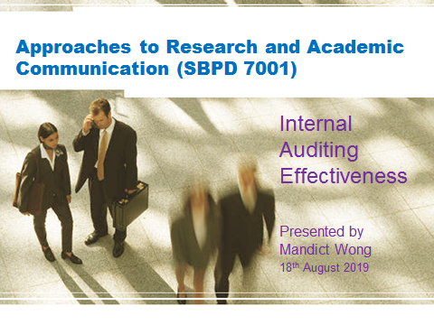
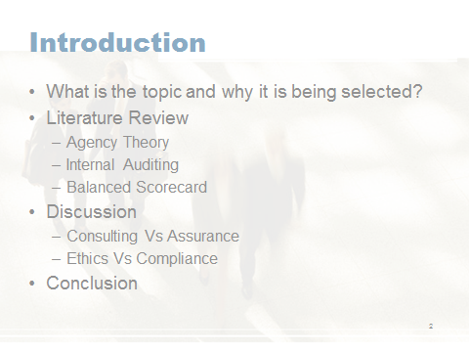
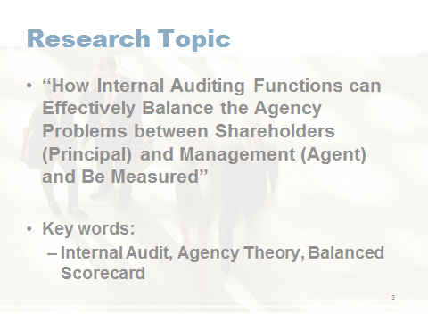
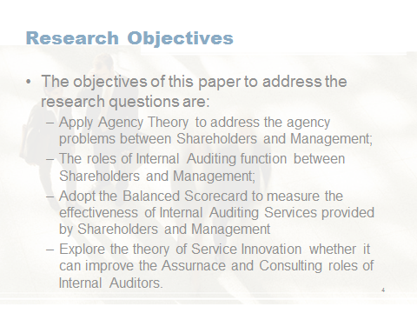
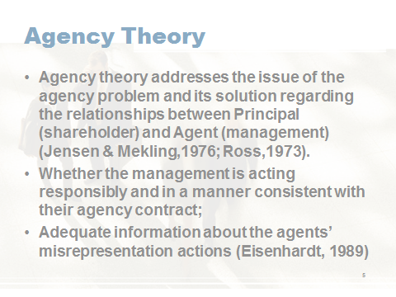
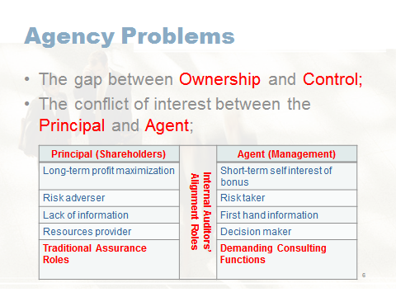
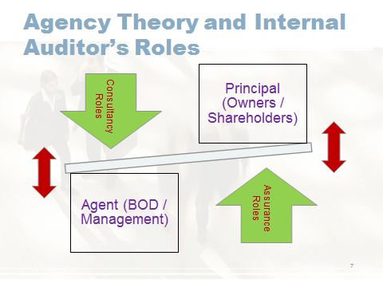
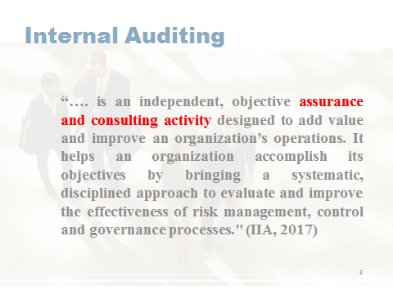
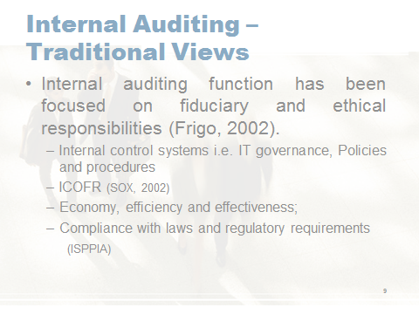
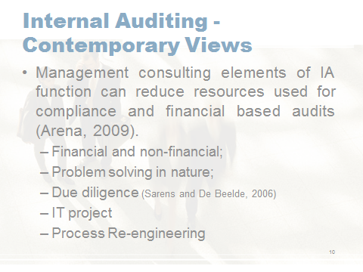
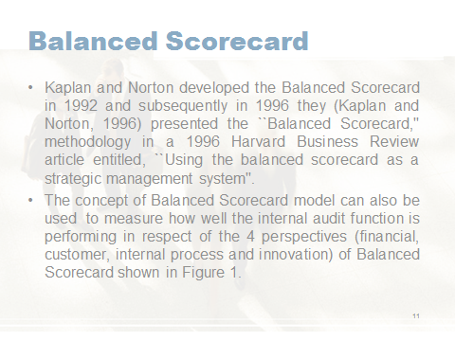
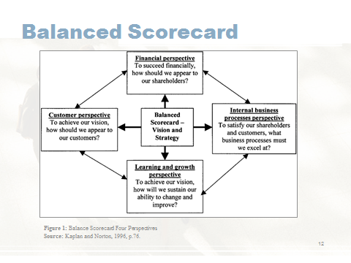
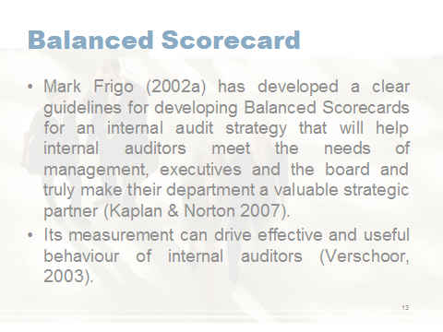
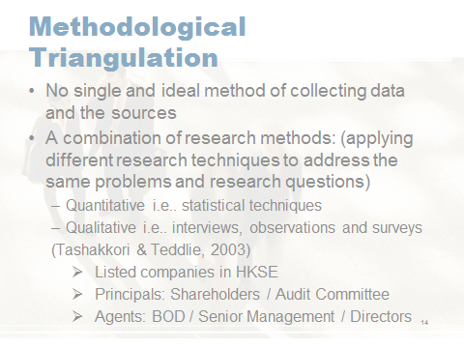
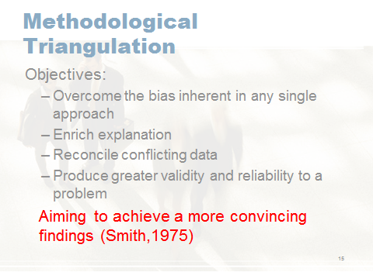
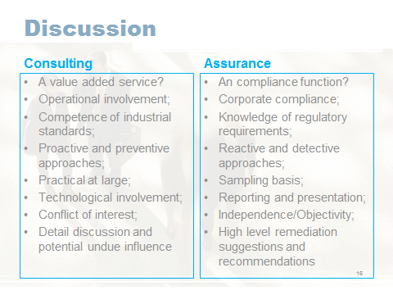
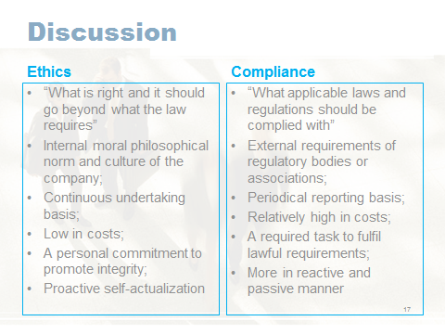
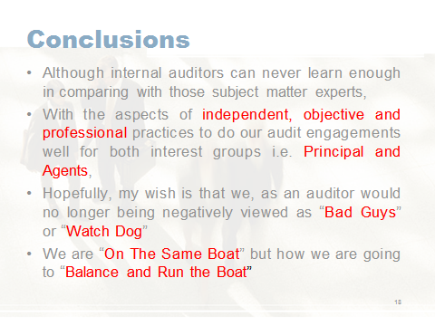

Reference

Adams, M. (1994) ‘Agency Theory and the Internal Audit’, Managerial Auditing Journal, Vol. 9, No. 8, pp. 8-12. Available at:
https://doi-org.ezproxy.lb.polyu.edu.hk/10.1108/02686909410071133
(Accessed: 31 July 2019).

Archambeault, D. S., DeZoort F. T. and Holt T. P. (2008) ‘The need for an internal auditor report to external stakeholders to improve governance transparency’, Accounting Horizons, 22(4): 375–89. Available at:
https://search-proquest-com.ezproxy.lb.polyu.edu.hk/docview/208906906/fulltextPDF/F8DA6DF000224D64PQ/1?accountid=16210
(Accessed: 16 August 2019).

Arena, M. and Azzone, G. (2009) ‘Identifying Organizational Drivers of Internal Audit Effectiveness’, International Journal of Auditing, 13(1), pp.43–60. Available at: https://onlinelibrary.wiley.com/doi/abs/10.1111/j.1099-1123.2008.00392.x
(Accessed: 16 August 2019).

Boţa-Avram, C., Popa, I. and Ştefănescu, C. (2010) ‘Methods of Measuring the Performance of Internal Audit’, Annals of the Stefan cel Mare University of Suceava: Fascicle of the Faculty of Economics and Public Administration, 10(Special Number), pp.137–146. Available at: http://www.seap.usv.ro/annals/ojs/index.php/annals/article/viewFile/330/340
(Accessed: 16 August 2019).

Boyle, D. M., DeZoort F. T. and Hermanson D. R. (2015) ‘The effects of internal audit report type and reporting relationship on internal auditors’ risk judgments’, Accounting Horizons, 29 (3): 695–718. Available at: http://web.a.ebscohost.com.ezproxy.lb.polyu.edu.hk/ehost/pdfviewer/pdfviewer?vid=1&sid=1687885f-8ba5-4437-83c2-1e434e7cf11d%40sessionmgr4007
(Accessed: 16 August 2019).

Carcello, J.V., Hermanson, D.R. and Raghunandan, K. (2005) ‘Factors associated with U.S. public companies' investment in internal auditing’, Accounting Horizons, 19(2), pp.69–84. Available at:
https://search-proquest-com.ezproxy.lb.polyu.edu.hk/docview/208912001/fulltextPDF/2EB0A0E2018B4A78PQ/1?accountid=16210
(Accessed: 16 August 2019).

Christopher, J., Sarens G. and Leung P. (2009) ‘A critical analysis of the independence of the internal audit function: evidence from Australia’, Accounting, Auditing & Accountability Journal, 22 (2): 200–20. Available at:
https://search-proquest-com.ezproxy.lb.polyu.edu.hk/docview/37104649?accountid=16210&rfr_id=info%3Axri%2Fsid%3Aprimo
(Accessed: 10 August 2019).

Cooper, B., Leung P. & Wong G. (2006) ‘The Asia Pacific literature review on internal auditing’, Managerial Auditing Journal, 21(8), pp.822–834. Available at:
https://search-proquest-com.ezproxy.lb.polyu.edu.hk/docview/274530680/fulltextPDF/13B15CC562504D80PQ/1?accountid=16210
(Accessed: 10 August 2019).

Cooper, R.G. & Brentani U. (1991) ‘New Industrial Financial Services: What Distinguishes the Winners’, Journal of Product Innovation Management, 8(2), pp.75–90. Available at: https://www-sciencedirect-com.ezproxy.lb.polyu.edu.hk/science/article/pii/073767829190002G
(Accessed: 17 August 2019).

Cronbach, L. J. (1951) ‘Coefficient alpha and internal structure of tests’, Psychometrika, 16(3), 297-334. Available at:
https://pdfs.semanticscholar.org/e985/ac2e151903000cac310ffbc5b2cb4fbb9dd5.pdf
(Accessed: 16 August 2019).

Cronbach, L.J. and Meehl P.E. (1955) ‘Construct validity in psychological tests’, Psychological Bulletin, 52(4), pp.281–302. Available at:
https://marces.org/EDMS623/Cronbach LJ & Meehl PE (1955) Construct validity in psychological tests.pdf
(Accessed: 16 August 2019).

DeVellis, R. F. (2003) Scale development: Theory and applications, 2nd Ed. Thousand Oaks, CA: Sage Publications, Inc.
Dunifon, R. (2005) How to Read a Research Article. Available at:
https://www.human.cornell.edu/sites/default/files/PAM/Parenting/professional pages/How-20to-20Read-20a-20Research-20Article.pdf
(Accessed: 16 August 2019).

Dunleavy, P. (2003) Authoring a PhD: how to plan, draft, write, and finish a doctoral dissertation, Basingstoke, New York: Palgrave Macmillan.

Frigo, M.L. (2002a) A Balanced Scorecard Framework for Internal Auditing Departments (Paperback), The Institute of Internal Auditors Research Foundation, Altamonte Springs, Florida.

Frigo, M.L. (2002b) ‘Strategy and the balanced scorecard’, Strategic Finance, 84(5), pp.6–9. Available at: https://faculty.biu.ac.il/~shnaidh/zooloo/nihul/The%20balanced%20scorecard%20frigo.pdf
(Accessed: 15 August 2019)

Gill et al., 2010. Research methods for managers, 4th ed., London: SAGE.

Goodwin, J. (2004) ‘A comparison of internal audit in the private and public sectors’, Managerial Auditing Journal, Vol. 19 No. 5, pp. 640-50.
DOI: 10.1108/02686900410537766

Gramling, A. et al., 2004. ‘The Role of the Internal Audit Function in Corporate Governance: A Synthesis of the Extant Internal Auditing Literature and Directions for Future research.’, Journal of Accounting Literature, 23, p.194. Available at:
https://search-proquest-com.ezproxy.lb.polyu.edu.hk/docview/216303617?accountid=16210&rfr_id=info%3Axri%2Fsid%3Aprimo
(Accessed: 10 August 2019).

Grix, J., 2010. The foundations of research, 2nd ed., Basingstoke; New York: Palgrave Macmillan.

Head, S. (2009) ‘Current Trends and Issues Facing Internal Audit’, Internal Auditing, 24(5), pp.3–8,10–12,14–16. Available at:
https://search-proquest-com.ezproxy.lb.polyu.edu.hk/docview/214396689?accountid=16210&rfr_id=info%3Axri%2Fsid%3Aprimo
(Accessed: 10 August 2019).

Institute of Internal Auditors Research Foundation (1994) Developing Productivity in Quality Measurement Systems for Internal Auditing Departments, The Institute of Internal Auditors Research Foundation, Altamonte Springs, FL.

Institute of Internal Auditors (2007) Professional Internal Auditing Standards: Standards for the Professional Practice of Internal Auditing and Statement of Responsibilities of Internal Auditors, Altamonte Springs, FL: Institute of Internal Auditors.

Joksimović M. and Alseddig A. (2017) ‘The internal audit as function to the corporate governance’, Megatrend Revija, 14(2), pp.109–125. Available at:
http://web.a.ebscohost.com.ezproxy.lb.polyu.edu.hk/ehost/detail/detail?vid=0&sid=c9891475-fa94-4075-abee-d7a8a7c4de3b%40sdc-v-sessmgr01&bdata=JnNpdGU9ZWhvc3QtbGl2ZQ== - AN=127081647&db=bsu
(Accessed: 10 August 2019).

Kaplan, R. and Norton, D. (2007) ‘Using the Balanced Scorecard as a Strategic Management System’, Harvard Business Review, 85(7,8), pp.150–161. Available at:
http://hershbine.net/wp-content/uploads/23-Using-the-Balanced-Scorecard-as-a-Strategic-Management-System-1.pdf
(Accessed: 16 August 2019).

Lenz, R. and Hahn, U. (2015) ‘A synthesis of empirical internal audit effectiveness literature pointing to new research opportunities’, Managerial Auditing Journal, 30(1), pp.5–33. Available at: https://papers.ssrn.com/sol3/papers.cfm?abstract_id=2540871
(Accessed: 16 August 2019).

Lenz, R., Sarens, G. and D’Silva, K. (2013) ‘Probing the discriminatory power of characteristics of internal audit functions: sorting the wheat from the chaff’, International Journal of Auditing, 18(2), pp.126-138. Available at:
https://onlinelibrary.wiley.com/doi/abs/10.1111/ijau.12017
(Accessed: 16 August 2019).

Lin, S., M. Pizzini, M. Vargus, and I. Bardhan. 2011. ‘The role of the internal audit function in the disclosure of material weaknesses’, The Accounting Review, 86 (1): 287–323. Available at:
https://www-jstor-org.ezproxy.lb.polyu.edu.hk/stable/pdf/29780233.pdf?refreqid=excelsior%3A54502831fc777e240842321b4cdef62c
(Accessed: 16 August 2019).

Lueg, R. (2015) ‘Strategy maps: the essential link between the balanced scorecard and action’ The Journal of Business Strategy, 36(2), pp.34–40. Available at:
https://www.researchgate.net/publication/275219583_Strategy_maps_the_essential_link_between_the_Balanced_Scorecard_and_action
(Accessed: 16 August 2019).

Lueg, R., and Vu, L. (2015) ‘Success factors in balanced scorecard implementations - A literature review’, Management Revue, 26(4), 306-327.
DOI:http://dx.doi.org.ezproxy.lb.polyu.edu.hk/10.1688/mrev-2015-04-Lueg

McCall, S. (2002) ‘The auditor as consultant’, The Internal Auditor, 59(6), pp.35–39. Available at:
https://search-proquest-com.ezproxy.lb.polyu.edu.hk/docview/202760554/fulltextPDF/D139B6072D5144DBPQ/1?accountid=16210
(Accessed: 10 August 2019).

McNamee, D. and McNamee, T. (1995) ‘The transformation of internal auditing’, Managerial auditing journal, 10(2), pp.34–37. Available at:
https://www.emeraldinsight.com/doi/abs/10.1108/02686909510079639
(Accessed: 16 August 2019).

Munteanu and Zaharia (2014) ‘Current Trends in Internal Audit’, Procedia - Social and Behavioral Sciences, 116, pp.2239–2242. Available at:
https://julac.hosted.exlibrisgroup.com/primo-explore/fulldisplay?docid=TN_sciversesciencedirect_elsevierS1877-0428(14)00568-0&context=PC&vid=HKPU&lang=en_US&search_scope=All&adaptor=primo_central_multiple_fe&tab=default_tab&query=any,contains,Currht
(Accessed: 10 August 2019).

Norman, C., Rose A. and Rose J. (2010) ‘Internal audit reporting lines, fraud risk decomposition, and assessments of fraud risk’, Accounting, Organizations and Society, 35 (5): 546–57. Available at:
https://www-sciencedirect-com.ezproxy.lb.polyu.edu.hk/science/article/pii/S0361368209001056
(Accessed: 16 August 2019).

Pickett, S. (2000) ‘Developing internal audit competencies’, Managerial auditing journal, 15(6), pp.265–278. Available at:
https://www.researchgate.net/publication/235255359_Developing_internal_audit_competencies
(Accessed: 16th August 2019).

Prawitt, D.F. (2003) ‘Managing the internal audit function’, The Institute of Internal Auditors Research Foundation. Available at:
https://na.theiia.org/iiarf/Public%20Documents/Chapter%206%20Managing%20the%20Internal%20Audit%20Function.pdf
(Accessed: 16 August 2019).

Roussy, M. and Perron, A. (2018) ‘New Perspectives in Internal Audit Research: A Structured Literature Review’, Accounting Perspectives, 17(3), pp.345–385. Available at:
https://onlinelibrary-wiley-com.ezproxy.lb.polyu.edu.hk/doi/epdf/10.1111/1911-3838.12180
(Accessed: 17 August 2019).

Rust, R., Zahorik, A. and Keiningham, T. (1995) ‘Return on quality (ROQ): Making service quality financially accountable’, Journal of Marketing, 59(2), p.58. Available at:
https://www-jstor-org.ezproxy.lb.polyu.edu.hk/stable/1252073?sid=primo&origin=crossref&seq=1#metadata_info_tab_contents
(Accessed: 17 August 2019).

Sarens, G. and Abdolmohammadi, Mohammad J (2011) ‘Monitoring effects of the Internal audit function agency theory versus other explanatory variables’, International journal of auditing: IJA, 15(1), pp.1–20. Available at:
https://julac.hosted.exlibrisgroup.com/primo-explore/fulldisplay?docid=TN_gbv654558213&vid=HKPU&tab=default_tab&context=PC
(Accessed: 31 July 2019).

Soh, D.S.B. and Martinov-Bennie, N. (2011) ‘The internal audit function’, Managerial Auditing Journal, 26(7), pp.605–622. Available at:
https://www-emerald-com.ezproxy.lb.polyu.edu.hk/insight/content/doi/10.1108/02686901111151332/full/pdf
(Accessed: 10 August 2019).

Soh, D.S.B. and Martinov-Bennie, N. (2011) “The internal audit function, perceptions of internal audit roles, effectiveness and evaluation”, Managerial Auditing Journal, 26(7), pp.605-622. Available at:
https://www.researchgate.net/publication/227429933_The_internal_audit_function_Perceptions_of_internal_audit_roles_effectiveness_and_evaluation
(Accessed: 16 August 2019).

Teddlie, C. and Tashakkori, A. (2009) Foundations of mixed methods research: integrating quantitative and qualitative approaches in the social and behavioral sciences, Los Angeles: SAGE.

Thomson, A. (2009) Critical reasoning: a practical introduction 3rd ed., London; New York: Routledge.

Verschoor, C.C. (2003) ‘A Balanced Scorecard Framework for Internal Auditing Departments’, Internal Auditing, 18(6), pp.44–45. Available at:
https://search-proquest-com.ezproxy.lb.polyu.edu.hk/docview/214381463?accountid=16210&rfr_id=info%3Axri%2Fsid%3Aprimo
(Accessed 16 August 2019).

Van Peursem, K. (2004) ‘Internal auditors' role and authority’, Managerial Auditing Journal, 19(3), pp.378–393. Available at:
https://www.emerald.com/insight/content/doi/10.1108/02686900410524382/full/pdf (Accessed 16 August 2019).

Wellington, J et al. (2005) Succeeding with Your Doctorate, London: SAGE Publications Ltd.

Ziegenfuss, D.E. (2000) ‘Developing an internal auditing department balanced scorecard’, Managerial Auditing Journal, 15(1/2), pp.12–19. Available at:
https://julac.hosted.exlibrisgroup.com/primo-explore/fulldisplay?docid=TN_emerald_s10.1108%2FEUM0000000005305&context=PC&vid=HKPU&lang=en_US&search_scope=All&adaptor=primo_central_multiple_fe&tab=default_tab&query=any,contains,Developing%20an%20internal%20auditing%20department%20balanced%20scorecard&sortby=rank&offset=0
(Accessed: 16 August 2019).

