Needs Analysis
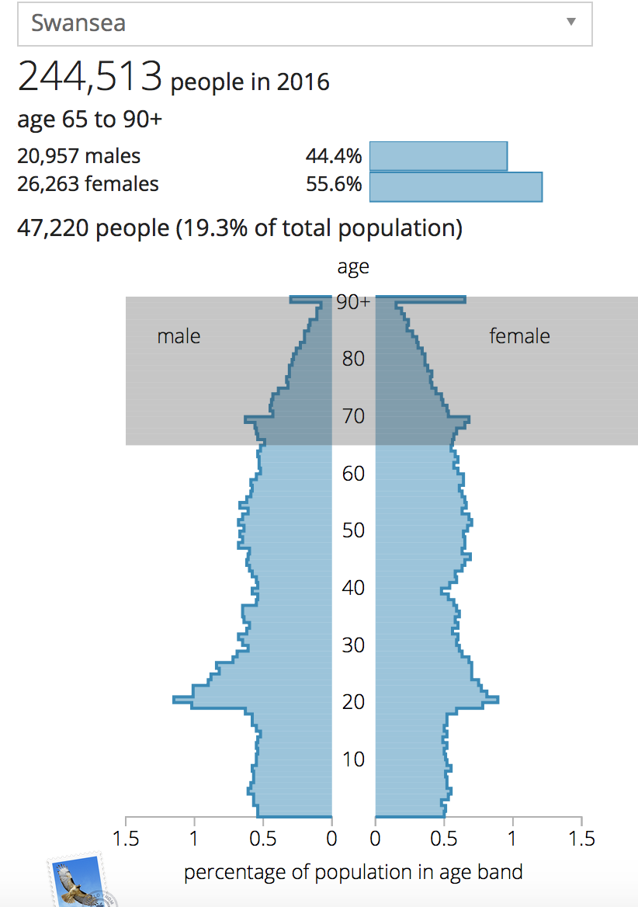
Wales has an ageing population. The National assembly for Wales found that the country’s population was made up of 18 per cent of over 65’s in 2008. Moreover, this is expected to rise by 8 per cent by 2033. Making the over 65’s population in Wales over a quarter of the whole population (Baxter and Boyce, 2011).
Figure 1. Graph displaying the percentage of population of 65+ in the Swansea area in 2016.
The graph displays the percentage of population in the Swansea area in 2016. It shows that the population consisted of 244,513 people in 2016. 47,220 (19.3 per cent) of the total population in the Swansea area were made up by people aged 65 and over. With 20,957 being males and 26,263 being female (ONS, 2017).
I will aim to identify the gaps and needs of the over 65’s age group in the South Wales area. I aim to gather data in order to discover and measure areas of improvement for my target group to help me determine my methods to reach these achievements.

Health
The national health organization believe that health is "a state of complete physical, mental, and social well-being and not merely the absence of disease or infirmity". They suggest that good health leads an individual to participate in employment, exercise and have an active lifestyle. Between 2015 and 2016 the office of national statistics reported that 51 per cent of people over the age of 16 were mostly satisfied with their health. The age group that was the most or completely satisfied with their health were 16 to 24 whereby 59 per cent of the group were satisfied. Furthermore, 40.1 per cent of individuals over the age of 75 were least likely to report that they are fully satisfied with their health and this reflects on the fact that individuals develop more health issues as they get older.
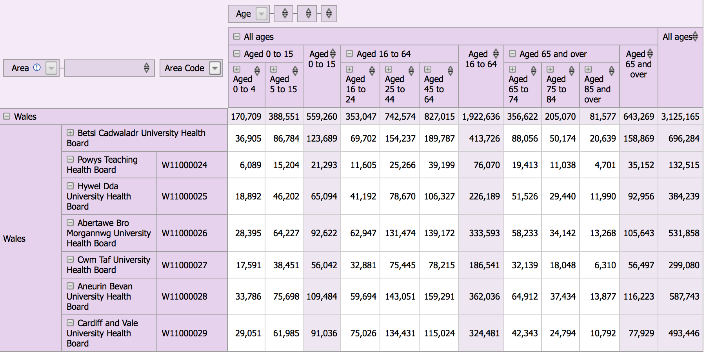
Figure 2. A table displaying the population estimates for the local health boards in Wales in 2017.
The table shows population estimates for the local health boards in Wales in 2017 in numbers. The table shows the number of people in the ‘Abertawe Bro Morgannwg University Health board’ who were aged over 65 were 105,643 people with 58,233 of those being aged 65 to 74. Those in the group aged 75 to 84 made up 34,142 people in the Abertawe health board and 13,268 of people were aged 85 and over. For the group aged 65 and over there were significantly more people within the Abertawe health board compared to those in Cardiff and Vale, Cwm Taf, Powys and Hywel Dda. The age group 65 and over also had significantly more people than the age group 0 to 15 with a difference of 13,021 people. Moreover, the health board with the most amount of people is that of ‘Aneurin Bevan University Health Board’ with 587,743 people.

Loneliness and Social Isolation
Loneliness and social isolation are a growing problem with the over 65’s in the UK population with 36 per cent of this age group, claiming that they do not feel in touch with modern society and a further 8 per cent stating that they do not feel a part of their communities. These issues can cause feelings of disconnectedness for the over 65’s and the outside world, with less than half of the individuals within this age group expressing that they spend most days alone without seeing their families. The major factors that play a role in an individual’s loneliness are; health and disability, being widowed, living alone and age. Increased chronic loneliness and social isolation for the over 65’s can cause a deterioration in health and well-being. It has been shown to increase blood pressure and cardiovascular heart disease, as well as causing sleep problems leading to memory loss. The increase of cortisol and stress levels can weaken the individuals immune system (Age UK, 2015). Three quarters of women over 65 live alone as well as a third of men. Data from the cognitive function and ageing study reported that 25.3 per cent of older people in Wales voiced that they feel lonely as well as 26.9 per cent of older people expressing that they are socially isolated (National Assembly for Wales, 2017).
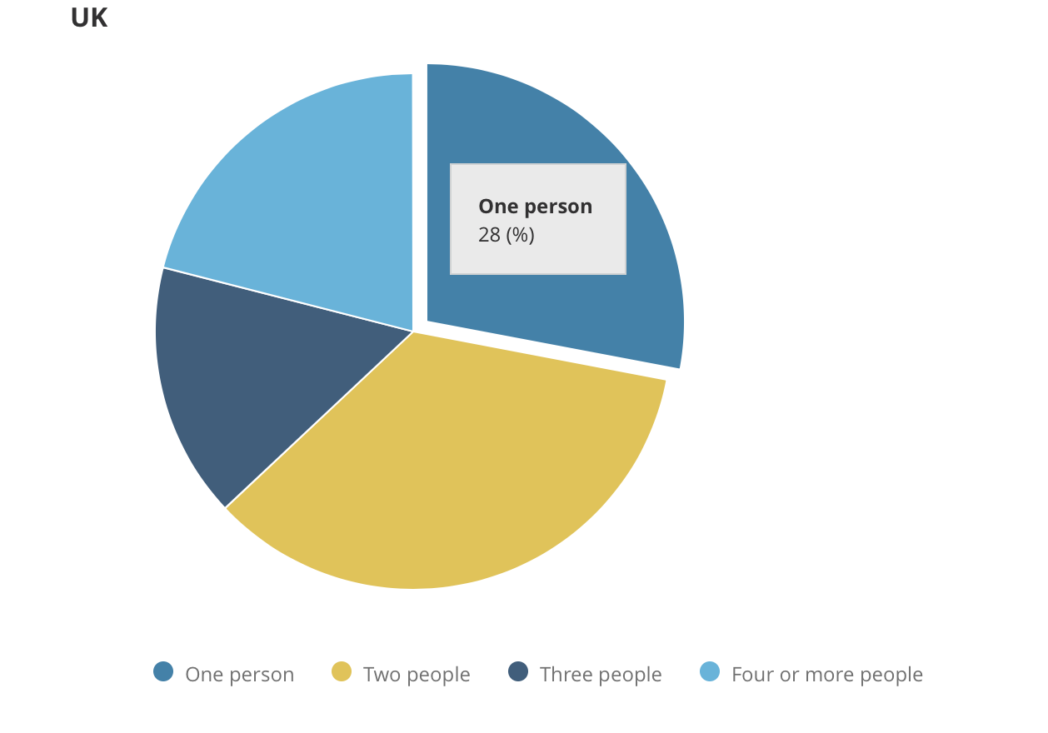
Figure 3. A pie chart displaying the percentage of the UK population on household size in 2017.
Figure 3. shows the percentage of population on household sizes in 2017. The graph shows the percentage of household sizes consisting of one person, two people, three people and four or more people. The percentage of a ‘one person’ household is 28 per cent, therefore, over a quarter of the population in the UK are living alone. A household made up of two people is the largest percentage of the population on household size then four or more people and finally three people being the lowest percentage.
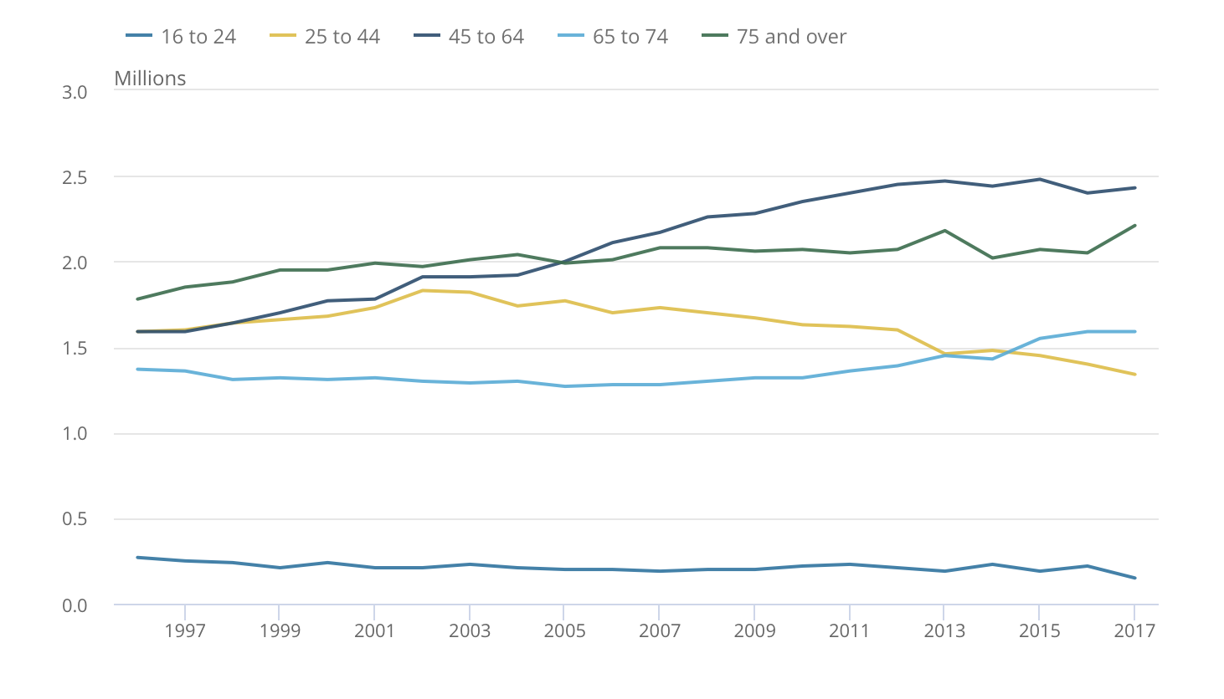
Figure 4. A line graph displaying the number of people in by age group living alone from 1996 to 2017.
Figure 4 shows the number of people in millions living alone by age group from 1996 to 2017. Although the group for 65 and does not have the largest amount of people living alone, it shows that it is steadily increasing. There is a significant increase in those 64 to 74 living alone with an increase of 15 per cent over the two decades. The number of people over 75 living alone has also made a significant increase, with an even larger amount of 24 per cent from 1996 to 2017 (ONS, 2017).

Employment
With life expectancy on the rise in Wales and changes in pensions, the work force in Wales is getting older. It has been reported that by 2022, a third of individuals in the work force will be over the age of 50. In addition, those individuals are planning to retire at a later age. 36 per cent of over 50’s in Wales plan to retire between age 65-69, 15 per cent plan to retire at age 70 or above and 18 per cent of people in Wales plan to work until they are physically or mentally unable to work. The concerned issue here is the unprepared business who are unable to deal with these trends. Statistics show that 43 per cent of small or medium businesses in Wales do not provide training or development for older workers and 68 per cent of medium sized businesses have no plans in places for the employees who opt to work beyond their expected age of retirement (Welsh Government, 2019).
Internet and Technology

2016
2015
2014
2013
2012
2011
23
20
33
32
29
39
%
56
52
66
61
74
71
81
78
75
81
79
88 88
86 87
84
85
88
100
90
80
70
60
50
40
30
20
10
0
Percentage of recent internet users by age
All adults 55-64
65-74
75+

Figure 5. A graph displaying the percentage of recent internet users by age from 2011 to 2016.

Figure 5 shows the percentage of internet users in terms of age from 2011 to 2016 who have used the internet within the last 3 months. The graph shows the percentage of ‘All adults’, 55-64, 65-74 and 75+. The table shows that the use of internet is definitely increasing for all age groups. However, there is still a large proportion of older users having no use of the internet with there being 4.2 million people over the age of 65, never having used the internet in their lifetime. The graph shows that the number of people over the age of 75 using the internet has almost doubled from 2011-2016 (from 20 per cent to 39 per cent). The percentage of internet users for the age group, 65-74 has increased by 22 per cent within 5 years. Also increasing by 13 per cent and equalling to ‘All adults’ is the age group 55-64. And finally, ‘all adults’ increasing from 79 per cent to 88 per cent. Leaving 61 per cent of over 75’s not having use of the internet. 26 per cent of those aged 65-74 being non-internet users. And only 12 per cent of those aged 55-64 and ‘all adults’ having no internet use.
In conclusion, I believe that in the South Wales area there are many issues with Health for the over 65’s. An important factor is due to age, however, there can be links with loneliness and isolation and feeling disconnected to modern society. There is an increase in the number of over 50’s planning to retire at a later age. This could be due to financial issues or worry, however, it could also be due to wanting to keep an active and busy lifestyle that they are used to. In addition, I believe that the internet and technology play a huge role in society today as we live in a digital world and there is a large gap for the percentage of internet users over the age of 65. By enabling over 65’s to make more use of technology and the internet, there may be a chance to reduce issues such as loneliness and social isolation and possibly their health and well-being caused by this.

Reference List
Age UK (2015) Evidence Review: Loneliness in Later Life. [Online] Available at: https://www.ageuk.org.uk/globalassets/age-uk/documents/reports-and-publications/reports-and-briefings/health--wellbeing/rb_june15_lonelines_in_later_life_evidence_review.pdf (Accessed on: 11th January 2019).
Welsh Government (2019) Is your business ready to Capitalise on a rapidly ageing Work Force? [Online] Available at: http://www.ageingwellinwales.com/Libraries/Documents/Older-workers-infographic-eng.pdf (Accessed on: 12th January 2019).
Baxter, J. and Boyce, S. (2011) The Ageing population in Wales. [Online] Available at: https://www.assembly.wales/NAfW%20Documents/ki-020.pdf%20-%2003112011/ki-020-English.pdf (Accessed on: 10th January 2019) Overview of the UK population: July 2017. [Online] Available at: https://www.ons.gov.uk/peoplepopulationandcommunity/populationandmigration/populationestimates/articles/overviewoftheukpopulation/july2017 (Accessed on: 10 January 2019).
National Assembly for Wales (2017) Inquiry to Loneliness and Isolation. [Online] Available at: http://www.assembly.wales/laid%20documents/cr-ld11310/cr-ld11310-e.pdf (Accessed on: 11th January 2019).
ONS (2017) Families and Households: 2017. [Online] Available at: https://www.ons.gov.uk/peoplepopulationandcommunity/birthsdeathsandmarriages/families/bulletins/familiesandhouseholds/2017 (Accessed on: 10th January 2019).

