MANAGING PEOPLE
Table of Contents
1.0 Introduction 3
2.0 Part 1 3
a) The importance of the behaviours according to the CIPD Profession map for effective HR professionals working in the UK 3
b) The application of the map to HR professionals working on a global scale regardless of sectors and sizes of organisations 5
3.0 Part 2 7
a) The causes of skill shortage faced by the public sector in the UK 7
b) Identification of long term labour market development to address the skills shortages in healthcare sector professions in the UK 8
4.0 Conclusion 8
References 10

1.0 Introduction
In terms of managing people in the workplace, the role of the human resource professionals are considered as the important aspect. In this regard, it can be seen that some behaviours, knowledge and principles are stated in the CIPD Profession map that can assist the human resource professionals in order to take the appropriate decision in terms of managing people in the workplace. In this task, the discussion will be done on the basis of the importance of core behaviour for effective HR practices along with the application of the CIPD Profession map to the HR professionals working in the global scale. In addition to that, this task also includes the discussion on the causes of the issue of skill shortage that is facing by the public sector in the UK and the long term marker development for addressing the issue of skill shortage in the healthcare sector of the UK.

2.0 Part 1

a) The importance of the behaviours according to the CIPD Profession map for effective HR professionals working in the UK
According to the CIPD Profession map, there are 8 types of core behaviours that can help the HR professionals in order to drive the performance of the organisations at the peak, and act confidently in the area of managing people (CIPD People Profession, 2022). Those core behaviours for the HR professionals are mentioned as:
- Ethical practice
- Professional courage and influence
- Valuing people
- Working inclusively
- Commercial drive
- Passion for learning
- Insight focused
- Situational decision making
The importance of ethical practice is mentioned as it can help the HR professionals to act persistently according to the laws and regulations related to the HR and people management of the UK. On the other hand, the HR professionals can handle the sensitive data and information in a professional manner with the help of ethical practice. This behaviour is also important for the HR professionals to show honesty in their work so that they can deal with other people in a more effective manner.
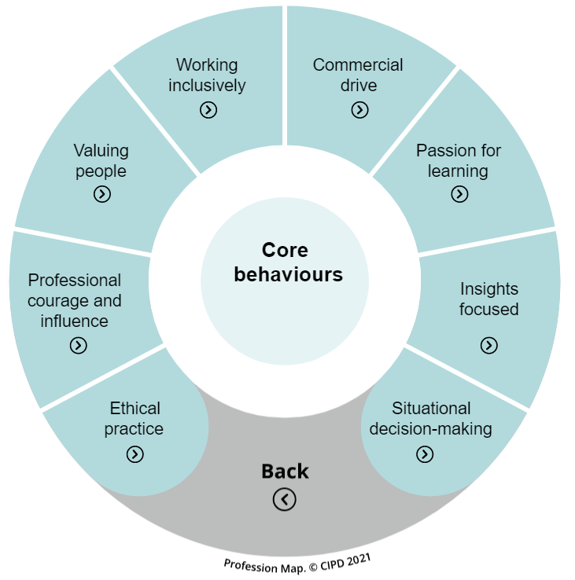
Figure 1: The core behaviours as per the CIPD profession map
(Source: CIPD People Profession, 2022)
The second behaviours “Professional courage and influence” is helpful for the HR professionals to initiate a conversation with a different range of people by understanding different influencing factors or situations in the communication. In addition to that, this behaviour can influence the HR professionals to identify their mistakes so that they can rectify them in the course of managing people. The HR professionals can exchange their viewpoint and opinions clearly with the help of this behaviour (Roper and Higgins, 2020). The third behaviour “Valuing people” can help the HR professionals to empathise with other people in the workplace so that a supportive environment can be created that can endure the overall development of the organisation. This behaviour is beneficial for HR professionals to show value to the opinion of different people so that different perspectives can emerge within the organisation. This behaviour can allow the HR professional to advise the colleagues for their betterment and ensure the wellbeing of the people.
The fourth behaviour “Working inclusively” can help the HR people to operate with a diverse workforce and maintain a positive relationship with the people in the workplace. This also helps to show respect and sensitivity to others so that a positive environment can be maintained (Royce et al., 2021). On the other hand, the passion and interest for learning is important for HR professionals to try new ideas and approaches so that they can manage the people of the organisations in a better manner. This can also help the HR professional to take the feedback positively so that the learning can be endured. Additionally, with the help of situational decision making, the HR professionals are able to take the decision for the people of the organisations that can be beneficial for the further development of the organisation.

b) The application of the map to HR professionals working on a global scale regardless of sectors and sizes of organisations
In the CIPD Profession map, there are different aspects that are included such as specialist knowledge, core behaviour, core knowledge along with the purposes of the CIPD Profession map. In this profession map, the general behaviour, knowledge including core and specialised knowledge are included so that the HR professionals can be able to manage people of the organisations in a more effective manner. In this regard, it can be said that, with the help of the proper knowledge and behaviour, the HR professionals can be able to manage the people in a proper manner so that the overall development of the organisation can be ensured with the improvement of the performance of the workers (CIPD People Profession, 2022). This particular CIPD profession map can bring the opportunity to the organisation to redefine the boundaries of the people who are associated as the HR professionals within different business organisations. In this manner, various business organisations readdress the impact of the HR department on the businesses so that the business aspect can be improved (Short and Anderson, 2020). It can be said that this profession map can be applicable to the HR professionals working on a global scale irrespective of the sectors and size of the organisation as this map is emphasising on driving the changes, managing the complexity within the organisation and navigating the uncertainty within the organisation.
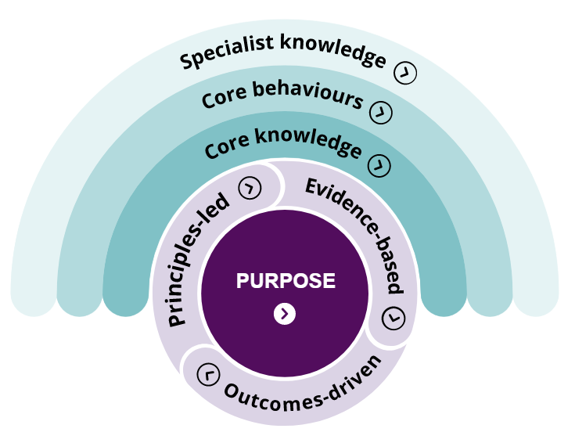
Figure 2: The CIPD profession map
(Source: CIPD People Profession, 2022)
In addition to that, this can be helpful for the business organisation and HR professionals to drive the people of the organisation in a manner so that the employees can be encouraged to improve their performance. This map can be applicable for all types of organisations as it can help the organisation to create and maintain a positive working environment so that their overall sustainability can also be ensured in the competitive market. On the other hand, this map is also helpful for making the decision for the organisations in terms of managing people within the workplace so that this map can be used by all the organisations irrespective of their sector and size in the market (Vincent and Pagan, 2019). Furthermore, this map can allow the organisations to consider the development from technology along with the cultural aspects. Additionally, the map can enable the organisation to maintain clarity and transparency in the skills, expertise and knowledge in the workplace so that the issue of skill shortage can be mitigated by the organisation (Heaslip et al., 2019). This can also be used by various organisations to develop professional credibility so that professional skills can be nurtured within the organisation.

3.0 Part 2

a) The causes of skill shortage faced by the public sector in the UK
According to the recent statistics of the labour market, the companies in different sectors of the UK including the public sectors of the UK are facing the problems of skill shortage. Due to this reason, the companies in different industries including healthcare sector, manufacturing industry are suffering from the issue of attracting and retaining employees in the organisations so that the continuity in the organisational operations are being negatively impacted. It can be seen that, in the UK the employment rate is high however the healthcare sector is suffering from 64% lack of skilled labourers whereas this issue is counted as 54% in the construction industry and 52% in the public sector (CIPD, 2022). This issue is emerging from the problem of the hard-to-fill vacancies. In this regard, in the mentioned sector, the companies were receiving on average 50 applications for the vacant positions in the workplaces in the year 2018 and 2019 but in the year 2021, the number of applications had fallen down to 15 applications per vacant position in the companies in the public sector of the UK (CIPD, 2022). In this regard, some of the companies had identified that after the implementation of the Brexit, the lack of the supply of the labours from the European Union so that the public sector of the UK is suffering from the issue of skill shortage which is mainly dependent on the workforce supplied by the EU.
On the other hand, the public sector of the UK is providing a low amount of pay to their employees so that people are not getting attracted to the vacant positions in the companies of the public sectors of the UK. Therefore it can be seen that, the expectations of the job seekers or the potential employees and the wages provided by the companies are not matching with each other so that the issue of skill shortage is persisting in the public sectors of the UK (Consterdine and Samuk, 2018). In addition to that, the companies in the public sector of the UK are not taking the issue seriously so that the issue is hampering the hiring of the proper workforce. Furthermore, the companies are dependent on the temporary workforce and the recruitment agencies so that they cannot able to reach the wide range of workforce. This can create a barrier to mitigate the issue of the hard to fill vacancies. On the other hand, only 9% of companies in the UK are investing in technology to address the issue of skill shortage along with the issue of labour shortage. In this way, the companies are unable to implement the long term intervention regarding the issue of skill shortage despite the high employment rate.

b) Identification of long term labour market development to address the skills shortages in healthcare sector professions in the UK
In this regard, in the healthcare sector of the UK, the recruitment is based on the recruitment agencies, local newspaper, social media. It can be observed in the healthcare sector of the UK, the people of the local areas are not applying in the vacant positions therefore the healthcare sector has to be reliable on the immigrant people from the EU. In addition to that, there are some factors that are contributing to the issue of skill shortage in the healthcare sector, such as high amounts of stress, lack of work-life balance, inflexible working hours and working patterns (Ajayi et al., 2019). In addition to that, the mentioned sector is facing the issue of labour shortage and skill shortage due to the low amount of wages and the lack of training for developing the required qualities and traits among the employees. In order to mitigate the issue of skill shortage in the healthcare industry by considering the long term labour market the employers of the industry can increase the wages that are to be offered to the potential employees.
On the other hand, in terms of mitigating the issue of skill gap or skill shortage, the employers can maintain a close connection with the local medical and nursing institutes so that they can be able to recruit the skilled workers from those institutions. On the other hand, the industry can secure financial support from the government of the UK so that the companies can ensure the retention of the employees and the proper development of the business organisations (Kasnauskiene and Palubinskaite, 2020). In addition to that, the companies can consider to invest more amount of financial resources to the training aspects of the potential and existing employees so that the employees can achieve their success in their career path (CIPD, 2022). In this regard, the companies can provide a low amount of pay during the training sessions and can increase the pay in their actual time of employment. In this manner, the companies in the healthcare sectors can be able to meet the needs of the employees so that the issue of skill shortage can be mitigated.

4.0 Conclusion
It can be concluded from the above discussion that this task includes the discussion on the importance of the core behaviour defined in the CIPD profession map on the work of the HR professionals in the UK. In this regard, the ethical practice, inclusive style of work, valuing people, passion for learning can help the HR professionals of the UK in order to make the proper decision for managing people by considering the opinions of the employees within the organisations. This professional map can be applicable to all the sectors due to its principles and core knowledge. The companies of the UK are suffering from the issue of skill shortage due to low pay and less attractiveness.

References
Ajayi, S.O., Jones, W. and Unuigbe, M., 2019. Occupational stress management for UK construction professionals: Understanding the causes and strategies for improvement. Journal of engineering, design and technology.
CIPD People Profession. 2022. Core behaviours | CIPD Profession Map. [online] Available at: <https://peopleprofession.cipd.org/profession-map/core-behaviours#gref> [Accessed 26 August 2022].
CIPD People Profession. 2022. Profession Map | CIPD Profession Map. [online] Available at: <https://peopleprofession.cipd.org/profession-map#gref> [Accessed 26 August 2022].
CIPD. 2022. Addressing skills and labour shortages post-Brexit | CIPD. [online] Available at: <https://www.cipd.co.uk/knowledge/work/trends/skills-labour-shortages#gref> [Accessed 26 August 2022].
CIPD. 2022. Labour Market Outlook | Surveys | CIPD. [online] Available at: <https://www.cipd.co.uk/knowledge/work/trends/labour-market-outlook#gref> [Accessed 26 August 2022].
CIPD. 2022. New CIPD research on labour and skills shortages reinforces urgent case for a temporary immigration ‘safety valve’ and long-term reform of skills policy | CIPD. [online] Available at: <https://www.cipd.co.uk/about/media/press/201021labour-skills-shortages#gref> [Accessed 26 August 2022].
Consterdine, E. and Samuk, S., 2018. Temporary migration Programmes: The cause or antidote of migrant worker exploitation in UK. Journal of International Migration and Integration, 19(4), pp.1005-1020.
Heaslip, G., Vaillancourt, A., Tatham, P., Kovács, G., Blackman, D. and Henry, M.C., 2019. Supply chain and logistics competencies in humanitarian aid. Disasters, 43(3), pp.686-708.
Kasnauskiene, G. and Palubinskaite, J., 2020. Impact of high-skilled migration to the UK on the source countries (EU8) economies. Organizations and Markets in Emerging Economies, 11(1), pp.55-68.
Kornelakis, A. and Petrakaki, D., 2020. Embedding employability skills in UK higher education: Between digitalization and marketization. Industry and Higher Education, 34(5), pp.290-297.
Roper, I. and Higgins, P., 2020. Hidden in plain sight? The human resource management practitioner's role in dealing with workplace conflict as a source of organisational–professional power. Human Resource Management Journal, 30(4), pp.508-524.
Royce, M., Jariwala, J., Petzer, M. and Turner, J., 2021. Perspectives of authentic assessment and professional practice interventions in teaching and learning. In SHS Web of Conferences (Vol. 99, p. 01033). EDP Sciences.
Short, H. and Anderson, V.A., 2020. Standards formation and the implications for HRD. European Journal of Training and Development.
Vincent, S. and Pagan, V., 2019. Entrepreneurial agency and field relations: A realist Bourdieusian analysis. Human Relations, 72(2), pp.188-216.

