
BMSW6105 Coaching and Mentoring Skills for the Workplace
Coaching and Mentoring within an organisational context.

December 9, 2022
Samantha davis
1812476

Executive Summary.
Whilst defining coaching and mentoring the following report is going to identify the differences and similarities between the two. The report will be comparing both to other learning initiatives by studying Clutterbucks Four Styles of Helping. The report will also highlight the tangible and intangible benefits of coaching and mentoring to both the employees and employer. The author will identify the necessary skills needed to be an excellent coach/mentor. The report will be highlighting the importance of utilising the various coaching models and the benefits and drawbacks to an organisation for using their line managers in these roles.
It is also important to evaluate the role of coaching and mentoring whilst dealing with change and helping to build resilience. The report will show that by building resilience through coaching and mentoring that the changes can be managed more effectively.
The author will also include a reflection using the Gibbs Model on their performance whilst coaching a colleague in a peer coaching exercise. After completing the reflection, the author will include their own personal development plan. The reflection and conclusion will help to answer the importance of coaching and mentoring within the workplace and identify the necessary skills and attribute an individual need to be successful within these roles.

Contents
Introduction 3
Main findings 4
Task 1 Similarities and differences between coaching and mentoring 4
Task 2: The line manager as a coach/mentor 7
Task 3: Resilience and change 9
Task 4: Reflection 10
Conclusions 12
References 13
Appendices 16

Introduction
The purpose of the report is to define and compare the similarities/ differences between coaching and mentoring within the workplace.
‘Coaching relates primarily to performance improvement (often short-term) in a specific skills area. The goals, or at least the intermediate or sub-goals, are typically set with or at the suggestion of the coach. While the learner has primary ownership of the goal, the coach has primary ownership of the process. In most cases, coaching involves direct extrinsic feedback (i.e., the coach reports to the coached what he or she has observed).’(Meggison and Clutterbuck, Techniques for Coaching and Mentoring)
“Mentoring relates primarily to the identification and nurturing of potential for the whole person. It can be a long-term relationship, where the goals may change but are always set by the learner. The learner owns both the goals and the process. Feedback comes from within the mentee – the mentor helps them to develop insight and understanding through intrinsic observation, that is, becoming more aware of their own experiences.’
The author will be pinpointing the skills a competent coach/mentor would need and the various benefits of introducing Coaching and Mentoring and different learning initiatives to improve and develop an organisations workforce.
The author will also be looking at how Coaching and Mentoring can help in ways for managing change and improving on the employee’s willingness to change. The author will be referencing various Models throughout including the GROW and Oscar Model.
The report will also include a personal reflection on the performance of an individual taking part in a peer coaching exercise using the Instant Pay Off Model (Landsberg,2015) and will be referencing The Gibbs Reflective Cycle.
The author will be using credible sources including books, journals, and websites to complete the report.

Main findings

Task 1 Similarities and differences between coaching and mentoring
Coaching is increasing your effectiveness as a leader whilst helping others to develop and grow. (Landsberg, 2015)
“Coaching aims to produce optimal performance and improvement at work. It focuses on specific skills and goals, although it may also have an impact on an individual’s personal attributes such as social interaction or confidence. The process typically lasts for a defined period or forms the basis of an on-going management style.” (Coaching and Mentoring | Factsheets | CIPD, 2021)
Coaching is a process that aims to improve performance and focuses on the ‘here and now’ rather than on the distant past or future. (Skills you need, 2021).
A good coach can play a pivotal role in the performance of an employee and can help an individual grow and develop immensely and will improve their performance. Some of the necessary skills needed to maximise the coaching experience would be the ability to:
To coach to the best of their ability the coach could align their coaching techniques with that of the OSCAR Model.
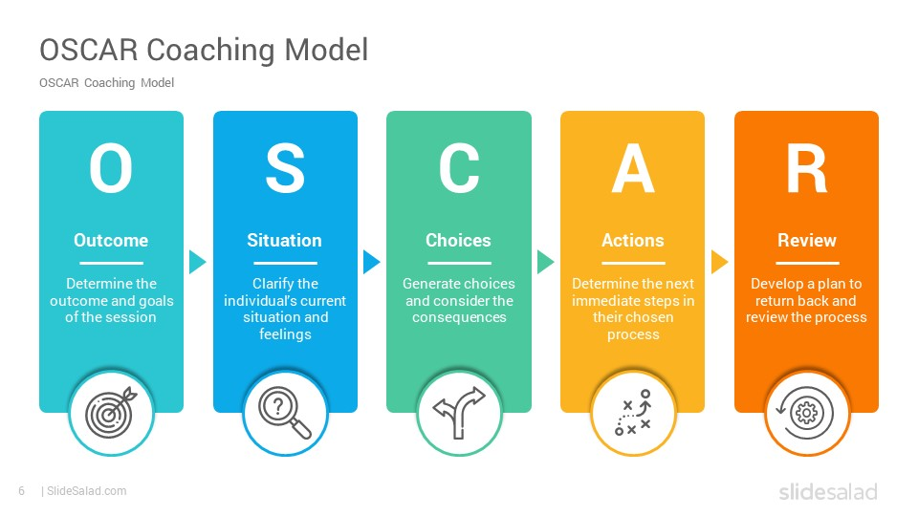(Oscar model coaching - Bing, 2021)

Thomas Addington and Stephen Graves define mentoring as “A mutual relationship with an intentional agenda designed to convey specific content along with life wisdom from one individual to another. Mentoring does not happen by accident, nor do its benefits come quickly. It is relationally based, but it is more than a good friendship…mentoring is not two people who just spend time together sharing”
Whilst David Clutterbuck says, “A mentor is a more experienced individual willing to share knowledge with someone less experienced in a relationship of mutual trust” (16 mentoring definitions, 2021)
Although coaching and mentoring are defined differently they share the same end goal of improving and developing an employee’s skills and attributes. The main similarities are
- One to one training
- Encourage a commitment to action and the development of lasting personal growth & change.
- Support the individual in setting appropriate goals and methods of assessing progress in relation to these goals.

There are also 3 very distinctive differences
- Duration- Whilst coaching only lasts for a short time to achieve its mission mentoring will be more long term typically 9months to a year.
- Focus- Whilst coaching is more Task based and will focus on the developing of specific skills and issues mentoring will be more Relationship based.
- Performance-The purpose of coaching is to improve the individual's performance on the job. This involves either enhancing current skills or acquiring new skills. The mentoring on the other hand is to develop the individual not only for the current job, but also for the future.
Coaching and mentoring are not the only learning initiatives that organisations are adapting to.
(Clutterbuck, 2014) Clutterbucks Four basic styles on helping suggest that there are 4 ways of learning and that mentoring feeds on all four.
1. Coaching
2. Counselling
3. Networking
4. Guidance
Counselling and Wellbeing Programmes can compare to Coaching and Mentoring however there are significant benefits to these other two learning initiatives.
“As the line between work and life blurs, providing a robust suite of well-being programs focused on physical, mental, financial, and spiritual health is becoming a corporate responsibility and a strategy to drive employee productivity, engagement, and retention.
Many employers are putting in place innovative programs for financial wellness, mental health, healthy diet and exercise, mindfulness, sleep, stress management, and more. The aim? To both increase worker productivity and meet new social expectations.” (Well-being: A strategy and a responsibility, 2021)
Coaches and Mentors can be excellent in their field however they are not trained professionals in the need for individuals to receive Counselling, they are however excellent individuals who will be able to recognise the signs that individuals may need to seek this professional service. The main difference between being coached/ mentored or counselled is that a counsellor can help an individual both mentally and emotionally. With the help of a counsellor or wellbeing programme an employee can become more stable and confident in dealing with added stress or difficulties the job presents.
It is important that organisations are looking at ways they can improve their wellbeing programmes to ensure the staff retention is at its best and that all staff are happy in the workplace to ensure the growth and success of an organisation.

Task 2: The line manager as a coach/mentor
(Downey, 2003) believes that the role of a line manager is multi facing and in today’s climate they take on the role of Leader Manager Coach and Mentor.
“The role of the manager, in short, is becoming that of a coach. Increasingly, coaching is becoming integral to the fabric of a learning culture—a skill that good managers at all levels need to develop and deploy. (Harvard Business Review; 2021)

There are benefits and drawbacks to this multi facing role as you have one individual responsible for everything. An effective line manager as coached/mentor must possess a certain set of skills and attributes as they are the link between the employees and the management team. There are numerous skills the manager will need to possess including
• Excellent communication
• Organisational/Time Management
• Delegation skills
• Honest/Trustworthy
• Motivational skills
• Accountable
• Invested
• Creative (Connor and Pokora, 2009)
For the line manager to be an effective coach and mentor they need to familiarise themselves with the GROW model and put the model into practice. The GROW Model is a simple four-step process that helps you structure coaching and mentoring sessions with team members.
GROW is an acronym that stands for:
• Goal
• Reality.
• Options (or Obstacles)
• Will (or Way Forward)
(Grow model coaching - Bing, 2021)
It is important for a team leader to be successful in coaching and mentoring that they
1. Establish the goal
2. Identify the reality of where they are
3. Explore the options
4. Establish the Will
This model relies heavily on the excellent communication skills of the line manager as the GROW Model encourages plenty of questions at each level.
The benefits of the line manager being the coach/mentor. There will be better team performance as everyone is working towards the same goal. The working relationships will be improved, and creativity and innovation are invited. The team will also be more committed as they have built a rapport with their line manager and have a greater understanding of their demands.
Unfortunately, there are also some drawbacks to the line manager also being the coach/mentor including
Groupthink
Inequality in who gets coaching
Time pressures

Task 3: Resilience and change
“Change management is the overarching approach taken in an organisation to move from the current to a future desirable state using a coordinated and structured approach in collaboration with stakeholders.” (What is change management and organisational change? | APM, 2021)
“Change management is defined as a structured approach to transitioning individuals, teams, and organisations from a current state to a desired future state. It can be applied to situations such as downsizing, introducing a new internal process or adding new technology. Research shows that actively managing change can increase the success rate of these initiatives” (Society for Human Resource Management, 2015)
Change management is defined as the methods and manners in which a company describes and implements change within both its internal and external processes. This includes preparing and supporting employees, establishing the necessary steps for change, and monitoring pre- and post-change activities to ensure successful implementation. (What is Change Management? Organizational, Process, Definition & Tools | ASQ, 2021)
Research has shown that coaching can play a big part in the change management, this can be done in gaining trust promoting equality and fairness and engaging employees in the change process. It is also a great time to communicate and collaborate by promoting creativity and asking employees for their ideas and recommendations.
Fundamentally, resilience refers to positive adaptation, or the ability to maintain or regain mental health, despite experiencing adversity.
Coaching and mentoring can be invaluable helping reduce resilience within change. The coach/mentor is in an excellent position of trust to help eradicate people’s fears and resistance and by understanding the various stages of resilience and familiarizing themselves with Lewins (1947) and Kotters change model they can help the transitiong happen at a positive an steady pace while alleviating any employees stress or tensions.
A coach or mentor can help facilitate change through educating themselves on the Kubler- Ross Change Model. (Kubler ross change curve - Bing, 2021)
This model can help greatly with understanding where an individual is in the change curve. Each step can be controlled to minimise the feeling by having a good coach/mentor employed. Throughout the five steps the coach could be the best asset the organisation has. A coach or mentor can help facilitate change through educating themselves on the Kubler- Ross Change Model. (Kubler ross change curve - Bing, 2021)
This model can help greatly with understanding where an individual is in the change curve. Each step can be controlled to minimise the feeling by having a good coach/mentor employed. 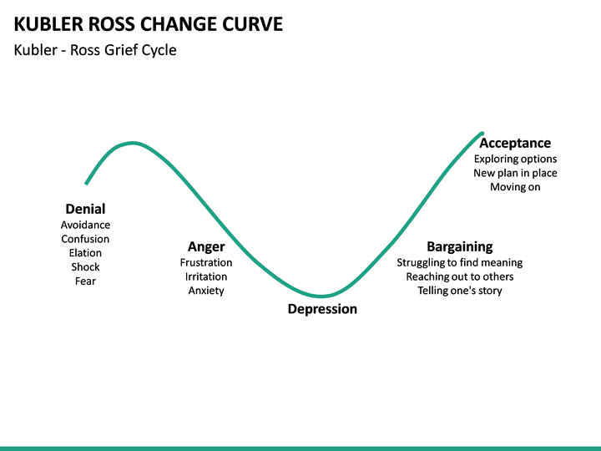 (Kubler ross change curve - Bing, 2021)

Task 4: Reflection
To critically evaluate my performance in the role of coach for our peer coaching exercise it was important to sit down and reflect on the experience. By reflecting on the experience, it would me identify both my strengths and weaknesses and often will help highlights areas I could improve on to make me more efficient in the future
Reflecting is a way of helping an individual develop critical thinking skills and helping them to improve in the future. Reflecting will help an individual become more aware of their strengths and weaknesses and helps them understand what they have learned and how they could do things differently to improve on their goals in the future. (Why 'Reflection' Encourages a Better Learning Experience - Learning Pool, 2021)
During the coaching experience I was playing the part of coach whilst my fellow student Dani was playing the role of coachee. To reflection, I decided to use Gibbs Reflective Cycle to help me learn from my experience.
- Description- In the session it was immediately identified that Dani had a problem with her organisational skills, and this was affecting her ability to meet deadlines and succeed in her role as a team leader. I decided to use the Instant Pay Off Model (Landsberg, 2015) to help me coach Dani more efficiently.
- Feelings- This was a difficult one as I felt the Instant Pay Off Model was too informal to get the necessary results and I think for coaching to be truly successful it needs to take place over a suitable timeframe and not just a one-off session.
- Evaluation/ Analysis- I felt that this exercise would have worked better had I been coaching a stranger as the informalities of the model tended to make the exercise feel like 2 friends having a chat. I also think it could have worked better had we had an observer taking notes and highlighting the positives and negatives of the session.
- Conclusions- After the exercise and some brainstorming I realised I would have preferred to use a different model as I felt the Instant Pay Off Model was too basic and reliant on the coached.
- Action Plan- After reflecting on the experience I decided if I was to be in a coaching position again I would definitely consider using a different coaching model as I believe the GROW and OSCAR are both more effective than the Instant Pay Off, I have also provided a PDP to highlight my aims and objectives as this will allow me to monitor and change my progress accordingly.
My PDP will help me monitor by progress moving forward and help me achieve the set targets by having implemented the plan. I also thought it would be beneficial to perform a SWOT analysis on my skills and would use this tool to help me determine my strengths and weaknesses. (How SWOT (Strength, Weakness, Opportunity, and Threat) Analysis Works, 2022).
After discussing with Dani her feelings on being coached by myself I concluded that I had excellent communication skills and made her feel relaxed and comfortable with the session.
I personally did not feel like it was a coaching session but due to the style of the Instant Pay Off Model was more of an informal chat. I did enjoy acting as coach, but had we been given more time I would have liked for it to be a bit more formal and professional with a detailed plan being implemented to move forward.

Conclusions
The report shows that not only is coaching and mentoring beneficial for the coached or mentored but that it is also an excellent skill to possess as a line manager. Throughout any form of interaction between individuals/ work colleagues it is important to be as open and transparent throughout. Communication is one of the greatest skills you can possess as an effectively and honestly.
Whilst the report has highlighted the evolving roles of the line manager it is important to realise that there is also trained professionals who can be brought in when the need occurs.
Whilst an organisation will benefit greatly both financially and productively through in house coaching and mentoring it is important to know when there is a need for external organisations to come in and do some training to also develop and enhance the skills and knowledge of the employees.
“One on one coaching has been rated as the most beneficial for companies in achieving their goals.” (Mook, 2021)
Whilst the report shows that a coach and mentor is beneficial to an organisation it is also important to ensure that these individuals are not put upon too much and that they familiarise themselves with all the necessary models and theories that will nor only make them more successful but also help the organisation move forward and adapt to the world around them.

References
https://journals.sagepub.com/doi/pdf/10.1177/070674371105600504
Landsberg, M. (2015) The Tao of Coaching: Boost your effectiveness at work by inspiring and developing those around you. London: Profile Books
1000ventures.com. 2021. Instant Payoff Coaching: Building Coachee's Problem-Solving Skills in 10 Minutes (Your first-ever Business e-Coach). [online] Available at: <http://www.1000ventures.com/business_guide/crosscuttings/coaching_instant-payoff.html#:~:text=When%20To%20Use%20Instant%20Payoff%20Coaching%20You%20can,%E2%86%92%20problem.%20%E2%86%92%20Problem%20Solving%20Strategies%3A%204%20Levels> [Accessed 5 December 2022].
2022. [online] Available at: <https://www.skillsyouneed.com/https://www.skillsyouneed.com/learn/coaching.htmlaching.html> [Accessed 5 December 2022].
Apm.org.uk. 2022. What is change management and organisational change? | APM. [online] Available at: <https://www.apm.org.uk/resources/what-is-project-management/what-is-change-management/> [Accessed 5 December 2022].
Asq.org. 2022. What is Change Management? Organizational, Process, Definition & Tools | ASQ. [online] Available at: <https://asq.org/quality-resources/change-management> [Accessed 5 December 2022].
Bing.com. 2022. grow model coaching - Bing. [online] Available at: <https://www.bing.com/images/search?view=detailV2&ccid=dt%2fVMj4X&id=055254A015E841CD12790A880646733A052DBE0B&thid=OIP.dt_VMj4XWhrLYyQRZ7cPqgHaFj&mediaurl=https%3a%2f%2fwww.performanceconsultants.com%2fwp-content%2fuploads%2fimages_Grow+Model.gif&exph=720&expw=960&q=grow+model+coaching&simid=607994247651809926&ck=C7788074E13CA981A7C0EFC2DDC15BB5&selectedIndex=0&FORM=IRPRST&idpp=overlayview&ajaxhist=0> [Accessed 5 December 2022].
Bing.com. 2022. Oscar model coaching - Bing. [online] Available at: <https://www.bing.com/images/search?view=detailV2&ccid=zibY0hsu&id=1FD4CE4C5AAC7F747301230925972F364D689E66&thid=OIP.zibY0hsupIg1xxKFA0TJEgHaEK&mediaurl=https%3a%2f%2fwww.slidesalad.com%2fwp-content%2fuploads%2f2020%2f11%2fOSCAR-Coaching-Model-PowerPoint-Templates-0005.jpg&exph=540&expw=960&q=oscar+model+coaching&simid=608049644137964877&ck=E49EFBE185E4E1AA7AB17FA967131728&selectedIndex=8&FORM=IRPRST&ajaxhist=0> [Accessed 5 December 2022].
CIPD. 2022. Coaching and Mentoring | Factsheets | CIPD. [online] Available at: <https://www.cipd.co.uk/knowledge/fundamentals/people/development/coaching-mentoring-factsheet> [Accessed 4 December 2022].
Clutterbuck, D. (2014). Everyone needs a mentor. 5th edition. CIPD, London.
Clutterbuck, D., Megginson, D. and Bajer, A., 2016. Building and Sustaining a Coaching Culture. London: The Chartered Institute of Personnel and Development.
Connor, M. and Pokora, J., 2009. Coaching and mentoring at work. 2nd ed. Berkshire: McGraw-Hill/Open University Press, pp.5-11.
Deloitte Insights. 2022. Well-being: A strategy and a responsibility. [online] Available at: <https://www2.deloitte.com/uk/en/insights/focus/human-capital-trends/2018/employee-well-being-programs.html> [Accessed 5 December 2022].
Downey, M., 2003. Effective coaching. Thomson/Texere, p.110.
Harvard business review. 2022. [online] Available at: <https://hbrhttps://hbr.org/2019/11/the-leader-as-coach.org/2019/11/the-leader-as-coach> [Accessed 5 December 2022].
Hawkins, P. and Smith, N., 2013. Coaching, Mentoring and Organizational Consultancy. 2nd ed. Maidenhead: McGraw-Hill Education, p.33.
Landsberg, M., 2015. The Tao of Coaching. 3rd ed. London: Profile Books, p.7.
Learning Pool. 2022. Why 'Reflection' Encourages a Better Learning Experience - Learning Pool. [online] Available at: <https://learningpool.com/why-reflection-encourages-a-better-learning-experience/> [Accessed 5 December 2022].
Mathews, S. (1997). Mentoring and coaching: the essential leadership skills. London: FT Pitman. (Financial Times Management Briefings)
Megginson, D. and Clutterbuck, D. (2005). Techniques for coaching and mentoring. Amsterdam; London: Elsevier Butterworth Heinemann
Mindtools.com. 2022. Gibbs' Reflective Cycle: Helping People Learn from Experience. [online] Available at: <https://www.mindtools.com/pages/article/reflective-cycle.htm> [Accessed 4 December 2022].
Momentwmconsulting.co.uk. 2021. Momentwm Consulting – Creating futures where individuals, teams, and organisations flourish. [online] Available at: <https://www.momentwmconsulting.co.uk/> [Accessed 5 April 2021].
Mook, M., 2022. Change Management: Using Coaching to Equip Your Team for Success. [online] Training Industry. Available at: <https://trainingindustry.com/articles/leadership/change-management-using-coaching-to-equip-your-team-for-success/> [Accessed 5 December 2022].
Training Journal. 2022. 16 mentoring definitions. [online] Available at: <https://www.trainingjournal.com/blog/16-mentoring-definitions> [Accessed 5 December 2022].
Training, C., 2022. Change Management Training. [online] Store.shrm.org. Available at: <https://store.shrm.org/Change-Management-Training?_ga=2.71133712.1800077249.1617997308-1552243950.1617997308> [Accessed 5 December 2022].
Worthlearning. 2022. Oscar Coaching Model - Worthlearning. [online] Available at: <https://www.worthlearning.co.uk/oscar-coaching-model/> [Accessed 4 December 2022].

Appendices
Appendix 1: Gibbs Reflective Cycle

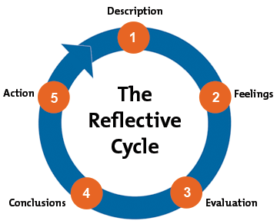
(Gibbs' Reflective Cycle: Helping People Learn from Experience, 2021)

Appendix 2: Personal Development Plan
Personal Development Plan
Name: Samantha Davis
What do I want to learn? | How will I achieve? | What resources will I need? | What are my success criteria? | Completion  Date.
To become a coach/mentor | To attend a C/M conference | Time off from work.  Purchase books and watch TED talks | Complete course  Gain a certificate, | TBC
To mentor the new employees | By setting up a goal with the staff and doing regular sessions | To carry out the various roles of a mentor | When the employees are comfortable with their learning. | Ongoing
To coach the current staff in the upcoming changes. | To familiarise myself with the changes and then coach my peers | All relevant information and guidelines of the necessary changes | All staff are up to date on the changes.  Had a positive experience | TBC
To familiarise myself with all coaching/mentoring models. | Study the models  Practice sessions | Online, Library and Lecturers | When I am confident in my understanding of the models. | Ongoing

Appendix 3: Instant Pay Off Coaching Model.
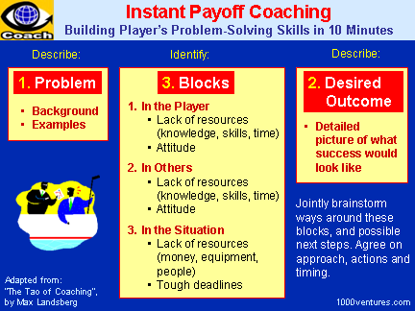
(Instant Payoff Coaching: Building Coachee's Problem-Solving Skills in 10 Minutes (Your first-ever Business e-Coach), 2021)

