~Digital Skills for Personal and Professional Growth~
~BMSW4008~
~Evidence of Learning~
~ E-portfolio~

Lecturer name: Philippa Fitzgerald

Student name: Marius-Ionel Patrascu
Student id: 2329813
Date: 26 August 2025

Table of Contents
Task 1: Questionnaire Analysis for M&S Burger Van 3
Task 2: Website and Marketing Materials Development 7
Task 3: The Importance of Excel in the Digital Era 14
Task 4: Reflection 18
References 20
Appendix: Task 1 Raw Data 23

List of Figures
Figure 1 Q1 Bar Graph 3
Figure 2 Q2 Bar Graph 4
Figure 3 Q4 Bar Graph 4
Figure 4 Q10 Bar Graph 5
Figure 5 Home Page 7
Figure 6 Home Page 8
Figure 7 Menu Page 9
Figure 8 Flyer 10
Figure 9 Instagram Post 11
Figure 10 Spreadsheet 13
Figure 11 Bar Chart 13

Task 1: Questionnaire Analysis for M&S Burger Van
Introduction
M&S Burger Van, founded by Marius and Simona, introduces authentic Romanian street food—featuring mici, covrigi, and fusion burgers with cabbage and garlic sauces—to Queen Street, Cardiff, capitalizing on its bustling foot traffic. The goal is to achieve £120,000 in first-year sales and a 30% increase in repeat customers. A 10-question market research questionnaire, crafted using Microsoft Forms, was distributed to 13 classmates acting as potential customers, with responses collected over 33 days, averaging 1 minute 22 seconds per response. Analysis pinpointed four critical questions—Q1 (visit frequency), Q2 (menu preference), Q4 (portion satisfaction), and Q10 (recommendation likelihood)—offering valuable insights to refine this venture (Reedy and Parker, 2017).
Data Insights and Observations
Q1: How often do you eat from a burger van?
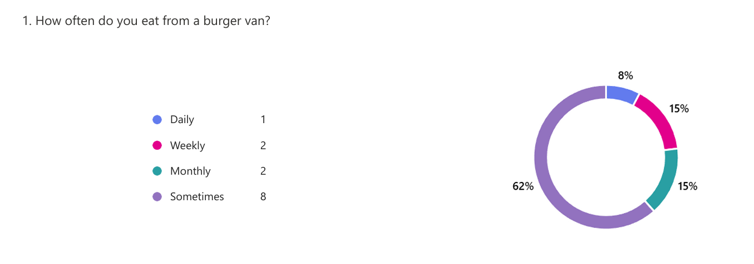
Figure 1 Q1 Bar Graph
Responses show 1 daily (7.7%), 2 weekly (15.4%), 2 monthly (15.4%), and 8 sometimes (61.5%). This indicates a dominant trend of occasional consumption, with “sometimes” reflecting over half the respondents. The pattern suggests burger vans are not a regular habit, likely due to location or awareness, presenting a challenge for M&S on Queen Street (Vanarama, 2024).
Q2: What is your favorite item on our menu?
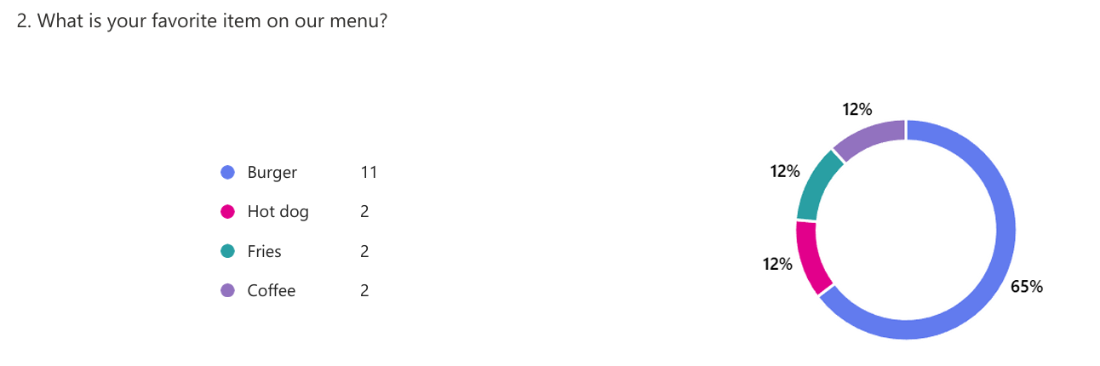
Figure 2 Q2 Bar Graph
Eleven respondents (84.6%) favored burgers, with 2 each (15.4%) selecting hot dogs, fries, and coffee (total exceeds 13, possibly indicating multi-selections; assumed single choice). A clear trend emerges burgers are the top draw, aligning with M&S’s core offering. This pattern supports a focus on Romanian-inspired burgers (Dadwal, 2020).
Q4: How satisfied are you with the portion sizes?
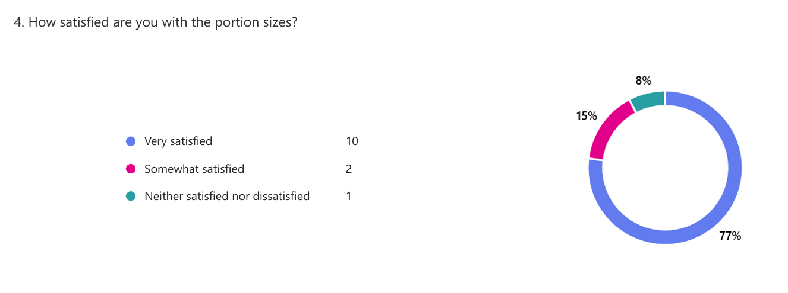
Figure 3 Q4 Bar Graph
Ten respondents (76.9%) were very satisfied, 2 (15.4%) somewhat satisfied, and 1 (7.7%) neither satisfied nor dissatisfied. The trend leans heavily toward approval, with 92.3% expressing satisfaction. This pattern highlights generous portions as a strength, appealing to Cardiff’s value-seeking crowd (Bencsik, 2017).
Q10: Would you recommend our burger van to others?
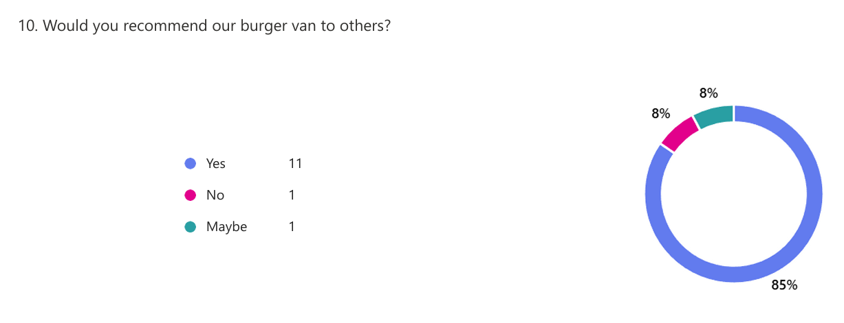
Figure 4 Q10 Bar Graph
Eleven respondents (84.6%) said yes, 1 (7.7%) no, and 1 (7.7%) maybe. The trend indicates strong advocacy potential, with a pattern suggesting word-of-mouth could drive growth. This supports M&S’s repeat customer goal (Paulus and Nijstad, 2003).
Key Findings and Implications
The low frequency of visits (Q1) reveals a hurdle: only 23.1% visit weekly or daily, implying M&S must enhance visibility and convenience on Queen Street to convert occasional visitors into regulars (Street Food Expo, 2025). The 84.6% burger preference (Q2) validates the focus on Romanian fusion burgers, offering a foundation to build menu appeal and meet sales targets. High portion satisfaction (92.3%, Q4) suggests a competitive edge, resonating with customers seeking hearty, affordable options in a busy location. The 84.6% recommendation rate (Q10) indicates a loyal base, ripe for leveraging through referrals to boost the 30% repeat customer aim (Soltanifar et al., 2021).
Strategic Applications for M&S Burger Van
To tackle the 61.5% “sometimes” visits (Q1), M&S will establish a fixed Queen Street schedule and launch a “Buy 4, Get 1 Free” loyalty card, targeting busy professionals and tourists to increase frequency toward the 30% repeat goal. The 84.6% burger preference (Q2) reinforces prioritizing a “Mici Deluxe Burger” (£7.50) with authentic Romanian spices, driving £120,000 sales through targeted promotion. Portion satisfaction (Q4) will be marketed with “Hearty Romanian Bites,” enhancing perceived value and attracting Cardiff’s diverse foot traffic. The high recommendation rate (Q10) supports a “Refer a Friend, Get 10% Off” campaign, amplifying word-of-mouth to secure loyal customers (Byrd, 2021).
Conclusion
The questionnaire data affirms M&S Burger Van’s Romanian street food concept, with strong burger preference, portion approval, and recommendation potential supporting its Queen Street strategy. Addressing infrequent visits through visibility and incentives will be key to achieving £120,000 sales and 30% repeat growth, positioning M&S competitively in Cardiff’s vibrant street food scene (Sandhu, 2020).

Task 2: Website and Marketing Materials Development
Introduction
M&S Burger Van, a partnership between Marius and Simona, brings authentic Romanian street food—mici burgers, covrigi, and fusion delights with cabbage and garlic sauces—to Queen Street, Cardiff, leveraging its high foot traffic. With a goal of £120,000 in first-year sales and a 30% increase in repeat customers, the business relies on insights from a 13-response Microsoft Forms questionnaire. Key findings include an 84.6% preference for burgers, 92.3% satisfaction with portion sizes, 61.5% "sometimes" visit frequency, and 84.6% recommendation likelihood. These insights shaped the creation of a two-page Weebly website (Home Page and Menu Page) and Canva-designed marketing materials (Flyer and Instagram Post) (Burgess et al., 2018).
Home Page Design and Strategy
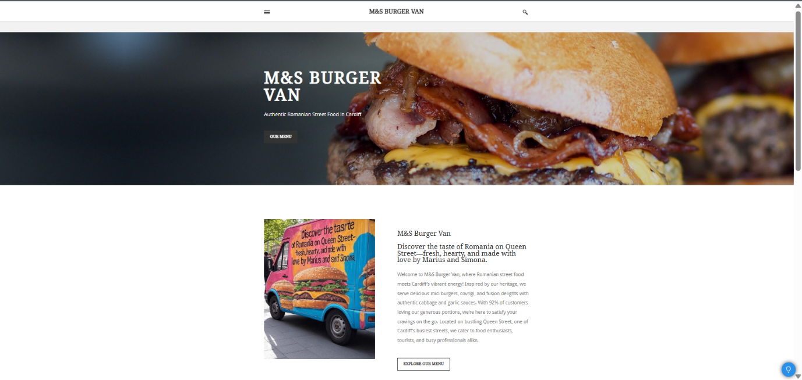
Figure 5 Home Page
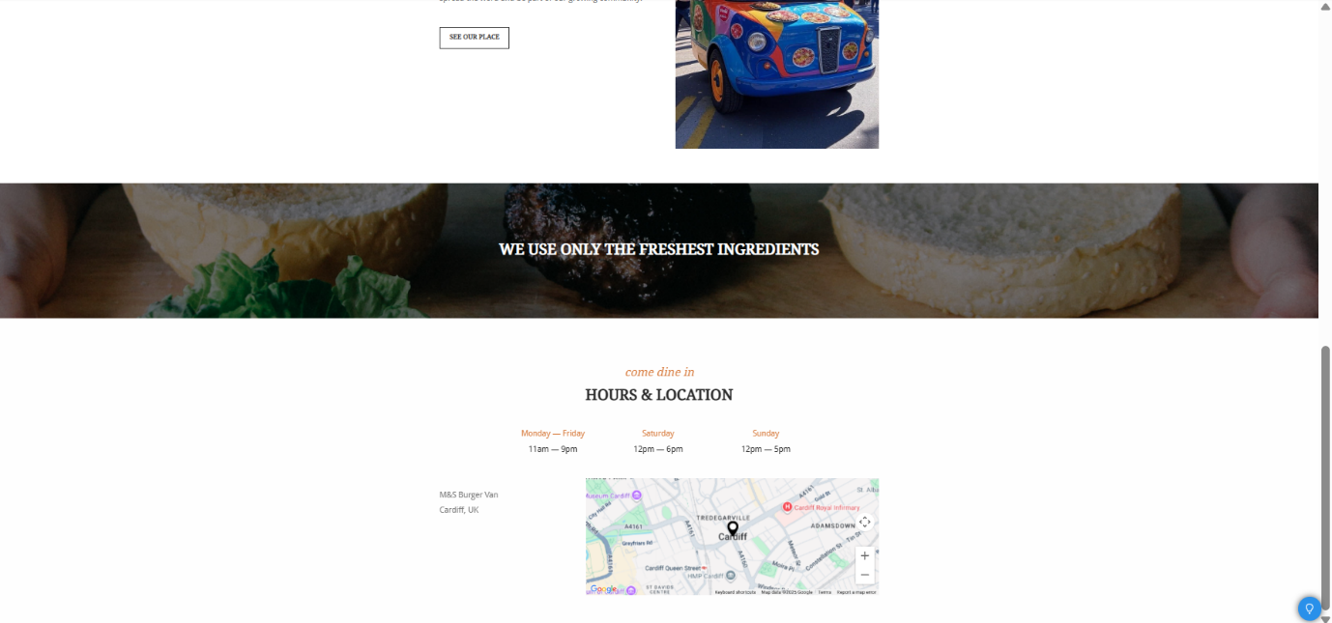
Figure 6 Home Page
The Home Page was crafted to reflect the 84.6% burger preference and 92.3% portion satisfaction from the questionnaire. The header, "M&S Burger Van: Authentic Romanian Street Food in Cardiff," immediately targets food lovers and tourists seeking cultural experiences. The tagline, "Savor Hearty Romanian Flavors on Queen Street," leverages the 92.3% satisfaction rate, appealing to value-conscious professionals. Given the 61.5% "sometimes" visit frequency, a prominent "Find Us on Queen Street" section with a map link addresses location awareness, encouraging regular visits from Cardiff’s busy foot traffic.
Segmentation focuses on three groups: food enthusiasts drawn to authentic mici burgers, tourists exploring Cardiff’s culinary scene, and professionals needing quick, hearty meals. Content highlights "92% Love Our Portions" to attract value-seekers, while a "Loyalty Program: Buy 4, Get 1 Free" CTA targets repeat business, supporting the 30% growth goal. The page features a vibrant image of a Mici Burger, reinforcing the USP.
For SEO, the meta description reads, "Enjoy authentic Romanian street food in Cardiff at M&S Burger Van. Visit Queen Street for mici burgers and more!" Keywords like "Romanian street food Cardiff" and "Queen Street food van" are embedded in headers and alt texts, optimizing for local searches. Weebly’s SEO tools ensure "M&S street food" appears in site tags, boosting discoverability. The design uses a red-white-blue color scheme inspired by the Romanian flag, enhancing cultural appeal (Clark, 2024).
Menu Page Design and Strategy
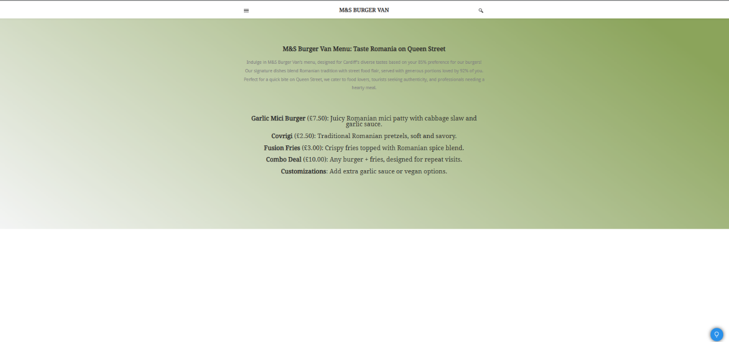
Figure 7 Menu Page
The Menu Page builds on the 84.6% burger preference, listing items like the Garlic Mici Burger (£7.50) and Covrigi (£2.50). The header, "M&S Burger Van Menu: Taste Romania on Queen Street," targets food enthusiasts and tourists, while "Generous Portions Loved by 92%" from Q4 satisfaction appeals to professionals seeking value. The 61.5% "sometimes" frequency is addressed with a £10 Combo Deal (burger + fries), encouraging repeat visits. The 84.6% recommendation rate inspires a "Share Your Favorite" CTA, driving word-of-mouth.
Segmentation targets food lovers with customizable options (e.g., extra garlic sauce), tourists with authentic Romanian bites, and professionals with quick-service combos. Descriptions like "Authentic Mici with Cabbage Slaw" highlight cultural resonance, supported by the 92.3% portion approval. A red-white layout reflects Romanian heritage, with a centered menu grid for clarity.
SEO includes a meta description: "Check M&S Burger Van’s menu for authentic Romanian street food in Cardiff. Order mici burgers and covrigi on Queen Street!" Keywords "Cardiff Romanian burgers" and "mici prices" are used in headings and alt texts, targeting local and niche searches. Weebly’s settings embed these terms for search engine ranking (Kirtok et al., 2023).
Flyer Design and Strategy
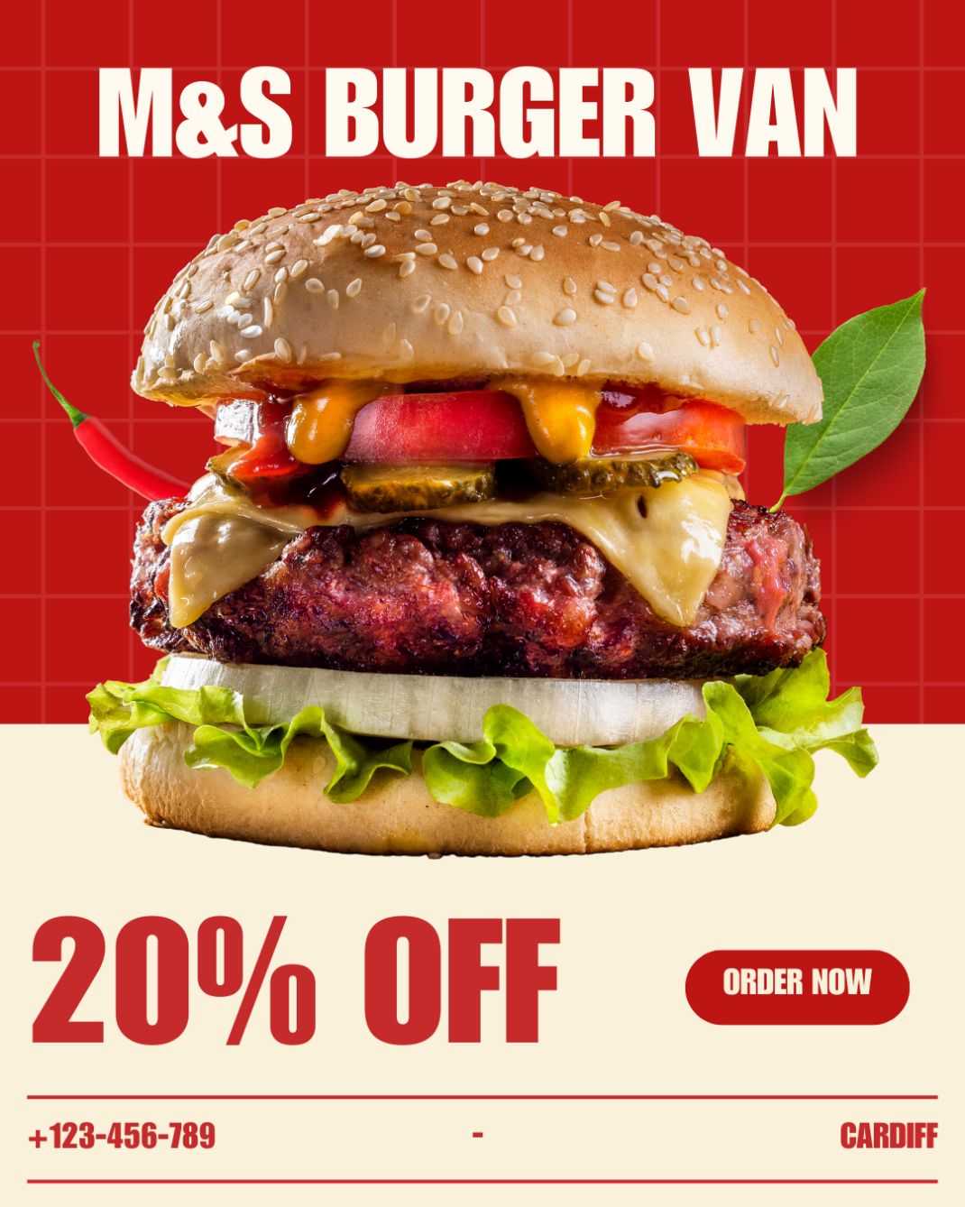
Figure 8 Flyer.
The Canva-designed flyer for M&S Burger Van captures immediate attention with its bold red background, central image of a stacked burger, and headline “20% OFF”. This design draws directly on questionnaire insights, especially the 84.6% burger preference and 92.3% satisfaction with portion sizes. By positioning the burger image as the hero element, the flyer appeals to food enthusiasts who value hearty meals.
The discount message—20% OFF—addresses the 61.5% of respondents who visit burger vans only “sometimes”, incentivizing trial and encouraging repeat visits. A clear “Order Now” call-to-action supports this push toward engagement. Additionally, the inclusion of location (Cardiff) and contact details enhances accessibility, making it easier for potential customers to find the van.
Cultural authenticity is maintained through the minimalist yet bold design, reflecting confidence in product quality rather than overloading with text. The red theme, inspired by energy and appetite stimulation, resonates with both professionals on lunch breaks and tourists seeking vibrant food experiences. By using promotional discounts and bold visuals, the flyer positions M&S Burger Van as an attractive, affordable street food option aligned with its mission of achieving £120,000 in sales and 30% repeat business growth.
Instagram Post Design and Strategy
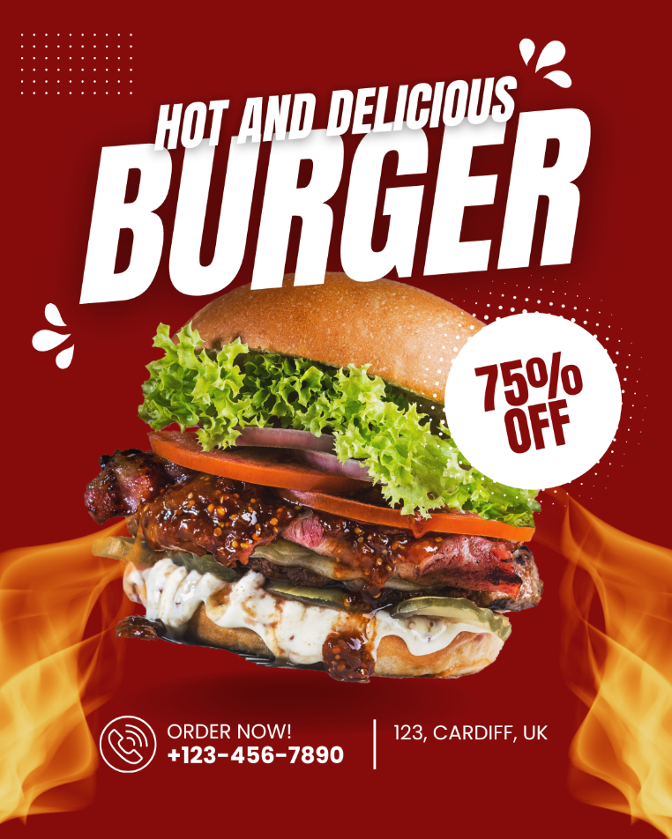
Figure 9 Instagram Post
The Instagram post design leverages social media aesthetics to connect with Cardiff’s digitally engaged audience. Featuring a close-up of a burger with fiery background elements, paired with the text “Hot and Delicious Burger – 75% OFF”, the post aligns with the 84.6% burger preference insight while amplifying urgency through an aggressive discount. This strategy taps into impulse buying behavior common among social media users.
Segmentation is evident:
- Food enthusiasts are drawn by the high-quality visuals and indulgent burger appeal.
- Tourists are targeted through location tagging (Cardiff, UK) and hashtags.
- Professionals are attracted to the quick, takeaway-friendly nature of the offer.
The “Order Now!” button and phone number make the promotion actionable, while the 75% discount directly tackles the 61.5% “occasional” customer base, converting them into immediate buyers. Storytelling is subtly embedded through the fiery design and bold typography, which symbolize passion and excitement around the food experience.
SEO and discoverability are enhanced with hashtags such as #CardiffBurgers, #StreetFoodCardiff, and #RomanianStreetFood. This ensures the post reaches beyond existing followers, engaging new customers. By combining strong visuals, urgency-driven messaging, and digital engagement tactics, the Instagram strategy strengthens brand awareness and supports M&S Burger Van’s repeat customer growth goal.
Conclusion
M&S Burger Van’s website and marketing materials effectively use questionnaire insights to target Cardiff’s audience through segmentation and SEO. The Home and Menu Pages establish a strong online presence, while the Flyer and Instagram Post drive engagement. This strategy positions M&S to achieve £120,000 sales and 30% repeat growth, competing in Cardiff’s dynamic street food market.

Task 3: The Importance of Excel in the Digital Era
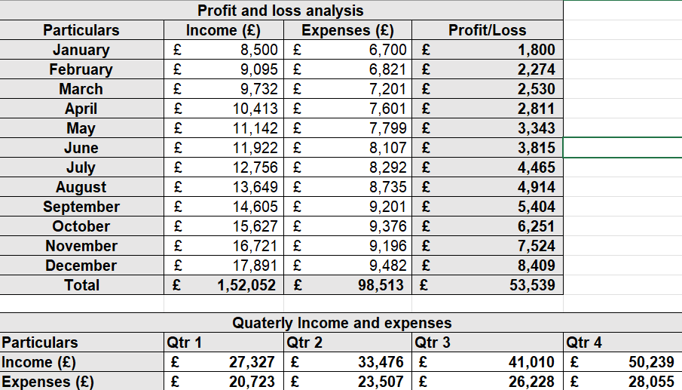
Figure 10 Spreadsheet.
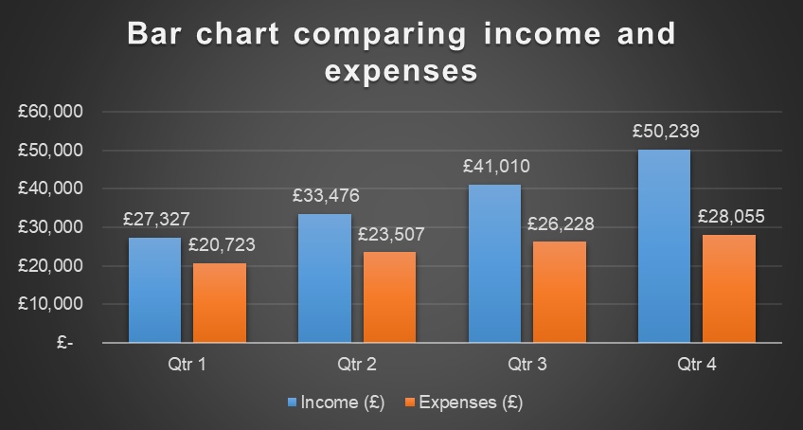
Figure 11 Bar Chart
Introduction
Microsoft Excel, introduced in 1985, remains a vital tool in the digital era, blending traditional spreadsheet functionality with modern data capabilities. At M&S Burger Van, a joint venture between Marius and Simona that offers Romanian street food on Queen Street, Cardiff, Excel monitors sales, helps to produce forecast sales of circa 120,000 a year and assists in operations efficiency. It is the wish of this small business to achieve an increment of 30 percent in repeat customers, so it takes advantage of the flexibility of Excel in a world of sophisticated analytical tools (Charlesworth, 2024).
Main Body
Excel is particularly useful in handling data, an essential ingredient of any business venture such as M&S Burger Van struggling to succeed in the challenging Cardiff street food trade. In high foot traffic position at Queen Street, the daily sales data at Excel can easily be recorded on the tables- 50 Mici Burgers at a price of 7.50. Pivot tables are used to check the answer to the questionnaire, where the trends are seen that most of the people prefer burgers (84.6%). OneDrive compatibility with the Cloud enables Marius and Simona to create a collaborative work environment because they can access updated information in real-time when they are not in the laboratory. This reflects the requirements of digital literacy, in which structured access to large bodies of information helps in making sound decisions (Kelly et al., 2023). The convenience of using the Excel application on a wide range of devices, has helped the application level the playing field, where small businesses can now compete without necessarily having to purchase expensive software, which once was CONVENIENCE.
Excel has financial discipline capacities that are essential to M&S as it targets sale of 120,000 pound. Applying formulae like =SUM(B2:M2) in computation of total income and =IF(B4>2000,Profitable,Review) in calculating the individual performances, M&S forecasts a figure of 120,300 over the 12 months. Using UK street food average (=7.50 per transaction), and Queen Street footfall, the spreadsheet will estimate monthly revenues (e.g. =9,500 in January) and expenses (e.g. =7,500), which gives 28,200 profit. Scenario analysis, adjusting for seasonal tourist spikes, aids decisions like adding a van, highlighting Excel’s strategic value (Kumiega, 2025). This planning is vital in the digital era, where data-driven forecasts outpace intuition, giving M&S a competitive edge in Cardiff’s market.
Excel boosts workplace efficiency, essential for M&S’s small-scale operation. Macros automate repetitive tasks, such as logging daily sales, saving time for Marius and Simona. Conditional formatting highlights profitable months (e.g., green for profits over £2,000), enabling quick reviews. Integration with Power BI enhances visual analytics, supporting project management for the E-Portfolio and aligning with digital agility needs (Levina, 2024). In Cardiff’s fast-paced environment, where quick decisions maximize foot traffic, Excel’s efficiency reduces manual workload. Its compatibility with legacy systems ensures continuity for startups transitioning to digital tools, maintaining productivity without retraining costs (Salmela et al., 2022).
Despite its strengths, Excel faces challenges from cloud-native alternatives like Google Sheets, which offer real-time collaboration. For M&S, Google Sheets’ free tier is tempting, but Excel’s advanced formulas (e.g., array functions) and extensive training resources (e.g., Microsoft Learn) provide superior depth. Security concerns with cloud tools are mitigated by Excel’s offline mode, safeguarding sensitive sales data. However, its learning curve can deter novices, though online tutorials bridge this gap. Compared to fintech platforms, Excel’s affordability suits M&S’s budget, avoiding subscription fees while delivering robust analytics (Street Food Expo, 2025).
Excel’s relevance persists due to its adaptability in the digital landscape. AI-driven features like Ideas suggest trends from M&S’s sales data, keeping it competitive against newer tools. Its widespread use in industries—finance, retail, education—ensures employability, with 78% of middle-skill jobs requiring spreadsheet skills (Vanarama, 2024). For students, Excel training enhances data literacy, preparing them for roles in data analysis, a skillset projected to grow 11% annually (Yuningsih et al., 2024). M&S benefits from this ecosystem, using Excel to project expansion and train staff, reinforcing its role in bridging traditional and digital workflows.
Conclusion
Excel remains indispensable in the digital era for M&S Burger Van, enabling data management, financial forecasting, and efficiency to achieve £120,000 sales and 30% repeat growth. Its ability to organize Queen Street sales, predict profits, and streamline operations underscores its practical value. Despite challenges from alternatives, Excel’s affordability, advanced features, and educational impact ensure its relevance. As technology evolves, Excel’s integration with AI and cloud tools positions it as a cornerstone for small businesses and a key employability skill, empowering M&S to thrive in Cardiff’s dynamic market (Kelly et al., 2023).

Task 4: Reflection

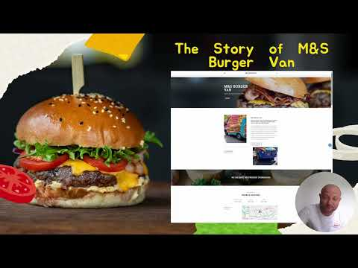
https://www.youtube.com/watch?v=JXCRx42O9ZM

For the promotional video of M&S Burger Van, storytelling techniques were applied to highlight authenticity, customer value, and brand identity. The video begins with a personal introduction where I appear on screen, establishing trust and credibility with the audience. This aligns with the storytelling principle of creating a connection between narrator and viewer (Belova, 2021). The brand logo and tagline, “Authentic Romanian Street Food in Cardiff” are prominently displayed to reinforce brand visibility.
The narrative follows a problem–solution–benefit structure: first addressing the challenge of finding authentic, hearty street food in Cardiff, then presenting M&S Burger Van as the solution, and finally highlighting the benefits such as generous portion sizes, affordable pricing, and unique Romanian flavors. Visuals of sizzling mici burgers and hearty portions serve as sensory storytelling, appealing to sight and imagination (Coker, Flight and Baima, 2021).
Techniques like emotional appeal (cultural authenticity and customer satisfaction), call-to-action (“Visit us on Queen Street – Order Now!”), and customer-centric framing (“92% of our customers love our portions”) were integrated to make the message persuasive. Research shows that storytelling enhances consumer engagement and increases purchase likelihood compared to traditional argumentative advertising (Júnior et al., 2022).
Altogether, the video communicates M&S Burger Van’s value proposition clearly, creating a compelling and memorable brand story.

References
Akbar, A., Suheri, and Sinaga, J. B. (2023). Design Website for Digital Promotion SMEs Product by Optimize SEO Techniques. International Journal of Computer Sciences and Mathematics Engineering, 2(2), 231–240. https://doi.org/10.61306/ijecom.v2i2.46
Belova, A. (2021). Storytelling in advertising and branding. Cognition, Communication, Discourse, 22(22), 13–26. https://doi.org/10.26565/2218-2926-2021-22-01
Bencsik, A. (Ed.). (2017). Knowledge Management Initiatives and Strategies in Small and Medium Enterprises. IGI Global. http://doi:10.4018/978-1-5225-1642-2
Burgess, J., Marwick, A., and Poell, T. (2018). The SAGE Handbook of Social Media. SAGE Publications Ltd. http://www.doi.org.ezproxy.uwtsd.ac.uk/10.4135/9781473984066
Byrd, L. S. (Ed.). (2021). Cultivating Entrepreneurial Changemakers Through Digital Media Education. IGI Global. http://doi:10.4018/978-1-7998-5808-9
Charlesworth, L. (2024). What is Microsoft Excel used for and is it still relevant? Kaplan. https://kaplan.co.uk/blog/features/is-microsoft-excel-still-relevant
Clark, R. (2024). The ultimate guide to street food trucks. Raccoon. https://www.raccoon.co.uk/blog/guide-to-street-food-trucks
Coker, K. K., Flight, R. L., and Baima, D. M. (2021). Video storytelling ads vs argumentative ads: how hooking viewers enhances consumer engagement. Journal of Research in Interactive Marketing, 15(4), 607–622. https://doi.org/10.1108/jrim-05-2020-0115
Dadwal, S. S. (Ed.). (2020). Handbook of Research on Innovations in Technology and Marketing for the Connected Consumer. IGI Global. http://doi:10.4018/978-1-7998-0131-3
Júnior, J. R. de O., Limongi, R., Lim, W. M., Eastman, J. K., and Kumar, S. (2022). A story to sell: The influence of storytelling on consumers’ purchasing behavior. Psychology and Marketing, 40(2), 239–261. https://doi.org/10.1002/mar.21758
Kateruna, K., Salimon, O., and Chernysh, T. (2024). Content marketing in design: visual strategies for attracting the target audience. Intellect XXІ, (3, 2024). https://doi.org/10.32782/2415-8801/2024-3.13
Kelly, O., Hall, T., and Connolly, C. (2023). Digital Workplace Skills: Designing the Integrated Learning of Accounting and Microsoft Excel. Accounting, Finance and Governance Review, 30. https://doi.org/10.52399/001c.77593
Kirtok, A. I., Kantaryuk, G. V., and Kantaryuk, E. A. (2023). Marketing trends in the field of design. Innovative Economics and Law, (3), 6–12. https://doi.org/10.53015/2782-263x_2023_3_6
Kumiega, A. (2025). Automated Ledger or Fintech Analytics Platform? FinTech, 4(2), 14. https://doi.org/10.3390/fintech4020014
Levina. (2024). Here’s Why It’s Important for Students to Know Excel. Universitas Multimedia Nusantara. https://www.umn.ac.id/en/heres-why-its-important-for-students-to-know-excel/
Paulus, P., and Nijstad, B. (Eds.). (2003). Group Creativity: Innovation through Collaboration. Oxford University Press. https://oxford-universitypressscholarshipcom.ezproxy.uwtsd.ac.uk/view/10.1093/acprof:oso/9780195147308.001.0001/acprof-9780195147308
Pinto, F. M., and Guarda, T. (Eds.). (2020). Digital Marketing Strategies and Models for Competitive Business. IGI Global. http://doi:10.4018/978-1-7998-2963-8
Reedy, K., and Parker, J. (Eds.). (2017). Digital Literacy Unpacked. Facet Publishing. ProQuest Ebook Central.
Salmela, H., Baiyere, A., Tapanainen, T., and Galliers, R. D. (2022). Digital Agility: Conceptualizing Agility for the Digital Era. Journal of the Association for Information Systems, 23(5), 1080–1101. https://doi.org/10.17705/1jais.00767
Sandhu, K. (Ed.). (2020). Digital Transformation and Innovative Services for Business and Learning. IGI Global. http://doi:10.4018/978-1-7998-5175-2
Soltanifar, M., Hughes, M., and Gocke, L. (2021). Digital Entrepreneurship. Springer. http://doi:10.1007/978-3-030-53914-6
Street Food Expo. (2025). Trends and Figures Defining UK Street Food in 2024. Street Food Business Expo 2025. https://www.streetfoodexpo.co.uk/news/trends-and-figures-defining-uk-street-food-in-2024
Vanarama. (2024). The UK’s Appetite for Food Vans: Unwrapped. Vanarama. https://www.vanarama.com/blog/vans/uk-appetite-for-food-unwrapped
Yuningsih, Y., Andriani, L., Luthfi Firdaus, Dwi Nugroho, and Rafi Putra Pradipta. (2024). Improving SMEs Business Productivity with Microsoft Excel Training in the Big Data Era. Journal of Social Sciences and Technology for Community Service, 5(2), 448–448. https://doi.org/10.33365/jsstcs.v5i2.4720

Appendix: Task 1 Raw Data
Q1: How often do you eat from a burger van?
- Daily: 1 (7.7%)
- Weekly: 2 (15.4%)
- Monthly: 2 (15.4%)
- Sometimes: 8 (61.5%)
Q2: What is your favorite item on our menu?
- Burger: 11 (84.6%)
- Hot Dog: 2 (15.4%)
- Fries: 2 (15.4%)
- Coffee: 2 (15.4%) Note: Total exceeds 13 due to possible multi-selections; assumed single choice for analysis.
Q3: How would you rate the taste of our food?
- Very Good: 7 (53.8%)
- Good: 1 (7.7%)
- Exceptional: 3 (23.1%)
- Fair: 2 (15.4%)
- Poor: 0 (0%)
Q4: How satisfied are you with the portion sizes?
- Very Satisfied: 10 (76.9%)
- Somewhat Satisfied: 2 (15.4%)
- Neither Satisfied nor Dissatisfied: 1 (7.7%)
Q5: How quickly is your food served?
- Very Quickly: 6 (46.2%)
- Quickly: 6 (46.2%)
- Average: 1 (7.7%)
- Slow: 0 (0%)
Q6: Are our prices fair?
- Yes: 11 (84.6%)
- Maybe: 2 (15.4%)
- No: 0 (0%)
Q7: How would you rate the friendliness of our staff?
- Excellent: 10 (76.9%)
- Above Average: 0 (0%)
- Average: 3 (23.1%)
- Below Average: 0 (0%)
- Poor: 0 (0%)
Q8: Is there anything you’d like us to add to the menu?
- Yes: 1 (7.7%)
- No: 10 (76.9%)
- Maybe: 2 (15.4%)
- Other: 0 (0%)
Q9: How clean and tidy do you find our burger van?
- Very Clean: 9 (69.2%)
- Clean: 3 (23.1%)
- Needs Improvement: 1 (7.7%)
Q10: Would you recommend our burger van to others?
- Yes: 11 (84.6%)
- No: 1 (7.7%)
- Maybe: 1 (7.7%)

