Chapter Four – Analysis of Results
Introduction
As stated in the methodology chapter, I have utilised a questionnaire as a quantitative research collection tool. I will now analyse and display the findings to the overall question; should police in the UK be routinely armed? The rationale for a questionnaire as the collection method was to ensure a large sample pool was targeted, to maximise efficiency in the completion and although other methodological techniques were considered, a questionnaire was better suited to the research timeframe.

Research Objectives
In order for the overall research question to be answered, a quantitative style of data collection was utilised by the researcher. Specifically, multiple-choice answers with predetermined categories, as a way of improving the consistency of the participants answers. The results of this analysis (see figure 1) show that out of the sixty participants, twenty-three participants felt that police within the UK should be routinely armed. When you compare that with the twenty-three who opposed that, you can clearly see that the publics opinion is completely split. This is also reflective of the research conducted by Simon (2019) which established that only 21.6% of police officers felt they should be routinely armed, highlighting that there is no overwhelming opinion.

Figure 1:
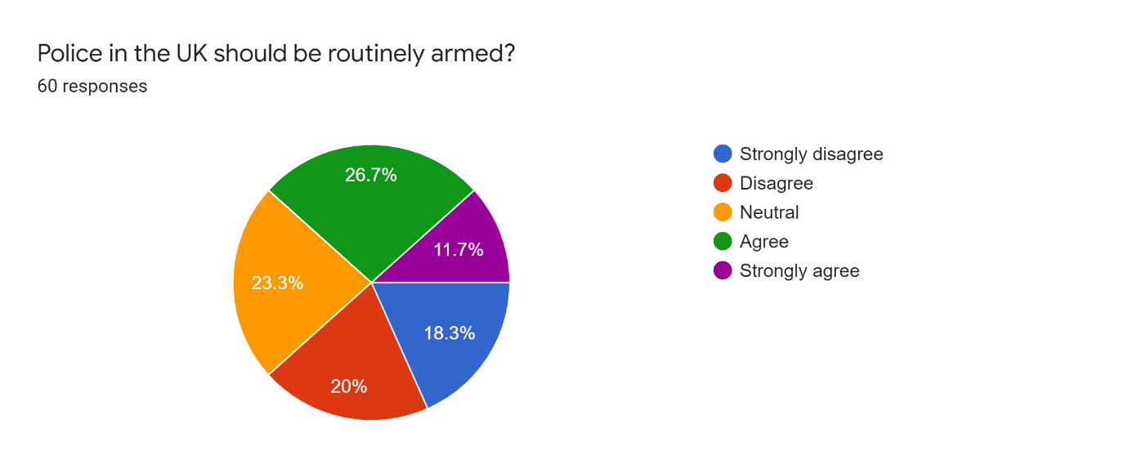

In addition to the quantitative data, the questionnaire also employed qualitative data collection through open ended questions such as “provide your reasoning” and “why do you think that “. By asking the participants for their motives to their answers, the research collected qualitive data that is descriptive and allows for a deeper understanding into the participants answers. Through the utilisation of In Vivo coding, the descriptive answers received by the participants can be separated into seven categories: Safety, Not Necessary, Crime Development, Responsibility, Middle ground, Demand and Uncertain. In Vivo coding uses the participants’ own words to categorise their responses, rather than the researcher interpreting what they say (Turner, 2016). When participants were asked about their reasoning behind their answers, a number of participants mentioned officer safety, for example, “Provides police with further protection when responding to incident” and “This would be a deterrent to certain individuals and give police extra protection. That being said, one participant highlighted a different approach to arming police (see figure 2).

Figure 2:
“Officers need specific, intense training to effectively use a firearm safely and make the best decision given the circumstances. It is not possible to train all officers to a high enough standard and keep this training up to date with all officer. If all officers are armed, more persons will die or be seriously injuries by police and many of these will be due to unlawful force through lack of effective training and officers panicking.”

Participant Romeo, whose answer is above, highlights a key theme that materialised throughout the recipients’ answers. If more officers have weapons, the likelihood of unlawful force or inappropriate use is likely to rise. Through a descriptive and detailed response, Participant Romeo has allowed the researcher to have a better understanding into their answer, instead of it being a fixed response through a closed question.

To establish other opinions when it came to arming police, sub research objectives were also factored into the questionnaire, such as the publics perception of armed police, ethical considerations and how armed police are utilised and respond to terrorism. As a way of ascertaining the publics thoughts surrounding armed police, discrete quantitative data collection was employed. Discrete data is quantitative data that has been broken down so it can be managed numerically, with the results displayed visually (Fullstory, 2022). By employing closed questions, it ensured the participants answers were within a predetermined criteria and could be analysed by its fixed values. (See figure 3) highlights that 46.7%, which is equal to twenty-eight participants out of the sixty in total, would feel safer if there were more armed police. Through the analysis, I feel that the question posed is too ambiguous and in order for more accurate information to be obtained, a more in-depth question would have been better suited. For example, using a qualitative collection method so that participants could describe and articulate their deeper feelings regarding armed police, instead of a quantitative pre-set answer.
Figure 3: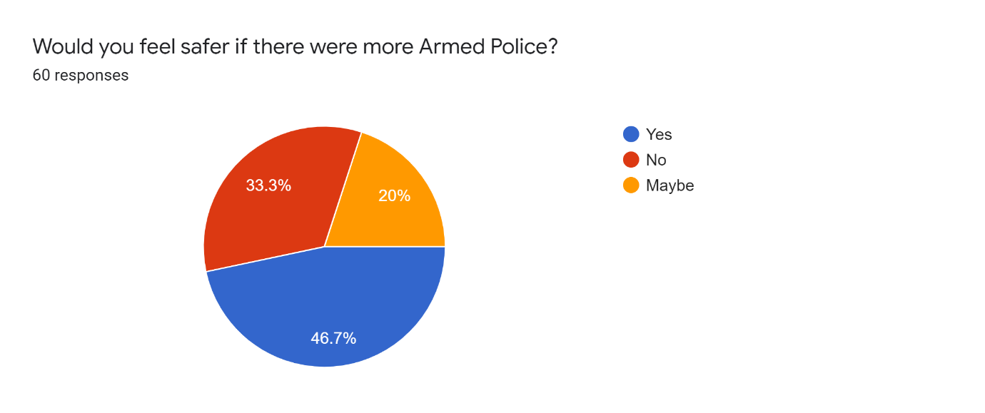

Conclusion
This project utilised a questionnaire as the primary method of collecting participants responses. The questionnaire allowed questions posed to be of a quantitative nature, with predetermined answers set out by the researcher, but also incorporated qualitative data collection by asking the participants to explain and rationalise their opinions. Through the analysis of their answers, this project has established that the public do not have a definitive opinion on whether police in the UK should be routinely armed, with the sixty respondents answering twenty-three for and twenty-three against. The next chapter will explore the findings of this project and provide a conclusion to the overall question set out at the start; Should police in the UK be routinely armed?

Word Count: 819 out of 750 (=/- 10%)

Bibliography:
Fullstory (2022) What is quantitative data? How to collect, understand, and analyze it. Available at: What is Quantitative Data? How to Collect and Analyze It | FullStory (Accessed on: 13.04.2022).
SIMON, J (2019) Perceptions of Armed Policing: Barriers and Motivations to Becoming an eAuthorised Firearms Officer, Canterbury Christ Church University (United Kingdom).
Turner, D (2016) In vivo coding and revealing life from the text. Available at: In vivo coding and revealing life from the text (quirkos.com) (Accessed on: 12.04.2022).

