[Draw your reader in with an engaging abstract. It is typically a short summary of the document. When you’re ready to add your content, just click here and start typing.]

Database & Application Development
Part A Green Leaf Organics Database
ID: 2333138
Submission: 02/03/2026
Lecturer: Dr Malik Uzair Mehmood
Mekonnen Assefa Tessema
Contents
1. Introduction 3
2. Database Design 3
2.1 Identification of Entities and Relationships 3
2.2 ERD Overview 5
2.3 Relational Schema 5
ERD DIAGRAM 7
2.4 Normalisation 8
3. Implementation Documentation 10
3.1 Table Creation and Constraints 10
3.2 Sample Data Insertion 12
3.3 Testing the Database 15
3.4 Triggers and Functions 15
4. Stored Procedures and Transactions 17
4.1 CRUD Stored Procedures 17
4.2 Transaction Handling 18
4.3 Transaction Scenario Example 19
5. Performance Optimisation 19
5.1 Key Queries 19
5.2 Indexing Strategy 20
5.3 Benefits of Indexing 20
6. Conclusion and Reflection 20
REFERENCE 22

1. Introduction
GreenLeaf Organics is a UK-based company that specialises in sustainable and eco-friendly products, including organic food, natural skincare items, and biodegradable household goods. The company is committed to promoting healthier lifestyles while reducing environmental impact. As customer demand continues to grow, GreenLeaf Organics has recognised the need to expand its operations by developing an online platform that can efficiently manage its products, suppliers, and customer interactions.
At present, handling large volumes of data without a structured system can lead to inefficiencies, errors, and difficulties in maintaining accurate records. For a business that relies heavily on trust, product quality, and transparency, it is especially important to ensure that data is organised and reliable. An effective database system provides a centralised way to store and manage information, allowing the company to streamline its processes and improve overall performance [1].
The purpose of this report is to design and implement a relational database system that supports the key business functions of GreenLeaf Organics. These functions include managing supplier information, organising product listings, handling customer accounts, processing orders, and collecting product reviews. By structuring the data in a logical and organised way, the database helps ensure consistency, reduces duplication, and supports efficient data retrieval.
In addition to the design, this report explains how the database is implemented and tested using realistic data. It also explores important database features such as transactions, stored procedures, and indexing. These features play a key role in improving system reliability, ensuring that operations are completed correctly, and enhancing performance when handling large amounts of data.
Overall, this report demonstrates how a well-designed database system can support the growth of GreenLeaf Organics by providing a strong and scalable foundation for its online platform.

2. Database Design

2.1 Identification of Entities and Relationships
The database for GreenLeaf Organics is designed by identifying the key entities involved in the business and understanding how they interact with each other. These entities represent real-world objects within the system and form the foundation of the database structure.
The Supplier entity is used to store information about the companies or individuals that provide products to GreenLeaf Organics. This includes details such as the supplier’s name, contact information, and certification status, which is particularly important because the company focuses on organic and eco-friendly products [2]. Each supplier can supply multiple products, which creates a one-to-many relationship between Supplier and Product.
The Product entity contains information about the items available for sale on the platform. This includes attributes such as product name, price, stock level, and expiry date. Each product is linked to one supplier, ensuring that the origin of each item is clearly recorded. This relationship is important for maintaining product traceability and quality assurance.
The Category entity is used to organise products into meaningful groups, such as organic food, eco-friendly household goods, or natural skincare. Categorisation improves the user experience by making it easier for customers to browse and find products. Since a product can belong to more than one category, and each category can contain multiple products, this results in a many-to-many relationship.
The Customer entity stores information about users who purchase products from the platform. This includes their name, email, and address. Customers play a central role in the system, as they interact with products, place orders, and provide feedback. Each customer can place multiple orders over time, forming a one-to-many relationship with the Order entity.
The Order entity represents a transaction made by a customer. It records details such as the date of purchase and links back to the customer who placed the order. Since a single order can include multiple products, a separate entity is needed to manage this complexity.
The OrderItem entity acts as a linking table between Order and Product. It allows each order to contain multiple products while also storing additional details such as the quantity of each product purchased. This resolves the many-to-many relationship between orders and products.
Similarly, the ProductCategory entity is introduced as a linking table to manage the many-to-many relationship between Product and Category. This ensures that products can be assigned to multiple categories without duplicating data.
Finally, the Review entity captures customer feedback on products. It includes attributes such as rating and comments, allowing customers to share their experiences. This entity connects both Customer and Product, as each review is written by a customer about a specific product. This feature supports user engagement and helps other customers make informed purchasing decisions.

2.2 ERD Overview
The Entity Relationship Diagram (ERD) provides a visual representation of how these entities are connected within the system [3]. It clearly shows the structure of the database and the relationships between different tables.
In this design, one supplier can supply many products, but each product is associated with only one supplier. This ensures a clear and simple supply chain structure. Similarly, one customer can place many orders, but each order belongs to a single customer, allowing the system to maintain accurate purchase histories.
Orders and products have a many-to-many relationship, which is resolved through the OrderItem table. This allows each order to contain multiple products and each product to appear in multiple orders. The use of this linking table also makes it possible to store additional details, such as quantity and price at the time of purchase.
Products and categories also share a many-to-many relationship. This is handled using the ProductCategory table, which allows flexible classification of products without repeating data. For example, a product such as organic soap can belong to both “Natural Skincare” and “Eco Household” categories.
Customers can leave reviews for products, creating a relationship between Customer and Review, as well as Product and Review. This adds an interactive element to the system and enhances customer engagement.
Overall, the ERD ensures that all relationships are logically structured and that the system can support the required business processes efficiently.

2.3 Relational Schema
The ERD is translated into a relational schema by creating tables for each entity and defining primary and foreign keys to maintain relationships and data integrity [4].
The Supplier table includes SupplierID as the primary key, along with attributes such as Name, Certification, and Contact details. The Product table uses ProductID as its primary key and includes attributes such as Name, Price, and Stock, along with SupplierID as a foreign key to link each product to its supplier.
The Category table contains CategoryID and Name, while the ProductCategory table includes both ProductID and CategoryID as foreign keys, forming a composite key that links products and categories.
The Customer table stores CustomerID, Name, Email, and Address. The Order table includes OrderID as the primary key, along with CustomerID as a foreign key and the order date. This structure ensures that each order is correctly linked to the customer who placed it.
The OrderItem table includes OrderItemID as the primary key and contains foreign keys for both OrderID and ProductID. It also stores the quantity of each product within an order, making it essential for handling multi-product transactions.
Finally, the Review table contains ReviewID as the primary key and includes CustomerID and ProductID as foreign keys, along with Rating and Comment fields. This ensures that each review is linked to both a customer and a product.
This relational schema ensures that the database maintains strong data integrity using keys and constraints [5]. It also supports efficient data retrieval and updates, making it suitable for a growing online platform like GreenLeaf Organics.

ERD DIAGRAM (Green-Leaf-Organics)
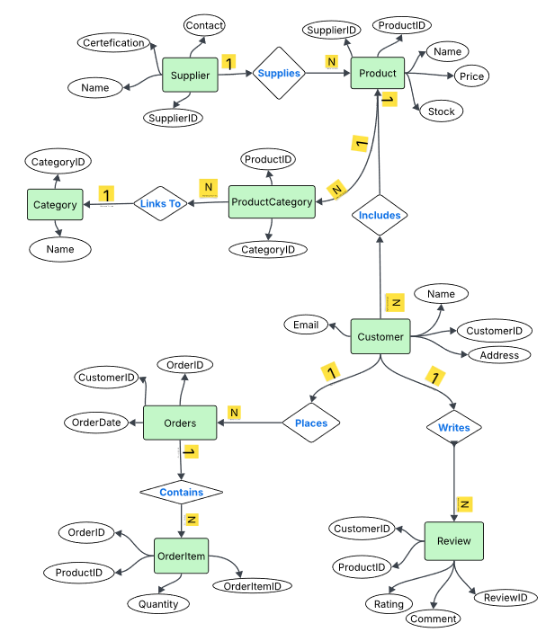

2.4 Normalisation
The database design for GreenLeaf Organics has been carefully structured using normalisation principles to ensure that data is stored efficiently and without unnecessary duplication. Normalisation is a step-by-step process that improves the organisation of data by breaking it into smaller, related tables while maintaining clear relationships between them [6]. In this design, the database has been normalised up to Third Normal Form (3NF), which is widely accepted as a suitable level for most business applications.
The first stage, known as First Normal Form (1NF), ensures that all fields contain atomic values. This means that each column stores only a single piece of information, and there are no repeating groups or multi-valued attributes within a table. For example, instead of storing multiple product categories in a single field, each category is stored separately and linked through a dedicated table. This makes the data easier to manage and query.
The second stage, Second Normal Form (2NF), focuses on removing partial dependencies. This applies to tables with composite keys, where all non-key attributes must depend on the entire primary key rather than just part of it. In the GreenLeaf database, this is particularly relevant in linking tables such as OrderItem and ProductCategory. By ensuring that attributes depend fully on their keys, the design avoids storing incomplete or misleading data.
The final stage, Third Normal Form (3NF), removes transitive dependencies. This means that non-key attributes should not depend on other non-key attributes. Instead, they should depend only on the primary key. For instance, supplier details such as name and certification are stored in the Supplier table rather than being repeated in the Product table. This separation prevents inconsistencies and ensures that updates to supplier information only need to be made in one place.
Overall, normalising the database to 3NF reduces redundancy, improves data integrity, and makes the system more flexible and scalable [7]. It also simplifies maintenance, as changes to data can be made without affecting multiple parts of the database.

3. Implementation Documentation

3.1 Table Creation and Constraints
The implementation of the GreenLeaf Organics database begins with the creation of tables using Structured Query Language (SQL). Each table is designed based on the entities identified in the earlier design phase, ensuring that the structure reflects the real-world processes of the business. During this stage, particular attention is given to defining appropriate constraints, as these rules help maintain data accuracy, consistency, and integrity across the system.
Primary keys are assigned to each table to uniquely identify every record. For example, each supplier, product, customer, and order is given a unique identifier, which ensures that no two records can be confused or duplicated. This is essential for maintaining reliable data, especially as the database grows and complexity.
Foreign keys are then used to establish relationships between tables. These keys link related data together, such as connecting products to their suppliers or orders to customers. By enforcing these relationships, the database ensures that only valid and existing data can be referenced. For instance, a product cannot be assigned to a supplier that does not exist in the Supplier table. This helps prevent errors and maintains logical consistency throughout the system.
In addition, NOT NULL constraints are applied to important fields to ensure that essential information is always provided. For example, attributes such as product name, price, and customer email must not be left empty, as they are critical for the functioning of the system. This reduces the risk of incomplete records that could affect business operations.
CHECK constraints are also used to enforce valid data entry by restricting the range or format of values. A common example in this system is the rating field in the Review table, where values are limited to a range between 1 and 5. This ensures that all reviews follow a consistent format and prevents invalid data from being entered into the database.
Overall, the use of these constraints plays a vital role in ensuring that the database operates reliably. They act as safeguards that protect the quality of the data, support accurate relationships between tables, and contribute to the overall stability of the system.
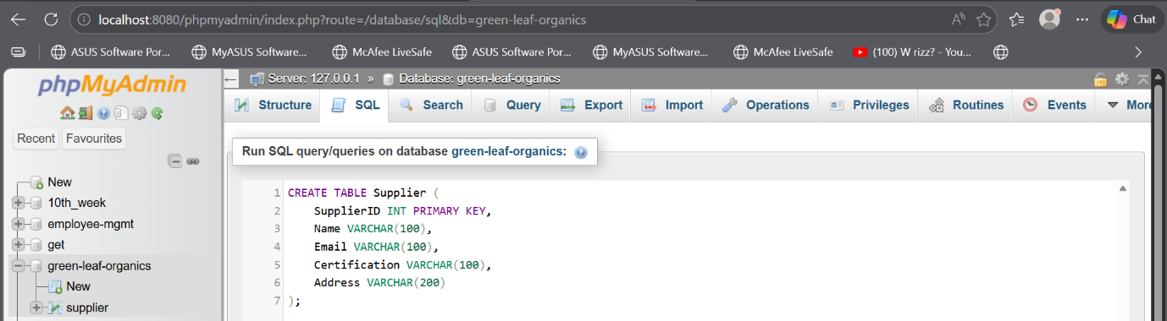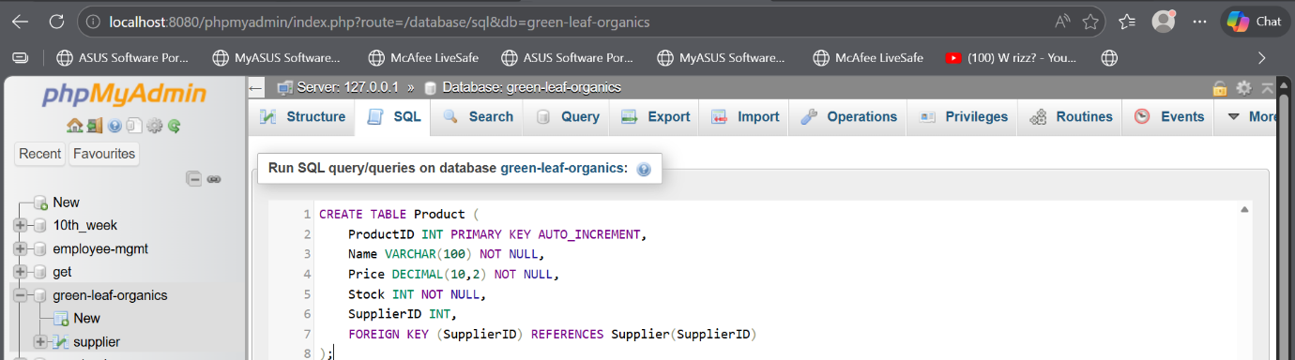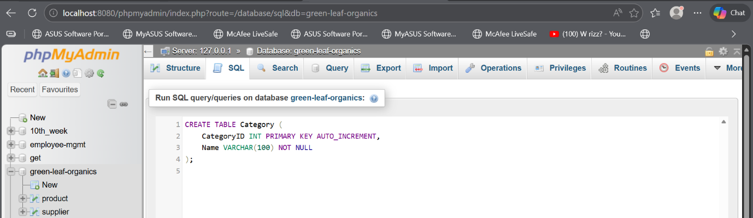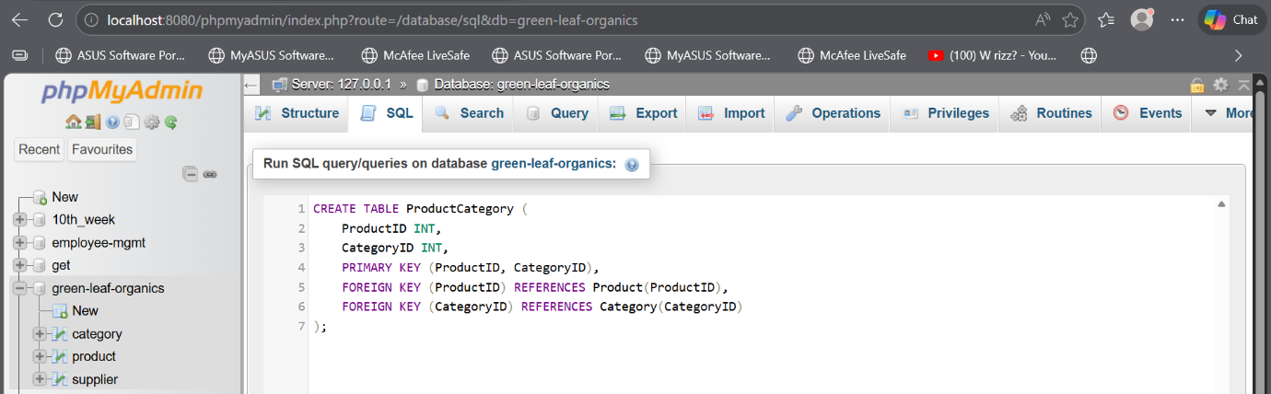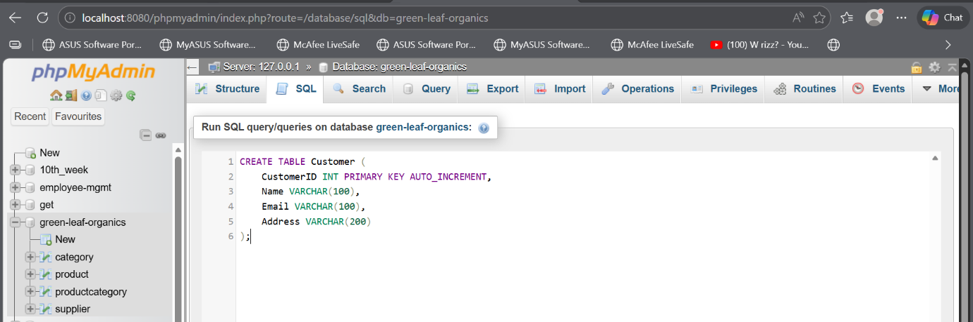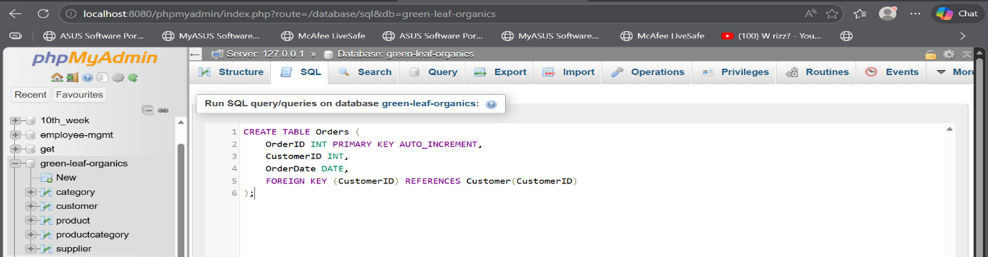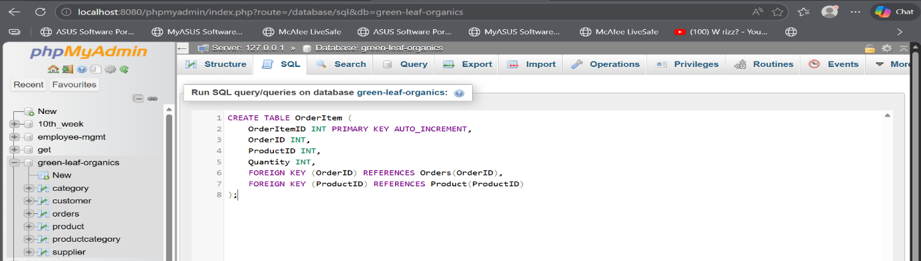
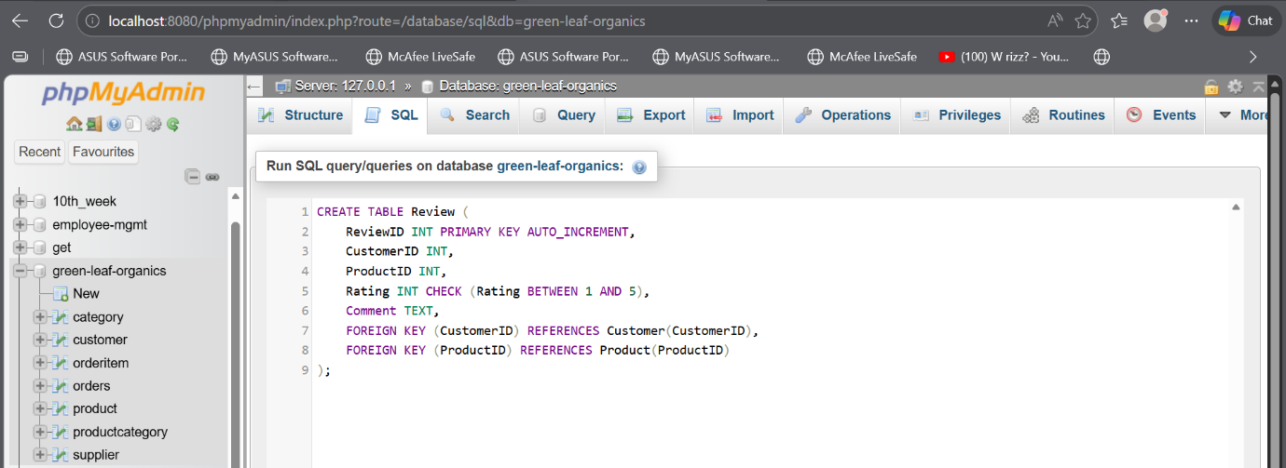

3.2 Sample Data Insertion
After the tables and constraints have been successfully created, the next step in the implementation process involves inserting sample data into the database [8]. This stage is essential because it allows the system to be tested in a way that reflects real-world business operations. By using realistic and meaningful data, it becomes possible to evaluate whether the database structure, relationships, and constraints function as expected.
The sample data includes multiple suppliers, each with valid certification details to reflect the company’s focus on organic and eco-friendly standards. These suppliers are linked to a range of products, ensuring that the relationship between suppliers and products is properly tested. The products themselves are assigned to different categories, demonstrating how the system handles classification and supports flexible product organisation.
In addition, customer records are created with relevant details such as names, email addresses, and locations. These customers are then used to simulate purchasing behaviour by placing orders that contain multiple items. This helps to test the Order and OrderItem tables, ensuring that transactions involving several products are processed correctly and that quantities and relationships are accurately maintained.
By inserting this variety of sample data, the database can be tested under realistic conditions, allowing potential issues to be identified and resolved early. It also helps confirm that queries return accurate results, constraints are enforced correctly, and relationships between tables operate as intended. Overall, this step provides confidence that the system is ready to handle actual business data in a reliable and efficient manner.
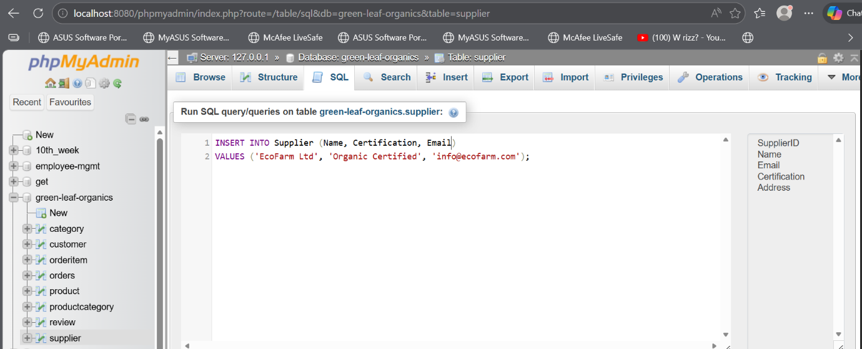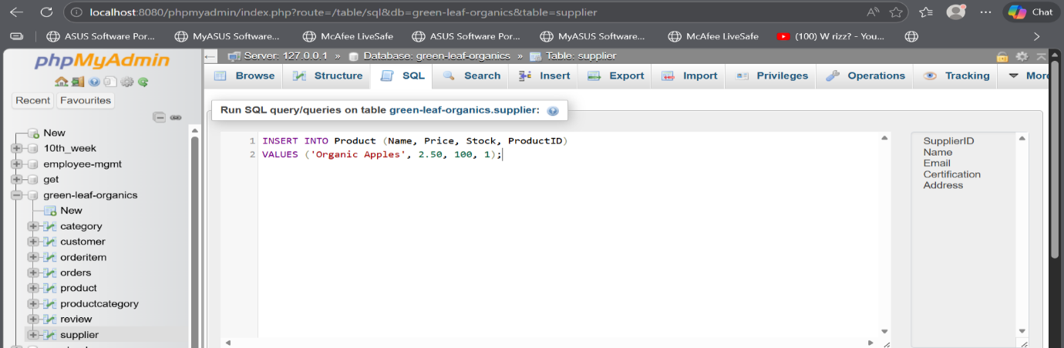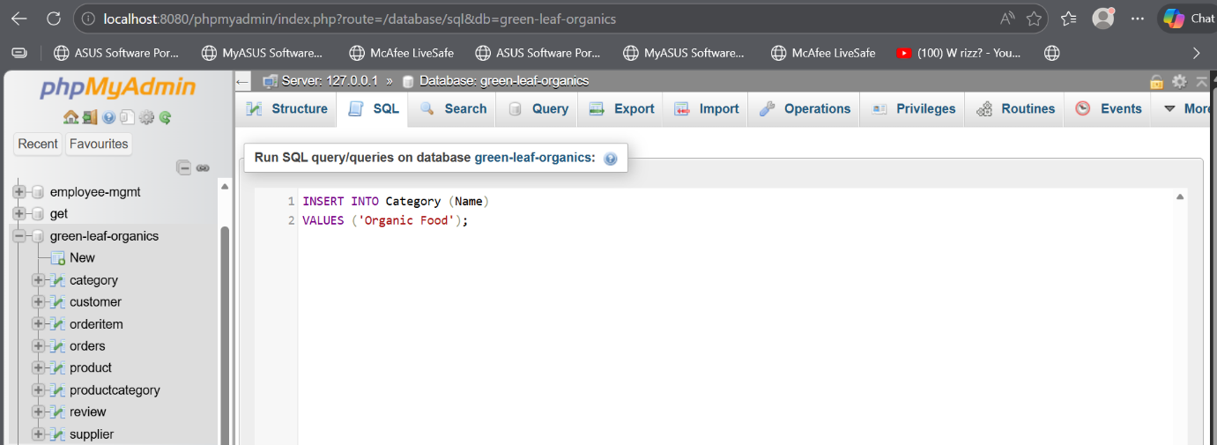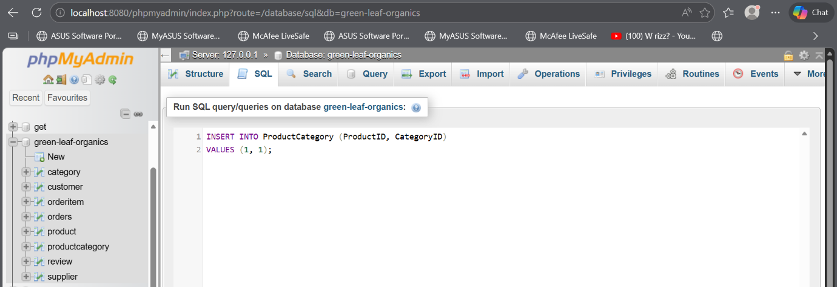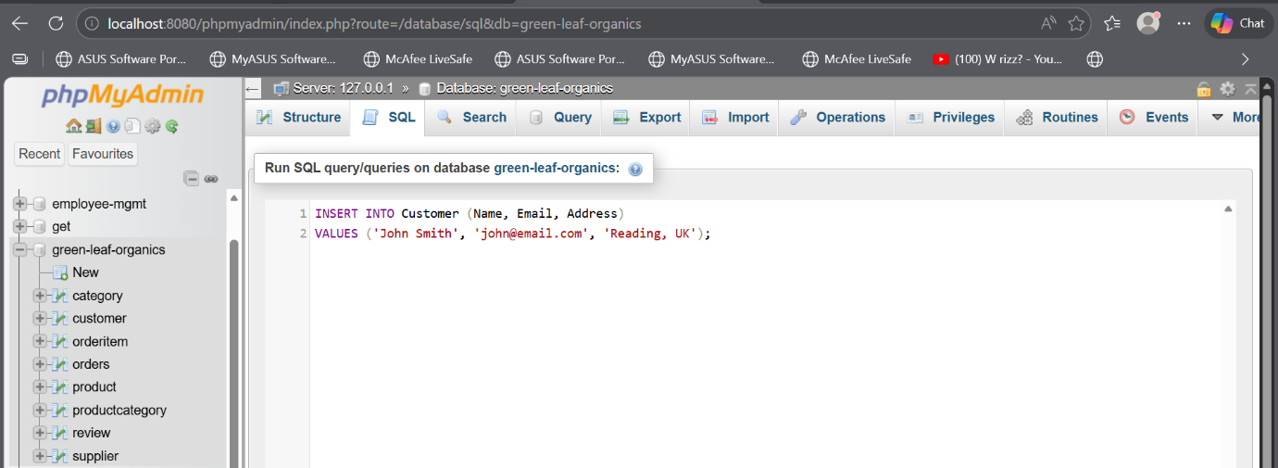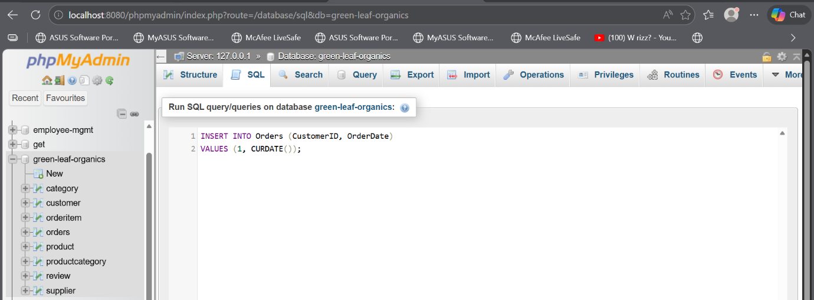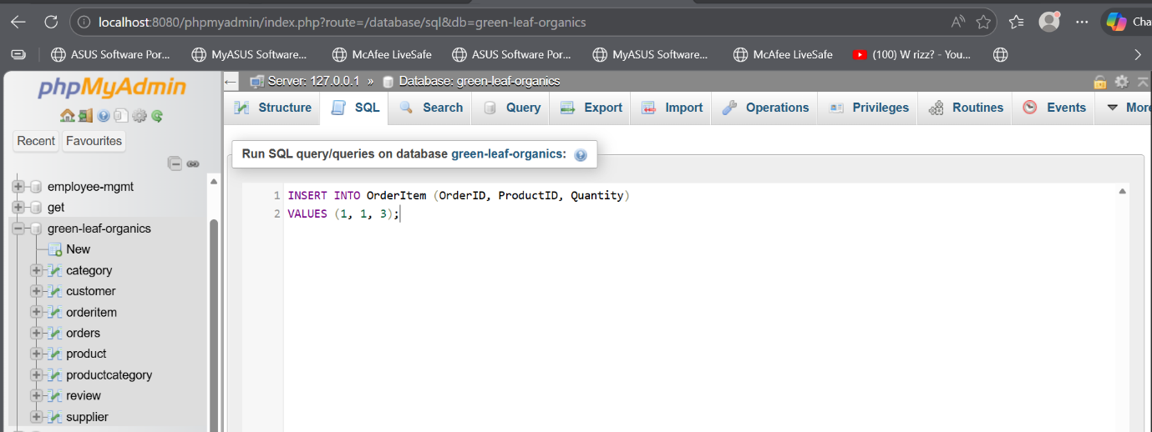
Database tables:
- Supplier
SupplierId (PK) | Name | Email | Certification | Address
1 | EcoFarm Produce Ltd | info@ecofarmproduce.co.uk | Soil Association Organic | London, UK
2 | GreenHarvest Suppliers | contact@greenharvest.co.uk | EU Organic Certified | Manchester, UK
3 | PureNature Skincare | sales@purenature.co.uk | COSMOS Organic | Birmingham, UK
4 | BioHome Essentials | support@biohome.co.uk | EcoCert Certified | Leeds, UK
5 | Organic Valley Foods | info@organicvalleyfoods.co.uk | Soil Association Organic | Bristol, UK

- Product
ProductID (PK) | Name | Price | Stock | SuppliedId (FK)
101 | Organic Apples (1kg) | 3.50 | 120 | 1
102 | Organic Carrots (1kg) | 2.20 | 200 | 2
103 | Natural Aloe Vera Gel | 6.99 | 75 | 3
104 | Organic Honey (500g) | 5.50 | 90 | 5
105 | Biodegradable Dish Soap | 4.25 | 140 | 4
106 | Organic Spinach (500g) | 2.80 | 110 | 1
107 | Natural Lavender Body Lotion | 8.99 | 60 | 3
108 | Eco-Friendly Bamboo Toothbrush | 2.99 | 180 | 4

- Category
CategoryID (PK) | CategoryName
1 | Organic Vegetables
2 | Organic Fruits
3 | Natural Skincare
4 | Eco Household
5 | Organic Grocery

- ProductCategory
ProductCategoryID (PK) | Name | CategoryID (FK)
1 | Organic Apples (1kg) | 2
2 | Organic Carrots (1kg) | 1
3 | Natural Aloe Vera Gel | 3
4 | Organic Honey (500g) | 5
5 | Biodegradable Dish Soap | 4
6 | Organic Spinach (500g) | 1
7 | Natural Lavender Body Lotion | 3
8 | Eco-Friendly Bamboo Toothbrush | 4

- Customer
CustomerId (PK) | Name | Email | Address
1 | Sarah Johnson | sarah.johnson@email.com | 22 Park Road, London, UK
2 | Michael Brown | michael.brown@email.com | 15 Green Street, Manchester, UK
3 | Aisha Khan | aisha.khan@email.com | 9 Oak Lane, Birmingham, UK
4 | Daniel Smith | daniel.smith@email.com | 40 River View, Leeds, UK
5 | Emily Taylor | emily.taylor@email.com | 18 Hill Avenue, Bristol, UK

- Orders
OrderID (PK) | OrderDate | CustomerID(FK)
1001 | 2026-02-10 | 1
1002 | 2026-02-12 | 2
1003 | 2026-02-14 | 3
1004 | 2026-02-15 | 4
1005 | 2026-02-16 | 5

- OrderItem
OrderItemID (PK) | OrderID (FK) | ProductID(FK) | Quantity
1 | 1001 | 101 | 2
2 | 1001 | 105 | 1
3 | 1002 | 102 | 3
4 | 1002 | 108 | 2
5 | 1003 | 103 | 1
6 | 1003 | 107 | 1
7 | 1004 | 104 | 2
8 | 1004 | 106 | 2
9 | 1005 | 101 | 1
10 | 1005 | 108 | 3

- Reviews
ReviedID (PK) | CustomerID (FK) | ProductID (FK) | Rating
1 | 1 | 101 | 5
2 | 2 | 102 | 4
3 | 3 | 103 | 5
4 | 4 | 104 | 4
5 | 5 | 108 | 5

3.3 Testing the Database
Once the sample data has been inserted, the database is thoroughly tested to ensure that it performs as expected and supports the required business operations. Testing is an important step because it verifies that the relationships between tables are correctly established and that all constraints are functioning properly.
One of the key tests involves retrieving product lists based on specific categories. This confirms that the relationship between Product and Category, managed through the ProductCategory table, is working correctly. It also demonstrates that customers will be able to browse products efficiently on the online platform.
Another important test focuses on stock management. When orders are placed, the system must automatically update product stock levels. By simulating customer purchases and checking the resulting stock quantities, it is possible to confirm that the database accurately reflects inventory changes. This is essential for preventing issues such as overselling products.
In addition, customer order history is tested by retrieving all orders associated with a particular customer. This ensures that the relationship between Customer and Order is correctly implemented and that the system can provide accurate purchase records. Such functionality is important for both customer experience and business analysis.
Overall, these tests confirm that the database structure is reliable and that data can be stored, retrieved, and updated correctly [9]. They also help identify any potential issues before the system is used in a real-world environment.
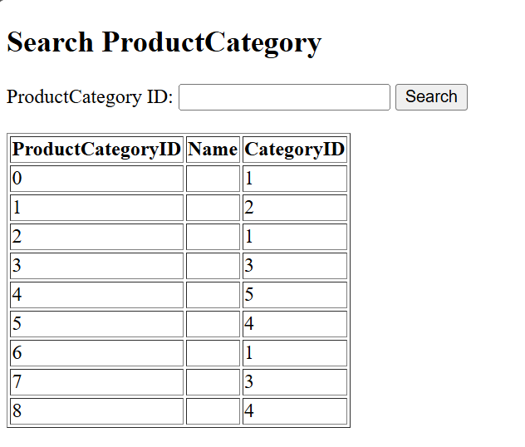
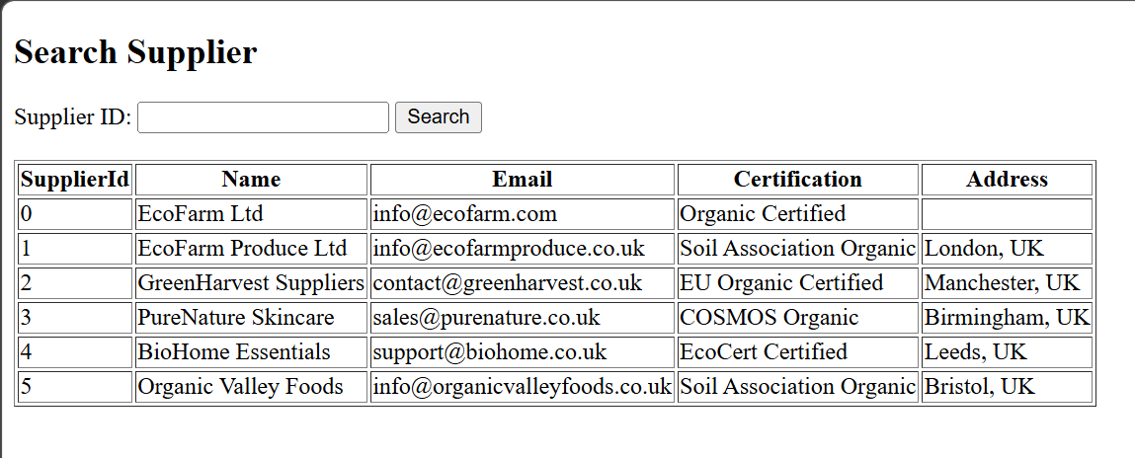
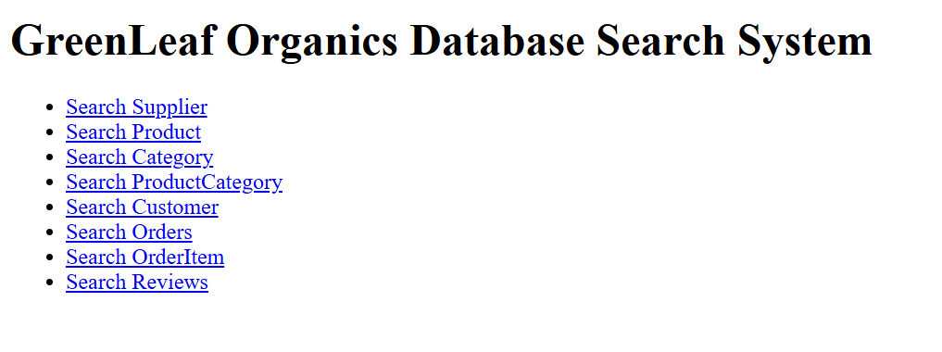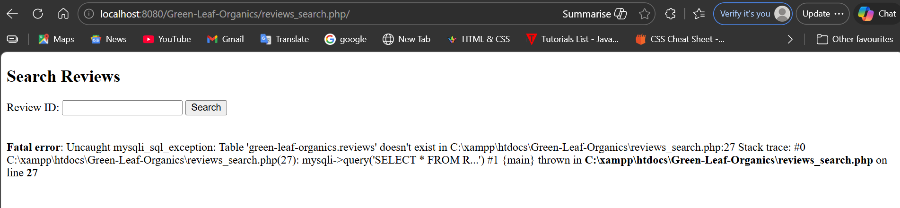
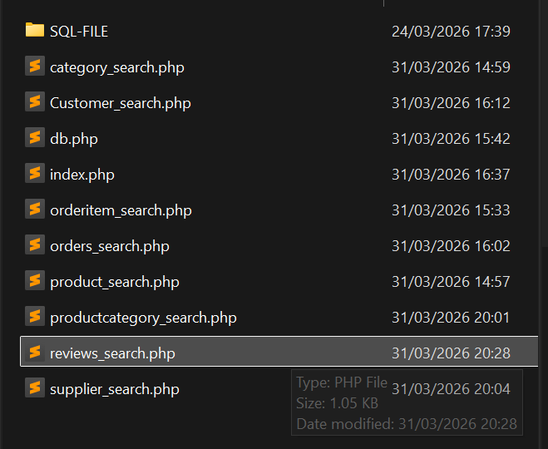
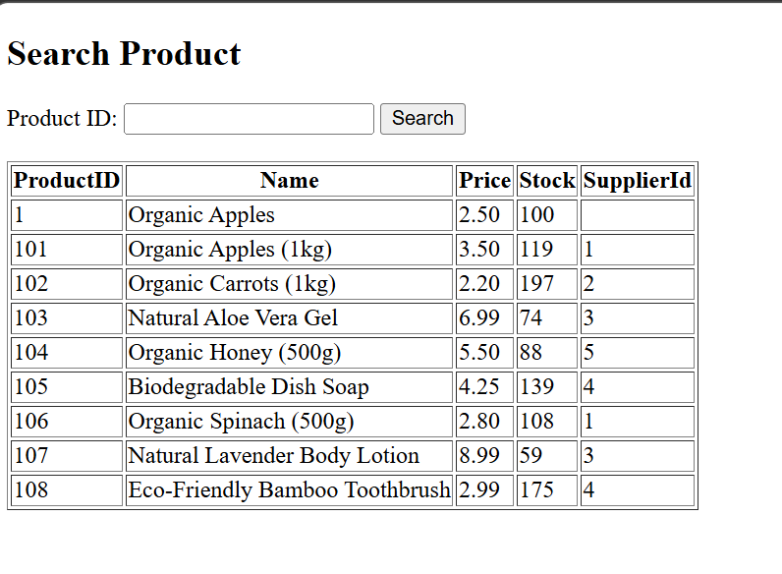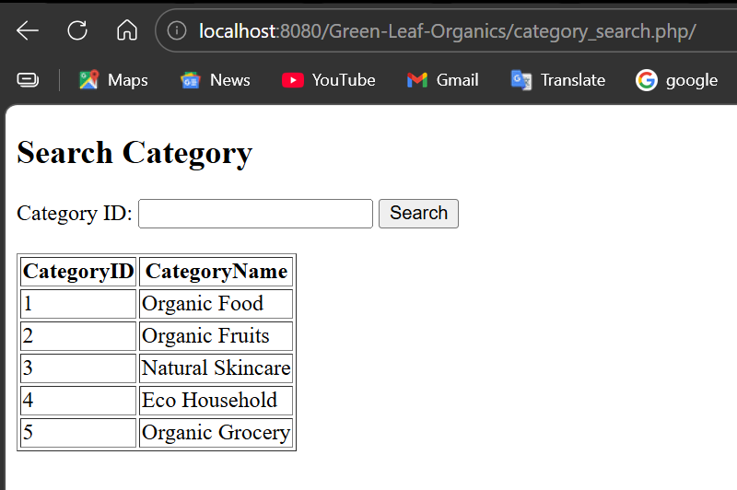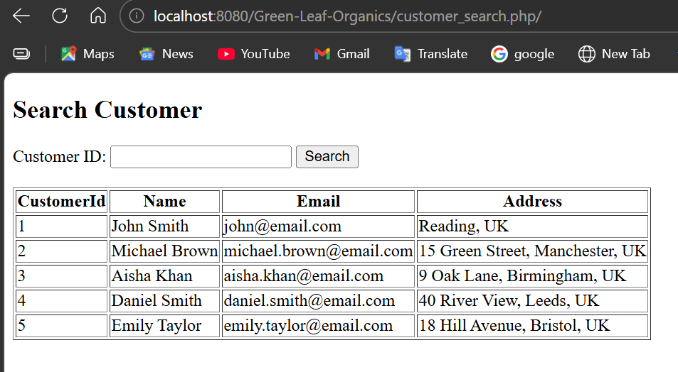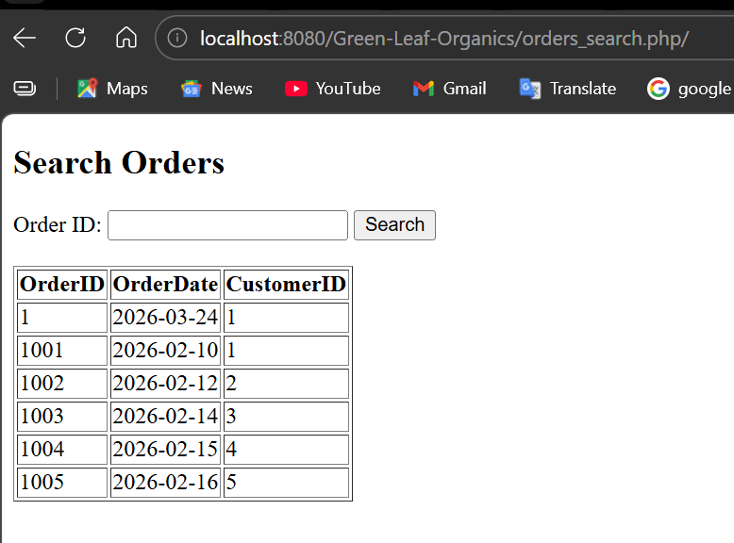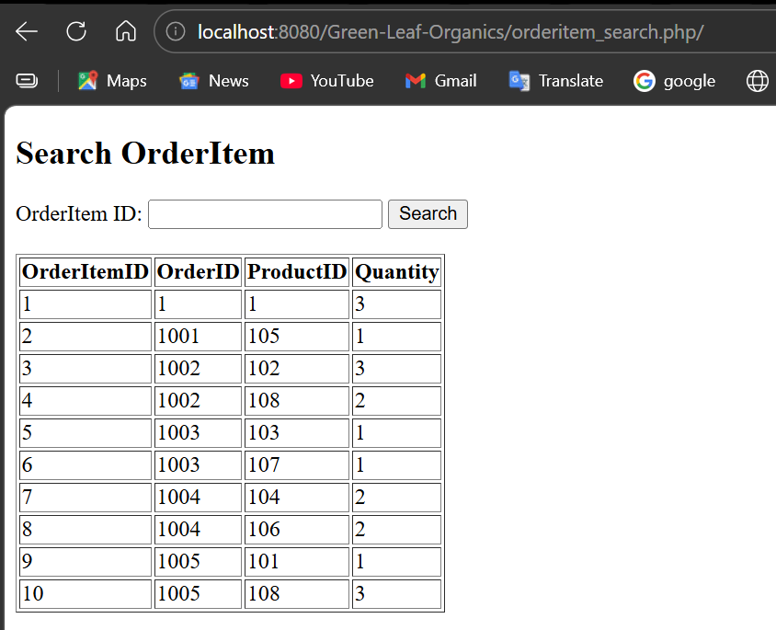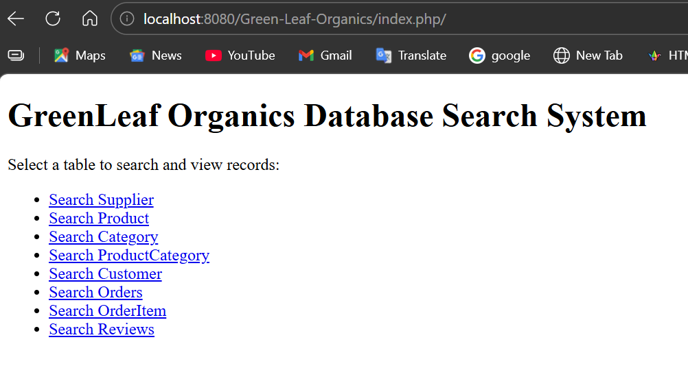

3.4 Triggers and Functions
Triggers and functions are implemented to automate certain processes within the database and improve overall efficiency. A trigger is a set of instructions that automatically executes when a specific event occurs, such as inserting or updating data in a table [10]. This reduces the need for manual intervention and ensures that important operations are consistently performed.
In the GreenLeaf Organics database, one trigger is used to automatically update stock levels whenever a new order is placed. When a record is inserted into the OrderItem table, the trigger reduces the corresponding product’s stock quantity. This ensures that inventory levels remain accurate at all times without requiring additional manual updates.
Another trigger is designed to support auditing by logging changes made to product data. For example, if a product’s price or stock level is updated, the trigger records the change in a separate log table. This provides a history of modifications, which can be useful for tracking errors, ensuring accountability, and maintaining transparency within the system.
Functions are also used to perform calculations within the database. For instance, a function can be created to calculate the total cost of an order by summing the prices of all items included in that order. This simplifies query operations and ensures that calculations are performed consistently across the system.
Together, triggers and functions enhance the automation, accuracy, and reliability of the database. They help ensure that important processes are handled efficiently and that the system can support the operational needs of GreenLeaf Organics.
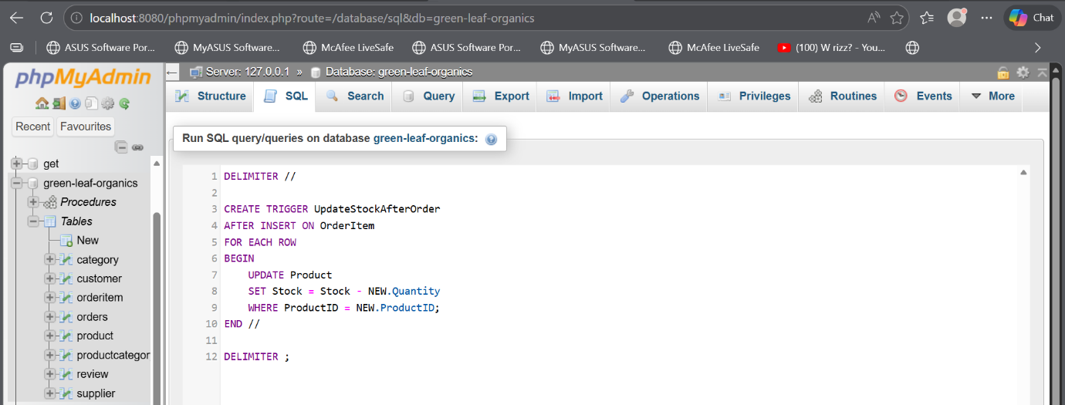
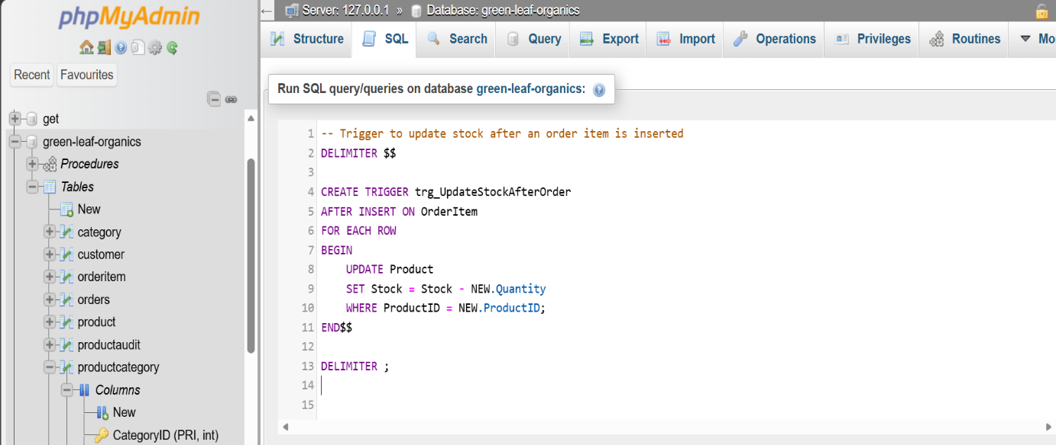
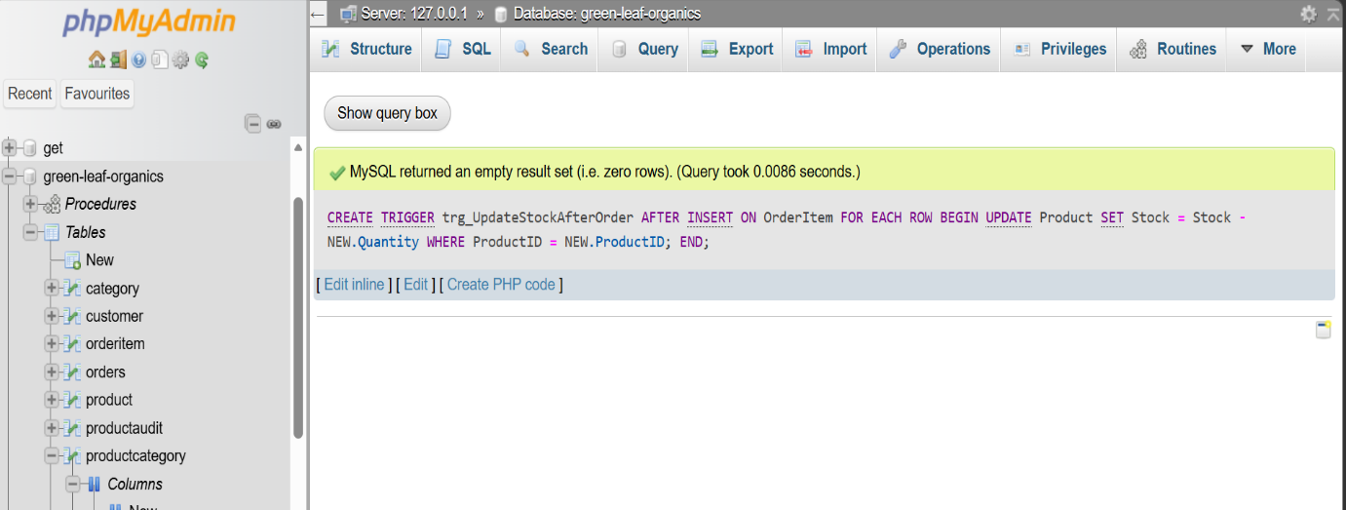
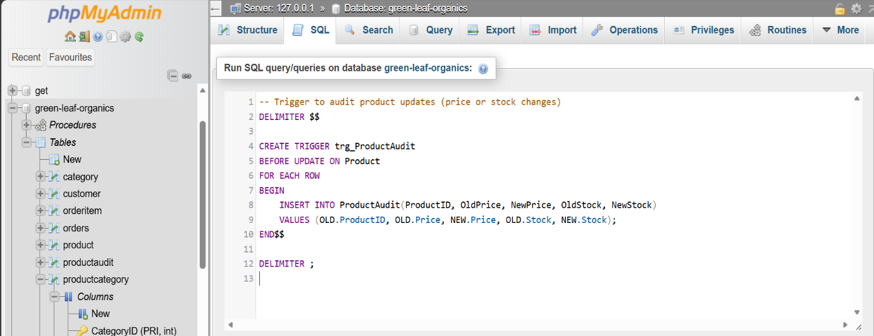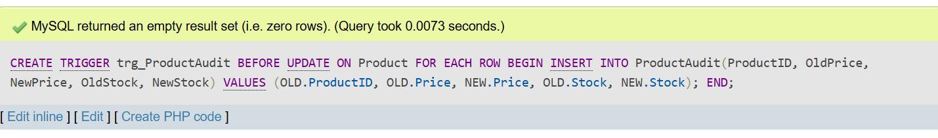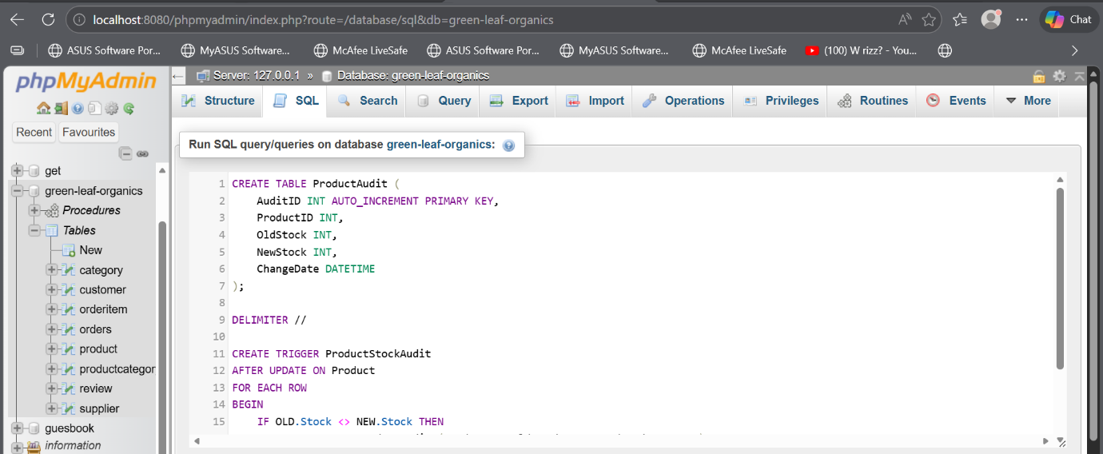
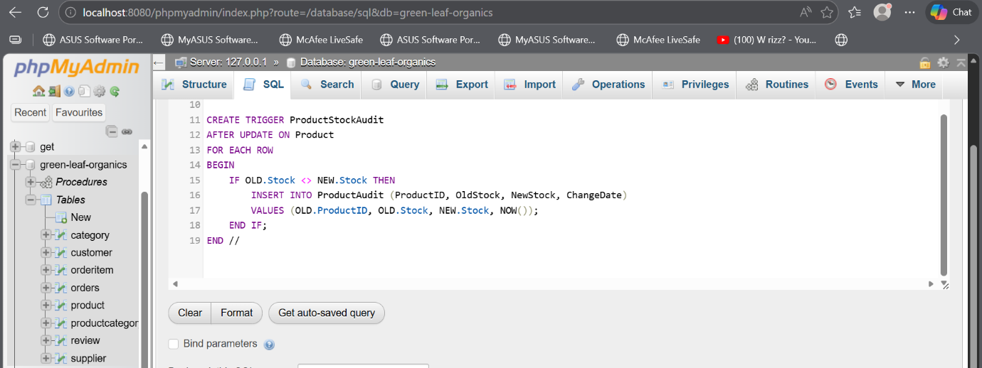

4. Stored Procedures and Transactions

4.1 CRUD Stored Procedures
Stored procedures are an essential part of the database design as they help manage data operations in a structured and reliable way. In this system, stored procedures are created to handle the main CRUD operations, including inserting new products, updating existing product details, and deleting records safely [11]. By using stored procedures, the database ensures that all operations follow a consistent process, which reduces the likelihood of errors. In addition, stored procedures improve security by limiting direct access to the database tables and allowing controlled execution of predefined operations. Overall, they contribute to better data management and system reliability.
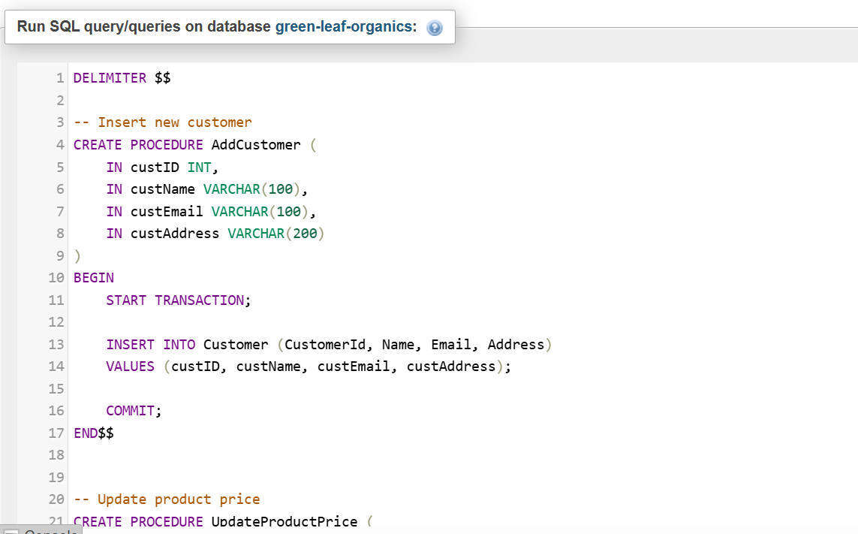
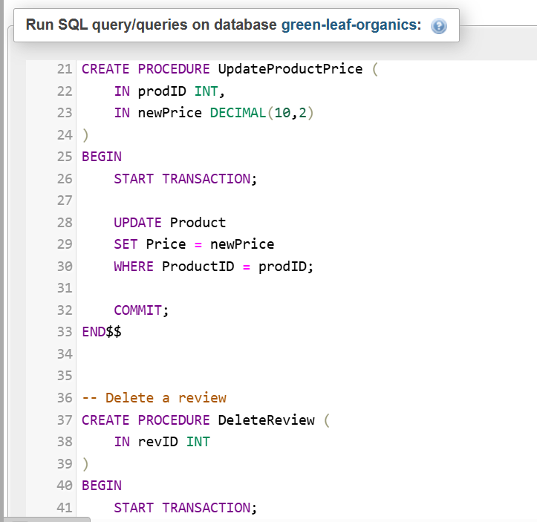
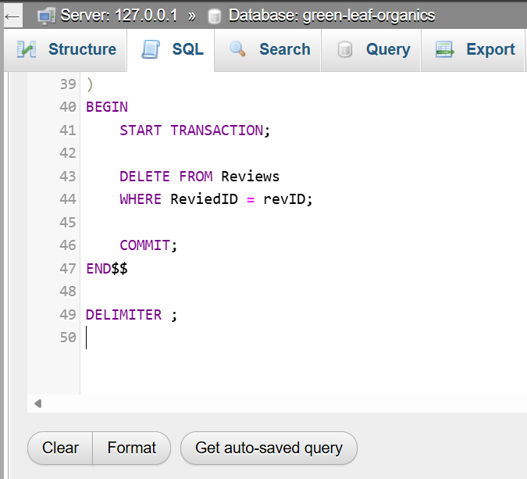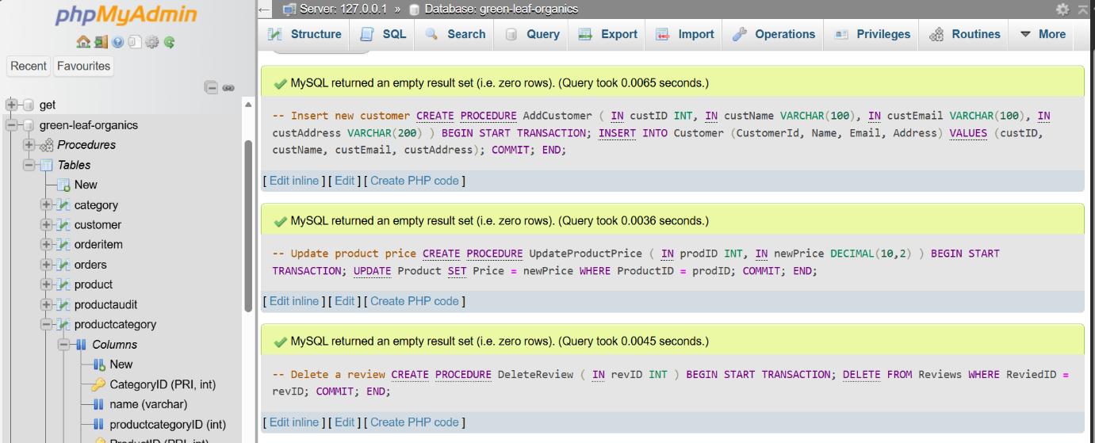
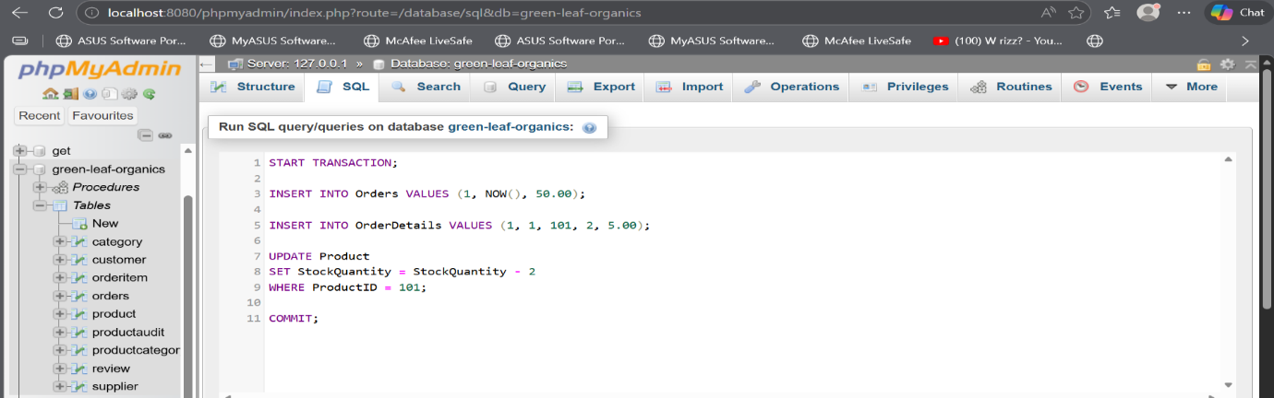

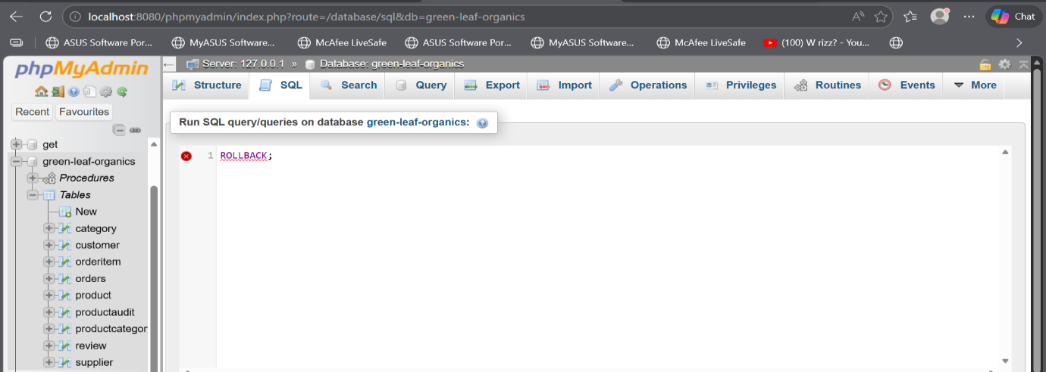

4.2 Transaction Handling
Transaction handling is used to ensure that multiple related database operations are completed successfully as a single unit. A transaction begins with the BEGIN statement, which marks the start of the process. Once all operations are completed successfully, the COMMIT statement is used to save the changes permanently in the database. However, if an error occurs during any part of the transaction, the ROLLBACK statement is executed to undo all changes made during the transaction. This ensures that the database remains accurate and prevents partial or inconsistent data from being stored.
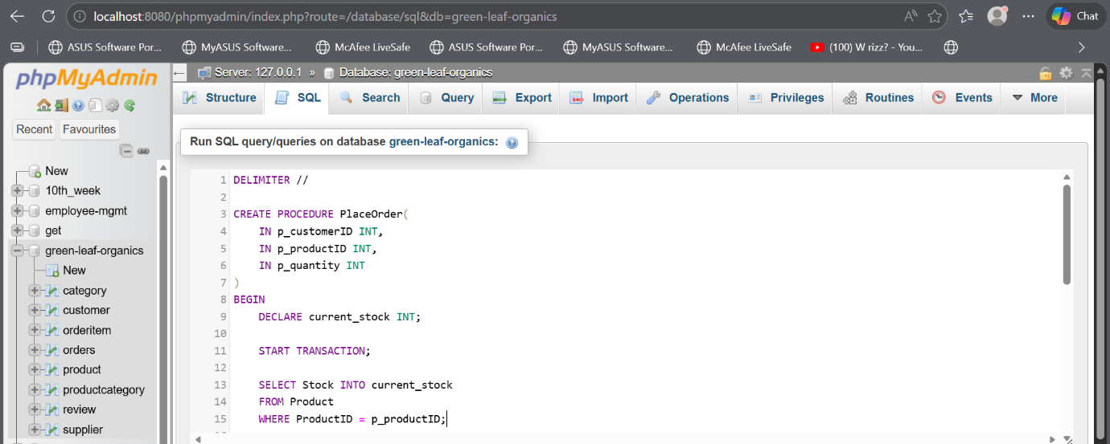
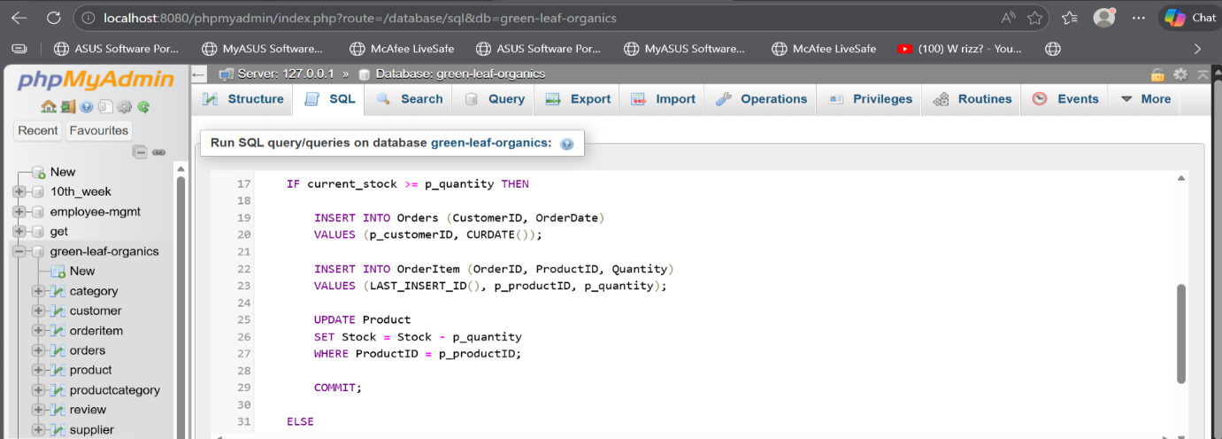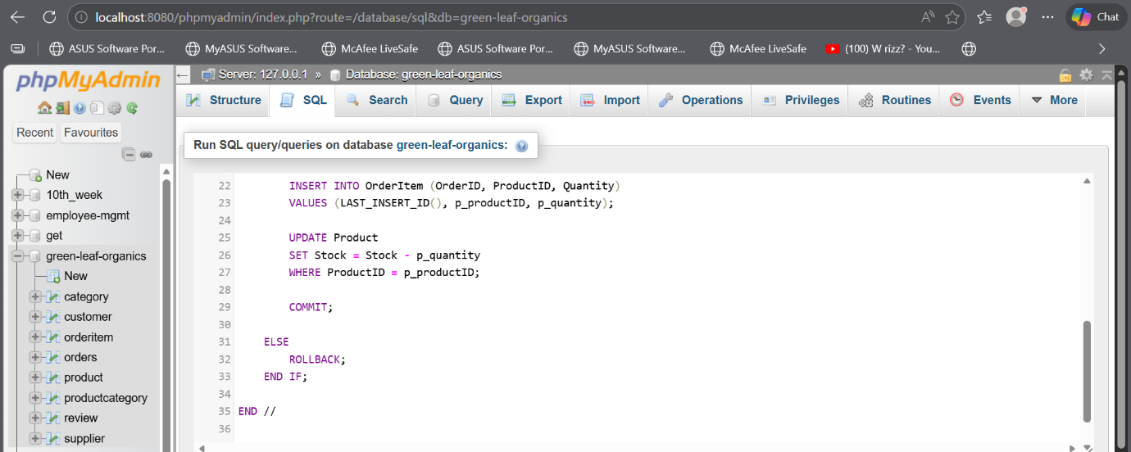
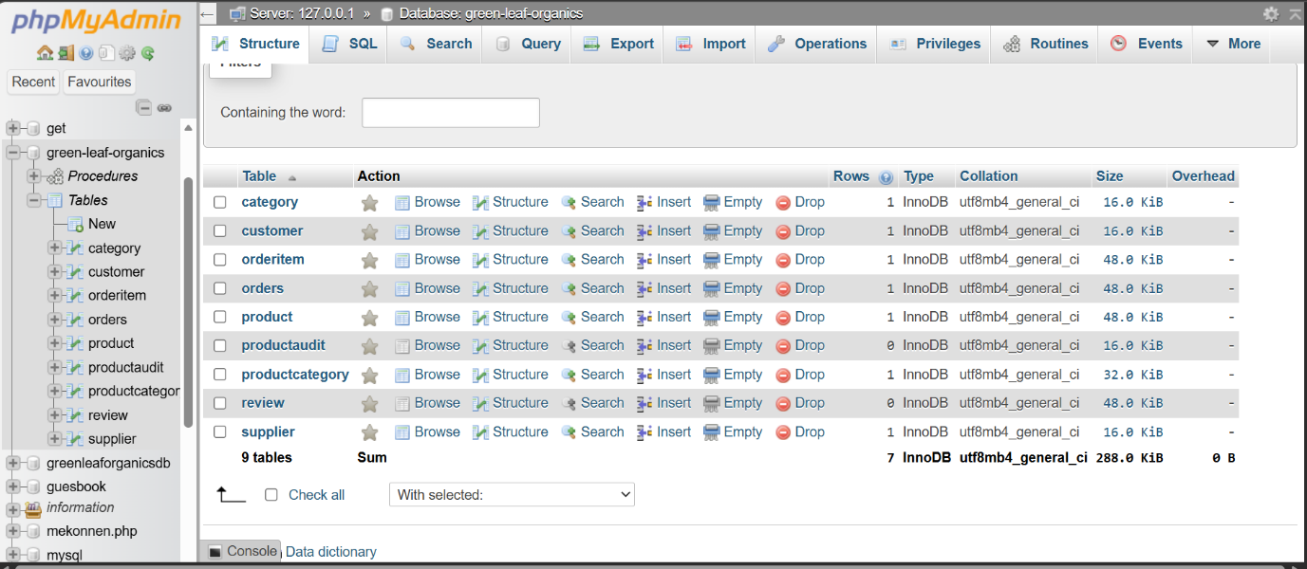
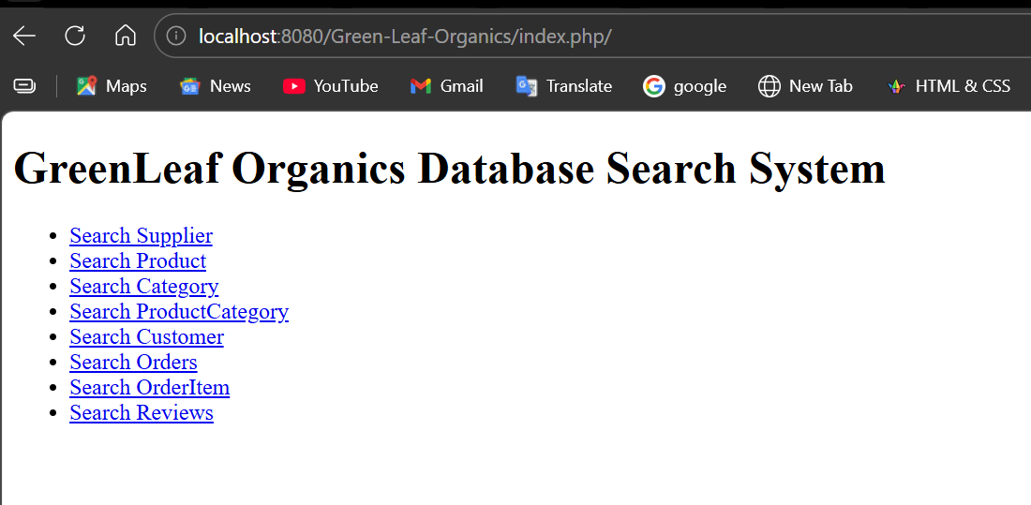

4.3 Transaction Scenario Example
A common example of a transaction in this system is the process of placing an order. This involves several steps, including inserting a new order record, adding multiple order items, and updating the stock levels of the products purchased. All these actions must be completed together for the transaction to be valid. If any step fails, such as when there is insufficient stock available, the system will automatically perform a rollback to reverse all previous actions. This prevents incomplete orders from being recorded and ensures that stock levels remain accurate. Transactions are therefore critical in maintaining data integrity, particularly in systems where multiple operations are closely connected [12]. 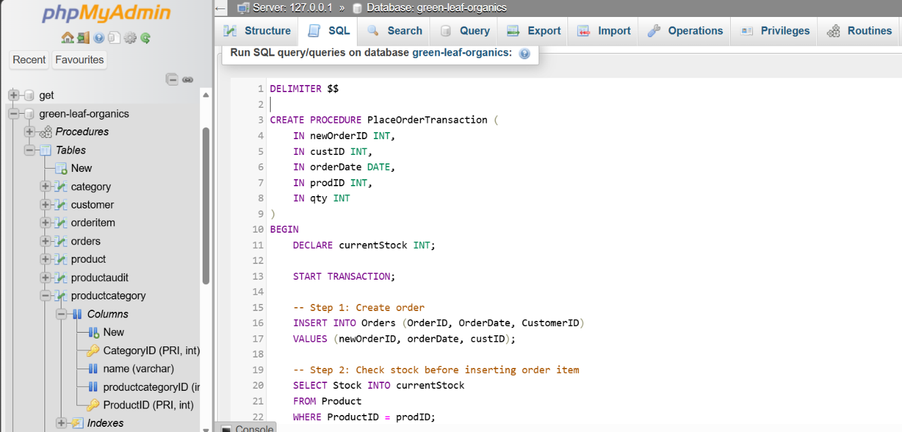
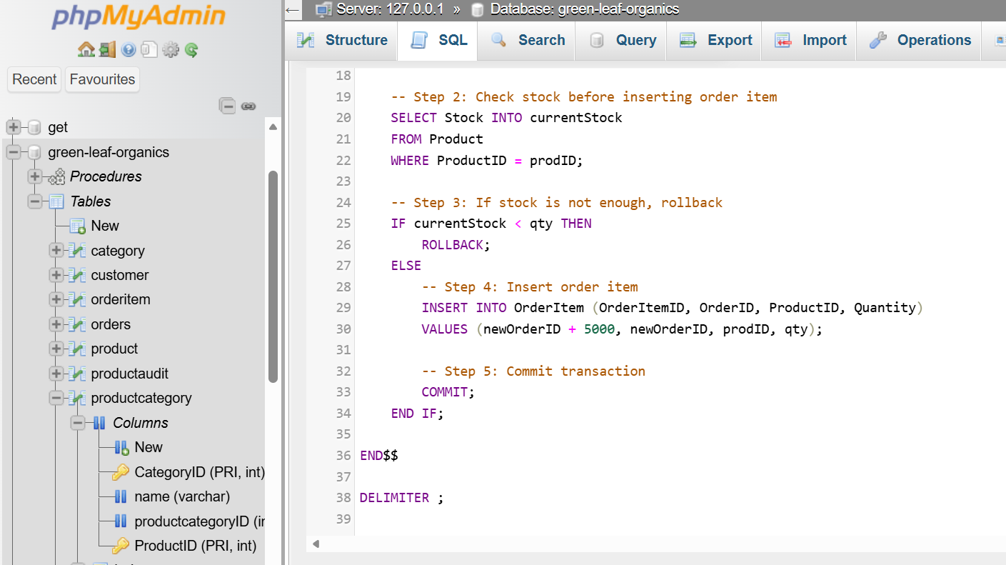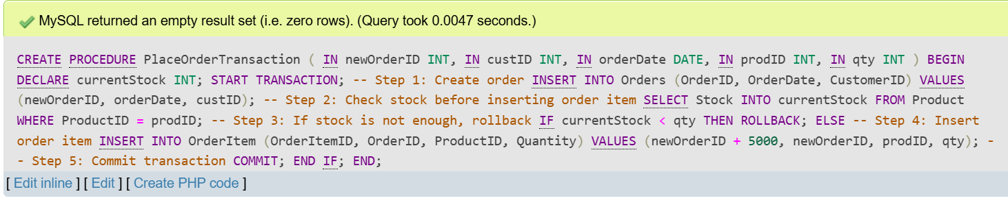

5. Performance Optimisation

5.1 Key Queries
In order to ensure efficient system performance, it is important to identify the most frequently used queries. In this database, common operations include searching for products by category, viewing a customer’s order history, and retrieving lists of products supplied by specific suppliers. These queries are essential for the daily operation of the system, as they directly support user interactions and business processes. Ensuring that these queries run efficiently is therefore a key consideration in the database design. 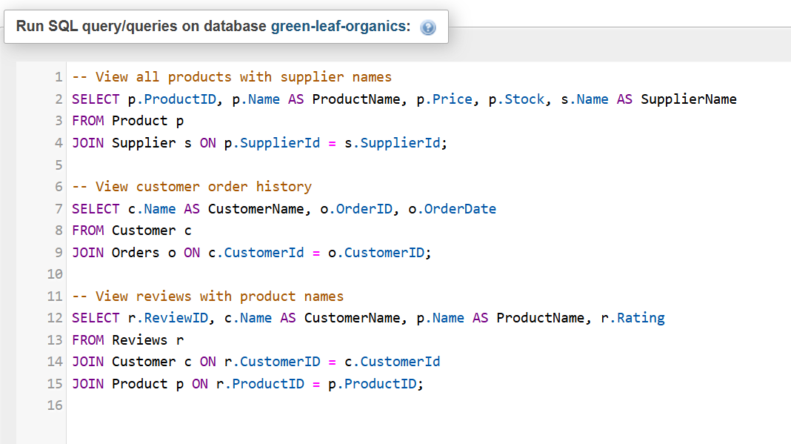
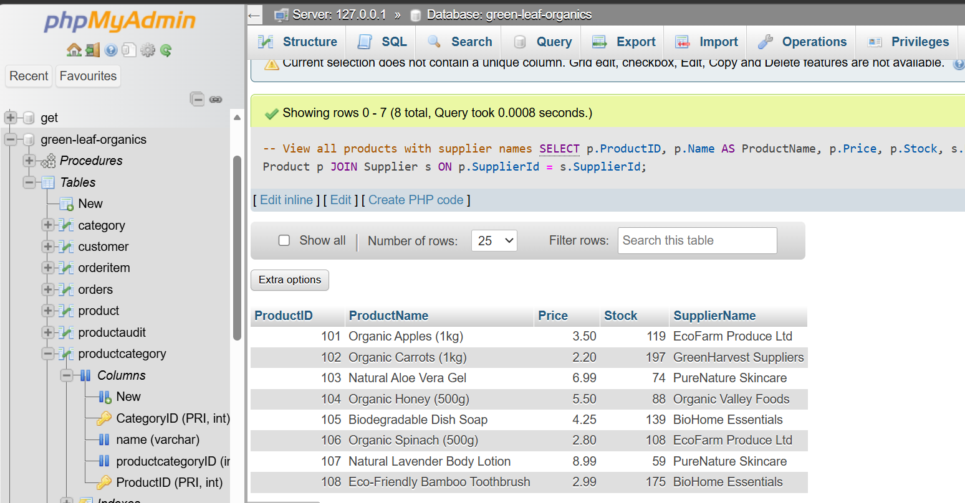

5.2 Indexing Strategy
To improve the performance of these frequently used queries, indexes are created on important columns such as ProductID, CustomerID, and CategoryID. Indexes work by providing a faster way to locate data within large tables, reducing the need for full table scans. This is particularly useful in a system like GreenLeaf Organics, where the amount of data is expected to grow over time. By carefully selecting which columns to index, the database can achieve a balance between fast data retrieval and efficient storage.
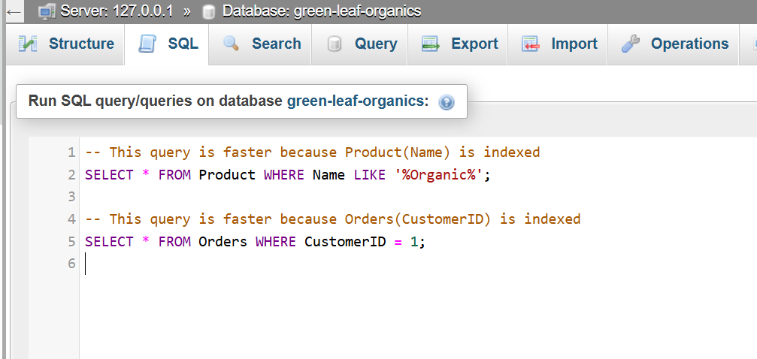
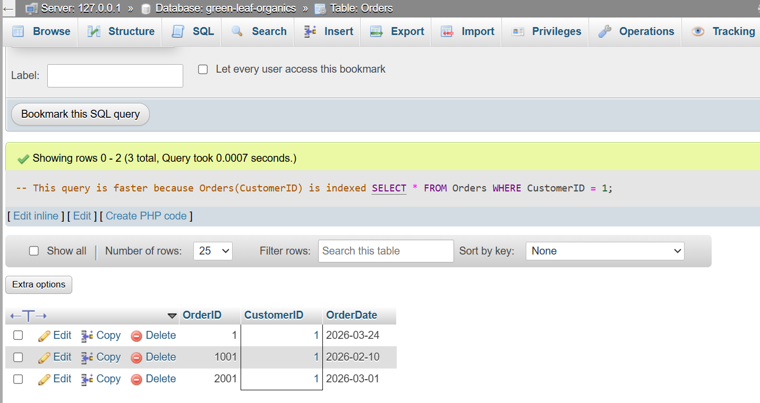
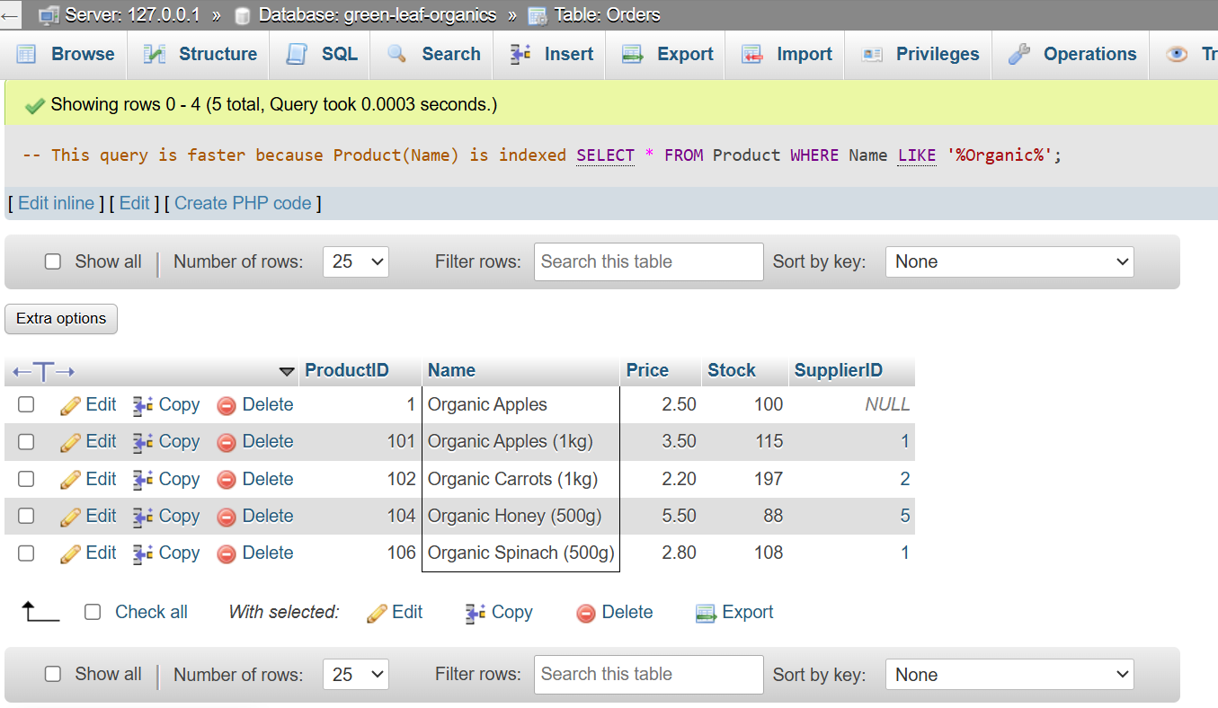

5.3 Benefits of Indexing
The use of indexing significantly improves the speed and efficiency of data retrieval [13]. For example, searching for products becomes faster, customer order histories can be accessed more quickly, and supplier-related queries are processed more efficiently. This leads to an overall improvement in system responsiveness and user experience. However, it is important to note that excessive indexing can have negative effects, such as slowing down data insertion and updates. For this reason, indexing must be applied carefully and only to columns that are frequently used in queries.
COMMIT AND ROLLBACK:
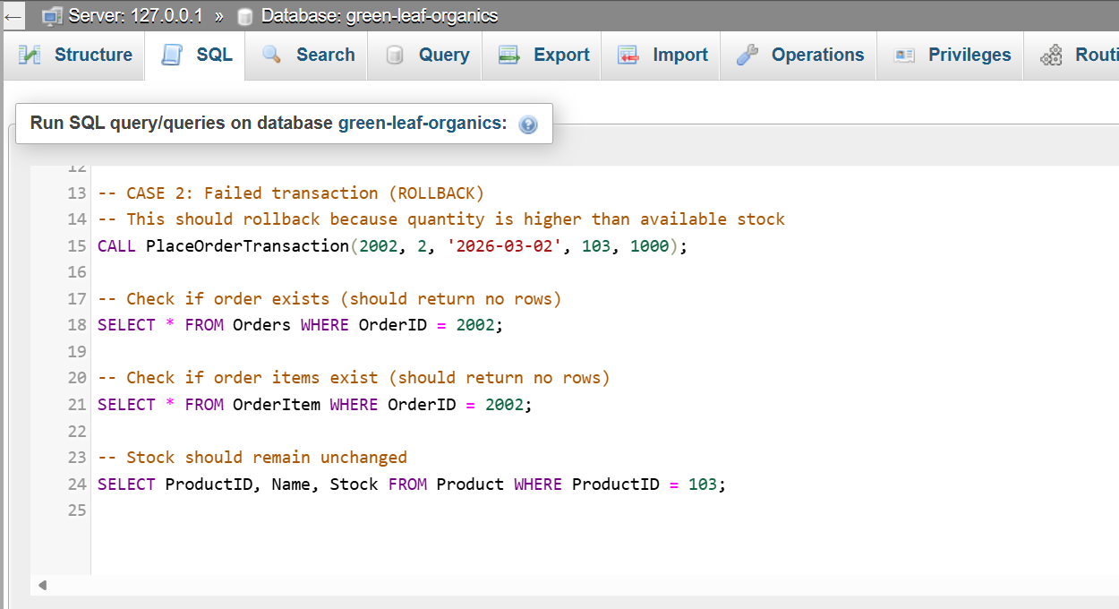
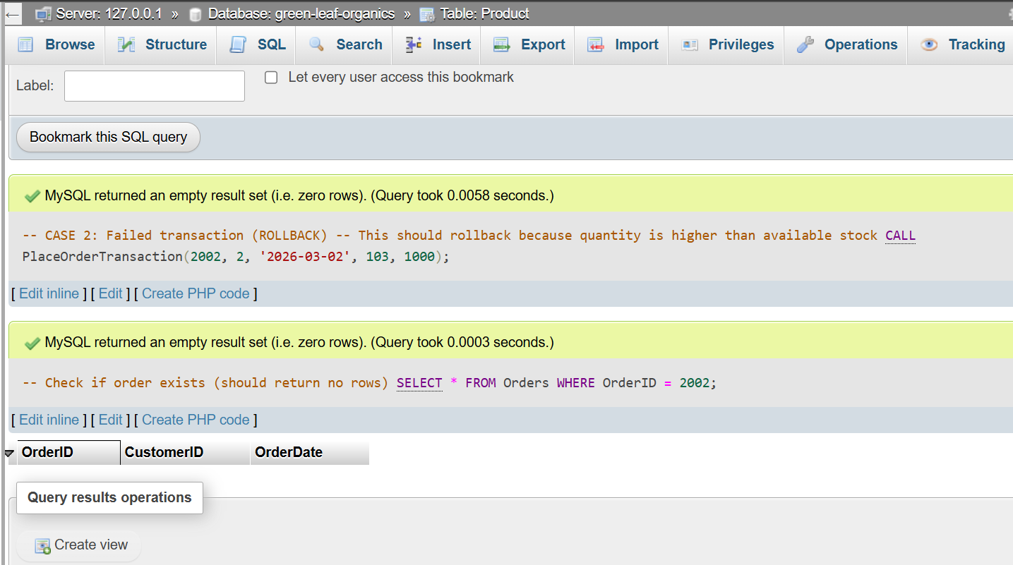

6. Conclusion and Reflection
This project successfully designed and implemented a relational database system tailored to the needs of GreenLeaf Organics. The final solution effectively supports the organisation’s core business operations, including product management, supplier tracking, customer account management, and order processing. By structuring the database around these key functions, the system provides a reliable foundation for the company’s planned online platform.
A key strength of the design is the use of normalisation, which ensures that the database remains efficient and avoids unnecessary duplication of data. This improves data consistency and makes the system easier to maintain over time. In addition, the implementation of stored procedures and transaction handling enhances the reliability of the system by ensuring that operations are carried out correctly and that errors do not result in incomplete or inconsistent data. The use of indexing further improves performance by allowing faster data retrieval, which is particularly important as the volume of data grows.
During the development process, one of the main challenges was accurately modelling the relationships between entities to reflect real-world business processes. In particular, handling many-to-many relationships, such as the relationship between products and categories, required careful consideration. This challenge was successfully addressed by introducing linking tables, which allowed these relationships to be managed efficiently while maintaining a clear and structured design.
Looking ahead, there are several opportunities to further enhance the system. Additional features such as advanced reporting tools, user authentication mechanisms, and integration with external platforms could be implemented to improve functionality and user experience. These improvements would support future business growth and provide greater value to both the company and its customers.
Overall, the database system meets the requirements of GreenLeaf Organics and demonstrates a practical and effective approach to database design and implementation. It provides a solid and scalable foundation for the company’s online operations and highlights the importance of well-structured data management in supporting modern business systems.
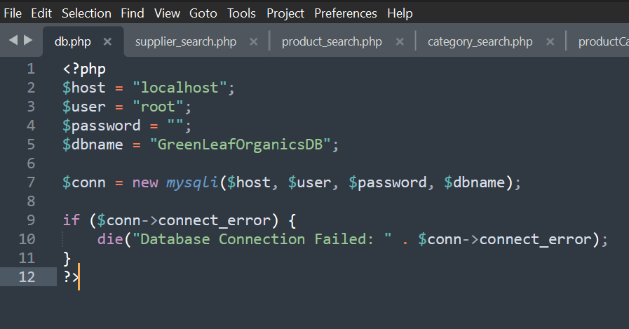
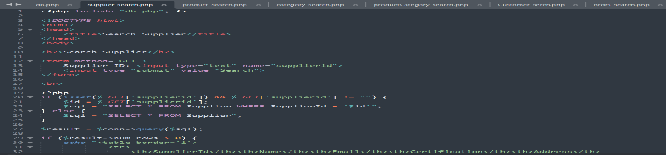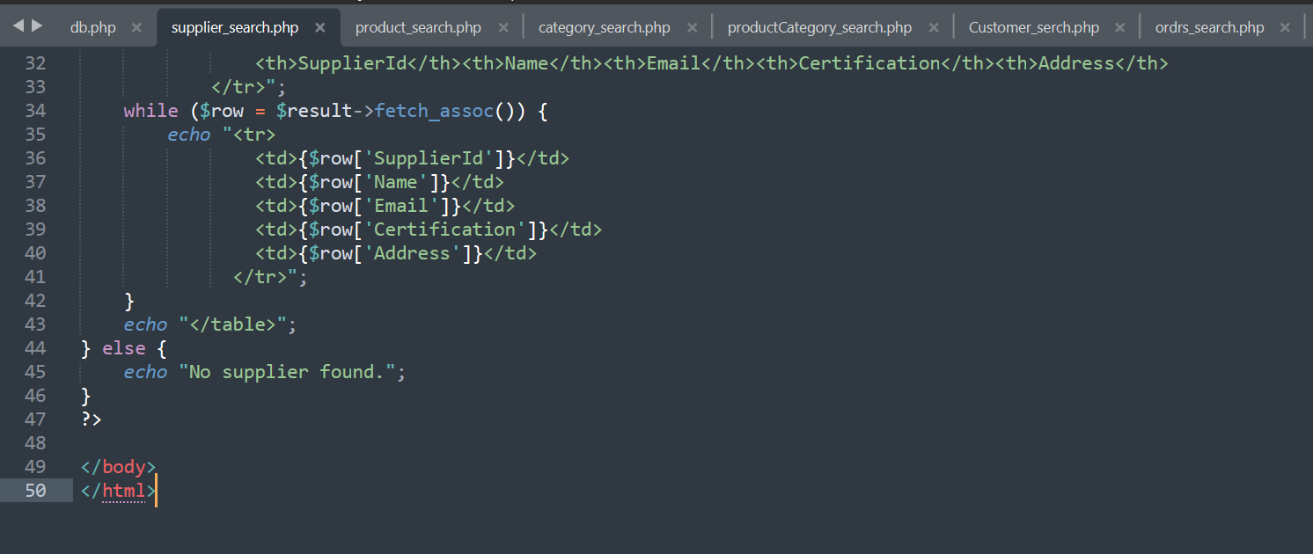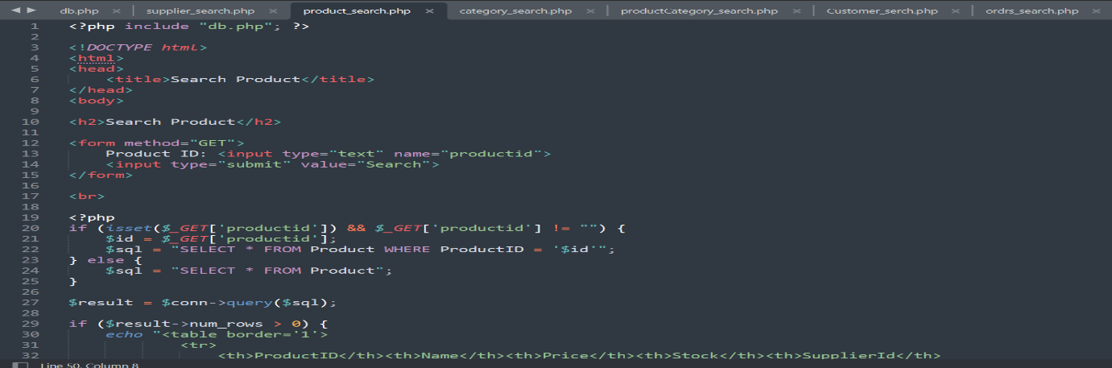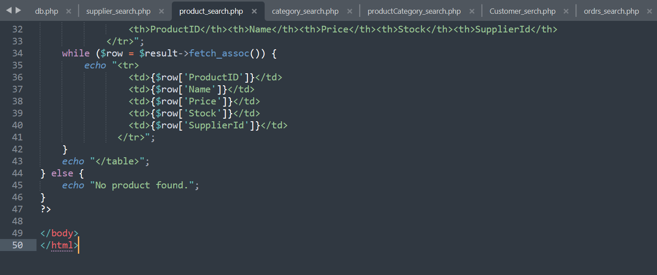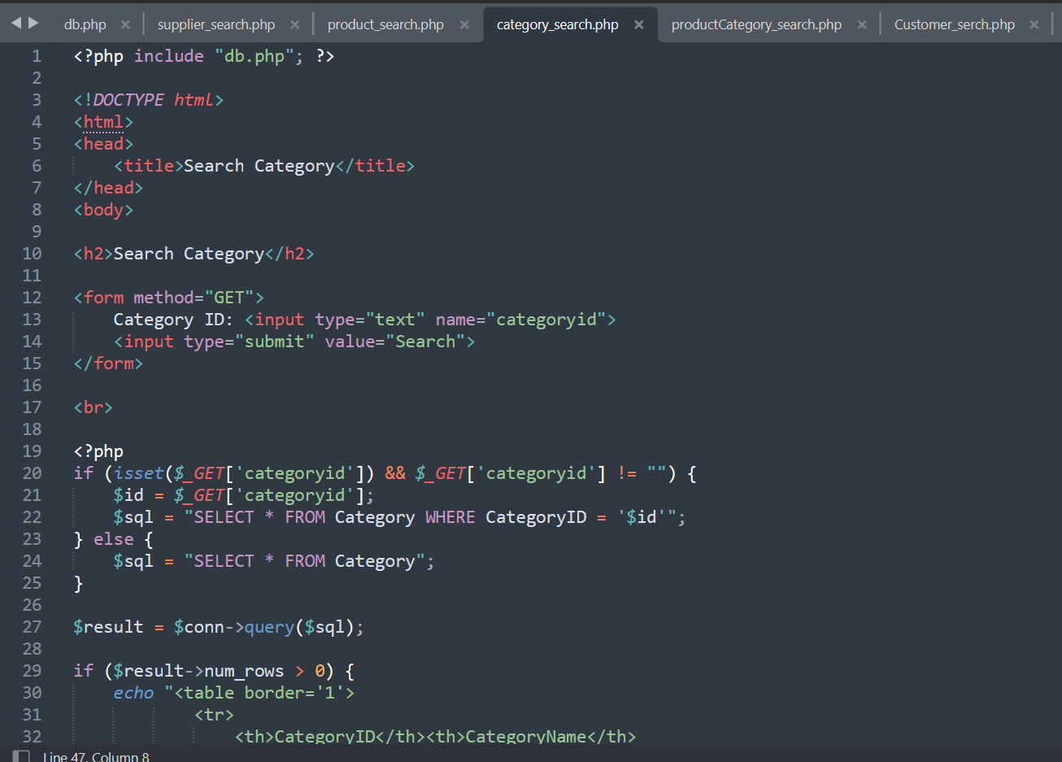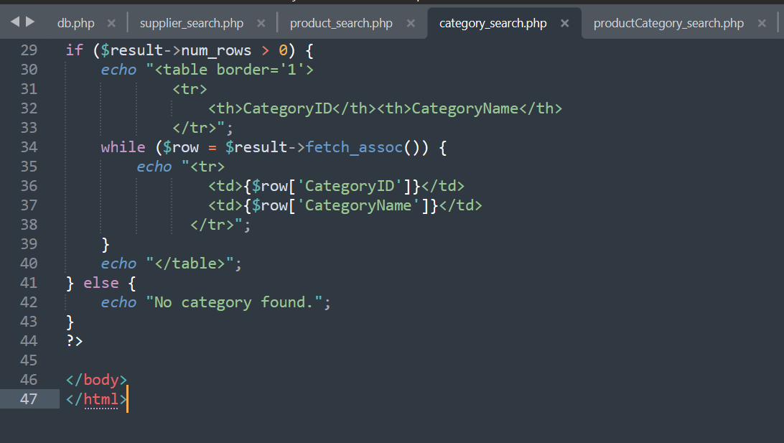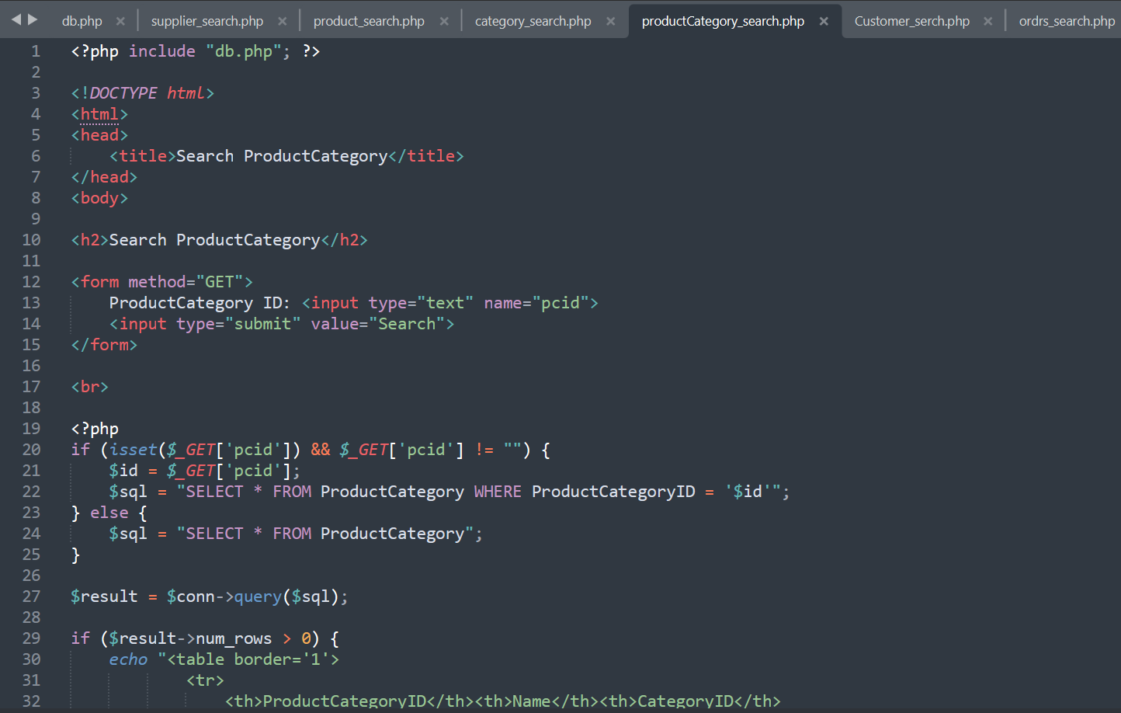

REFERENCE
[1]. J. Ma, S.-Y. Lin, X. Chen, H.-M. Sun, Y.-C. Chen, and H. Wang, “A Blockchain-Based Application System for Product Anti-Counterfeiting,” IEEE access, vol. 8, pp. 77642–77652, 2020, doi: 10.1109/ACCESS.2020.2972026.
[2]. H. Jeon, C. Lim, J. Lee, and B. J. Kim, “Design of Terpene‐Based Eco‐Friendly Solution Process for High‐Performance Organic Solar Cells,” Advanced functional materials, vol. 36, no. 7, Jan. 2026, doi: 10.1002/adfm.202513779.
[3]. W. De A. Perin, D. Cury, C. S. De Menezes, and C. Z. De Aguiar, “Active Learning with Concept Maps: Enhancing Understanding of Entity-Relationship Diagrams in Database Modeling,” in Proceedings - Frontiers in Education Conference, IEEE, Oct. 2023, pp. 1–9. doi: 10.1109/FIE58773.2023.10343471.
[4]. S. Kanwal, N. R. Chaudhry, R. Choudhary, Y. A. Shaik, P. Yadav, and A. Rashid, “Foreign Key Constraints to Maintain Referential Integrity in Distributed Database in Microservices Architecture,” International journal of advanced computer science & applications, vol. 16, no. 6, 2025, doi: 10.14569/IJACSA.2025.0160696.
[5]. P. Mcminn, C. J. Wright, and G. M. Kapfhammer, “The Effectiveness of Test Coverage Criteria for Relational Database Schema Integrity Constraints,” ACM transactions on software engineering and methodology, vol. 25, no. 1, pp. 1–49, Dec. 2015, doi: 10.1145/2818639.
[6]. C. Stefanidis and G. Koloniari, “An interactive tool for teaching and learning database normalization,” in Proceedings of the 20th Pan-Hellenic Conference on Informatics, New York, NY, USA: ACM, Nov. 2016, pp. 1–4. doi: 10.1145/3003733.3003790.
[7]. S. Kolahi, “Dependency-preserving normalization of relational and XML data,” Journal of computer and system sciences, vol. 73, no. 4, pp. 636–647, June 2007, doi: 10.1016/j.jcss.2006.10.014.
[8]. Y. Bai, distributor IEEE Xplore, and publisher Wiley, SQL server database programming with visual basic.net : concepts, designs and implementations, First edition. Hoboken, New Jersey: John Wiley & Sons, Inc., 2020. doi: 10.1002/9781119608493.
[9]. T. M. Connolly and C. E. Begg, Database Systems : a practical approach to design, implementation, and management, Sixth, Global edition. Boston: Pearson, 2015.
[10]. M. Chen, Z. Chen, Z. You, and K. Liang, “Dynamic event-triggered consensus of multi-agent systems with trigger-dependent communication delay,” Journal of King Saud University. Computer and information sciences, vol. 37, no. 8, Art. no. 255, Oct. 2025, doi: 10.1007/s44443-025-00277-y.
[11]. Authors Nahrun Hartono and Zulkarnaim Masyhur, “Optimizing transaction data performance in database management systems,” Matrix : jurnal manajemen teknologi dan informatika, vol. 13, no. 2, pp. 106–114, July 2023, doi: 10.31940/matrix.v13i2.106-114.
[12]. A. Alazeb and B. Panda, “Maintaining Data Integrity in Fog Computing Based Critical Infrastructure Systems,” Jan. 2020, doi: 10.48550/arxiv.2001.04443.
[13]. J. R. Hidalgo and P. Salembier, “On the use of indexing metadata to improve the efficiency of video compression,” IEEE transactions on circuits and systems for video technology, vol. 16, no. 3, pp. 410–419, Mar. 2006, doi: 10.1109/TCSVT.2006.869967.

