

Postgraduate/Distance Learning
Assignment coversheet & feedback form

THIS SHEET MUST BE THE FIRST PAGE OF THE ASSIGNMENT YOU ARE SUBMITTING (DO NOT SEND AS A SEPARATE FILE)

For completion by the student:
Student Name: Ling Duong

Student University Email: 2221051@student.uwtsd.ac.uk

Module code:  HPCA7008  Module title:  Foundations in Cultural Astronomy and Astrology | Student ID number:  2221051 |  |  | Educational support needs:  Yes
Assignment title:
Essay based on a Sky Journal

Assignment due date: 8th December 2022
This assignment is for the 1st
module of the degree
I confirm that this is my original work and that I have adhered to the University policy on plagiarism.
Signed: Ling Duong
Email submission:if you are submitting this form via email, please tick this box □
(as a substitute for your signature) to confirm that you agree to the above declaration.
Assignment Mark
1st Marker’s Provisional mark
2nd Marker’s/Moderator’s provisional mark
External Examiner’s mark (if relevant)
Final Mark

NB. All marks are provisional until confirmed by the Final Examination Board.

For completion by Marker 1 :
Comments:

Marker’s signature: |  |  | Date:
For completion by Marker 2/Moderator:

Comments:

Marker’s Signature: |  | Date:
External Examiner’s comments (if relevant)

External Examiner’s Signature: |  | Date:

Essay on a Sky Journal
Word Count: 2094

Introduction:

This paper focuses on my observations of the sky journal from the month of November 2022. I observed the sky from two different locations in the United Kingdom. The first is from the urban area in Brixton, London and the other is in the rural area of Bury St Edmunds, Suffolk. Each location offers an insight on how the landscape effects the night sky. I have recorded these insights though a phenomenological approach of describing my thoughts and insights verbally, as well as providing photographic evidence. Keeping in mind of Van Gogh’s view of the enchanted sky and other secondary sources.

Author and Vincent Van Gogh:

I am a British woman of Chinese-Vietnamese heritage, who lives in London, United Kingdom. I come from an artistic background and have been trained as an animator. The urban location of Brixton is the place I have lived all of my life. My family home resides within a council estate. In contrast to my chosen rural area, Bury St Edmunds, Suffolk. The location of my workplace is a countryside estate, surrounded by the land my boss’s family owns for generations. I have never analysed the sky and landscape in such contrasting areas, so I hope to understand the different perspectives and reflect on the aspects which comes out of my primary source material.

Vincent Van Gogh is a Dutch post-impressionist painter who lived during (1853-1890). During his lifetime, he has written hundreds of letters, mostly to his brother Theo, which were later compiled by Theo’s wife ‘Johanna van Gogh-Bonger’ and published as a book in 1914 called ‘The Letters of Vincent Van Gogh’. It describes an autobiographical account to Van Gogh’s life through a series of letters, but most importantly, his thinking process and philosophy in relation to his paintings. In relation to Van Gogh’s quote ‘Be clearly aware of the stars and infinity on high. Then life seems almost enchanted after all.’ This describes that although we are going about our everyday lives on earth, be mindful and look up, as nature is around us. Van Gogh lived a difficult life, so looking at the sky gave him a sense of peace with nature. Robert Hughes perfectly describes Van Gogh’s paintings as a representation of the natural world, a continuous field of energy of which nature is the manifestation. We are both artists who draws upon the symbolic archetypes of nature. In the light of Van Gogh’s work, my research aims to derive these thoughts from the sky to the landscape.

Methodology:

I would like to highlight at the outset that my research changed halfway through my observations. My original sky journal was supposed to be looking at the visibility of the planets in relation to Jupiter and the Moon, but I was not sure if I had done that correctly, as I was moving location because of work, so I changed my sky journal to the sky’s relationship to the landscape. Because of this, I was not able to capture the visual evidence of the landscape when I was observing Jupiter and the Moon in the countryside. My thoughts and observations were recorded in the month of November 2022 and the photographs were taken from my phone, to accompany my reflections during this period.

Connection:

The first theme which came out of the sky journal was connection. From my sky journal of the night sky in the countryside of Bury St Edmunds, Suffolk. The first thing I noticed, was how dark it was. It made me think that this is how Van Gogh would have viewed the sky, one hundred and thirty years ago. On 3rd November, ‘You really get a sense of the sky above, especially when there are not many buildings around. Even when there are trees present, there is an overwhelming feeling of them blending in with the landscape (figure 01, 02, 03, 04).’ Although not clearly shown on the photos, I remember seeing it in person. This reminds me of Van Gogh’s ‘The Starry Night’ painting. As an artist myself and especially in Van Gogh’s later paintings, you can see the same brush stroke technique in the sky, trees and buildings, as though they are one with the cosmos. To me, this is the visual embodiment of enchantment (image 01). Hughes describes ‘the jabbing motion of the brush strokes as though nature were opening its veins.’

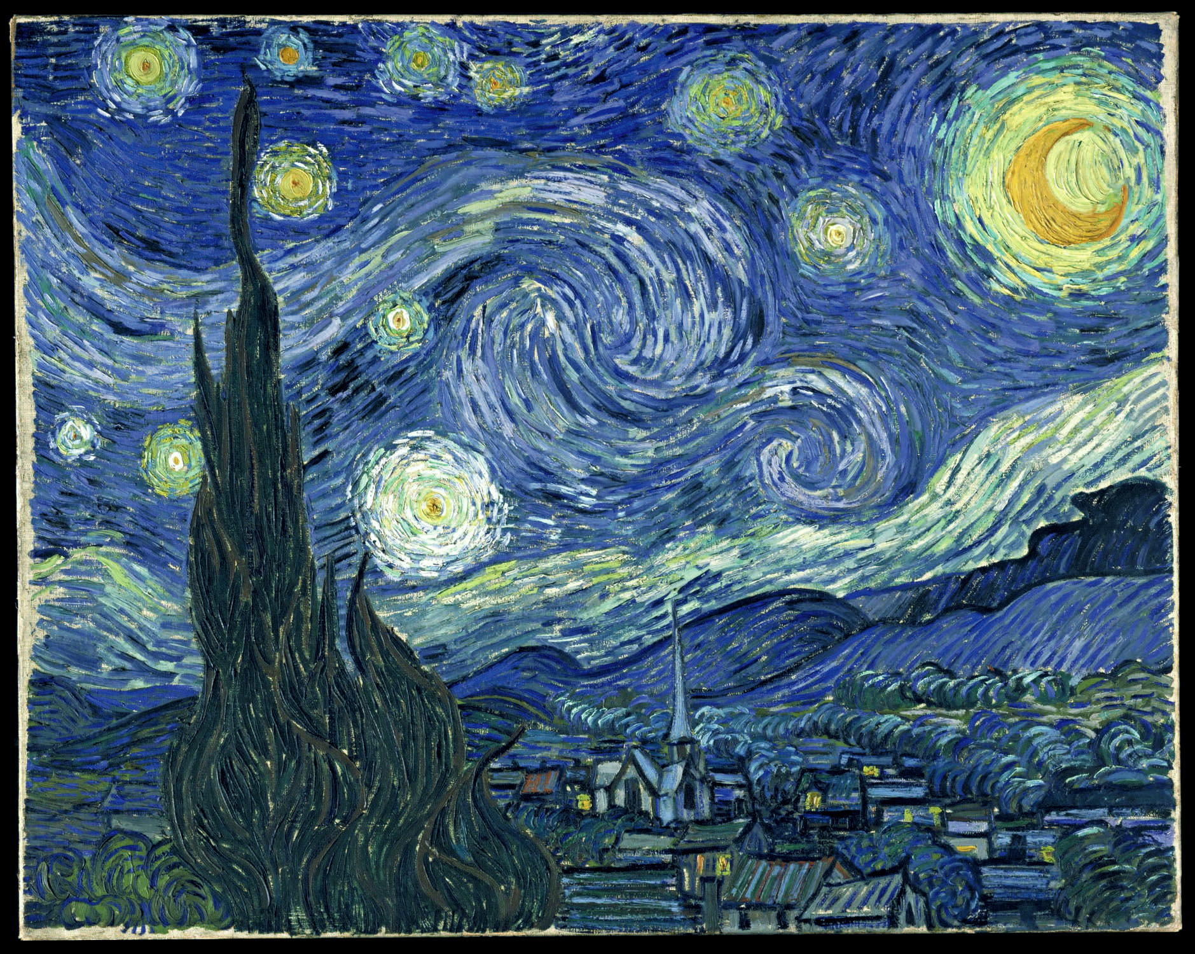
Image 01: Vincent Van Gogh, Starry Night

My observations range from 7pm – 11pm. In my sky journal on 4th November ‘you cannot help but to notice the halo glow of the moon when it is a clear sky (figure 02).’ Van Gogh muses that he ‘wants to paint men and women with the touch of the eternal, whose symbol was once a halo, which we try to convey by the very radiance and vibrancy of our colouring.’ Van Gogh was a religious person and was definitely in touch with something profoundly spiritual. When one observes the halos of the moon, one can easily see how such an effect or observation causes a magical experience. On 7th November, there was a change in weather ‘a slight wind blows across the trees, as the moon peeps through the clouds. The moon feels shy today and does not want to be seen (figure 04).’ There was a sense of harmonious calmness of my mind. Like Van Gogh’s painting (image 01), it makes you feel that you too are a part of the cosmos.

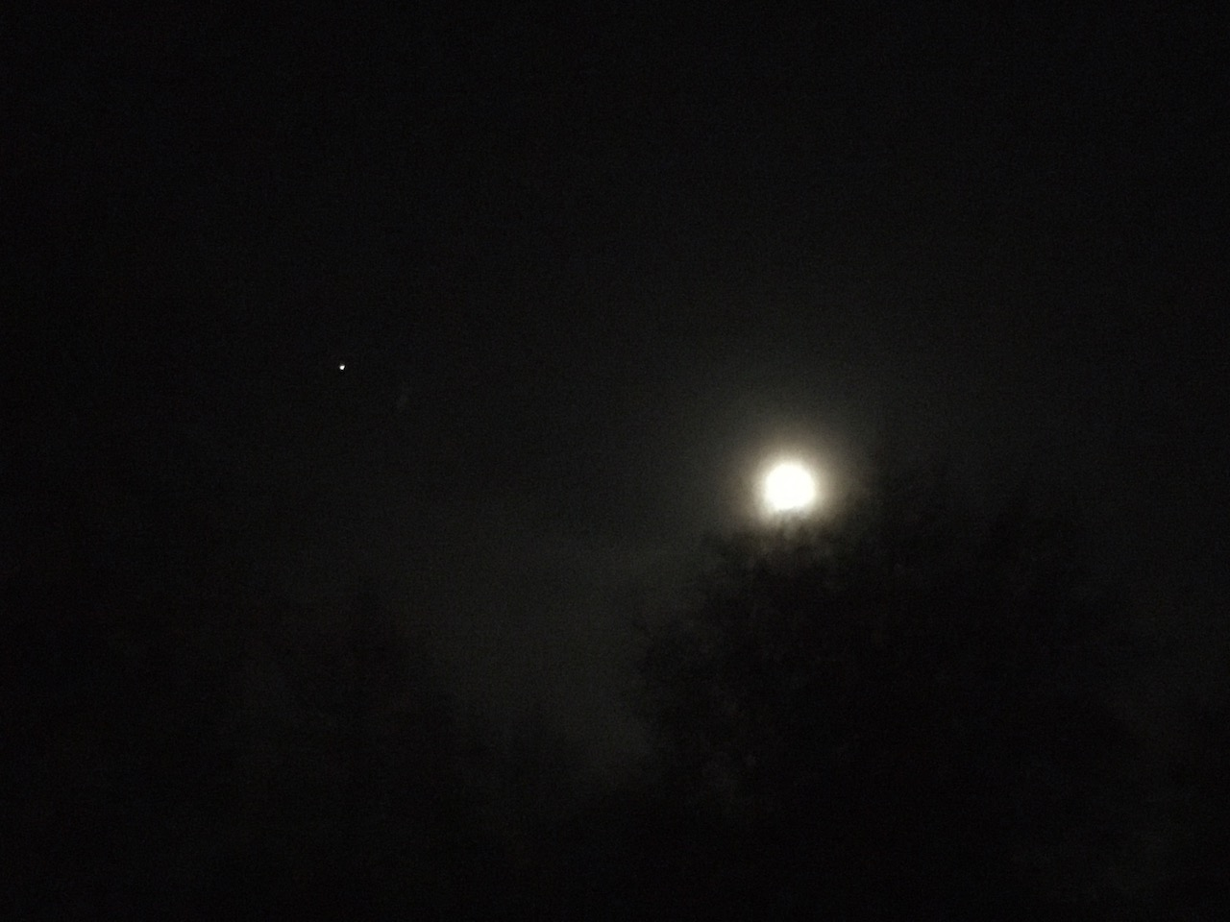
Figure 01: Night sky of Moon & Jupiter with tree, Bury St Edmunds, Suffolk,
Thursday 3rd Nov 2022, 18:32.

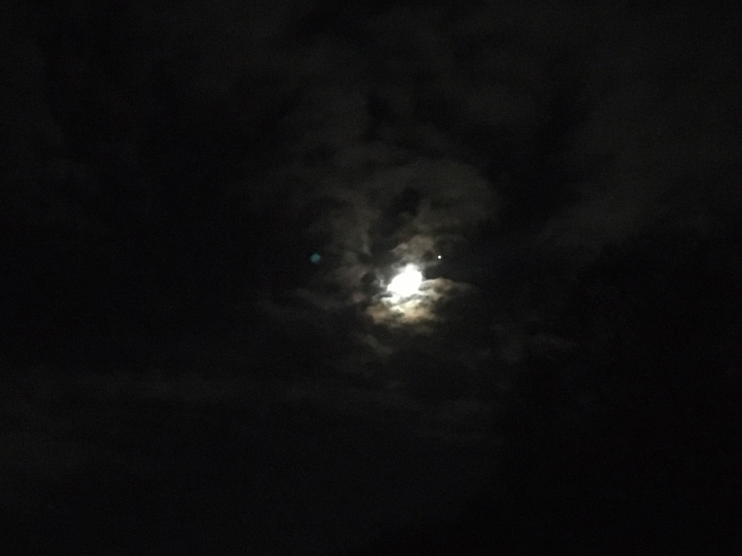
Figure 02: Halo glow of the Moon & Jupiter of the cloudy night sky,
Bury St Edmunds, Suffolk, Friday 4th Nov 2022, 23:47.

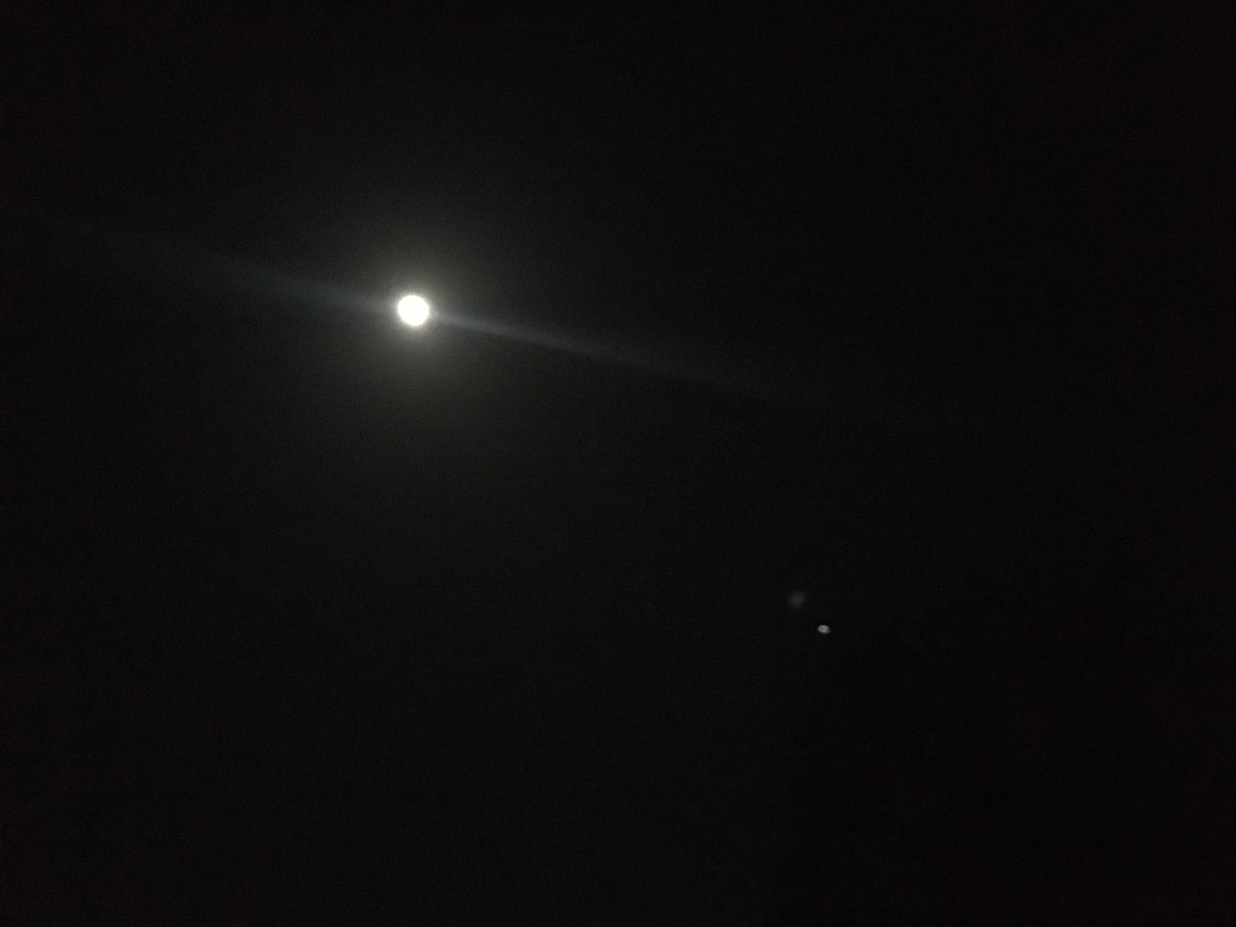
Figure 03: Clear night sky of the halo Moon & Jupiter, Bury St Edmunds,
Suffolk, Sunday 6th Nov 2022, 23:28.

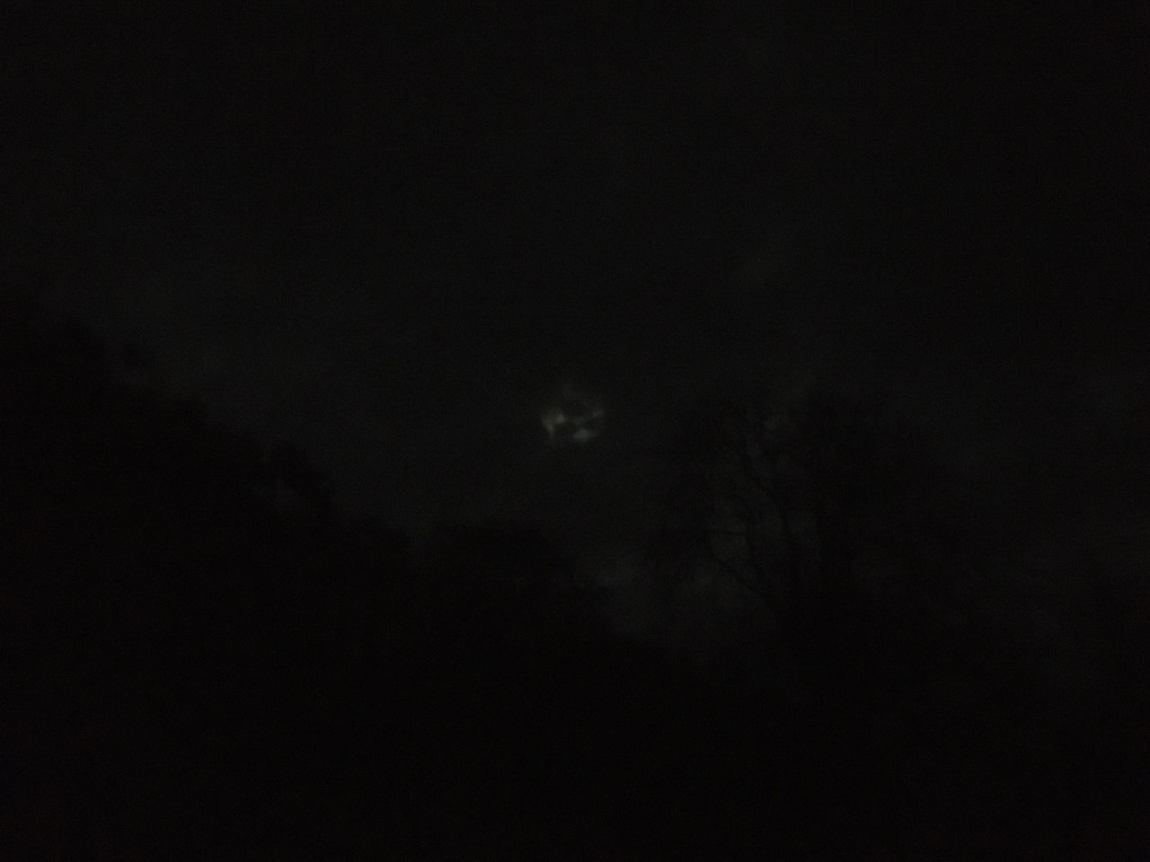
Figure 04: Cloudy night sky of the Moon & Jupiter, Bury St Edmunds,
Suffolk, Monday 7th Nov 2022, 19:14.

Disconnection:

The second theme which appears in my sky journal is disconnection. There is a number of things which I have noticed when observing the sky from the urban setting of Brixton, London. Namely artificial street lights and man-made buildings. This changes the view of the sky, as expressed in my sky journal on 9th November. ‘I can see the moon and Jupiter, as they are still one of the brightest objects in the sky, but the world feels smaller (figure 05). Overtime, I stopped seeing the moon (figure 06).’ Like missing pieces of a puzzle, the sky felt disjointed. Sometimes I will see a moving dot of satellites passing by. I mistake them as stars. The noise pollution was noticeable on 24th and 25th November ‘There are definitely a lot of police car sirens around. It makes me feel really frustrated, I can barely see Jupiter (figure 07). You really do feel the disconnection between the sky and the Earth, like two separate entities (figure 08).’ This is parallel to how Richard Tarnas describes it in Sky and Psyche:

When the sky and the psyche are seen as radically separate, this creates a very different world view for the human being to live with than a word view and cosmology in which the sky is ensouled.’

Iranian philosopher Seyyed Hossein Nasr who has written a book about the need for a sacred science explains that ‘Western man in the modern period, has succeeded in reducing reality to the world experienced by external senses, hence limiting the meaning of reality and removing the concept of ‘reality’ as a category pertaining to God.’ Reality meaning our spiritual disconnection towards nature and humans moral disregard of seeing our disenchanted world as mere objects, trees are just for lumber and animals as harvestable commodities.

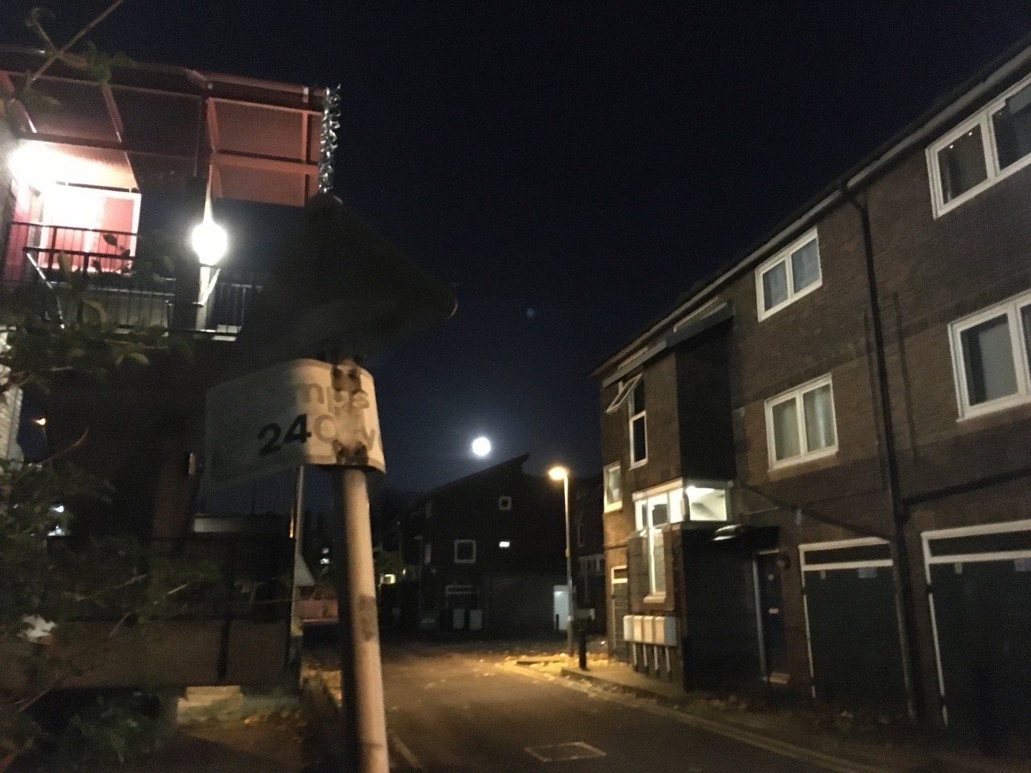
Figure 05: Moon amongst the houses, Brixton, London. Wednesday 9th Nov 2022, 18:05.

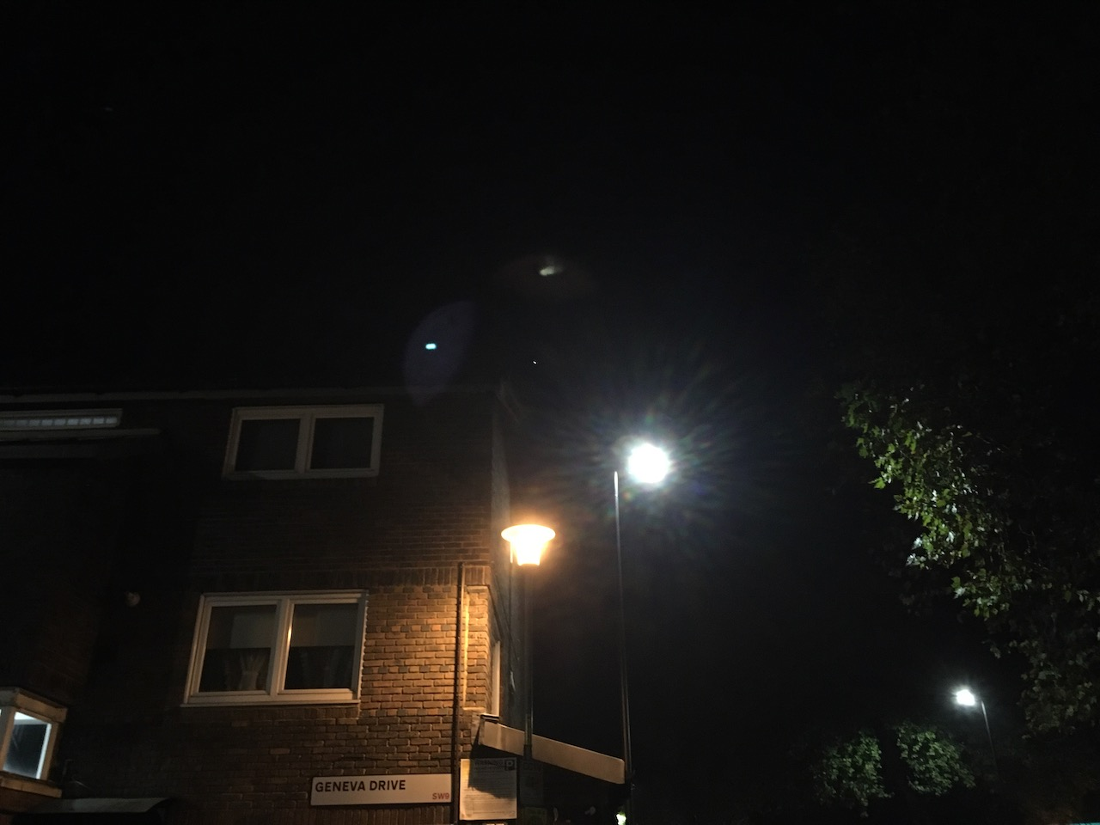
Figure 06: Jupiter amongst the houses, Brixton, London. Thursday 10th Nov 2022, 18:27

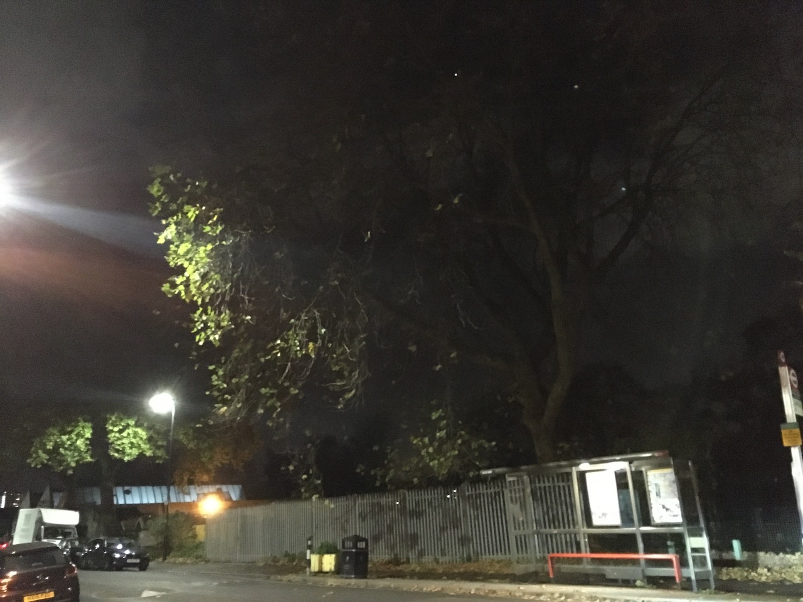
Figure 07: Jupiter hiding in the trees, Brixton, London. Thursday 24th Nov 2022, 21:32

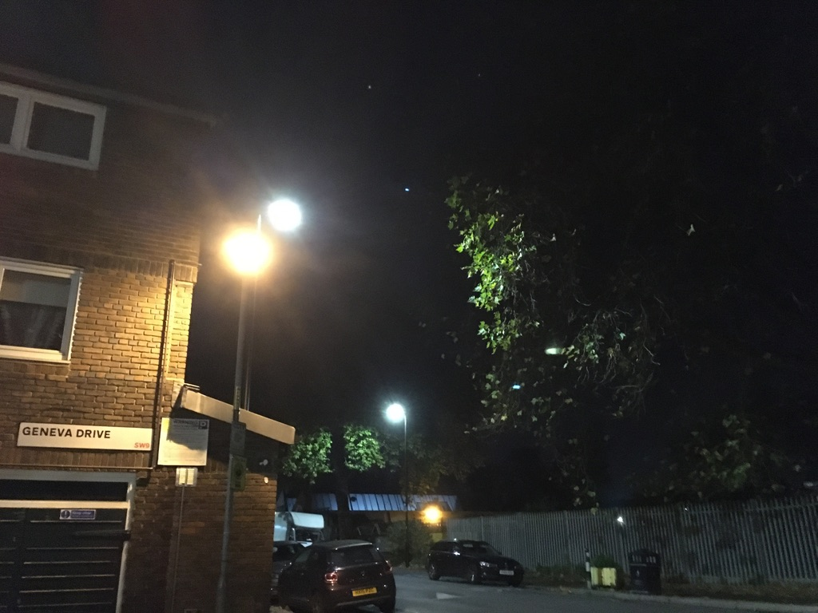
Figure 08: Jupiter amongst the landscape, Brixton, London. Friday 25th Nov 2022, 19:37

Conclusion

The aim of this research was to observe the sky’s relationship in the city of London, in contrast to the countryside landscape of Bury St Edmunds, Suffolk, United Kingdom. Compile it into a month sky journal and to present it as a primary source to analyse, while keeping in mind Van Gogh’s enchantment quote in his autobiographical letters. Upon my first reflections of writing the sky journal, I had a real sense of unease because this contradicts my entire British education upbringing. We learn facts from the third person perspective and not our own. Upon further analysing this tension, I realised this method of writing the sky journal could be found within non-western perspectives, namely the Native Americans. In David Peat’s book, ‘Blackfoot Physics’, the Native Americans process knowledge by coming-to-knowing. ‘This requires one to come into a relationship with the energies and animating spirits of the universe.’ ‘This can only be learnt by one’s personal experience of observing, watching, listening and dreaming within nature and society.’

The connection and disconnection themes which came out from analysing the sky journal within a rural and urban landscape, led me to question the traditional cosmology of microcosm and macrocosm. Leonard Barkan understanding is to know oneself, one has to study the cosmos. In Manly Hall’s book ‘The Secret Teachings of All Ages’, he quotes Paracelsus astrological take on the matter: ‘The body comes from the elements, the soul from the stars, and the spirit from God. All that the intellect can conceive of comes from the stars (the spirits of the stars, rather than the material constellations)’. Nasr coins the term sacred science to understand the metaphysical principles. He quotes Rūmī poem, which parallels Paracelsus’s understanding:

The Stars of Heaven are ever re-filled by the star-like souls of the pure.
The outer shell of Heaven, the Zodiac, may control us; but our inner essence rules the sky.
In form you are microcosm, in reality the macrocosm.

Carl Jung brings the notion back to modern times, ‘our psyche is set up in accord with the structure of the universe, and what happens in the macrocosm likewise happens in the infinitesimal and most subject reaches of the psyche.’ This leads me to feel Van Gogh visually summarised the microcosm and macrocosm analogy in his Starry Sky painting (image 01). The influence of light pollution, satellites and planes in the sky of the city of London compared to Van Gogh’s era of 1800s could not be ever more contrasting. Tarnas implies this simply as when ‘there is a larger loss of the sacred, for when you lose it in the cosmos and nature, then you begin to lose it inside as well.’ If humans disconnect themselves to nature, it could lead one to mental distress and long-term illnesses. In Leventes Hufnagel’s report: ‘Light pollution, Urbanization and Ecology’. Artificial light not only effects the natural diurnal cycle of plants, it can also lead to long term illnesses: ‘Light pollution has been found to be a risk factor for breast cancer in the form of artificial light at night, with melatonin being the mediator between environment and the epigenome.’ My thoughts within the sky journal of November 2022 has shifted my perspective of the sky’s relationship to the landscape. It has offered me an insight into the material and spiritual realms of my surroundings. A passage from ‘The Old Astronomer to his Pupil’ poem, written by Sarah Williams (1868) encapsulates my overview of the paper.

Thou my soul may set in darkness,
it will rise in perfect light.
I have loved the stars too fondly
to be fearful of the night.

Bibliography
Al-Naggar, Redhwan, and Lutfi Al-Maktari, Artificial Light at Night and Breast Cancer, Www.intechopen.com (IntechOpen, 2021) <https://www.intechopen.com/chapters/75764> [accessed 1 December 2022]

Barkan, Leonard, Nature’s Work of Art, New Haven: Yale University Press, 1975

Campion, Nicholas, and Patrick Curry, Sky and Psyche: The Relationship between Cosmos and Consciousness, Edinburgh: Floris Books, 2006

F. David Peat, Blackfoot Physics : A Journey into the Native American Universe, Boston, Ma: Weiser Books, 2005

Hall, Manly P, The Secret Teachings of All Ages, New York, New York: Discovery Publisher, 2020

Hufnagel, Levente, Light Pollution, Urbanization and Ecology, BoD – Books on Demand, 2022

Hughes, Robert, The Portable van Gogh, Rizzoli International Publications, 2008

Jung, C. G., Memories, Dreams, Reflections, New York: Pantheon, 1963; Vintage, 1989

Ronald De Leeuw, and Arnold Julius Pomerans, The Letters of Vincent van Gogh, London: Penguin Books, 1997

Seyyed Hossein Nasr, Need for a Sacred Science, State University of New York Press, 2013

Williams, Sarah, Twilight Hours: A Legacy of Verse ... With a Memoir by E. H. Plumptre, Third and enlarged edition, Strahan and Co Publishers, 1872

Vincent Van Gogh, Starry Night (1889), Museum of Modern Art, New York. <https://en.wikipedia.org/wiki/Vincent_van_Gogh#/media/File:VanGogh-starry_night_ballance1.jpg> [accessed 2 December 2022]

‌

Robert Hughes, The Portable van Gogh, Rizzoli International Publications, 2008, p. 9.
Robert Hughes, The Portable van Gogh, Rizzoli International Publications, 2008, p. 8.
Vincent Van Gogh, Starry Night (1889), <https://en.wikipedia.org/wiki/Vincent_van_Gogh#/media/File:VanGogh-starry_night_ballance1.jpg> [accessed 2 December 2022]
Ronald De Leeuw and Arnold Julius Pomerans, The Letters of Vincent van Gogh, London: Penguin Books, 1997, p. 394.
Campion, Nicholas, and Patrick Curry, Sky and Psyche: The Relationship between Cosmos and Consciousness, Edinburgh: Floris Books, 2006, p. 184
Seyyed Hossein Nasr, Need for a Sacred Science, State University of New York Press, 2013, p. 7
Campion, Nicholas, and Patrick Curry, Sky and Psyche: The Relationship between Cosmos and Consciousness, Edinburgh: Floris Books, 2006, p. 190
F. David Peat, Blackfoot Physics : A Journey into the Native American Universe, Boston, Ma: Weiser Books, 2005, p. 55
F. David Peat, Blackfoot Physics : A Journey into the Native American Universe, Boston, Ma: Weiser Books, 2005, p. 59
Barkan, Leonard, Nature’s Work of Art, New Haven : Yale University Press, 1975, p. 8
Hall, Manly P, The Secret Teachings of All Ages, New York, New York: Discovery Publisher, 2020, p. 54.
Seyyed Hossein Nasr, Need for a Sacred Science, State University of New York Press, 2013, p. 2.
Seyyed Hossein Nasr, Need for a Sacred Science, State University of New York Press, 2013, p. 19.
Jung, C. G., Memories, Dreams, Reflections, New York: Pantheon, 1963; Vintage, 1989, p. 335.
Campion, Nicholas, and Patrick Curry, Sky and Psyche: The Relationship between Cosmos and Consciousness, Edinburgh: Floris Books, 2006, p. 190
Redhwan Al-Naggar and Lutfi Al-Maktari, Artificial Light at Night and Breast Cancer, www.intechopen.com (IntechOpen, 2021), p. 1.
‌ Williams, Sarah, Twilight Hours: A Legacy of Verse ... With a Memoir by E. H. Plumptre, Third and enlarged edition, Strahan and Co Publishers, 1872, p. 69

