University of Wales
Trinity Saint David
BA Business Management - LCBB4005
The Global Business Environment

Environmental Analysis of Automobile Industry and Toyota Motor Corporation
Marketing Fundamentals Analysis and Evaluation – ASSIGNMENT 1

Teodora Georgieva
Student ID: 2111818
Date of submission: 12th of January 2022
Word Count: 2199 words

ABSTRACT
This report will explain external factors and their importance for the development of the automotive industry worldwide. We will look at the structure of Toyota Motor Corporation with its strengths and weaknesses, as well as strategies for future development and stability in the competition.

Table of Contents
Abstract ………………………………………………………………………………………………………………………………………….2
Table of Content………………………………………………………………………………………………………………………………3
1. Introduction …………………………………………………………………………………………………………………………….4
2. External business environment of Toyota Motor Corporation……………………………..…………………..4
2.1 Industry overview and analysis………………………………………………………………………………..................4
2.2 Porter’s Five Forces analysis …………………………………………………………………………………………………..5
2.3 PESTEL Analysis………………………………………………………………………………………………………………………6
3. Internal environment of Toyota Motor Corporation ………………………………………………………….……8
3.1 Core competency …………………………………………………………………………………………………………………..9
3.2 SWOT Analysis……………………………………………………………………………………………………………………….9
3.3 Value Chain Analysis…………………………………………………………………………………………………………….12
4. Recommendation……………………………………………………………………………………………………………………14
5. Conclusion……………………………………………………………………………………………………………………...........15
6. References …………………………………………………………………………………………………………………………….16

1.Introduction
The automotive industry occupies a large share of the overall economy. Organizations are striving for international activity in order to have a larger potential market, high sales and revenue growth. Analysing the financial and political situation, access to resources or cheap labour are factors in making organizational decisions. In the last few years, the whole sector has been affected by external factors, such as Covid19, Brexit, and last but not least, the deepening environmental problem. Through the analyses such as PESTEL, Five Forces, SWOT in the report will focuses on Toyota Motor Corporation as a representative of this industry and its strengths and weaknesses of maintaining economic stability, new markets, satisfied customers and workers.

2.External Business Environment of Toyota Motor Corporation
2.1 Industry Overview and Analysis
As a result of the rapid pace of global warming and climate change, the car industry is joining the fight to save the planet. The main idea of the industry is to use alternative fuels.
We are also witnessing a change in consumer demand in terms of size, price and economy of the car. Different behaviours in mobility are already being observed. Electric wheels and scooters as well as other such alternative technologies will affect the traditional automotive sector.
As part of this industry, Toyota is striving to fit into the overall plan and introducing its innovations as hybrid and all-electric cars.
Toyota Motor Corporation was founded on August 28, 1937 by Kiichiro Toyoda in the Japanese city of Toyota. The main activity of the company is the production and sale of motor vehicles such as cars, trucks, buses, station wagons, minivans and vehicle parts. The company's activities include financial services for the purchase or leasing of Toyota cars.
(Carlier, 2021) Over 366 283 people working for the company. Toyota Motor Corporation operates in Europe, Nort America, Asia Pacific, Africa, Japan and Latin America.
(Carlier, 2021) As a leading manufacturer for 2020 of motor vehicles Toyota has sales of about eight million cars. The company is the first to present a hybrid car with great success. Electric vehicles are also a priority for the company, and their new series - BZ Beyond Zero will soon be on the market.

2.2 PORTERS 5 FORCES ANALYSIS
This analysis shows the strong influence of external factors in the industry and sets out Toyota Motor Corporation’s short- and long-term strategies to maintain its position and market (Toyota, 2021).
2.2.1 Threat of New Entrants
Entering this industry is very difficult due to the fact that it requires high capital to develop the brand, to establish the business, as well as high costs for delivery of materials. Therefore, the threat of a new entrant is weak.
2.2.2. Competitive Power of Rivalry
There are rivals in the market who pursue an aggressive marketing policy and introducing of innovation. Differentiation of the market in terms of price, image, fuel technology, determines the great strength of competition. Due to this fact, Toyota must skilfully choose its future strategies (Ferguson, 2017).
2.2.3 Power of Customers
Here the client has great bargaining power. There are a large number of competing companies on the market that offer similar quality or price, as well as technological parameters. The information is available to everyone through company websites or dealerships, so the customer can make his decision very quickly and easily.
2.2.4 Bargaining Power of Suppliers
Every supplier is interested in finding a market for their products. A large company like Toyota is a desirable partner. Due to the large number of companies supplying materials and parts, their bargaining power is relatively low depending on what service or product they offer.
2.2.5 Threat of Substitutes
Nowadays, there are more and more substitutes such as electric bicycles, scooters, well-organized public transport. The reasons pushing the consumer to this choice are different - low costs, environmental beliefs. The strength of the substitutes is moderate due to the inconvenience and speed of movement. However, this factor must be taken into account in the future, and the company's products will need to become environmentally friendly and more affordable.

2.3. PESTEL ANALYSIS
(E. Shatskaya1, 2016) The market changes every day. Many new things come into being and the scenario changes within seconds. The automotive industry is more than 150 years old. It is important for our live but unfortunately, it has a huge impact on climate change.

2.3.1 Political Factors
As a multinational company with operations in more than 170 countries, political and governmental regulations, as well as the economic situation of the countries are essential. Tensions between China and Japan are a major obstacle to business development between these two technological powers. Following the events of 2016 and 2017 in India and the demonetization of banknotes, car trade has deteriorated.
Safety for the industry is a key parameter.
The governments have imposed laws on both road users and vehicle manufacturers such as seat belts, airbags and various protection systems.
The automotive business, as one of the main polluters, must take responsibility and replace the old energy sources whit a new one that do not harm the environment.
Toyota is imposing its new hybrid models with great success, as well as promising to produce its new 3.5 million EV batteries per year until 2030 for all-electric cars. ((TMC), 2021)

2.3.2 Economic Factors
Income, inflation and consumer purchasing power also determine the state of the business. During Covid 19, when many people lost their jobs and narrowed their budgets, this had a significant impact on sales. The preferred cars turned out to be lower budget or those with lower fuel consumption. This is also due to the supply crisis and the increase in its price. With the growing number of competing companies such as Tesla, BMW, Mercedes, Ford, sales revenues are shrinking. In order to meet the requirements of the consumer, it is necessary to increase the budget for new technological improvements and innovations.
2.3.3 Social Factors
(Pestle Analysis, 2015)Improving the way of life, as well as meeting the needs of society is the right approach of organizations to maintain stable positions. Customer behaviours are leading to the proposals that business must make.
It is common in developed countries that every household owns a car, and sometimes two. The size of the vehicle is determined by our needs and social status. Thus, the market is open for both large and small cars, low-budget and luxury. Another criterion on the basis of which the consumer makes a decision when buying is the question of saving our planet from environmental catastrophe. The customer turns his attention to cars using hybrid technologies or to all-electric. Due to a defect in acceleration and defective pedals, the company is withdrawing a large number of cars from the market. The results of facing the dissatisfaction of many future customers are primarily financial losses, but mostly the company loses consumer confidence in the reliability of the brand.
2.3.4 Technological factors
The technological factor is undoubtedly one of the fastest changing, but also a major criterion that must be met by all manufacturers in the industry. Toyota Motor Corporation, despite its constant innovations, has to catch up with Tesla, which launched a driven car completely independent.
Improving car safety is another very important requirement. Mandatory seat belts, airbags and advanced emergency braking systems give great freedom and peace of mind while driving.
Toyota Motor Corporation is investing billions of dollars in research and development of new security technologies as well as new energy sources. It was the first company to introduce a hydrogen car.
2.3.5 Environmental Factors
The factor here that we will mention is the pollution of the environment by the automotive industry. This is exactly what companies in this industry are working on, namely reducing the greenhouse effect by introducing hybrid, electric and hydrogen car models. By 2050, Toyota has set itself the goal of creating a zero-emission vehicle both during installation and throughout the period of use, reducing the use of water resources and good recycling practices.
2.3.6 Legal Factors
Toyota is facing a class action lawsuit due to a malfunction in the acceleration. The company lost the battle and paid a $ 1.2 billion fine.
Another lost battle fought in Delhi in 2009 before the Supreme Court. The company is facing “Prius Auto Industries”, claiming to have taken their “Prius” brand. In 2019, the court's opinion was in favour of “Prius Auto Industries” due to the fact that the brand was registered in 2002, and the Prius trademark became known only in 2010.
3.Internal Environment of Toyota Motor Corporation
(Britton, 2006)Management is always considered as the main factor in the internal analysis of the company. It is a system of roles of entrepreneurs, resource managers, those who motivate staff and coordinate the main processes. All of them contribute to the achievement of the goals of the organization.
3.1 Core Competency of Toyota Motor Corporation
Toyota Motor Corporation is a company that manufactures its cars with high quality at the best price. Strategies for cost leadership, product diversity and the introduction of technological innovation are key to the brand's success.

3.2 SWOT Analysis
3.2.1 Strengths
One of Toyota's strongest points is the brand's recognition as one of the leaders in the automotive industry with a history of 1937. According to sales revenue for 2020, it ranks first 9.53 million dollars ahead of its competitor Volkswagen 9.31 million dollars.
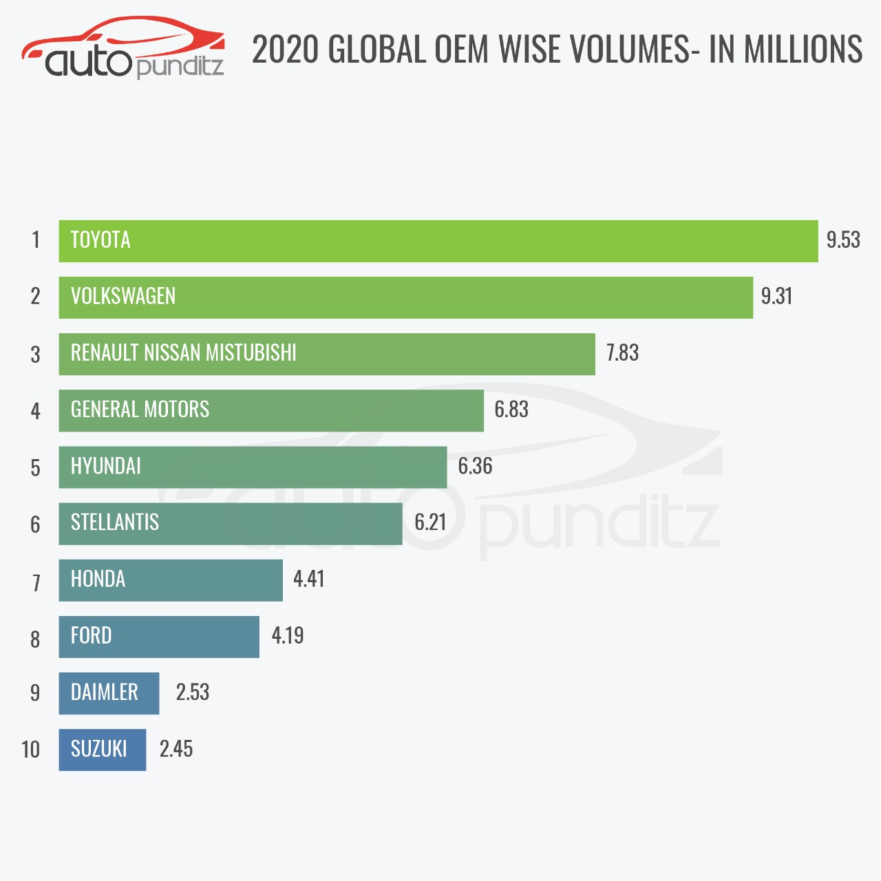
Source: Team Auto Punditz, 2020
Based on its huge production of various cars including Lexus, Daihatsu, Hino, trucks and related parts, the brand is one of the most -prices in this industry.

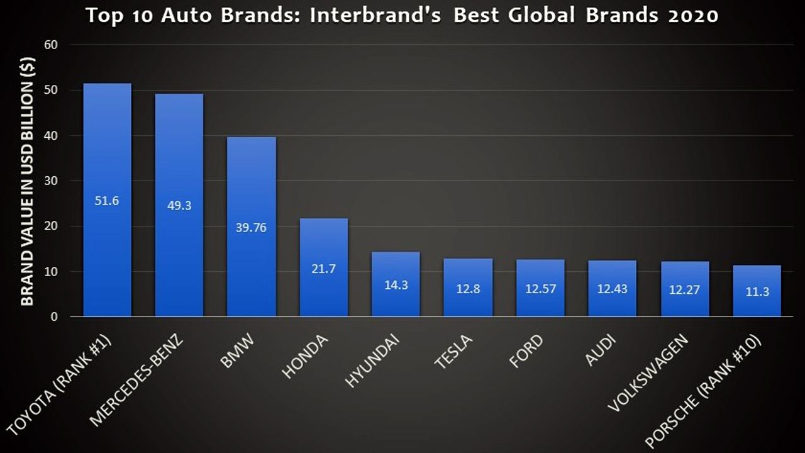

Source: Autox ,2020 Top automotive brands in Interbrand’s 2020 Global Brand Ranking

The company achieves high sales growth through its stable market positions in various geographical regions. Toyota has a wide distribution network and production in Japan and Asia, Europe, America, Africa, the Middle East and Oceania.
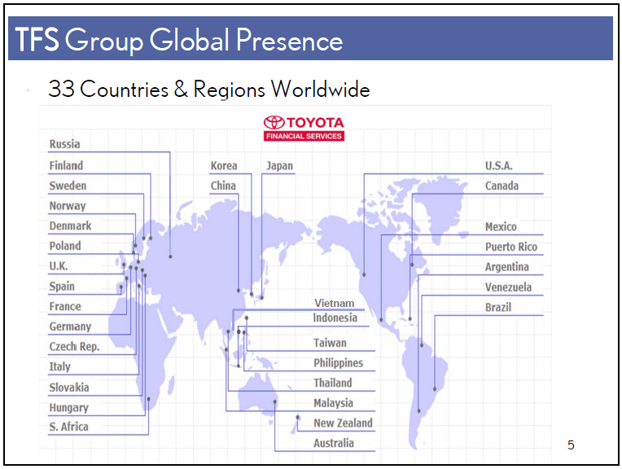
Source: Toyota Motor Corporation Company report
Another strong feature that defines Toyota's leadership is the focus on innovation 1.9 trillion yen in the year ended March 2021and the expansion of ever-higher quality products. The large investments the company makes in research support the company's technological leadership among its competitors.

3.2.2 Weaknesses
Recall products affect the brand image. Toyota had one in 2011, when 111,000 models were withdrawn. In 2012, the company was investigated for a faulty driver's window on the 2007 Camry and RAV4. In 2014, Toyota paid $ 1.2 billion to avoid a lawsuit to cover up information about defective pedals. Unusual noise and oil leaks are another case of recall of 181,000 cars.
A decline in total revenues is observed due to political or economic instability, as well as local legislation in various geographical areas in which the company operates.
In markets such as India and China, which are now developing rapidly, the company does not have a well-established structure at the expense of its competitors.
3.2.3 Opportunities
Due to new environmental policy, differing market demand and customer beliefs, Toyota needs to step up its efforts to produce fully electric and low-fuel vehicles.
3.2.4 Threats
Threats to Toyota are growing. New emission standards require investment in this area. In this way, the profit in the short term will be lower.
The price of the raw materials used has been higher in recent years. Competitive companies in the production of electric and hybrid cars are increasingly on the market, as well as those that compete with the company in terms of prices and design.
3.3 Value Chain Analysis
Toyota stands out as one of the leaders in the automotive industry. The company surpasses some of its competitors, namely with high quality, affordable prices, adequate technical and marketing services, innovation. Value chain analysis will show us how the company can increase its productivity.
3.3.1 Primary Activities:
- Incoming logistics:
Toyota's plants, as well as their distribution centres and warehouses, receive parts from suppliers around the world. This incoming logistics is extremely well regulated.
- Outbound logistics:
Thousands of parts are sent daily from the company's main warehouses to various Toyota centres around the world. Their main centre is based in Belgium, and from there, through a perfectly established distribution network, each regional centre receives its orders.
- Operations:
In addition to its manufacturing facilities, Toyota also has research, distribution and service centres around the world.
- Marketing and sales:
The aggressive behaviour of competitors forces Toyota to use marketing tricks such as advertising and promotions. To promote its products, the company uses its distribution centres, website and social media. Events such as car races and exhibitions are another approach to promoting the brand's products.
3.3.2 Support Activities:
- Technology:
This brand is recognized worldwide for its reliable and high-tech cars. The company's investments in the use of new energy sources, artificial intelligence and their systems for security and consumer comfort are a leading element in their policy to maintain strategic positions in the market.
- Infrastructure:
Infrastructurally, the company is very well positioned in the market. In most major global markets, Toyota has its own offices and production centres.
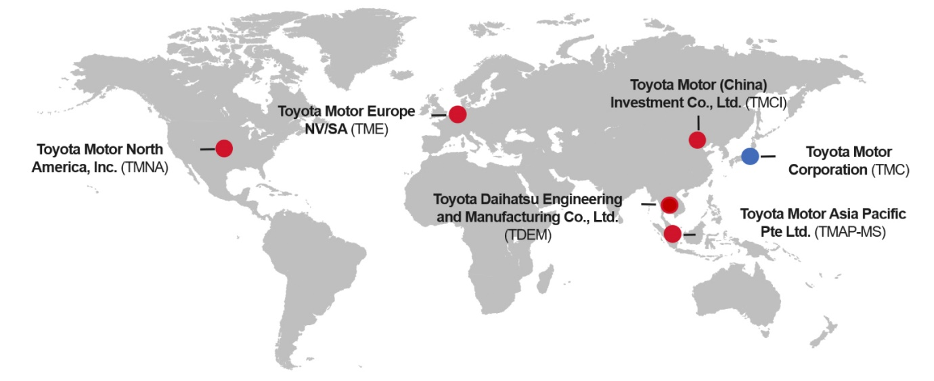Source: Toyota- Europe.com/ Toyota in the World
- Employees:
Toyota had 366,283,000 employees in fiscal 2021 (Statista, 2021). One of the company's philosophies is 'Producing happiness for all'. This also applies to employees. Toyota strives to maintain their physical and mental health, as well as safety at work.
- Delivery:
The raw materials are sourced from all over the world, and the company seeks to establish long-term partnerships to support the local economy.

4.Recomendation
- Improving the qualification of the staff.
- Expand the Asian market by offering products in line with local demand.
- Increasing hybrid models.
- Production of more electric vehicles.
- Development of alternative technologies for ecological production and energy.
- Improving customer feedback for maximum satisfaction.

5. Conclusion
The main topic of this report presents to the reader the automotive industry and the behaviour of its participants, led by external factors.
Providing information on how Toyota Motors Corporation makes its decisions to develop and maintain stability in conditions of political, financial and environmental destabilization. In addition, recommendations are proposed, the implementation of which would lead to positive results in the long run.

6.References

References
(TMC), T. M. C., 2021. Media Briefing on Battery EV Strategies. Tokyo: Toyota Motor Corporation.
Bansal, D. K., 2020. Top automotive brands in Interbrand’s 2020 Global Brand Ranking. [Online]
Available at: https://www.autox.com/news/industry-news/top-automotive-brands-in-interbrands-2020-global-brand-ranking-108545/
[Accessed 26 12 2021].
Britton, I. W. A. C., 2006. The business environment. 5th edition ed. Leicester: Pearson Prentice Hall.
Carlier, M., 2021. Consolidated number of Toyota Motor Corporation employees from FY 2012 to FY 2021. [Online]
Available at: https://www.statista.com/statistics/294192/number-of-toyota-employees/
[Accessed 22 12 2021].
Carlier, M., 2021. Statista. [Online]
Available at: https://www.statista.com/topics/1893/toyota/#dossierKeyfigures
[Accessed 21 12 2021].
E. Shatskaya1, M. S. K. N., 2016. PESTEL ANALYSIS AS A TOOL OF STRATEGIC ANALYSIS. Sheffield, Conference Proceedings, p. 48.
Ferguson, E., 2017. Toyota’s Five Forces Analysis (Porter’s Model). [Online]
Available at: http://panmore.com/toyota-five-forces-analysis-porters-model
[Accessed 25 12 2021].
McIntyre, I., 2016. Marketing Through The Different Stages Of The Business Lifecycle. [Online]
Available at: https://www.entrepreneur.com/article/283058
[Accessed 13 12 2021].
Pestle Analysis, 2015. Social Factors Affecting Business. [Online]
Available at: https://pestleanalysis.com/social-factors-affecting-business/
[Accessed 22 12 2021].
Pratap, A., 2018. VALUE CHAIN ANALYSIS OF TOYOTA MOTORS. [Online]
Available at: https://notesmatic.com/value-chain-analysis-of-toyota-motors/
[Accessed 27 12 2021].
Skeldon, P., 2021. Internet retailing. [Online]
Available at: https://internetretailing.net/industry/industry/73-rise-in-online-saves-john-lewis-from-collapse-and-hastens-revamp-22848
[Accessed 17 12 2021].
Statista, 2021. Consolidated number of Toyota Motor Corporation employees from FY 2012 to FY 2021. [Online]
Available at: https://www.statista.com/statistics/294192/number-of-toyota-employees/
[Accessed 27 12 2021].
Team Auto Punditz, 2020. Global Car Sales Analysis 2020. [Online]
Available at: https://www.autopunditz.com/post/global-car-sales-analysis-2020
[Accessed 26 12 2021].
Toyota, 2021. Global Toyota. [Online]
Available at: https://global.toyota/en/company/profile/
[Accessed 25 12 2021].
Toyota, 2021. Toyota in the World; our global operation. [Online]
Available at: https://www.toyota-europe.com/world-of-toyota/this-is-toyota/toyota-in-the-world
[Accessed 27 12 2021].

