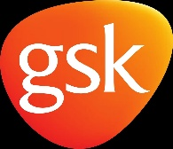
GlaxoSmithKline
GlaxoSmithKline is one of the largest pharmaceutical companies established in 200 from a merger of four other healthcare businesses. This company can be most appropriately identified as a science-led company due to its involvement in this aspect: development and manufacturing of medicines and vaccines, and of course not to exclude the consumer goods for the industry. The company has a few health conditions in which they are specialized and interested, which will be the following: HIV, respiratory diseases oncology, and immunology. As the company so existentially well distributed and established it also had its fair periods of success profitably wise such as in the 2020 financial year, GlaxoSmithKline reported a total operating profit increase of 2% which can be attributed to its decline in operating expenses, furthermore an increase in the turnover by 3% which could have significantly been more increased if it wasn’t the case of covid-19 and further occurrence the lockdown safety measures.
Marketing mix analysis
Product marketing Mix of Glaxo Smith
GlaxoSmithKline has practically evolved to be a multinational company. which produces and manufactures with a product range mainly based on healthcare and pharmaceutical sections which are committed and aimed to provide a better life by offering various and well-selected options to meet its customers' demand and needs. The company is strictly and multi-purposefully involved in the manufacturing, research, and development of medications and dosage-form formulation., whereby having a well-established and diversified product range such as the following Pharmaceuticals – GlaxoSmithKline is involved in manufacturing products which are applicable to treatable or prescribed diseases such as,: diabetes, infections, cancer, etc. A extended amount of the medications provided by this company are established and developed closely in order too assure best quality possible and assure costumer satisfaction. For bacterial infections it includes mupirocin and amoxicillin, for HIV infection zidovudine, for herpes virus infection there is valacyclovir and for parasite infections it has albendazole. Medicines are always useful and applicable for all kind of case scenarios available for diseases or mental health severe or less severe conditions.
Place in the Marketing Mix of GlaxoSmithKline:
GlaxoSmithKline is globally active in approximately 115 countries and is a well established company which contains ninety-nine thousand employees and is entitled to a headquarters that are based in United Kingdom mainly. By far the most profitable of its markets is in the United States and to manage demand and costs of the company multiple headquarters were needed but are still considerably less existent or significant are least for the area which they are applicable to, but to name some of them, here are some examples: Philadelphia and North Carolina and it have a division for consumer products in Pennsylvania. GlaxoSmithKline depends heavily on its Research and Development facilities and is one of the largest investors in the world for R&D. It is also the biggest funder of R&D in the private sector of the United Kingdom. It has R&D sites situated in locations such as United States, United Kingdom, India, France, Croatia, China, and Canada.
The company has facilities for biopharmaceutical products in Hungary, Germany, Canada, Belgium, and the United States. For prescription products, its manufacturing sites are in the United States, Ireland, the United Kingdom, Singapore, Romania, Poland, Malaysia, Italy, France, and Australia. For consumer products, it has manufacturing facilities in Kenya, Brazil, Canada, the United States, Ireland, and the United Kingdom. GlaxoSmithKline has therefore a very extended and efficient distribution facilities ,including all time accessible products which can available in various supermarkets, hypermarkets, and its over-the-counter medications are available at prescription stores and medical facilities, therefore being an understatement of the company to be brand recognizable for its target and due to the efficient distribution of products, and the purposeful meaning of the products sold automatically causes it to be not only brand recognized but also generally maintaining a good reputation due to efficiency of the company and its purpose.

Price in the Marketing Mix of GlaxoSmithKline:
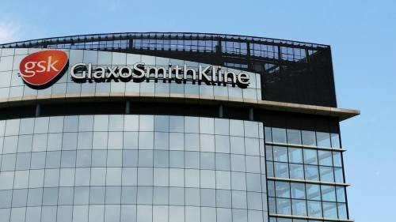
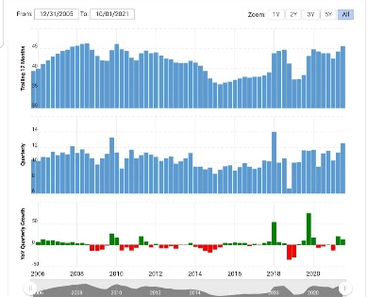
In order to make a judgment whether GlaxoSmithKline is accurate setting prices for the goods and products sold, the inference of a real event which has occurred in regards of this company, therefore establishing in year 2015 in which GlaxoSmithKline revenue was estimated to be 27206.91 million dollars and its total profits was supposed to be at an estimated 9521.22 million dollars as well as not to exclude out of the equation the Market Capitalization which was around 99600 million dollars. The primary mission of the company is to practically make a significant and evolved difference in the market which the operate into and to be able to identify itself from its competitors. Considering that year 2015 has been at a high demand and profitability, it will be easy to establish efficient strategy of setting prices reasonably and being able to reach as many individuals as possible and attract more potential or returning customers and last but not least profit and sales .. This was an efficient strategy for this company to aim for as the products and needed all the time, but this was possible by keeping its profit margin minimum to provide maximum benefits through rational prices.
Furthermore, extend of defining whether the company has set appropriate prices and if it had an overall good performance at least at a constant level is shown in the table down below which presents the revenue from when it was first established to this year of 2021 GlaxoSmithKline annual/quarterly revenue history and growth rate from 2006 to 2021. Revenue is the main source of information which define the loss,profit and expenses of the business within a given time frame and this is fully established within years 2017 to 2020 below:
GlaxoSmithKline revenue for the quarter ending September 30, 2021, was $12.516B, a 12.06% increase year-over-year.
GlaxoSmithKline revenue for the twelve months ending September 30, 2021, was $45.566B, a 4.07% increase year-over-year.
GlaxoSmithKline annual revenue for 2020 was $43.783B, a 1.58% increase from 2019.
GlaxoSmithKline's annual revenue for 2019 was 3.1B, a 4.77% increase from 2018.
GlaxoSmithKline's annual revenue for 2018 was 1.14B, a 5.75% increase from 2017.
Therefore, just by analyzing the performance of this company between 2017 to 2019, it can be concluded that profit margin, revenue, and total sales have remained at a constant and well-maintained level which
Promotions in the Marketing Mix of GlaxoSmithKline
GlaxoSmithKline successfully applies some strategic marketing strategies in order to sustain and provide effective and suitable products for its consumer and oral healthcare products. Social media platforms and its commercials for nutritional healthcare products like Boost and Horlicks are a very effective method to promote their products and services and attract more potential costumers. It is a strong and effective tool for advertising, as well as many other options including billboards, flyers, newspaper, social media accounts to provide updates and so on. GlaxoSmithKline has roped in several celebrities like Kepi Dev, Virendra Sehwag and Sachin Tendulkar for acting in commercials and endorsing its products. But moreover, this comes back to the main aim of GlaxoSmithKline which is to be able to bring differentiated, high-quality and needed health care to as many individuals which are in need of this products due to a health mental or physical condition or disease which the individual might suffer from. Of course, the objective out of this aim is to achieve preventing and treating the diseases which are applicable at time and keeping people well.
In order for the business to still be able to create and maintain along the way a good reputation and image ,GlaxoSmithKline takes the following actions: support partners through donations, capability development, employee volunteering and product donations, with a focus on improving health and access to healthcare for those individual which are in need ,as making their products accessible at all time is a must due to both aims and objectives specifically set focusing on well being of people.
-Another aspect that also needs to be considered in terms of Glaxo Smith and how well it manages to promote itself is by considering such things as their official website or social media accounts, and more specifically how effective is their communication towards its target audience/market. For this corporate standards will be the most suitable element to refer to as color schemes(such as logo which is orange, a representative color which leads to easy brand recognition),writing style which should be catchy, straight to the point but also mostly formal as serious matters in regards of health and well being are being addressed ,therefore being professional is a required aspect),version control (which can include updates which either audience or workers in this particular department should be aware of.)and last but not least house style (assuring employees are using appropriate format for official documents or information in order to maintain accuracy and consistency as iti is essential to use a particular font such as Arial and size 15 which is a very significant aspect to be considered by employees and its costumers
image and information reference : https://en.m.wikipedia.org/wiki/GlaxoSmithKline
https://www.google.com/amp/s/amp.ft.com/content/0e8a4cb7-020c-4d3c-91f9-8b2430d6b762

