Declaration of Use of Digital Search Tools

I acknowledge the use of digital search tools to identify and access academic literature relevant to this thesis.
Google Scholar (https://scholar.google.com/) was used on multiple occasions to locate peer-reviewed journal articles relating to youth work, youth clubs, and young people’s mental health. Google search was also used to locate policy documents, organisational reports, and specific youth research journals.
In addition, individual journal websites and publisher platforms were accessed to locate relevant articles, including youth studies, social policy, and community psychology journals using Google platform.
Example search prompts included:
- Youth clubs and young people’s mental health
- Youth work and relational practice
- Belonging and wellbeing in youth services
- Youth clubs as safe spaces for young people
- Youth work and mental health support
- Participation and youth voice in youth work
- Relational youth work practice
- Youth clubs and social support
- Young people’s experiences of youth services
- Community youth work and wellbeing
These search tools were used solely to locate relevant literature. All sources cited in this thesis were read, interpreted, and written about by the author and are referenced in accordance with academic conventions.
I confirm that I have not presented any AI-generated text as my own work. I confirm that I retain drafts, notes, and records of the materials consulted before and after using these search tools.



The Role of Youth Clubs in Supporting Young People’s Mental Health:
Fostering Social Support, Resilience, and Personal Growth within Community Spaces

Emma Jain Williams

MA Children and Young People’s Mental Health

University of Wales Trinity Saint David School of Psychology
Empirical Thesis: March 2026

Declaration

STATEMENT 1:
The dissertation does not include work accepted for any other degree or professional qualifications.
Signed …… (candidate)
Date …14/03/2026

STATEMENT 2:
The dissertation has been composed by me and is my own work.
Signed …… (candidate)
Date …14/03/2026

Acknowledgements

I would like to express my sincere gratitude to the youth club, the youth workers, and especially the young people who generously gave their time, experiences, and honesty to this research. Your openness and willingness to share your perspectives made this study possible, and it has been a privilege to learn from you.
I would like to thank my supervisor, Dr Charlotte Greenway, for her support throughout this project. From the beginning, she believed in me, responded patiently to my many emails, and offered constant encouragement and trust in my work, always reminding me not to doubt myself. Her guidance and patience have supported both my academic development and personal growth. Her supervision has been invaluable, and I am deeply grateful. Additionally, My thanks also go to the lecturers across the master’s programme, whose teaching, guidance, and feedback throughout each module helped shape the thinking that led to this research.
A special thank you to my good friends George and Helen for meeting with me to talk through and shape my topic choice, you have both been wonderful cheerleaders throughout. I am also grateful to my cohort for the encouragement, humour, and support along the way. The shared experiences, conversations, and friendships formed during this journey will not be forgotten. A special thanks goes to Claudia, we worked through academic challenges, laughed, stressed.. but got there in the end.
I am deeply grateful to my family for their constant support throughout this journey. To my partner Paul, thank you for standing beside me during the challenging moments and for reminding me, often when I needed it most, that I could do this. To my children, Isaac, Jay, and Rosie, thank you for seeing the ups and downs of this process, for the hugs when things felt difficult, and the cheers when things went well. Your love and encouragement mean more than you know. Finally, my daughter, who I miss dearly. Celyn, for the weekly check-ins from New Zealand, the motivation, and the encouragement along the way, love and miss you.
I would like to thank my parents for their flexibility and understanding with my working hours, which allowed me the time and space to carry out this research, and to acknowledge the customers, who often saw me working away on my laptop, in their own way, became part of this journey, cheering me on from the sidelines.
A special thanks to Kerri, for giving up her valuable time to proofread my final work, the last step for submitting, so thank you! This project would not have been possible without the support, belief, patience, and kindness of all of you.

Table of Contents

Declaration iii
Acknowledgements iv
Table of Contents v
Chapter 1: Plain English Summary 1
Chapter 2: Systematic Literature Review 3
2.1: Abstract 3
2.2: Introduction 4
2.3: Methods 9
2.3.1: Search strategy 9
2.3.2: Table 1. Search terms 9
2.3.3: Inclusion and Exclusion Criteria 10
2.3.4: Quality Appraisal Procedure 11
2.3.5: Screening and Selection 12
2.3.6: Table 2: Summary Characteristics of studies 13
2.4: Results 18
2.4.1: Overview of studies 18
2.4.2: Quality appraisal results 18
2.4.3: Table 3: CASP-informed Quality Appraisal of Studies 19
2.4.4: Theme 1: Conceptualising Well-being in Youth Clubs Across National Contexts: Relational, Emotional, and Developmental Dimensions. 21
2.4.5: Theme 2: Youth Clubs as Non-formal Educational and Developmental Environments. 23
2.4.6: Theme 3: Participation, Belonging, and Youth Voice in Youth Club Settings. 24
2.4.7: Theme 4: Structural Challenges and Policy Contexts Shaping Youth Club Impact. 26
Synthesis and Implications 27
2.5: Discussion 28
2.6: Limitations 32
Reference List 34
Appendix A: PRISMA Diagram 43
Chapter 3: Empirical Research Paper 44
3.1 Abstract 44
3.2: Introduction 45
3.3: Method 50
3.3.1: Overview and methodological approach 50
3.3.2: Participants 50
3.3.3: Ethics 51
3.3.4: Setting and recruitment 52
3.3.5 Procedure 52
3.3.6: Materials 54
3.3.7: Data management, safeguarding, and confidentiality 54
3.3.8: Reflexivity 54
3.4: Results 56
3.4.1: Table 1: Overview of themes 57
3.4.2: Theme 1: Belonging as the Foundation of Emotional Safety 59
3.4.3: Theme 2: Relational Care and Support 61
3.4.4: Theme 3: Developing Confidence and Agency Through Recognition, Responsibility, and Self-Expression 62
3.4.5: Synthesis of Findings 64
3.5 Discussion 65
3.5.1: Concluding synthesis and implications 69
3.5.2: Limitations 71
Reference List 73
Chapter 4: Reflection 79
References List 88
Appendices: 89
Appendix A: Demographic Questionnaire: 89
Appendix B: Ethics Form: 90
Appendix C: Study Consent Sheet 118
Appendix D: Information Sheet 120
Appendix E : Interview Questionnaire & Focus group Structure: 122
Appendix F: Transcript Extracts 125
Appendix G: Ethnographic Observation – Examples 144
Appendix H: Thematic steps 1-4 153
Appendix I: Reflective journal examples 170
Appendix J: Initial research proposal 176

Chapter 1: Plain English Summary

This research explores how youth clubs support young people’s mental health and well-being in everyday ways. The study focuses on a rural community youth club in West Wales and reflects the experiences of young people living in that community. It examines how young people experience youth clubs as places where they feel safe, supported, and able to be themselves. Mental health support is often discussed in terms of clinical services and diagnoses. However, many young people experience everyday stress and emotional pressure without needing formal intervention. This research explores how youth clubs may help young people manage these pressures through relationships, activities, and informal support.
The research asked a simple question:
How do youth clubs in Wales foster mental health and resilience through everyday relational practices, and how do these spaces address barriers to inclusion?
The study used qualitative research methods, which focus on people’s experiences and perspectives. Rather than relying on surveys or statistics alone, the research involved spending time in the youth club, observing sessions, talking with young people, and listening to their views. Young people choose whether to take part, and participation was always voluntary. Ethical approval was obtained before the research began, and care was taken to protect young people’s privacy and well-being throughout.

A total of 15 young people took part through interviews, small group discussions, and observations of youth club sessions over six weeks. These methods helped the researcher understand not only what young people said about the youth club, but also how relationships developed within the space over time. The findings suggest that youth clubs play an important role in supporting young people’s mental health, not through formal therapy but through everyday experiences. Young people described youth clubs as places where they could relax, feel accepted, and talk to trusted adults and peers. Relationships with youth workers were especially important and developed through consistency, trust, and shared activities.
Young people also described the youth club as different from home or school. It offered more freedom than school and more independence than home while still feeling safe. This helped young people feel confident, valued, and included. Activities, shared humour, and simply spending time together contributed to a strong sense of belonging. The research also highlighted challenges. Building trust took time, and young people engaged at their own pace. This shows the importance of allowing time for relationship-building and not rushing participation.
Overall, this study shows that youth clubs can support young people’s mental health in meaningful but often overlooked ways. The findings suggest that youth work should be recognised as an important part of community-based mental health support. By listening to young people’s voices, this research highlights the value of everyday relationships and informal spaces in promoting mental well-being. The findings are relevant to youth work and policy approaches currently used in Wales.

Chapter 2: Systematic Literature Review

Youth Clubs and Open-Access Youth Work in Supporting Young People’s Mental Health and Development: A Systematic Literature Review

2.1: Abstract

Youth clubs are increasingly recognised as important forms of community-based support for young people’s mental health. However, the evidence base remains fragmented and young people’s perspectives often underrepresented. This systematic literature review examined how youth clubs contribute to young people’s mental health and what these spaces mean to them. A systematic search of seven electronic databases which identified 15 studies published between 2014 and 2025. Included studies comprised qualitative (n = 9), quantitative (n = 3), and mixed-methods (n = 3). Findings were synthesised using a reflexive thematic approach. Four interrelated themes were identified: (1) conceptualisations of well-being; (2) youth clubs as non-formal educational and developmental environments; (3) participation, belonging, and youth agency; and (4) structural challenges relating to funding and policy contexts. Overall, youth clubs were found to support mental health primarily through relational processes such as trust and emotional safety. However, these benefits were frequently constrained by outcome-driven accountability, and limited youth influence. The review underscores the need for participatory, developmentally appropriate research that foregrounds young people’s experiences, and highlights the limitations of outcome-driven frameworks in capturing the relational processes central to youth club practice.
Keywords: youth clubs; young people; mental health; participation

2.2: Introduction

Although a growing body of research examines youth work and its outcomes, much of this literature is framed through policy-driven indicators such as behaviour change, participation rates, or measurable well-being scores (de St Croix, 2018; Simmonds, 2025). Far less attention has been paid to how young people themselves understand and experience youth club participation in relation to mental health (Johnson, 2017). In this context, youth work is widely understood as a form of non-formal education that supports young people’s development through voluntary participation, relationships, and community-based activities (Davies, 2018; Jeffs & Smith, 2010), where young people aged 11–25 engage on their own terms with trained youth workers (Welsh Government, 2019; Kiilakoski & Kivijärvi, 2014). These environments prioritise belonging, participation, and everyday relational support, distinguishing them from more targeted or deficit-oriented forms of provision (Baldridge et al., 2017).
Yet their role has long been ambivalent. Tickle (2016) notes that youth clubs have historically been framed both as “sanctuaries” offering safety and connection, and as mechanisms for managing behaviour by keeping young people “off the streets.” This dual positioning reflects a persistent tension between empowerment and social regulation (Turnbull, 2017; Williamson, 2021), challenging the voluntary ethos upon which trust-based youth work depends (Jeffs & Smith, 2010; Ord, 2016; Taylor, 2017). This tension raises important questions about how youth work is understood and evaluated within contemporary policy contexts.
Despite these tensions, public health research highlights the protective role of community participation. The Lancet Commission on Adolescent Health and Well-being identifies engagement in community-based activities as central to young people’s connection and holistic development (Patton et al., 2016). However, across the United Kingdom (UK), young people face increasing challenges, including rising mental health difficulties, social inequality, and reduced access to youth services (Children’s Commissioner, 2023). In 2022, 18% of children aged 7–16 and 22% of those aged 17–24 were identified as having a probable mental disorder (NHS Digital, 2022). These trends underscore the importance of accessible community-based provision for young people (Ord & Smith, 2022; Turner et al., 2024).
Evidence examining youth club participation and young people’s mental health provides important contextual insight into the potential role of youth provision. Youth club closures have been linked to increases in adverse educational and crime-related outcomes, indicating a potential protective role for sustained provision (Villa, 2024). Longitudinal studies also report improvements in school engagement and reduced behavioural risk (Enns et al., 2022), while earlier evaluations associate regular attendance with stronger academic attitudes and social connectedness (Anderson-Butcher et al., 2003). Synthesising these studies, the “Youth Clubs Toolkit” (Keenan et al., 2026), estimates an average 11% reduction in adverse outcomes alongside improved school engagement and community engagement.
Against this backdrop, research focusing on marginalised young people highlights the importance of sustained, trusting adult–youth relationships, which have been linked to inclusion and emotional safety, often found in youth clubs (Frederick et al., 2023; Sapiro & Ward, 2020). Resilience research similarly conceptualises mental health as shaped through multisystemic and interactive processes rather than individual traits (Ungar et al., 2023). For young people navigating poverty and exclusion, risks of marginalisation intensify (France & Roberts, 2017), making relational environments that foster belonging and connectedness particularly important for mental health and inclusion (Allen et al., 2021). Yet much of the existing evidence prioritises measurable results. This imbalance is not merely methodological but conceptual, privileging externally defined indicators over the relational processes through which mental health support emerges (Sapiro & Ward, 2020)
Nonetheless, the role of youth clubs is shaped by national policy traditions and conceptualisations of youth work, meaning their purpose and function vary across contexts. International research often frames youth clubs through outcome-oriented Positive Youth Development (PYD) models, whereas UK and European traditions more commonly emphasise relationship-based provision grounded in voluntary participation (Shek et al., 2019; Eriksen & Seland, 2021; Jeffs & Smith, 2010; Davies, 2018). These differences illustrate how youth clubs are shaped by political and cultural conditions, highlighting the importance of interpreting their contribution to mental health within specific national contexts.
Beyond national context, understandings of youth mental health in the literature often remain individualised, emphasising constructs such as confidence, resilience, or coping skills (Renwick et al., 2022). While valuable, these framings risk treating mental health as an individual attribute rather than a socially shaped experience influenced by structural conditions (Ungar, 2011; Ritchie & Ord, 2017; Ní Charraighe & Reynolds, 2024). They may also reproduce deficit narratives of young people, overstating what youth clubs can “fix” while overlooking their role as stabilising community spaces that support everyday mental health.
Despite growing recognition of the value of youth clubs, much of the literature remains shaped by policy priorities and performance-driven evaluation rather than young people’s perspectives. Austerity and what de St Croix (2018) terms the “youth impact agenda”—the prioritisation of short-term, performance indicators—have further redirected attention away from relational youth work practice. This shift has coincided with major contraction in youth service infrastructure. Local authority spending on youth services has declined by more than two-thirds in real terms since 2010, with over 1,200 council-run youth centres closing across England and Wales between 2010 and 2023 (UNISON, 2024; YMCA England & Wales, 2025). In Wales, although a slight increase in centres was reported in 2023–2024, provision remains approximately 62% lower than in 2010–2011 (YMCA England & Wales, 2025). These pressures risk undermining the trust and continuity central to meaningful youth work (Taylor, 2017; Fyfe & Mackie, 2024). Understanding youth clubs’ contribution therefore requires attention not only to measurable results but also to the relational and contextual conditions through which support is experienced (Kusier et al., 2024).
Taken together, existing research links youth clubs to relational forms of support associated with mental health, particularly through trust, participation, and informal social connection. However, the evidence base remains divided across disciplines, shaped by outcome-driven evaluation frameworks, and uneven in its engagement with young people’s perspectives (Ord et al., 2018; de St Croix, 2018). These relationship-based processes are often acknowledged but rarely synthesised, while conceptualisations of mental health remain narrow and individualised.
This systematic literature review synthesises and critically examines empirical research on youth clubs and young people’s mental health addressing the following research question:
How do youth clubs contribute to young people’s mental health and well-being, and what do these spaces mean to young people themselves?
Aims:

To explore evidence of mental health outcomes associated with youth club participation.
To understand the processes through which youth clubs enable or limit young people’s participation.
To assess how youth clubs foster belonging and youth agency.
Together, these aims establish a foundation for examining the diverse ways in which youth clubs support young people’s mental health.

2.3: Methods

2.3.1: Search strategy

A systematic database search (2014–2025) was undertaken to capture contemporary evidence of youth clubs and mental health of young people. This period was selected to capture the period following post-austerity reforms in the UK, when youth services experienced significant restructuring, reshaping the role of community provision in supporting young people.
Seven electronic databases were searched: ScienceDirect, JSTOR, ProQuest, PsycINFO, PsycARTICLES, EBSCOhost, and a supplementary search platform, Google Scholar. These databases were chosen for their breadth and disciplinary range, covering psychology, sociology, education, health, and social policy. Search terms were structured across four main facets: youth clubs, safe and supportive spaces, mental health and resilience, Inclusion, and young people (See Table 1). Boolean operators (AND/OR) were applied to maximise sensitivity and precision.

2.3.2: Table 1. Search terms
Facet | Search terms
Youth clubs | “youth club” OR “youth centre” OR “open access youth work” OR “youth organisation” OR “youth provision” OR “youth service”
Facet | Search terms
Mental health | “mental health” OR “well-being” OR “resilience” OR “personal growth” OR “confidence”
Safe/supportive spaces | “safe space” OR “belonging” OR “inclusion” OR “support” OR “community support”
Young people | “young people” OR “youth” OR “adolescent” OR “teenager” OR “11–25 years”
Note: All facets combined with AND; all terms within facets combined with OR
In addition to database searching, two supplementary strategies were used. Targeted journal searches were conducted in high-relevance journals (Journal of Youth Studies, Youth & Policy, Young, Children & Society, and Journal of Education Policy) to identify studies not consistently captured through database indexing. Second, citation chaining was undertaken by manually screening the reference lists of included studies to locate additional eligible literature.

2.3.3: Inclusion and Exclusion Criteria

The following inclusion criteria were applied: (1) the research employed qualitative, quantitative, or mixed-methods designs using recognised empirical approaches to data collection and analysis; (2) the study focused on youth clubs, open-access youth work, or comparable forms of community-based youth provision; (3) participants included young people aged 11–25 years, or professionals working directly with this age group; (4) the research addressed at least one review focus, including safe and supportive environments, resilience and personal growth, inclusion and accessibility, or mental health and well-being; (5) the research was written in English, or a translation was available; and (6) the findings were reported in peer-reviewed journals or constituted empirical grey literature meeting AACODS quality standards. For the purposes of this review, young people were defined as individuals aged 11–25 years, reflecting contemporary understandings of youth extending into emerging adulthood (Arnett, 2000; (Poobalan, 2010; UNICEF, 2019). No geographical restrictions were applied to enable international comparison across youth work contexts.
Studies were excluded if (1) they focused exclusively on adult populations or university students; (2) they lacked live participants, such as purely theoretical or conceptual papers; (3) they examined general leisure or extracurricular activities without a clear youth club or open-access youth work component; (4) they were non-empirical publications, including commentaries or opinion pieces, or constituted systematic reviews, meta-analyses, or narrative literature reviews; and (5) they addressed topics such as substance use or criminal justice without a direct and explicit connection to youth clubs and young people’s well-being.
These criteria ensured that only studies directly examining young people’s experiences of youth clubs and open-access youth work in relation to mental health.

2.3.4: Quality Appraisal Procedure

The methodological quality of included studies was assessed using design-appropriate appraisal frameworks. Qualitative studies and qualitative components of mixed-methods studies were appraised using the Critical Appraisal Skills Programme (CASP) criteria, focusing methodological appropriateness, data collection, analysis, and contribution (see Table 3). Quantitative studies were assessed in relation to internal validity (measurement and outcome clarity), external validity (sample adequacy and representativeness), and transparency of statistical analysis. Any eligible empirical grey literature was appraised using the AACODS checklist (Tyndall, 2010). These assessments informed confidence in the synthesis and interpretation of findings.

2.3.5: Screening and Selection

The initial search yielded 643 records. After removing duplicates, titles and abstracts were screened against the inclusion and exclusion criteria, 16 studies progressing to full-text review. Reference list screening and targeted journal searches identified two additional studies. Following full-text assessment, 15 studies were retained, comprising qualitative, quantitative, and mixed-method designs (Table 2). The study selection process is summarised in the PRISMA flow diagram (Appendix A) (Page et al., 2021). One potentially relevant grey literature source was excluded at the full-text stage for failing AACODS quality standards.

2.3.6: Table 2: Summary Characteristics of studies

Summary characteristics and data extraction of studies on Youth clubs/community settings and youth work (n = 15)
Reference and Country | Design and Focus | Method, Sample and Setting | Key Findings | Quality and Comments
de St Croix & Doherty (2023) UK (England) | Qualitative multi-cite ethnographic study.  Exploring how young people and youth workers create and sustain places of belonging, identity, and engagement. | Observations, interviews, and workshops with young people aged 11-21, and Youth workers in youth and community club settings (n=8). | Youth clubs function as third places, providing belonging, identity association, and safety. | Strong. Longitudinal,  Multi-cite
Turner et al. (2024) UK (England) | Qualitative. Exploring young people’s perspectives on loneliness and the role of youth services in addressing it. | Semi-structured interviews, focus group and metaphor mapping. (n=14) young people 10-18. | Causes of loneliness included exclusion, bullying, lack of belonging, and lack of supportive spaces and confidence | Strong. Appropriate methods, linked to well-being outcomes.
Reference and Country | Design and Focus | Method, Sample and Setting | Key Findings | Quality and Comments
Barker et al. (2022), UK (England) | Qualitative, participatory study exploring how young people experienced community ties, belonging and well-being during and after COVID-19. | Interviews, focus group and photo elicitation. Young people aged 13-24 recruited from youth clubs, community groups, and schools | Youth clubs and community groups were described as social capital and community ties | High quality methodology, strong alignment with young people’s experiences.
Cicognani et al. (2015), Italy | Quantitative, exploring how participation in youth/community groups influence young people’s well-being and a sense of community. | cross-sectional survey (n=835) young people aged 16-26. Self-report questionnaires. Community and youth organisations across Italy. | Participation in youth groups was associated with empowerment. | Moderate. Not directed at solely youth clubs, discusses sense of community, with a focus on resilience.
Petersen (2025)  Denmark | Qualitative. Focused on how youth clubs contribute to inclusion and broader well-being for under deprived areas. | Case study, ethnographic fieldwork, semi-structured interviews. young people 10-18 | Youth clubs acted as bridges to inclusion, and transitions offering non-formal safe spaces. | Strong. Direct youth voice.
Reference and Country | Design and Focus | Method, Sample and Setting | Key Findings | Quality and Comments
Sneed (2025) UK (Scotland) | Qualitative. Exploring how youth work and participatory research contributes to young people’s well-being | Participatory approaches, photo elicitation, engagement with community stakeholders. young people aged 11-25. Stakeholders. | Youth clubs created safe and supportive spaces, external constraints often limited change. | Strong. Directly explores safe spaces.
Sanders et al. (2015) New Zealand & Canada | Quantitative. Examining positive youth development (PYD) in enhancing young people’s resilience and well-being. | Data collection, self-report questionnaires. (n=605) young people aged 12-17. Multi-system serves use settings. | PYD approaches were significantly linked to higher levels of youth resilience and protective factors. | Moderate. Large sample, robust statistical analysis, not linked directly to youth clubs.
Kiilakoski & Kivijärvi (2014) Finland | Mixed methods. Exploring how youth clubs function as spaces of non-formal learning. | Case study, comparative analysis. Observations, interview, questionnaires. Young people aged 13-20 and youth workers across (n=1000) youth clubs in Finland. | Youth clubs valued as spaces for association and non-formal learning. | Strong. Large dataset, effective method.
Reference and Country | Design and Focus | Method, Sample and Setting | Key Findings | Quality and Comments
Holding et al. (2022) UK (England) | Qualitative. Young people’s perspectives on mental health support, including the role of community spaces. | Semi-structured interviews, focus groups (n=42) aged 13-21 years old. Recruited from schools, youth clubs, and community settings. | young people described difficulty in accessing formal mental health services, mental health gaps. | Strong. Robust design, good sample, diversity of participants.
Ramey et al. (2023) Canada | Quantitative. Focus on the relationship between safer spaces in Youth Development Programme’s and health related quality of life (QoL). | Cross sectional survey. Youth centres, Youth Development Programmes (n=282), Mean age = 16.97. Diverse groups (LGBTQ/Low-income youths) | Safer spaces were significantly related to higher QoL among young people. Highlights protective role of youth clubs and inclusion. | Strong. Large sample, diverse participants, significant findings related to young people’s QoL.
Garasia et al. (2015)  Uk (England) | Mixed methods. Evaluate how young people perceive youth clubs, and opportunities to be political in youth clubs. | Participatory framework, peer to peer research, surveys (n=42) young people, focus groups (n=27) young people aged 12-18 years old. Recruitment from youth clubs’ schools. | Youth clubs provided safe, connective spaces, but youth voice was often limited by adult control. | Strong peer led methodology, focus mainly on political voice in youth clubs.
Reference and Country | Design and Focus | Method, Sample and Setting | Key Findings | Quality and Comments
Walker et al. (2025) UK (England) | Qualitative. Investigation in to how youth organisations contribute to safety for young people. | Observations (n=10), policy review, focus groups (n=9) interviews (n=13) Young people | Identified youth clubs as enablers of safety, relational trust. Barriers with organisational strain. | Moderate, strong on safety and safeguarding, however, not on well-being and resilience.
Thompson & Woodger (2020) UK (England) | Mixed methods needs analysis. To evaluate the role of youth clubs, and the needs of young people. | Surveys with parents, young people and consultations with stakeholders. Total (n=426) London borough. | Youth clubs were found as the most needed service in demand. Provision needed. | Moderate. Highlights priorities, however, does not explore young people’s experiences.
McPherson (2020) UK (Scotland) | Qualitative. Ethnographic-inspired research. | Semi-structured interviews and participant observation.  (n=10) young people aged 16-21 years old. Mean age 17.5. Conducted within further education (FE) colleges and youth work settings. | Youth work helped rebuild confidence, foster relationships, provide alternative pathways to education. | Strong. Rich, qualitative insights; strong youth voice. Focused on young people already re-engaged in youth work.
Nolas  (2014)  UK | Qualitative,  Ethnographic study. | Participant observation, Participatory video. Interviews with young people and youth workers. Six Groups (n=18) young people 13-18 years of age. | Findings revealed tokenism, with inclusion undermined by adult-led agendas. | Moderate. Rich ethnographic insight into participation, but findings limited by small sample size and tokenism risks.

2.4: Results

2.4.1: Overview of studies

The final 15 studies in this review were synthesised, spanning the UK, Europe, and other international contexts. The evidence base comprised qualitative (n = 8), quantitative (n = 4), and mixed-methods (n = 3) studies, with substantial variation in participant ages, sample sizes, and settings.

2.4.2: Quality appraisal results

Table 3 presents the CASP appraisal results for qualitative and mixed-methods studies. Quantitative studies were assessed using the internal and external validity domains described in the Methods section; these assessments informed confidence in the findings but are not presented in tabular form.

2.4.3: Table 3: CASP-informed Quality Appraisal of Studies

Quality Appraisal of Qualitative and Mixed-Methods Studies
Study | Design | Clear Aims | Appropriate Method | Sample Adequate | Data Collection | Findings Clear | Value / Contribution | Overall Confidence
de St Croix & Doherty (2023, UK) | Qualitative | Y | Y | Y | Y | Y | Y | High
Turner et al. (2024, UK) | Qualitative | Y | Y | Y | Y | Y | Y | High
Barker et al. (2022, UK) | Qualitative | Y | Y | Y | Y | Y | Y | High
Petersen (2025, Denmark) | Qualitative | Y | Y | Y | Y | Y | Y | High
Sneed (2025, UK/Scotland) | Qualitative | Y | Y | Y | Y | Y | Y | High
Kiilakoski & Kivijärvi (2014, Finland) | Mixed Methods | Y | Y | Y | Y | Y | Y | High
Garasia, Begum-Ali & Farthing (2015, UK) | Mixed Methods | Y | Y | N | Y | Y | Y | Moderate
Walker et al. (2025, UK) | Qualitative | Y | Y | Y | Y | Y | Y | Moderate
Thompson & Woodger (2020, UK) | Mixed Methods | Y | Y | Y | Y | Y | Y | Moderate
McPherson (2020, UK/Scotland) | Qualitative | Y | Y | N | Y | Y | Y | Moderate
Nolas (2014, UK) | Qualitative | Y | Y | N | Y | Limited | Y | Moderate
Note. Y = Yes; N = No. Appraisal was informed by CASP criteria. Overall confidence ratings (High, Moderate) reflect methodological rigour and relevance to the review. Mixed-methods studies were appraised primarily on qualitative components.

To address the research question, findings were organised into four interrelated themes that reflect both individual experiences and structural influences:
- Conceptualising Well-being in Youth Clubs Across National Contexts -explores relational, emotional, and developmental dimensions of well-being.
- Youth Clubs as Non-formal Educational and Developmental Environments – examines their role in learning, confidence-building, and resilience.
- Participation, Belonging, and Youth Voice in Youth Club Settings – considers how inclusion and agency are fostered or constrained.
- Structural Challenges and Policy Contexts Shaping Youth Club Impact – highlights funding pressures, inequality, and policy-driven accountability.
The first three themes align closely with the review’s aims, addressing well-being, development, and participation, while the fourth captures the wider social and policy factors that shape these processes.

2.4.4: Theme 1: Conceptualising Well-being in Youth Clubs Across National Contexts: Relational, Emotional, and Developmental Dimensions.

Youth clubs were examined in relation to young people’s well-being, capturing both outcome-focused measures and relational accounts across different national contexts.
- Developmental: Well-being conceptualised through measurable outcomes such as resilience, self-esteem, coping skills, or quality of life, often assessed using structured frameworks or standardised instruments.
- Relational: The quality of relationships with peers and youth workers, including supportive interactions.
- Emotional: Subjective experiences of belonging, validation, and psychological safety.
Definitions of young people’s well-being varied across studies and national contexts, reflecting different conceptual approaches to youth work. International studies more commonly conceptualised well-being through structured developmental frameworks. For example, Sanders et al. (2015), using large-scale data from Canada and New Zealand, found that PYD practices were significantly associated with higher resilience and overall well-being. Similarly, Ramey et al. (2023) reported that “safer spaces” within Canadian youth programmes were associated with improved health-related quality of life, particularly among LGBTQ+ and low-income young people. However, these studies primarily measured well-being using standardised self-report instruments such as the KIDSCREEN-10 scale, which may capture measurable outcomes more readily than relational or emotional processes.
By contrast, UK-based studies tended to frame well-being as relational, process-based, and contextually embedded within youth work practice. Turner et al. (2024) reported that youth club participation reduced loneliness and improved self-esteem, particularly among young people with experiences of bullying or social isolation. Similarly, Barker et al. (2022) found that during the COVID-19 pandemic youth clubs sustained social capital and community ties. Other qualitative research described youth clubs as “redemptive spaces” where recognition restored self-worth and trust supported personal growth (McPherson, 2020). Recent studies further highlight their compensatory role in filling gaps left by overstretched mental health services (Holding et al., 2022; Walker et al., 2025).

2.4.5: Theme 2: Youth Clubs as Non-formal Educational and Developmental Environments.

Two central functions emerged across the studies. Youth clubs provided alternative learning pathways for young people disengaged from or excluded from school. McPherson (2020) found that participants viewed school as rigid and unresponsive, with one describing it as “trying to fit a square into a circle” (p. 315), reflecting a sense of misfit within formal education. In contrast, youth clubs were experienced as spaces of recognition and capability. Petersen (2025) similarly reported that flexible, relational practice enabled youth workers to bridge gaps left by formal systems, supporting inclusion and learning through everyday interaction. Kiilakoski and Kivijärvi (2015) characterised youth clubs as adaptive environments where development occurs through participation and voluntary engagement rather than structured instruction, while also noting constraints such as peer hierarchies and age divisions that complicate inclusive practice in informal settings.
Young people frequently contrasted the impersonal nature of school with the affirming relationships experienced in youth clubs: adults “see something in you that your teachers don’t… it just makes me more confident; they’re honestly the best people I’ve met in my life” (Kiilakoski & Kivijärvi, 2014, p. 316). These accounts link recognition, trust, and relational support with increased self-belief.
Beyond alternative learning pathways, youth clubs also functioned as developmental environments that nurtured transferable skills, confidence, and emotional resilience. Barker et al. (2022) found that participation in youth and community projects fostered social capital, connecting young people to wider educational and economic opportunities. Collaborative activities and supportive relationships strengthened communication, teamwork, and leadership capacities. Walker et al. (2025) similarly reported that sustained relationships with youth workers supported self-awareness, emotional regulation, and coping strategies during transitions to adulthood.
However, several studies also identified structural constraints that limited these developmental benefits. Thompson and Woodger (2020) observed that increasing policy pressures for measurable outcomes had shifted provision toward output-driven programming, reducing space for creativity and youth-led learning. de St Croix and Doherty (2023) similarly found that relational, person-centred aspects of youth work were often undervalued in systems prioritising short-term results.

2.4.6: Theme 3: Participation, Belonging, and Youth Voice in Youth Club Settings.

Participation, belonging, and youth voice within youth club settings revealed both empowering experiences and constraints shaped by adult authority and organisational culture. Earlier studies highlighted limitations in participation practices within youth clubs. Garasia et al. (2015) found that some young people perceived youth clubs as spaces primarily shaped by adult agendas, where participation was encouraged but decision-making power remained limited. Similarly, Nolas (2014) reported that participation was often conditional, occurring “within adults’ rules.” Together, these findings suggest that youth clubs do not automatically produce empowering participation and may reproduce hierarchical relationships unless opportunities for meaningful influence are intentionally supported.
More recent research presents a more positive account. de St Croix and Doherty (2023) described youth clubs as intentionally created “third places” where young people felt safe, accepted, and able to speak openly. One participant characterised their club as “an escape from everyday life... somewhere extra you can go to talk about things you won’t at home or school” (p. 1036). These accounts highlight belonging built through trust, continuity, and voluntary engagement. McPherson (2020) similarly found that recognition from youth workers supported confidence and identity rebuilding, suggesting that participation develops gradually through everyday interactions rather than formal consultation processes.
However, inclusion was not experienced equally. Kiilakoski and Kivijärvi (2015) found that although many young people described youth clubs as inclusive, those marginalised in school or community contexts felt less able to influence activities. Participation was shaped by gender, confidence, and peer dynamics, indicating that belonging remains an ongoing relational process rather than a fixed condition.
Research during and after the COVID-19 pandemic further highlighted the importance of belonging. Barker et al. (2022) found that youth clubs provided stable and familiar spaces during lockdown recovery, helping young people maintain a sense of normality and connection. However, experiences were not uniformly positive. Turner et al. (2024) reported that although many young people experienced reduced loneliness, others continued to feel isolated, noting that “you can be with friends and still feel lonely” (p. 7). Opportunities for meaningful participation were shaped by relationships, continuity, and the extent to which young people were genuinely involved in decision-making (Walker et al., 2025; Thompson & Woodger, 2020).

2.4.7: Theme 4: Structural Challenges and Policy Contexts Shaping Youth Club Impact.

Evidence consistently highlighted the impact of funding constraints on youth provision. Thompson and Woodger (2020) found that 74% of respondents viewed youth clubs as the most urgently needed form of youth provision, with over half identifying mental health as a priority area for support. Despite this demand, austerity-era funding reductions were associated with reduced service capacity and uneven provision across local authorities. Walker et al. (2025) similarly reported that chronic underfunding limited staff availability and organisational capacity to sustain inclusive environments, indicating that safety and belonging depended on stable resourcing and relationships rather than being automatic features of provision.
Policy frameworks also shaped youth work practice. De St Croix and Doherty (2023) reported that outcome-based funding models increasingly prioritised measurable outputs, with youth workers expressing concern that practice was becoming aligned with funding criteria rather than young people’s needs. Cross-national comparisons further highlighted differences in policy environments. In Scandinavian contexts, youth clubs were embedded within welfare systems providing stable funding and long-term continuity (Petersen, 2025; Kiilakoski & Kivijärvi, 2014). By contrast, UK studies reported uneven provision across regions, with some areas maintaining youth clubs while others had experienced substantial service loss (McPherson, 2020; Holding et al., 2022).

Synthesis and Implications

Across the studies, unstable funding and outcome-driven policy were consistently identified as challenges to sustaining youth club provision. These structural conditions were reported to affect service stability, staffing capacity, and the ability to maintain relational, inclusive environments that support young people’s well-being and development. Together, these findings suggest that sustaining youth clubs requires policy and funding approaches that recognise the relational nature of youth work rather than prioritising short-term measurable outputs.

2.5: Discussion
The reviewed evidence identifies several interconnected patterns explaining how youth clubs contribute to young people’s mental health, while also highlighting conceptual and structural tensions shaping these outcomes. Youth clubs appear most supportive when they prioritise relationships, consistency, and trust. However, the predominance of cross-sectional designs and reliance on self-report measures limit causal inference, while the heterogeneity of youth club provision across contexts complicates comparison of mechanisms and impacts. The evidence is therefore best interpreted as indicating plausible mechanisms and associations rather than definitive effect estimates. Taken together, this highlights a gap between evidence of positive outcomes and understanding of how these outcomes are produced, reinforcing the importance of examining relational processes within real-world youth club contexts.
Within these limits, studies nonetheless associate youth club participation with improved well-being, including gains in school engagement and community connectedness, alongside reductions in adverse outcomes (Villa, 2024; Anderson-Butcher et al., 2003). However, these estimates derive from limited quasi-experimental evidence and offer little insight into how well-being is delivered in practice. Definitions of well-being also varied considerably. Internationally, PYD frameworks tend to operationalise well-being through measurable traits such as confidence, resilience, and life satisfaction (Sanders et al., 2015; Cicognani et al., 2015; Ramey et al., 2023). While useful for policy evaluation, such approaches risk reducing well-being to individual attributes detached from young people’s lived realities.
By contrast, UK research more often conceptualises well-being as relational and grounded in belonging and connection (Turner et al., 2024; Barker et al., 2022; McPherson, 2020). This highlights a conceptual divide between outcome-led and experience-led understandings of youth work, in which the dominance of adult-defined indicators leaves limited space for young people’s perspectives. As a result, core elements of well-being, such as feeling valued, heard, and safe, remain underexplored. Future research should therefore prioritise youth-informed understandings of well-being.
Within this broader interpretation, youth clubs function as developmental environments where young people build confidence, transferable skills, and social responsibility through non-formal learning (Walker et al., 2025; Barker et al., 2022). These findings support Jeffs and Smith’s (2010) argument that learning in youth work occurs through relationships rather than instruction and align with theories of psychosocial and socio-emotional development emphasising autonomy, competence, and relatedness (Ryan & Deci, 2000). Through voluntary participation and supportive relationships, youth clubs provide opportunities for identity exploration, emotional regulation, and purpose, consistent with PYD frameworks emphasising resilience and agency (Lerner et al., 2005; Eccles & Gootman, 2002).
However, these processes are not guaranteed. The conditions that enable such learning—time, care, and flexibility—are often undervalued within accountability systems prioritising short-term results (de St Croix & Doherty, 2023). This tension risks reducing youth work to service delivery, where measurable outcomes take precedence over relationships and developmental processes. Policy and evaluation frameworks should therefore recognise relational, emotional, and identity-related growth as legitimate indicators of impact.
The extent to which relational practice translated into meaningful participation was also uneven. Some studies described youth clubs as “third spaces” fostering trust, inclusion, and identity exploration (de St Croix & Doherty, 2023; McPherson, 2020), while others revealed participation constrained by adult authority (Garasia et al., 2015; Nolas, 2014). These contrasts suggest that empowerment is not inherent to youth work but emerges through shared power and consistent relationships. When young people are consulted but not genuinely heard, it risks reproducing the hierarchies youth work seeks to challenge (Shamrova & Cummings, 2017). Participation should therefore be understood as an ongoing personal practice rather than a procedural goal (Hart, 1992; Lundy, 2007).
Crucially, these dynamics cannot be understood in isolation from the broader political and economic conditions shaping youth provision. Austerity, short-term funding cycles, and workforce pressures disrupt continuity and weaken the relational core of practice (Thompson & Woodger, 2020; Walker et al., 2025; Holding et al., 2022). As Walker et al. (2025) emphasise, safety and belonging are not automatic features of youth clubs but outcomes dependent on trust and stable investment. International comparisons demonstrate how sustained welfare funding supports long-term provision (Petersen, 2025; Kiilakoski & Kivijärvi, 2014). For the UK and Wales, these findings underline the need to recognise youth work as essential social infrastructure rather than discretionary provision, ensuring equitable and reliable access for young people.
Taken together, the review shows that youth clubs contribute most strongly to mental health through voluntary, trust-based relationships. Yet these qualities are increasingly threatened by funding instability and policy pressures. The synthesis highlights differences between international outcome-focused models and the more process-oriented understandings evident in UK research. Across contexts, the relational core of youth work emerges as the most consistent mechanism supporting safety, belonging, and growth. Strengthening youth work therefore requires policy approaches that recognise interpersonal processes, not only measurable outcomes, as central to young people’s mental health, particularly in underrepresented contexts such as Wales. Without sustained investment and policy recognition, the relational conditions that underpin youth work practice may become increasingly difficult to maintain.

2.6: Limitations

While this systematic literature review addressed the stated aims, several limitations should be acknowledged. First, the evidence base is heavily weighted toward UK-based studies, particularly from England and Scotland (e.g., Turner et al., 2024; Barker et al., 2022; McPherson, 2020). This concentration limits the generalisability of findings to other national contexts. Although studies from Canada, Italy, Denmark, and Finland were included to provide comparative insight (Sanders et al., 2015; Cicognani et al., 2015; Ramey et al., 2023; Petersen, 2025; Kiilakoski & Kivijärvi, 2014), differences in welfare regimes, policy frameworks, and cultural understandings of youth work constrain the transferability of these findings to the Welsh context.
Second, methodological limitations were evident across the included studies. Many qualitative studies relied on small, non-representative samples (McPherson, 2020; de St Croix & Doherty, 2023), while quantitative studies predominantly used self-report measures to assess outcomes such as well-being and resilience (Sanders et al., 2015; Cicognani et al., 2015). While valuable, these approaches may oversimplify complex relational constructs such as belonging, participation, and well-being. In addition, the predominance of cross-sectional designs limits insight into the longer-term impacts of youth club participation (Bryman, 2016). More broadly, the evidence base varies in methodological quality, and design, with limited longitudinal and theoretically grounded research. Limited integration of theoretical frameworks is evident across the literature, with many studies remaining descriptive rather than explicitly grounded in theory, thereby restricting deeper conceptual understanding of youth work practice.
A further limitation concerns the extent to which research methods were developmentally and participatory appropriate for young people. Although some studies foregrounded youth perspectives, many relied on adult-framed measures, practitioner accounts, or conventional interview formats that may not fully capture young people’s experiences, particularly for younger participants or those with additional needs (Garasia et al., 2015; Nolas, 2014; Walker et al., 2025). This methodological gap contributes to the continued dominance of adult-defined indicators of impact and limits understanding of how young people themselves conceptualise well-being, belonging, and participation. In addition, restricting the review to English-language, peer-reviewed publications may have excluded relevant practice-based or community-led research, introducing potential publication bias.
Collectively, these limitations highlight the need for more context-specific, youth-centred research that explores young people’s experiences of youth clubs in greater depth. Addressing these gaps provides a rationale for the subsequent empirical study, which seeks to foreground young people’s voices within a Welsh youth club setting and examine well-being as a relational and contextual process rather than solely as an individual outcome. While this study does not seek to address all limitations identified in the literature, it responds directly to key gaps relating to youth voice, contextual depth, and the relational dimensions of well-being within Welsh youth club settings.

Reference List

Allen, K. A., Kern, M. L., Rozek, C. S., McInerney, D. M., & Slavich, G. M. (2021). Belonging: a review of conceptual issues, an integrative framework, and directions for future research. Australian Journal of Psychology, 73(1), 87–102. https://doi.org/10.1080/00049530.2021.1883409
Anderson-Butcher, D., Newsome, W. S., & Ferrari, T. M. (2003). Participation in Boys & Girls Clubs and relationships to youth outcomes. Journal of Community Psychology, 31(1), 39–55. https://doi.org/10.1002/jcop.10036
Arnett, J. J. (2000). Emerging adulthood: A theory of development from the late teens through the twenties. American Psychologist, 55(5), 469–480. https://doi.org/10.1037/0003-066X.55.5.469
Baldridge, B. J., Beck, N., Medina, J. C., & Reeves, M. A. (2017). Toward a new understanding of community-based education: The role of community-based educational spaces in disrupting inequality for minoritized youth. Review of Research in Education, 41(1), 381–402. https://doi.org/10.3102/0091732X17698347
Barker, J., Turner, S., & Smith, M. (2022). Youth wellbeing and community support. Journal of Community Psychology, 50(4), 1752–1766. https://doi.org/10.1002/jcop.22759
Bryman, A. (2016). Social research methods (5th ed.). Oxford University Press.
Children’s Commissioner for England. (2023). The state of children’s mental health. https://www.childrenscommissioner.gov.uk
Cicognani, E., Zani, B., Fournier, B., Gavray, C., & Born, M. (2015). Gender differences in youths’ political engagement and participation: The role of parents and adolescents’ social and civic participation. Journal of Adolescence, 36(1), 1–11. https://doi.org/10.1016/j.adolescence.2014.09.001
Cromwell Simmonds, C. J. J. (2025). The social service industrial complex: Exploring the supportive and obstructive factors of critical youth work (Doctoral dissertation, University of Toronto).
Davies, B. (2019). Youth work and informal education: Finding common ground. Palgrave Macmillan.
de St Croix, T. (2018). Youth work, performativity and the “youth impact agenda”. Youth & Policy, 119, 18–31. https://doi.org/10.1080/02680939.2017.1372637
de St Croix, T., & Doherty, L. (2023). ‘It’s a great place to find where you belong’: Creating, curating and valuing place and space in open youth work. Children’s Geographies, 21(6), 1029–1043. https://doi.org/10.1080/14733285.2023.2171770
Eccles, J., & Gootman, J. A. (2002).
Community programs to promote youth development.
National Academies Press.
Enns, J., Nickel, N., Château, D., Katz, A., Sarkar, J., Lambert, D., & Brownell, M. (2022). A longitudinal cohort study of participation in the Boys & Girls Clubs of Winnipeg. International Journal of Population Data Science, 6(1), 1735. https://doi.org/10.23889/ijpds.v6i1.1735
Eriksen, I. M., & Seland, I. (2021). Conceptualizing well-being in youth: The potential of youth clubs. Young, 29(2), 175–190. https://doi.org/10.1177/1103308820937579
Farthing, R. (2012). Why youth participation? Some justifications and critiques of youth participation using New Labour policy as a case study. Youth & Policy, 109, 71–97.
France, A., Roberts, S. (2017). Youth, Class and Intersectionality. In: Youth and Social Class. Palgrave Macmillan, London. https://doi.org/10.1057/978-1-137-57829-7_5
Fyfe, I., & Mackie, A. (2024). Are you for real? Investigating authenticity in community-based youth work practice. Journal of Youth Studies, 27(1), 1–16. https://doi.org/10.1080/13676261.2023.2266307
Garasia, H., Begum-Ali, S., & Farthing, R. (2015). Youth clubs are made to get children off the streets: Some young people’s thoughts about opportunities to be political in youth clubs. Youth & Policy, 115, 1–18.
Garrett, P. M. (2003). The politics of social work. Policy Press.
Hart, R. (1992). Children’s participation: From tokenism to citizenship. UNICEF Innocenti Research Centre.
Holding, E., Crowder, M., Woodrow, N., Griffin, N., Knights, N., Goyder, E., & Fairbrother, H. (2022). Exploring young people's perspectives on mental health support: A qualitative study across three geographical areas in England, UK. Health & Social Care in the Community, 30(6), e6366–e6375. https://doi.org/10.1111/hsc.14078
Jeffs, T., & Smith, M. K. (Eds.). (2010). Youth work practice (2nd ed.). Palgrave Macmillan.
Johnson, V. (2017). Moving beyond voice in children and young people’s participation. Action Research, 15(1), 104–124. https://doi.org/10.1177/1476750315622544
Keenan, C., Mallion, J. S., Nugent, R., Hedges, S., Idrees, I., Allen, K., … Torres, O. (2026). Youth clubs. In Youth clubs toolkit. Youth Endowment Fund. https://youthendowmentfund.org.uk/toolkit/youth-clubs
Kiilakoski, T., & Kivijärvi, A. (2014). Youth clubs as spaces of non-formal learning. Journal of Youth Studies, 17(1), 40–54. https://doi.org/10.1080/13676261.2013.815702
Kusier, A. O., McLean, S., Harden, A., & Moore, G. (2024). What works, for whom, and in what circumstances? A realist review of youth work interventions supporting young people’s mental health and wellbeing. Children and Youth Services Review, 157, 107453. https://doi.org/10.1016/j.childyouth.2024.107453
Lerner, R. M., Lerner, J. V., Almerigi, J. B., et al. (2005).
Positive youth development, participation in community youth development programs, and community contributions of fifth-grade adolescents.
The Journal of Early Adolescence, 25(1), 17–71.
Lundy, L. (2007).‘Voice’ is not enough: Conceptualising Article 12 of the United Nations Convention on the Rights of the Child. British Educational Research Journal, 33(6), 927–942.
McPherson, C. (2020). ‘It’s just so much better than school’: the redemptive qualities of further education and youth work for working-class young people in Edinburgh, Scotland. Journal of Youth Studies, 23(3), 307–322. https://doi.org/10.1080/13676261.2019.1599103
NHS Digital. (2022). Mental health of children and young people in England. https://digital.nhs.uk
Ní Charraighe, A., & Reynolds, A. (2024). Re-thinking youth work as initial mental health support for young people. Children & Society, 38(6), 1920–1942. https://doi.org/10.1111/chso.12709
Nolas, S.-M. (2014). Exploring young people's and youth workers’ experiences of spaces for “youth development”: Creating cultures of participation. Journal of Youth Studies, 17(1), 26–41. https://doi.org/10.1080/13676261.2013.793789
Ord, J. (2016). Youth work process, product and practice: Creating an authentic curriculum in work with young people. Journal of Youth Studies, 19(2), 209–224. https://doi.org/10.1080/13676261.2015.1039962
Ord, J., & Smith, M. (2022). Youth work and informal education. Open University Press.
Patton, G. C., Sawyer, S. M., Santelli, J. S., Ross, D. A., Afifi, R., Allen, N. B., … Viner, R. M. (2016). Our future: A Lancet Commission on adolescent health and well-being. The Lancet, 387(10036), 2423–2478. https://doi.org/10.1016/S0140-6736(16)00579-1
Petersen, K. E. (2025). Children and young people in socially and educationally excluded living conditions – leisure and youth clubs’ work with inclusion processes aimed at the school. International Journal of Inclusive Education, , 1–18. https://doi.org/10.1080/13603116.2025.2508984
Poobalan, A. S., Aucott, L. S., Precious, E., Crombie, I. K., & Smith, W. C. S. (2010). Weight loss interventions in young people (18 to 25 year olds): a systematic review. Obesity Reviews, 11(8), 580–592. https://doi.org/10.1111/j.1467-789X.2009.00673.x
Ramey, H. L., Lawford, H. L., Berardini, Y., Mahdy, S. S., Khanna, N., Ross, M. D., & von Hugo, T. K. (2023). Safer spaces in youth development programs and health in Canadian youth. Health Promotion International, 38(6), daad166. https://doi.org/10.1093/heapro/daad166
Renwick, L., Pedley, R., Johnson, I., Bell, V., Lovell, K., Bee, P., & Brooks, H. (2022). Conceptualisations of positive mental health and wellbeing among children and adolescents in low‐and middle‐income countries: A systematic review and narrative synthesis. Health Expectations, 25(1), 61–79. https://doi.org/10.1111/hex.13407
Ritchie, D., & Ord, J. (2017). The experience of open access youth work: The voice of young people. Journal of Youth Studies, 20(3), 269–282. https://doi.org/10.1080/13676261.2016.1212162
Ryan, R. M., & Deci, E. L. (2000).
Intrinsic and extrinsic motivations: Classic definitions and new directions.
Contemporary Educational Psychology, 25(1), 54–67.
https://doi.org/10.1006/ceps.1999.1020
Sanders, J., Munford, R., Thimasarn-Anwar, T., Liebenberg, L., & Ungar, M. (2015). The role of positive youth development practices in building resilience and enhancing wellbeing for at-risk youth. Child Abuse & Neglect, 42, 40–53. https://doi.org/10.1016/j.chiabu.2015.02.006
Sapiro, B., & Ward, A. (2020). Marginalized youth, mental health, and connection with others: A review of the literature. Child & Adolescent Social Work Journal, 37(4), 343-357. https://doi.org/10.1007/s10560-019-00628-5
Shek, D. T. L., Dou, D., Zhu, X., & Chai, W. (2019). Positive youth development: Current perspectives. Adolescent Health, Medicine and Therapeutics, 131–141. https://doi.org/10.2147/AHMT.S179946
Sneed, H. (2025). Navigating wellbeing through youth work and participatory research: Insights from post-COVID-19 Scotland. Youth, 5(1), Article 1. https://doi.org/10.3390/youth5010001
Taylor, T. (2017). Youth work, austerity and resilience. Journal of Youth Studies, 20(4), 498–513. https://doi.org/10.1080/13676261.2016.1241867
Thompson, N., & Woodger, D. (2020). Young people need youth clubs. A needs analysis in a London borough. Youth and Policy.
Tickle, S. J. (2016). The youth centre as a ‘sanctuary’ in aiding safer communities for young people. Early Career Academics Network Bulletin, 29.
Turner, S., Fulop, A., & Woodcock, K. A. (2024). Loneliness: Adolescents’ perspectives on causes and prevention through youth services. Children and Youth Services Review, 157, 107442. https://doi.org/10.1016/j.childyouth.2024.107442
Tyndall, J. (2010). The AACODS checklist is designed to enable evaluation and critical appraisal of grey literature. Chin J Evid Based Med, 7(1), 507–513.
Ungar, M. (2011). The social ecology of resilience: Addressing contextual and cultural ambiguity of a nascent construct. American Journal of Orthopsychiatry, 81(1), 1–17. https://doi.org/10.1111/j.1939-0025.2010.01067.x
Ungar, M., Theron, L., & Höltge, J. (2023). Multisystemic approaches to researching young people’s resilience: Discovering culturally and contextually sensitive accounts of thriving under adversity. Development and Psychopathology, 35(5), 2199–2213.
UNICEF. (2019). Adolescents, youth and the transformation of the future. United Nations Children’s Fund. https://www.unicef.org
UNISON. (2024). The decline of youth services in the UK. https://www.unison.org.uk
United Nations. (1989). Convention on the Rights of the Child. https://www.ohchr.org/en/instruments-mechanisms/instruments/convention-rights-child
Villa, C. (2024). The impact of youth clubs on education and crime: Evidence from London closures [Working paper]. https://policycommons.net/artifacts/19553894/workingpaper/20454424/
Walker, J., Bradbury-Leather, V., & Wroe, L. (2025). Towards safety: The enablers and barriers that create safety in and around youth work organisations. Journal of Youth Studies. Advance online publication. https://doi.org/10.1080/13676261.2025.2518954
Welsh Government. (2019). Youth work strategy for Wales 2019. https://www.gov.wales/youth-work-strategy-wales
Williamson, H. (2021). Youth work and society (2nd ed.). Policy Press.
YMCA England & Wales. (2025). Out of service: The state of youth provision. https://www.ymca.org.uk

Appendix A: PRISMA Diagram
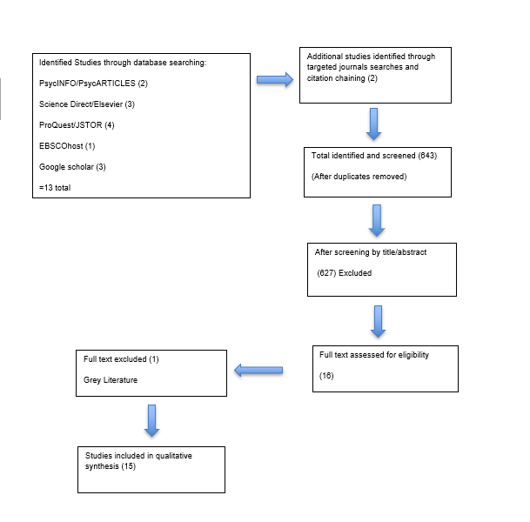

Chapter 3: Empirical Research Paper

The Role of Youth Clubs in Supporting Young People’s Mental Health:
Fostering Social Support, Resilience, and Personal Growth within Community Spaces.

This manuscript has been written for submission to the British Journal of Health Psychology, in accordance with the journal’s instructions to authors.

3.1 Abstract

Youth clubs are increasingly recognised as informal community spaces that support young people’s mental health; however, existing research often prioritises quantifiable outcomes over lived experience, particularly in Welsh contexts. This study explored how young people experience youth clubs as relational spaces that support mental health and inclusion. A qualitative design was employed. Fifteen young people aged 11–19 were recruited from a rural youth club in West Wales using purposive sampling. Data were generated through walk-and-talk interviews, creative focus groups, and ethnographic observation, and analysed using reflexive thematic analysis. Three interrelated themes were identified: (1) belonging and emotional safety; (2) relational care and support; and (3) developing confidence and agency through recognition, responsibility, and self-expression. Findings show that youth clubs support mental health through relational processes, including peer inclusion, trusted adult relationships, emotional safety, and opportunities for participation. These processes foster confidence, coping, and belonging, but operate primarily within the youth club setting rather than addressing wider structural stressors. Taken together, the findings position youth clubs as preventative, relationship-based spaces that complement formal mental health provision and warrant sustained policy recognition and investment within youth work systems.

Keywords: Youth clubs; mental well-being; relational practice; belonging

3.2: Introduction

Youth clubs are commonly understood as open-access, community-based youth work provision operating outside formal education and statutory mental health services (Keenan et al., 2026). In Wales, youth work is situated within a rights-based and prevention-oriented policy framework shaped by the Well-being of Future Generations (Wales) Act 2015, commitments to the United Nations Convention on the Rights of the Child (United Nations, 1989), and the Youth Work Strategy for Wales, which emphasises participation, youth voice, and prevention (Welsh Government, 2019). Recent statutory Directions (2024/25) further formalise a youth work entitlement and embed expectations of participation and accountability within local provision, positioning youth clubs as community infrastructures that support inclusion and well-being (Welsh Government, 2024).
Nevertheless, the enactment of these commitments is often shaped by organisational and accountability pressures (Simmonds, 2025). Research examining the implementation of Wales’s whole-school approach to emotional and mental health similarly identifies uneven capacity and resource constraints when translating preventative policy frameworks into everyday practice (Greenway et al., 2025), highlighting wider challenges in embedding relational approaches to well-being across youth-serving perspectives. Within this context, critical youth policy scholarship demonstrates how participatory agendas are frequently absorbed into governance frameworks that prioritise measurable outputs over meaningful youth voice (Garrett, 2003; Farthing, 2012; Corney et al., 2024; Davies, 2024). Participation may therefore be evidenced through attendance or behavioural indicators rather than young people’s own priorities, narrowing understandings of youth clubs as relational and preventative mental health spaces (Simmonds, 2025).
In contrast, qualitative research highlights the relational character of youth club practice, with young people describing these spaces as sites of belonging, friendship, and being listened to (Ritchie & Ord, 2017). Youth work is frequently experienced as accessible, non-stigmatising support distinct from statutory services (Ní Charraighe & Reynolds, 2024). However, these benefits are sustained within wider structural pressures, including workforce instability and uneven resourcing (Bailey et al., 2024). This highlights a tension between the relational strengths of youth work and the structural conditions that constrain its sustainability.
Within open-access youth work, participation is voluntary and relationship-centred (Jeffs & Smith, 2010; Ord, 2016). Such environments are associated with emotional safety, trust, and agency, recognised protective factors for young people’s mental health (Ritchie & Ord, 2017; Ní Charraighe & Reynolds, 2024). International research similarly identifies belonging, and interpersonal safety as key mechanisms supporting youth mental health in community settings (Eriksen & Seland, 2021; Kusier et al., 2024). However, much of this evidence derives from comparatively well-resourced welfare systems, limiting its direct applicability to contemporary Welsh youth provision (Jones, 2015). This highlights the need for context-specific research examining how these relational processes operate within local youth work systems.
Despite this policy architecture, empirical evidence examining how these commitments are enacted in everyday Welsh youth club practice remains limited, with existing research highlighting gaps in understanding the delivery and impact of youth work across Wales (Welsh Government, 2021). Emerging research suggests that young people value youth provision as spaces of belonging, safety, and connection. For example, a recent study examining participation through the co-produced digital platform RPlace found that digital engagement can facilitate youth voice within community development contexts (Hughes et al., 2025). The study highlighted young people’s desire for inclusive environments characterised by belonging and relational safety within youth provision. However, its reliance on anonymous self-report survey data limits insight into the interpersonal dynamics through which well-being is negotiated in everyday youth work settings. While the study offers valuable emerging evidence, its status as a preprint and its focus on digital engagement rather than sustained face-to-face youth club practice mean that questions remain regarding how well-being within everyday interactions is enacted within open-access, community-based settings.
Similarly, Bacon’s (2023) sector-level analysis of the voluntary youth work sector in Wales highlights the role of youth organisations in responding to contemporary challenges, including mental health and poverty, while identifying pressures such as unstable funding and uneven local authority support. Yet this work primarily foregrounds organisational concerns rather than young people’s experiences. Consequently, there remains limited context-specific evidence examining how well-being is constructed and sustained through everyday relationships within open-access youth clubs in Wales, particularly in relation to diverse groups of young people, including those who are neurodivergent or from culturally diverse backgrounds (Black et al., 2024), highlighting the need for research that captures these processes in practice.
Alongside these gaps in evidence, how youth mental health is conceptualised within research also warrants attention (Ritchie & Ord, 2017). Much of the literature frames youth mental health in individualised terms such as resilience or coping (Hart et al., 2016; Ungar & Theron, 2020). In contrast, this study conceptualises mental health as relational well-being emerging through participation, belonging, and trusted relationships (Ungar, 2011; Quinn et al., 2020). Youth clubs are therefore understood as social environments in which well-being is co-constructed (Lindskov, 2026).
Consistent with this perspective, the study is informed by rights-based and participatory frameworks. A rights-based approach positions young people as active agents with the right to influence decisions affecting their well-being (United Nations, 1989), while participatory theory emphasises shared power, trust, and meaningful opportunities for engagement beyond consultation (Hart, 1992; Shamrova & Cummings, 2017). Within open-access youth work, where participation is voluntary and relationship-centred (Jeffs & Smith, 2010; Ord, 2016), these perspectives provide a coherent framework for examining how mental health is supported through everyday youth work interactions. Evidence suggests that adult-led or tokenistic participation can constrain belonging and well-being (Corney et al., 2022), whereas supportive youth work environments foster emotional safety and agency (Ritchie & Ord, 2017; Ní Charraighe & Reynolds, 2024).
Overall, while youth clubs are widely recognised as spaces of relational support, significant gaps remain in understanding how these processes operate within contemporary Welsh contexts shaped by accountability reform and resource pressures. Existing research remains predominantly adult-led, policy-focused, or derived from non-Welsh contexts, limiting insight into young people’s experiences of mental health within open-access youth clubs. This creates a need for locally grounded, youth-centred research that captures how well-being is experienced and constructed through everyday relational practice. In response, this study asks:
How do youth clubs in Wales foster mental health and resilience through everyday relational practices, and how do these spaces address barriers to inclusion?

3.3: Method

3.3.1: Overview and methodological approach

This study adopted a qualitative approach to explore young people’s experiences of mental health within an everyday youth club setting. Data were analysed using reflexive thematic analysis to support an inductive, context-sensitive exploration of meaning (Braun & Clarke, 2006, 2019, 2021). Further detail is provided below.

3.3.2: Participants

Sampling and characteristics
Purposive sampling was used to recruit young people aged 11–25 who regularly attended an open-access community youth club (defined as attending at least once per week). This age range reflected the club’s policy and aligned with Welsh and UK youth work guidance (Welsh Government, 2019), enabling exploration of experiences across early adolescence to young adulthood within a single setting. Focusing on regular attenders ensured participants had sufficient engagement to reflect on everyday youth work relationships and practices.
A total of 15 young people participated, aged 11–19 years (M = 14.0, SD = 2.5). Although the youth club offered provision up to age 25, participants reflected the age profile of regular attendees during the data collection period. A short demographic questionnaire captured age, gender identity, and attendance patterns (see Appendix A). Thirteen participants self-identified additional support needs; these were not further specified or analysed to foreground shared relational experiences rather than categorical differences.
This sampling strategy may introduce selection bias, as regular attenders may already experience higher levels of belonging or confidence; however, this was appropriate given the study’s focus on embedded, everyday youth work experiences. Transferability to less engaged young people is therefore limited.

3.3.3: Ethics

Ethical approval was granted by the Faculty Ethics Committee prior to data collection (see Appendix B). Young people aged 16 and over provided informed consent, while parental or guardian consent alongside young person assent was obtained for those under 16 (see Appendix C). Participation was voluntary, and information was provided in accessible formats appropriate to participants’ ages and abilities (see Appendix D). Young people were reminded that participation could be withdrawn at any time without affecting their involvement in youth club activities.
Safeguarding procedures followed youth club and university guidance, and limits of confidentiality were clearly explained prior to participation. All data were anonymised during transcription to protect participants’ identities. These procedures align with ethical guidance for research with children and young people (UK Research and Innovation [UKRI], 2025; Health Research Authority [HRA], 2024).

3.3.4: Setting and recruitment

The study took place in a single community youth club in rural West Wales. The researcher completed an organisational induction and volunteered as a youth worker, working within safeguarding policies and professional boundaries. Because the researcher held a dual role as youth worker and researcher, specific steps were taken to minimise potential power imbalances and perceptions of coercion. These included (a) clear separation of youth work and research roles; (b) explicit, separate consent for research participation; and (c) repeated verbal reminders that participation was voluntary. These procedures align with ethical guidance for research with children and young people (UKRI, 2025). Recruitment remained open for six weeks to accommodate fluctuating attendance linked to school terms and holidays. Data collection continued until sufficient depth and repetition across the dataset suggested that additional data were unlikely to generate substantially new insights.

3.3.5 Procedure
Data collection and analysis
A Mosaic-informed approach (Clark, 2017) guided data collection to support choice, voice, and inclusion across ages and abilities. Multiple methods were used, including walk-and-talk interviews, creative focus groups (drawing and photo elicitation), and ethnographic observation. Participants chose whether to take part in interviews, focus groups, or both, supporting agency and comfort. Creative methods supported expression beyond verbal communication (Clark & Moss, 2001).
Interviews and focus groups followed semi-structured guides (see Appendix E), lasted between 9 and 30 minutes, and were audio recorded with informed consent. All interviews and focus groups were transcribed verbatim (see Appendix F). Participants could pause or withdraw at any time without impact on their youth club involvement. Pseudonyms were used for interview participants, while focus group contributors were identified by group (FGA/FGB), participant letter or number, and age, maintaining confidentiality while supporting analytic clarity.
Ethnographic observations focused on interactions between young people and youth workers, group dynamics, and the use of space during youth club sessions. Observations were recorded through fieldnotes and short video clips used for analytic recall (see Appendix G). Visual data collection followed ethical guidance, prioritising activity areas to minimise identifiability and seeking additional consent where individuals were identifiable (UK Data Service, 2025; UKRI, 2025).
The dataset comprised 11 walk-and-talk interviews with young people aged 11–18 (6 female, 5 male), two focus groups (one with four participants aged 11–14 and one with seven participants aged 11–19), and ethnographic observation (approximately 33 hours) across 15 youth club sessions over six weeks.
Data were analysed using reflexive thematic analysis (Braun & Clarke, 2006, 2019, 2021), recognising the researcher’s active role in interpreting meaning rather than discovering themes. Analysis involved familiarisation through repeated engagement with transcripts and fieldnotes, followed by inductive coding. Codes were organised into broader conceptual groupings and collated into candidate themes, which were iteratively reviewed and refined through ongoing engagement with the dataset. Themes were then defined and named, with final themes presented in Table 1 in the Results section (see Appendix H for thematic steps 1–4).

3.3.6: Materials

Materials included information, consent and debrief forms, a demographic questionnaire, creative materials to support expression, audio recording equipment, observation notebooks, and a reflective diary. Materials were developmentally appropriate and ethically managed in line with Mosaic principles.

3.3.7: Data management, safeguarding, and confidentiality

All data were anonymised at transcription, and consent forms were stored separately from research materials. Digital files were encrypted and stored on password-protected university systems accessible only to the researcher and supervisor, in line with UK GDPR and the Data Protection Act (2018). Audio and video files were stored in restricted-access directories using neutral filenames to minimise identification risk. Safeguarding disclosures were managed in accordance with youth club policy and university guidance. Limits to confidentiality were clearly explained during the consent process (UK Data Service, 2025).

3.3.8: Reflexivity

The researcher’s dual role as a volunteer youth worker facilitated rapport and trust with participants but also introduced potential sources of bias, including the normalisation of routine practices and the possibility of overlooking tensions embedded within everyday interactions. This positional proximity required sustained reflexive attention, particularly where emotional labour and relational familiarity had the potential to shape interpretation.
These influences were addressed through the maintenance of clear professional boundaries, reinforcement of voluntary participation, and systematic reflexive journalling throughout the research process (see Appendix I ). Consistent with principles of reflexive thematic analysis, reflexivity was treated as an ongoing analytic practice through which the researcher critically examined how personal experiences, assumptions, and relational positioning informed the development and interpretation of themes (Braun & Clarke, 2006, 2019, 2021; UKRI, 2025).

3.4: Results

Analysis of the qualitative data generated three overarching themes: (1) Belonging as the Foundation of Emotional Safety, (2) Everyday Care Within Relational Youth Work, and (3) Developing Confidence and Agency Through Recognition, Responsibility, and Self-Expression. Together, these themes illustrate how youth club participation supports young people’s mental health through everyday relational, emotional, and participatory processes. An overview of the themes, associated subthemes and example quotes is presented in Table 1.

3.4.1: Table 1: Overview of themes
Overview of themes, subthemes, and example illustrative quotes
Theme | Subtheme | Illustrative Quotes
Belonging as the Foundation of Emotional Safety | Friendship, protection, and peer belonging | “Helping people make friends… we help them feel included.” (Benji, 13) “I had a fake friend before, now I have proper friends here.”  (Jade, 12) “Walking in here feels different to outside, like safer, where I can be me.” (FGB, Participant 3, 14)
 | Emotional safety through routine and atmosphere | “That’s where we sit together and talk… it feels safe.” (Alice, 12)  “It’s a break from the four walls of my room.” (Max, 18)  “I only come to youth club on Thursdays. If it was every day, I think it would be much better for me.” (FGA, Participant D, 11)
Everyday Care Within Relational Youth Work | Empathy, inclusion, and material support | “We went to a theme park… most probably wouldn’t afford it otherwise.” (FGA, Participant C, 14)  “You don’t get laughed at… if someone messes up people just help.” (FGB, Participant 3, 14)  “Sometimes it’s the only meal some people might get that’s warm.” (Andrew, 15)
 | Trusted adults and informal emotional support | “You don’t make a big deal, you just ask if they’re alright.” (FGB, Participant 4, 12)  “If I need to talk about anything troubling me, youth workers help.” (Poppy, 14)  “The workers, yeah. I wouldn’t talk to teachers like that, they are cool.” (FGB, Participant 5, 15)
Developing Confidence and Agency Through Recognition, Responsibility, and Self-Expression | Relational recognition and confidence development | “I used to have no confidence… now I put my hand up in class all the time.” (FGA, Participant A, 14)  “I was really shy… now I’m way more confident because I come here.” (FGA, Participant B, 12)
 | Responsibility, participation, and self-expression | “I was elected president of the youth forum… I felt proud.” (Ryan, 14)  “I learned I don’t have to hide parts of myself here.” (FGB, Participant 2, 13)
Note. FGA = Focus Group A; FGB = Focus Group B; Interview quotes are drawn from walk-and-talk interviews. Ages indicate participant age at time of data collection.

3.4.2: Theme 1: Belonging as the Foundation of Emotional Safety

This theme captures how belonging and emotional safety were gained through peer relationships, routines, and shared space within the youth club.
Friendship, Protection, and Peer Belonging
Belonging was most strongly articulated through friendships characterised by trust, protection, and mutual care. Inclusion was described as an active, peer-led process, particularly towards young people who were socially isolated. Benji (13) explained, “Helping people make friends … we help them feel included,” framing belonging as a shared relational responsibility. This was echoed in focus groups, where one participant described the club as “my second home,” explaining that “when I come here, I feel happy and calm” (FGA, Participant B, age 13), positioning belonging as emotional security rather than attendance alone. This was reflected elsewhere, with one participant explaining that “walking in here feels different to outside, like safer” (FGB, Participant 3, age 14).
Several participants contrasted this experience with negative social encounters elsewhere. Jade (12) reflected, “I had a fake friend before, now I have proper friends here,” while another noted, “School is just, well you have to go don’t you. And home, it’s ok, but lonely” (Ryan, 14). These accounts position the youth club as an alternative relational space where trust can be rebuilt following experiences of exclusion, suggesting that belonging functions as a protective factor against social anxiety and isolation.

Emotional Safety Through Space, Routine, and Atmosphere
Beyond peer relationships, emotional safety was closely tied to the club’s routines and physical environment. Participants described emotional regulation as a gradual shift from stress to calm. Andrew (15) explained, “It gets rid of stress. When I’m here, I don’t really think about stuff that’s going on at home or school” Similarly, one young person described arriving “proper stressed” but feeling able to “breathe again” once settled in the space (FGB, Participant 2, age 13). Sarah (17) reflected on the importance of this routine, noting, “I realised when I didn’t come to the youth club my mental health was worse.”
Importantly, participants did not suggest that the club eliminated difficulties; rather, it provided a reliable space in which emotions could be processed safely. As Poppy (14) described, “It feels like pressing pause on the day.” The value of this stability was also reflected in young people’s desire for greater access, with one participant noting, “I only come to youth club on Thursdays. If it was every day, I think it would be much better for me” (FGA, Participant D, age 11). Another reinforced this anticipation, explaining, “If I’m feeling like it’s not a very good day, then I’ll be excited to come here and that will be my motivation for the day” (Alice, 12).
The physical environment further supported this sense of comfort. Alice (12) described the sofas as significant: “that’s where we sit together and talk… it feels safe.” For others, simply being away from isolating environments mattered, with Max (18) describing the club as “a break from the four walls of my room.” One participant illustrated this transition through a drawing of the entrance with a rainbow above it, explaining, “when I go inside, I’m happy” (FGB, Participant 3, age 14). Ethnographic observations similarly showed that young people often arrived dysregulated but became calmer during sessions, with the flexible use of space supporting emotional regulation through familiarity, choice, and shared presence. As Sam (17) described, the club felt “like a safe bubble where you can just exist without worrying.”

3.4.3: Theme 2: Relational Care and Support

This theme captures how well-being was supported through everyday practices of care, empathy, and support enacted by both peers and staff.
Relational Care: Empathy, Inclusion, and Material Support
Empathy emerged as an ordinary and embedded aspect of daily life within the youth club, frequently conveyed through peer protection and inclusion. One participant explained, “If someone’s hurt, we protect them” (FGA, Participant C, age 13), while another noted, “You don’t get laughed at. If someone messes up, people just help” (FGB, Participant 4, age 12). This sense of acceptance extended across difference, with Max (18) reflecting that “there’s no like ‘oh he’s ADHD… he’s a bit odd’, it’s like everyone is accepted.”
Care was also expressed through material practices that supported dignity and inclusion. Participants framed provisions such as ‘Free Meal Friday’ as essential rather than optional. Andrew (15) explained that “sometimes it’s the only meal some people might get that’s warm,” while another participant added, “I love Fridays, because it’s free food” (Alice, 12), highlighting awareness of economic hardship within the peer group. Access to shared activities also mitigated inequalities in opportunity, with one participant noting, “We went to a theme park… most probably wouldn’t afford it otherwise” (FGA, Participant A, age 14).
Ethnographic observations further illustrated how empathy was enacted through everyday interactions. Young people regularly invited peers to join activities without pressure and offered quiet reassurance during moments of distress, as one participant explained: “You don’t make a big deal, you just ask if they’re alright” (FGB, Participant 6, age 15), reinforcing dignity and mutual care.
Trusted Adults and Informal Emotional Support
Alongside peer support, youth workers were consistently described as trusted adults, providing emotionally safe, non-judgmental support. Jenny (15) said, “If I need to talk to anyone about anything troubling me, youth workers help,” while Max (13) contrasted the club with college: “not like ‘you do this, you do that’, it’s more relaxed here.” This enabled young people to seek support without fear of being disciplined or managed.
For some young people, this support was particularly significant where understanding was limited elsewhere. Sam (17) reflected, “They told me it’s okay to be myself,” while another added that “staff actually listen instead of telling you off straight away” (FGB, Participant 4, age 12), Ethnographic observations supported this interpretation, with youth workers engaging alongside young people as relational partners rather than supervisors.

3.4.4: Theme 3: Developing Confidence and Agency Through Recognition, Responsibility, and Self-Expression

Building on the emotional safety established in earlier themes, this theme examines how participation in the youth club supported confidence, agency, and personal growth through recognition, encouragement, and responsibility.
Relational Recognition and Confidence Development
Confidence was frequently described as developing through relational affirmation rather than individual achievement. One participant reflected, “I used to have no confidence… now I put my hand up in class all the time.” (FGA, Participant A, age 14). Change over time was also evident in focus group data, with one participant explaining, “When I started Year 7, I was really shy… now I’m way more confident because I come here” (FGA, Participant B, age 12). This was reinforced through visual data within the focus group, with the participant bringing a drawing of herself before and after coming to the youth club, represented through one eye closed and one eye open. This visual account illustrates how participants described changes in confidence over time through their involvement in the youth club.
Responsibility, Participation, and Self-Expression
Being trusted with responsibility further reinforced young people’s sense of agency. Ryan (14) described how leadership roles enhanced confidence: “I was elected president of the youth forum, I felt proud.” Others highlighted creative recognition, such as Jade (12), whose photographs were displayed in the club, stating: “My mum is getting me a camera for Christmas now,” suggesting that affirmation within the club supported confidence and aspiration beyond the setting. Ethnographic observations showed young people taking on meaningful responsibilities, operating the food counter, assisting with meal preparation, and co-creating rules. One participant reflected, “It makes you feel like they actually believe you can do it” (FGB, Participant 7, age 16). Self-expression was embedded within these opportunities for agency. Alice (12) stated, “Express yourself, be who you want,” suggesting that emotional safety enabled self-expression and risk-taking rather than functioning as an outcome in itself. This was echoed in focus groups: “I learned I don’t have to hide parts of myself here,” indicating a shift from identity protection to identity expression (FGB, Participant 2, age 13).

3.4.5: Synthesis of Findings

Taken together, the findings indicate that youth club participation supports young people’s mental health and well-being through relational processes embedded in everyday practice. Youth clubs function as safe, inclusive environments where acceptance, reduced judgement, and relief from everyday stress are consistently experienced. Supportive peer relationships and trusted adults foster emotional regulation, empathy, and dignity, while opportunities for responsibility and self-expression strengthen confidence and agency. These benefits operate within the immediate setting rather than addressing wider structural stressors. Young people are not passive recipients of support but active contributors to a shared culture of inclusion and well-being.

3.5 Discussion

The following discussion interprets these findings through rights-based and participatory perspectives, situating them within wider debates on youth work, mental health, and outcome-driven policy. This study explored how young people experience youth clubs as spaces that support mental health, with particular attention to relational practices, inclusion, and participation. In this study, the findings indicate that youth clubs function as forms of relational infrastructure through which mental well-being is supported, rather than operating as formal intervention services. In doing so, the study both confirms and extends existing youth work and mental health literature (de St Croix & Doherty, 2023; Ní Charraighe & Reynolds, 2024) while critically highlighting the limits of youth clubs as responses to wider structural inequalities.
Consistent with previous research, young people steadily described the club as a space of acceptance, familiarity, and relief from judgement, often in contrast to experiences of stress, exclusion, or scrutiny within school and other settings (Ritchie & Ord, 2017; Eriksen & Seland, 2021). These accounts reinforce conceptualisations of youth clubs as relational “third spaces” that offer psychological safety beyond home and formal education, where well-being is supported through trust, informality, and voluntary engagement rather than behavioural regulation (Ritchie & Ord, 2017; Lindskov, 2026).
However, this study extends the literature by showing that emotional safety is not simply an environmental feature but an actively constructed relational condition. building on previous work that emphasises relational youth work practice (de St Croix & Doherty, 2023) well-being emerged through shared routines, predictable spaces, peer presence, and continuity of relationships, rather than through individual coping strategies or skill acquisition. In this study, a notable finding is that young people overwhelmingly described the club as a sanctuary without obvious behavioural containment. These findings suggest that emotional safety therefore appeared to emerge not through surveillance or behavioural control but through relational authority, where adults were trusted because they were consistent and non-judgmental. This supports arguments that youth work environments enable learning and development through relational trust rather than formal discipline or regulation (Tickle, 2016).
These conclusions demonstrate the limitations of outcome-driven models of youth work evaluation that privilege behavioural change, attendance, or short-term indicators as markers of impact (UK Youth, 2024). Instead, they support critiques that such frameworks overlook the relational and emotional processes young people identify as central to well-being and participation (Simmonds, 2025). Emotional safety, therefore, was embedded in everyday interactions rather than environmentally given. However, participants did not describe youth clubs as addressing wider structural difficulties beyond the club setting. The findings therefore caution against positioning youth clubs as substitutes for specialist mental health or structural interventions, instead highlighting their role in buffering everyday stress and supporting emotional regulation within contexts of austerity and service fragmentation (Ní Charraighe & Reynolds, 2024; Jones, 2015).
A key contribution of this study is that these findings demonstrate how care and empathy are enacted through everyday interactions. Peer-led acts of protection, reassurance, and inclusion were described as routine, aligning with research that positions youth clubs as sites of collective care and mutual responsibility grounded in informal relational practice (Ritchie & Ord, 2017). Crucially, these practices supported mental health without requiring disclosure or formal identification of need, reinforcing youth work’s role as an accessible, non-stigmatising form of support (Ní Charraighe & Reynolds, 2024). Notably, many participants self-identified as having additional support needs, which may have shaped the emphasis placed on emotional safety, care, and non-judgemental support within the findings.
Another key consideration is the role of youth workers as trusted adults, further reinforcing existing evidence emphasising the importance of relational support for young people’s mental health (Ní Charraighe & Reynolds, 2024). Participants clearly distinguished youth workers from school-based authority figures, describing them as emotionally available, respectful, and approachable. This contrasts with behaviourist or compliance-oriented youth policy models, which risk undermining the relational conditions young people identify as most supportive (Garrett, 2003; Bessant, 2003; Farthing, 2012). These relational practices also reflect humanistic principles of acceptance, non-judgement, and growth through relationships, reinforcing the view that young people’s mental well-being is supported when they feel valued and understood rather than assessed or managed (Ritchie & Ord, 2017).
Similarly, material support, particularly access to food and activities, also emerged as an important dimension of relational care. Young people demonstrated awareness of poverty and inequality within their peer group, echoing evidence that youth clubs increasingly function as informal safety nets amid funding instability (Bacon, 2023). However, participants also recognised the limits of these supports, which mitigated immediate exclusion without addressing underlying structural inequalities. This highlights a critical tension identified within Welsh youth work literature: youth clubs absorb the consequences of social inequality while lacking the structural power or resources to address its causes (Bacon, 2023; Jones, 2015).
Confidence and agency in this study developed through recognition, trust, and responsibility rather than individual achievement; participants described confidence as relational and cumulative, emerging through encouragement, being listened to, and being entrusted with meaningful roles (Shamrova & Cummings, 2017). These findings demonstrate that relational youth work not only provides emotional safety but also creates conditions in which young people feel recognised and able to express their identity. This was evident in participatory visual data, reinforcing confidence as a gradual, relational process rather than a fixed or measurable outcome. Meaningful participation appeared to depend on trust and everyday opportunities for influence within the club. These findings challenge outcome-driven conceptions of participation that equate engagement with attendance or consultation, instead supporting relational models that emphasise shared power, everyday influence, and young people’s control over the terms of their involvement (Davies, 2018; Hart, 1992).
When participation was experienced as authentic within everyday relational practice, young people were positioned as contributors rather than service users, reinforcing belonging and self-worth (Hart, 1992; United Nations, 1989). This highlights how participation within youth work is shaped through shared decision-making, continuity of relationships, and youth-led responsibility rather than attendance metrics alone. Methods that foreground comfort and choice may therefore be important for capturing youth-defined meanings of participation. Taken together, these findings demonstrate that youth clubs function not as sites of intervention, but as relational infrastructures in which young people’s well-being emerges through belonging, care, and everyday participation.

3.5.1: Concluding synthesis and implications

In answering the research question, this study shows that youth clubs support young people’s mental health not through formal intervention or outcome delivery but as social environments where well-being is shaped through everyday experiences of emotional safety and recognition. Young people described how trusted relationships, peer inclusion, and informal support enabled emotional regulation, reduced judgement, and the development of confidence and agency. These processes were collective and embedded in ordinary interactions rather than individualised coping strategies or therapeutic agendas.
Taken together, the findings can be conceptualised as a relational pathway model of youth club mental health support, in which belonging functions as the entry condition for emotional safety; emotional safety enables informal disclosure and relational care; and sustained recognition through responsibility and self-expression supports the development of confidence and agency.
By foregrounding young people’s experiences, the study extends youth work literature by demonstrating how practices often marginalised within outcome-driven evaluation frameworks constitute a central mechanism through which youth clubs support mental health. At the same time, the findings highlight the limits of this support: while youth clubs provide emotional buffering and stability, they cannot address the wider structural conditions shaping young people’s distress. These findings therefore suggest that youth clubs should be recognised within policy and commissioning frameworks as preventative, relationship-based spaces that complement rather than replace specialist services.
This study contributes to youth work and mental health scholarship by demonstrating that youth clubs function not simply as supportive settings, but as relational infrastructures in which belonging, emotional safety, and recognition are co-produced through everyday practice. In doing so, it highlights the limitations of outcome-driven frameworks in capturing the relational processes central to youth club provision.

3.5.2: Limitations

Several limitations should be acknowledged. First, the study was conducted within a single open-access youth club in rural West Wales. While this enabled a rich, contextually grounded analysis of everyday relational practice, it limits transferability to other settings, particularly urban provision or youth clubs operating under different organisational, cultural and funding conditions. The findings therefore offer analytic rather than statistical generalisation, illuminating processes rather than outcomes (Jeffs & Smith, 2010; Ritchie & Ord, 2017).
Participants were regular attenders, and young people who were less engaged or who had discontinued attendance were not included. Although appropriate for examining embedded relational experiences, this may mean that more critical or marginalised perspectives are underrepresented. In addition, although the youth club provided provision up to age 25, participants were aged 11–19, reflecting the profile of regular attenders during the data collection period. The findings may therefore not fully reflect the experiences of young adults aged 20–25, who may engage with youth provision differently or have distinct support needs.
The researcher’s dual role represents both a strength and a limitation. While this supported trust and depth of insight, it may also have shaped the data toward more affirming accounts, as participants may have been less willing to articulate criticism, ambivalence, or negative experiences within a familiar relational context. The researcher’s established presence within the youth club may also have contributed to the normalisation of routine practices, reducing the visibility of tensions, exclusions, or taken-for-granted dynamics. These risks were mitigated through reflexive journalling, clear role boundaries, and supervisory oversight; nevertheless, researcher positionality inevitably may of shaped both data generation and interpretation.
The study foregrounds lived experiences of mental well-being rather than clinical outcomes or long-term impact; findings therefore illustrate relational support rather than therapeutic or causal effects. Many participants self-identified additional support needs. While this reflects the inclusive ethos of the youth club, it may mean the findings reflect experiences for whom youth clubs function as particularly important supportive spaces. As these needs were not categorised or analysed, the findings are illustrative of this context rather than representative of specific groups.
Future research should examine how relational practices operate across diverse youth club contexts, particularly for less engaged or marginalised young people. Longitudinal and participatory designs would be especially valuable in exploring how youth-centred understandings of mental health can be more meaningfully embedded within policy, commissioning, and evaluation structures.

Reference List

Bacon, C. (2023). Mapping the voluntary youth work sector in Wales.
Bailey, K., Allemang, B., Vandermorris, A., Munce, S., Cleverley, K., Chisholm, C., & Toulany, A. (2024). Benefits, barriers and recommendations for youth engagement in health research: Combining evidence-based and youth perspectives. Research Involvement and Engagement, 10(1), 92. https://doi.org/10.1186/s40900-024-00504-2
Bessant, J. (2003). Youth participation: a new mode of government. Policy Studies, 24(2–3), 87–100. https://doi.org/10.1080/0144287032000170984
Black, M. H., Helander, J., Segers, J., Ingard, C., Bervoets, J., de Puget, V. G., & Bölte, S. (2024). Resilience in the face of neurodivergence: A scoping review of resilience and factors promoting positive outcomes. Clinical Psychology Review, 113, 102487. https://doi.org/10.1016/j.cpr.2024.102487
Braun, V., & Clarke, V. (2006). Using thematic analysis in psychology. Qualitative Research in Psychology, 3(2), 77–101. https://doi.org/10.1191/1478088706qp063oa
Braun, V., & Clarke, V. (2013). Successful qualitative research: A practical guide for beginners. SAGE.
Braun, V., & Clarke, V. (2019). Reflecting on reflexive thematic analysis. Qualitative Research in Sport, Exercise and Health, 11(4), 589–597. https://doi.org/10.1080/2159676X.2019.1628806
Braun, V., & Clarke, V. (2021). Thematic analysis: A practical guide. SAGE.
Clark, A. (2017). Listening to young children, expanded third edition: A guide to understanding and using the mosaic approach. Jessica Kingsley Publishers.
Corney, T., Cooper, T., Shier, H., & Williamson, H. (2022). Youth participation: Adultism, human rights and professional youth work. Children & Society, 36, 677–690. https://doi.org/10.1111/chso.12526
Corney, T., Marion, J., Baird, R., Welsh, S., & Gorman, J. (2024). Youth work as social pedagogy: Toward an understanding of non-formal and informal education and learning in youth work. Child & Youth Services, 45(3), 345–370. https://doi.org/10.1080/0145935X.2024.2301801
Davies, B. (2018). Austerity, youth policy and the deconstruction of the youth service in England. Springer.
Davies, B. (2024). The Impact of Fourteen Years of UK Conservative Government Policy on Open Access Youth Work. Youth, 4(2), 492-508. https://doi.org/10.3390/youth4020034
de St Croix, T., & Doherty, L. (2023). ‘It’s a great place to find where you belong’: Creating, curating and valuing place and space in open youth work. Children’s Geographies, 21(6), 1029–1043. https://doi.org/10.1080/14733285.2023.2171770
Eriksen, I. M., & Seland, I. (2021). Conceptualising well-being in youth: The potential of youth clubs. Young, 29(2), 175–190. https://doi.org/10.1177/1103308820937571
Farthing, R. (2012). Why youth participation? Some justifications and critiques of youth participation using New Labour’s youth policies as a case study. Youth & policy, 109(109), 71-97.
Garrett, P. M. (2003). Youth work and the politics of recognition. Youth & Policy.
Gibbs, G. (1988). Learning by doing: A guide to teaching and learning methods. Further Education Unit.
Greenway, C., Ryder, N., & Eleri, S. (2025). From policy to practice: Education practitioners’ engagement with Wales’s framework on embedding a whole-school approach to emotional and mental health and well-being. Pastoral Care in Education. Advance online publication. https://doi.org/10.1080/02643944.2025.2540429
Hart, A., Gagnon, E., Aumann, K., & Heaver, B. (2016). Resilience in children and young people: Making it meaningful in contexts of adversity. Educational Psychology in Practice, 32(1), 3–17. https://doi.org/10.1080/02667363.2015.1102203
Hart, R. A. (1992). Children’s participation: From tokenism to citizenship. UNICEF Innocenti Research Centre.
Health Research Authority. (2024). UK policy framework for health and social care research.
Hughes, L., James, M., Mannello, M., & Brophy, S. (2025). Improving communities based on the voices of children and young people in Wales: Findings from RPlace. medRxiv. https://doi.org/10.1101/2025.05.02.25326861
Jeffs, T., & Smith, M. (2010). Youth work practice (3rd ed.). Palgrave Macmillan.
Jones, H. (2015). Youth work in England: An uncertain future? In M. Arnot & C. Reay (Eds.), Youth and inequality in education (pp. 117–135). Routledge.
Keenan, C., Mallion, J. S., Nugent, R., Hedges, S., Idrees, I., Allen, K., Bignall, T., Murphy, L., Towers, J., & Hinks, J. (2026). Youth clubs. Youth Endowment Fund.
Kusier, A. O., Ubbesen, T. R., & Folker, A. P. (2024). Understanding mental health promotion in organised leisure communities for young people: A realist review. Frontiers in Public Health, 12, 1336736. https://doi.org/10.3389/fpubh.2024.1336736
Lindskov, C. (2026). Exploring key factors and conceptualizations for well-being in lower secondary education: embracing student voices in the well-being debate. Youth and Society, 58(1), 3-33. https://doi.org/10.1177/0044118X251343633
Ní Charraighe, A., & Reynolds, A. (2024). Re-thinking youth work as initial mental health support for young people. Children & Society, 38(6), 1920–1942. https://doi.org/10.1111/chso.12709
Ord, J. (2016). Youth work process, product and practice: Creating an authentic curriculum in work with young people (2nd ed.). Routledge.
Quinn, N., Davidson, G., McDonnell, S., & McAuliffe, C. (2020). The social determinants of mental health: An interdisciplinary review. International Journal of Environmental Research and Public Health, 17(18), 6866. https://doi.org/10.3390/ijerph17186866
Ritchie, D., & Ord, J. (2017). The experience of open access youth work: The voice of young people. Journal of Youth Studies, 20(3), 269–282. https://doi.org/10.1080/13676261.2016.1212162
Shamrova, D. P., & Cummings, C. E. (2017). Participatory action research with children and youth. Children and Youth Services Review, 81, 400–412. https://doi.org/10.1016/j.childyouth.2017.08.022
Simmonds, C. J. J. C. (2025). The Social Service Industrial Complex: Exploring the Supportive and Obstructive Factors of Critical Youth Work (Doctoral dissertation, University of Toronto (Canada).
Tickle, S. J. (2016). The youth centre as a sanctuary in aiding safer communities for young people. Early Career Academics Network Bulletin, 29.
UK Data Service. (2025). Managing and sharing research data: A guide to good practice. https://ukdataservice.ac.uk
UK Research and Innovation. (2025). Guidance for researchers working with children and young people. https://www.ukri.org/publications/guidance-for-researchers-working-with-children-and-young-people/
UK Youth. (2024). Youth work matters: Findings from the Youth Evidence Base research.
https://www.ukyouth.org/resources/youth-work-matters/
Ungar, M. (2011). The social ecology of resilience. American Journal of Orthopsychiatry, 81(1), 1–17. https://doi.org/10.1111/j.1939-0025.2010.01067.x
Ungar, M., & Theron, L. (2020). Resilience and mental health: How multisystemic processes contribute to positive outcomes. The Lancet Psychiatry, 7(5), 441–448. https://doi.org/10.1016/S2215-0366(19)30434-1
United Nations. (1989). Convention on the Rights of the Child. https://www.ohchr.org/en/instruments-mechanisms/instruments/convention-rights-child
Welsh Government. (2019). Youth work strategy for Wales 2019. https://www.gov.wales/youth-work-strategy-wales
Welsh Government. (2024). Directions to local authorities and local authority youth support services: 2024 to 2025. https://www.gov.wales/directions-local-authorities-and-local-authority-youth-support-services-2024-2025

Chapter 4: Reflection

This chapter follows Gibbs’ (1988) reflective cycle and examines the process of completing the master’s dissertation, from topic development through to fieldwork, analysis, and write-up. The study involved applied qualitative research conducted within a rural community youth club in West Wales, exploring how young people experience youth clubs as spaces that support mental health through everyday relational practices. A reflective diary was used throughout the six-week fieldwork period to support structured reflexivity, informing critical insight into experiences, decisions, and researcher development. Although Gibbs’ (1988) reflective cycle is presented as a linear model, it is applied flexibly in this chapter to reflect the iterative nature of the research process, with stages revisited at different points where appropriate.
At the outset, several potential research topics were available to me, leaving me initially uncertain about the direction to take. Reflecting on my previous experiences in school settings helped clarify this decision. In conversations with young people, youth clubs were frequently described as spaces where they felt comfortable, able to talk openly, and be themselves. Hearing this repeatedly sparked curiosity and motivation, alongside a concern that these everyday spaces were often overlooked within wider mental health discussions. Engaging with Welsh youth policy, particularly the Youth Work Strategy for Wales (Welsh Government, 2019), reinforced that focusing on community-based youth provision aligned with my professional values and interests, increasing confidence in the chosen research focus.
Another factor shaping my topic choice was the opportunity to extend my research skills. My undergraduate dissertation relied heavily on survey data, which prioritises predefined categories and can oversimplify the relational and contextual dimensions of youth work. This recognition led me to adopt qualitative fieldwork for this study, enabling a deeper exploration of meaning and context. While this shift was energising, it also involved uncertainty about moving beyond familiar methods, highlighting the emotional dimension of methodological decision-making.
Alongside refining the research focus, the systematic literature review became one of the most time‑consuming stages of the early research process. This phase took several weeks and required sustained engagement with academic databases and research tools that were initially unfamiliar to me. Learning how to use these tools felt overwhelming and prompted moments of self‑doubt about my academic competence, and tested my resilience more than I imagined. However, as my familiarity increased, these feelings shifted towards a sense of achievement and growing intellectual curiosity. Finalising the studies for inclusion in the SLR was particularly rewarding and strengthened my confidence in the academic foundations of the main research chapter. I was also surprised by the limited availability of Welsh‑based research directly exploring youth clubs and mental health. Rather than discouraging me, this gap reinforced the relevance of my project and the value of contributing to an underexplored area of youth work research.
Prior to gaining ethical approval, I had already contacted the youth club and secured a voluntary role, meaning we were both prepared to begin as soon as clearance was confirmed. This reinforced that ethical approval is not just procedural but a crucial foundation for responsible research, and its confirmation gave me a renewed sense of readiness and motivation to move into fieldwork. Although the additional steps required to formalise my volunteer position felt lengthy at times, reflection helped me recognise their importance for safeguarding and accountability, and I felt grateful that my existing enhanced DBS helped prevent delays. The final induction with the youth club manager and director initially made me nervous, but it proved supportive and informative, easing my anxieties and strengthening my confidence and preparedness to enter the setting.
Although I felt practically prepared, the initial transition into the setting was emotionally challenging. Despite previous experience working with young people, I had to navigate unfamiliar informal dynamics and establish my position within a voluntary, youth-led space. This initial sense of unease was captured in my reflective diary during the first week of fieldwork, where I noted: “Walking in, I felt a bit out of my depth… the young people looked at me with wide eyes – it was a bit intimidating.” I also recorded having to consciously reassure myself, writing that “I had to remind myself that I am an adult and that I do have confidence… and I couldn’t help but laugh at how out of my comfort zone I felt.” Reflecting on these early entries, I recognised that my discomfort did not stem from a lack of experience, but from entering a space where authority was informal and acceptance was interpersonal or relational rather than assumed. This moment highlighted the importance of humility, patience, and emotional self-regulation when researching within youth-led environments.
Early recruitment progressed more slowly than anticipated, with some young people expressing interest but not immediately returning consent forms. At this stage, I felt uncertain about whether sufficient data could be gathered within the required timeframe. Reflecting at the time, I noted in my diary “I wasn’t getting many consent forms back, and I didn’t feel fully accepted yet, I am questioning my confidence and whether I will be able to complete the research.” Through reflection, I began to recognise that recruitment within a youth club context could not be separated from relationship-building. Participation needed to emerge organically rather than being driven by researcher timelines or efficiency. I came to understand young people choose whether they trust you, like you, and want to talk to you. And those choices happen on their timeline, not mine, so I became more patient. Rather than viewing slow recruitment as a methodological limitation, I came to understand it as a necessary feature of ethical, youth-led research practice, and started to relax a little, which made me feel more at ease.
As fieldwork progressed, I reflected more critically on the level of my presence within the youth club. Although I was attending regularly, I realised that limited contact time may have slowed familiarity and trust. Following discussion with the youth club manager, I increased my attendance from two to three evening sessions per week. and this was another emotional turning point. At first, I felt guilty, as though I hadn’t been doing enough, or that I was somehow failing. Conversely, this change had a noticeable impact. Increased presence enabled engagement with young people attending on different evenings, supported more natural relationship development, and helped me feel less like a visitor and more embedded within the setting. Reflecting on this shift, I noted in week 4 “being here more frequently, I feel I am finally seen as an active youth worker and am becoming part of their space and accepted, this feels good.” This reinforced the importance of consistency and visibility in relational youth work practice. I felt excited that the young people were actually wanting to engage with me now. This shift prompted deeper reflection on the significance of the space. I felt I had experienced first‑hand how sustained presence and acceptance increased my own confidence, This echoed the study’s findings, reinforcing how relational continuity and trust can foster belonging and inclusion and trust for young people also. As I settled further into the setting, I found myself enjoying the noisy, lively environment and increasingly felt valued and lucky to be part of the space.
When conducting interviews, I initially felt nervous, despite preparation, this was a new experience for me as a researcher. After the first two interviews, reflective review allowed me to refine my use of prompts and probing, supporting increased confidence over time. This aligns with qualitative literature that positions interviewing as a skill developed through practice and reflexive learning (Braun & Clarke, 2019). My ongoing role as a youth work volunteer further supported relational familiarity and participant comfort. Although multiple focus groups were not initially planned, four participants expressed strong motivation to participate together and preferred to remain a small group. I remember thinking “ will I get this opportunity again, will they be this eager to participate if I wait?” Responding flexibly, I facilitated two smaller focus groups rather than one larger session. This decision reflected participatory principles that prioritise young people’s agency and control. Rather than seeing this adaptation as a methodological weakness, it became a valuable learning moment, reinforcing the importance of flexibility and responsiveness in ethical qualitative research. Although recruitment took longer than anticipated, the final study involved 15 young people across interviews and focus groups. When it came to analysing the data, I was at first wondering how on earth I would get through it, the analysis phase felt overwhelming due to the volume and richness of the data. As I became more immersed in the data, I began to recognise that interpretation was already occurring through repeated reading and early coding. Realising how much they had shared with me left me feeling both humbled and deeply aware of the responsibility I carried as a researcher. 11 interviews, two focus groups, and 33 hours of observation. When I look at those numbers, I don’t see data, I see faces, laughter, awkward moments, and genuine connection. Those moments have stayed with me far more than anything I wrote down.
Overall, the analysis process significantly developed my competence as both a researcher and youth work volunteer. As I became more settled in the youth club, my confidence grew, reinforcing the relational nature of confidence development identified within the study. Methodologically, I learned to view uncertainty and discomfort not as signs of failure but as integral to ethical, rigorous qualitative research. Periods of self‑doubt encouraged deeper reflexive engagement, strengthening both the analysis and my commitment to representing young people’s voices responsibly.
In conclusion, Stage Five of Gibbs’ (1988) reflective cycle considers what I would change or strengthen if undertaking this research again. The dissertation was challenging throughout, from narrowing the focus and conducting the systematic literature review to fieldwork, analysis, and write-up. Each stage required sustained critical engagement, time management, and emotional resilience, highlighting the iterative nature of qualitative research. Addressing challenges as they arose and working to planned timelines helped reduce pressure in the final stages.
While the six‑week fieldwork period was sufficient to generate rich data, researching with young people highlighted the importance of time, trust, and sustained relational engagement. In hindsight, a longer period, such as twelve weeks may have enabled deeper relationship‑building and greater participation from young people who were initially hesitant, reflecting ethical principles of voluntary and youth‑led involvement. Similarly, I could have started volunteering sooner, before research began which may have sped up the trust process, however, this may or may not have had an impact on the overall findings.
A longitudinal approach could have offered insight into how experiences of youth clubs develop over time, particularly around confidence and belonging. Similarly, comparative case studies across different youth clubs might have illuminated how contextual, cultural, funding and organisational factors shape relational practice and support young people’s mental health. Although I considered these wider perspectives, time constraints and word limits required clear decisions about scope, leading me to focus on centring young people’s voices within one community setting to ensure depth, ethical engagement, and relational understanding.
Informal conversations with youth workers during fieldwork also prompted reflection on future research directions. One youth worker shared their experience of attending the same youth club as a young person before later returning as a youth worker, highlighting the potential value of intergenerational perspectives within youth work research. While this study appropriately prioritised young people’s voices, incorporating reflective accounts from youth workers with lived experience of youth club participation could offer a valuable comparative layer in future studies, enriching understanding of continuity, intergenerational practice over time.
At times, the research process felt overwhelming, and I experienced periods of stress and self‑doubt where completion felt unachievable. Reaching the end of the project therefore represents a significant personal and academic achievement.
Reflecting, this experience reinforced that trust, familiarity, and ethical participation cannot be rushed in qualitative youth research. It also highlighted the importance of believing more strongly in my own capabilities as a novice researcher, and recognising when self‑doubt risks limiting decision‑making.
The final youth club session was marked by mixed emotions. Alongside relief and a sense of fulfilment in completing data collection and meeting my responsibilities as both a researcher and youth work volunteer, I experienced sadness associated with stepping away from a space where meaningful relationships and trust had been built. I also felt a sense of responsibility and unease in leaving a youth work team who had been consistently supportive, welcoming, and inclusive, particularly as I became more aware of the limited funding, reliance on charitable donations, and ongoing pressures under which the youth club operated. Feeling part of a team and, at times, a wider youth work ‘family’. That ending made me reflect deeply on responsibility on how we enter and leave youth spaces ethically and respectfully. Reaching the end is therefore not just an academic milestone for me, it feels like a personal one. I recognised that the young people taught me far more than I could ever teach them. They showed me that trust is built slowly, that belonging grows quietly, and that humour can be a powerful form of resilience. Ultimately, this experience didn’t just shape my dissertation, it shaped me. It strengthened my commitment to ethically grounded research that listens carefully to young people and moves at their pace.

References List

Braun, V., & Clarke, V. (2019). Reflecting on reflexive thematic analysis. Qualitative Research in Sport, Exercise and Health, 11(4), 589–597. https://doi.org/10.1080/2159676X.2019.1628806
Gibbs, G. (1988). Learning by doing: A guide to teaching and learning methods. Further Education Unit.
Welsh Government. (2019). Youth work strategy for Wales 2019. https://www.gov.wales/youth-work-strategy-wales

Appendices:

Appendix A: Demographic Questionnaire:



Demographic Information.
- What is your gender identity?
☐ Male
☐ Female
☐ Non-binary
☐ Prefer to self-describe: ____________
☐ Prefer not to say
- What is your age? ___________
- How often do you attend this youth club?
☐ Weekly or more
☐ A few times a month
☐ Occasionally
- Do you identify as having a disability or additional support needs?
☐ Yes
☐ No
☐ Prefer not to say
- Do you currently attend any other youth or community services?
☐ Yes
☐ No
- Do you think youth clubs are important for young people and the community?
☐ Yes, why? (Optional) ___________
☐ No, why? (Optional) ___________

Appendix B: Ethics Form:

APPLICATION FOR ETHICAL APPROVAL

RESEARCH STUDENTS
This form is to be completed by the student within SIX months for full-time students and TWELVE months for part time students, after the commencement of the research degree or following progression to Part Two of your course.

Once complete, submit this form via the MyTSD Doctoral College Portal at (https://mytsd.uwtsd.ac.uk).

This document is also available in Welsh.

RESEARCH STAFF ONLY
All communications relating to this application during its processing must be in writing and emailed to pgresearch@uwtsd.ac.uk , with the title ‘Ethical Approval’ followed by your name.

STUDENTS ON UNDERGRADUATE OR TAUGHT MASTERS PROGRAMMES should submit this form (and receive the outcome) via systems explained to you by the supervisor/module leader.
In order for research to result in benefit and minimise risk of harm, it must be conducted ethically. A researcher may not be covered by the University’s insurance if ethical approval has not been obtained prior to commencement.

The University follows the OECD Frascati manual definition of research activity: “creative work undertaken on a systematic basis in order to increase the stock of knowledge, including knowledge of man, culture and society, and the use of this stock of knowledge to devise new applications”. As such this covers activities undertaken by members of staff, postgraduate research students, and both taught postgraduate and undergraduate students working on dissertations/projects.
The individual undertaking the research activity is known as the “principal researcher”.

Ethical approval is not required for routine audits, performance reviews, quality assurance studies, testing within normal educational requirements, and literary or artistic criticism.
Please read the notes for guidance before completing ALL sections of the form.
This form must be completed and approved prior to undertaking any research activity. Please see Checklist for details of process for different categories of application.
SECTION A: About You (Principal Researcher)
1 | Full Name: |  | Emma Jain Williams
2 | Tick all boxes that apply: |  | Member of staff: | ☐ | Honorary research fellow: | ☐
 | Undergraduate Student | ☐ | Taught Postgraduate Student | ☒ | Postgraduate Research Student | ☐

3 | Institute/Academic Discipline/Centre: | Centre for Psychology and Counselling
4 | Campus: | University of Wales Trinity Saint David, Carmarthen Campus
5 | E-mail address: | 2107833@student.uwtsd.ac.uk
6 | Contact Telephone Number:
 | For students:
7 | Student Number: | 2107833
8 | Programme of Study: | MA Children and Young People’s Mental Health (CYMH)
9 | Director of Studies/Supervisor: | Dr Charlotte Greenway

SECTION B: Approval for Research Activity
1 | Has the research activity received approval in principle?  (please check the Guidance Notes as to the appropriate approval process for different levels of research by different categories of individual) |  | YES | ☒ | NO | ☐
 |  |  |  |  | Date
2 | If Yes, please indicate source of approval (and date where known): Approval in principle must be obtained from the relevant source prior to seeking ethical approval | Research Degrees Committee |  | ☐
2 |  | Institute Research Committee |  | ☐
2 |  | Other (write in)  Dr Charlotte Greenway |  | ☒ | 25/07/2025

SECTION C: Internal and External Ethical Guidance Materials
 | Please list the core ethical guidance documents that have been referred to during the completion of this form (including any discipline-specific codes of research ethics, location-specific codes of research ethics, and also any specific ethical guidance relating to the proposed methodology). Please tick to confirm that your research proposal adheres to these codes and guidelines. You may add rows to this table if needed.
1 | UWTSD Research Ethics & Integrity Code of Practice | ☒
2 | UWTSD Research Data Management Policy | ☒
3 | UWTSD Student Code of Conduct (2021) | ☒
4 | UWTSD Data Protection and Storage Protocol (2022) | ☒
5 | BPS Code of Human Research Ethics (April 2021) | ☒
6 | BPS Data Protection Regulation – Guidance for Researchers (2018) | ☒

SECTION D: External Collaborative Research Activity
If there are external collaborators then you should gain consent from the contact persons to share their personal data with the university. If there are no external collaborators then leave this section blank and continue to section E.
1 | Institution
2 | Contact person name
3 | Contact person e-mail address
4 | Is your research externally funded? |  | YES | ☐ | NO |  | ☐
5 | Are you in receipt of a KESS scholarship? |  | YES | ☐ | NO |  | ☐
6 | Are you specifically employed to undertake this research in either a paid or voluntary capacity? | Voluntary | YES | ☐ | NO | ☐
7 |  | Employed | YES | ☐ | NO | ☐
8 | Is the research being undertaken within an existing UWTSD Athrofa Professional Learning Partnership (APLP)? | If YES then the permission question below does not need to be answered. | YES | ☐ | NO |  | ☐
9 | Has permission to undertake the research has been provided by the partner organisation? | (If YES attach copy)  If NO the application cannot continue | YES | ☐ | NO |  | ☐

Were research activity is carried out in collaboration with an external organisation
10 | Does this organisation have its own ethics approval system? | YES | ☐ | NO | ☐
 | If Yes, please attach a copy of any final approval (or interim approval) from the organisation (this may be a copy of an email if appropriate).

SECTION E: Details of Research Activity
1 | Indicative title: | The Role of Youth Clubs in Supporting Young People’s Mental Health: Fostering Social Support, Resilience, and Personal Growth in Community Spaces.
2 | Proposed start date: | November 2025 | Proposed end date: | March 2026
Introduction to the Research (maximum 300 words per section)
Ensure that you write for a Non-Specialist Audience when outlining your response to the points below:
- Purpose of Research Activity
- Proposed Research Question
- Aims of Research Activity
- Objectives of Research Activity
Demonstrate, briefly, how Existing Research has informed the proposed activity and explain
- What the research activity will add to the body of knowledge
- How it addresses an area of importance.
3 | Purpose of Research Activity  This research explores how youth clubs support young people’s mental health by fostering resilience, well-being, and peer connection. It responds to rising concerns following austerity and COVID-19-related service cuts, which have been linked to increased isolation and anxiety among young people (Roberts, 2020; Institute for Fiscal Studies [IFS], 2023). In Wales, the Youth Work Strategy (Welsh Government, 2022), based on the United Nations Convention on the Rights of the Child (UNCRC, 1989), affirms that every young person has the right to inclusive, community-based support for their personal and social development. However, access remains uneven, especially in socioeconomically disadvantaged and rural areas (Petersen, 2021).  Moreover, community youth clubs, especially open-access, youth-led spaces, are increasingly recognised as protective environments for young people. Research shows that unstructured leisure time in trusted, adult-supported settings fosters confidence, belonging, and emotional safety (Eriksen & Seland, 2021). Relational aspects of youth work are central to this impact: strong peer connections and trusted relationships with youth workers are seen to help create inclusive spaces where young people can express themselves without judgement (Deary & Ritchie, 2016) . Early engagement in such programmes has been linked to long-term improvements in mental well-being (Berrie et al., 2023). Notably, during the pandemic, youth workers often became key sources of support when clinical services were inaccessible (Ní Charraighe, 2023).  This research is underpinned by three intersecting theories: Social Support Theory (Cohen & Wills, 1985), which emphasises the protective value of relationships; Ecological Systems Theory (Bronfenbrenner, 1979), which places youth experiences within broader social systems; and Resilience Theory (Masten, 2001), which explores how stable, supportive environments promote positive adaptation. The research aims to provide context-specific insights that advance academic knowledge, guide youth work practice, and shape inclusive, responsive policy.  References  Berrie, L., Adair, L., Williamson, L., & Dibben, C. (2023). Youth organisations, social mobility and health in middle age: evidence from a Scottish 1950s prospective cohort study. European Journal of Public Health, 33(1), 6–12. https://doi.org/10.1093/eurpub/ckac144  Bronfenbrenner, U. (1979). The ecology of human development: Experiments by nature and design. Harvard University Press.  Cohen, S., Mermelstein, R., Kamarck, T., & Hoberman, H. M. (1985). Measuring the functional components of social support. In I. G. Sarason & B. R. Sarason (Eds.), Social support: Theory, research and applications (pp. 73–94). Springer. https://doi.org/10.1007/978-94-009-5115-0_5  Deary, I. J., & Ritchie, S. J. (2016). Processing speed differences between 70- and 83-year-olds matched on childhood IQ. Intelligence, 55, 28–33. https://doi.org/10.1016/j.intell.2016.01.002  Eriksen, I. M., & Seland, I. (2021). Conceptualising well-being in youth: The potential of youth clubs. Young, 29(2), 175–190. https://doi.org/10.1177/1103308820937571  Institute for Fiscal Studies. (2023). Cuts to youth services and their impact. UK Parliament. https://researchbriefings.files.parliament.uk/documents/CBP-10132/CBP-10132.pdf  Masten, A. S. (2001). Ordinary magic: Resilience processes in development. American Psychologist, 56(3), 227–238. https://doi.org/10.1037/0003-066X.56.3.227  Ní Charraighe, A., & Reynolds, A. (2024). Re‐thinking youth work as initial mental health support for young people. Children & Society, 38(6), 1920–1942. https://doi.org/10.1111/chso.12836  Petersen, K. E. (2021). Leisure and youth clubs’ work with young people of ethnic minority background living in socially deprived housing areas: creating processes of hope and empowerment through social pedagogical work. International Journal of Social Pedagogy, 10(1): 10. DOI: https://doi.org/10.14324/111.444.ijsp.2021.v10.x.010.  Ritchie, R., & Ord, J. (2016). The experience of youth work in supporting young people’s emotional well-being: A qualitative study. Journal of Youth Studies, 19(9), 1196–1210. https://doi.org/10.1080/13676261.2016.1145631  Roberts, K. (2020). Locked down leisure in Britain. Leisure Studies, 39(5), 617–628. https://doi.org/10.1080/02614367.2020.1791937  United Nations. (1989). Convention on the Rights of the Child. https://www.ohchr.org/en/instruments-mechanisms/instruments/convention-rights-child  Welsh Government. (2022). Youth work strategy for Wales: Implementing UNCRC principles. https://www.gov.wales/sites/default/files/publications/2019-06/youth-work-strategy-for-wales.pdf
4 | Research Questions  This study is guided by three primary research questions, designed to explore how young people experience youth clubs as supportive environments and how these settings impact their mental well-being, resilience, and sense of inclusion.  - How do youth clubs create safe and supportive environments that foster social connection, promote mental well-being, and help young people cope with everyday challenges?  This question seeks to understand young people’s emotional and social experiences within youth clubs. It explores how these spaces offer a sense of psychological safety, belonging, and informal support through trusted relationships, unstructured leisure time, and accessible peer networks.  - In what ways do youth clubs contribute to building resilience and facilitating personal growth in young people?  This question investigates how participation in youth club activities helps young people develop adaptive skills, confidence, and emotional strength in response to adversity. It connects directly with resilience theory and aims to identify the protective factors embedded in community-based youth work.  - How do youth clubs, as community-based support systems, address barriers to accessibility and inclusion for diverse groups of young people?  This question examines how youth clubs promote equity, participation, and inclusivity, especially for those who may face marginalisation based on factors such as socioeconomic background, ethnicity, gender identity, or neurodivergence.  These research questions are designed to centre young people’s voices and experiences. The Mosaic Approach (Clark & Moss, 2001) will be used to enable participants to share their perspectives through a variety of creative, non-verbal, and visual means, ensuring accessibility and authenticity in data collection.  Collectively, the questions aim to provide insight into how youth clubs function as low-threshold, community-based mental health supports and how they contribute to young people’s social and emotional development in meaningful, youth-led ways.
5 | Aims of Research Activity  The primary aim of this research is to explore how participation in community youth clubs supports young people’s mental health, fosters emotional resilience, and provides experiences of emotional safety, inclusion, and belonging. Central to this aim is the use of the Mosaic Approach, a participatory, child-friendly methodology that enables young people to share their experiences through creative and multimodal expression. This approach ensures that youth voices are prioritised and authentically represented throughout the research process.  A secondary aim is to generate context-rich insights that contribute to the development of inclusive, youth-led practice within community-based youth work settings. The findings will also aim to inform wider policy conversations surrounding youth mental health and informal support systems in Wales and beyond. While the benefits of youth work are increasingly acknowledged, there remains a lack of qualitative, youth-centred research that explores how these spaces are experienced and valued by young people themselves.  This study also seeks to address the growing demand for non-clinical, accessible interventions in youth mental health. With statutory services often overstretched, there is a pressing need to understand how informal, relationship-based settings, such as youth clubs, can serve as complementary forms of emotional support.  The research is underpinned by three intersecting psychological frameworks:  Social Support Theory (Cohen & Wills, 1985), which emphasises the protective effects of meaningful social relationships;  Ecological Systems Theory (Bronfenbrenner, 1979), which situates youth experiences within multiple interacting environments;  Resilience Theory (Masten, 2001), which explores how stable, supportive contexts promote adaptive coping in adversity.  By combining theory, participatory methods, and practice relevance, the research aims to offer valuable, youth-informed contributions to the understanding of resilience and mental well-being in community youth work.
6 | Objectives of Research Activity  This research has been designed with a set of interconnected objectives that reflect its commitment to youth participation, mental health promotion, and applied impact. These objectives are grounded in psychological theory and current policy priorities regarding inclusive, community-based youth support.  - To explore young people’s experiences of emotional safety, resilience, and belonging within a community youth club setting.  This objective seeks to understand how youth club environments influence young people’s perceptions of support and well-being.  - To use the Mosaic Approach to enable diverse forms of youth expression, including drawings, photography, and conversation.  This participatory, multimodal framework allows young people to represent their thoughts and feelings in developmentally appropriate and accessible ways.  - To identify the social and relational processes within youth clubs that promote mental well-being and personal growth.  This includes examining peer interactions, youth worker relationships, and the informal structures that foster emotional development.  - To examine how youth clubs address barriers to access and inclusion, particularly for young people from marginalised or under-represented groups.  This objective responds to policy concerns about equity and aims to highlight features that make youth clubs welcoming and inclusive.  - To produce actionable recommendations for youth work practice, informing community strategies to support youth mental health and promote inclusive environments.  Together, these objectives aim to ensure the research is academically robust, ethically sound, and socially impactful, with young people’s voices at its centre.  (this box should expand as you type)
Proposed methods (maximum 600 words)
Provide a brief summary of all the methods that may be used in the research activity, making it clear what specific techniques may be used. If methods other than those listed in this section are deemed appropriate later, additional ethical approval for those methods will be needed. You do not need to justify the methods here, but should instead describe how you intend to collect the data necessary for you to complete your project.
7 | This study will adopt a qualitative, Mosaic-informed approach to explore how youth clubs support young people’s mental health, with a focus on emotional safety, resilience, and peer connection. A qualitative design is suited to capturing the richness and nuance of young people’s experiences, which are often overlooked in quantitative research (Lim, 2025). Drawing on the Mosaic Approach (Clark & Moss, 2001), the study will use creative, flexible, and age-appropriate methods that support meaningful, diverse expressions. While not formally participatory, the approach centres youth voice and experience, reflecting the inclusive ethos of youth work.  Research will take place in a single community youth club in West Wales, offering a familiar, supportive setting conducive to openness, trust, and authentic insight.  The researcher has formally requested and obtained permission from the youth club’s management, following an earlier informal approach. The target population includes young people aged 11–25 who regularly attend the club, reflecting its existing demographic. Approximately 20 participants will be recruited to ensure a diversity of perspectives across age, gender identity, and background.  Purposive sampling will be used to ensure participants are directly relevant to the research questions (Makamo, 2024). The youth club manager will introduce the researcher during visits, helping to build trust. The researcher will engage informally with young people, distribute information sheets, and explain the study in accessible terms. Participation will be entirely voluntary, with no pressure to take part.  Participants aged 16 and over will provide informed consent. For those under 16, assent will be obtained alongside parental/guardian consent. The youth club manager will support communication with parents/carers in line with the club’s safeguarding policies. All participants will receive youth-friendly information sheets and have the study explained verbally if needed. Confidentiality, voluntary participation, and the right to withdraw will be clearly stated.  Participants will first complete a short demographic questionnaire capturing anonymised information (e.g., age, gender identity, support needs, attendance patterns). This contextual data will support analysis and ensure diversity within the sample.  Participants will then be invited to take part in one or more of the following qualitative methods, offered flexibly over six weeks or until data collection is complete:  Ethnographic-style Observations: Informal observations during regular youth club sessions will be conducted to understand group dynamics, peer interactions, and the natural use of space. Observations will help contextualise findings and provide insight into behaviours and relationships that may not emerge in interviews.  Photo/Drawing Elicitation Focus Groups: Small group discussions using images or drawings created or chosen by participants. These visual prompts support expression beyond words, reduce communication barriers, and foster shared reflection. Sessions will take place in relaxed settings and be audio-recorded with consent.  One-to-One Walk-and-Talk Interviews: Informal interviews conducted while walking around the club or nearby spaces. This method suits young people who prefer movement-based interaction and facilitates open conversation in familiar environments. Interviews will be audio-recorded with consent.  Each method is designed to be age-appropriate, inclusive, and responsive to participant preferences. Participants may withdraw at any time, and briefings/debriefings will be provided. All data will be anonymised, and safeguarding protocols established by the youth club will always be followed.  Data will be analysed using thematic analysis (Braun & Clarke, 2006, 2019), following their six-phase framework. This includes familiarisation, coding, theme development, review, definition, and final reporting. A reflexive approach will be embedded throughout to account for the researcher’s positionality and influence on interpretation (Braun et al., 2019).
Location of research activity
Identify all locations where research activity will take place.
8 | The research will take place at a community youth club in West Wales. All activities, including observations, focus groups, and walk-and-talk interviews, will be conducted within the youth club premises or nearby safe outdoor areas used during regular sessions. Permission will be obtained from the youth club’s management before any research begins.
Research activity outside of the UK
If research activity will take place overseas, you are responsible for ensuring that local ethical considerations are complied with and that the relevant permissions are sought. Specify any local guidelines (e.g. from local professional associations/learned societies/universities) that exist and whether these involve any ethical stipulations beyond those usual in the UK (provide details of any licenses or permissions required). Also specify whether there are any specific ethical issues raised by the local context in which the research activity is taking place, for example, particular cultural and/or legal sensitivities or vulnerabilities of participants. If you live in the country where you will do the research then please state this.
9 | (this box should expand as you type)

10 | Use of documentation not in the public domain: Are any documents NOT publicly available? | NO | ☒
10 |  | YES | ☐
11 | If Yes, please provide details here of how you will gain access to specific documentation that is not in the public domain and that this is in accordance with the current data protection law of the country in question and that of England and Wales.  (this box should expand as you type)

 | Does your research relate to one or more of the seven aims of the Well-being of Future Generations (Wales) Act 2015? | YES | NO
12 | A prosperous Wales | ☐ | ☒
13 | A resilient Wales | ☒ | ☐
14 | A healthier Wales | ☒ | ☐
15 | A more equal Wales | ☒ | ☐
16 | A Wales of cohesive communities | ☒ | ☐
17 | A Wales of vibrant culture and thriving Welsh language | ☐ | ☒
18 | A globally responsible Wales | ☐ | ☒
19 | If YES to any of the above, please give details:
This research directly supports a healthier Wales by exploring how youth clubs promote mental well-being and emotional resilience in young people through inclusive, community-based support. It also aligns with a resilient Wales, as it examines how consistent, caring environments help young people adapt positively in the face of adversity.
The study contributes to a more equal Wales by amplifying the voices of young people, particularly those from marginalised or underserved communities, ensuring their experiences shape understanding and future provision.
It supports a Wales of cohesive communities by investigating the role of youth clubs in fostering connection, safety, and belonging, which are essential for inclusive, thriving local communities.

SECTION F: Scope of Research Activity
 | Will the research activity include: | YES | NO
1 | Use of a questionnaire or similar research instrument? | ☒ | ☐
2 | Use of interviews? | ☒ | ☐
3 | Use of focus groups? | ☒ | ☐
4 | Use of participant diaries? | ☐ | ☒
5 | Use of video or audio recording? | ☒ | ☐
6 | Use of computer-generated log files? | ☐ | ☒
7 | Participant observation with their knowledge? | ☒ | ☐
8 | Participant observation without their knowledge? | ☐ | ☒
9 | Access to personal or confidential information without the participants’ specific consent? | ☐ | ☒
10 | Administration of any questions, test stimuli, presentation that may be experienced as physically, mentally or emotionally harmful / offensive? | ☐ | ☒
11 | Performance of any acts which may cause embarrassment or affect self-esteem? | ☐ | ☒
12 | Investigation of participants involved in illegal activities? | ☐ | ☒
13 | Use of procedures that involve deception? | ☐ | ☒
14 | Administration of any substance, agent or placebo? | ☐ | ☒
15 | Working with live vertebrate animals? | ☐ | ☒
16 | Procedures that may have a negative impact on the environment? | ☐☒ | ☒☐
17 | Other primary data collection methods. Please indicate the type of data collection method(s) below. | ☒ | ☐
 | Details of any other primary data collection method:  The study will also use creative methods based on the Mosaic Approach, including photo elicitation and participant-created drawings or maps. These methods are designed to support non-verbal, youth-friendly expression and are optional and fully consented. All materials will be anonymised unless participants give explicit permission for visual content to be shared. | ☒ | ☐
If NO to every question, then the research activity is (ethically) low risk and may be exempt from some of the following sections (please refer to Guidance Notes).
If YES to any question, then no research activity should be undertaken until full ethical approval has been obtained.
SECTION G: Intended Participants
If there are no participants then do not complete this section, but go directly to section H.

 | Who are the intended participants: | YES | NO
1 | Students or staff at the University? | ☐ | ☒
2 | Adults (over the age of 18 and competent to give consent)? | ☒ | ☐
3 | Vulnerable adults? | ☐ | ☒
4 | Children and Young People under the age of 18? (Consent from Parent, Carer or Guardian will be required) | ☒ | ☐
5 | Prisoners? | ☐ | ☒
6 | Young offenders? | ☐ | ☒
7 | Those who could be considered to have a particularly dependent relationship with the investigator or a gatekeeper? | ☐ | ☒
8 | People engaged in illegal activities? | ☐ | ☒
9 | Others. Please indicate the participants below, and specifically any group who may be unable to give consent. | ☐ | ☒
 | Details of any other participant groups:  (this box should expand as you type) | ☐ | ☒

Participant numbers and source
Provide an estimate of the expected number of participants. How will you identify participants and how will they be recruited?
10 | How many participants are expected? | Approximately 20 participants are expected to take part. This number is intended to capture a range of perspectives across age groups while remaining manageable within the research timeline. However, as the youth club operates on a drop-in basis, the final number may be slightly higher or lower depending on attendance and participant interest.
11 | Who will the participants be? | Participants will be young people aged 11–25 who regularly attend a community youth club in West Wales. This group reflects the club’s typical demographic and includes both younger adolescents and young adults. The sample will include a diverse mix in terms of age, gender identity, and background.
12 | How will you identify the participants? | Participants will be identified through purposive sampling in collaboration with the youth club staff. The researcher will spend time at the club to build rapport, and the youth club manager will introduce the researcher to potential participants. Information sheets will be shared directly with young people and, for those under 16, with their parents/carers through existing communication channels within the youth club, such as email. Participation will be entirely voluntary, with no pressure to take part.

 | Information for participants: | YES | NO | N/A
13 | Will you describe the main research procedures to participants in advance, so that they are informed about what to expect? | ☒ | ☐ | ☐
14 | Will you tell participants that their participation is voluntary? | ☒ | ☐ | ☐
15 | Will you obtain written consent for participation? | ☒ | ☐ | ☐
16 | Will you explain to participants that refusal to participate in the research will not affect their treatment or education (if relevant)? | ☒ | ☐ | ☐
17 | If the research is observational, will you ask participants for their consent to being observed? | ☒ | ☐ | ☐
18 | Will you tell participants that they may withdraw from the research at any time and for any reason? | ☒ | ☐ | ☐
19 | With questionnaires, will you give participants the option of omitting questions they do not want to answer? | ☒ | ☐ | ☐
20 | Will you tell participants that their data will be treated with full confidentiality and that, if published, it will not be identifiable as theirs? | ☒ | ☐ | ☐
21 | Will you debrief participants at the end of their participation, in a way appropriate to the type of research undertaken? | ☒ | ☐ | ☐
22 | If NO to any of above questions, please give an explanation
 | (this box should expand as you type)

 | Information for participants: | YES | NO | N/A
24 | Will participants be paid? | ☐ | ☒ | ☐
25 | Is specialist electrical or other equipment to be used with participants? | ☐ | ☒ | ☐
26 | Are there any financial or other interests to the investigator or University arising from this study? | ☐ | ☒ | ☐
27 | Will the research activity involve deliberately misleading participants in any way, or the partial or full concealment of the specific study aims? | ☐ | ☒ | ☐
28 | If YES to any question, please provide full details
 | (this box should expand as you type)
SECTION H: Anticipated Risks
Outline any anticipated risks that may adversely affect any of the participants, the researchers and/or the University, and the steps that will be taken to address them.

If you have completed a full risk assessment (for example as required by a laboratory, or external research collaborator) you may append that to this form.
1 | Full risk assessment completed and appended? |  | Yes | ☐
1 |  |  | No | ☒
2 | Risks to participants  For example: sector-specific health & safety, emotional distress, financial disclosure, physical harm, transfer of personal data, sensitive organisational information
 | Risk to participants:  - Participants may experience emotional discomfort when reflecting on sensitive topics like mental health, exclusion, or personal challenges.  - Creative tasks (e.g. drawing, photo elicitation) may unintentionally trigger personal or distressing memories.  - Observations may cause discomfort if participants feel watched or evaluated.  - Disclosure of sensitive or identifiable information (e.g. mental health needs or demographic data) may raise privacy concerns.  - Young participants (under 16) may not fully understand what participation involves.  - Participants concern over potential breach of confidentiality or data privacy due to the handling of sensitive or identifiable information. | How you will mitigate the risk to participants:  - All activities are voluntary. Participants can stop or withdraw at any time without pressure or consequence. Emotional support will be available through trusted youth workers and the youth club’s safeguarding team on site. Participants may withdraw from the study at any time, and the researcher will consult with their supervisor should any concerns arise.  - Tasks are participant-led and flexible. The researcher will provide clear briefings and monitor for distress. Debriefings will follow each session to ensure participant well-being. Participants may withdraw from the study at any time, and the researcher will consult with their supervisor should any concerns arise.  - Participants will be informed about the observation in advance, and consent will be obtained. Observations are informal, non-judgemental, and focused on environment and group dynamics. Participants may withdraw from the study at any time, and the researcher will consult with their supervisor should any concerns arise.  - All data will be securely stored, anonymised, and treated confidentially according to GDPR and BPS ethical standards.  - Child- and young person-friendly  Information sheets and verbal explanations will be provided. Parental consent and child assent will be obtained.  - To mitigate this, all data will be anonymised and securely stored following UWTSD and BPS guidelines. Access will be restricted to the research team and files protected by password-secured university systems. Participants will be informed about confidentiality and data protection before taking part.
3 | If research activity may include sensitive, embarrassing or upsetting topics (e.g. sexual activity, drug use) or issues likely to disclose information requiring further action (e.g. criminal activity), give details of the procedures to deal with these issues, including any support/advice (e.g. helpline numbers) to be offered to participants. Note that where applicable, consent procedures should make it clear that if something potentially or actually illegal is discovered in the course of a project, it may need to be disclosed to the proper authorities
If a safeguarding concern or disclosure arises, the researcher will follow the youth club’s safeguarding policy and report the matter immediately to the Designated Safeguarding Lead (DSL). The researcher will explain to participants that confidentiality cannot be maintained where there is a risk of harm or illegal activity. The DSL will decide on any further action in line with statutory guidance.

(this box should expand as you type)
4 | Risks to the investigator  For example: personal health & safety, physical harm, emotional distress, risk of accusation of harm/impropriety, conflict of interest
 | Risk to the investigator:  - Risk of misunderstandings or accusations regarding research conduct.  - Potential conflicts of interest affecting objectivity or boundaries.  - Health and safety concerns in community settings.  - The researcher may encounter emotional burden from handling sensitive participant disclosures. | How you will mitigate the risk to the investigator:  - The study will adhere to BPS ethical guidelines, ensuring clear communication and transparency with both participants and supervisors. Participants will be provided with information sheets outlining the research aims, procedures, and their rights. Informed consent will be obtained prior to participation; all data will be treated with strict confidentiality and anonymity. Participants will be reminded that they have the right to withdraw from the study at any stage without penalty.  - Maintain professional distance; disclose any conflicts to supervisors promptly.  - The researcher will undertake an induction before placement and follow university and youth club safety protocols before each visit.  - Clear boundaries will be maintained, and the researcher will keep a reflective journal after each session to support well-being and manage emotional impact. Additionally, the researcher will speak to the academic supervisor if any concerns arise and access well-being services within the university.
5 | University/institutional risks  For example: adverse publicity, financial loss, data protection
 | Risk to the University:  - There is a potential risk to UWTSD’s reputation and integrity if ethical standards and research protocols are not properly followed by the researcher and participants.  - Data could be exposed, leaked or used for other purposes | How you will mitigate the risk to the University:  - To mitigate risks, the research will strictly follow the UWTSD Research Ethics & Integrity Code of Practice, the UWTSD Student Code of Conduct, the British Psychological Society’s (BPS) Code of Human Research Ethics (2021), and the BPS Code of Ethics and Conduct (2021), ensuring the study is conducted with respect, responsibility, and professionalism at all times.  - Data will be anonymised and stored securely in line with UWTSD Research Data Management policy and the BPS Code of Human Research Ethics (2021). University-approved Microsoft 365 tools (e.g. password-protected OneDrive) will be used to prevent unauthorised access. All procedures comply with the UWTSD Research Ethics and Integrity Code of Practice.
6 | Environmental risks  For example: accidental spillage of pollutants, damage to local ecosystems
 | Risk to the environment:  N/A  (this box should expand as you type) | How you will mitigate the risk to environment:  N/A  (this box should expand as you type)

 | Disclosure and Barring Service
 | If the research activity involves children or vulnerable adults, a Disclosure and Barring Service (DBS) certificate must be obtained before any contact with such participants. | YES | NO | N/A
7 | Does your research require you to hold a current DBS Certificate? | ☒ | ☐ | ☐
8 | If YES, please give the certificate number. If the certificate number is not available please write “Pending”; in this case any ethical approval will be subject to providing the appropriate certificate number. | 001735234551
SECTION I: Feedback, Consent and Confidentiality

1 | Feedback  What de-briefing and feedback will be provided to participants, how will this be done and when?
 | Participants will be debriefed immediately after each session in a supportive and age-appropriate manner. The debrief will allow them to reflect, ask questions, and share how they felt about the activity. A brief verbal summary will be provided, along with a paper version, with reassurance about their contributions and the next steps in the research. Where appropriate, creative outputs (e.g. drawings or photos) will be returned or discussed. Youth workers will be available for additional support if needed.
2 | Informed consent  Describe the arrangements to inform potential participants, before providing consent, of what is involved in participating. Describe the arrangements for participants to provide full consent before data collection begins. If gaining consent in this way is inappropriate, explain how consent will be obtained and recorded in accordance with prevailing data protection legislation.
Participants will be provided with a youth-friendly information sheet explaining the purpose of the study, what participation involves, their rights (including the right to withdraw), confidentiality, and how their data will be used. This information will be explained verbally if needed to ensure full understanding.
For participants aged 16 and over, written informed consent will be obtained prior to any data collection. For those under 16, assent will be obtained from the young person alongside parental or guardian consent. The youth club’s management team will support this process by distributing consent forms to parents/carers via their established communication channels, such as email or text message, in line with their safeguarding procedures.
During ethnographic observation, only young people who have provided informed consent (and parental/guardian consent where required) will be included in any recorded data or fieldnotes; non-consenting individuals will not be observed in any detail, and no identifiable information about them will be collected or retained. Consenting participants will be identified to the researcher in advance and discreetly distinguished through the use of a visual indicator, such as a coloured wristband, to ensure that non-consenting individuals are not included in any observational data.
Participants will be reminded that they can withdraw their consent at any time, including during ethnographic observation, without giving a reason and without any negative consequences. If a participant wishes to withdraw while being observed, they can do so by informing the researcher directly or by notifying a member of youth club staff, who will relay the message to the researcher. The researcher will then immediately cease recording or noting any observations related to that individual, and any data previously collected about them will be removed from the dataset.
All consent procedures will comply with GDPR and UWTSD data protection policies, and all consent documentation will be securely stored by the researcher.
3 | Confidentiality / Anonymity  Set out how anonymity of participants and confidentiality will be ensured in any outputs. If anonymity is not being offered, explain why this is the case.
Participants’ anonymity and confidentiality will be protected throughout the research. Each participant will be assigned a unique ID number and pseudonym, which will be used in all transcripts, field notes, and reporting to ensure individuals cannot be identified.
All identifying information will be stored separately from research data in a secure, password-protected folder within the researcher’s UWTSD 365 account. Audio recordings will be deleted after transcription and anonymisation. Any visual materials (e.g. drawings or photos) will only be used in outputs with written consent, and any identifying features will be blurred or excluded.
In reports and presentations, data will be presented in a way that avoids identification, using aggregated themes and anonymised quotes. Confidentiality will only be breached if a safeguarding issue arises, following the youth club’s safeguarding policy and UWTSD’s ethical protocols. This will be clearly explained during the consent process.

SECTION J: Data Protection and Storage

 | Does the research activity involve personal data (as defined by the General Data Protection Regulation 2016 “GDPR” and the Data Protection Act 2018 “DPA”)? | YES | NO
1 | “Personal data” means any information relating to an identified or identifiable natural person (‘data subject’). An identifiable natural person is one who can be identified, directly or indirectly, in particular by reference to an identifier such as a name, an identification number, location data, an online identifier or to one or more factors specific to the physical, physiological, genetic, mental, economic, cultural or social identity of that natural person. Any video or audio recordings of participants is considered to be personal data. | ☒ | ☐
 | If YES, provide a description of the data and explain why this data needs to be collected:
2 | The research will involve the collection of personal data such as signed consent forms, participants’ age, gender, and audio recordings of their responses during interviews or creative tasks. This information is necessary to understand the diverse experiences of young people and ensure representation across age, gender, and other demographics. Audio recordings are required for accurate transcription and analysis of participants’ perspectives.
 | Does it involve special category data (as defined by the GDPR)? | YES | NO
3 | “Special category data” means sensitive personal data consisting of information as to the data subjects’ –  (a) racial or ethnic origin,  (b) political opinions,  (c ) religious beliefs or other beliefs of a similar nature,  (d) membership of a trade union (within the meaning of the Trade Union and Labour Relations (Consolidation) Act 1992),  (e) physical or mental health or condition,  (f) sexual life,  (g) genetics,  (h) biometric data (as used for ID purposes), | ☒ | ☐
 | If YES, provide a description of the special category data and explain why this data needs to be collected:
4 | Participants may share information relating to their mental health, emotional well-being, and experiences of exclusion or adversity, which are considered special category data under GDPR. This data is essential to address the research questions focused on youth mental health, resilience, and the role of youth clubs in providing emotional support. Collection will be done with informed consent and handled with strict confidentiality and anonymisation measures.  (this box should expand as you type)

 | Will data from the research activity (collected data, drafts of the thesis, or materials for publication) be stored in any of the following ways? | YES | NO
5 | Manual files (i.e. in paper form)? | ☒ | ☐
6 | University computers? | ☐ | ☒
7 | Private company computers? | ☐ | ☒
8 | Home or other personal computers? | ☐ | ☒
9 | Laptop computers/ CDs/ Portable disk-drives/ memory sticks? | ☒ | ☐
10 | “Cloud” storage or websites? | ☒ | ☐
11 | Other – specify: | ☐ | ☒
12 | For all stored data, explain the measures in place to ensure the security of the data collected, data confidentiality, including details of backup procedures, password protection, encryption, anonymisation and pseudonymisation:
Data will be stored in accordance with the UWTSD Research Data Management policy. It will be saved on the researcher’s personal laptop using the university’s Microsoft 365 secure cloud storage, protected by passwords and encryption. The researcher will keep regular backups on a password-protected external drive. All data will be anonymised or pseudonymised, with access limited to the researcher and supervisory team.
Signed consent forms will be stored separately from research data in a locked cabinet (for paper copies) and/or on a password-protected, encrypted university drive (for digital copies), accessible only to the researcher, in line with UWTSD data protection and GDPR requirements.

 | Data Protection
 | Will the research activity involve any of the following activities: | YES | NO
13 | Electronic transfer of data in any form? | ☒ | ☐
14 | Sharing of data with others at the University outside of the immediate research team? | ☐ | ☒
15 | Sharing of data with other organisations? | ☐ | ☒
16 | Export of data outside the UK or importing of data from outside the UK? | ☐ | ☒
17 | Use of personal addresses, postcodes, faxes, emails or telephone numbers? | ☐ | ☒
18 | Publication of data that might allow identification of individuals? | ☐ | ☒
19 | Use of data management system? | ☐ | ☒
20 | Data archiving? | ☐ | ☒
21 | If YES to any question, please provide full details, explaining how this will be conducted in accordance with the GDPR and Data Protection Act (2018) (and any international equivalents, where appropriate):
 | Audio recordings of interviews and focus groups will be securely transferred and stored using the university’s Microsoft 365 encrypted and password-protected system. Transcriptions will anonymise participant data by replacing names with pseudonyms or ID codes. All handling of personal and special category data will comply fully with GDPR and the Data Protection Act 2018. Access to data will be limited to the researcher and supervisor, ensuring confidentiality throughout. Data will not be shared outside the research team.
22 | List all who will have access to the data generated by the research activity:
Researcher: Emma Jain Williams
Supervisor: Dr Charlotte Greenway

23 | List who will have control of, and act as custodian(s) for, data generated by the research activity:
 | Emma Jain Williams
24 | Give details of data storage arrangements, including security measures in place to protect the data, where data will be stored, how long for, and in what form. Will data be archived – if so how and if not why not.
All research data, including audio recordings, transcripts, and notes, will be stored securely on the researcher’s personal laptop within the university’s Microsoft 365 OneDrive account, which is password protected and encrypted. Data will be fully anonymised using pseudonyms and ID codes to protect participant identities. Backup copies will be maintained within the secure OneDrive environment to prevent loss.
Data will be retained securely until the submission of the thesis, after which it will be securely deleted. Data will not be archived because this is a one-off study with no ongoing research use planned, and maintaining data beyond the thesis completion is not required.

25 | Please indicate if your data will be stored in the UWTSD Research Data Repository (see https://researchdata.uwtsd.ac.uk/ ). If so please explain. (Most relevant to academic staff)
 | At present, there are no plans to use the UWTSD Research Data Repository for storing the data.
26 | Confirm that you have read the UWTSD guidance on data management (see https://www.uwtsd.ac.uk/library/research-data-management/) | YES | ☒
27 | Confirm that you are aware that you need to keep all data until after your research has completed or the end of your funding | YES | ☒

SECTION K: Declaration
The information which I have provided is correct and complete to the best of my knowledge. I have attempted to identify any risks and issues related to the research activity and acknowledge my obligations and the rights of the participants.

In submitting this application I hereby confirm that I undertake to ensure that the above named research activity will meet the University’s Research Ethics and Integrity Code of Practice which is published on the website: https://www.uwtsd.ac.uk/research/research-ethics/
1 | Signature of applicant: |  | Date: 08/09/2025

For STUDENT Submissions:
2 | Director of Studies/Supervisor: | Dr Charlotte Greenway | Date:  15/10/25
3 | Signature: |  | Date:  15/10/25

For STAFF Submissions:
4 | Academic Director/ Assistant Dean: |  | Date:
5 | Signature: |  | Date:

Checklist: Please complete the checklist below to ensure that you have completed the form according to the guidelines and attached any required documentation:
☒ | I have read the guidance notes supplied before completing the form.
☒ | I have completed ALL RELEVANT sections of the form in full.
☒ | I confirm that the research activity has received approval in principle
☐ | I have attached a copy of final/interim approval from external organisation (where appropriate)
☐ | I have attached a full risk assessment (where appropriate) ONLY TICK IF YOU HAVE ATTACHED A FULL RISK ASSESSMENT
☒ | I understand that it is my responsibility to ensure that the above named research activity will meet the University’s Research Ethics and Integrity Code of Practice.
☒ | I understand that before commencing data collection all documents aimed at respondents (including information sheets, consent forms, questionnaires, interview schedules etc.) must be confirmed by the DoS/Supervisor, module tutor or Academic Director.

RESEARCH STUDENTS ONLY
Once complete, submit this form via the MyTSD Doctoral College Portal at (https://mytsd.uwtsd.ac.uk).

RESEARCH STAFF ONLY
All communications relating to this application during its processing must be in writing and emailed to pgresearch@uwtsd.ac.uk , with the title ‘Ethical Approval’ followed by your name.

STUDENTS ON UNDERGRADUATE OR TAUGHT MASTERS PROGRAMMES should submit this form (and receive the outcome) via systems explained to you by the supervisor/module leader.

Reference list

Braun, V., & Clarke, V. (2006). Using thematic analysis in psychology. Qualitative Research in Psychology, 3(2), 77–101. https://doi.org/10.1191/1478088706qp063oa
Braun, V., Clarke, V., Hayfield, N., & Terry, G. (2019). Thematic analysis. In P. Liamputtong (Ed.), Handbook of research methods in health social sciences (pp. 843–860). Springer. https://doi.org/10.1007/978-981-10-5251-4_103
British Psychological Society. (2021). Code of human research ethics (4th ed.). https://www.bps.org.uk/guidelines-standards/code-human-research-ethics
Bronfenbrenner, U. (1979). The ecology of human development: Experiments by nature and design. Harvard University Press.
Clark, A., & Moss, P. (2001). Listening to young children: The Mosaic approach. National Children’s Bureau.
Cohen, S., Mermelstein, R., Kamarck, T., & Hoberman, H. M. (1985). Measuring the functional components of social support. In I. G. Sarason & B. R. Sarason (Eds.), Social support: Theory, research and applications (pp. 73–94). Springer. https://link.springer.com/chapter/10.1007/978-94-009-5115-0_5
Lim, W. M. (2025). What is qualitative research? An overview and guidelines. Australasian Marketing Journal, 33(2), 199–229. https://doi.org/10.1177/14413582241264619
Makamo, N. (2024). Youth perceptions (18–24) on the role of youth clubs in delivering family planning information and services in Blantyre district.
Masten, A. S. (2001). Ordinary magic: Resilience processes in development. American Psychologist, 56(3), 227–238.
Oates, J., Carpenter, D., Fisher, M., Goodson, S., Hannah, B., Kwiatowski, R., Prutton, K., Reeves, D., & Wainwright, T. (2021). BPS Code of human research ethics [Conference paper].

Appendix C: Study Consent Sheet


Study Consent Sheet
I understand that this research study is being carried out by a student currently enrolled on the MSc Children and Young People’s Mental Health programme as part of their dissertation empirical project research. Participation in this study will entail providing demographic information and taking part in one or more of the following age-appropriate research activities, which explore young people’s experiences of attending a community youth club:
- Ethnographic-style Observation: The researcher will observe youth club sessions informally, noting social interactions and group dynamics without interrupting activities.
- Photo/Drawing Elicitation Focus Groups: I may be invited to create or select images or drawings representing my experiences of the youth club, which will then be discussed in a small group.
- One-to-One Walk-and-Talk Interviews: I may take part in individual interviews conducted while walking around the youth club or nearby outdoor spaces to support relaxed, open conversation.
I understand the overall research project will take place over approximately six weeks, but each participant’s involvement will be limited to 30–60 minutes per chosen activity.
I understand that participation in this study is voluntary, and I am free to withdraw at any time during or at the end of the study without giving a reason.
I understand that I will have the opportunity to participate in one or all parts of the research, depending on what I feel comfortable with.
I understand I can change my mind and stop taking part in the project at any time before the research is finished. I can also ask for parts of what I’ve shared (like drawings or things I said) to be taken out. But once everything is written up and finished, it might not be possible to remove it
I understand that I will be provided with the contact details of the researcher and the research supervisor at the end of the study should I have any concerns.
I understand that anything I share will be kept private. My name won’t be used — instead, a code will be used so no one knows it’s me. Everything I say or do will be stored safely and looked after properly.
I also understand that at the end of the study, I will be provided with a debrief sheet by the researcher containing contact information for further support or questions.
If you consent to take part in the study, please sign below:
Participant Consent
Name: ________________________
Signature: ________________________
Date: ________________________
Parental/Guardian Consent (for participants under 16)

I confirm that I have read and understood the information provided about this study, and I give permission for my child to participate. I understand that participation is voluntary and that I can withdraw this consent at any time.
Parent/Guardian Name: ________________________
Signature: ________________________
Date: ________________________

Appendix D: Information Sheet


Study Information sheet
This document provides key information regarding the study and the details about what will be expected of you as a participant. Therefore, please read this information carefully before providing your consent to take part.
You are invited to take part in a research study about youth clubs and how they support young people. The study is being carried out by Emma Williams, a student at the University of Wales Trinity Saint David, as part of her master’s research project.
The aim is to explore how youth clubs help young people feel emotionally safe, build resilience and personal growth, and help shape connections with other young people. You can choose whether or not you want to take part, and you can also stop at any time. You don’t have to explain why, and it won’t affect anything else you do at the club. Before proceeding, please read this information sheet thoroughly. If you do not feel comfortable sharing your experiences about this topic, then you are advised not to take part in the study.

Study Procedure:
If you agree to take part, you’ll first be asked to complete a short form about yourself (like your age, gender, and how often you come to the youth club). Then, you can choose to take part in one or more optional activities. These include being part of a focus group where you talk about pictures or drawings that represent your experience of the club, a one-to-one walk-and-talk conversation with the researcher, or just being present in the youth club while the researcher quietly observes what’s going on during a normal youth club session. These activities will take about 30 to 60 minutes, and the research will run over a period of around six weeks. You can choose which parts you would like to take part in, and everything will be explained clearly.

All the information you give will be kept private. You won’t be named in anything the researcher writes, and a special code number will be used instead. Only the researcher and their university supervisor will see the data, and it will be stored safely on a password-protected system. After the study is finished, the data will be analysed and any identifying information will be removed. Once the results are written up, the data will be securely deleted.
If you are 16 or over, you can give your own consent to take part. If you are under 16, there will also be a need to ask your parent or carer to give permission. The youth club manager will help with this by sharing the consent forms with your parent or carer.
You will be fully debriefed at the end of the study and given details of who to contact if you have any questions or concerns. If you're happy to take part, you can now read and sign the consent form.

Appendix E : Interview Questionnaire & Focus group Structure:

Interview Questionnaire



Walk-and-Talk informal semi-structured Interview Questions
Open-ended, flexible, and conversational — The below questions allow the participant to lead while the researcher gently guides the discussion, with prompts if needed to cover the research topic. walk-and-talk interviews will focus on individual, embodied experiences of the club environment, exploring how personal engagement fosters resilience, self-confidence, and emotional well-being.

- What brings you here most often, or what makes you want to come back?
- Can you show me a space that feels important or “yours” — what makes it feel that way?
- How does being here affect your mood or stress levels after a typical day?
- Can you tell me about a time when being here helped you handle something difficult or made you feel proud of yourself?
- Has anyone here helped you through something or inspired you in some way?
- Tell me about a moment that stands out as really positive or meaningful.
- How do you think the club could support you as you get older or face new challenges?
- Do you feel different when you're here compared to home or school
- If you could change one thing to make the club more welcoming or supportive, what would it be?
- How would you describe this club to a friend who doesn’t come — what would you want them to know?

Focus Group Structure

Semi-Structured Focus Group Guide with Participant-Provided Visual Elicitation
Purpose:
The focus group aims to explore how youth clubs support young people’s mental health through collective understandings of safety, inclusion, and belonging, allowing participants to co-construct shared meanings of community support using participant-selected images or drawings as prompts for reflection.

Part 1 – Welcome & Creating a Safe Space (10 mins)
- Warm welcome and introductions
- Explain the purpose of the focus group
- Emphasise that this is a safe, respectful, and non-judgemental space
- Agree on ground rules together:
  - Confidentiality: what’s shared in the room stays in the room
  - Voluntary sharing: participants can pass on any question
  - Respect: listen to each other without interrupting or judging
  - Support: emotional support is available if anything feels upsetting
- Icebreaker: Finish the Sentence
“When I walk into the youth club, I usually feel ______.”
Part 2 – Visual Elicitation Sharing (15–20 mins)
Participants would be prompted to prepare and bring a photo or drawing that shows what the youth club means to them. It could reflect how it makes them feel, what a safe space feels looks like, or a memory from the youth club that matters to them.”
- If they forget or don’t want to bring one, they can create something simple on the day or just join the conversation.
Activity in Session:
Participants take turns (if they choose) to:
- Show or describe their image/drawing
- Explain why they chose it
- Talk about the feelings or stories connected to it
Note: Sharing is completely optional. Those who prefer not to speak can simply listen or share at another time.
Part 3 – Guided Discussion Prompts (20–30 mins)
1. Belonging & Community
- What helps you feel like you belong here?
- What makes this a safe space for you or others?
2. Mental Health & Well-being
- How does being here affect how you feel?
- Do you think the youth club helps support your mental well-being?
3. Support & Relationships
- Are there people here you trust or talk to?
- How important are friendships or connections you have made at the youth club?
4. Growth & Identity
- Have you learned anything about yourself here?
- Has this space helped you grow, build confidence, or helped you feel more yourself?
- Do others feel the same way, or has anyone had a different experience?”
This encourages dialogue between participants, not just with you.
5. Reflecting
- What stands out to you after hearing others share?
- Do you notice any common themes or feelings?
- How do your experiences connect or differ as a group?
6. Final Reflections
- What’s the most important thing this youth club gives you?
Part 4 – Wrap-Up & Support (5 mins)
- Thank participants warmly
- Provide the debrief sheet and emotional support contacts
- Reassure them that their contributions are voluntary and can be withdrawn later
- Invite them to speak to a youth worker or the researcher or safeguarding officer privately if they feel upset
- Emphasise again that this was a safe space.

Appendix F: Transcript Extracts

Focus Group B:

Youth Club Members (7 Participants, Mixed Gender Identities, Ages 12–16)

Facilitator: Before we start chatting properly, we’re going do a quick activity. If you’ve brought a photo or drawing, you can show it or just describe it. There’s no pressure — if you forgot or don’t want to share, that’s totally fine. You can just listen or include yourself when you are ready.
Participant 2 (13, Female): I brought a photo of the sofa. It’s not even anything special, but that’s where we all sit and talk. When I look at it, I just think calm and friends.
Participant 1 (15, Male): Yeah, same kinda. I didn’t bring one but if I did it’d be the pool table. Like when you’re playing pool, you’re not thinking about anything else, takes my mind of stuff playing pool.
Participant 3 (14, Non-binary): I drew mine. It’s like the front door of the club with loads of colours. ’Cause walking in here feels like .. different to outside, like safer, where I can be me.
Participant 4 (12, Female): Mine’s a picture of food we cook. I picked it ’cause Fridays are my favourite and everyone eats together.
Participant 6 (15, Female): I didn’t bring anything but when you said picture, I just thought of everyone being loud, laughing and yeah happy place. That’s what it means to me.
Participant 7 (16, Male): I didn’t do a picture of anything here, but I brought a picture of somewhere we went on a trip. It reminds me that coming here means I get to do things I wouldn’t normally get to do, like going places and trying new stuff.
Participant 3 (14, Non-binary): Mine’s kinda boring, it’s just the games room, but that’s where I first talked to people, and made friends.
Facilitator: Thanks for sharing those. You can hear already there’s lot’s of different reasons why this place matters, but also some similarities. Let’s keep that in mind as we talk.
1. Belonging & Community
Facilitator: What helps you feel like you belong here?
Participant 1 (15, Male): It’s just chill. Like no one’s judging what you wear or say. You walk in and people just go, “alright?” and you’re in.
Participant 2 (13, Female): Yeah, no one’s like staring at you. At school people proper look you up and down.
Participant 7 (16, Male): Facts. Here it don’t matter if you’re quiet or loud, you just fit somehow.
Participant 3 (14, Non-binary): I feel like people actually notice if you’re not here as well. Like if I miss a week, someone will ask where I was.
Participant 3 (14, Non-binary): Yeah, that’s true. It’s not fake friendly either.
Facilitator: What makes this a safe space for you or others?
Participant 4 (12, Female): You don’t get laughed at. If someone messes up, people just help them.
Participant 6 (15, Female): And the staff don’t let stuff slide. If someone’s being rude or weird, they sort it quick.
Participant 7 (16, Male): Yeah, so it never turns into drama.
Participant 1 (15, Male): Plus people respect who you are here. That’s a big thing.
2. Mental Health & Well-being
Facilitator: How does being here affect how you feel?
Participant 7 (16, Male): I come in stressed from school, like proper stressed, and then after a bit I’m calm.
Participant 4 (12, Female): Same. It’s like you can breathe again.
Participant 3 (14, Non-binary) Yeah, it’s like switching your brain off for a bit.
Participant 2 (13, Female) Or switching it to something better.
(Group laughs)
Facilitator: Do you think the youth club helps support your mental health?
Participant 1 (15, Male) Definitely. If I didn’t come here I’d just sit in my room on my phone feeling worse.
Participant 4 (12, Female): Same. My anxiety’s way lower when I’m here.
Participant 7 (16, Male) It makes me happier. Like I leave in a better mood than when I came.
Participant 6 (15, Female): It’s like a reset button, innit.
3. Support & Relationships
Facilitator: Are there people here you trust or talk to?
Participant 1 (15, Male): The workers, yeah. I wouldn’t talk to teachers like that, they are cool.
Participant 4 (12, Female): Same. They actually listen instead of telling you off straight away, and stuff, they want to help
Participant 2 (13, Female ):You can say stuff here and not feel stupid after.
Participant 4 (12, Female): And friends too. Like proper friends, not just people you sit next to in class.
Facilitator: How important are those friendships?
Participant 6 (15, Female): Really important. These people know the real me, even my mother doesn’t know me
Participant 4 (12, Female): I’ve met people here I wouldn’t even talk to at school, but we get on here.
Participant 7 (16, Male): Everyone’s kind of the same level here, everyones like a bit strange (Laughing)
Participant 1 (15, Male): Yeah, no one’s trying to be better than anyone else.
4. Growth & Identity
Facilitator: Have you learned anything about yourself here?
Participant 4 (12, Female): Ummm, I’m more confident than I thought. I actually talk now much more about stuff.
Participant 1 (15, Male): I learned I’m good at helping. Like cooking and stuff. I like staying behind and cleaning up.
Participant 2 (13, Female): I learned I don’t have to hide parts of myself here, nobody cares… well nobody judges me for being me
Participant 6 (15, Female): Same. I’m not scared to try new things now, kinda given me confidence, everyones different anyway.
Facilitator: Has this space helped you grow, build confidence, or helped you feel more yourself?
Participant 6 (15, Female): Yeah, I’m calmer. I don’t kick off as much as I used to.
Participant 4 (12, Female): I feel like I’ve grown up a bit being here.
Facilitator: Does anyone feel different or had a different experience?
Participant 1 (15, Male): Nah, just different reasons but same feeling, I can cope better now with stuff after coming here
Participant 7 (16, Male): Yeah, we all need this place for something.
5. Reflecting Together
Facilitator: What stands out to you after hearing others share?
Participant 7 (16, Male): That everyone’s dealing with stuff, even if they don’t say it.
Participant 4 (12, Female): Makes you realise you’re not on your own.
Participant 1 (15 male): Yeah, I Thought it was just me sometimes.
Facilitator: Do you notice any common themes or feelings?
Participant 6 (15, Female): Feeling safe.
Participant 2 (13, Female): Being accepted.
Participant 3 (14, Non-binary): Having somewhere to go instead of being stuck at home or outside.
6. Final Reflections
Facilitator: What’s the most important thing this youth club gives you?
Participant 2 (13, Female): Somewhere I belong.
Participant 3 (14, Non-binary) Being accepted.
Participant 1 (15 male) Something positive to do.
Participant 4 (12, Female): People who care.
Participant 7 (16, Male): Confidence.
Participant 6 (15, Female): A safe place.

Interview 2: Jade,12.
Facilitator:
So what brings you here most often or what makes you want to come back?
Jade
I come here for loads of like arts, crafts, drama and to see my friends and I like to come back so I can like practise like no drama and like. See my friends and just like.
Facilitator:
Oh, that's fab. Can you show me a space that feels important to you? Yeah. Do you want me to come with you? So what is this space?
Jade
This space is where I took pictures. This girl called Lakey came in. She brought her camera in and we were taking pictures and I took pictures of the sunflower. Oh, that's amazing, Earth, and I'd be up close.
Facilitator:
Oh my gosh. And now they're hanging. On the wall
Jade
Yeah, they're hanging on the wall 'cause they thought they hanged up the best pictures. And three of my pictures on there.
Facilitator:
So this is a nice space. For you, yeah. How does being here affect your mood or stress levels after a typical day?
Jade
After school, in school I normally feel like sad and stuff 'cause people are just mean and loud and then when I come here my friend's making me happy and I just don't feel myself. I had a fake friend before, now I have proper friends here.

Facilitator:
That's really lovely. That's really nice. Can you tell me about the time when being here helped you handle something difficult or made you feel proud of yourself.
Jade
Uh, one thing that made me proud of my umm, my pictures and umm, what was it?
Facilitator:
Yeah, let's do it again. Can you tell me about a time when being you helped?
You handle something difficult,
Jade
uh, where I was getting like bullied on the bus and they just helped me and stuff.
Facilitator:
Oh, I'm sorry, is that better now?
Jade
Yes, better.
Facilitator:
Good, good. So you like taking photos?
Jade
Yeah, my mum has got me a camera for Christmas. And does that come from the interest here from doing? on Facebook so I've seen them. I asked her for a camera. Now she's got for Christmas.
Facilitator:
Well, that's wonderful. That's really lovely, that is. Has anyone here helped you through something or inspired you in some way?
Jade
Yeah, my friends helped me through a lot of things. Bullying. She's just stepped up to me and stuff.
Facilitator:
That's wonderful. That's really nice to have a friend like. That tell me about the moment that stands out as really positive or meaningful here.
Jade
Hmm 1 positive thing is probably like me being myself here because normally in school I don't feel myself. I don't like presenting stuff in front of the class. Then when I'm here I just like be loud and my friend makes me laugh all the time and stuff.
Facilitator:
Really good. So how do you think the club could support you as you get older or face new challenges?
Jade
Probably like gaining my confidence and stuff because I'm really shy.
Facilitator:
Well are doing an amazing job now. So do you feel different when you're here compared to home or school? You're sort of answered that one earlier. Anything else you'd like to add?
Jade
No,
Facilitator:
If you could change one thing to make the club more welcoming or supportive, what would it be?
Jade
How we make more friends since because normally new people come they don't like have any friends. So it's just like nice if people just go up and like make them like their self here. That's really like my friend did with me.
Facilitator:
make you feel welcome
Jade
Yeah.
Facilitator:
And how would you describe this club to a friend who doesn't come here?
I'm saying you were going to to in school and you're going to tell somebody to come and they haven't been here before. What would you? Want them to Know about the club,
Jade
It's fun, it's it makes you happy, it makes you feel yourself. Loads of the like work and activities and stuff, because out there they're making like a Christmas tree thing, like a grass thing to go on the table.
Facilitator:
Garland I think it' is?,
Jade
yeah, so. Yeah, because normal people like making stuff and there's pool and like. Loads of stuff going on computers.
Facilitator:
Fabulous. That's the end of it. You've done absolutely wonderful and I do love your photos and you should be proud to have them hanging on the wall.

Interview 4: Ryan, 14
Facilitator:
OK? So what brings you here most often or what makes you want to come back? Probably.
Ryan
The best thing is that they offer the activities that are available here? Theres always loads to do and trips and stuff, we went to a theme park and I got to go and most probably wouldn’t afford it
Facilitator:
wonderful. Can you show me a space that is important to you here?
Ryan
Probably the kitchen because it has brought me out of myself, like cooking and stuff so.
Facilitator:
Oh, that's really good. That's something you think you like to do later on?
Ryan
Well, not really. Skills though, taught me skills
Facilitator:
Really good. How does being here affect your food or your stress levels after a typical day or.
Ryan
Makes me calmer, accepted and not judged. I'm. Happy, I guess, because I get to Be with my friends.
Facilitator:
Can you tell me about the time when being here helped you? Inspired Have you handled something difficult?
Ryan
Youth club like this extra space, I was elected president of the youth forum so that means you've got responsibilities needed.
Facilitator:
That's wonderful. You should feel proud about that. That's really good. What is it? A youth forum? And you're the president.
Ryan
Yeah,
Facilitator:
Congratulations. Has anyone here helped you through something or inspired you in some way?
Ryan
One of the youth club staff inspired me. He is always cooking in the kitchen, I like to help and learn new skills, and he manages to feed everyone on a Friday, sometimes it’s the only meal some people might get that’s like, yeah warm.
Facilitator:
Tell me about the moment that stands out as a special positive. or meaningful to you from the youth club. How do you think the club could support you as you get older or face new challenges?
Ryan
I see life Skills and awareness that help you live life, really important to me, and finances. Teach us how to use money, given me more confidence
Facilitator:
Wonderful, thank you so much for that. Do you feel different when you're here compared to at home or in school?
Ryan
Yeah, a little bit 'cause it's more special. Enjoying see, and school is just , well you have to go don’t you. And home, its ok, but lonely
Facilitator:
If you could change one thing to make the cat more welcoming off the supportive, do you think it's anything?
Ryan
No, it's perfect the way it is.
Facilitator:
That's really lovely. And how would you describe this club to a friend who doesn't come?
Ryan
Umm, it helps you express yourself, be who you want with no judgement, loads of free activities, a good space to be yourself, and the youth workers are really like friends too.
Facilitator:
Wonderful you know all that was fabulous, honest answers. Thank you so much for doing that.

Interview 6: Sam, 17 Non-binary

Facilitator:
What brings you here most often, or what makes you want to come back?
Sam
It’s the one place I don’t have to act a certain way — people just let me be and get me.”
Facilitator:
Can you show me a space that feels important or ‘yours’?
Sam
The art table. I’ve painted loads of stuff there. I spose i can express myself, ohh and we had a cool lady in to do, like, painting in the dark, like illuminous... yeah that was so cool, i like that stuff here, i could never do that if i didnt come her i guess.
Facilitator:
How does being here affect your mood or stress levels after a typical day?
Sam
I calm down here. Just breath, like , im not stressed like in college, i struggle sometimes with college work and I cant wait to get out of that place some days. At home it’s ok, but i dont have any company at home so its cool to be here.
Facilitator:
Can you tell me about a time when being here helped you handle something difficult or made you feel proud?
Sam
When I spoke up in the youth meeting about changing the snacks and stuff here, i felt quite proud of myself for that tbh.
Facilitator:
Has anyone here helped you through something or inspired you?
Sam
Yeah, the youth worker who organises the lgbtq group. They told me it’s okay to speak out and be myself everyone is different and individual.
Facilitator: Prompt: “What difference did that make for you?”
Sam
It made me feel free tbh, i wasnt ashamed of being me , umm more confident, my mother doesnt get me see, she doesnt understand.
Facilitator:
Tell me about a positive or meaningful moment.
Sam
That i spose, just finding me and not caring what anyone thinks
Facilitator:
If you could change one thing to make the club more welcoming or supportive, what would it be?
Sam
uhmm, Nothing, its fab just as it is
Facilitator:
How would you describe the club to a friend?
Sam
Like a safe bubble where you can just exist without worrying, a safe space for me tbh

Interview 7: Andrew, 15
Facilitator:
What brings you here most often, or what makes you want to come back?
Andrew
Football gaming umm and seeing my mates.” well some of my mates here are from different schools so i met knew friends and we meet here, so its good. And food, Fridas are good, sometimes it’s the only meal some people might get that’s warm.
Facilitator:
Can you show me a space that feels important or ‘yours’?
Andrew:
The games room. It’s where we all mess about together. They have really cool gaming computers here, which is different to home because I’ve only got an old Xbox.
Facilitator:
How does being here affect your mood or stress?
Andrew
It gets rid of stress. When I’m here, I don’t really think about stuff that’s going on at home or at school. It’s just a cool space. I’m kind of different, so people don’t really interact with me much at school, and being here takes my anxiety away.
Facilitator:
A time when being here helped with something difficult?
Andrew
When my best friend moved away, I was gutted. The staff got me to help with activities though, do some volunteering, so I had something to do.”
Facilitator:
Has anyone here helped or inspired you?
Andrew
Yeah, the youth workers mostly. They actually listen to you and don’t judge. When I’m stressed or anxious, they check in and make sure I’m okay. They helped me come out of my shell a bit and made me feel like I matter, not just someone in the background.
Facilitator:
Tell me about a moment that stands out as really positive or meaningful ?
Andrew:
One time I helped set up one of the activities and people actually thanked me and said I did a good job. That doesn’t really happen for me at school, so it felt nice. It made me feel more confident and like I belonged here, like I was part of something.
Facilitator:
One thing you’d change to make it more supportive?
Andrew
Maybe having an outdoor pitch with lights and stuff. I know there’s only a small garden so it probably won’t happen, but it would be cool to play football outside, especially later on, not just be on the computers all the time. See im not cool and dont want to join a football club
Facilitator: Prompt: “Do you think that Would change who comes along?”
Andrew
Ummm yeah i think so, some boys go and hang in the park and stuff kick around, so I think so, and be safer wouldnt it, than hanging in the park in the dark.
Facilitator:
How would you describe this club to a friend?
Andrew
It’s somewhere to have fun, be safe and just enjoy tbh, just a safe and nice place to be and nobody looks odd at you

Interview 8: Poppy, 14
Facilitator:
What brings you here or keeps you coming back?
Poppy
It’s friendly. You can talk about anything without feeling stupid or judged, which makes it easier to come back. If I need to talk about anything troubling me, youth workers help
Facilitator:
Can you show me a space that feels important to you?
Poppy
The kitchen. We always make meals and chat in there. We check ingredients, make shopping lists, and cook together. It feels like a shared space where everyone helps out and talks.
Facilitator:
How does being here affect your mood?
Poppy
It helps me unwind after school. It feels like pressing pause on the day. School’s over and I can relax and just enjoy myself.
Facilitator:
Can you tell me about a time when being here helped with something difficult or made you feel proud?
Poppy
When I led a craft session for the younger ones. I didn’t think I could do it at first, but I did, and it made me feel proud and more confident in myself.
Facilitator:
Has anyone here inspired you?
Poppy
Yeah, one of the workers who went to university. Hearing about that made me think maybe I could go too. I’d like to be a chef one day because I really enjoy cooking.
Facilitator:
Tell me about a moment that stands out as positive or meaningful
Poppy
When we built the computer together. It was really cool, and then we got to play games on it. I don’t have a gaming computer at home because they cost so much, so it meant a lot to me. I got really into it and it made me think I might Even though I’m a girl, it wasn’t awkward at all helping the boys — nobody cared, and that made it feel even better.
Facilitator:
If you could change one thing to make the club more supportive, what would it be?
Poppy
Maybe more funding for trips. The trips are really special, like when we went to Drayton Manor, which was amazing. My mum can’t always afford to give me money for things like that, so it would be nice if more trips were possible.
Facilitator:
How would you describe this club to someone who’s never been?
Poppy
It’s fun and relaxed, and you can just hang out and enjoy yourself. It doesn’t matter if you’re a girl, boy, or anything else — you’re supported no matter what.

Interview 9: Benji, 13

Facilitator:
What brings you here most often, or what makes you want to come back?
Liam
The football, Xbox, and Free Meal Friday. I really like the meals on Fridays, especially helping to cook and sometimes serving the food. It makes me feel cool, like a chef. I also come because of my mates.
Facilitator:
Can you show me a space that feels important or ‘yours’?
Liam
The sofa by the TV — that’s our spot where we all hang out together. I also really like the kitchen. It feels like a proper restaurant, and I enjoy being in there and helping out.
Facilitator:
How does being here affect your mood after a day at school?
Liam
It makes me feel way better. School is stressful and I don’t have many friends there. Here, we just laugh and chill. These are my friends, even if they don’t go to my school. I’m a bit different and school’s hard for me, but being here helps me relax and feel more comfortable.
Facilitator:
Can you tell me about a time when being here helped you handle something difficult?
Liam
When I’m feeling angry or stressed because of school, coming here helps. Playing pool calms me down, and one of the youth workers talked to me and helped me think things through instead of getting mad. Doing things like cooking and helping out gives me something positive to focus on and makes me feel better.
Facilitator:
Has anyone here helped you through something or inspired you in some way?
Liam
Yeah, the older lads helped me with football games and computer games. I’m not very confident and I used to give up because I thought I was rubbish, but they encouraged me to keep trying. I’m still not that good, but I enjoy it now, and it helped me feel less nervous about trying new things.
Facilitator:
Tell me about a moment that stands out as really positive or meaningful.
Liam
Helping to cook and serve the food on Friday stands out. I liked being trusted to do it properly and learning real skills you’d use in a job. Non-judgmental environment It made me feel more confident and like I’m good at things, not just the weird kid from school.
Facilitator:
If you could change one thing to make the club more supportive, what would it be?
Liam
Better snacks. Other than that, not really — the youth workers are cool and make it good for everyone.
Facilitator:
How would you describe this club to a friend who doesn’t come?
Liam
It’s fun and everyone gets along. You don’t have to act cool here, you can just be yourself.

Appendix G: Ethnographic Observation – Examples

Session 1
- Week: 1
- Duration: Friday evening session
- Setting: Youth club main hall, kitchen, games room, pool area
Observed Activities
Youth workers welcomed young people as they arrived, using friendly verbal greetings and open body language. A large number of young people attended the session, resulting in a busy and noisy environment. Youth workers were observed preparing and serving free food from the kitchen area. A long line of young people formed as food was served, with visible eagerness to receive meals.
Recreational activities took place simultaneously across the club. The pool table was in constant use, with young people taking turns. The games room was full, predominantly occupied by boys, with one girl present. Music and conversation were audible throughout the building.
Interactions and Relationships
Young people were positioned in separate peer groups throughout the space. Peer dynamics were visible, with groups forming around shared activities such as pool, gaming, and socialising. Youth workers moved between groups, engaging in conversation, monitoring behaviour, and offering support where needed.
Some young people interacted energetically, including laughing and animated movement. Boys were observed engaging in competitive behaviours during games, while girls were observed dancing together and laughing. Interactions between staff and young people appeared informal and ongoing.
Use of Space
Different areas of the youth club were used simultaneously for varied purposes. The kitchen functioned as a central gathering point during food service. The pool table area attracted consistent engagement. The games room was densely occupied. Open areas allowed space for movement, socialising, and dancing.
Following the completion of food service, several young people left the youth club. As attendance decreased, remaining groups spread out, and the overall use of space became less crowded.
Atmosphere and Behaviour
At the beginning of the session, the atmosphere was loud, energetic, and, at times, intimidating due to high noise levels and crowd density. As food service concluded and attendance reduced, the environment became noticeably calmer. Noise levels decreased, and interactions appeared more relaxed.
The session included young people of mixed ages. Youth workers remained visible and active throughout, interacting with different groups and contributing to a sense of order and routine within the busy environment.
Ethnographic Observation – Youth Club
Session 3
- Week: 2
- Duration: Friday evening session
- Setting: Youth club main hall, kitchen, craft area, pool table, games room
Observed Activities
The session included free meal provision, resulting in high attendance and a busy environment. A total of 38 young people attended, with 34 receiving meals. Youth workers coordinated food preparation and service, supported by young people who assisted in the kitchen during food service.
Young people also engaged in a range of activities before and after the meal, including crafts, pool, gaming, and informal socialising. After the meal was served and consumed, the number of young people in the building reduced, and activity levels decreased.
Interactions and Relationships
Young people appeared more familiar with the researcher during this session, initiating interactions and conversations more frequently. Friendship groups were observed occupying familiar and consistent spaces within the youth club.
Girls were primarily observed engaging in craft activities, while boys were more frequently observed around the pool table and in the games room. One girl was observed spending extended time in the games room, appearing integrated within that group. Following the meal, young people participated in games and social interaction, with a noticeable increase in cooperative behaviour.
A care worker attended the session alongside a young person who was non-verbal. The young person was supported throughout the session, with staff and peers interacting in ways that allowed inclusion within activities.
Young people approached peers and youth workers to ask questions as part of market research activities, gathering information in preparation for selling items at the youth club Christmas market.
Use of Space
The kitchen was actively used during food preparation and service, with young people assisting youth workers. The craft area was occupied mainly by girls, while the pool table and games room were consistently used by boys. After food service, the space became less crowded, allowing greater movement and calmer use of shared areas.
Different areas of the youth club continued to serve specific social functions, with young people returning to familiar locations within the building.
Atmosphere and Behaviour
The atmosphere was lively and energetic during the meal service, with high levels of noise and movement. After the meal, the environment became noticeably quieter and calmer. The presence of shared food, young people helping in the kitchen, and post-meal games contributed to a family-like atmosphere.
The presence of a care worker and non-verbal young person was accommodated within the session, contributing to an inclusive and supportive environment. Youth workers remained actively involved across all areas of the youth club.

Ethnographic Observation – Youth Club
Session 5
- Week: 3
- Duration: Thursday evening session
- Setting: Youth club main hall, kitchen, activity spaces, computer room

Observed Activities
During this session, two additional youth groups attended alongside the regular group. The planned activity was a litter and recycling session led by a guest arts practitioner. Free food was provided during the session, despite it not being a usual free-meal evening.
The session was busy and noisy, with a high number of young people present. Many young people took part in the recycling and arts-based activities, while others observed or moved between spaces. Some young people continued to use the computer room for gaming.
At the end of the session, a number of young people remained behind to help with tidying and cleaning the space.
Interactions and Relationships
There was visible interaction between regular attendees and young people from the visiting youth groups. Some young people actively engaged with new peers, while others observed from a distance. Mixed-age interactions were evident throughout the session.
One young person became visibly dysregulated and anxious during the session. A youth worker spent an extended period with this young person in the kitchen area, offering support and remaining alongside them until the young person appeared more settled.
Youth workers circulated throughout the space, supporting activities, responding to individual needs, and engaging with both regular and visiting young people.
Use of Space
The main hall was used for the recycling and arts activities, accommodating a large number of participants. The kitchen was used as a quieter space where a youth worker supported a young person experiencing anxiety.
The computer room continued to be used primarily by boys for gaming. Shared spaces allowed for both group activities and quieter one-to-one support when needed.
Atmosphere and Behaviour
The overall atmosphere was energetic and loud due to increased attendance and the presence of visiting youth groups. Despite this, the space appeared organised and purposeful. Young people largely engaged with the planned activities, and behaviour remained manageable throughout the session.
The willingness of some young people to stay behind and assist with cleaning contributed to a sense of shared responsibility within the group.
Ethnographic Observation – Youth Club
Session 6
- Week: 3
- Duration: Wednesday evening session
- Setting: Youth club main hall, craft area, kitchen counter, quiet room, computer room
Observed Activities
The researcher was welcomed positively upon arrival. A Christmas wreath-making activity was led by a visiting facilitator. Many young people engaged with the craft activity, appearing focused and sustained in their participation. Youth workers also took part in the crafting alongside young people.
Christmas-related discussions were common throughout the session, including conversations about Christmas plans and the creation of Christmas wish lists facilitated by youth workers. Christmas music was played during the session, contributing to ongoing activity and movement, including dancing.
New young people were observed working at the kitchen counter during food service. Groups of girls were observed dancing together in shared spaces.
Interactions and Relationships
Youth workers interacted closely with young people throughout the session, participating in activities, chatting, and laughing. Collaborative interactions were visible between young people and staff, as well as among peers.
One young person approached a group of girls who were dancing and initially stepped away. The group verbally invited the young person to join if they wished. The interaction appeared welcoming and non-judgmental, with no pressure placed on participation.
The quiet room was used by older young people as a space for privacy and conversation. Although the space was occupied, it was not quiet. Youth workers monitored the room, maintaining boundaries and reminding young people of club rules and expectations around respect.
Use of Space
The craft area was heavily used during the wreath-making activity, with materials shared across tables. The kitchen counter functioned as both a service area and a social point, with new faces engaging in tasks.
The quiet room served as a semi-private space rather than a silent area. The computer room continued to be used by a consistent group of boys across sessions.
Atmosphere and Behaviour
The atmosphere was lively and festive, with high spirits, music, laughter, and movement. Youth workers maintained clear boundaries while allowing a relaxed and inclusive environment. Patterns of attendance were noticeable, with some young people attending regularly across sessions and others appearing only on specific days.

Session 8
Week: 4
Duration: Friday evening session
Setting: Main hall, kitchen, pool table, craft area
Observed Activities
Friday’s session included a free meal service, with young people queuing and interacting while food was prepared and served by youth workers. Friendship groups were observed occupying familiar spaces: girls around the craft tables, boys in the pool and games areas. Some girls explored the games room, integrating with peer groups.
Youth workers facilitated the meal service while also engaging in conversations and supporting collaboration on activities. Young people were involved in planning for the upcoming Christmas market, including counting and discussing costs.
Interactions and Relationships
A care worker attended with a young person who was non-verbal, and staff ensured the area was supportive and inclusive. Peer support was observed as young people sought help from one another and from youth workers in preparation for market activities.
Use of Space
The kitchen, craft area, and hall were well-utilized. After the meal, the atmosphere shifted to quieter games and socialising.
Atmosphere and Behaviour
The session reflected a “family” atmosphere, with laughter, shared responsibilities, and collaborative engagement fostering a sense of belonging for all attendees.

Session 9
Week: 5
Duration: Wednesday evening session
Setting: Craft area, kitchen, computer room, sofas
Observed Activities
Attendance was lower, but engagement remained high. Two young people were observed gaming on the Nintendo Switch, demonstrating playful competitiveness. The craft table was busy with Christmas market preparations, with young people collaborating to count, calculate costs, and organize materials.
Youth workers were present to maintain calm and facilitate participation, ensuring that high energy levels did not disrupt the session. Sofas were used for socialising, particularly by groups of girls, with laughter and conversation continuing throughout.
Interactions and Relationships
Collaboration between peers was evident, with shared responsibilities at the craft table and support from staff when needed. Youth workers modelled calm, reflective engagement, supporting young people in maintaining focus while enjoying the session.
Use of Space
Craft and gaming areas were active, while sofas provided a social and semi-private space. Staff monitored movement and interaction to balance energy and engagement.
Atmosphere and Behaviour
The environment was productive and inclusive, with young people collaborating on shared tasks while maintaining friendships and social connections.

Session 10
Week: 5
Duration: Thursday evening session
Setting: Main hall, craft area, kitchen, outdoors (recycling activity)
Observed Activities
Two additional youth groups joined the session for a litter and recycling activity led by a guest arts facilitator. Free food was provided. The space was busy and lively, with mixed ages interacting. Young people were observed learning new tasks, participating in group activities, and observing new peers.
One young person became visibly anxious; two youth workers collaborated to support regulation, chatting with the young person and offering reassurance. After approximately 15 minutes, the young person returned to full engagement and laughter.
Interactions and Relationships
Youth workers modelled reflective and supportive behaviour, collaborating to ensure inclusion. Peer collaboration was visible in group tasks, with older or more confident young people mentoring newcomers.
Use of Space
Craft tables, recycling areas, and kitchen spaces were utilized effectively for collaborative work. Some boys continued gaming in the computer room, maintaining familiarity and comfort within the club.
Atmosphere and Behaviour
The session highlighted inclusivity, with staff and peers fostering supportive relationships and engagement across mixed-age groups.

Session 11
Week: 5
Duration: Friday evening session
Setting: Main hall, kitchen, craft area, computer room
Observed Activities
The free meal service created a busy, social atmosphere. Young people were familiar and interacting with the researcher, demonstrating comfort and belonging. Girls engaged in crafts, boys in pool and gaming. A young person assisted in the kitchen, preparing food and interacting with peers.
Preparation for the Christmas market continued, including collaborative planning and counting for sales. A sense of family and inclusion was apparent throughout the session, with staff actively facilitating peer interactions and supporting participation.
Interactions and Relationships
Youth workers promoted collaboration and inclusion, supporting both new and regular attendees. Young people encouraged one another and engaged collectively in preparing for activities.
Use of Space
The kitchen, craft area, and hall were heavily utilized. Quiet spaces were available for young people seeking privacy or calm, though activity remained lively.
Atmosphere and Behaviour
The session was inclusive, celebratory, and structured to support collaboration, creativity, and social engagement across age and ability.

Session 12
Week: 6
Duration: Wednesday evening session
Setting: Main hall, craft area, computer room, kitchen, quiet room
Observed Activities
The session was festive, with Christmas-themed crafting and preparation for events. Young people were focused on tasks, collaborating on crafts and sharing materials. Youth workers were active participants, guiding and supporting engagement while maintaining boundaries.
Peer interactions were warm and inclusive, with young people inviting one another to join activities. A young person initially hesitant to participate in dancing was verbally invited to join, reflecting non-judgmental peer support.
Interactions and Relationships
Youth workers maintained a balance of support and autonomy, allowing young people to lead interactions while ensuring safety and inclusion. Relationships between peers were supportive, with mentoring and collaborative problem-solving observed throughout.
Use of Space
Craft areas, computer rooms, and kitchen counters were highly active. The quiet room served as a semi-private space for older or quieter young people, with staff ensuring adherence to club rules.
Atmosphere and Behaviour
The session maintained high energy while remaining structured. Collaboration, inclusion, and shared responsibility were central to the atmosphere. The session reinforced the club as a safe and supportive environment fostering belonging for all young people.

Appendix H: Thematic steps 1-4

Step 1: Familiarisation phase.

Initial familiarisation involved repeated engagement with interview transcripts, focus group discussions, and ethnographic observation notes in order to develop an early understanding of how young people described their experiences of the youth club. Across the dataset, discussions frequently centred on belonging, emotional safety, supportive peer relationships, and the role of youth workers in creating a trusting environment. Young people often contrasted the youth club with other settings, particularly school or home, highlighting differences in judgement, authority, and opportunities to speak openly. Descriptions of the club as a place to “relax,” “be yourself,” or “feel calmer” appeared consistently across interviews and focus groups. Observational fieldnotes further reinforced these patterns, capturing everyday interactions, humour, and informal conversations that reflected a culture of inclusion and care. During this stage, reflexive notes were recorded to document early impressions, emotional responses, and recurring ideas within the data. This process supported immersion in the dataset and enabled the identification of preliminary patterns that later informed the development of initial codes and themes.

Step 2: Example of initial coding:

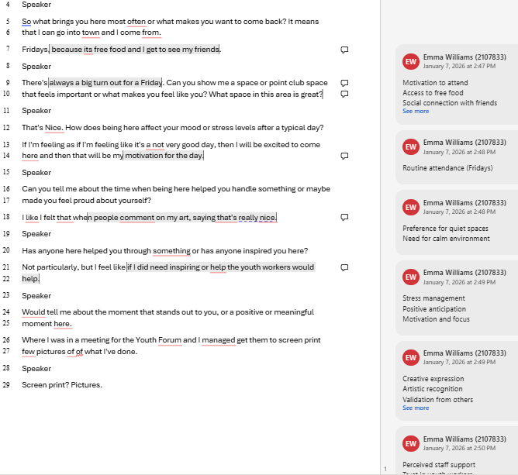

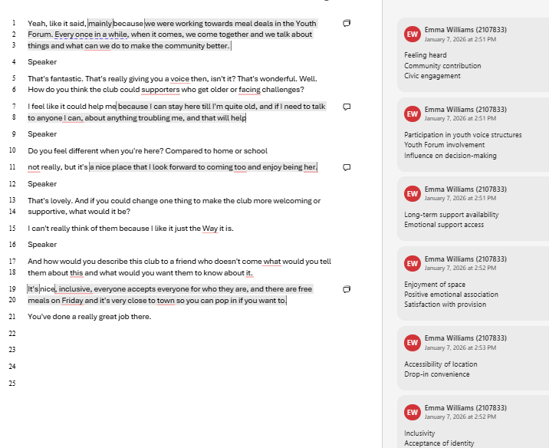
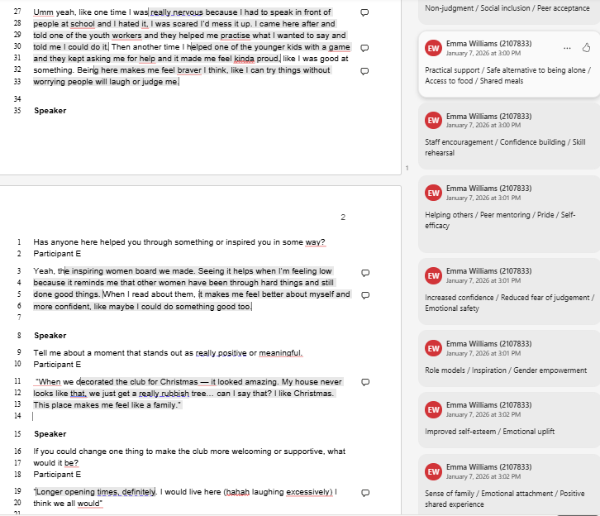

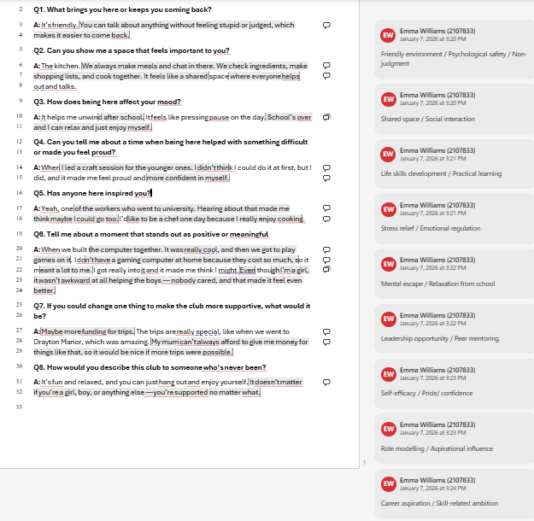
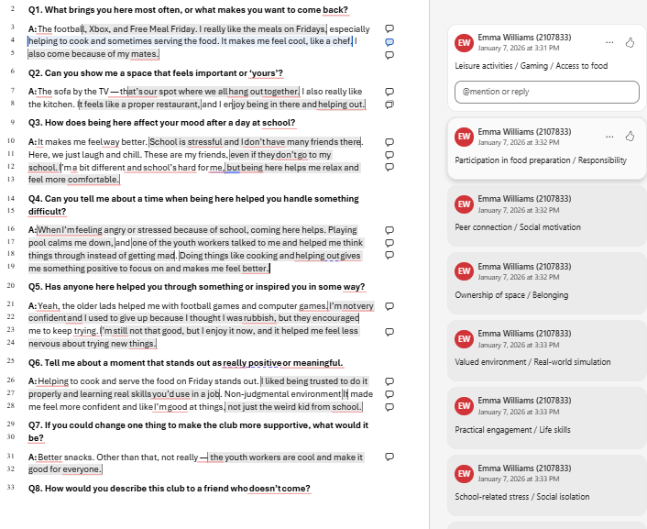

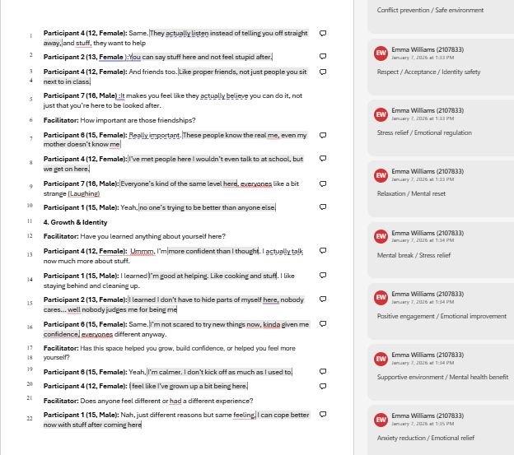

Example Coding Framework:
Column 1 | Column 2 | Column 3
Acceptance | Calm | Activity participation
Acceptance / Inclusion | Calm environment | Arts and crafts participation
Acceptance / Respect | Comfort | Collaborative learning
Authentic self-expression | Comfortable communication | Creative activities
Authenticity | Coping skills | Creative expression
Authenticity / Acceptance | Coping strategies | Creative recognition
Belonging | Emotional attachment | Drama participation
Belonging / Acceptance | Emotional benefit | Experiential learning
Belonging / Social cohesion | Emotional escape | Hands-on activities
Belonging / Social connection | Emotional freedom | Hands-on learning
Collective care | Emotional improvement | Leisure activities
Collective need / Individual benefit | Emotional regulation | Music and dance participation
Community contribution | Emotional security | Outdoor learning
Community support | Emotional support | Recreation
Comfort / Social bonding | Emotional wellbeing | Shared activities
Connection with others | Feeling heard | Social enjoyment
Cross-school friendships | Feeling safer | Activity zones
Equality | Friendly environment | Calm spaces
Equality among peers | Mental break | Collaborative tasks
Inclusivity | Mental escape | Festive themes
Equality | Mental health benefit | High-energy play
Non-judgment | Mental reset | Meal preparation together
Inclusivity / Social support | Mood improvement | Seasonal activities
Inclusion of new members | Positive emotional association | Spatial organisation
Inclusive environment | Psychological safety | Access to opportunities
Non-judgment | Relaxation | Access to resources
Non-judgment / Identity acceptance | Safe personal space | Career aspiration
Peer bonding | Safe space | Creative achievement
Peer connection | Safety | Financial awareness
Emotional support | Safety / Security | Life skills development
Peer engagement | Sense of calm | Practical engagement
Peer inclusion | Sense of belonging | Practical learning
Peer loyalty | Sense of family | Skill acquisition
Peer relationships | Stress reduction | Skill rehearsal
Peer support | Stress relief | Technical skill development
Belonging | Supportive environment | Agency over participation
Peer support / Emotional support | Trusted relationships | Choice in participation
Positive peer influence | Trusted adults | Civic engagement
Recognition / Belonging | Staff encouragement | Co-creation of rules
Respect | Staff expertise | Community decision-making
Shared social space | Staff support | Contribution
Social bonding | Staff support / Listening | Empowerment
Social cohesion | Staff support / Trust | Leadership opportunity
Social connection | Staff as role models | Peer mentoring
Social diversity | Positive staff relationships | Peer leadership
Social equality | Supportive staff | Participation in youth forum
Social expansion | Youth worker relationship support | Responsibility
Social expansion / Inclusivity | Anxiety reduction | Shared responsibilities
Social interaction | Anxiety reduction / Emotional relief | Youth decision-making
Social joy | Calm | Youth voice
Social mixing | Comfort | Access to food
Supportive peer environment | Emotional safety | Basic needs support
Welcoming behaviour | Emotional safety / Safe space | Food preparation participation
Calm | Emotional security | Free meals
Comfort | Emotional support | Material support
Coping strategies | Emotional uplift | Resource access
Emotional attachment | Emotional wellbeing | Resource inequality awareness
Emotional benefit | Feeling heard | Accessibility
Emotional escape | Friendly environment | Accessibility of location
Emotional freedom | Mental break | Alternative environment
Emotional improvement | Mental escape | Alternative supportive environment
Emotional monitoring | Mental health support | Atmosphere
Emotional regulation | Mood improvement | Comfortable environment
Emotional regulation / Self-control | Positive emotional outcome | Drop-in convenience
Emotional security | Psychological safety | Environmental comfort
Emotional support | Relaxation | Familiar spaces
Emotional wellbeing | Safe personal space | Ownership of space
Feeling heard | Safe space | Positive atmosphere
Feeling safer | Safety | Quiet spaces
Friendly environment | Safety / Security | Safe environment
Mental break | Sense of calm | Structured environment
Mental escape | Sense of belonging | Youth-friendly environment

Step 3: Searching for themes.

Raw data, 227 initial codes after duplicates removed, grouped into 10 thematic categories
Theme | Subtheme / Category | Example Codes | No. of Codes
1. Belonging, Social Connection & Peer Relationships | Peer belonging and connection | Peer support; friendship groups; familiar spaces (sofas, computer room); family-like atmosphere; shared activities | 28
 | Peer inclusion and collective care | Invitation to join activities; peer-led inclusion; empathy for newcomers; peer protection; crisis support | 18
 | Social cohesion and friendship networks | Social expansion; cross-school friendships; new friendships; mixed-age interactions; peer mentoring | 16
2. Inclusion, Acceptance & Identity Safety | Identity acceptance and inclusion | Non-judgment; identity acceptance; LGBTQ+ affirmation; gender inclusion; authentic self-expression | 20
 | Accessibility and personal support | Accessibility; drop-in environment; personalised support; unconditional support | 12
 | Safe communication and comfort | Safe communication; calm environment; safe personal space; comfort | 10
3. Emotional Wellbeing, Regulation & Mental Health | Emotional regulation and coping | Emotional regulation; coping skills; resilience; self-control | 14
 | Emotional relief and stress reduction | Stress relief; anxiety reduction; mental reset; mood improvement | 12
 | Emotional support networks | Trusted adults; staff support; peer emotional support; crisis support | 16
4. Skill Development, Confidence & Personal Growth | Confidence and personal development | Confidence; self-efficacy; pride; courage | 14
 | Leadership and responsibility | Leadership opportunities; peer mentoring; rule co-creation; responsibility | 10
 | Skill building and creative engagement | Life skills; employability skills; communication skills; creative expression | 12
5. Engagement, Enjoyment & Participation | Activity engagement | Hands-on activities; creative participation; gaming; music; dance | 12
 | Enjoyment and social motivation | Enjoyment; anticipation; shared experiences; positive engagement | 10
 | Food and shared experiences | Meal preparation; eating together; access to food | 6
6. Staff Relationships & Youth Voice | Staff support and trust | Trusted adults; encouragement; emotional guidance; staff attachment | 10
 | Youth agency and decision-making | Youth forum participation; decision-making; choosing activities | 8
 | Staff facilitation and behaviour support | Conflict management; adapting approaches to young people’s needs | 6
7. Safe Spaces & Environmental Structure | Physical and emotional safety | Safe environment; security; quiet spaces; emotional safety | 10
 | Spatial organisation | Activity zones; mixed-use spaces; shared social spaces | 8
 | Boundaries and rules | Group-created rules; boundary setting; structured environment | 6
8. Inclusion & Equality in Broader Context | Social equality and fairness | Equality among peers; non-competition; fairness | 8
 | Accessibility and marginalised inclusion | Inclusion of marginalised youth; accessible location | 6
 | Empathy and understanding others | Consideration for others; empathy; social awareness | 6
9. Achievement, Recognition & Aspirational Influence | Recognition and validation | Pride; acknowledgement; validation from others | 8
 | Aspirational influence | Role modelling; inspiration; career aspiration | 7
 | Empowerment and contribution | Youth voice; empowerment; influence | 6
10. Attendance & Long-term Engagement | Participation and motivation | Voluntary attendance; motivation to attend; routine attendance | 6
 | Sustained engagement | Long-term participation; desire for increased access | 5

Step 4 Defining final themes and sub-themes:

Theme 1
Belonging as the Foundation of Emotional Safety
This theme captures how young people experience the youth club as a socially and emotionally safe environment where belonging is created through peer relationships, shared routines, and familiar spaces. Emotional safety emerges through everyday interactions, social inclusion, and predictable environments that allow young people to relax, regulate emotions, and feel accepted.
Theme 2
Everyday Care Within Youth Work Relationships
This theme describes how well-being is supported through informal, relational practices of care enacted by both peers and youth workers. Support occurs through empathy, dignity, practical assistance, and non-judgmental listening rather than formal intervention, creating an environment where young people can access emotional support without stigma.
Theme 3
Developing Confidence and Agency Through Recognition, Responsibility, and Self-Expression
This theme captures how participation in youth club activities supported young people’s confidence, agency, and personal development. Confidence emerged through relational affirmation, encouragement from peers and youth workers, and opportunities to take on meaningful roles within the club. Experiences such as leadership positions, creative recognition, and being trusted with responsibility enabled young people to see themselves as capable contributors rather than passive recipients of support. Unlike the previous themes, which centre on emotional safety and relational care, this theme reflects how those conditions create opportunities for growth, participation, and identity expression. Confidence therefore developed gradually through everyday participation and recognition within the youth club environment.

Initial coding generated 227 codes, which were grouped into ten thematic categories. Through reflexive review and comparison across the dataset, categories were further refined into three overarching themes and subthemes:

Final Theme | Subtheme | Example Codes
Belonging as the Foundation of Emotional Safety | Friendship, Protection, and Peer Belonging | Peer inclusion; cross-school friendships; peer mentoring
 | Emotional Safety Through Space, Routine, and Atmosphere | Calm spaces; routines; emotional relief
Everyday Care Within Youth Work Relationships | Empathy, Inclusion, and Material Support | Peer empathy; shared meals; inclusion
 | Trusted Adults and Informal Emotional Support | Staff listening; encouragement; relational authority
Developing Confidence and Agency Through Recognition, Responsibility, and Self- Expression | Relational recognition and confidence development | Pride; validation; encouragement
 | Responsibility, participation, and self-expression | Leadership roles; youth forum
 |  | Arts participation; photography

Appendix I: Reflective journal examples

Session one:
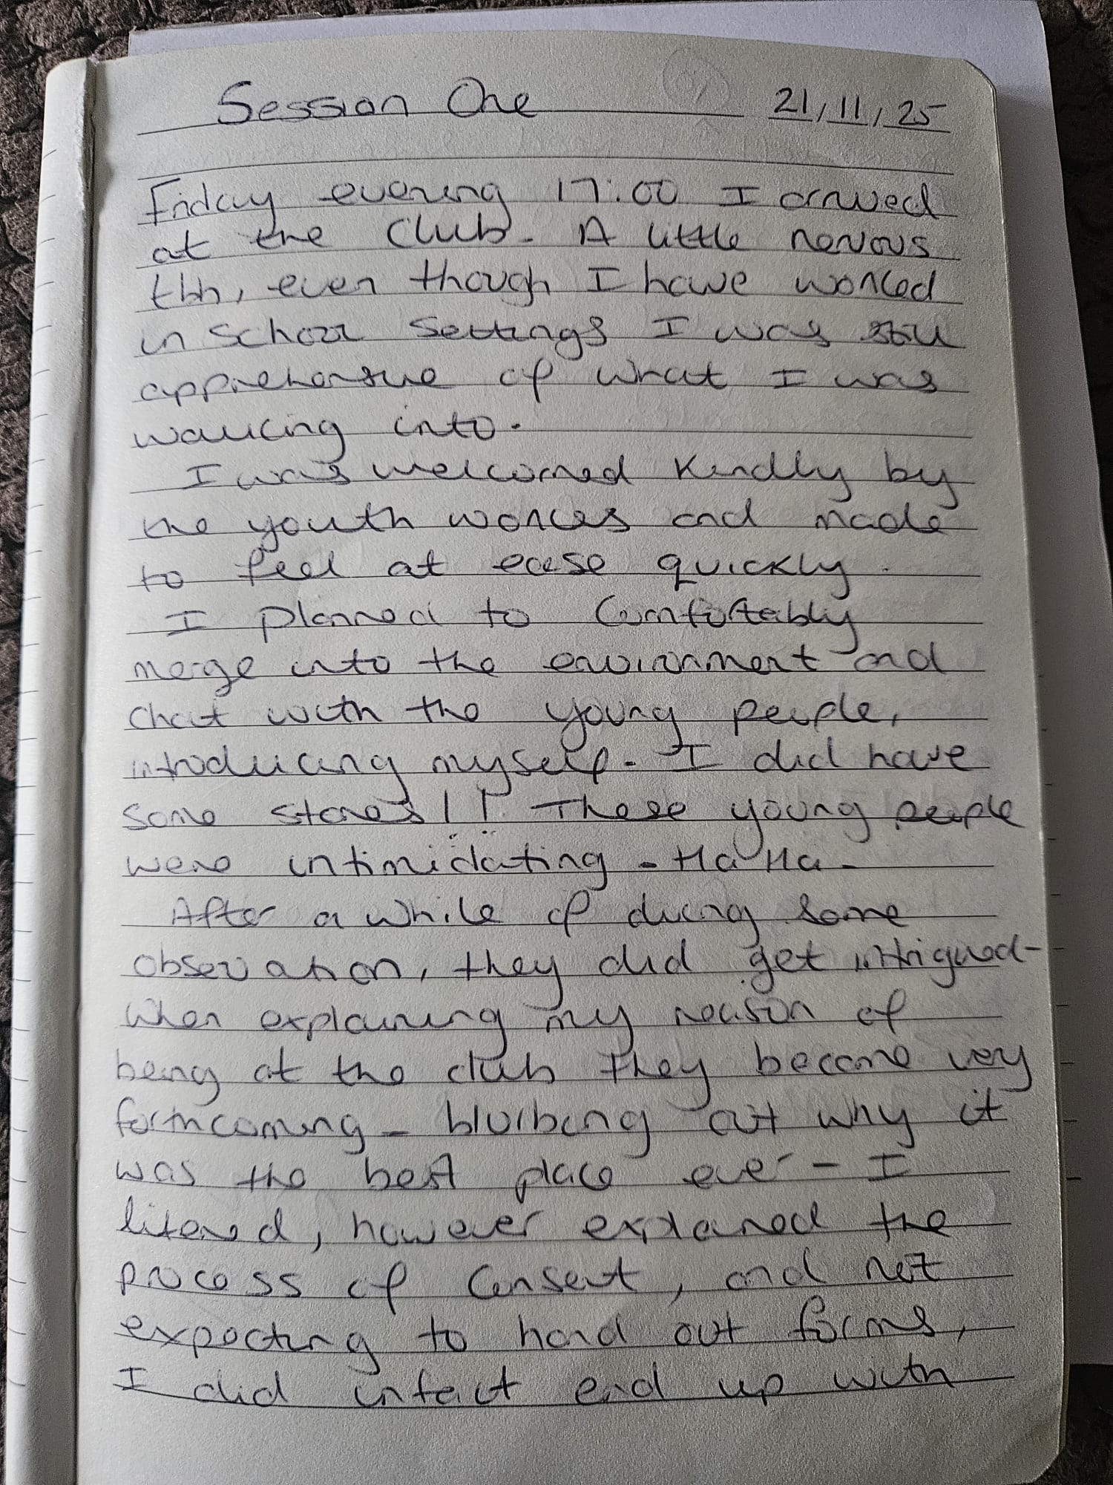
Session four:

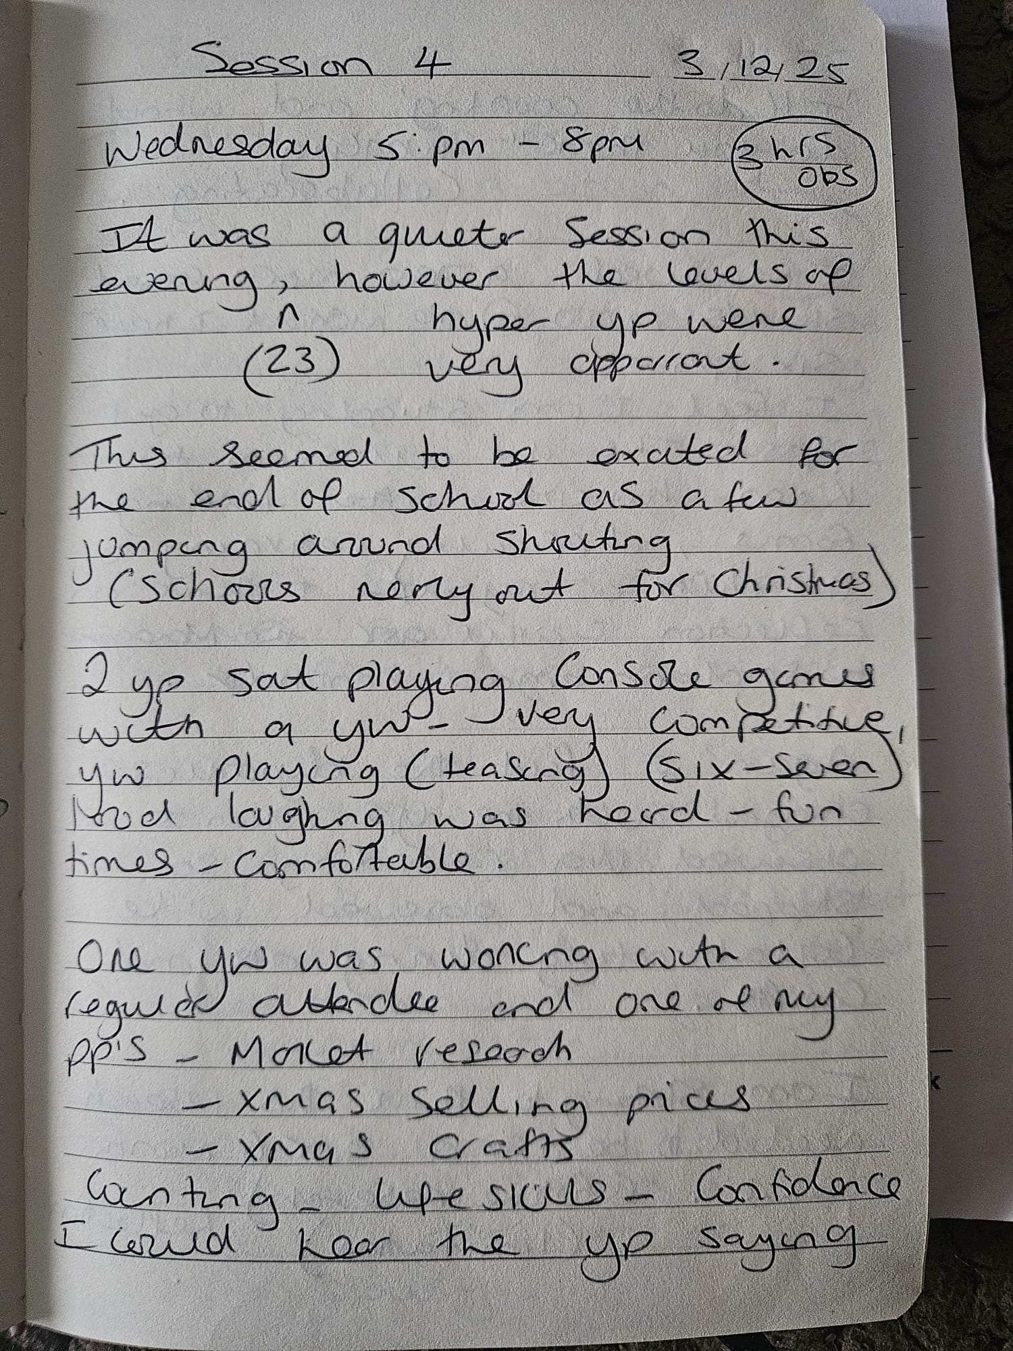
Session Four
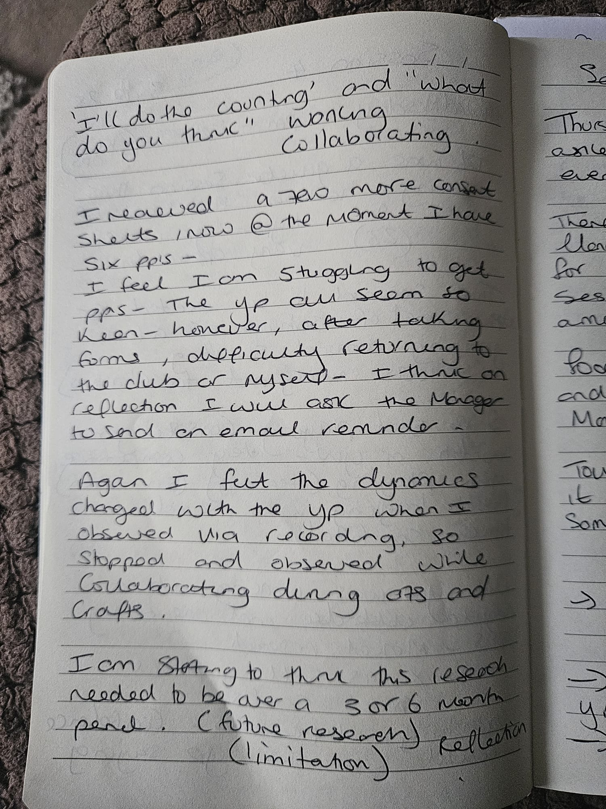

Session Five
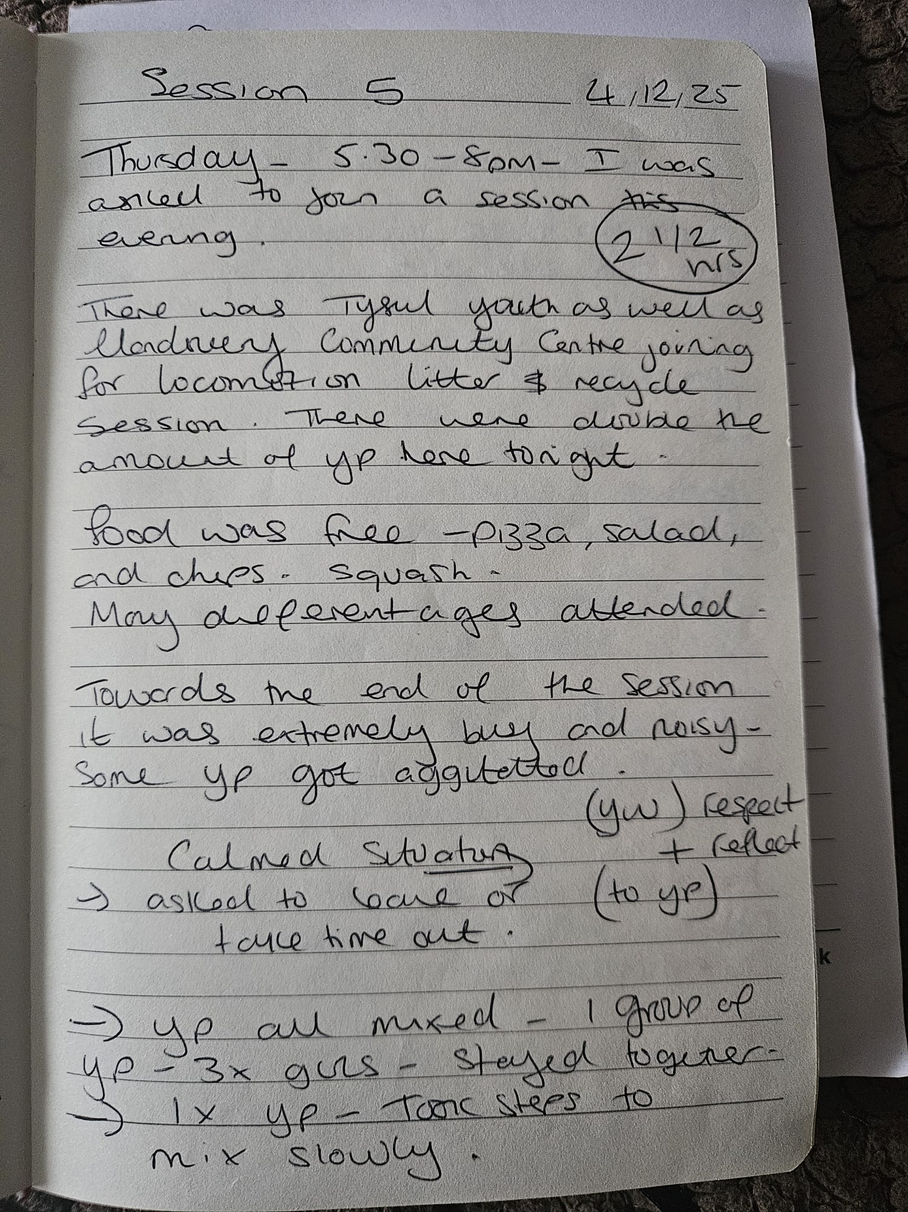

Session Six
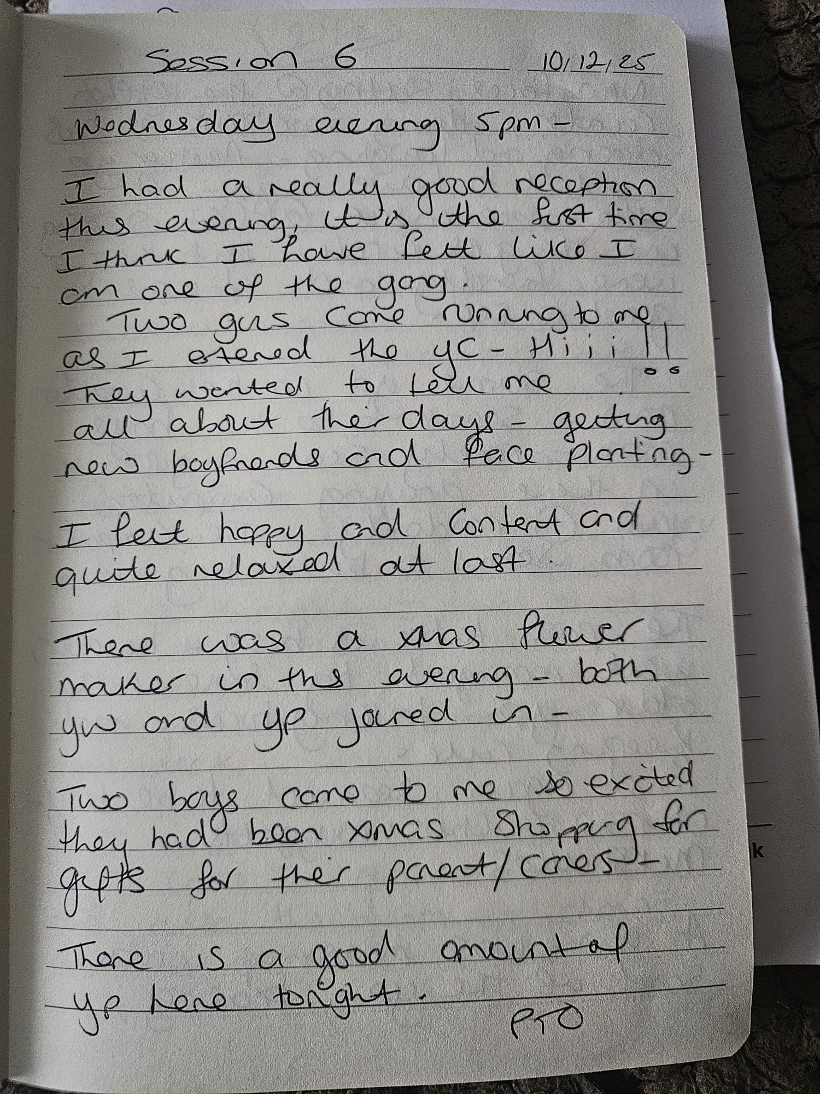

Session Six
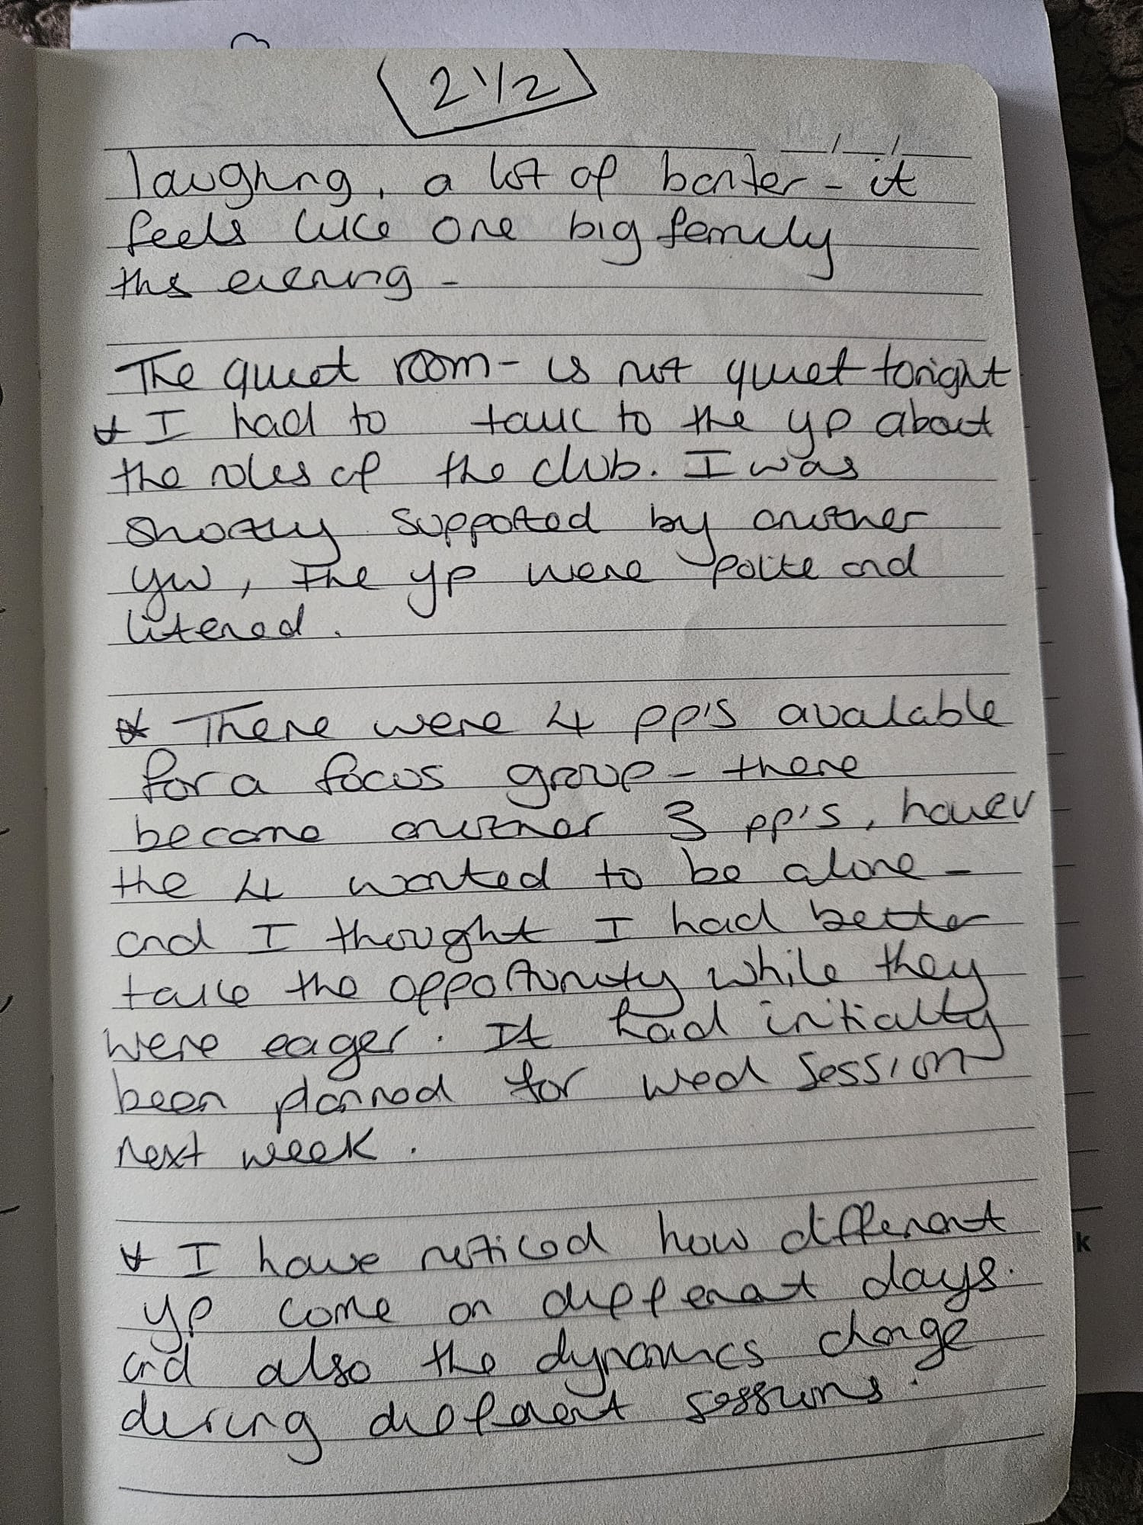

Appendix J: Initial research proposal

MA Children and Young People’s Mental Health
MSc Part II Applied Psychology Research Dissertation: Research Proposal 2024-25

Name: Emma Jain Williams 2107833

Proposed supervisor: Dr Charlotte Greenway
Project Title: The Role of Youth Clubs in Supporting Young People’s Mental Health: Fostering Social Support, Resilience, and Personal Growth in Community Spaces.

Lay summary of the project
This research project aims to explore how youth clubs support young people’s mental health, especially at a time when many local services have closed due to budget cuts and the Covid-19 pandemic. Youth clubs can be seen as more than just social spaces; they can offer safety, connection, and opportunities to build confidence and resilience.
The research will take place at a local youth club in Carmarthenshire involving young people aged 11 to 25. It will use creative and informal methods such as photo-based activities, walk-and-talk interviews, and friendly observation during club sessions. These approaches are designed to help young people express their thoughts and feelings in ways that feel natural and comfortable.
The goal is to understand what makes youth clubs feel inclusive and emotionally supportive and why they matter to young people’s wellbeing. The findings could help inform youth workers, organisations, and policymakers in shaping more supportive and inclusive youth services.
By listening directly to young people, this research aims to show how youth clubs can play a vital role in helping young people cope with life’s challenges and feel supported.
Background literature review

This research responds to growing concerns around youth mental health, particularly following widespread youth service closures linked to austerity and the COVID-19 pandemic (Roberts, 2020). A consistent body of research links reductions in accessible support spaces to increased isolation, anxiety, and reduced well-being among young people (Institute for Fiscal Studies [IFS], 2023). In Wales, the youth work strategy, grounded in the United Nations Convention on the Rights of the Child (UNCRC), emphasises every young person’s right to safe, inclusive, community-based opportunities for development (Welsh Government, 2022). Yet access remains uneven, particularly in marginalised areas.
Research has highlighted the value of unstructured leisure time in adult-supported, youth-led environments such as youth clubs, which foster emotional resilience, confidence, and belonging (Eriksen & Seland, 2021). These spaces support informal “hanging out”, offering a sense of safety and gradually building independence. Longitudinal evidence by Berrie et al. (2023) found that early participation in youth programmes was linked to improved mental health and wellbeing into adulthood, reinforcing the long-term protective value of such settings.

Ritchie and Ord (2016) further emphasise the importance of open access youth work, showing how association with peers, trusted relationships with youth workers, and a strong sense of belonging are central to young people’s engagement. Their findings highlight how these spaces offer not only practical support but also emotional safety and affirmation, particularly for those who feel excluded elsewhere. Their study presents a significant counter to the current shift toward targeted youth work, underscoring the enduring value of open, community-based provision.
The COVID-19 pandemic further exposed the gaps in formal provision. Ní Charraighe (2023) observed that youth workers in Scotland and England became de facto first responders to rising mental health needs, stepping in where clinical services were inaccessible. This highlights the central role of relationship-based, community-level responses to youth well-being.
Peer-led support is also gaining traction as an effective, low-threshold intervention. Simmons et al. (2023) found significant improvements in anxiety and depression outcomes for young people involved in peer-led programmes, demonstrating the power of shared experience and informal support structures within youth settings.

This study is framed by three intersecting psychological theories. Social Support Theory (Cohen & Wills, 1985) provides a lens for understanding how peer and adult relationships buffer against stress. Ecological Systems Theory (Bronfenbrenner, 1979) situates young people within layered socio-environmental systems, acknowledging how youth clubs interact with broader developmental contexts. Resilience Theory (Masten, 2001) highlights how stable, caring environments promote positive adaptation in the face of adversity.
While the value of youth work is increasingly recognised, there remains a need for applied, youth-led research that explores how these spaces are experienced on the ground. This project addresses that gap by working with a community youth club to examine how emotional safety, peer relationships, and inclusion are understood by young people themselves, offering insights that may inform both practice and policy.

- Proposed methodology:
- Study Design and Justification
This study will adopt a qualitative, mosaic-informed approach to explore how youth clubs support young people’s mental health, focusing on emotional safety, resilience, and peer connection. A qualitative design is suited to capturing the richness of young people’s experiences, often missed in purely quantitative research (Lim, 2025). Inspired by the Mosaic approach (Clark & Moss, 2001), the study will use creative, flexible, and age-appropriate methods to support meaningful expression. While not formally participatory, this approach values diverse ways of hearing young people’s voices. Research will be conducted in one community youth club, a familiar, supportive setting that promotes trust, openness, and authentic insight and reflects the inclusive ethos of youth work.

- Target population and participant recruitment strategy
Permission to conduct research will be sought by formally contacting the youth club’s management. The target population includes young people aged 11–25 who regularly attend the youth club in West Wales, reflecting the club’s typical demographic and capturing a range of developmental stages. Approximately (n=20) will be the target number of participants recruited to provide diverse perspectives.
The researcher will attend the club over six weeks or until data collection is complete within the study timeline. Purposive sampling will be used to ensure participants are relevant to the research questions, consistent with previous research (Makamo, 2024). The youth club manager will introduce the researcher to help build trust. The researcher will then provide information sheets and engage informally with young people. Participation will be entirely voluntary, with no pressure to take part.
- Data collection method and justification
Data collection will begin with the distribution of an information sheet outlining the study's purpose, what participation involves, and participants' rights, including confidentiality and withdrawal. This will be youth-friendly and explained verbally if needed.
Participants aged 16 and over will provide informed consent. For those under 16, assent will be obtained alongside parental/guardian consent. The youth club manager will support this by contacting parents/carers directly or sharing consent forms via existing channels (e.g. email or printed handouts), in line with the club’s safeguarding procedures.
Once consent is secured, participants will complete a short demographic questionnaire collecting non-identifiable information (e.g. age, gender identity, club attendance, support needs, service use, and perceptions of youth club value). This will help ensure diversity and contextualise findings.
Participants will subsequently have the opportunity to engage in one or more of three qualitative methods, which will be conducted on an ad hoc basis.
Ethnographic-style Observation. Informal observations of group dynamics and peer interaction during regular youth club sessions. This method allows the researcher to contextualise young people’s experiences within their everyday environment and gain insights that might not surface through direct questioning.
Photo/Drawing Elicitation Focus Groups. Small group discussions using images or drawings created or chosen by participants to express their experiences. This method supports expression beyond verbal communication and helps reduce barriers related to literacy, confidence, or language. Sessions will be conducted in a relaxed, youth-friendly space and audio-recorded with consent.
One-to-One Walk-and-Talk Interviews: Informal individual interviews conducted while walking around the youth club or nearby areas to encourage open, natural conversation. This approach respects young people’s preference for movement-based interaction and allows exploration of outdoor or informal “safe spaces” as supportive environments. Interviews will be audio-recorded with informed consent, and participants may pause or withdraw at any time. Established youth club safeguarding and referral protocols will be followed to provide appropriate support if needed.
All methods are designed to be flexible and age-appropriate to promote comfort, agency, and expression. Briefings and debriefings will be provided before and after each activity. Safeguarding protocols established by the youth club will be followed throughout.

- Primary Research questions:

This study is guided by the following primary research questions, designed to explore young people’s experiences and perceptions of youth clubs as supportive community spaces:

- How do youth clubs create safe and supportive environments that foster social connection, promote mental well-being, and help young people cope with everyday challenges?
- In what ways do youth clubs contribute to building resilience and facilitating personal growth in young people?
- How do youth clubs, as community-based support systems, address barriers to accessibility and inclusion for diverse groups of young people?

While these questions guide the study, new themes may arise during data collection and analysis. These emergent insights will be explored inductively to enrich understanding of young people’s experiences in the youth club setting.

- Planned analyses
Data will be analysed using thematic analysis (Braun & Clarke, 2006, 2019), a method well-suited to qualitative, exploratory research. Thematic analysis supports an inductive, flexible approach to identifying and interpreting patterns of meaning across data sources. This aligns with both the Mosaic-informed methodology and the interpretive nature of the study, recognising the researcher’s active and reflexive role in meaning-making (Braun et al., 2019).

The analysis will follow Braun and Clarke’s six-phase framework:

Familiarisation with the data, including transcripts from focus groups and walk-and-talk interviews, observation notes, and any visual materials.
Generating initial codes and manually coding all data sources to ensure close engagement and interpretive depth.
Searching for themes and identifying potential themes by grouping related codes across the dataset.
Reviewing themes and refining themes in relation to the research questions and theoretical frameworks.
Defining and naming themes and developing a coherent narrative that reflects key patterns in the data.
Producing the report using anonymised participant quotes and, where consent is provided, visual materials (e.g. drawings or photographs) to illustrate key findings.

Themes will be interpreted through the lens of social support theory, ecological systems theory, and resilience theory, drawing connections between individual experiences and the wider social, relational, and developmental contexts in which youth clubs operate.
A reflexive approach will be embedded throughout the analysis, involving continuous reflection on the researcher’s positionality, assumptions, and influence on the interpretation of data.

Main Ethical considerations (500 words max)
This study involves working with young people aged 11–25, requiring careful consideration of issues including consent, safeguarding, confidentiality, and appropriate researcher conduct within an informal youth work setting. The study will seek an ethical review and approval from the University of Wales Trinity Saint Davids (UWTSD) Research Ethics & Integrity Code of Practice committee and follow the UWTSD Research Data Management Policy.
Informed consent and assent will be central to the research process. Participants aged 16 and above will provide informed consent directly. For those under 16, both parental or guardian consent and the young person’s assent will be required. Age-appropriate information sheets will be provided, and verbal explanations will be offered to ensure participants fully understand the purpose of the study, what participation involves, and their rights, including the right to withdraw from the study at any time, without having to give a reason and without consequence.
Participants will also be informed that they may withdraw specific pieces of data (e.g. drawings or quotes) at any stage prior to final analysis. Once findings have been anonymised and incorporated into the final dissertation, full withdrawal may not be possible.
The youth club manager and safeguarding manager will provide the researcher with an induction covering relevant policies, protocols, and staff roles to ensure full integration into the organisation’s safeguarding framework. Existing safeguarding procedures will be strictly followed throughout the study. The researcher will complete safeguarding training before data collection and work under youth club staff supervision. Any disclosures or concerns will be promptly reported to the club’s safeguarding lead. The researcher holds an enhanced DBS certificate.
Confidentiality and data protection will be carefully managed. All data will be anonymised and securely stored on an encrypted, password-protected university drive, accessible only to the researcher. Signed consent forms, field notes, and printed transcripts will be securely kept in a locked cabinet, accessible only to me.
Where visual materials (e.g. drawings or photographs) are used, consent will be obtained for their inclusion in research outputs, and participants will retain the right to withdraw individual items. After the research has been completed, analysed and results finalised, all data will be securely destroyed in accordance with university data protection policy.
As the researcher will also be a temporary placement member, careful attention will be given to boundaries, transparency, and positionality. Participants will clearly understand the difference between informal interaction and formal research. A reflexive journal will be kept tracking the researcher’s evolving insights, relationships, and ethical challenges, helping to maintain awareness of bias and power dynamics throughout the study (Reid et al., 2018).

This study takes a youth-centred, rights-based approach consistent with the United Nations Convention on the Rights of the Child (UNCRC), ensuring that young people’s voices are valued and respected. Ethical integrity will be upheld throughout, guided by openness, consent, care, and young people’s autonomy and wellbeing in line with the universities and the BPS code of conduct (Oates et al., 2021).
What are the expected outputs from this project?

This research will aim to generate applied insights into how youth clubs support social connection, resilience, and emotional safety among young people. Findings may inform policy decisions around the funding and sustainability of youth services in Wales and beyond. The study also has the potential to contribute to youth work training, particularly in trauma-informed care, emotional well-being, and inclusive engagement.
In addition, the creative, youth-led methods (e.g. walk-and-talk interviews and photo elicitation) may inform the design of youth-friendly spaces and programmes that better respond to young people’s mental health needs. Findings could be shared with youth organisations, practitioners, and policymakers to support future service development and practice innovation.
However, the impact of such research is contingent on meaningful engagement with the findings by decision-makers. Without a commitment to sustained investment in open-access youth work, even well-evidenced recommendations risk being overlooked. There is also a risk of tokenism if young people’s voices are collected but not acted upon. The study therefore aims not only to generate knowledge but also to advocate for the structural recognition of youth work’s value, particularly in the context of austerity and uneven access to support across communities.

Timescales for project completion (not included in the word count if a table/chart but MUST be completed)

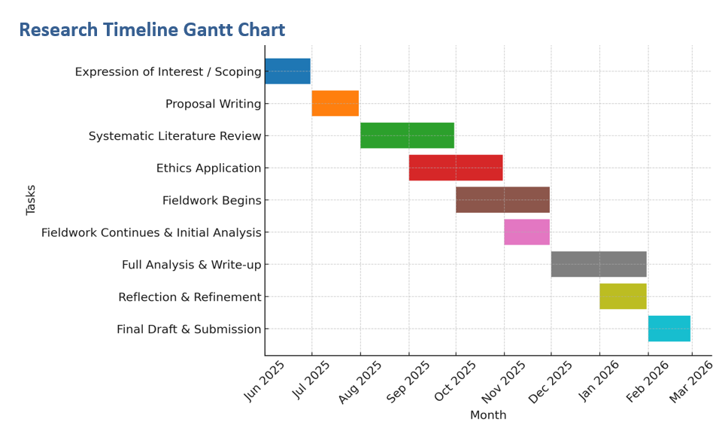
Up to ten key references (not included in word count)

Berrie, L., Adair, L., Williamson, L., & Dibben, C. (2023). Youth organisations, social mobility and health in middle age: Evidence from a Scottish 1950s prospective cohort study. European Journal of Public Health, 33(1), 6–12. https://doi.org/10.1093/eurpub/ckac181
Braun, V., & Clarke, V. (2006). Using thematic analysis in psychology. Qualitative Research in Psychology, 3(2), 77–101. https://doi.org/10.1191/1478088706qp063oa
Clark, A., & Moss, P. (2001). Listening to young children: The Mosaic approach. National Children’s Bureau.
Cohen, S., Mermelstein, R., Kamarck, T., & Hoberman, H. M. (1985). Measuring the functional components of social support. In I. G. Sarason & B. R. Sarason (Eds.), Social support: Theory, research, and applications (pp. 73–94). Springer. https://doi.org/10.1007/978-94-009-5115-0_5
Eriksen, I. M., & Seland, I. (2021). Conceptualising well-being in youth: The potential of youth clubs. Young, 29(2), 175–190. https://doi.org/10.1177/1103308820937571
Institute for Fiscal Studies. (2023). Cuts to youth services and their impact. https://researchbriefings.files.parliament.uk/documents/CBP-10132/CBP-10132.pdf
Ní Charraighe, A., & Reynolds, A. (2024). Re‐thinking youth work as initial mental health support for young people. Children & Society, 38(6), 1920–1942. https://doi.org/10.1111/chso.12849
Ritchie, D., & Ord, J. (2016). The experience of open access youth work: The voice of young people. Ethnography and Education, 11(3), 269–282. https://doi.org/10.1080/17457823.2016.1200054
Simmons, M. B., Cartner, S., MacDonald, R., Whitson, S., Bailey, A., & Brown, E. (2023). The effectiveness of peer support from a person with lived experience of mental health challenges for young people with anxiety and depression: A systematic review. BMC Psychiatry, 23, 194. https://doi.org/10.1186/s12888-023-04765-5
Welsh Government. (2022). Youth work strategy for Wales: Implementing UNCRC principles. https://www.gov.wales/sites/default/files/publications/2019-06/youth-work-strategy-for-wales.pdf

