Name: Kamran Khan
Student Number: 2246128
Module: Health, Wellbeing and Sustainable Development BMHP6030
Assignment Title: Component 2: Written Assignment (Report)
Lecturer Name: Parese Ahmed

Table of Contents
Introduction 3
Section 1: SDG 3: Good Health and Wellbeing (NCDs + mental health) 3
WHO Global NCD Action Plan 3
England Tackling Obesity Strategy 5
Greater Manchester’s Bee Network Active Travel Programme 5
Recommendations 6
Section 2: SDG 11: Sustainable Cities and Communities 6
UN-Habitat New Urban Agenda 6
UK Clean Air Zones 7
Lahore Clean Air Initiatives 8
Recommendations 9
Conclusion 9
References 10

Introduction
Rapid urbanisation is reshaping how health and wellbeing are produced and distributed. Cities can enable access to jobs, education, healthcare and social networks, yet they also concentrate health risks through air pollution, overcrowded housing, traffic injury, sedentary lifestyles, heat exposure and widening inequalities. In this context, the Sustainable Development Goals (SDGs) matter because they provide a shared, globally recognised framework that links health outcomes to the social and environmental conditions that drive them shifting policy attention from healthcare alone to prevention, equity and sustainable development (Buse and Hawkes, 2015). This report therefore examines how SDG 3 (Good Health and Wellbeing) and SDG 11 (Sustainable Cities and Communities) interact to shape population health through urban environments.
The report aims to critically evaluate the effectiveness of selected global, national and local policies and initiatives aligned with these goals, and to develop evidence-informed recommendations for improvement. Analysis is structured in two main sections. Section 1 assesses SDG 3 with a focus on non-communicable diseases and mental health, examining how policies balance individual behaviour change with structural determinants. Section 2 evaluates SDG 11, focusing on housing, transport and green infrastructure as “health-producing” systems. Across both sections, evaluation is guided by the Social Ecological Model, Built Environment Theory, and Health Impact Assessment (HIA) to connect theory to real-world policy design, implementation and outcomes.

Section 1: SDG 3: Good Health and Wellbeing (NCDs + mental health)
SDG 3 aims to ensure healthy lives and promote wellbeing for all at all ages, explicitly covering non-communicable diseases (NCDs), mental health, environmental risks, and health systems (including universal health coverage) (United Nations, 2025). In urban settings, SDG 3 outcomes are strongly patterned by the built environment (land-use, transport, housing quality, green space) and by structural determinants (income, work, discrimination), meaning policy success depends on cross-sector governance rather than health services alone (Seelajaroen and Jitmaneeroj, 2025).

WHO Global NCD Action Plan
The WHO Global Action Plan for the Prevention and Control of NCDs (2013–2020; later extended toward 2030 alignment) sets targets and recommended best buys across tobacco, alcohol, diet and physical activity, and strengthens surveillance and health-system response (WHO, 2013). Its main advantage is that it makes NCD prevention a whole-of-government agenda (e.g., fiscal, marketing limits, primary care integration). But, practically, translation into national policy tends to lean toward individual-level solutions (education campaigns, apps, advice) since they are easier politically than control over commercial drivers (food marketing, ultra-processed products, car dependency) or revamping the city form. This policy lifestyle creep is a notoriously popular failure mode of NCD policy: the upstream drivers are recognised, but downstream interventions control delivery (Akhtar et al., 2025).
In the context of Social Cognitive Theory (SCT), a number of NCD programs, such as healthy swaps activity challenges, focus on observational learning and behavioural capability, but lack investment in environmental facilitators that enable the behaviour to be realistic (safe pavements, safe cycle lanes, low-cost healthy food). SCT processes, including self-efficacy, are disrupted whenever the environments are obesogenic since repeated failure diminishes perceived control (Egele, Klopp and Stark, 2025). Likewise, campaigns may tend to raise perceived threat (threats of obesity, diabetes, CVD) but not as much perceived barriers (cost, time, unsafe streets, long commutes) or enduring cues to action after short campaigns using the Health Belief Model (HBM) thus limiting permanence (Razmara et al., 2018).
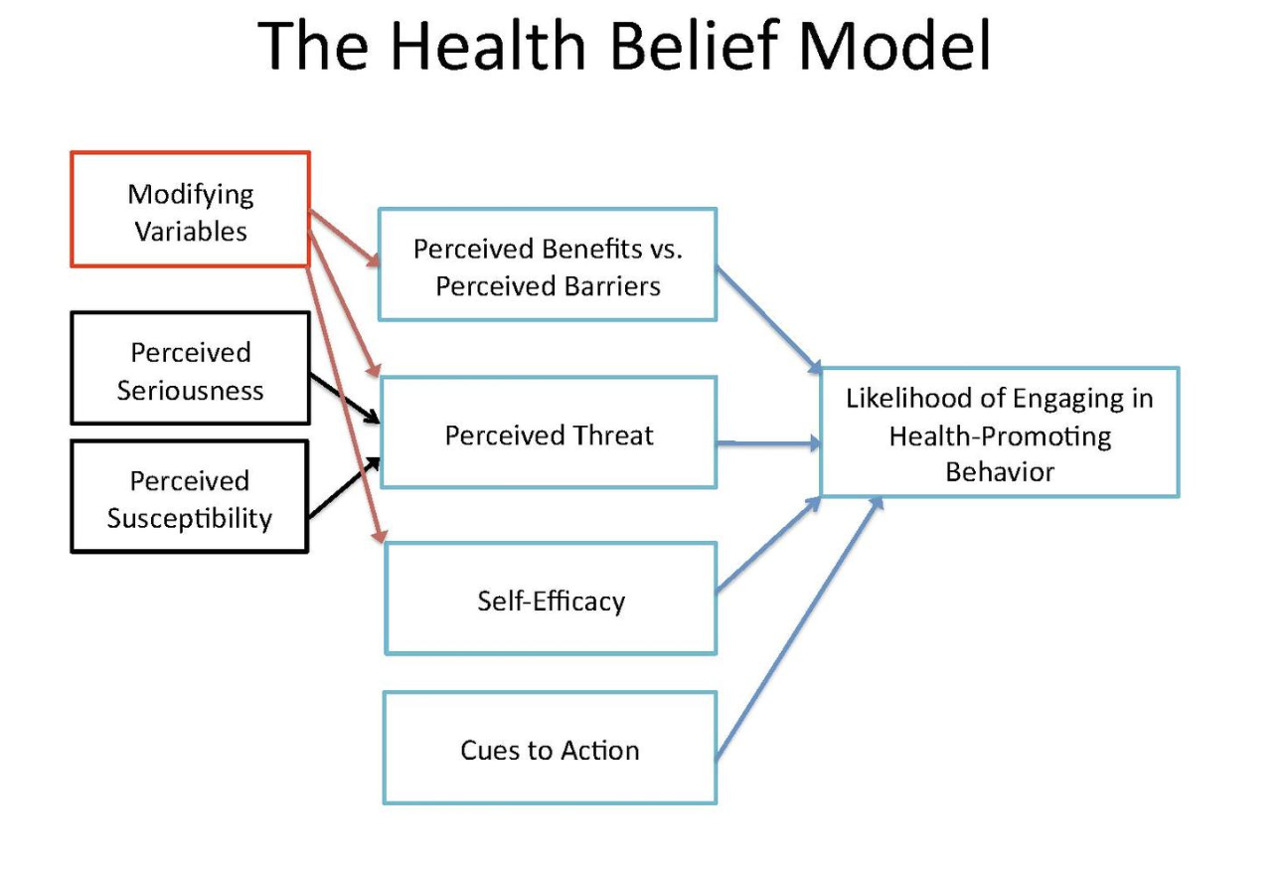
Figure 1: Health Belief Model (Bourne and Williams, 2022)
Mental health is also embedded in SDG 3 targets (e.g., 3.4). WHO’s Comprehensive Mental Health Action Plan (2013–2030) reinforces prevention and service coverage, but implementation is constrained by workforce gaps, stigma, and unequal access especially for low-income urban residents facing precarious housing and pollution stressors (Singh, 2021).

England Tackling Obesity Strategy
The 2020 strategy to tackle obesity in England expressly mentions their intention to modify the environment and promote healthier decisions through strategies like labelling and weight management assistance (Department of Health & Social Care, 2020). The strongest-supported national lever in this area is the fiscal/regulatory policy of sugar-sweetened beverages. The UK Soft Drinks Industry Levy (SDIL) has facilitated significant decreases in sugar content through reformulation (government reporting shows there are significant decreases in sugar content in the market), and modelling and empirical studies attribute these decreases to decreases in sugar purchases and estimated health benefits. Average sugar content in levy-liable soft drinks fell by 46% between 2015 and 2020, according to the UK government’s 2024 SDIL review (Gov UK, 2024). It means that structural choice architecture can be more effective than information-only interventions due to the ability to change the defaults of the whole population, including less health-literate groups (Cobiac et al., 2024).
Limits do exist, obesity patterns are socially structured, and individual product interventions cannot be enough to offset a wider exposure to ultra-processed foods and poverty, as well as limited mobility. Delivery has been unequal and under policy delay/rollback pressures, which demonstrates its susceptibility to political cycles and industry lobbyisms. National strategies like England Tackling Obesity, in HBM terms have enhanced cues to action (labels, campaigns) but not yet addressed barriers to action such as affordability, housing instability and time poverty particularly in deprived urban regions (Dicken and Batterham, 2024). However, obesity is not driven by price alone. Cultural dietary norms, local food environments, health literacy, psychological stress, emotional eating, and geographical inequalities such as poor access to safe exercise spaces or healthy food outlets also shape behaviour, meaning that fiscal measures alone cannot address the full complexity of obesity (Agurs-Collins et al., 2024).

Greater Manchester’s Bee Network Active Travel Programme
A more specific local example is Greater Manchester’s Bee Network active travel programme, which links walking, wheeling and cycling infrastructure to wider public health goals under SDG 3. Its value lies not in isolated cycle lanes but in building connected, safer networks that can support physical activity, reduce exposure to traffic pollution and improve wellbeing. This reflects current evidence that network quality and perceived safety matter more than piecemeal provision. However, its effectiveness is still constrained by delivery barriers identified nationally, including fragmented governance, short-term funding and weak evaluation systems, all of which can limit long-term behaviour change. By 2025, Greater Manchester reported 161 km of completed segregated Bee Network routes, showing tangible local progress, but the wider challenge remains whether infrastructure growth is consistent, equitable and sustained enough to change travel habits across different communities. This aligns with the Social Ecological Model, which suggests behaviour change is more likely when supportive policy and community environments are in place rather than when responsibility is left to individuals alone (Ding et al., 2024; Beeactive, 2024).

Recommendations
To address the global challenges in meeting SDG it is recommended to integrate urban planning and health via “Health in All Policies” governance: embed SDG 3 targets into transport, housing and economic plans; align budgets across sectors (so prevention is not optional) (Ramirez-Rubio et al., 2019). Moreover, shift from lifestyle messaging to structural levers and scale best buys like pricing, marketing restrictions, procurement standards alongside targeted support for high-risk groups, to reduce inequalities. Build evaluation into delivery for active travel and obesity initiatives and implement routine equity-focused monitoring (by deprivation, gender, disability) and long-term funding to sustain networks rather than one-off schemes (Razmara et al., 2018)

Section 2: SDG 11: Sustainable Cities and Communities
SDG 11 seeks to make cities inclusive, safe, resilient and sustainable, covering housing, transport, participatory planning, disaster risk reduction, and protection of cultural/natural assets. SDG 11 is therefore a health policy in disguise: it shapes exposure to pollution, injury risk, heat, social isolation, and access to green space which are core determinants of SDG 3 outcomes (United Nations, 2025).

UN-Habitat New Urban Agenda
The New Urban Agenda (Habitat III, 2016) sets a normative global framework for integrated planning, sustainable mobility, and inclusive urbanisation. Its value lies in agenda-setting: it legitimises cross-sector approaches (planning–health–climate) and encourages participation (UN Habitat, 2020). The key constraint however is governance: it is mostly non-binding, dependent on national/local political goodwill, and it may be severely constrained by funding and capacity in swifter growing cities such as Lagos and Dhaka. UN-Habitat reports on progress show unbalanced implementation and resource disparities, which reflects structural difficulty in converting international obligations into local enforceable delivery. Practically, cities may embrace the vocabulary of sustainability without stopping car-driven development, neglecting informal settlements, and unequal service delivery that leads to policyimplementation disjunctures (UN Habitat, 2023).
In terms of Built Environment Theory, the implications of the New Urban Agenda are therefore correct: the form of cities determines behaviour and exposure (e.g. density, mixed use, street connectivity). However, in the absence of quantifiable responsibility (targets, enforcement instruments), it is unclear how the route between ambition and less pollution or better welfare is traversed (Nesmachnow and Callejo, 2025).

UK Clean Air Zones
SDG 11 is operationalised through Clean Air Zones (CAZs) and related low-emission policies that reduce transport-generated pollution and deliver direct SDG 3 co-benefits for health and wellbeing. Evidence from London’s expanded ULEZ shows that nitrogen oxides emissions were 27% lower than they would have been without the scheme, a meaningful public-health gain because NO₂ is associated with asthma exacerbation, impaired lung development and higher cardiovascular and cancer risk (London Assembly, 2025). Mebrahtu et al. (2025) similarly argue that Bradford’s clean air plan, including its CAZ, can generate measurable NOx reductions, although population-health improvements may take longer to appear. The main limitation is distributive: where alternatives are weak, charges may burden lower-income drivers. Environmental justice therefore requires CAZs to be paired with affordable public transport, scrappage support and active-travel options so that they are experienced as health-protective rather than punitive.

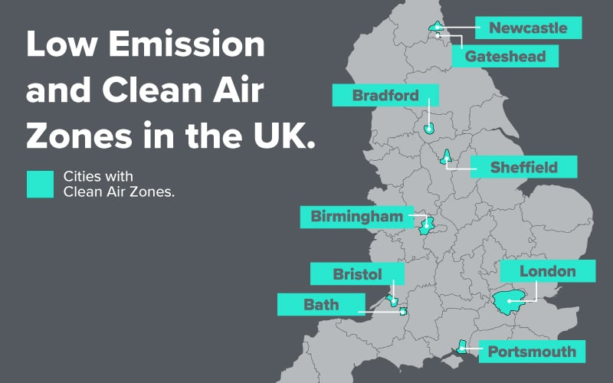
Figure 2: Clean Air Zones in UK (Brookes, 2021)
The Levelling Up agenda acknowledges geographical disparities in wellbeing and has missions based on local outcomes, and annual reporting of progress (Gov UK, 2025). This can assist in making cities healthier with investments in place, skills, and infrastructure in SDG terms. Nevertheless, critics outline instability of governance and policy turnover: should missions, metrics, or legislation be changed, long-term urban health planning becomes more difficult. In the perspective of Social Ecological Model, a long-term change cannot be made through a short funding cycle but through a stable upstream investment (housing quality, transport access, green space) (Vardoulakis et al., 2020).

London Ultra Low Emission Zone (ULEZ)
London has a fiercely good UK example related to SDG 11 with their Ultra Low Emission Zone (ULEZ). ULEZ was implemented to make the air in cities purer, charging high-pollutening vehicles and promoting clean transportation in the city. It can support SDG 11 by supporting the communities to become more sustainable, safer and healthier, and SDG 3 by exposing the communities to less harmful air pollution. The project has enhanced policing, control and awareness among citizens on emissions. Nevertheless, issues have not been resolved, such as affordability of low-income drivers, enforcement concerns and the necessity of providing fair alternatives, such as cleaner vehicles and reliable public transit (Greater London Authority, 2024).

Recommendations
A key recommendation is to make Health Impact Assessments (HIA) routine for major transport, housing and regeneration schemes, because HIA provides a structured way to predict health and equity effects before implementation and helps prevent unintended harms such as displacement or unequal exposure to risk (Harris-Roxas et al., 2012). Community participation should also be institutionalised as a delivery requirement, especially for marginalised groups, because this can improve legitimacy, local fit, policy uptake and trust, while ensuring interventions reflect lived realities rather than top-down assumptions (Ding et al., 2024). In addition, affordable healthy housing and mobility should be prioritised through joined-up measures such as subsidised public transport, scrappage support, housing-quality upgrades and anti-displacement protections to strengthen environmental justice in both UK and Pakistan contexts (Longhurst et al., 2018).

Conclusion
This report has shown that SDG 3 and SDG 11 are mutually reinforcing: urban environments operate as health systems that shape exposure (pollution, heat, injury), behaviour (activity, diet), and psychosocial wellbeing (stress, connection). SDG 3 policies on NCDs and mental health are most effective when they move beyond lifestyle framing and address structural determinants through fiscal, regulatory and environmental change, as illustrated by evidence on reformulation-focused approaches and the need for robust active travel networks. The SDG 11 programmes like the New Urban Agenda, Clean Air Zones, and the clean-air programming of Lahore show that city-level policy could offer tangible benefits to the environment, but they also illustrate the same limitations: lack of enforcement, insufficient funding, and the possibility of disadvantaging the worst off with costs. The broader meaning is that development needs multi-sector control, long-term stable investment and systematic Health Impact Assessment such that gains of sustainability interventions provide health benefits in an equitable manner. In their absence, SDG commitments will remain aspirational accounts as opposed to population-health perspectives.

References
Agurs-Collins, T. et al. (2024) ‘Perspective: Nutrition Health Disparities Framework: a Model to Advance Health Equity’, Advances in Nutrition, 15(4), pp. 100194–100194. Available at: https://doi.org/10.1016/j.advnut.2024.100194.
Akhtar, S. et al. (2025) ‘Non-communicable diseases prevention and control in Pakistan: recommendations from policy and public health experts’, BMC Proceedings, 19(S30), pp. 32–32. Available at: https://doi.org/10.1186/s12919-025-00350-4.
Beeactive (2024) Greater Manchester’s Active Travel Mission, TfGM Bee Active. Available at: https://beeactive.tfgm.com/greater-manchesters-active-travel-mission/ (Accessed: 12 March 2026).
Bourne, P.A. and Williams, T.-A. (2022) ‘A Comparative Analysis of The Behavior of Vaccinated and Unvaccinated Jamaicans Against the Covid-19 Virus’, Journal of Internal Medicine Research & Reports, pp. 1–8. Available at: https://doi.org/10.47363/jimrr/2022(1)102.
Brookes, H. (2021) Navigating Low Emission and Clean Air Zones: A Guide for UK Drivers | Vertu, Vertumotors.com. Available at: https://www.vertumotors.com/news/navigating-low-emission-and-clean-air-zones-a-guide-for-uk-drivers/ (Accessed: 23 February 2026).
Buse, K. and Hawkes, S. (2015) ‘Health in the sustainable development goals: ready for a paradigm shift?’, Globalization and Health, 11(1). Available at: https://doi.org/10.1186/s12992-015-0098-8.
Cobiac, L.J. et al. (2024) ‘Impact of the UK soft drinks industry levy on health and health inequalities in children and adolescents in England: An interrupted time series analysis and population health modelling study’, PLoS medicine, 21(3), pp. e1004371–e1004371. Available at: https://doi.org/10.1371/journal.pmed.1004371.
Department of Health & Social Care (2020) Tackling obesity: Empowering Adults and Children to Live Healthier Lives, gov.uk. Available at: https://www.gov.uk/government/publications/tackling-obesity-government-strategy/tackling-obesity-empowering-adults-and-children-to-live-healthier-lives (Accessed: 22 February 2026).
Dicken, S.J. and Batterham, R.L. (2024) ‘Ultra-processed Food and Obesity: What Is the Evidence?’, Current Nutrition Reports, 13(1). Available at: https://doi.org/10.1007/s13668-024-00517-z.
Ding, D. et al. (2024) ‘The co-benefits of active travel interventions beyond physical activity: a systematic review’, The Lancet Planetary Health, 8(10), pp. e790–e803. Available at: https://doi.org/10.1016/s2542-5196(24)00201-8.
Egele, V.S., Klopp, E. and Stark, R. (2025) ‘How Valid Is Bandura’s Social Cognitive Theory to Explain Physical Activity Behavior?’, European Journal of Investigation in Health, Psychology and Education, 15(2), p. 20. Available at: https://doi.org/10.3390/ejihpe15020020.
Ewald, D.R., Orsini, M.M. and Strack, R.W. (2023) ‘The path to good health: Shifting the dialogue and promoting social ecological thinking’, SSM - Population Health, 22. Available at: https://doi.org/10.1016/j.ssmph.2023.101378.
Greater London Authority (2024) The Ultra Low Emission Zone (ULEZ) for London | London City Hall, www.london.gov.uk. Available at: https://www.london.gov.uk/programmes-strategies/environment-and-climate-change/pollution-and-air-quality/ultra-low-emission-zone-ulez-london (Accessed: 18 March 2026).
Gov UK (2024) HMT-HMRC Soft Drinks Industry Levy Review, GOV.UK. Available at: https://www.gov.uk/government/publications/soft-drinks-industry-levy-review/hmt-hmrc-soft-drinks-industry-levy-review? (Accessed: 11 March 2026).
Gov UK (2025) Levelling-Up Missions annual report 2024 to 2025 (accessible version), GOV.UK. Available at: https://www.gov.uk/government/publications/levelling-up-missions-annual-report/levelling-up-missions-annual-report-2024-to-2025-accessible-version (Accessed: 22 February 2026).
Harris-Roxas, B. et al. (2012) ‘Health impact assessment: the state of the art’, Impact Assessment and Project Appraisal, 30(1), pp. 43–52. Available at: https://doi.org/10.1080/14615517.2012.666035.
London Assembly (2025) New evidence reveals that all Londoners are now breathing cleaner air following the first year of the expanded Ultra Low Emission Zone (ULEZ), London City Hall. Available at: https://www.london.gov.uk/media-centre/mayors-press-releases/new-evidence-reveals-all-londoners-are-now-breathing-cleaner-air-following-first-year-expanded-ultra (Accessed: 12 March 2026).
Longhurst, J. et al. (2018) ‘Analysing air pollution and its management through the lens of the UN sustainable development goals: A review and assessment’, WIT Transactions on Ecology and the Environment, 230, pp. 3–14. Available at: https://doi.org/10.2495/air180011.
Mebrahtu, T.F. et al. (2025) ‘Impact of an urban city-wide Bradford clean air plan on health service use and nitrogen dioxide 24 months after implementation: An interrupted time series analysis’, Environmental Research, 270, p. 120988. Available at: https://doi.org/10.1016/j.envres.2025.120988.
Nesmachnow, S. and Callejo, L.H. (2025) ‘The Urban Agenda’, Urban Science, 9(12), p. 500. Available at: https://doi.org/10.3390/urbansci9120500.
Ramirez-Rubio, O. et al. (2019) ‘Urban health: an example of a “health in all policies” approach in the context of SDGs implementation’, Globalization and Health, 15(1). Available at: https://doi.org/10.1186/s12992-019-0529-z.
Razmara, A. et al. (2018) ‘Prediction of safe driving Behaviours based on health belief model: the case of taxi drivers in Bandar Abbas, Iran’, BMC Public Health, 18(1). Available at: https://doi.org/10.1186/s12889-018-5300-5.
Seelajaroen, R. and Jitmaneeroj, B. (2025) ‘Interdependencies among SDGs: evidence-based insights for sustainable development indicators and policy’, Environmental and Sustainability Indicators, 27, pp. 100762–100762. Available at: https://doi.org/10.1016/j.indic.2025.100762.
Singh, O. (2021) ‘Comprehensive Mental Health Action Plan 2013–2030: We must rise to the challenge’, Indian Journal of Psychiatry, 63(5), p. 415. Available at: https://doi.org/10.4103/indianjpsychiatry.indianjpsychiatry_811_21.
UN Habitat (2020) The New Urban Agenda Illustrated | UN-Habitat, unhabitat.org. Available at: https://unhabitat.org/the-new-urban-agenda-illustrated (Accessed: 22 February 2026).
UN Habitat (2023) Progress in the implementation of the New Urban Agenda and the 2030 Agenda for Sustainable Development. Available at: https://unhabitat.org/sites/default/files/2023/05/2306199e.pdf (Accessed: 22 February 2026).
United Nations (2025) Goal 3: Ensure healthy lives and promote well-being for all at all ages, United Nations. Available at: https://sdgs.un.org/goals/goal3 (Accessed: 22 February 2026).
Vardoulakis, S. et al. (2020) ‘Urban Environmental Health Interventions towards the Sustainable Development Goals’, Science of The Total Environment, 748, p. 141530. Available at: https://doi.org/10.1016/j.scitotenv.2020.141530.
WHO (2013) Global Action Plan for the Prevention and Control of NCDs 2013-2020, www.who.int. Available at: https://www.who.int/publications/i/item/9789241506236 (Accessed: 22 February 2026).

