12/10/2025
Assessment
Portfolio Report on Contemporary Software Applications for Business

MODULE NAME: SOFTWARE SOLUTIONS FOR BUSINESS
MODULE CODE: ACCA 4026
LECTURER: AMITAVE BANIK
TRINITY SAINT DAVID UNIVERSITY OF WALES (LONDON CAMPUS)

Mohammad Hasan Tohin (2514325)
STUDENT ID:2514325
Executive Summary
This portfolio will discuss why modern software applications and digital platforms are so important to the functioning of modern business. It is organised into four main tasks that would present a thorough analysis of key digital tools. The initial assignment analyses the strategic choice between Software-as-a-Service (SaaS) and open-source e-commerce platforms, the comparison of features and costs and the technical obstacles of Shopify and WooCommerce. Subsequent to this, a report is presented which gives a visual map of the modern business software ecosystem using a mind map, which isolates such functions as CRM and productivity. The third assignment examines the strengths and weaknesses of four major MS Office applications, such as Word, PowerPoint, Excel, and Access, in information management with a practical demonstration on the use of VLOOKUP and Pivot table functions in Excel. Lastly, the portfolio evaluates the top modern communication and collaboration tools, such as Microsoft Teams, the Kanban workflow of Asana and Trello.

Table of Contents
Task 1: e-Commerce Website builders/software solutions 3
Shopify: The Managed SaaS Ecosystem 3
WooCommerce: The Open Source Extension 4
Comparison of the Feature Matrices of E-commerce Platforms 5
Task 2. Mind-map of contemporary software applications 7
a) Description of mind mapping and its benefits in Business Operations: 7
b) Mind map of contemporary software applications: 8
Task 3: Office Applications for creating, storing, presenting, and analysing information/data 9
a) Explanation of the four office software solutions for business operations: 9
b) Test VLOOKUP and PIVOT Table functions in Microsoft Excel 13
Task 4. Communication and Collaboration applications 26
a) Description of one contemporary Communication and one Online Collaboration application/tool 26
b) Communication and Collaboration applications 29
References 35

Task 1: e-Commerce Website builders/software solutions

Shopify: The Managed SaaS Ecosystem
Shopify is an e-commerce platform that is fully hosted and subscription-based, and is doing a great job of offering beginners, content creators, and dropshippers easy storefront hosting with heightened security, domain management, and a basic set of tools to build the site, at monthly prices of about USD 19 for Basic to USD 2300 for Plus.
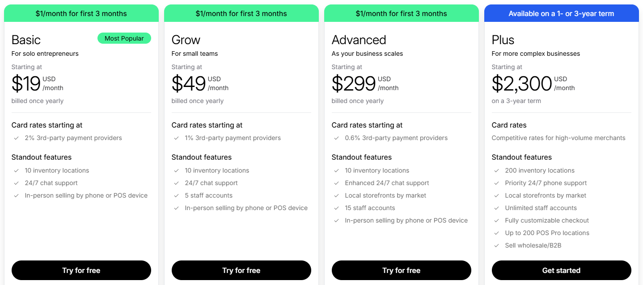
Figure: Shopify Subscription Plans[1]
Key Features and Advantages:
Shopify is also powerful due to its features in sales, which are built in and are said to be the most advanced in the industry. It encompasses advanced inventory management software, shipment flexibility (live carrier rates and print labels), and a strong Point of Sale (POS) system, which are required for the omnichannel retail[2]. The predictive pricing paradigm provides financial transparency.
Limitations:
Shopify is a proprietary platform and thus lacks the ability to be customised in depth via code-level methods, as well as competitors based on open-source[3]. The major drawback is that the platform charges transaction fees when using alternative payment gateways rather than the proprietary Shopify Payments system, which can quickly add up for high-volume sellers.

WooCommerce: The Open Source Extension
WooCommerce is a highly popular free, open-source plugin which can convert a self-hosted WordPress site into a fully operating e-commerce store. The platform is infinitely customizable and has the highest level of control, which is aimed at users/readers with technical knowledge or users who are integrating e-commerce into the existing WordPress content infrastructure[4].
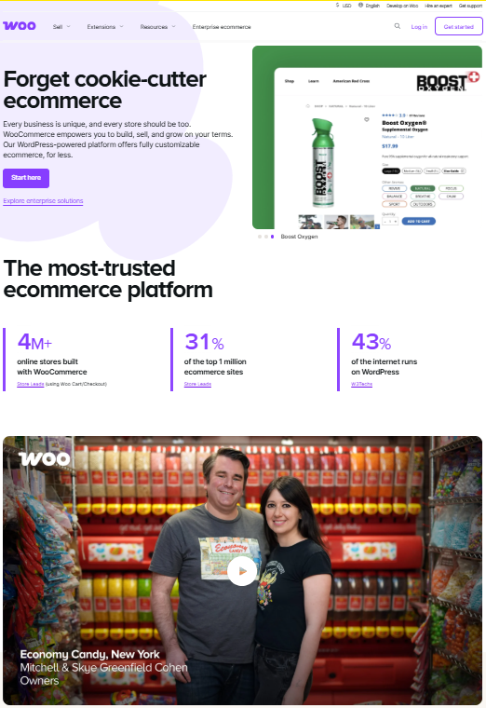
Figure: WooCommerce Platform by clicking https://woocommerce.com/

Key Features and Advantages:
WooCommerce has the greatest strength in the form of its own flexibility and ability to control the architecture of the platform. Since it is open source, any customisation of either its themes or extensions can be done without limitation, and most importantly, merchants can use any payment gateway without bearing the external charge of transaction that proprietary SaaS vendors charge. It is a freedom that potentially leads to a reduced TCO over the long term, as long as the merchant is successful in managing the related technical requirements.
Limitations:
WooCommerce is associated with a greater learning curve due to the need to handle some of the most important elements, like domain purchase, hosting, as well as the maintenance of security, which is not free and requires external technical expertise or expense[4]. The core plugin is free; however, additional features like complex shipping options or simplified inventory management may depend on other plugins, which can incur variable and recurring costs and introduce complexities.

Comparison of the Feature Matrices of E-commerce Platforms
Feature/Criterion | Shopify (SaaS) | WooCommerce (Open Source) | Influence on Business Decision-Making
Hosting & Maintenance | Fully Managed (High Reliability) | Self-Hosted (Variable Reliability/Responsibility)[5] | Identifies the overhead and infrastructure ownership, reducing the technical risk to Shopify users.
Cost Structure | Foreseeable Monthly Charges + Transaction Charges (where the external gateway is being used) | Low Base Cost, Hosting / Plugins (Variable) Costs (The cheaper long-term)[5] | Determines financial predictability against possible optimisation/savings in terms of internal expertise.
Technical Barrier | Low; excellent for beginners | High; it involves coding and hosting knowledge. | Make decisions on speed to market and reliance on professional staff
Sales Features | Ultimate in-built capabilities, strong POS integration | Needs extensions to support advanced functionality (e.g. complex shipping, stock, etc.) | Important to assist with the sales in omnichannels and the organisation of inventory

Task 2. Mind-map of contemporary software applications

a) Description of mind mapping and its benefits in Business Operations:
Mind mapping is a powerful visual representation that aims at organising ideas, information or tasks based on one central concept[6]. Through its related branches and nodes radiating outwards, the structure graphically reflects the natural processes of association used by the brain to structure thought and provides a methodical means of capturing and organising thought. The approach is very useful in business and academic settings.
The benefits of Mind Mapping in Business Operations:
- Increased Transparency and Organisation:
Mind mapping assists in simplifying and organising complex ideas to be simplified and organized into a visual representation, thereby becoming clear[6]. This can assist in activities like taking notes, registering project documents and mapping out reports, keeping the thoughts in order with the main goal.
- Vitalising Creativity and Ideation:
The non-linear form of a mind map promotes freedom of thought and brainstorming and is, thus, a very helpful tool in developing new ideas and innovative approaches to problems. It serves as a strategic guide to the breakdown of issues and a catalyst for decision-making.
- Enhanced Cooperation and Interaction:
Mind maps enhance collaboration in a team by giving them a common and understandable picture of the relationship among various aspects or ideas[7]. Having diverse viewpoints, team members may understand how their efforts will be integrated into the bigger picture of the project, which helps to identify gaps and quickly reach a consensus.

b) Mind map of contemporary software applications:
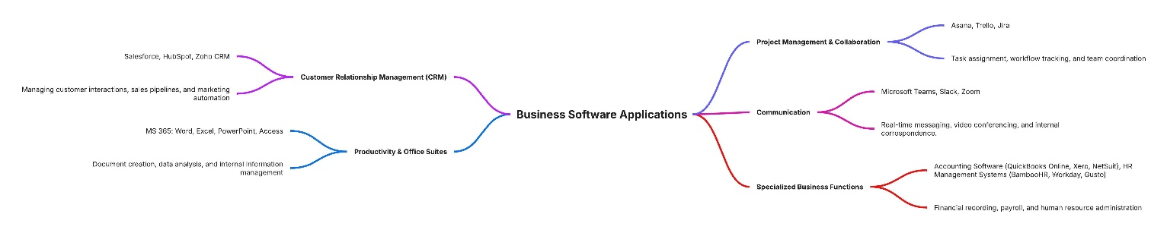
Figure: Mind Map of contemporary software applications
The mind map Business Software Applications, which is at its core, has a central node at its centre and is covering five major branches, which include Customer Relationship Management (CRM), Productivity and Office Suites, Project Management and Collaboration, Communication and Specialised Business Functions. Following this, each branch has several other tools listed and a brief explanation of how these tools can be used, like Salesforce, HubSpot and Zoho CRM to keep track of customer relationships, or Microsoft 365 to create documents and analyse data. Project Management & Collaboration includes such tools as Asana, Trello and Jira to assign tasks and track the working process, and Communication includes Microsoft Teams, Slack and Zoom to arrange real-time communication and meetings. Specialised Business Functions has accounting software (QuickBooks, Xero, NetSuite) and HR software (BambooHR, Workday, Gusto) related to accounting and HR management.
The positive aspect of this mind map:
It provides managers and students with a simple one-page overview of the fundamental software ecosystem required in performing day-to-day operations. It visually isolates functions but shows how they overlap under a similar business-applications strategy, which helps choose software more improved and integrate it[7]. Its brief titles also render it a good communication tool during meetings or training sessions in explaining how various systems facilitate customer management, internal productivity, collaboration and back-office processes.

Task 3: Office Applications for creating, storing, presenting, and analysing information/data

a) Explanation of the four office software solutions for business operations:
- MS Word: Document Administration and Creation
Word is the standard program in the industry when it comes to document creation of all kinds, whether it is a formal report, operational policy, or a personalised letter.
Major Features and Benefits:
The features of Word make it professional, enable co-authoring, and efficient. The contemporary ones also have built-in artificial intelligence (AI) Smart Templates and content suggestions that are faster to prepare and type[8]. Such features as change tracking and co-authoring provide effective collaboration of the team and efficient management of workflow. In the case of mass communication, the Mail Merge feature can assist in automatically creating individual documents using external sources (e.g., spreadsheets within Excel) of data, which will save the administrative efforts required.
Limitations:
Although Word should have advanced functionality in collaboration, it may be difficult to control versioning in this tool, especially in a distributed environment where strict management protocols are not in place. Formatting consistency is also not easy to maintain on very big or complicated documents. Moreover, to ensure the basic learning needs, the use of AI writing facilities should not clamp down on the need to learn to write in a constructive and comprehensible manner and to construct an argument.

- MS PowerPoint: Presentation and Communication
The major tool used to prepare the structured visual presentation to communicate findings, strategies, and performance metrics to internal and external stakeholders is PowerPoint.

Major Features and Benefits:
PowerPoint also helps to communicate through visual narrations. The current functionalities, such as PowerPoint Designer, rely on AI to create professional slide templates using the input materials and save time on design. The Loop Components are integrated to provide dynamic collaborative content that is updated in every place it is shared, which makes it possible to have real-time data inside a presentation[9]. The language barriers are also broken by the Real-Time Translation features, which are used in carrying out business internationally.
Limitations:
The first conceptual weakness is that there is a danger of death by PowerPoint where presenters overly use visual aids, and simplify or homogenise data and analysis[8]. This risks substituting substantiated and evidence-based, argumentative information with an oversimplified and visual summary in high-stakes professional settings, in particular.

- MS Excel: Data Analysis and Modelling Quantitative Analysis
MS Excel is a powerful instrument of quantitative analysis, financial modelling, list management, and business intelligence, being the support of operational data interpretation in practically any field.
Major Features and Benefits:
Excel has a strong point in being able to make complicated calculations, modelling and forecasting with some complicated functions (i.e. IF, VLOOKUP), as well as more sophisticated data summarisation features (i.e. Pivot Tables, Goal Seek). The introduction of new data analysis tools, including Copilot integration, makes it easier to handle big datasets[9]. The software enables companies to control the budgets, monitor stock, and compute sophisticated financial ratios effectively.
Limitations:
The greatest weakness of Excel is that it is not a relational database management system (RDBMS), but a spreadsheet application. Although it is good with tabular data and calculation, Excel is poor with complex data structures, relationship integrity and high volume, multi-user concurrency. In contrast to the more focused relational tools, Excel templates are calculation-oriented, whereas a platform such as Airtable would be more appropriate when defining automated workflows and multifaceted relationships between data[10].

- MS Access: Relational Database Management
MS Access is a desktop-based RDBMS, which is focused on the rapid application development (RAD) of small-to-medium scale data management systems and through which a user can make forms, queries, and reports without having to know much programming.
Major Features and Benefits:
Access facilitates the structuring, data storage and retrieval of data using normalised tables and provides a high level of relational integrity[9]. Other important aspects, such as embedded shapes and queries, give the users the chance to build customised data entry interfaces and generate tailor-made reports, which are paramount to control business information and simplify data operations.
Limitations:
In current cloud-first-based enterprises, access is becoming a legacy system. It has major limitations, which are scalability and connectivity. Being a desktop application, it cannot handle large groups of simultaneous users, nor does it have much ability to handle huge amounts of data like that found in business today[11]. In addition, older versions are no longer connectable to modern cloud-based applications such as Microsoft 365 and require elaborate hacks or switching to cloud-native platforms such as PostgreSQL, Airtable, or AppSheet[11].

Business Operations: MS Office Applications Synthesis
Application | Primary Business Role (L4 Context) | Key Features Highlighted | Contemporary Limitation (Justification)
MS Word | Creation of documents, reports and policies | Mail Merge, Co-authoring, Intelligent Smart Templates | Depending on the user discipline to maintain a good version control and consistency of the format.
MS PowerPoint | Presentation and Communication | PowerPoint Designer, Real-Time Translation, Loop Components | Risk of substituting in-depth analysis for simplified, visual summaries.
MS Excel | Financial modelling, quantitative data analysis, and list management | Advanced Statistical tools: IF/ VLOOKup/ Pivot Tables. | No support for sophisticated relational data or workflow automation (compared to specific database applications).
MS Access | Rapid application development, relational database management | Forms, Queries, Reports, and Data Entry Interfaces | Being treated more and more as a legacy system, integration issues with new cloud services[11].

b) Test VLOOKUP and PIVOT Table functions in Microsoft Excel
- Practical Test 1: VLOOKUP Function
The VLOOKUP (Vertical Lookup) function is very important to extract the data because a user can find a value in one column (the key) and retrieve the value in another column on the same row[12]. This automates the data connection between large tables.
The sample data set for this analysis has been made. so,
Procedure: VLOOKUP Test of Data Retrieval
Step 1: Set up the Data & Search Key
Ensure the data is in the first sheet. In a new cell (e.g., J4 to J8), enter the value that is wish to search for (the Lookup Value), for instance, Name of the students.
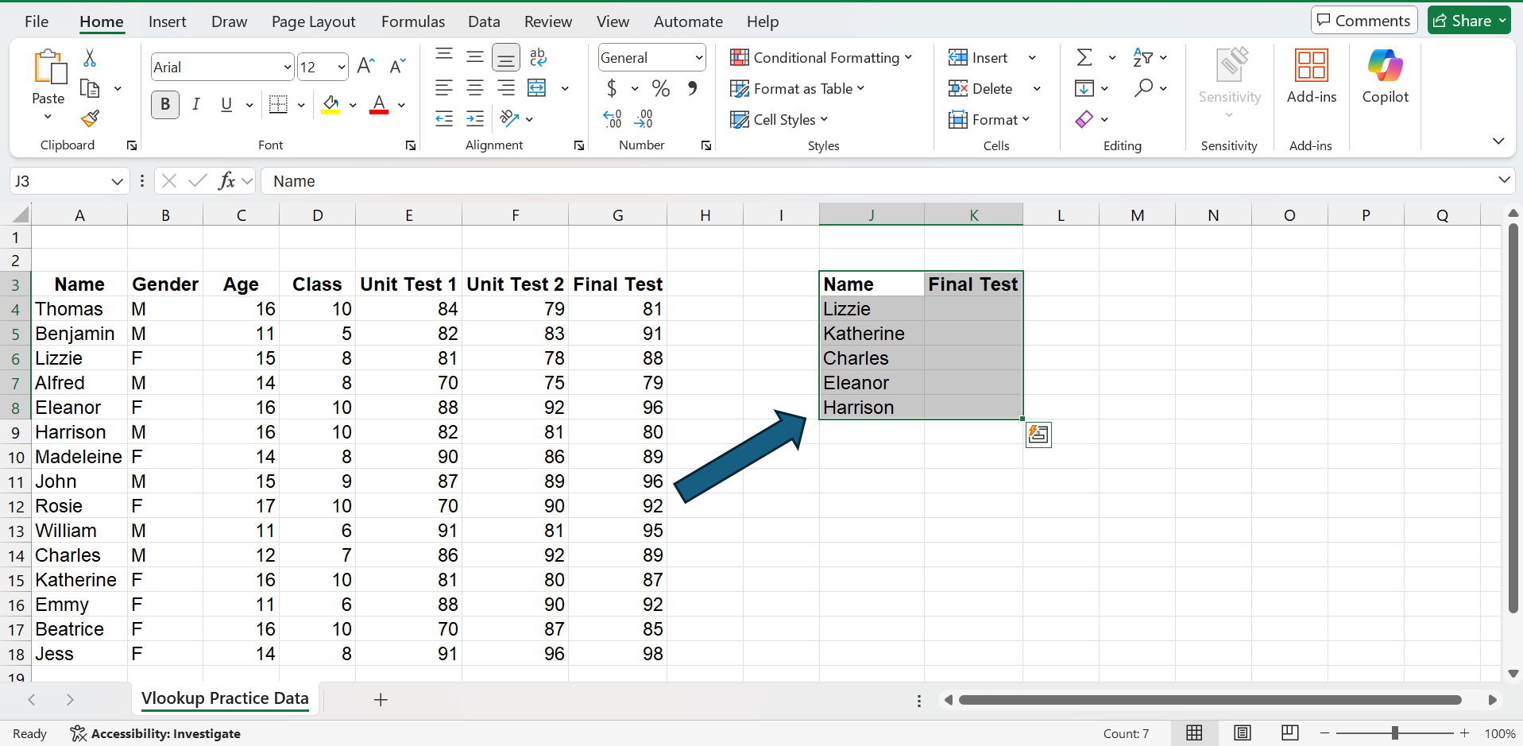
Necessity of this step: Defining the lookup value. The lookup value is defined in a way that there is a real separation between the search key and the data table, and this makes the formula easily reusable.

Step 2: Structure the VLOOKUP Formula
In the cell where the result should appear (e.g., K4), begin typing the VLOOKUP formula: =VLOOKUP(
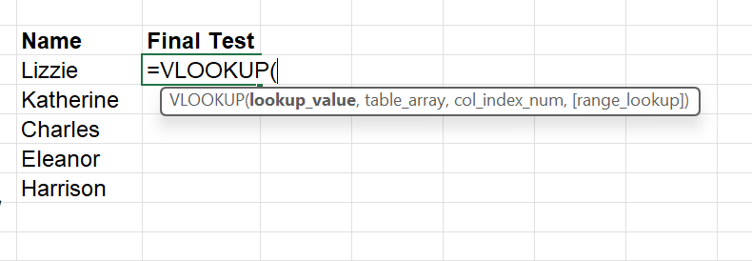
Necessity of this step:
This informs Excel that you are beginning a lookup sequence, and the formula tooltips will then assist you with the necessary parameters (lookup_value, table_array, col_index_num, [range_lookup]).

Step 3: Select the Lookup Value
Click on the cell containing the search key (e.g., J4) followed by a comma. This is the lookup value.
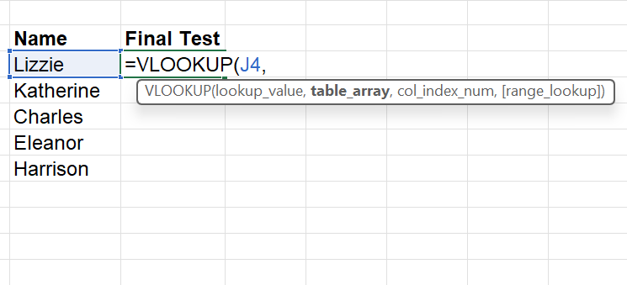
Necessity of this step:
Defining the Search Target. This is the core of the operation; this is what is known as informing Excel what particular value to search in the table.

Step 4: Define the Table Array
Select the entire data range where the search will occur (e.g., A3:G18). Crucially, the lookup value column must be the first column in this selection. This is the table_array. Then use $ signs or (fn + f4) to make this range absolute (e.g., $A$3:$G$18).
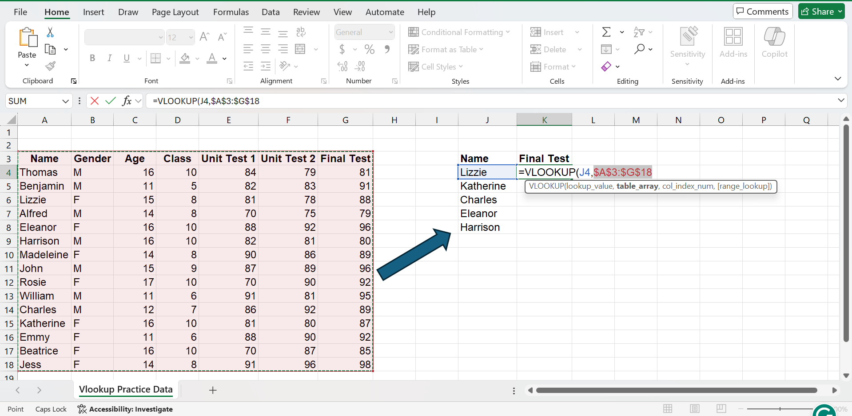
Necessity of this step:
Fixing the Scope. This limits the scope of a database being searched. As part of the reusability, the usage of absolute references ($) is important, so that the formula will not fail when copied down.

Step 5: Specify the Column Index Number
Enter the column number from the selected array that contains the data you want to retrieve. (e.g., here I want the Final Test, and it is the 7th column in the selected array, so then write 7 after the comma.
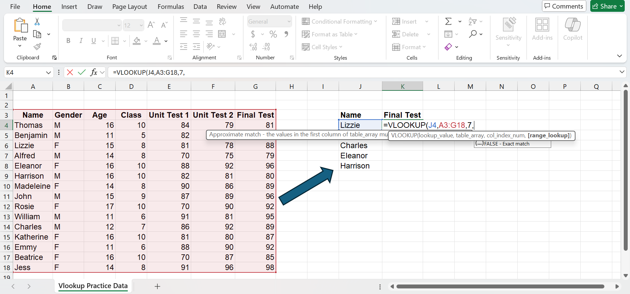
Necessity of this step:
Choice of Output. This option is adopted to make sure that after matching with the search key, Excel presents the relevant corresponding data field (Final Test) and not any random column.

Step 6: Set the Range Lookup
Enter FALSE (or 0). This ensures Excel finds an exact match.
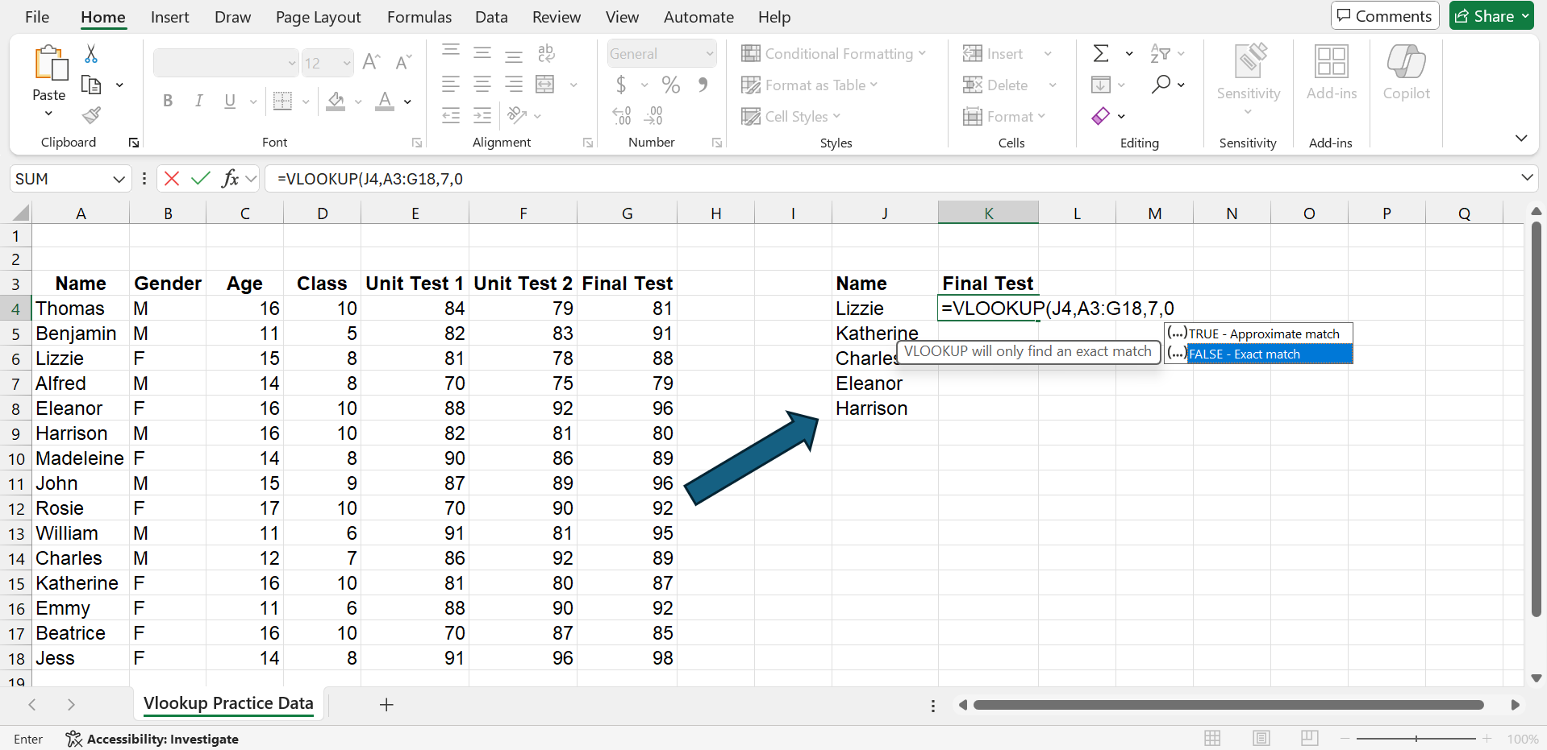

Necessity of this step:
Assuring Accuracy. FALSE provides precision, which is required of transactional data (ID, names, codes). A rough match can be given by using TRUE, which results in the selection of wrong data.

Step 7: Then press Enter to get the value.
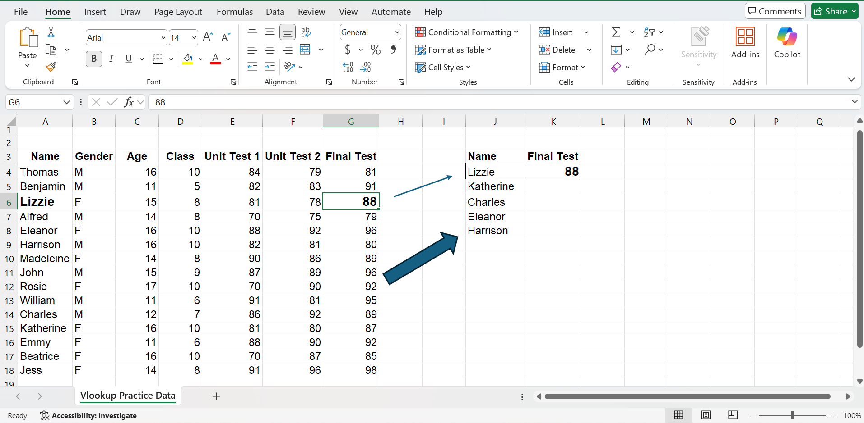

The outcome of the analysis (VLOOKUP Function):
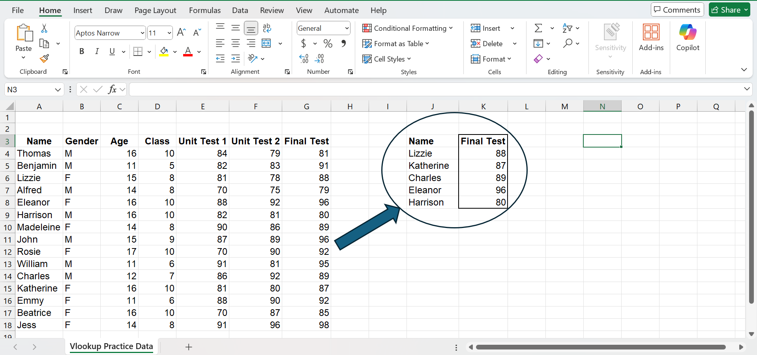
- Practical Test 2: Pivot Table
The Pivot Table is, perhaps, the most effective data analysis tool in Microsoft Excel. It enables users to summarise, rearrange, count, average and analyse extensive datasets in seconds without the need to write complicated formulas[13]. It converts the raw lists (that are transactions) to useful analytical data (summaries).
The sample data set for this analysis has been made. so,
Procedure: Pivot Table Analysis Testing
Step 1: Select the Data Range
Click anywhere within your dataset (e.g., E10). Navigate to the Insert tab and select PivotTable.
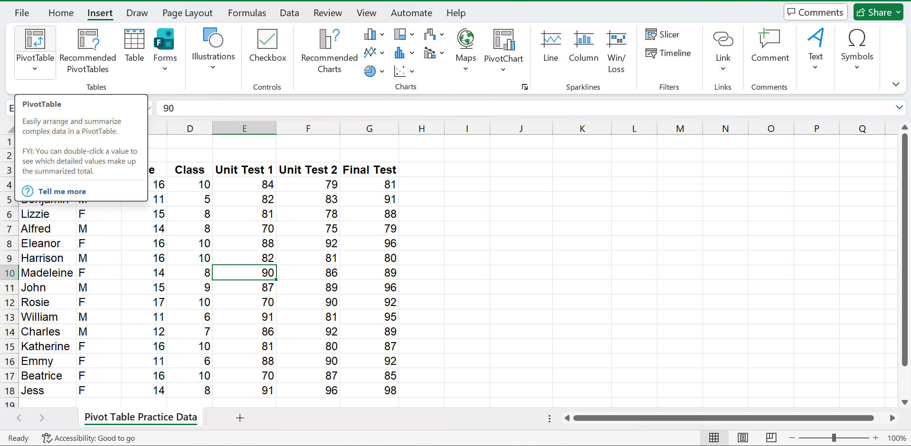
Necessity of this step:
Defining the Raw Material. This informs Excel which particular block of raw data will be utilised to be summarised. The creation of the Pivot Table depends on the accurate determination of the rows with the headers and the data limits.

Step 2: Define Location and Confirmation
After clicking the pivot table option, Excel will automatically select the entire data set. Then choose New Worksheet and click OK.
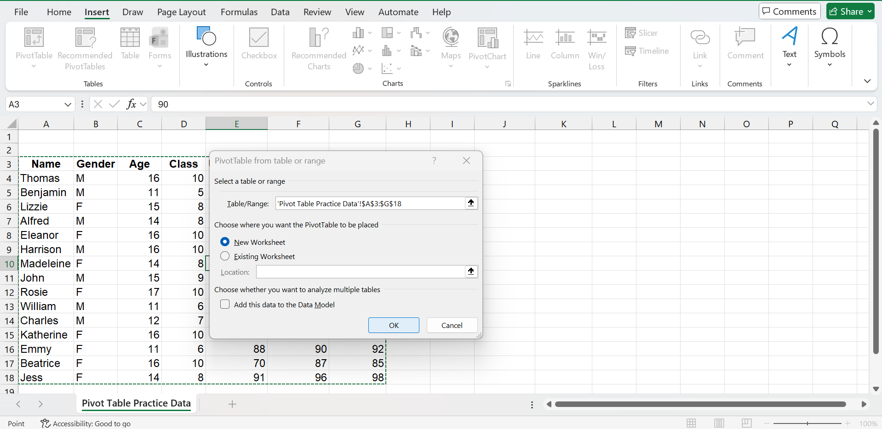
Then a new data sheet will open.
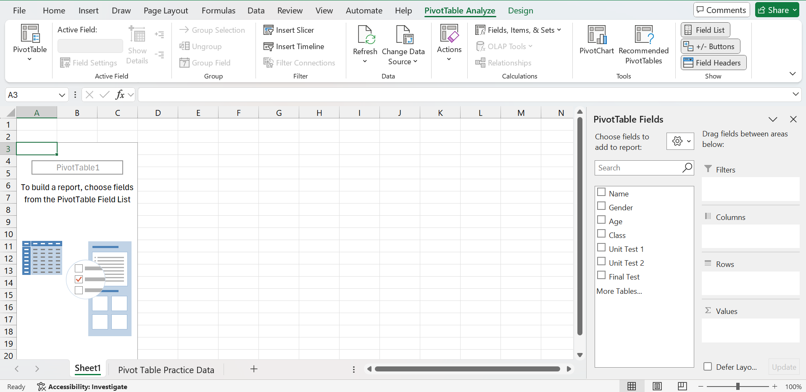
Necessity of the step:
Isolating Analysis. Analysis on a new sheet makes sure that raw data is not altered (non-destructive analysis) and that the summary report is only in a separate and clean sheet.

Step 3: Understanding the Pivot Table Elements
Once the new sheet is open, the PivotTable Field List will appear on the right, which contains four key areas: Filters, Columns, Rows, and Values.
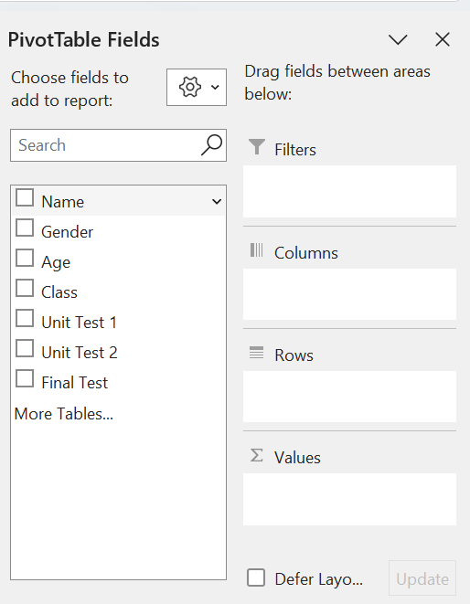
Necessity of understanding:
The Analytical Engine. The four components are the basic building blocks of any Pivot Table, which dictate the way the data is sliced and aggregated.
Rows: This is used in primary categorisation (e.g. Departments, Product Lines or, in this instance, Classes).
Values: The quantitative field on which the computation is performed. This is the sole place where functions such as SUM, AVERAGE, COUNT or MAX/MIN are done.
Columns: Groupings are presented horizontally as opposed to rows. As an example, the transposition of the term Gender would provide the average scores of males and females of each Class[13].
Filters: Filters help to isolate a particular subset of data to perform a targeted analysis.

Step 4: Define the Grouping (Rows Field)
Drag the 'Class' field from the Field List down into the Rows area.
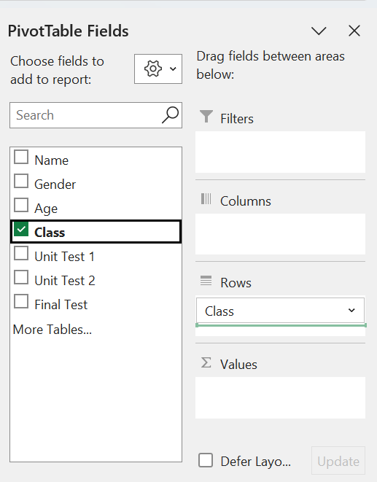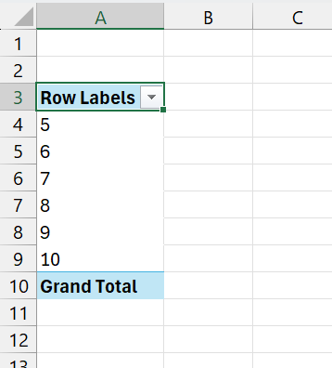
Necessity of this step:
Creation of Categorisation. The rows area establishes the main area of summarisation. The table is sorted with the help of the unique class numbers (e.g., 5, 6, 7, 8, 9, 10) by the raw list to separate it into different categories of analysis.

Step 5: Define the Metric (Values Field)
Drag the 'Final Test' field from the Field List down into the Values area. Excel will default to 'Sum of Final Test'.
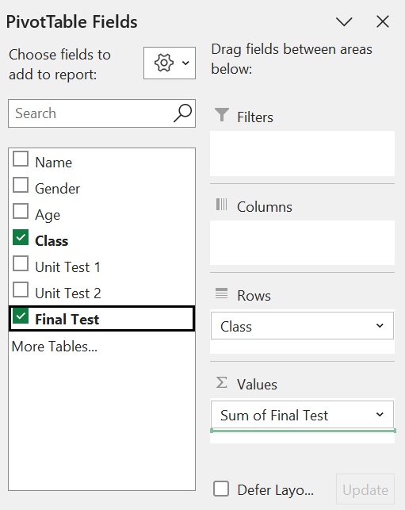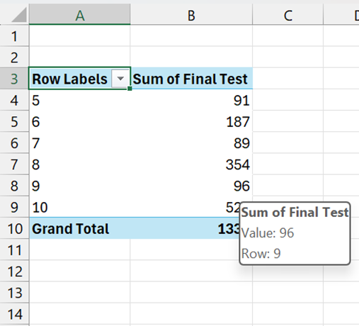
Necessity of this step:
The calculation is done in the Values section, where one must select the Target Metric. The default SUM is a sum of all scores, which is not often of much use for test scores.

Step 6: Change the Aggregation Method
Click on the field name in the Values area (e.g., "Sum of Final Test"). Select Value Field Settings.
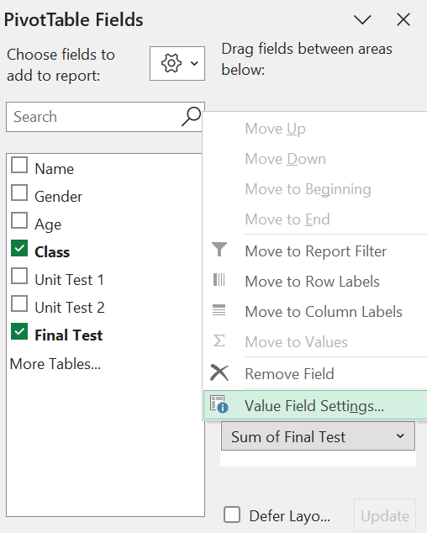
Then change the summary calculation from SUM to AVERAGE. Click 'OK'.
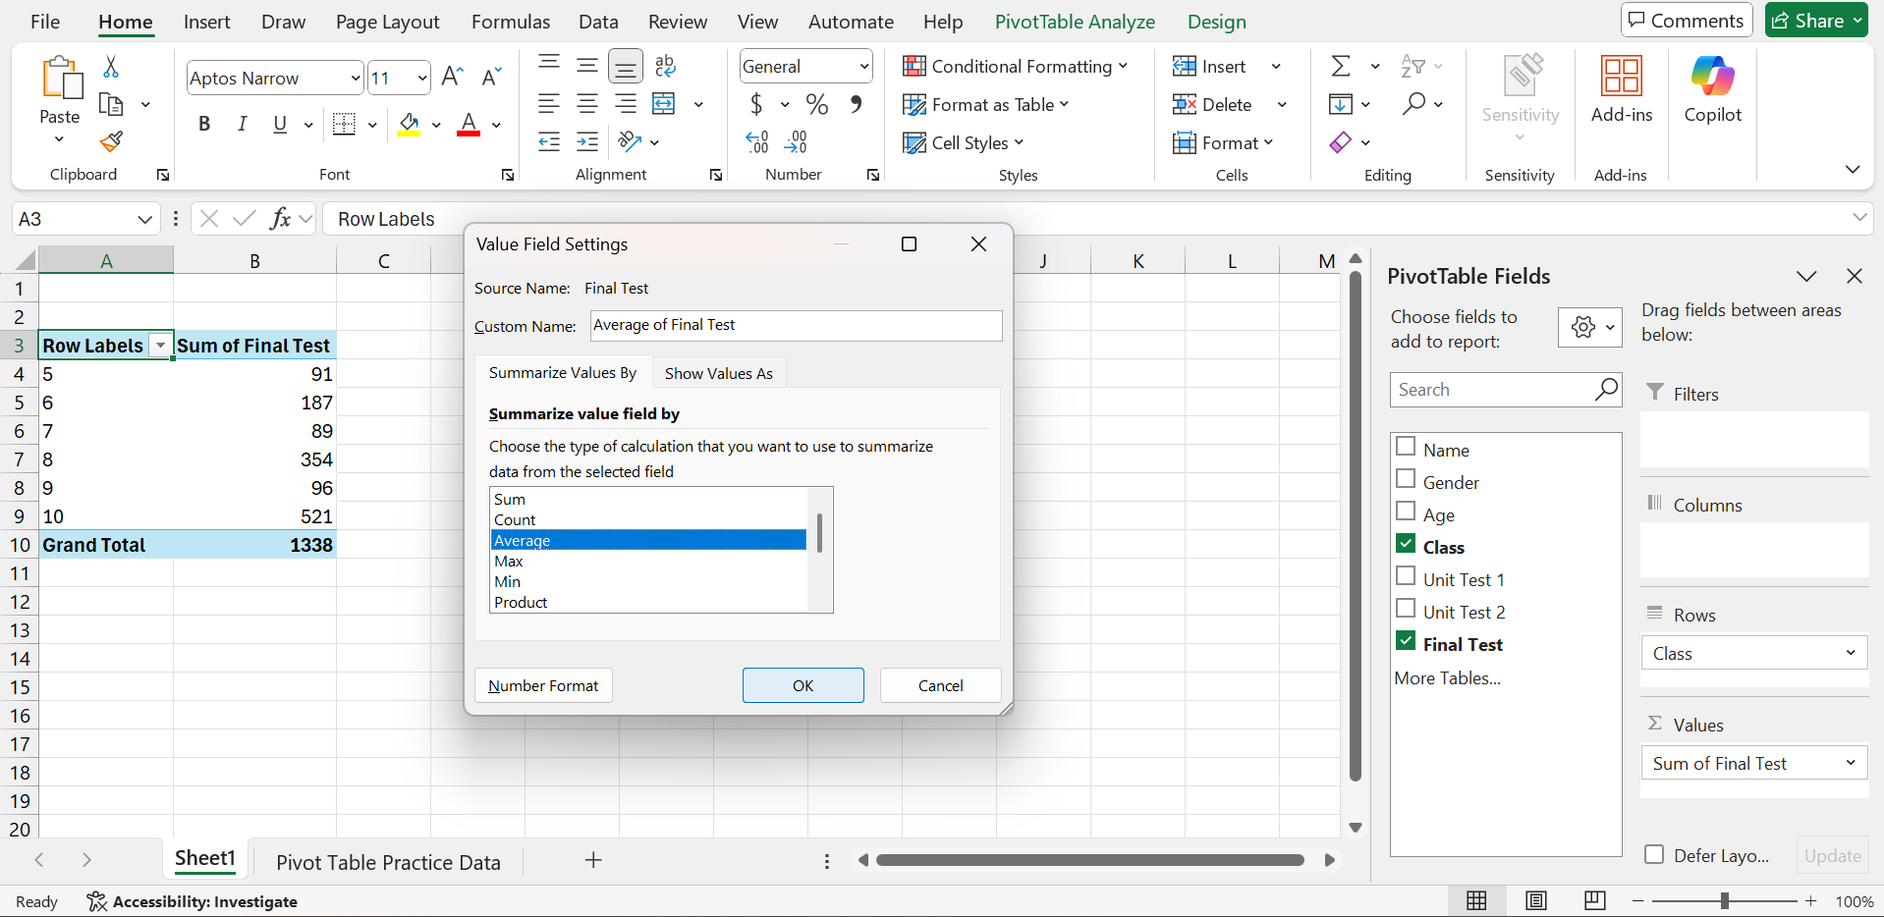

Then the table information will change like this:
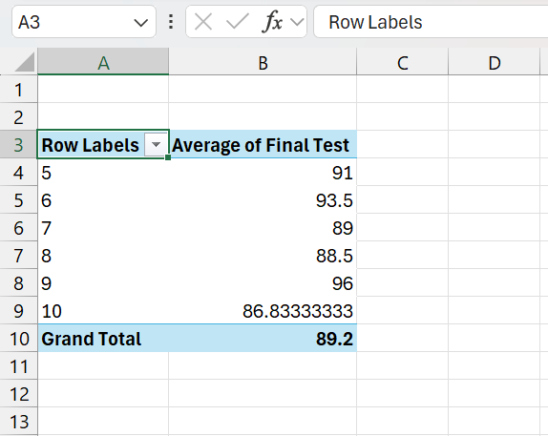
Necessity of this step:
Achieving Meaningful Insight. To sum test scores would not be of any value; to average would give the real mean of central tendency- the mean performance by each and every class. This operation converts crude aggregation to commendable analysis[13].

Step 7: Advanced Slicing (Filters Field)
Drag the 'Gender' field into the Filters area. Click the filter dropdown that appears above the table.
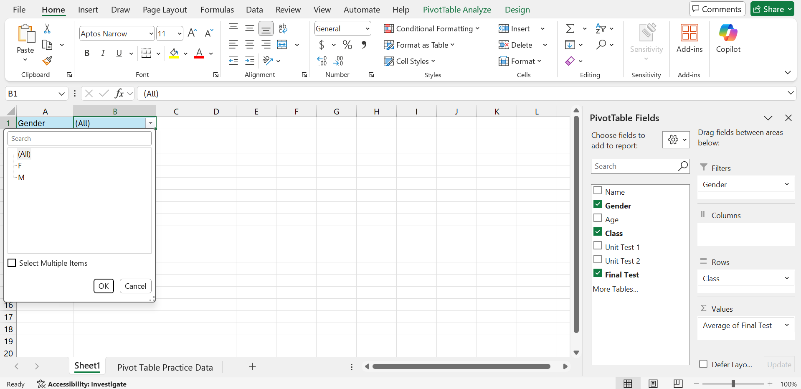
Necessity of the step:
Dynamic Data Subsetting. Now it is possible to add a filter to dynamically slice the data. It is possible to see the Average Final Test Score by Class of either M (Males) only or F (Females) only without the need to make up the table again.

Task 4. Communication and Collaboration applications

a) Description of one contemporary Communication and one Online Collaboration application/tool
- Communication Application: Microsoft Teams
Microsoft Teams is a unified communication and collaboration space which lies at the heart of the Microsoft 365 complex. It is an instant messaging solution, audio/video conferencing, and is tightly integrated with Office applications[14].
Significant Characteristics and Workflow Improvement:
The decisive point of teams is that they are perfectly integrated with the Microsoft productivity suite.

Figure: Integration of the Microsoft team with other Microsoft suites[14]
Within a conversation on Teams, the user is able to add and co-author Excel spreadsheets, Word documents or PowerPoint presentations without leaving the application. This profound integration greatly simplifies the workflow, minimises context switching and is very effective for those organisations that heavily invest in the M365 licensing[15]. Moreover, Teams provides high-grade video conferencing, which can support large-scale meetings with additional features, including AI meeting summaries.
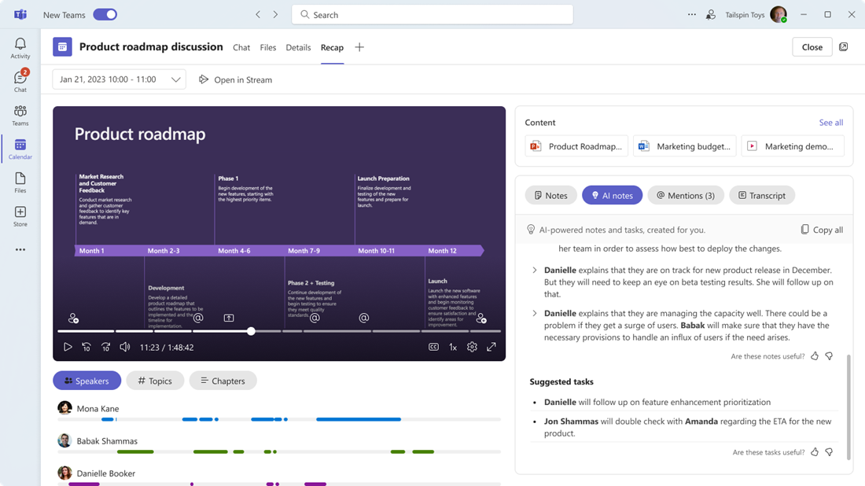
Figure: AI meeting summaries[14]
Strategic Implication:
The adoption of Teams is a strategic investment in a single vendor ecosystem. Whereas Slack is widely praised as quick and easy to use in bare messaging situations, Teams provides better value and centralisation of functionality to organisations where documents, spreadsheets, and presentations are shared and co-edited on a regular basis.

- Collaboration Application: Asana
Asana is a specialised work management tool meant to assist a team to plan, monitor, and coordinate complex projects and cross-functional goals.
Significant Characteristics and Workflow Improvement:
Asana has been designed to be highly visible and efficient and uses detailed task lists, subtasks, dependencies, and multiple project views (Kanban boards, lists, timelines).
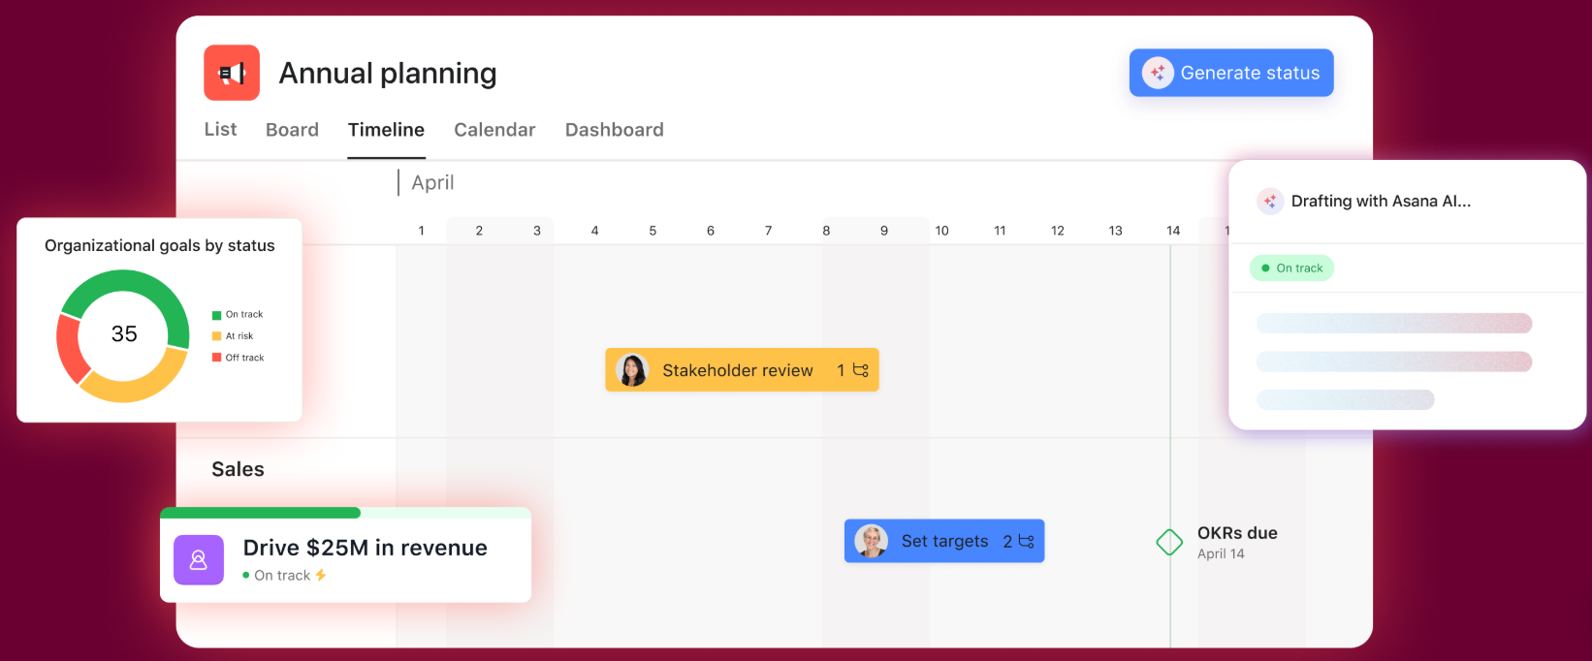
Figure: Feature list of Asana[16]
Asana is an excellent tool in supporting organisational objectives by providing a scalable platform that is designed to support tasks at an individual level as well as massive projects that require a cross-team or multi-team approach. Such features as multi-homing enable the reference of one task to another project and keep the required context in all the teams concerned.
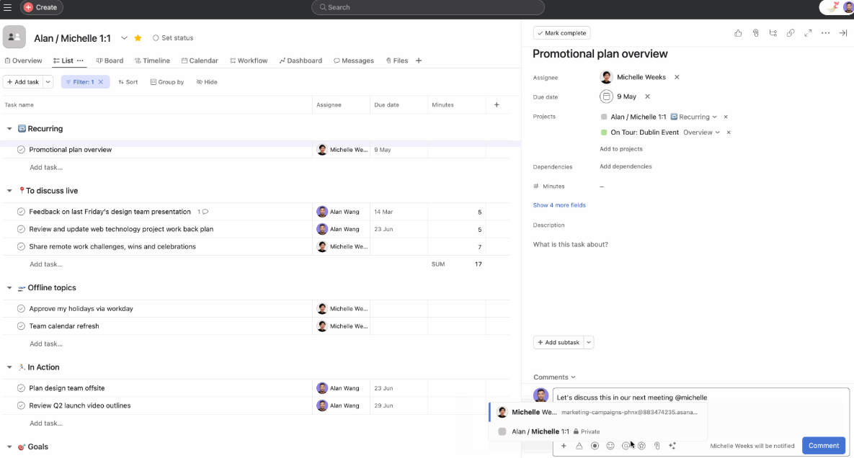
Figure: Multi-homing Example[16]

- Strategic Implication:
Asana has the strength of complex work management required by a company such as an enterprise, compared to simpler systems such as Trello, which is fantastic at managing repeatable workflows (e.g., content production lines). Its attention to higher objectives and reporting enables the management to intuitively standardise, visualise and monitor implementation relating to strategic objectives.

b) Communication and Collaboration applications
- Test 1: Communication Application - Microsoft Teams
Feature Tested: Making a meeting via the Calendar Integration.
Meeting scheduling is one of the fundamental operations of communication apps, which directly affects efficiency[17]. The integration of teams with Outlook makes all the availability of attendees checked in real-time, and it minimises administrative friction.
Step 1: Access the Calendar
Launch the Microsoft Teams program and visit the Calendar button on the left side of the navigation bar.
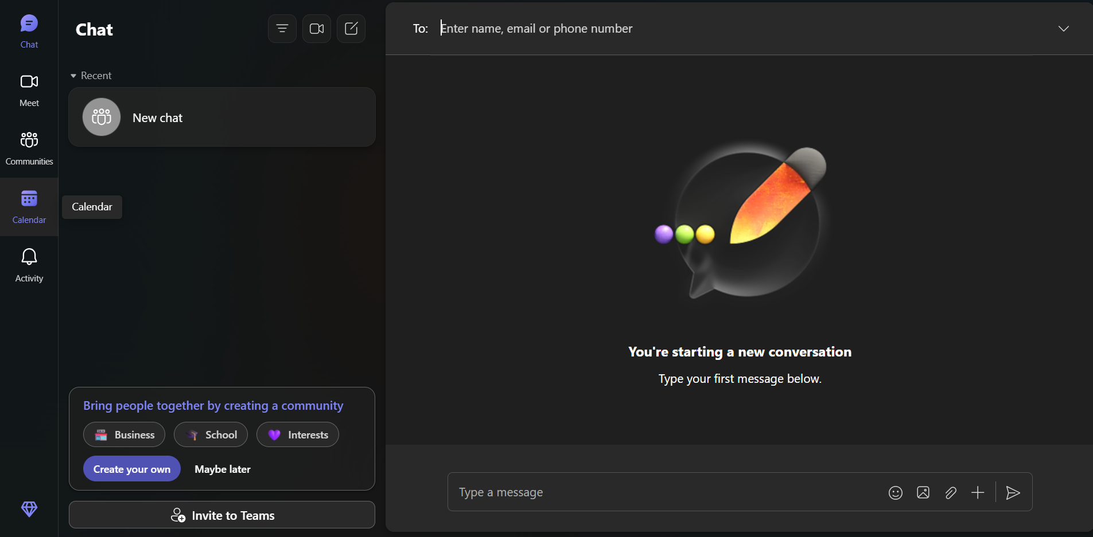

Then click on New meeting

This triggers the scheduling mechanism in the single hub, integrating chat and meeting applications.

Step 2: Define Meeting Details
After clicking on “New Meeting”, the “New Meeting Details” dashboard will open
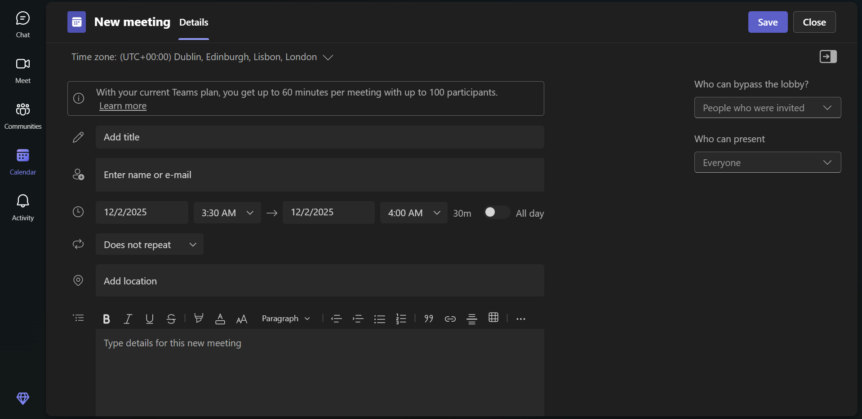
Then add the Title (e.g., Project Gamma Kick-off), date and time, and add the necessary details in the field of respective fields (Meeting Details, Location, etc.).
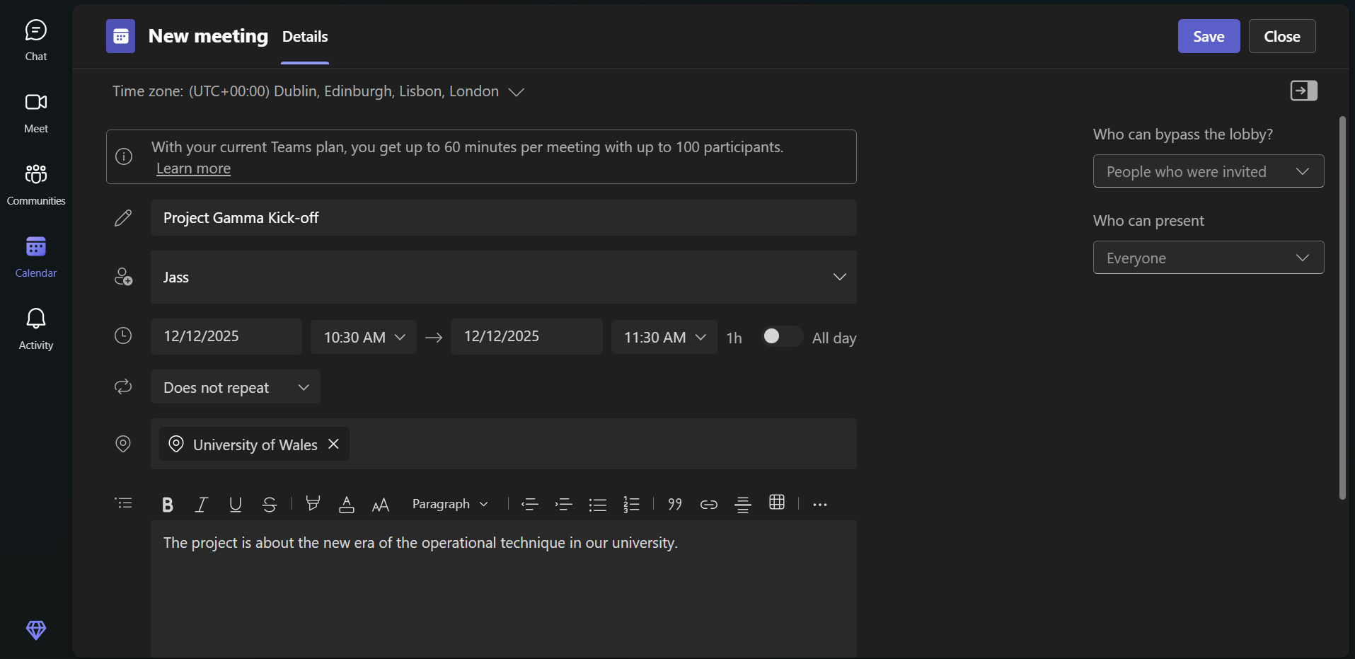
This is the formalisation of the communication request, purpose and participants. The scheduling conflicts are avoided by the possibility of seeing availability (in case it is integrated).

Step 3: Link to a Channel (Collaboration)
Crucially, add the meeting to a specific Channel (e.g., #Project-Gamma).
Connecting the meeting to a channel will guarantee that the recording and notes of the meeting and the chat logs are saved permanently in the project group in question, and thus, follow-up will be available to all those who are members of the channel and even those who are not present during the call[17].

- Test 2: Collaboration Application - Trello
Feature Tested: Creating a Kanban Workflow (Board, Lists, and Cards)
This illustrates the inherent cooperative nature of project monitoring and task delegation[18].

Step 1: Create the Project and Tasks
Navigate to Trello and create a new Board, naming it (e.g. Project Planning).
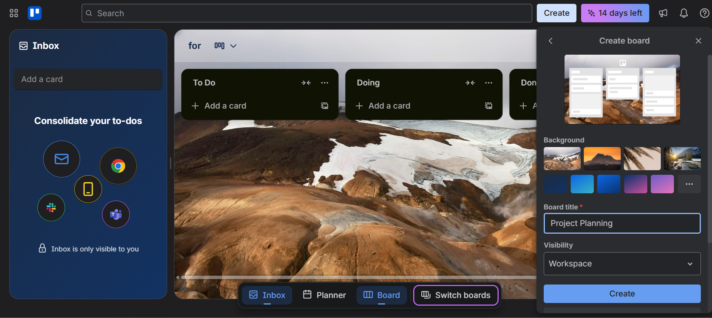
Next, create three sequential Lists: 'Plan & Research', 'In Creation', and 'Ready to Publish'.

The lists are used to establish the sequential project stages. This is the organisational bone structure that leads the process of the team.

Step 2: Create and Assign a Card
Click 'Add a card' under the 'Plan & Research' list. Title the card (e.g., Rivalry Analysis). Click the card, and use the sidebar to assign a team member and set a Due Date.

Click the card, and use the sidebar to assign a team member and set a Due Date.
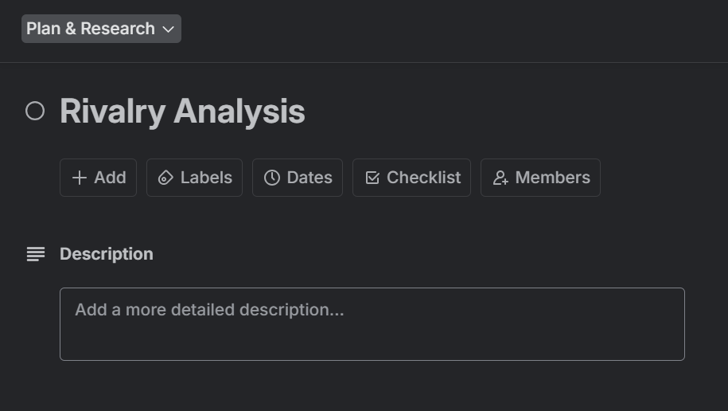
The atomic unit of work is referred to as the card. The grouping of a member and a time limit produces a feeling of possession and time limitations, which is a critical aspect of collaboration.

Step 3: Move the Task (Visual Progress)
Click and drag the Competitor Analysis Report card from the 'Plan & Research' list to the 'In Creation' list.
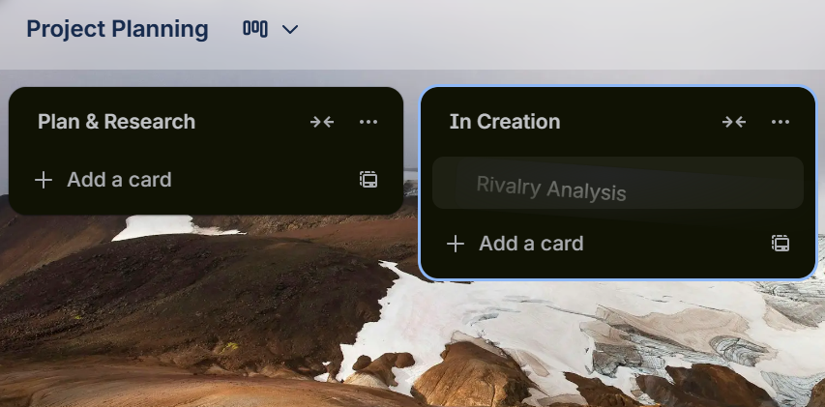
This physical gesture is what Kanban is all about, and it immediately informs the whole team of the status of the task. It indicates that collaboration is being initiated without the need to use an updated email.

References
[1] “Shopify Pricing - Setup and Open Your Online Store Today – Free Trial - Shopify.” Accessed: Dec. 02, 2025. [Online]. Available: https://www.shopify.com/pricing?term=shopify plan&adid=702861234195&campaignid=21389502694&branded_enterprise=1&BOID=brand&utm_medium=cpc&utm_source=google&gad_source=1&gad_campaignid=21389502694&gbraid=0AAAAAC3QZJqcvruZZ2s00qNGXw_-VUANn&gclid=Cj0KCQiAubrJBhCbARIsAHIdxD-KIG9y3Bz7d0yx_4rpnddDobpz82oos6J3m00_mY2vUT1vjdz_qNkaAlqcEALw_wcB
[2] “The 6 best eCommerce website building platforms in 2025.” Accessed: Dec. 02, 2025. [Online]. Available: https://zapier.com/blog/best-ecommerce-shopping-cart-software/
[3] “I Put Shopify vs WooCommerce to the Test in 2025: My Verdict.” Accessed: Dec. 02, 2025. [Online]. Available: https://www.websitebuilderexpert.com/ecommerce-website-builders/comparisons/woocommerce-vs-shopify/
[4] “WooCommerce vs Shopify 2025 (Complete Comparison Guide).” Accessed: Dec. 02, 2025. [Online]. Available: https://cmsminds.com/blog/woocommerce-vs-shopify/
[5] “Ecommerce Platform Comparison Tool: Compare Prices, Features & More!” Accessed: Dec. 02, 2025. [Online]. Available: https://www.tooltester.com/en/ecommerce-platforms/
[6] “What Is a Mind Map? Learn Its Benefits and How to Create One | The Workstream.” Accessed: Dec. 02, 2025. [Online]. Available: https://www.atlassian.com/work-management/project-management/mind-mapping
[7] “What Is A Mind Map? | MindMapping.com.” Accessed: Dec. 02, 2025. [Online]. Available: https://www.mindmapping.com/mind-map
[8] “The Best CRM Software of 2025- business.com.” Accessed: Dec. 02, 2025. [Online]. Available: https://www.business.com/categories/crm-software/
[9] “Microsoft 365 in 2025: The Complete Guide to Features, Benefits & Mastery Tips - Auscomp.com | Marketplace for Microsoft 365.” Accessed: Dec. 02, 2025. [Online]. Available: https://auscomp.com/microsoft-365-in-2025/
[10] “7 Reasons Why Airtable is Better than Excel.” Accessed: Dec. 02, 2025. [Online]. Available: https://www.seattlenewmedia.com/blog/why-is-airtable-better-than-excel
[11] “12 Microsoft Access Alternatives: Ranked and Tested 2025.” Accessed: Dec. 02, 2025. [Online]. Available: https://www.blaze.tech/post/microsoft-access-alternatives
[12] “How to use VLOOKUP Formula in Excel: Step-by-Step Guide.” Accessed: Dec. 02, 2025. [Online]. Available: https://www.simplilearn.com/tutorials/excel-tutorial/vlookup-in-excel
[13] “Pivot Tables in Excel - Step by Step Tutorial.” Accessed: Dec. 02, 2025. [Online]. Available: https://www.excel-easy.com/data-analysis/pivot-tables.html
[14] “What is Microsoft Teams? Everything You Need to Know - TechTarget.” Accessed: Dec. 02, 2025. [Online]. Available: https://www.techtarget.com/searchunifiedcommunications/definition/Microsoft-Teams
[15] “Microsoft Teams and Asana - Improve Your Project Collaboration - nBold.” Accessed: Dec. 02, 2025. [Online]. Available: https://nboldapp.com/microsoft-teams-and-asana/
[16] “Manage your team’s work, projects, & tasks online • Asana.” Accessed: Dec. 02, 2025. [Online]. Available: https://asana.com/?noredirect=true
[17] “Calendar Integration with Microsoft Teams - Mastermind Knowledge Base.” Accessed: Dec. 02, 2025. [Online]. Available: https://mastermind.helpscoutdocs.com/article/979-calendar-integration-with-microsoft-teams
[18] “The kanban way: how to visualize progress and data in Trello - Work Life by Atlassian.” Accessed: Dec. 02, 2025. [Online]. Available: https://www.atlassian.com/blog/trello/kanban-data-nave

