Cloud Computing Administration

Student name- Horatiu Lucian, Butunoi

a) As a Cloud Architect, your initial step is to use the Azure Total Cost of Ownership (TCO) Calculator to estimate the cost savings you can achieve by migrating your data from on-premises servers to Azure cloud services. 3
b) Critically analyse how Azure File Storage and its associated features, security measures will help GLI and demonstrate the implementation of Azure Storage account for GLI. Attach appropriate screen shots from Azure Portal. 9
c) Evaluate different Azure database options (Azure SQL Database, Azure Database for MySQL, Azure Database for PostgreSQL) and recommend the most suitable one for storing use profiles. Outline the steps to create an Azure database using the Azure portal. Include a screenshot of the Azure database creation. 14
Create MySQL server using Azure portal 17
Access MySQL server with Workbench 19
d)Analyse how GLI can configure backup schedules and retention policies using Azure Backup options for file shares and databases. Include a screenshot of backup configuration settings from Azure portal. 23
VIDEO LINK 23
e)GLI wants to ensure business continuity and minimize downtime in case of unexpected outages or disasters. Evaluate how Azure Site Recovery would assist GLI in disaster recovery to protect their storage and databases. 34

a) As a Cloud Architect, your initial step is to use the Azure Total Cost of Ownership (TCO) Calculator to estimate the cost savings you can achieve by migrating your data from on-premises servers to Azure cloud services.
It is needed to design on premise IT infrastructure for migrating with low cost to Azure free service. Assumption is also needed for making assumptions for setting up educational institutions.

1. On-Premise Infrastructure Overview:
Servers: GLI is responsible for operating on premise servers so that it can host multiple factors including administrative system, course materials and user profiles.
Number of Servers: Three different types of servers are needed in this situation that has been discussed below.
Server 1: Activity directory and domain control server
Server 2: Hosting server for creating learning management system
Server 3: Database server for storing data using MySQL
2. Storage: As per management of the institute, local storage is effective so that database administrators can store data including multimedia, documents and other files.
- Specifications: Every server should have following components
  - Dual CPU with 8 cores
  - 32 GB of RAM
  - 1 TB HDD storage
- Maintenance and Upgrade Costs: Maintenance is also needed to calculate so that hardware maintenance and software upgradation can be done. As per management, annual maintenance charge is 10000 dollars for every server.
3. Databases: Databases are needed to manage by GLI managers so that they can store data including student record, management data and course data.
- Database Assumptions:
  - MySQL Database: MySQL data is used that consist of following
    - Size: 1000 GB.
    - Annual maintenance cost: $15,000.

4. Networking: Communication is needed between servers as well as other devices and for that local network can be effective.
Network for this institution is required for transferring data, communication and internet.
- Assume moderate network usage for internal communication, data transfer, and internet connectivity.
- Estimated bandwidth for this network is 500 GB
- And cost is approximately 22000 dollars

Migration Strategy:
Migration strategy includes Azure free service and gradual migration.
Azure free service is responsible for reducing cost in the migration process.
On the other hand, gradual migration is responsible for migrating data to Azure server by allowing low cost and low disruption.

Migration to Azure Free Services:
Azure Blob Storage: Azure free tier offer 5 GB of storage and for that documents, multimedia and course materials can be migrated.
Azure SQL Database: Database is also possible to migrate from MySQL to Azure server that offers 250 GB storage.
Azure App Service: For testing and development, Azure App service is possible to use so that learning portals can be hosted in Azure.

Cost Considerations:
In this migration project, no direct cost is involved as Azure free service will be used. Though this is free service, additional cost can be included for using extra storage or extra computing resources.

The concerned approach is responsible for the smooth migration process from local server to Azure free service. This process involved lowest cost without compromising reliability and scalability for Azure cloud computing infrastructure. Cost estimation has been done for this purpose that has been evaluated below.
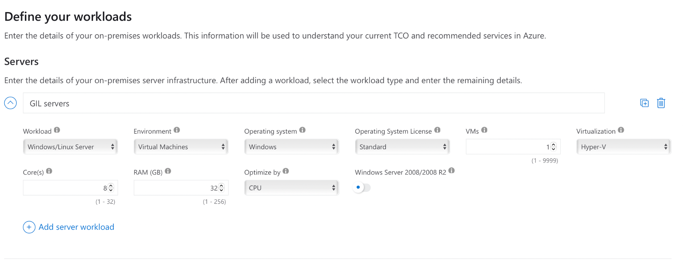
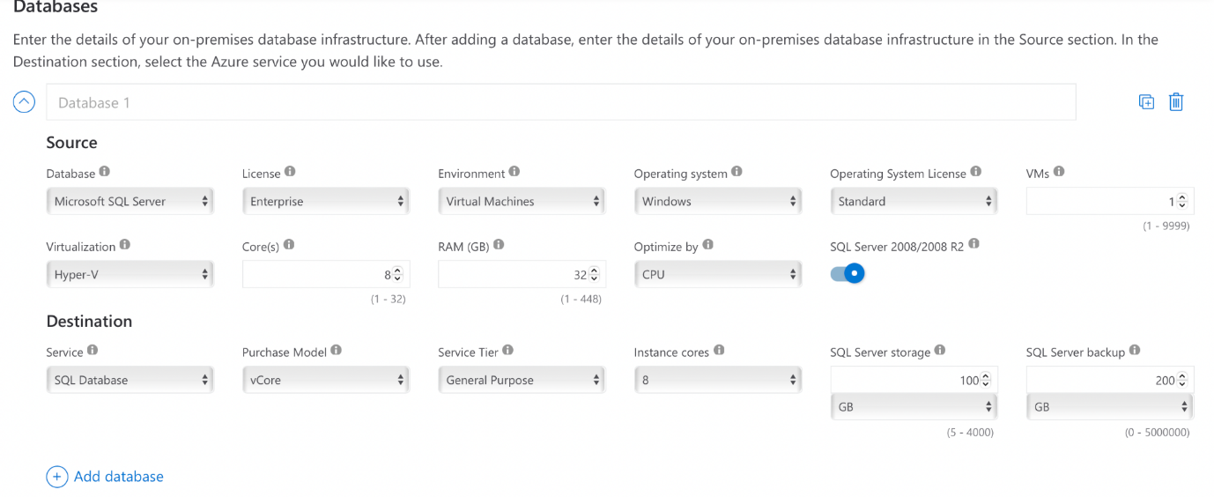

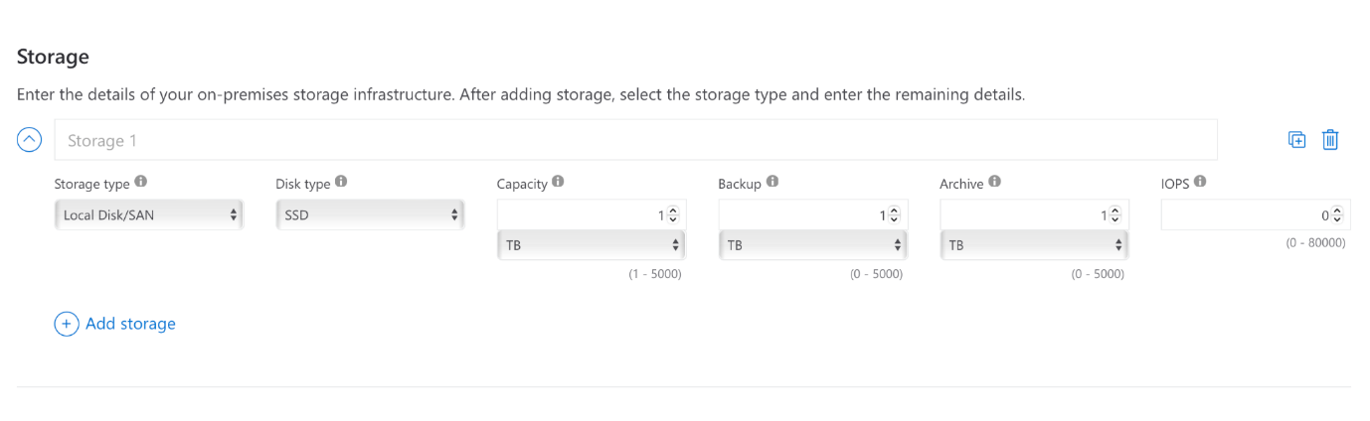
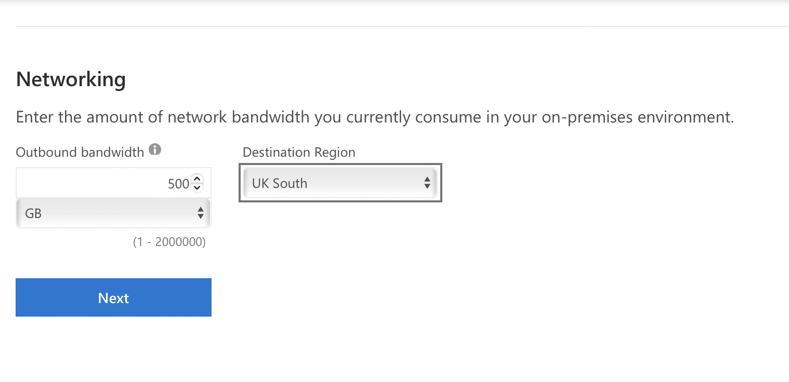

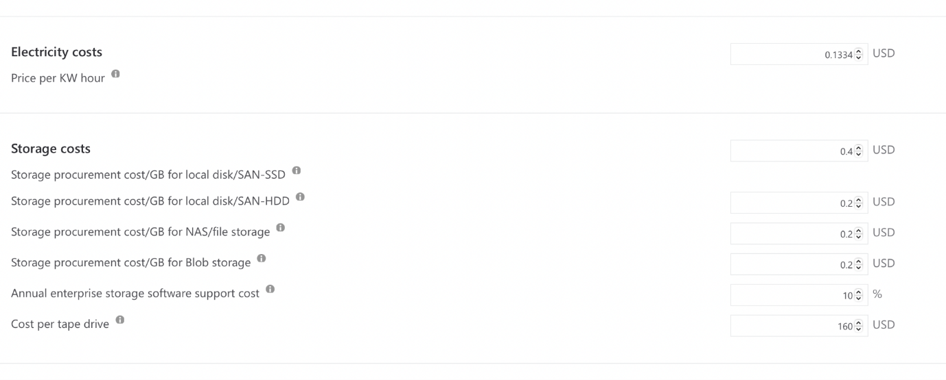
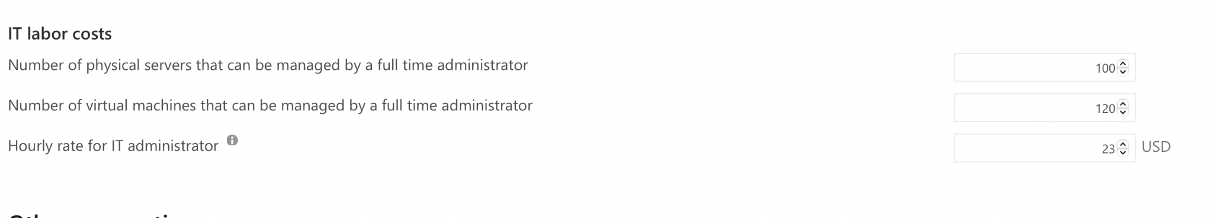

COST
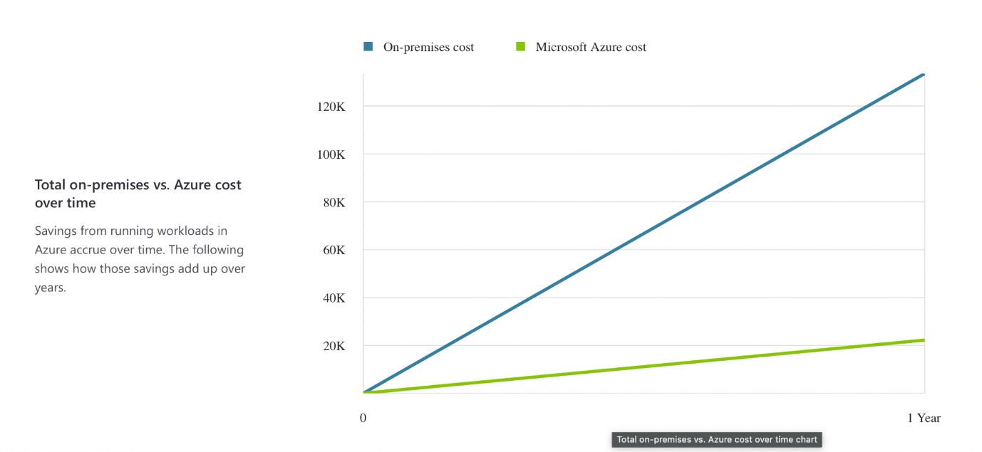
Comparison
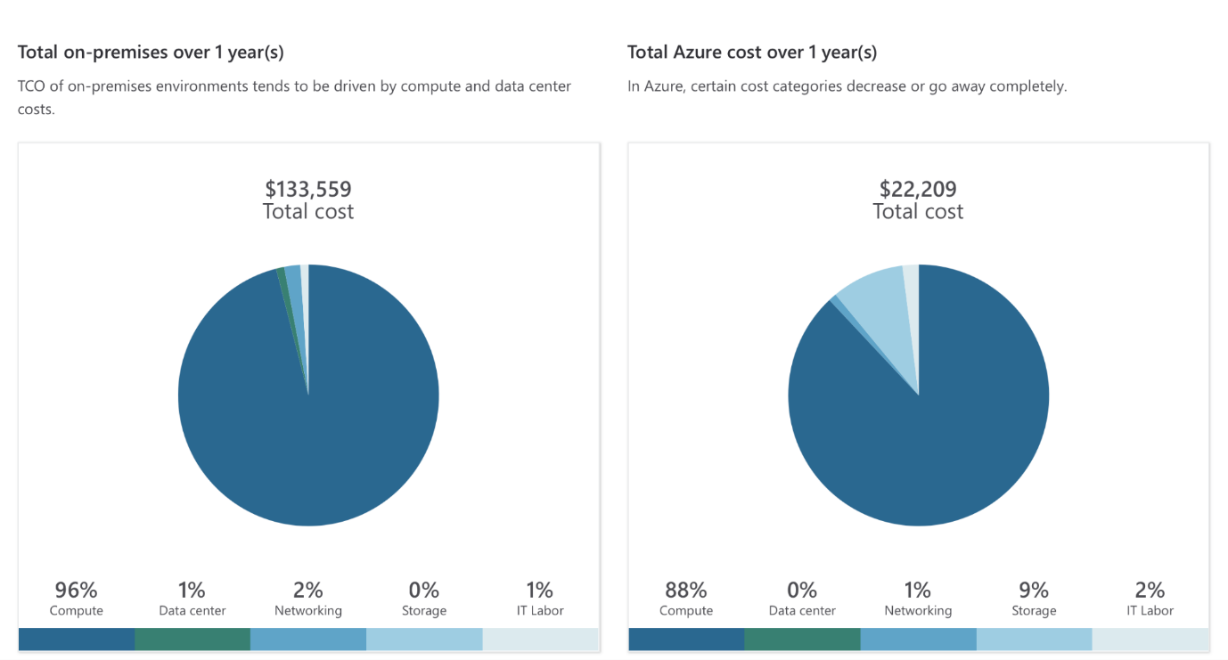

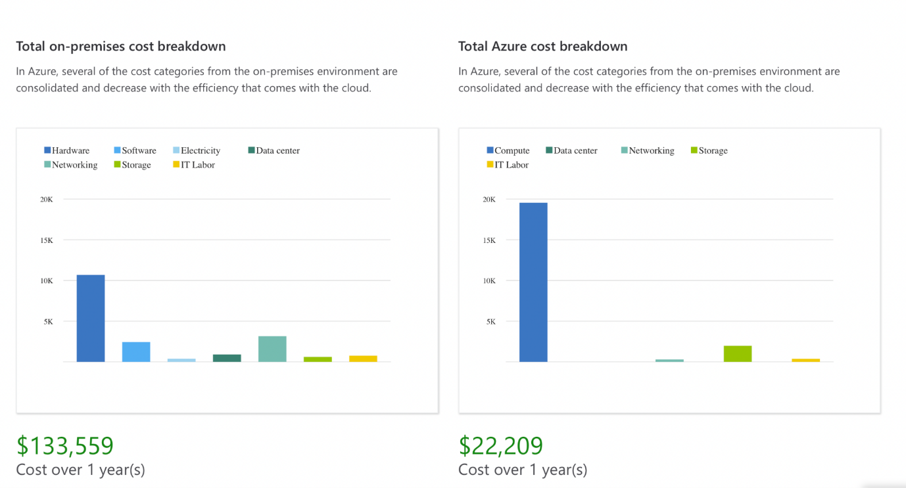
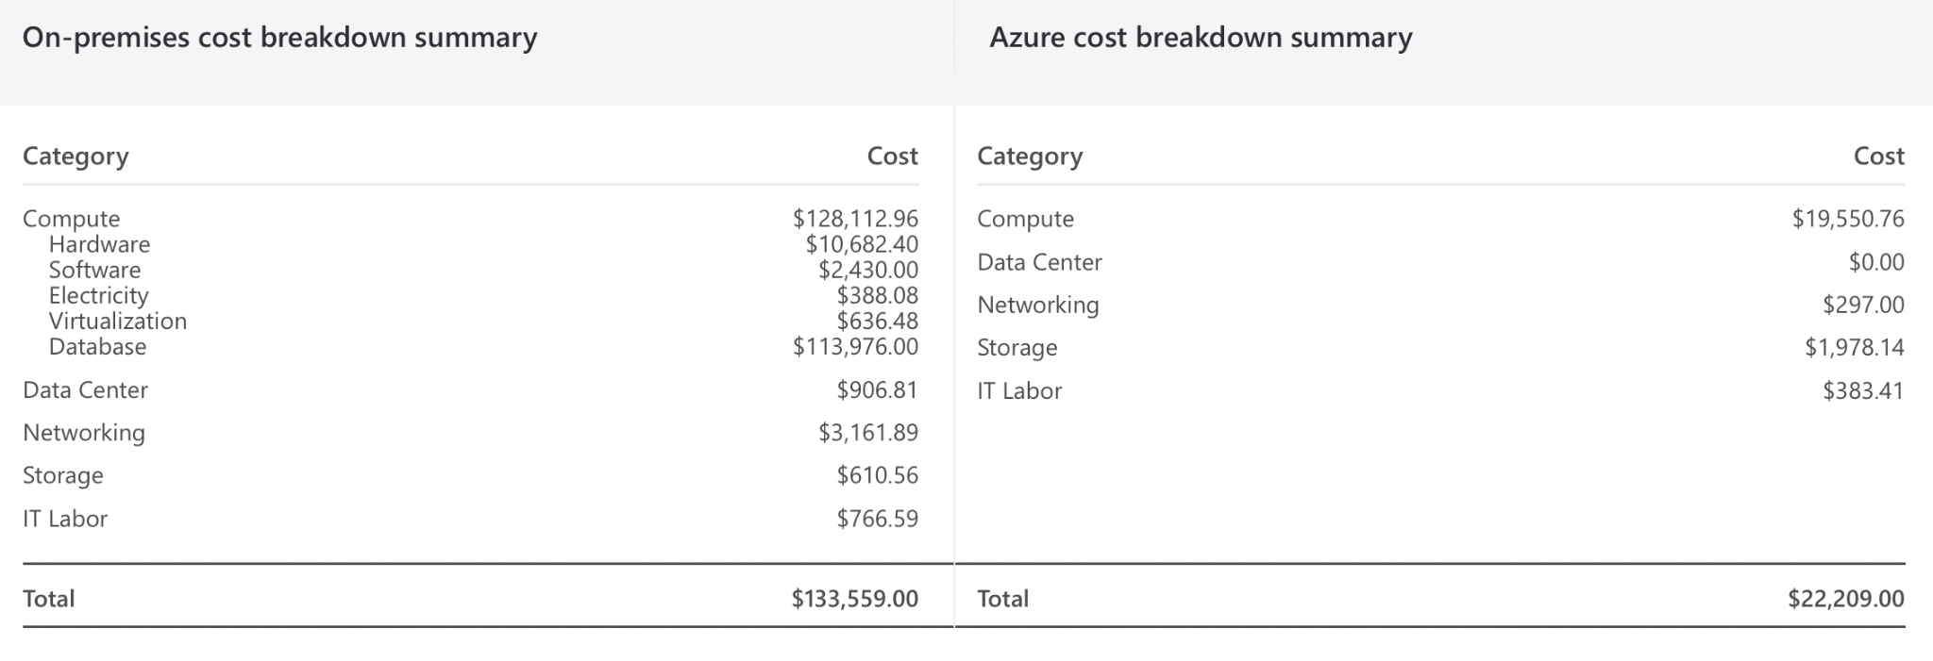
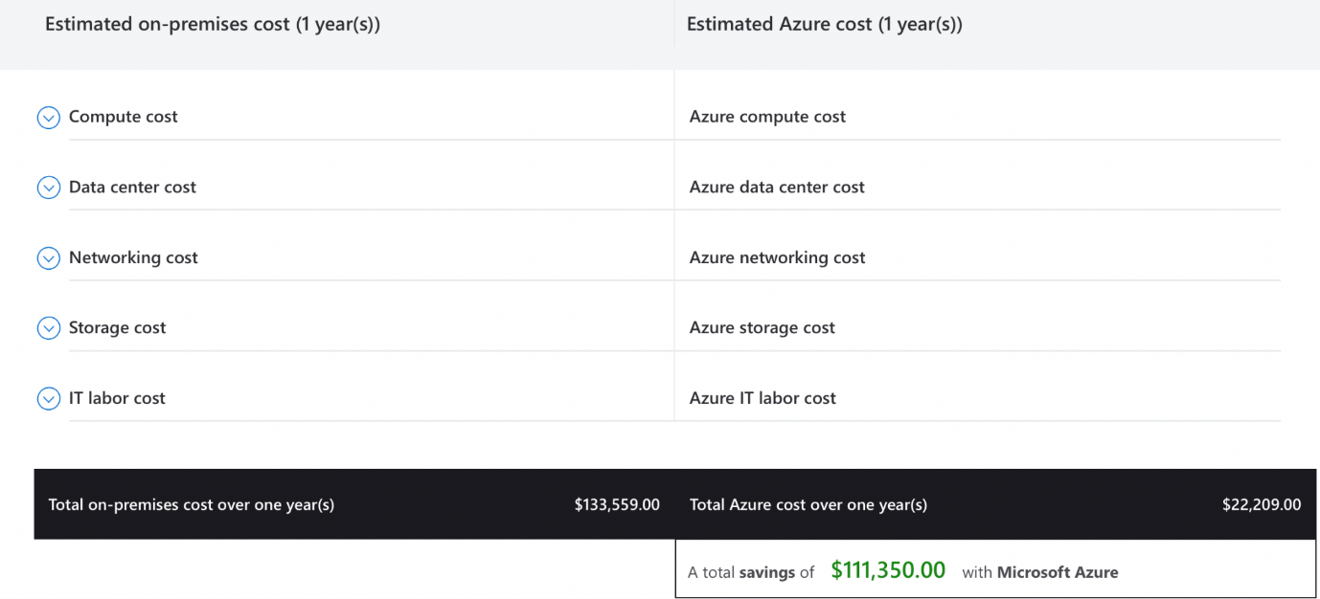

b) Critically analyse how Azure File Storage and its associated features, security measures will help GLI and demonstrate the implementation of Azure Storage account for GLI. Attach appropriate screen shots from Azure Portal.
Global learning institute needs to utilize security and Azure features for demonstrating implementation and demonstration of Azure storage account.
Benefits of Azure File Storage for GLI:
- Scalability: Scalability is one of the major benefits of Azure as this is capable of providing better storage capacity. It also helps in store source flexibility according to requirement. After using this cloud infrastructure, this organization has observed an increase in demand for GLI certificate and courses. Data storage requirement is possible to increase without investment or upgrade of software.
- Cost-Effectiveness: Azure provides a pay as you go model for its cloud file storage system. This is beneficial for GLI as they can minimize storage cost by performance and maintaining high availability of data.
- Global Accessibility: GLI operates globally and for that global accessibility of files, courses and other data is important. Azure cloud system is responsible for providing global accessibility to its users so that GLI and its stakeholders can access content from different geographical locations without compromising efficiency and accuracy.
- Integration with Existing Applications: Integration is important between Azure and existing application for seamless migration process. Azure is capable of migrating applications from existing sources to Azure cloud storage without compromising ongoing operations. Compatibility between Azure cloud storage and existing application has been found.
- Security Measures:
  - Encryption: Encryption process is secure in Azure system at rest in transit that helps to ensure data. High security is also there in the transmission and storage process.
  - Access Control: Azure active directory is used for integration purposes so that specific permission can be provided to specific users or groups.
  - Network Security: Suitable security features including virtual networks and firewalls are there so that access can be restricted as per traffic sources and IP addresses.
  - Data Protection: Data protection is another important factor in Azure and for that purpose snapshots, backup solutions and replication is there. These features are responsible for resilience, data protection as well as data recovery stages.

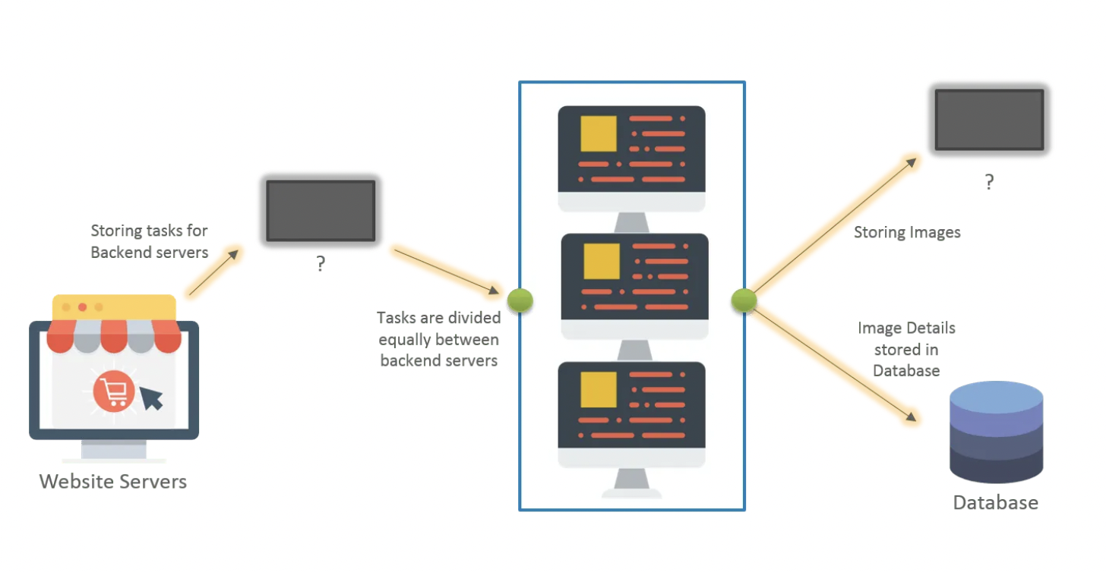
Above image processing website is responsible for distributing load within two classes including website server and backend server. Incoming page request is possible to handle by website server and backend server is responsible for correspondent operation in the website.
One entity is responsible in this architecture for storing incoming jobs to the website server. Concerned job then picked up through backend server for completing. In this process, this activity stopped after being picked up by the backend server so that the same activity can not be repeated.
File storage in azure cloud

Specific file storage system is there in Azure by creating files in a parent's share. Multiple shares can be there in the Azure Azure SMB file share system with the highest capacity of 5 TB.
Part 2:
Azure file service will be explain in this part. Azure file service has SMB 3.0 protocol that is possible to attach in windows operating system as external drive.
Step 1:
Check storage account overview page and then file service option.
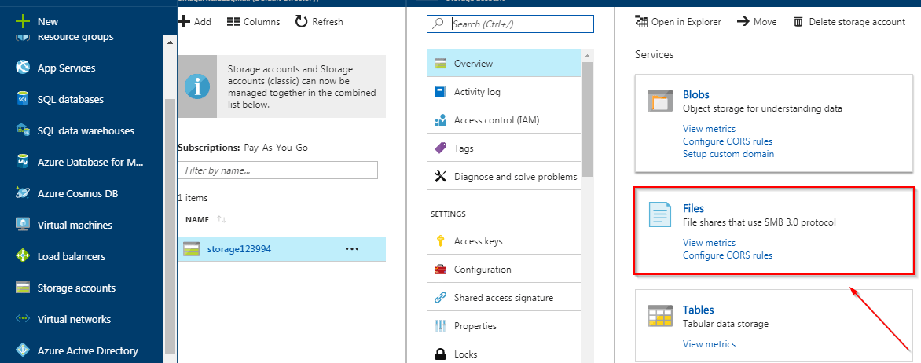
Step 2:
Provide file instance name and require size and then click ok.
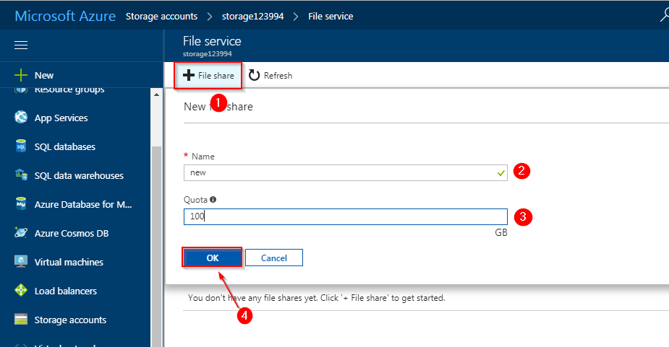
Step 3:

Select file service and then connect.
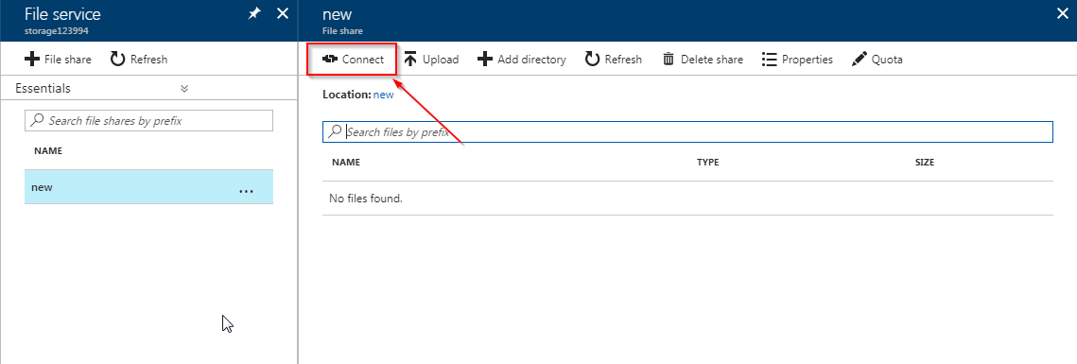
Copy link in property pane.
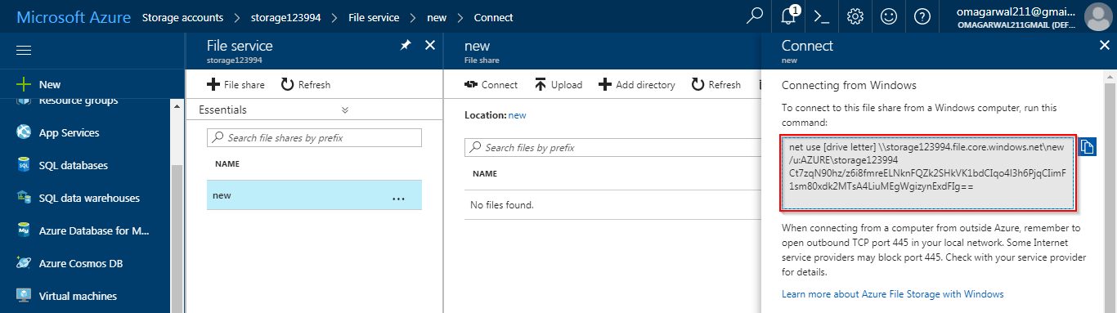
c) Evaluate different Azure database options (Azure SQL Database, Azure Database for MySQL, Azure Database for PostgreSQL) and recommend the most suitable one for storing use profiles. Outline the steps to create an Azure database using the Azure portal. Include a screenshot of the Azure database creation.
It is needed to discover multiple Azure databases including Azure MySQL, PostgreSQL and SQL databases. In this process, it is also required to check multiple factors including scalability, data structure, security and performance in the concerned system for GLI. Recommendation will be done based on these features.
1. Azure SQL Database:
Data Structure: Data structure of this Azure SQL database depends on SQL server engine and it supports structured data storage process.
Scalability: Scalability is an important part of Azure system and for that purpose suitable features are included such as elastic pools, auto scaling options and hyperscale.
Performance: Performance is possible to measure ifor query processing, cache mechanism and indexing so that data can be transmitted easily and efficiently.
Security: High security is involved in the Azure system for providing safety to data. In this situation, Azure database provides encryption, row level security and dynamic data masking.
Compatibility: This database is compatible with multiple tools and applications so that migration process can be easy.
2. Azure Database for MySQL:
Data Structure: Relational database structure is followed in Azure database and it also supports structured data systems.
Scalability: Scalability process is found in Azure database that makes this system flexible. Replicas as well as backup of this system is possible to do without any challenges.
Performance: Query processing process is efficient that makes Azure performance of Azure high. In has been also found that high performance data can be processed through Azure database.
Security: High security features are there in Azure database including firewall, virtual network and high auditing capabilities.
Compatibility: MySQL Azure database is compatible with different types of tools and applications.
3. Azure Database for PostgreSQL:
Data Structure: Structural storage process is used in Azure database PostgreSQL which is an open source database.
Scalability: Azure PostgreSQL has scalability that helps users to create and maintain databases. Automatic scaling as well as server configuration process is easy in this database.
Performance: High performance data processing is delivered by Azure PostgreSQL by indexing and implementing caching mechanisms.
Security: Security is a major requirement for Azure Database PostgreSQL software. Firewall, role based access as well as transit process is used in this software.
Compatibility: Compatibility is high in Azure PostgreSQL software that is responsible for migrating data from other software to Azure.
Recommendation:
Three different Azure database has been evaluated and it has been found that Azure MySQL is most effective as per requirement. Azure MySQL is responsible for storing information by providing high security, scalability and robustness. Another reason for selecting this software is its high compatibility that is responsible for migrating data from existing database to Azure MySQL.
Create MySQL server using Azure portal
Azure database for MySQL server is needed to find from Azure portal and then add for creating server.
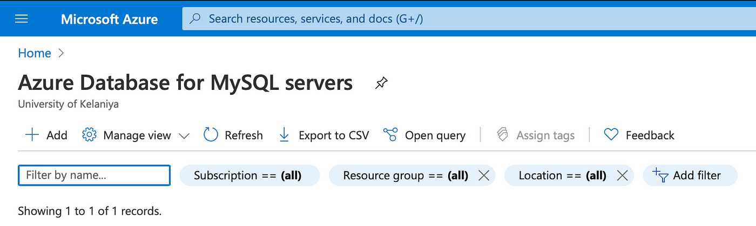

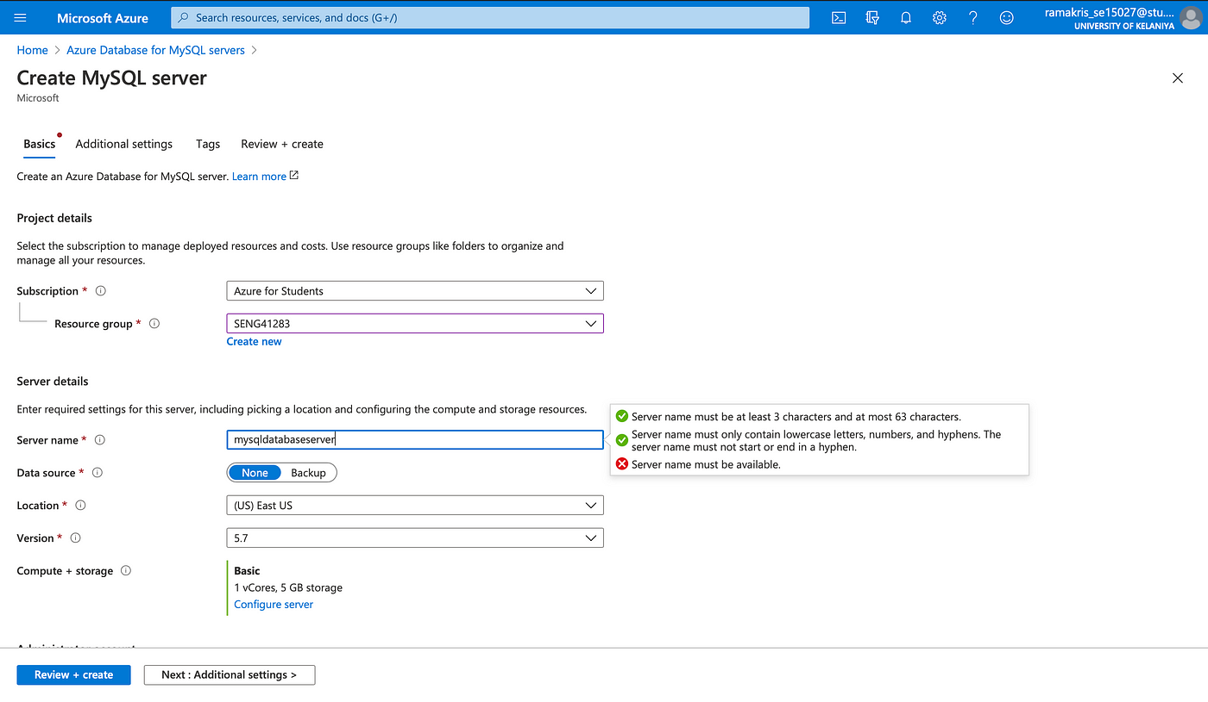
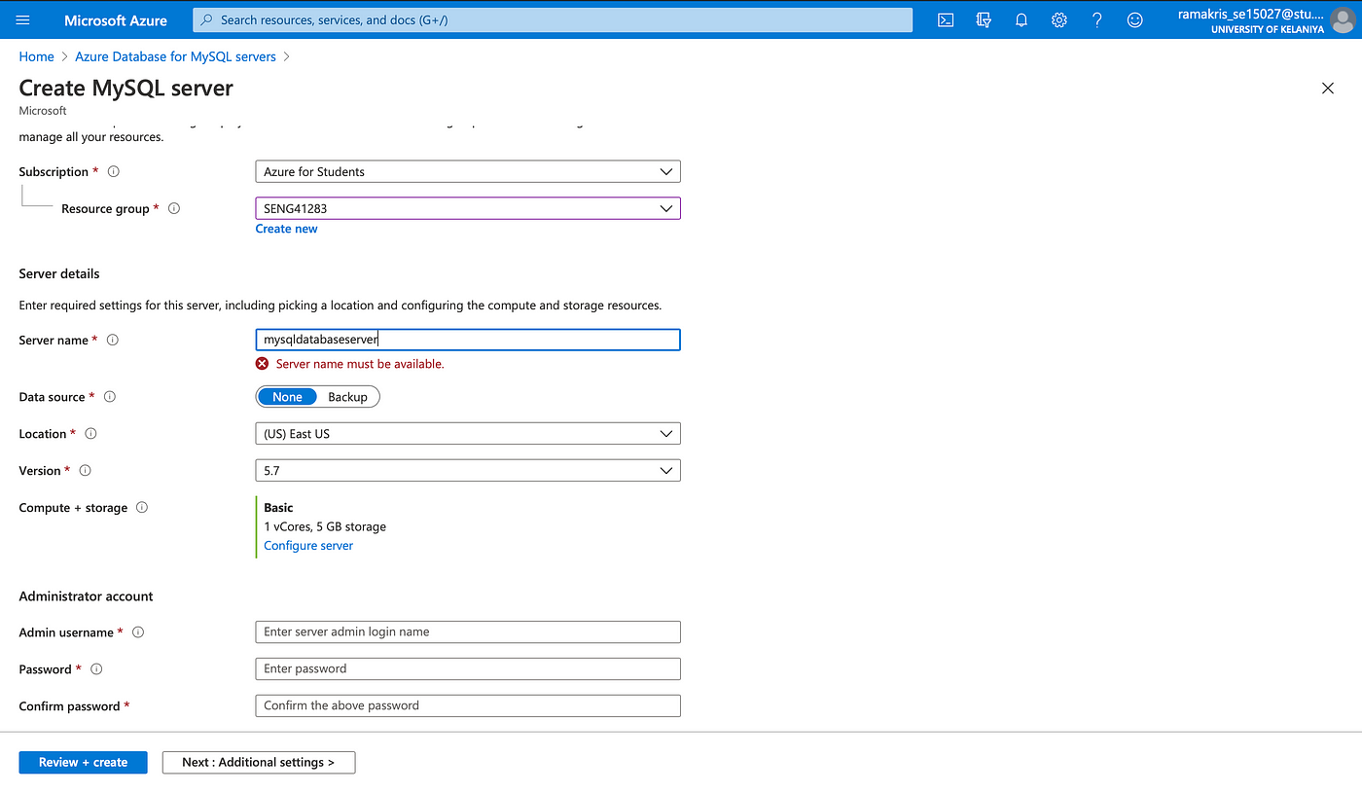
Credentials including name and password are needed to save secretly so that the database can have spring boot access.
After that it is needed to access the server from MySQL workbench in Azure server. MySQL workbench community is used for launching the concerned application.

Access MySQL server with Workbench
- + button is needed for establishing server connection in this database.
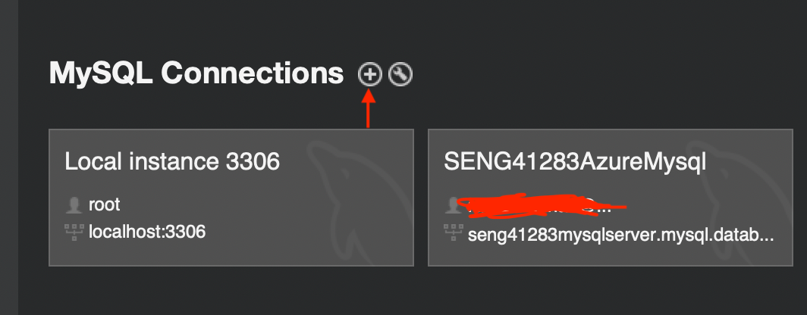

- In the new window, connection including connection name is shown and it can be changed to name as per users. Azure MySQL server data is needed including hostname user name.
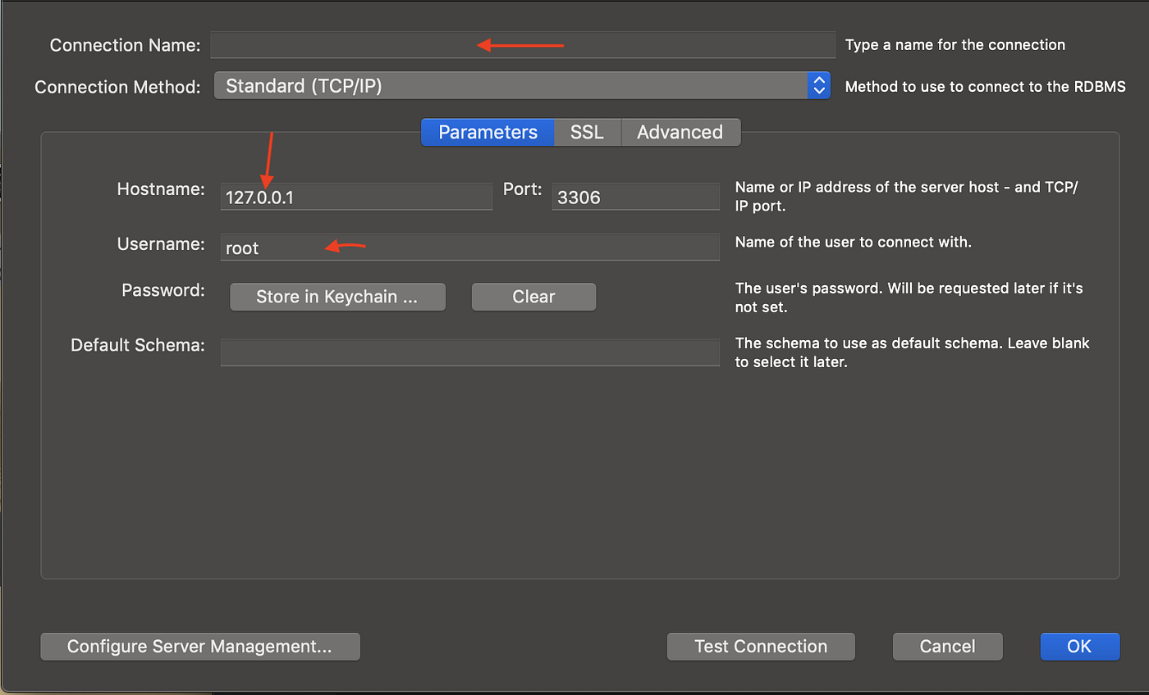

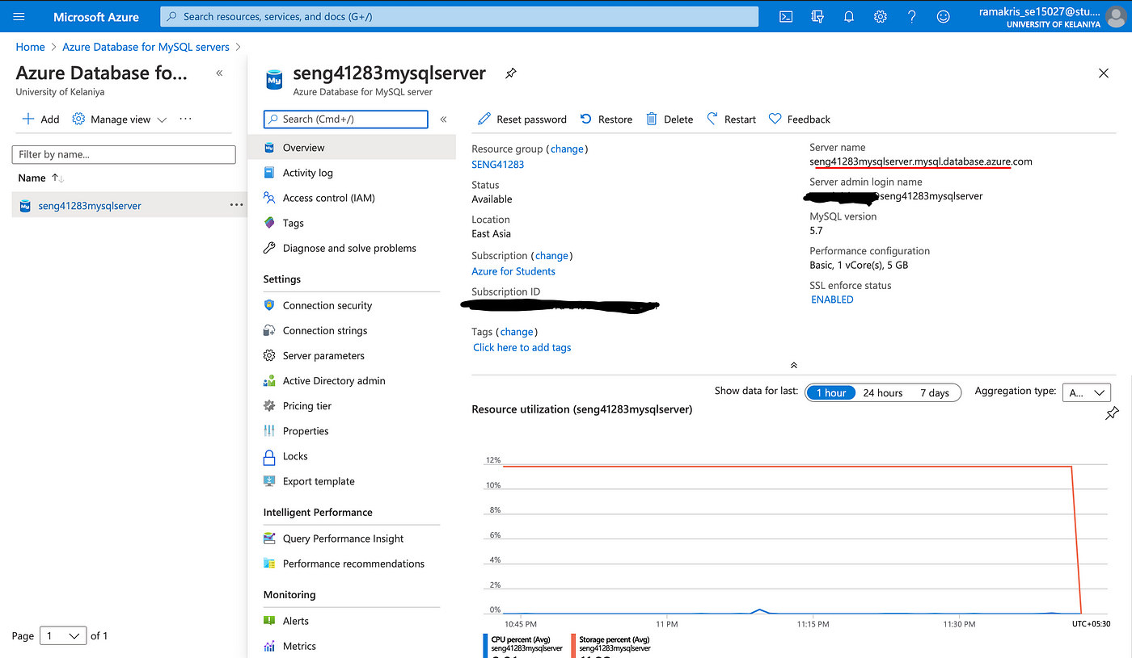

Admin user name is needed to provide while creating Azure MySQL server. For example, in figure 3, the user name is hort@server-name. This name is also possible to find in the database dashboard.
3. Required field is needed to click for a testing connection. In this situation, Azure Workbench needs to connect with the server using username and password. After successfully login, there is option for modifying database including database creation, table creation, data storage and sql query.
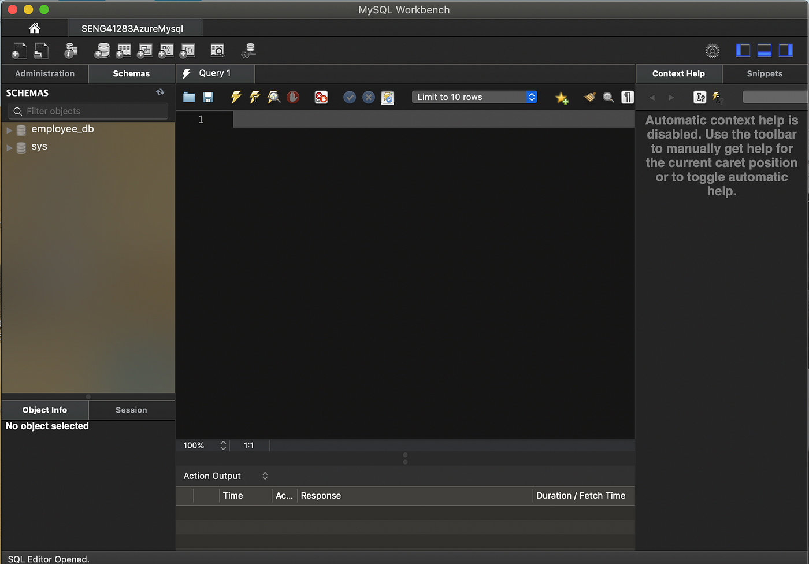
Create database employee_db so that data can be stored using spring boot technology.
This is created on the Azure server so this database is accessible remotely with the right credentials including username and password.
Apart from that, Azure server database is needed to edit for setting up IP addresses in MySQL server.
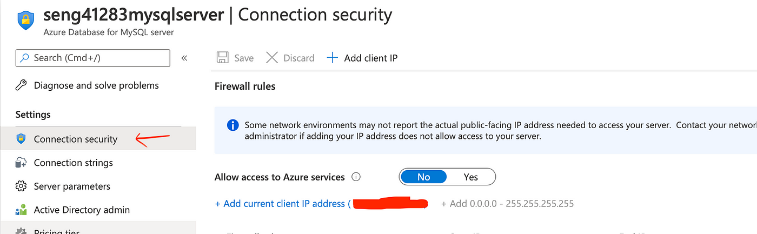
Scroll down in the dashboard and click connection security.
d)Analyse how GLI can configure backup schedules and retention policies using Azure Backup options for file shares and databases. Include a screenshot of backup configuration settings from Azure portal.
Backup process is also available in the Azure database as it uses Azure cloud through Azure virtual machines and on premises machines.
Both the big bucket and server are available in the Azure backup process. This process is essential as this is responsible for protecting Azure virtual machine as well as physical server. Backup is also applicable with other providers including amazon web services. Backup data can be found in Azure recovery vault or on premises storages.
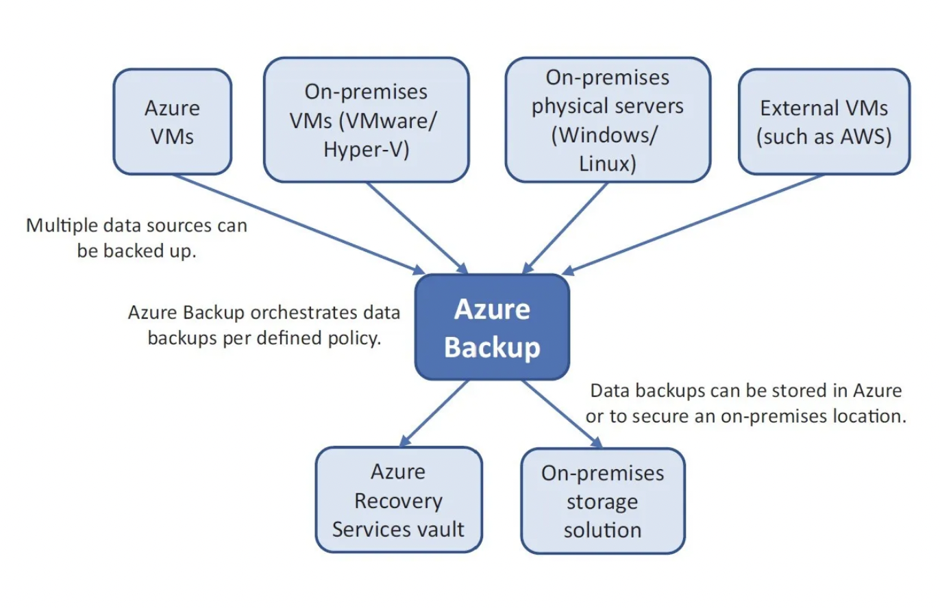

Policies and retention
Incremental backup model is used in Azure server for protecting instances. Backup operation is responsible for performing data backup and this is done by incremental backup. Recovery point is there in the backup process and the entire backup process is a time efficient process for optimizing network bandwidth and storage. Data is also possible to modify as per needs and transfer data securely to backup location.
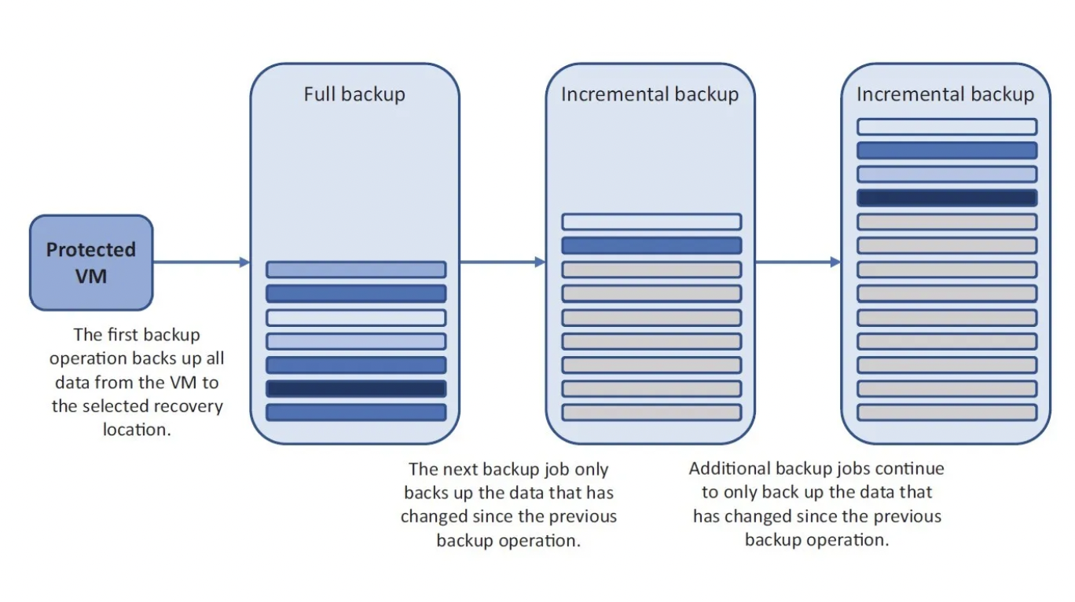
There are 9999 recovery points in Azure backup for every instance. Multiple options are available for the backup process including a daily backup to 27 years of packup for user data. Weekly backup is also available that can be upto 200 years. As per Azure backup policy, daily, weekly as well as yearly backup plan helps users. User to needs to implement a backup plan as per requirement through optimal backup strategy. It is also important to understand workload and identify acceptable recovery point objectives of the task along with time objectives so that the backup process for the task can be selected.
RECOVERY POINT OBJECTIVE

RPO point is responsible for the latest backup that allows restoring data in the Azure platform. Retention policy of Azure is also important in this situation by selecting a daily, weekly or yearly backup plan so that specific recovery plan can be established. It is also recommended to define the maximum amount of accepted data loss in the Azure platform. Below picture is responsible for defining RPO and its related acceptable data loss.
.
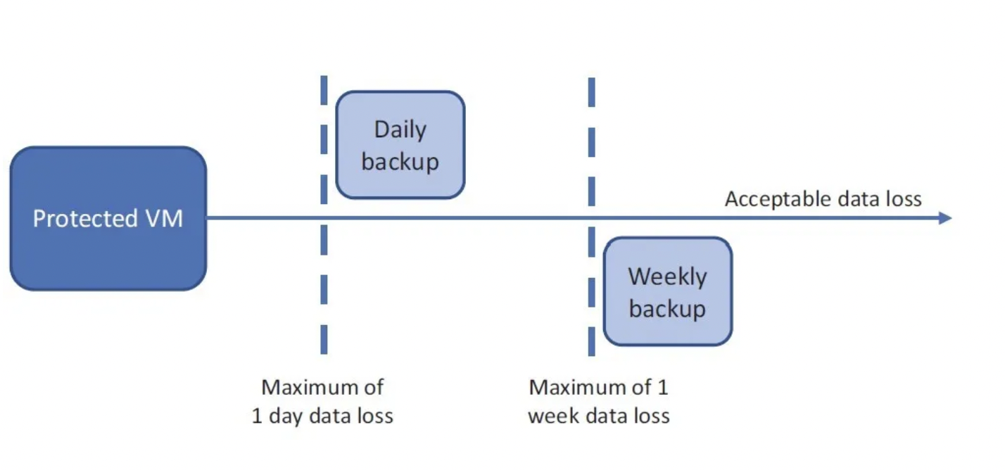
Backup schedules
Specific steps are needed to follow for creating a backup policy and vault and these steps have been elaborated below.
- Create resource after opening Azure portal from upper left menu
- Backup and site recovery option is needed selected followed by creating backup
- A name is needed to provide and new resource group is needed to choose followed providing a resource group name
- Location is needed to select from the provided option
- In resource group option, user needs to select created resource group
- After that it is needed to select the recovery service vault from the resource list and choose a backup policy. After that it is needed add policy in this platform
- In the Azure platform, there is an Azure virtual machine policy type which is needed to fill by providing a new policy name. A backup is created by default every day and in this situation required time is possible to select. Backup time and process is possible to review and select as per user requirement. AS different types of options are available, it is possible to create specific backup policies so that virtual instances can be protected and then user need to create backup process
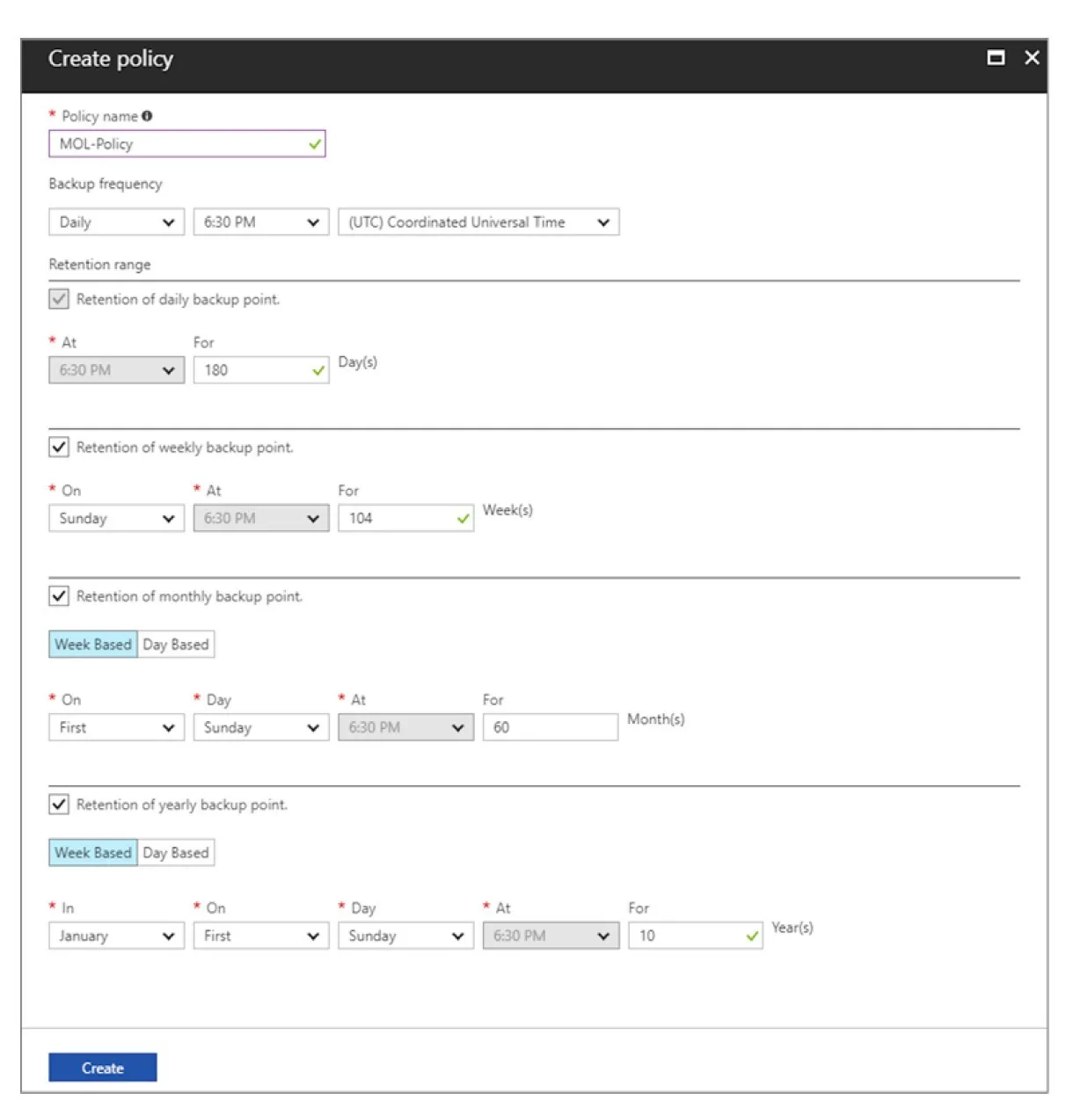
Below steps are needed to follow for backup virtual machine.
- In this situation it is needed identify required resource group followed by selected of created virtual machine
- Backup plan is needed to select from operation option
- Recovery service vault is created earlier that is needed to select as per backup policy. Entire retention option as well as schedule is needed select for enabling backup process in Azure platform
- This is an easy to apply backup policy and few seconds are required for that. After enabling backup policy, user should check the status report and ensure it show create first backup from warning.
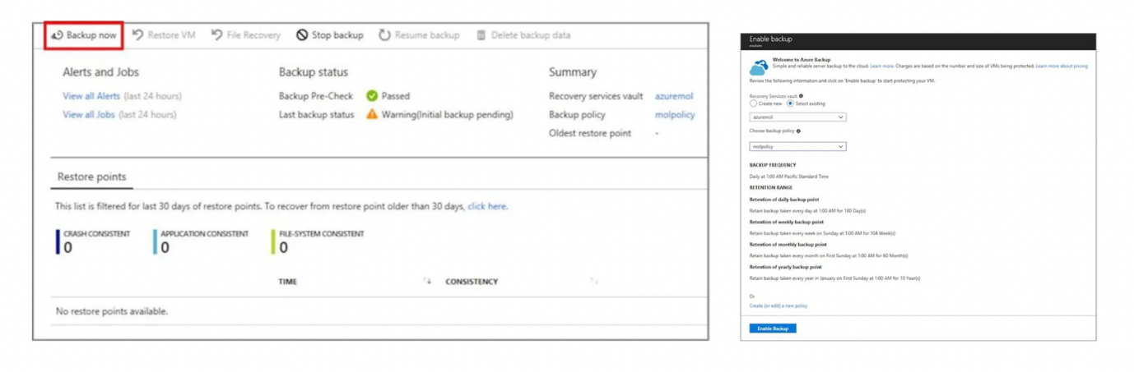
Restoring a VM
Azure platform backup process is responsible for restoring virtual machines to perform file level restore. It has been also found that file level restore operation is effective for the backup process. Restore jobs can be performed for deleting or overwriting files so that users can restore their data from the Azure platform. This restore process is responsible for determining Azure retention policies for backup. Essential data needs to retain for restoring files from six months ago. Virtual machine restore process helps to keep data save and helps to protect user’s data.
FILE-LEVEL RESTORE
Different types of Azure backup process is there in Azure platform and file level restore is one of the effective process. Main advantage of this type of strategy is flexibility for restoring file. It has been identified that Azure is responsible for creating recovery script so that user can download and run the script. Security is also essential in this situation and for that password protected system is important for completing data recover process. For restoration process, it is needed to provide password. In the below figure, the recovery script has been defined. Recovery script helps to retrieve data from backup data in Azure platform.
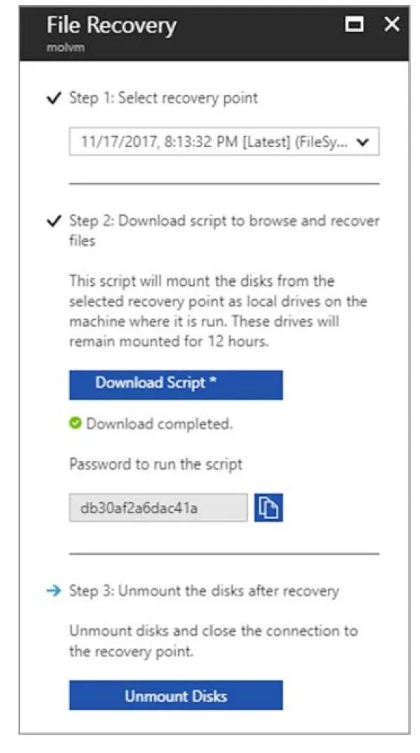
Below steps are needed to follow for restoring virtual machine
- Resource group is responsible for backing up virtual machine and data
- Backup option is needed to select from the main menu for creating a recovery point. It has been also found that this process is responsible for getting all data for this purpose.
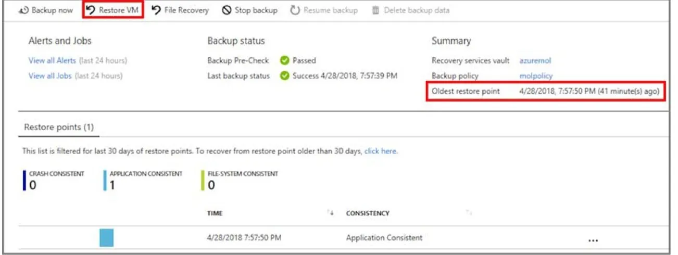
- There is a VM button option which is responsible for restoring data. Restoring points from the list is needed to identify for selection.
- After that it is needed to identify the restore type and choose a virtual machine for the restore process. It has been also found that restore disks are needed to restore so that data can be retrieved. Existing VM is responsible for obtaining data and restoring the complete virtual machine by creating a new instance and connecting to the virtual network.
- In the next process, it is needed to select Ok for data restore by connecting the recovery point and creating a virtual machine restore process.

VIDEO LINK
https://drive.google.com/file/d/1TzMD8aMS7jQjJ4B-g7DQSKfso9_y2SCZ/view?usp=sharing

e)GLI wants to ensure business continuity and minimize downtime in case of unexpected outages or disasters. Evaluate how Azure Site Recovery would assist GLI in disaster recovery to protect their storage and databases.
In the Azure process, it is needed to identify disaster recovery systems and for that Azure site recovery is most suitable. It has been identified that Azure is responsible for providing solutions to organization including GLI so that it can make sure minimum downtime can be implemented. Apart from that Azure site recovery process helps evaluate disaster recovery process. This helps to protect the database as well as storage so that complete process can be done. Both data backup as well as data retrive is important process in Azure platform which enables to complete database solution along with suitable threat mitigation strategy. It is also important to provide specific requirements so that users can identify threats and apply mitigation strategies.

1. Continuous Replication:
Continuous replication is also important in this situation which is helpful for data recovery. In the concerned situation, it ensures that GLI helps to provide critical service including database and hosting storage for replicating Azure in real time. It has been also found that continuous replication is effective to minimize data loss as well as it helps to make sure that GLI is capable of retrieving information from storage. This disaster recovery plan is just to implement while using the Azure platform for data security. This is a continuous process in Azure platform and this is capable of monitoring real data analysis processes.

2. Automated Failover and Failback:
Another important process is failover and failback that is effective for the ASR automation process. This helps to allow GLI to identify suitable data security and retrieved processes and switch replicated instances in Azure platform. It has been also found that the disaster recovery process is affecting infrastructure in the Azure platform. On the other hand, the failback process is capable of reverting primary infrastructure in GLI to restore. This process is responsible for ensuring a smooth transition to normal operations. It is recommended to implement both failover and failback processes in Azure platform so that the database system can be implemented properly and mitigate challenges.

3. Orchestration and Testing:
Orchestration capabilities are needed in the database system and Azure site recovery helps to provide this functionality for streamlining failover and failback process. This helps to allow GLI for defining recovery plans as well as sequencing tailored to Azure specific requirements. On the other hand, GLI is capable of conducting suitable data disaster recovery plans so that specific requirements can be identified and sequences can be tailored. It has been found that GLI is capable of conducting regular disaster recovery drills and ensuring the testing process has been implemented without any challenges. It has been also found that the production system can impact the entire process and it ensures effectiveness and reliability of the recovery plan.

4. Cross-Platform Support:
Cross platform is effective in database systems as ASR supports cross platform replication. This process is responsible for ASR to allow GLI to replicate virtual machines in Hyper V and virtual machines. This also works on the Azure physical server and security data by mitigating data security challenges. In this process, flexibility plays an important role in enabling GLI to protect multiple workloads as well as databases and storage. Underlying infrastructure is effective for storage purposes and it helps to protect data from unwanted threats. Multiple platforms are used in Azure platform and cross platform process is supported to make the process more effective and efficient. It has been also found that a suitable solution is needed in the concerned situation to get better results.

5. Cost-Efficiency:
Costing is an important criteria while selecting a database model and in this situation the pay as you go model is followed by Azure site recovery. This model is effective as users do not need to pay extra for their database. This minimizes the cost of users as they only pay for used storage and computing resources. Unconsumed resources are not chargeable which reduce huge costs for users. In failover scenarios, the concerned model is effective for smooth operation through Azure platform. On the other hand, Azure pricing option has multiple factors including hybrid benefits and reserved instances for more optimized cost and cost efficiency processes. This type of disaster recovery process is effective as well as cost efficient.

6. Integrated Monitoring and Reporting:
Monitoring process is an integral part of ASR that is responsible for providing dedicated reporting capabilities and monitoring processes. GLI can monitor as well as check the health of the database, replicate and protect the database through this technology. It has been also found that alter can be created in this monitoring process so that users including GLI can get notification about any threat to any database.
On the other hand, ASR has another function that is capable of providing a reliable and robust disaster recovery solution so that the database can be protected. Continuous replication process of GLI is also capable of solving this type of challenge. GLI is capable of implementing this recovery plan so that risk can be mitigated and resilience can be maintained.



