

STRATEGIC MANAGEMENT
LCMB7003
Lecturer: Amare Desta
Assignment Title: Strategic management report
Student Name: Fajil Askar
Student ID: 2309495

Order of content-
1)Virtual organization
2)Precis
3)Summary
4)PPT Slide

Virtual Organisation
Virtual organizations are a modern business model where employees work from different geographical locations but still operate effectively as a team utilizing the technology for communication and collaboration. Virtual organizations are brought into attention through main elements, advantages and disadvantages explored in this report. Elements include those such as the flexible structure in terms of the levels of hierarchy and teams that work virtually, along with informal communication. Along with these advantages there are also staff savings, better job satisfaction, and time utilization, ability to connect with a bigger talent pool, flexible hours, lower staff turnover, and access to new markets. Challenges here might be easy going, company culture-building, becoming a good communicator, and stakeholder compliance and information security. Strategic management involves the planning and designing of virtual firms as well as leading the virtual business; this entails leadership team identity alignment, technology integration, talent management, culture integration, performance management, risk management, quality over quantity communication, trust and accountability, team building, technological utilization, flexibility, and fluidity planning. The role of effective strategic management is paramount in virtual organizations and cannot be overlooked. Proper planning, innovative design, and strong leadership are imperative aspects of this strategic management which must be tackled to overcome emerging problems and catch the advantages of the remote work environment.
Introduction
Virtual enterprises represent a cutting-edge operating concept where people or organizations come together and work across organizational boundaries to optimize their abilities and spur their competences in order to attain common ambitions. Through a collaboration of entities in different size, scope, and structure, they ensure interaction through proper coordination. This cooperation has roots in the grid computers era, in early 2000s. It laid the ground for joint efforts of many organizations to bring about a unified collaboration. While there are similarities in the educational background to formal organizations, a virtual organization does itself apart by being a mosaic of networks, with members striving to complete the production process which to the end is assembled together with no defined boundaries. The power lever in virtual organizations is driven by the market, reflected in the latter's lasting contracts that are celebrated in existence. The XtreemOS project has turned out to be the top of its class in designing and organizing Virtual Organizations with these cutting edge technologies that dramatically increases the success rate of their operations and their overall collaboration. This discourse scrutinize the management's strategy challenges related to the virtual organization's planning, design, and the leadership style. With emphasis on their distinct operational and structural characteristics.
Planning Virtual Organizations
The complex nature of the strategic management of virtual organizations is characterized by the fact that organizing these systems entails lots of tactical overthrows to guarantee their effectiveness. First of all, there are a number of challenges to be identified, from arranging an effective organizational structure and assigning roles to optimal decision-making processes in the remote environment. Furthermore, the basis of such an innovative technology comprising of a strong and effective technical infrastructure that physically links remote workers who are far away in flexible communication systems is necessary (Magableh, 2021). This is the next key factor following the problem-solving-based hiring of both remote work team members and adequately motivated ones.
What cannot be missed within the structure presented is rational diversification of business activities all across the regions with optimum utilization of local resources for the benefit of domestic economy and creation of new value chains. Furthermore, spread of threats could involve cyber security threats and other compliance requirements but which are ultimately intended to ensure firewalls put around protect organizations (Magableh 2021). These matters gain popularity as the building of open communication lines and through the set of cooperation processes become central, which would finally lead to the efficiency of team members joining the remote and on-site crews.
Furthermore to that, the processes of handling different cultural backgrounds and the cultures of socialization as a whole form a new and interesting set of challenges which require the staff to be very aware of the cultures and to go a step further to become an integrated company. As presented in the end, the quality metrics and assessment criteria play the negotiating role in the matter of assessment of the team efficiency and planning of the future strategic directions of improvement (The analysts - Smith & Ruiz, 2020). Gives particular attention to the special strategic management issues that may carry interest of organizations and networks managers. They solve this problem by carefully scrutinizing digital operations of their organizations, helping them to take advantage of transformation potential of working remotely and overcoming every barrier related to telework.
Designing Virtual Organizations
Creating as well as managing virtual organizations usually happens as a process which is complicated and full of the challenges in strategy to have all systems running well. At the core of those complexities lies designing organizational structures that not only enable collaboration and performance in remote conditions, but make the most out of available resources and assets. This entails setting job and organizational boundaries during the onset of the virtual work environment that facilitate effective communication in its specific virtual style.
Technological system integration that allows for a smooth flow of data and virtual communication will also be of key importance. This is done through determining and using technologies and platforms which are designed in a way that it suits the organization's particular needs and at the same time is effective in increasing efficiency and productivity among the remote workers.
An additional important problem is in cultural integration area, as organizations must find the way how to create strong corporate culture that promotes collaboration, engagement and a sense of belonging among everyone who is in a remote team. Cultural integration strategies could be implemented via scheduled virtual meetings, team-building exercises such as virtual parties, and communication software with a core message of shared elements and goals.
Moreover, performance management processes that are efficient will have to cover several elements, for instance setting of performance objectives, provision of regular feedback and coaching, and evaluation with measurable results in consideration. Similarly, addressing and resolving vulnerabilities that stem from virtual actions like cyber security issues, data privacy matters, and regulatory compliance for instance remain critical (Johnson et al., 2020). The company's risk management approach should be strong and would include developing risk management models and advance supplementary plans so as to secure the corporation's reputation and assets.
Additionally, effective communication strategies that promote clear, transparent, and timely flows of information among the remote workers are critical. It is such objectively implementing channels of communication, formal process, and guidelines that will guarantee effective data circulation. It is important for business organization to ensure that their remote workforce involved in a perpetual training process, which will help them mainly to improve their skills, knowledge and general competence. This would mean offering not only digital training programs, workshops, and tools, but tools whose primary purpose is to help social workers to advance their careers.
Accepting and facilitating change becomes even more complicated in a virtual setting because there is no physical presence and the possibility of face-to-face communications. It is important to communicate the changes through the workforce, involve employees in the change process, and to give them support and resources to help them adapt to these changes (Johnson et al., 2020). These strategic management issues are crucial for virtual organizations and through them, the agencies can develop a virtual organization that is not only effective but also resilient and quick to adapt to changes.
Leading Virtual Organizations
The task of being a virtual leader means that this leader should apply divergent approaches because no physical communication exists. Leadership is grounded in competent verbal/written communication, solid technical expertise and the ability to maintain good relations with remote teams. Effective communications are pivotal in this regard, hence, various tools including email, instant messaging, video conferencing, and project management software can be used in order to keep the team updated on the progress and well-oriented on what is expected of each of them (Johnson et al., 2020). The trust and accountability are the essential ingredients of the process, which will not be possible without clear expectations, giving supportive feedback, and positive recognition. Establishment of accountability mechanism enables a manner in which every team member takes up their work and deliverables responsibly.
Virtual environment managers need to invest in team building to create a cohesive team dynamic. Virtual team-building activities which include online games and workshops promote a sense of teamwork and friendliness among the distant team members. Activities such as virtual happy hours, online games, or cooperative activities give us the reason to communicate so that the bonds become stronger even though we aren’t physically present (Johnson et al., 2020). Should be going along with the technological competence, leaders must learn how to use the diverse accessible tools that support virtual work. Skill in employing project management tools, video conferencing software, and collaboration platforms helps a team to work in the effective manner and increase productivity.
Flexibility and empathy are the key leadership competencies for virtual leaders. Changeability in strategy and ability to adapt to new concepts is the key for breaking through
individual remote workers emotion considered are necessary. Working with empathy and emotional intelligence enables one to create a sympathetic and an understanding zone that recognizes the special difficulties of tele-work (Suchek et al., 2021). Performance management in a virtual organization that works efficiently necessitates some clarity in goal setting, periodic feedback, and accountability only based on the outcomes. Leaders should concentrate on outcomes and not on micromanagement in order to keep the squad on the right track and the unity in the team. Continuous improvement of the capabilities of remote team members is undoubtedly vital for their prosperity and involvement in the group. With the help of training, mentoring as well as skill development methods, which allows team members to increase their abilities and be a substantial part of the organization's success.
Table Showing Strategic Management Matters in Virtual Organizations.
Strategic Management Subjects | Description
Planning Virtual Organizations | Determining organizational structure, technology infrastructure, talent management, resource allocation, and risk management.
Designing Virtual Organizations | Developing the principles of partnership, integrating the latest tech, advancing the cultural inclusion, implementing the ratings, and handling the problems.
Leading Virtual Organizations | Establishing communication channels, creating transparency and team accountability, designing team building projects, educating personnel on using technology, and being open to adaptations.

Figure 1. Strategic Management Matters in Virtual Organizations
The tables and charts above summarize the broad line of strategic management problems taking place in virtual organizations in the area of planning, designing, and leading. At the planning phase, organization must put emphasis on organizing the management work, digital resources, and risk mitigation. Developing a virtual enterprise consists of designing an effective organizational structure, technology adoption, culture integration, managing performance and risk. Efficiency of leadership in a virtual company is dependent on constructing proper channels of communication, building trust among team members, organizing team-building exercises, ensuring skilled enough in the technology use and being adaptable to change (Suchek et al., 2021). This is bedrock of a successful virtual company in modern business environment; to make the working environment efficient and conducive to productivity for the team regardless of their place of location.
Conclusion
In conclusion, the virtual organization in grid computing arises as a spectrum of participants holding common resource-sharing protocols, led by a unified goal. Drawing together a completely different type of being, such as these virtual entities; they put aside their diverse nature and work for common goals, and collaborate together while maintaining their distinct identities. Different from traditional company structures, virtual organizations are what they seem to have integrated relationship among clients, suppliers and others where they build a vector for operation which their joint efforts are the driving force and market orientation is the leading mechanism. The XtreemOS project, as an instance of an attempt to build suitable virtual organizations, underscores their significance and supports the trend of organizations of such kind that are employed for collaborative models, forming computing ecosystems. Virtual organization is a framework suitable for a robust resource plan and outlined objectives to be used for management purposes since the complex issues of planning and leadership are addressed. These strategies can be selected and used in the following forms: implementing correct business structures, integrating efficient IT systems, adequately handling talent, distributing the assets in rational way, reducing risks and developing an integrated organizational culture. The “strategic management” for virtual organizations would not work as that one of physical organizations, as it will help them to take advantage of the collaboration and overcome the obstacles inherent to the virtual environment.

Reference list
Albukhitan, S. (2020). Developing Digital Transformation Strategy for Manufacturing. Procedia Computer Science, 170(170), pp.664–671.
Centobelli, P., Cerchione, R., Chiaroni, D., Del Vecchio, P. and Urbinati, A. (2020). Designing business models in circular economy: A systematic literature review and research agenda. Business Strategy and the Environment, 29(4). doi:https://doi.org/10.1002/bse.2466.
Henry, A. (2021). Understanding Strategic Management. [online] Google Books. Oxford University Press. Available at: https://books.google.co.ke/books?hl=en&lr=&id=M7wyEAAAQBAJ&oi=fnd&pg=PP1&dq=Virtual+Organisations%E2%80%9D.+Your+evaluation+should+focus+on+discussing+the+strategic+management+issues+associated+with+planning [Accessed 27 Mar. 2024].
Johnson, J., Whittington, R., Regnér, P., Angwin, D., Johnson, G. and Scholes, K. (2020). Exploring Strategy. [online] Google Books. Pearson UK. Available at: https://books.google.co.ke/books?hl=en&lr=&id=ieksEAAAQBAJ&oi=fnd&pg=PT25&dq=Virtual+Organisations%E2%80%9D.+Your+evaluation+should+focus+on+discussing+the+strategic+management+issues+associated+with+planning [Accessed 27 Mar. 2024].
Magableh, G.M. (2021). Supply Chains and the COVID‐19 Pandemic: A Comprehensive Framework. European Management Review, [online] 18(3), pp.363–382. doi:https://doi.org/10.1111/emre.12449.
Margherita, A. and Heikkila, M. (2021). Business Continuity in the COVID-19 Emergency: A Framework of Actions Undertaken by World-Leading Companies. Business Horizons, [online] 64(5). doi:https://doi.org/10.1016/j.bushor.2021.02.020.
Smith, S.M. and Ruiz, J. (2020). Challenges and Barriers in Virtual teams: a Literature Review. SN Applied Sciences, [online] 2(6), pp.1–33. Available at: https://link.springer.com/article/10.1007/s42452-020-2801-5.
Suchek, N., Fernandes, C.I., Kraus, S., Filser, M. and Sjögrén, H. (2021). Innovation and the circular economy: A systematic literature review. Business Strategy and the Environment, 30(8), pp.3686–3702. doi:https://doi.org/10.1002/bse.2834.



Precis

Title: "An Empirical Study of ERP Implementation in Small and Medium Enterprises in Greece"
Authors: Roisin Mullins, Chatzichristos Christos, Federico Iannacci
This paper dissects the complex process of adopting Enterprise Resource Planning (ERP) systems by Small and Medium-Scale Enterprises (SMEs) operating in Greece. It highlights the need for companies to carefully select the compatible ERP system as well as the numerous challenges that are involved in its implementation. Two primary questions guide the study: firstly, whether the SMEs employing ERP in their daily operations are discriminated specifically in terms of their size compared to the others representing any global business; and secondly, the effects are the outcomes. Both positive or negative implications are objects of exploration.

The core aspect of this research is the insight how the ICT system has been adapted and reused in the Greek SMEs, with the focus on the use of ERP systems. He tries closing the gap in the related investigations in the application of ERP in SMEs in Greece and through them, also presenting useful standpoints for practitioners from the sector and academic investigators. Therefore, this study applies socio-technical method through which a survey-based research is used to collect the empirical data. This technique involves an initial collection of information that is then given for a subsequent analysis by this theory. There are various reasons why the grounded theory is being utilized for the research with regard to Greek SMEs is because it is an innate approach for investigative and explanatory research over the course of time, and of space.

The results of the study reveal that there is a glaring need for more knowledge on how to choose and apply ERP systems by Greek small and medium-sized enterprises. Although a well-planned ERP implementation can be associated with expense issues, the research study finds that most small and medium enterprises that execute this implementation can reap favorable results from this process. Does not only contribute in creation of models, which depict IBM ERP success, but also increases the spectrum of the information systems practical research. The survey outcomes also highlight a pressing need for SMEs in Greece to be educated about ERP systems, as these are becoming more and more strategic component. While there is a definite pattern of early problems and complexities to any ERP implementation, this thesis ends on a more optimistic note: if an ERP project is done the right way, the benefits for SMEs can be counted in the hundreds of thousands and more. ERP systems' transformative potential has the power of streamlining processes as well as raising decision-making abilities in business to an indecently high level. In addition to these implications, other research findings have been ascertained and are now applicable in the study around information systems. Through the uncovering of the ERP factors and the knowledge sharing on the ERP application approaches, the study extends in the current conversation on the ways to implementing ERP successfully in Greek SMEs. It offers the holistic view of the practical issues and benefits of ERP implementation in a selected socio-cultural situation that will, as a result, will make a relevant contribution to the information systems theory.
Overall, this research can be considered as a pioneering study that first investigates the behind implementation of ERP in Greek SMEs. It does this by helping to lift the curtain on the complexities of ERP adoption and use and thus offers valuable information that businesses and individuals can use to inform strategic decisions as they formulate their policies regarding their SMEs, and this is also a key foundation for further scholarly inquiry on this area.

Summary
An empirical study of ERP implementation, in Small and
Medium Enterprises in Greece.

The implementation of Enterprise Resource Planning (ERP) systems can significantly impact a company's business strategy, and selecting the right system is crucial. This study focuses on ERP system implementation in Greek small and medium-sized enterprises (SMEs) and examines whether the practices differ from global standards. The research investigates the impact of ERP implementation on small businesses and highlights the challenges faced by Greek SMEs in identifying their system needs and selecting appropriate software vendors. Despite these challenges, the study emphasizes that proper ERP implementation can have positive effects on Greek SMEs.

The primary purpose of this study is to understand how Information Technology (IT) is adapted and used in local companies in Greece in a well-defined context. The study aims to provide answers to the following questions: Has the Greek small and medium-sized enterprises (SMEs) using an ERP system any differences from the global ones (e.g., Chinese market)? Does ERP system implementation affect the small business in a positive or negative way?

This study adopts a socio-technical approach, focusing on understanding how Greek SMEs use ERP systems by exploring adaptation, implementation decisions, and procedures. Emphasizing the social aspect of information systems, the research aims to directly study individuals involved in these activities. Survey research is chosen to collect quantitative data for an ERP implementation toolkit, aligning with the need for applied social research measurement. While action research is not used due to the researcher's non-involvement in the implementation team, six case studies are conducted for triangulation purposes. Grounded theory is adopted, with an Etic perspective employed throughout the study, given the researcher's professional background (Petter et al., 2008). However, an Emic perspective will also be considered for economic data changes resulting from ERP system usage (8th ICESAL, 2011).
In selecting a cross-sectional survey over a quantitative method, the study seeks to avoid neglecting cultural and social aspects influencing systems development (Riemer et al., 2008). The survey's flexibility allows for comprehensive questioning about relevant factors, focusing on contemporary events (Kim et al., 2006). Critics have noted that quantitative methods might distance researchers from the phenomena under study, which contradicts the research objectives of this study.

This study critically evaluates existing information systems success models, particularly the Delone and McLean model, highlighting challenges in their application to SMEs in countries like Greece. While these models contribute to understanding IS success, they often lack thorough explanation of their underlying theory and epistemology, raising concerns about their utility. The paper also synthesizes the issue-based models as Like Gable's IS-Impact Measurement Model and Holland and Light's model, highlighting the challenges and need to embrace comprehensive evaluation mechanisms. On top of this, the transition to the new era of integrated information systems has influenced behavioral patterns in organizations, and, thus, old models of performance evaluation are no longer in demand. The dynamics of information system success in modern societies demands the reassessment of outdated approaches and moving toward new ways of thinking. Although there are modifications, some powerful researches are still based on these old instruments and measures. Thus, while it is obvious that the methods for conducting evaluation of the effect of ERPs needs to be updated to reflect the changes brought about these new environments, such as SME in the case of the Greece, there is a requirement for utilising advanced research methods to assess the probable impact of ERP implementation in these new environments.

The ERP landscape in Greek SMEs is characterized by a dominance of international vendors, with some presence of local software, particularly in small and medium-sized enterprises. While Greek SMEs prefer local IT solutions for their flexibility and cost-effectiveness, there is a lack of comprehensive studies on the extent of ERP adoption and functionality use within this sector. A Ministry of Development program highlighted the acute need for Greek SMEs to adopt modern ERP platforms, with almost all proposals requesting international or "quasi"-ERP solutions from Greek vendors. Despite the emphasis on e-business trends, Greek enterprises prioritize adopting modern IT solutions for their core processes before engaging in e-business initiatives.
In Greece, the philosophy behind ERP systems, aimed at creating value through economy of scales and complete resource planning based on industry-specific best practices, faces challenges in SME adoption. These companies, by Eurostat definitions, may derive competitive advantages through processes that diverge from industry-specific best practices due to various limitations. These limitations, including lack of capital, personnel, manufacturing capabilities, and regulatory constraints, make traditional ERP functionalities irrelevant for SMEs. The article questions the necessity of customization in ERP system implementation for success, which is a critical success factor in the Greek environment, as commercially available ERP systems often constrain rather than support SME operations

The survey aimed to determine if Greek SMEs use ERP systems as defined in the literature and to identify critical success factors for their implementation. It also aimed to uncover additional influences, particularly focusing on user satisfaction. Data were presented using frequencies, percentages, cross-tabulations, and charts, with explanations and reporting of key results. 300 companies are selected from the Greek stock market and local chamber of commerce of Athens and Thessaloniki. From 168 respondents only 154 companies used ERP other companies were using CRM or an SCM system. So, the 14 companies removed from the survey as they were not using ERP system. From the chosen sample most of the respondents are from the manufacturing sector 47.40% as we can see in figure 1, following 38.31% from Whole/ Retail sector and the remaining 14.29% from the service sector(fig.1).
Fig.1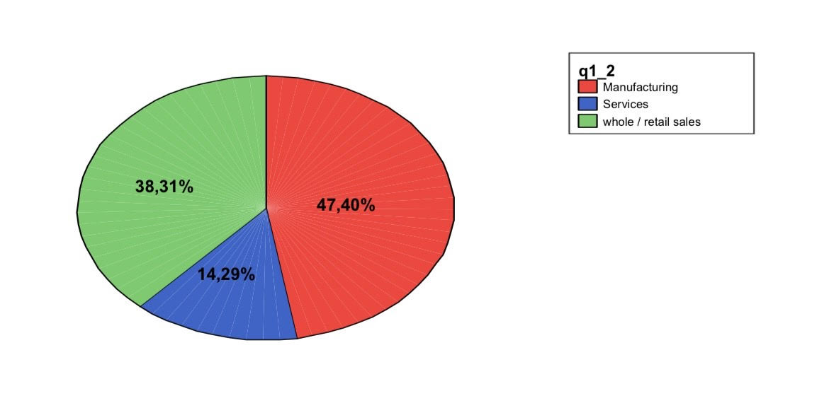20.8% percent of the respondents is CEO of the company, 17.5% are IT head and 15.6 % are head of accounting. Market-leading software SAP is mostly used ERP system followed by Microsoft Navision(fig.2).

Fig.2
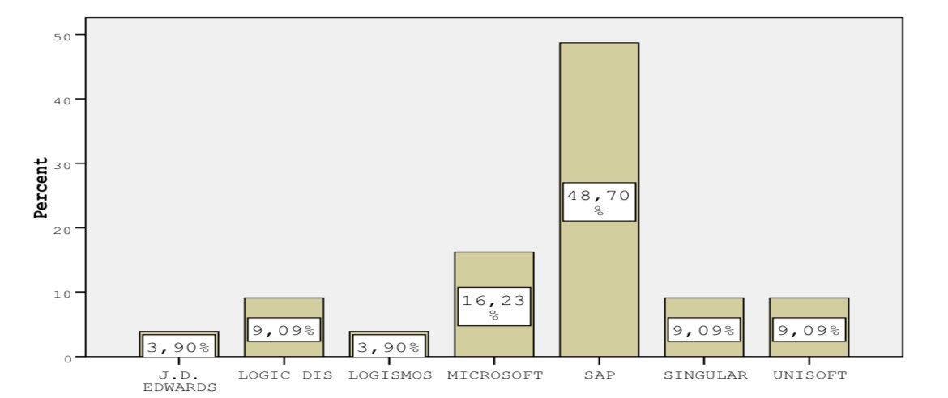After implementing the ERP system 60.7% percent of respondents reported 2% and up to 5% of total hike in gross sales, considering the expenses 48% saw -a 5% decrease in their expenses. The production efficiency has been increased hugely. The personal efficiency is also increased by 2% on 60% of cases. The main findings of the article are gathered through surveys made via addressed interviews to the managers of Greek SMEs, the data’s found through online surveys, telephone interviews and face to face meetings.

This study sheds valuable light on ERP system implementation in Greek SMEs, yet it faces limitations that pave the way for future research. Increasing the response rates of the surveys and becoming more dynamic in the selection of data, for instance through international partnerships based on statistical authorities, would lead to a better diversification of the sources. Investigating non-ERP systems, such as Decision Support Systems (DSS) and others besides would provide a deeper understanding of IT implementation in the SMEs of Greece. Moreover, the research should not remained within the boundaries of Greece to include SMEs originated from different cultural settings in order to make a comparison across cultures that will add and widen our understanding of ERP implementation dynamics. Utilizing the average scores as benchmarks for the additional surveys will direct the management through actions while the further research on the stakeholders’ feelings and the experiences with an ERP system will point out the places for an improvement. Finally, attempts should be made to overcome these shortcomings and take advantage of additional research orientations, thereby improving our knowledge on the SME IT adoption factors and shaping more successful management approaches.

The ERP systems supply organizations with the ability to connect the operations as well as information management but also present challenges, for instance, they adjust the work practices, and the culture of an entity. However complex the repercussions may be, ERP systems are able to organize business processes as well as give real-time information. On the other hand, there are several challenges such as the requirement for specialized technical support and customization. Research in the Greek context is rather limited and there have been no studies on ERP adoption and selection. SMEs, which make up the main part of business, will be able to utilize ERP systems, yet, they will have to address some issues unique to their business operations. Of these challenges is lack of resources and customization to match SMEs’ work practices. Further, the recurrence of bad ERP implementations exemplifies the significance of managing organizational change effectively. In the Greek market, the issue of vendors misinterpreting ERP systems and unethical practices is an additional one that further complicates implementations. Filling these gaps demands a holistic approach to the ERP system's mapping and an appropriate implementation strategy that is consistent with the features of the Greek SME environment. Onward consideration is necessary to measure ERP benefits for SMEs in Greece and identify methods of overcoming implementation barriers.

This study considers the case of ERP system implementation in Gree SMEs and provides insights into this theme which has been under-researched about adopting ERP systems. A socio-technical approach is used. Although ERP systems are created from an all-embracing perspective, the particular organizational, cultural, political and economic attributes of every country can influence their implementation. Differences in culture, laws of the land, and user choices are among the parameters which externally affect ERP implementation. Organizations that focus on Critical Success Factors (CSFs) have a smoother journey than those which do not. However, barriers such as the "not invented here" attitude and an environment that is not suitable, which are formed by national and organisational cultures, can hinder success. This study presents essentials for creating an ERP implementation toolkit customized for the Greek environment and increasing the probability of success in ERP implementations within Greek SMEs.

References
Al-Mashari, M., Al-Mudimigh, A., & Zairi, M. (2003). Enterprise resource planning: A taxonomy of critical factors. European Journal of Operational Research, 146(2), 352–364. https://doi.org/10.1016/s0377-2217(02)00554-4
Mullins, R., Christos, C., & Iannacci , F. (2011). An empirical study of ERP implementation, in Small and Medium Enterprises in Greece. https://drcc.eu/documents/final%20paper%20icesal_chatzichristos.pdf
Please Log In. (2021). Aisnet.org. https://aisel.aisnet.org/cgi/viewcontent.cgi?article=1448&context=jais
Poulymenakou, A. K., & Borotis, S. A. (2005). Adoption of Enterprise Resource Planning Systems in Greece. Lecture Notes in Computer Science, 559–570. https://doi.org/10.1007/11573036_53

Slides


