Daniel James Lewis

1702173

Fine Art: Studio, Site & Context

Module: Changemakers: Creativity and Value Creation

ADAA5000

Paul Duerinckx

Zine Evaluation

Word count: 514

Zine Evaluation
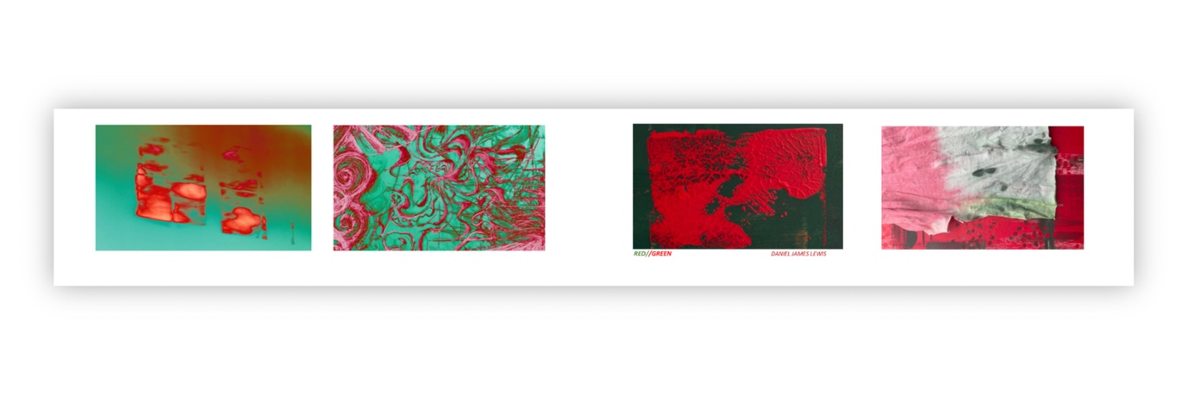
Fig. 1, Side 1 of Zine
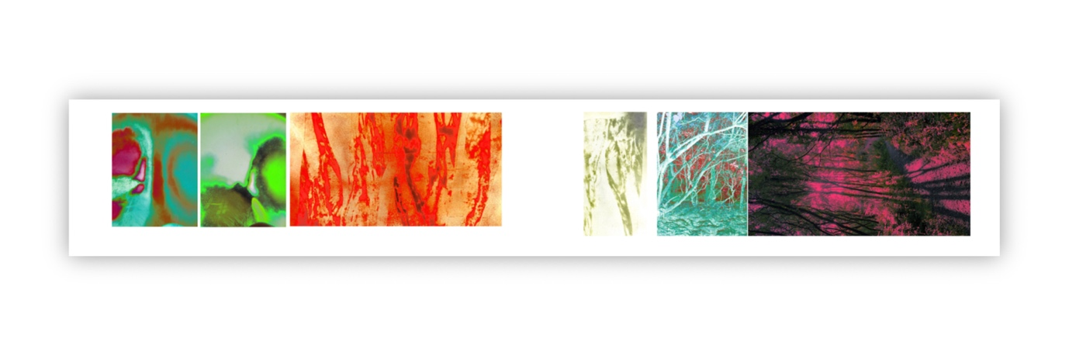
Fig. 2, Side 2 of Zine

For this project, I wanted to keep the contents fresh and relevant to my up-to-date art practice. My overarching subject within my art is heavily centred around colour, specifically reds and greens due to my colour blindness with those specific colours.

My art doesn’t always stick to the same mediums, so I wanted to show that within my zine. In my final, realised zine, I’ve included some of this variety, ranging from paintings, drawings, sculpture, digital photography, and digital editing. I wanted to show that I am a multidisciplinary artist, and the ways I can get to my individual desired outcomes, and the slight differences in visuals between each approach.

Before reaching this conclusion in showing a variety of my approaches, I had considered a single medium approach to this zine, keen to keep a more cohesive feel. (Akbari, 2018) I’d thought of printing images of my recent paintings, or painting new images from scratch for this project, as that is typically my medium of choice. I had considered only printing photographs, knowing that often has a sleeker look in my experience.
I realised what I was searching for in these different ideas was a sense of cohesiveness and thought using one medium would be the easiest route to achieve that.

The construction of the zine itself took a lot more thought than I had anticipated. I’ve made zines in the past and wanted to push this one further. Firstly, I considered the material of the zine, then considered my own practice and what I had been using in that. So, I contemplated using paper, glass or plastic panes, common materials I had already been using, or maybe other materials like acetate sheets that had been printed on, or fabrics that I’m less accustomed to. After contemplating these ideas, I realised some of these weren’t all that practical for my desired outcome and was simply overcompensating. Most of these materials wouldn’t have worked in relation to what I had intended to put into the zine. This led me back to simply printing onto photo paper, knowing it would result in a neater, sleeker finish on the white background, using photo paper with the intention of it being a thicker, sturdier paper in comparison to the more accessible, typical printer paper.
I decided to use little to no text within the zine from a stylistic point of view for the visual I was aiming for. I felt in this instance there wasn’t much to say and would just be adding for the sake of adding, I believed that the zine title, RED//GREEN, would speak for itself. (Sonnichsen, 2021)
The zine itself was printed onto two separate sheets of A4 paper, folded into quarters, and attached with coloured string. When closed, the zine is roughly the size of an A6 paper, then goes on to fold open to a double sided, 4-pane spread of images, stretching to roughly 42cm in length.

I feel the final product was successful, the zine showcases my practice and interest clearly, and was technically crafted in a way I’m pleased with.

References

Akbari, R. (2018) How to make a zine, – The Creative Independent. Available at: https://thecreativeindependent.com/guides/how-to-make-a-zine/ (Accessed: January 9, 2023).

Sonnichsen, A. (2021) Research guides: Zines: What's A zine, anyway?A, What's a Zine, anyway? - Zines - Research Guides at Mount Saint Mary's University Library. Available at: https://msmu.libguides.com/zines (Accessed: January 9, 2023).

