University of Wales Trinity Saint David

Certificate in Higher Education Skills for the Workplace

Academic and Employability Skills – BMSW4001

Reflective review on Employability skills

Author: Supervisor:
Neli Miteva Giridhar Katti
2113297

December 07, 2021

Introduction

Nowadays when technology is much more developed compared to the last sentry, the company industry is highly competitive, and employers are looking for people who can concentrate on strong employability skills rather than just the degrees they have. Businesses demand candidates with a diverse set of abilities to contribute to the workplace, as well as people who have many skills and are capable of doing a variety of tasks. As a result, candidates who enter the workplace should possess the necessary abilities. To increase our competitiveness in the workforce of the prospective, we should first determine what employability skills employers seek in graduate students, next conduct personal research, and analyze an improvement plan based on the skills required.
Employment skills and employability skills may often refer to be the same, they appear to be considerably different. Dependability and honesty are such abilities that make somebody employable, they are also known as employability skills. Where abilities such as knowledge and expertise in certain fields as well as communication, accountancy, and digital abilities are skills that are needed to perform well at work refer more as Employment skills.

Time Management skill
What is Time management? – “The practice of using the time that you have available in a useful and effective way, especially in your work” (Cambridge Advanced Learner's Dictionary & Thesaurus, 2021). Online you can find a lot and different references about Time Management. Sure, it is a very important employability skill but is as much as it is and daily in our personal life. However, if we take it factually, we will discover that this is also a total fundamental difference because we cannot manage time! “Time just keeps flowing steadily past you: 60 minutes per hour, 24 hours per day, 7 days per week.” (Levin, P., 2007, p. 1). A widely held approach to determine if a project, an assignment, or a task is worth our time or not is the 4 Ds of time management, sometimes called the 4 Ds of productivity, which are Do, Delay or referred also as Defer, Delegate, and Dump knowns as Drop. By categorizing a work or assignment, you can successfully control your time and remain concentrated on what is important to you.
Time Management is the way I plan my time on different activities and tasks in my day. Because my time is limited, for me is very important to plan it wisely and in the best possible way, as we cannot go back in time. When I start going back to school after so many years, I felt very insecure and terrified because I was not sure if I will be able to manage my time. Like most other older students juggling between families and work, I start to doubt myself. With three kids, a working husband, and learning sessions at the university was very hard to organize my time but eventually, everything started coming in his place.
The worst part was to travel a little bit too far than I anticipated and to be so far away from my family because in case of emergency I would not be able to react as fast as I would want. However, for me starting university is more positive and beneficial rather than negative. Although it was very hard in the beginning, I feel good around my new surround of people, and friendships, the new things I learn in class every time, and the time I have for myself. The reason everything is going so well is that I found how to improve my time management. Still, I have a lot to learn but the challenges I am about to meet are even more exciting. I learn for myself, that even in the weakest and doubters’ moments if I manage my time properly everything is possible. My time management skill has never been my strongest but with everything I learn from my teacher in Employability skills, I am more confident. For the future, the thing I can do better is to start planning as early as possible and prioritize better, and apply the 4 Ds strategy more often so I can improve my time management skill.

Notes taking
The distinction between encoding and external storage of notes was first made by Di Vesta and Gray (1972). Encoding notes facilitates learning, as the method facilitates encoding information. By evaluating the performance of undergraduates who hear a speech without taking notes in addition to the result of students who are listening and taking notes, it is determined if students do not listen or record notes. An experiment was conducted based on three note-taking purposes: encoding, encoding with storage and encoding with external storage, comparative on conventional, matrix, and linear techniques (Kiewra, K. A., DuBois, N. F., Christian, D., McShane, A., Meyerhoffer, M., & Roskelley, D. (1991). The encoding function is when you take notes, but without review, the encoding plus storage is taking notes with reviews, and encoding with external storage is when you take notes from somebody else. Based on note-taking functions, it was found that encoding plus storing performed better than encoding and external storage for recall, and that encoding performed best for synthesis. As for synthesis performance, external storage outperformed encoding. Matrix notes were shown to perform higher than conventional notes in the study concerning note-taking techniques. A note-taking system can be used to store communications and send information to another party or oneself at a later time. Such information could be conveyed in a variety of forms, using symbols, graphics, initials, texts, or a mix of all possibilities; hence, note-takers have a variety of alternatives at their disposal. Higher education has practiced notetaking for millennia, and it is a critical part of education. The act of taking notes consists in capturing information in a product-oriented fashion. To put it another way, regardless of the manner or tactics employed to take notes, notes are visual and tactile representations of information collected by a reader.
Even at an early age, I always loved to take notes. Taking notes helped me not just in school but in my personal life as well. The good thing is that I used to take notes all the time, and I did not have any issues. I felt confident in class which helped me understand my tasks for all the assignments I have, as well as I was able to help even others. In the future, I plan to develop my way of taking notes and make them more understandable and faster, including mind maps and symbols.

Digital skill
In today's digital economy, innovative tools are often presented as instruments that will improve cooperation, motivate students to return to school, and enable them to gain new multimedia reading skills. The Digital Education and Learning series emerged from this background to investigate the educational potential and realities of digital technology in a variety of disciplinary contexts across the educational range all around the globe. Bringing a digital environment to life requires electronic models. The ability to use digital tools provided students the ability to flourish in all aspects of life; the teaching and learning environment connected everyone to the rest of the civilized world. The goal is to meet the needs of both students and teachers, as well as students themselves, by giving them information on all online technologies which are important for education and development in the electronic era. An increasing number of worldwide organizations are working to improve people's employment prospects. More data is needed to understand the connection between employability and digital skills, particularly in conditions of determining whether the concentration of digital skills is sufficient intended for humanizing employment prospects. As the global economy continues to grow, the need for an information revolution and a knowledge economy has increased. According to Ashcroft (2005), this era has also been referred to as the digital age.
I always have been interested in digital skills and computer technologies. I was lucky enough to grow in a period when even people from the lower class could afford to buy a mobile phone or even a computer. I remember the first time we had to work on a computer in school, was so exciting and since then I tried to be familiar with all new technologies and the features they provide. All knowledge I have gained helped me with my assignments and nowadays, that is why I never struggle with the digital part of the tasks. Although I feel confident in my knowledge in the future, I would take some extra classes.
Team working skills
Human resource development advocates have come to accept that higher skills are increasingly in demand in the modern workplace over the past decade. Communication skills, information and technology abilities, problem-solving skills, working with orders, and enhancing one's own learning and achievement are all important in the United Kingdom. In addition, economists Freeman (1995) and Osterman (1995) have debated the relative significance of globalization and technological change as underlying economic imperatives propelling the growth in skill demand. Furthermore, a recent study shows that shifts in job and related skills are inextricably tied to new innovation (Bresnahan, 1999). Although a near-universal agreement that the demand for skills is increasing, we are still far from understanding or acceptance on the origins of basic skills.
Team working skill is my strongest skill. I always knew how to communicate and work with other people as part of a team. I have previous experience as I changed several workplaces in different areas and all of them, I had to work with someone else. I can proudly say that I never had an argument and always manage to keep good relationships with my colleagues even if I do not work with them anymore. I had the chance to work in a team on two of our assignments during the first term this year on two different modules. As a team, we had to choose a group leader and the rest of the group voted for me. I have been a team leader before and for me was easy to distribute all the tasks between all of us, keep in touch, and be sure all individual tasks will be with me on time so I can combine them and send over the final task before the deadline. As part of the second teamwork task, we had to deliver and presentation. Although I always was terrified to speak in front of an audience, the feedback we received was very positive. I dare to say my part of the presentation was presented very well, and our group received positive feedback as is shown in the attached appendix after my reference list.

Conclusion
I believe that graduates who are seeking a job with a high degree have an excellent chance because a higher degree helps them to find a better job. However, nowadays when the demand for a good job is higher than ever it is not enough to have just a degree. Employers are looking for much more like what types of employability skills they have if they will be able to attribute to the company and the business, which they give them the opportunity to distinguish themselves in the fiercely competitive market. I compiled a nine-part list of the most in-demand employability skills that the companies are looking for in their future employees. As a result, I created a future plan. Once I finish the course, I hope to increase my employability skills, and I intend to stick to the plan. After graduation, I want to find an excellent career in the employment industry.

Reference list

- Fajaryati, N., Budiyono., Akhyar, M. and Wiranto. (2020) ‘The Employability Skills Needed To Face the Demands of Work in the Future: Systematic Literature Reviews’, Open Engineering, Vol. 10 (Issue 1), pp. 595-603. https://doi.org/10.1515/eng-2020-0072

- Gravells, A. (2010) Delivering employability skills in the lifelong learning sector. Exeter: Learning Matters.

- Green, F., Ashton, D. and Felstead, A. (2001) ‘Estimating the determinants of supply of computing, problem‐solving, communication, social, and teamworking skills’, Oxford economic papers, 53(3), pp. 406–433. doi:10.1093/oep/53.3.406.

- Kiewra, K.A. et al. (1991) ‘Note-Taking Functions and Techniques’, Journal of educational psychology, 83(2), pp. 240–245. doi:10.1037/0022-0663.83.2.240.

- Levin, P. (2007) Skilful time management! Maidenhead, England ;: Open University Press.

- Pirzada, Kashan and Khan, Fouzia, (November 12, 2013) ‘Measuring Relationship between Digital Skills and Employability’. European Journal of Business and Management, Vol. 5, No. 24, 2013, Available at SSRN: https://ssrn.com/abstract=2382939

- Plan P. (2021) ‘The 4 Ds of time management’, [Online] Available from https://www.productplan.com/glossary/4-ds-of-time-management/. [Last accessed 06/12/2021]

- Siegel, J. (2021) Developing notetaking skills in a second language: insights from classroom research. London; Routledge.

Appendix

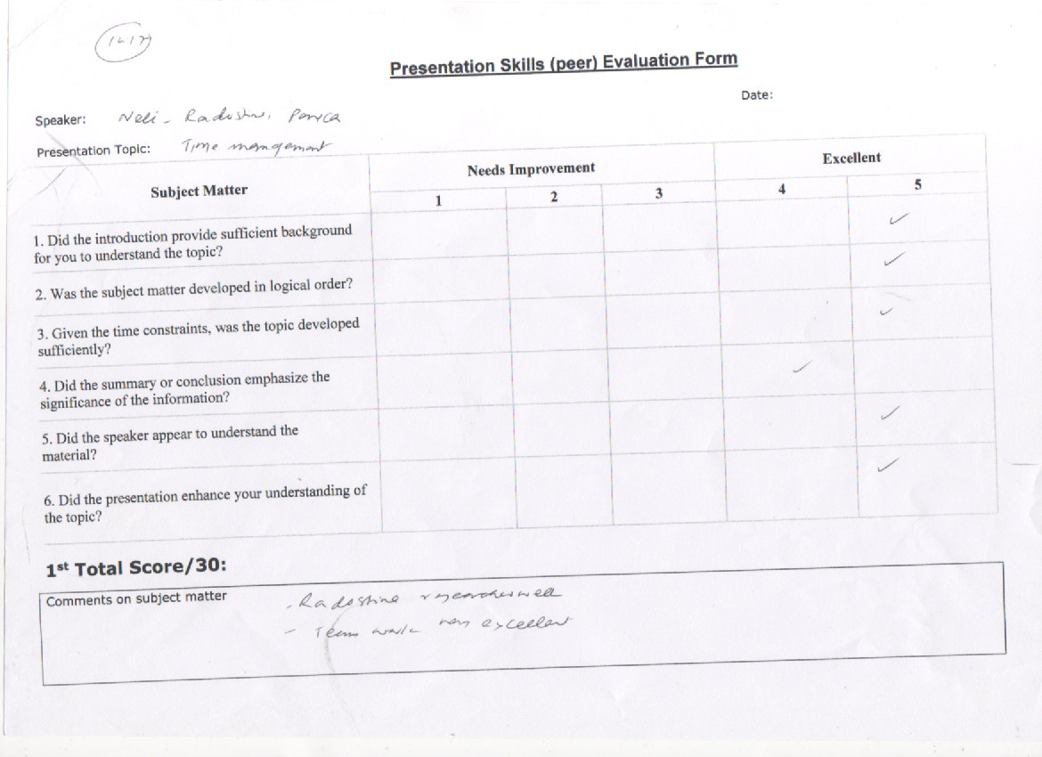

Appendix


