Case Study
the SA1 Swansea Innovation Matrix

8th January 2024
Rhodri Thomas

ACBA5000

Safiya Nanton
2114630
Table of Contents
Executive Summary 3
Location 4
1.0 Climate and Weather Conditions 4
1.1 Soil Conditions 6
1.2 Local Building codes and regulations 7
Foundation 8
2.0 Geotechnical Appraisal 8
2.1 Foundation Type 11
Design and Structural Properties 12
3.0 Material Properties 12
3.1.Fire Safety 13
3.2 Architectural Integration and Aesthetics 14
3.3.Environmental Impact 15
Conclusion 16
References 17
Annexes 19

Table of Figures
Figure 1: Map displaying site location in Swansea Bay. Exact location of building is highlighted.
Figure 2: Map displaying the flood risk areas in Swansea Bay around the location.
Figure 3: Map displaying the Soil composition of the Area with its corresponding legend.
Figure 4: Borehole Index found of the Swansea Bay area with the highlighted location of study
Figure 5: Borehole data (1)
Figure 6: Borehole data (2)
Figure 7: Illustration of a typical Prestressed Concrete Pile and its sizes
Figure 8: Examples of a building using Fibre Cement Cladding. Visionshuset or Vision House in Denmark

Executive Summary

Within the domain of construction, the foundation and superstructure are fundamental components that mutually establish the durability, constancy, and ecological viability of a building. The foundation, which serves as the fundamental support for the structure's structural integrity, requires an in-depth review, particularly considering the distinctive characteristics of the site. The objective of this research is to conduct an extensive investigation into the prerequisites for foundations, with a particular focus on the critical significance of geographical context in determining the most suitable construction method. Through an examination of the regional topography, we shall ascertain the extent of the excavation requirements, thereby illuminating any potential obstacles that may arise. Subsequently, our analysis expands to encompass the superstructure, where the choice of materials transforms into a complex interplay involving aesthetics, environmental impact, fire safety, structural integrity, and structural robustness. As we traverse this complex terrain, we shall meticulously examine every aspect, explicating the way the selection of materials plays a crucial role in constructing a building structure that is environmentally sustainable, visually appealing, and durable. This research endeavour aims to shed light on the interdependent connection that exists between the superstructure and foundation, demonstrating how their seamless integration is critical in the construction of long-lasting structures that effectively integrate functionality, safety, and environmental sustainability.
In the absence of borehole logs at the site, data was analysed by comparing information from nearby borehole logs to make a reasonable assumption regarding the composition of the soil. The soil composition of the site was determined to be sand, sandy clay, clay, and gravel. It is well known that these soil properties expand or contract in response to a variety of conditions. Engaging in building operations without the potential for inconsistent subsidence and fractures in the framework becomes challenging. These criteria were considered during the construction of a suitable form of foundation to support the structure. Deep foundation types are frequently employed in this situation; therefore, driven piles are advised for this area.

Location
The building is located in the port region of the city, next to both the marina and the extensive beach that extends for many kilometres. It is situated next to the university's main structure, the IQ, and the recently constructed library, Y Fforwm. Below is a map illustrating the previously mentioned location.
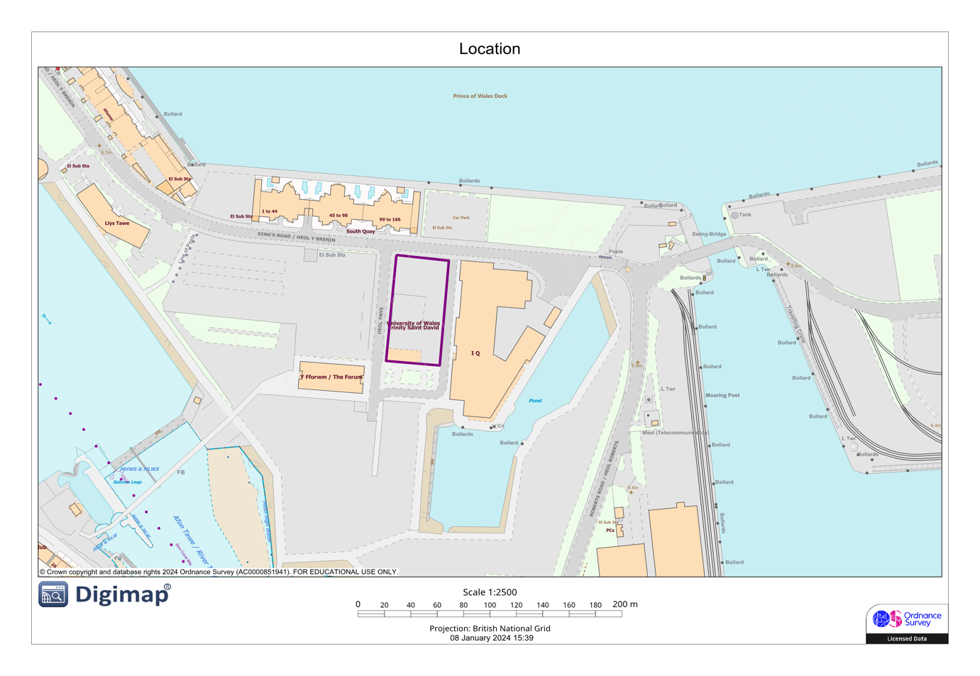
Figure 1: Map displaying site location in Swansea Bay. Exact location of building is highlighted.

1.0 Climate and Weather Conditions
In order to identify flood-prone areas and come up with plans to lessen their impact, a flood risk and management report is useful. The NRW website began hosting Preliminary Flood Risk Assessment (PFRA) reports on December 22, 2018, marking the beginning of the cycle. To develop a PFRA, it is critical to identify regions susceptible to inundation. These areas are distinguished by a significant risk of flooding, which presents a substantial menace to the welfare of individuals, the stability of the economy, the ecological system, and even cultural heritage. Swansea Bay was identified as one of nine regions in Wales that were susceptible to flooding at the time in question. The procedure discerns areas that are significantly susceptible to flooding and require further analysis through the development of flood hazard and risk maps, in addition to flood risk management strategies Pilman (n.d.).
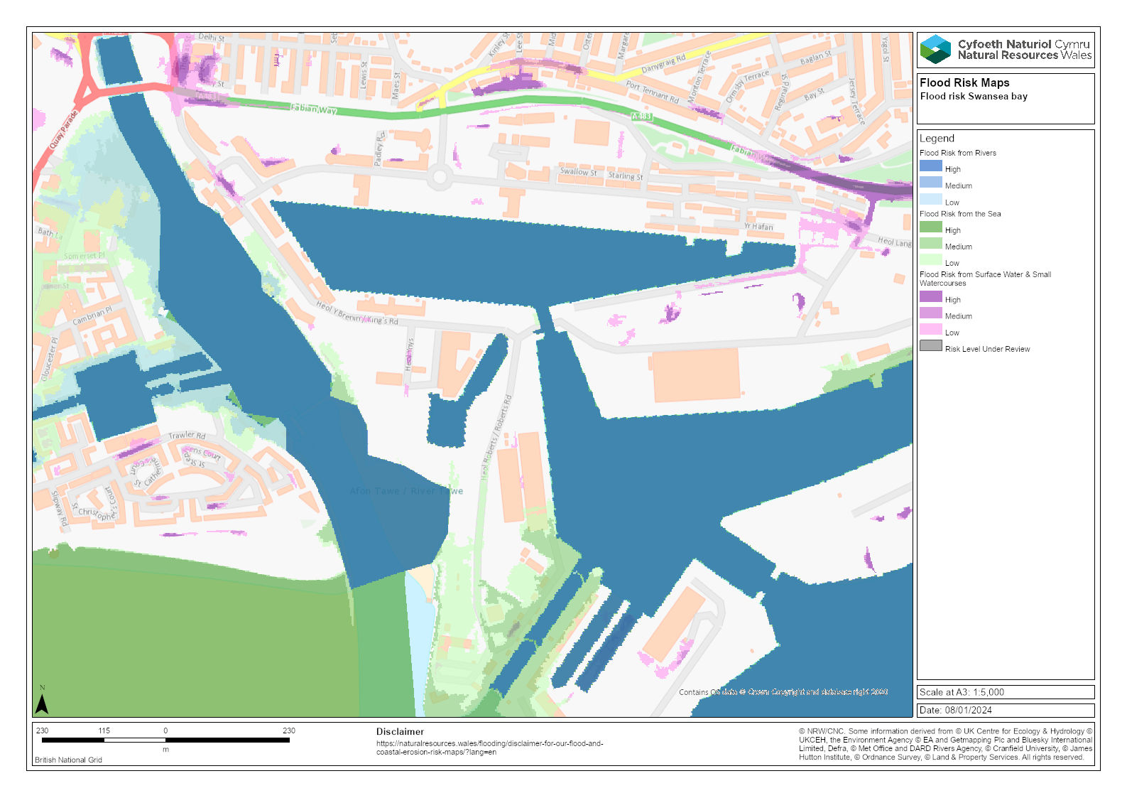
Figure 2: Map displaying the flood risk areas in Swansea Bay around the location.
The highlighted areas surrounding the location on the map above are susceptible to flooding, particularly from the sea.
Not only is at risk from flooding by the surrounding bodies of water, but other flooding events can also occur; Surface water flooding, ground water flooding and sewage system floods just to name a few. When the capacity of local drainage networks is surpassed by heavy precipitation, surface water flooding occurs, wherein water flows across the ground. Groundwater flooding transpires when the groundwater level increases to a height sufficient to cause the surface to be submerged, thereby flooded. It frequently develops in regions with favourable underlying geological conditions and is precipitation-induced. Coal mining areas in the majority of South Wales are generally associated with a higher risk of groundwater flooding. At present, historical records do not document any instances of groundwater flooding in the County and City of Swansea that could be deemed consequential in nature. Sewer systems are a prevalent feature in all urban areas included in the study region. Sewage systems of the past were predominantly constructed to transport foul and surface water concurrently, and as such, they were constructed to a lower standard. Prolonged intrusion of excessive water into the drainage network may lead to substantial detrimental ramifications.

1.1 Soil Conditions

To comprehend the changes in soil conditions of the area, it is important to possess a thorough awareness of its historical context. The area of South Wales, where Swansea is located on the southwestern periphery, was formerly a hub of industrial activity. Swansea had significant deindustrialization and economic collapse in the latter part of the 20th century, resulting in many social, economic, and environmental problems. This decline occurred after the city reached its industrial peak in the 18th and 19th centuries. The second phase of the industrial revolution, which began in the early 18th century, had a significant influence on the overall urban growth of Swansea. Swansea emerged as a significant worldwide centre and one of the first industrial cities in Britain throughout the 18th and 19th centuries, leading the way in the industrial revolution (Tallon, Bromley and Thomas, 2005).
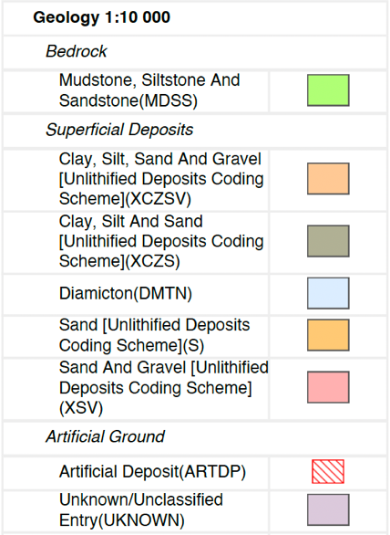
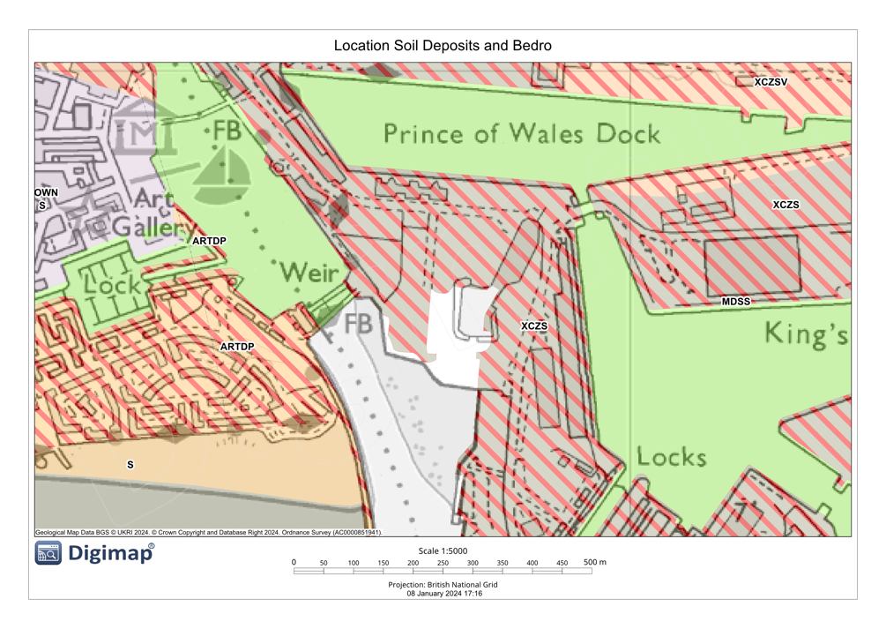
Figure 3: Map displaying the Soil composition of the Area with its corresponding legend.
The map shown above illustrates and identifies the soil composition of the area. This is crucial as it will aid in determining the load-bearing capacity of the soil and identifying the most suitable foundation type. As shown, the region of interest mostly consists of clay, silt, and sand. This information is elaborated upon in the subsequent borehole data provided.

1.2 Local Building codes and regulations

The Building regulations guidance provided by the Swansea Council (BS 6399-1:1996 standard), states that “The building shall be constructed so that the combined dead, imposed and wind loads are sustained and transmitted by it to the ground: […] without causing such deflection or deformation of any part of the building, or such movement of the ground, as will impair the stability of any part of another building.” Swansea Council (2010). This statement emphasises the significance of designing and constructing a structure in an approach that prevents excessive deflection or deformation and prioritises safety and stability. This underlines the importance of considering not only the structural integrity of the building but also its potential impact on the surrounding environment, to ensure that the structure does not compromise the stability of neighbouring structures. It is critical to comply with building regulations and technical standards in order to achieve these goals and ensure the long-term safety and stability of the constructed structure.

Foundation

2.0 Geotechnical Appraisal
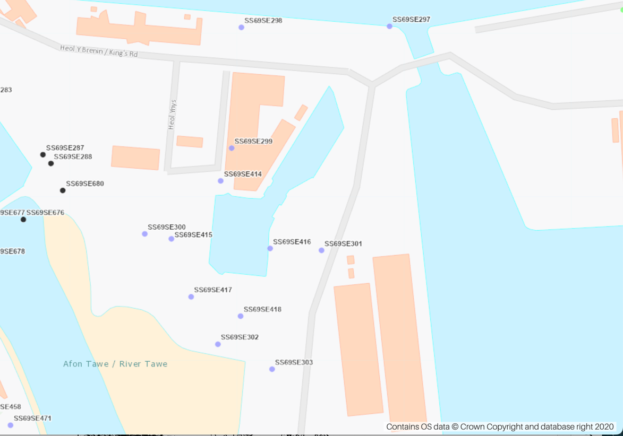
Figure 4: Borehole Index found of the Swansea Bay area with the highlighted location of study
The precise location under investigation lacks available borehole data. The analysis of data obtained from two boreholes in close proximity assisted in the comparison and determination of the soil composition and best depth of foundation needed.

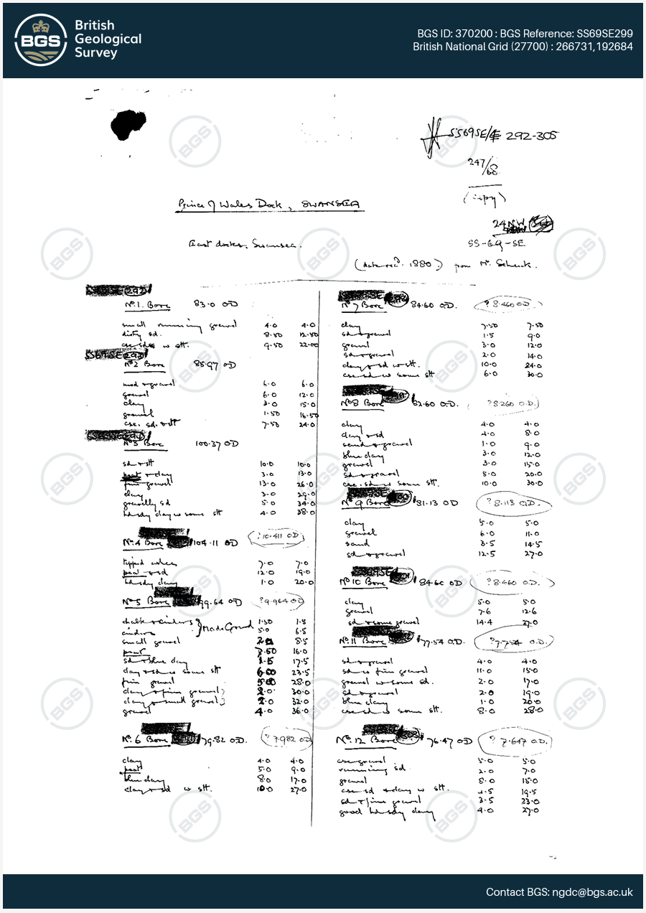
Figure 5: Borehole data (1)

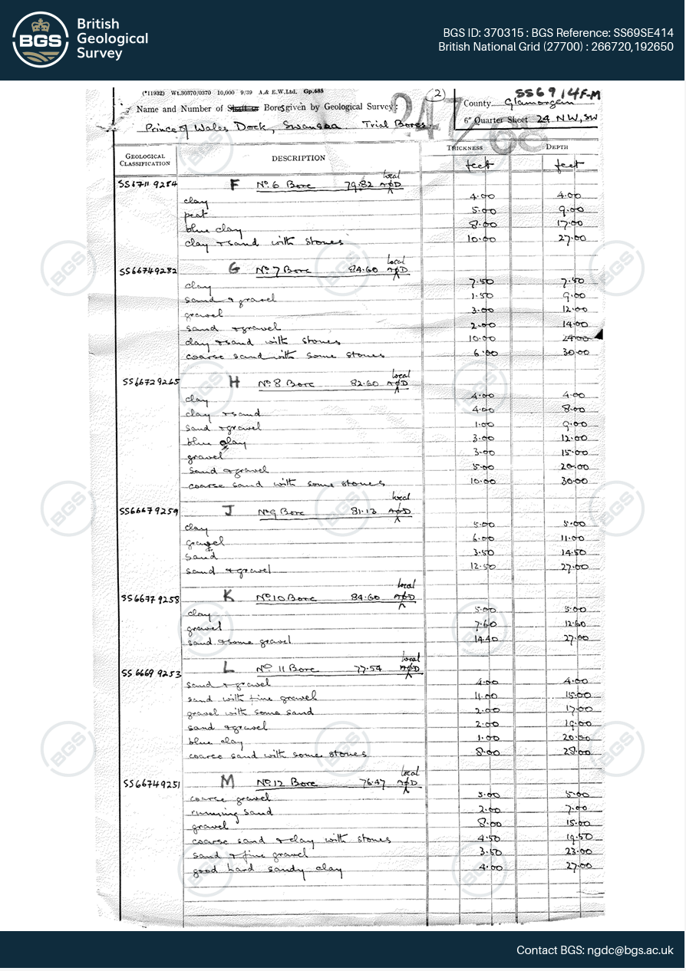
Figure 6: Borehole data (2)

After analysing the borehole data at the location, it was ascertained that the till beneath it was artificially created. A variety of rocks, including sand, clay, and fine gravel, can be observed at depths between 3 and 20 metres. The drill log reveals the presence of compact sandy clay, coarse sand, and stones at depths of 27 and 30 metres, consistent with the information obtained from both borehole logs. Primarily, this mixture of clay, sand, and aggregates (gravel) of varying sizes is employed to increase the soil's durability and rigidity. However, it is suboptimal for constructing load-bearing structures.

2.1 Foundation Type

Pile foundations have been widely used in the construction of high-rise buildings and multi-story structures to enhance load-bearing capacity, minimise foundation settlement, and accelerate the construction process (Zhanabayeva et al., 2021).
Based on the borehole data and the location of the site, a driven pile foundation is advised. Preventing the formation of additional air spaces in the soil by compressing the ground around and beneath the pile, as opposed to removing it, renders the current soil suitable. Before excavation, piles are frequently utilised to reduce expenses and accelerate the process. Additionally, they produce minimal disturbance, which is especially beneficial considering the proximity of the building to residential areas and the university.
To understand the behaviour of clayey soils when they experience partial drainage, it is essential to conduct direct shear tests that include a range of situations from undrained to drained. These experiments enable the modelling of soil behaviour under different loading circumstances. Considering the magnitude and importance of the project, it is recommended to do a pile load test that includes both horizontal and vertical loads. Implementing this approach is crucial to optimise soil characteristics and ensure the effectiveness of the foundation design for buildings (Comodromos, Papadopoulou and Rentzeperis, 2009).
Given that the boreholes achieved a maximum depth of 30 metres, it is optimal that the driven foundations attain the same depth. The utilisation of driven piles eliminates the necessity for excavation to cast concrete, thereby requiring only the excavation of the uppermost stratum of soil. As a result of the continuous compression that maintains the closure of hairline fractures in prestressed concrete piles, they are typically more resistant to corrosion and weathering than piles reinforced with conventional methods. The corrosion resistance of prestressed concrete in comparison to reinforced concrete obviates the necessity for specialised steel coatings (Hannigan et al., 2016). An illustration of a typical Prestressed Concrete pile can be found in Figure 7.
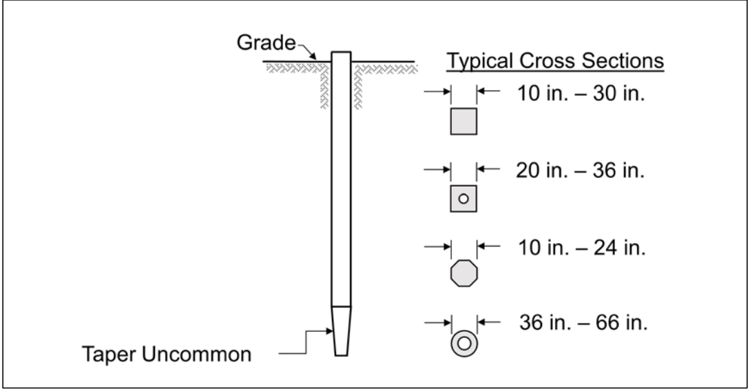
Figure 7: Illustration of a typical Prestressed Concrete Pile and its sizes

Design and Structural Properties

3.0 Material Properties

According to (Swansea Council, 2010), “[…] guidance on the support and fixing of wall cladding. An acceptable level of safety can be achieved by different means depending on the type and location of the cladding.” In essence, expresses that the cladding must be able to sustain and transfer all rigid, shifting, and wind loads to the building's support system. This ensures that the cladding improves the overall structural strength of the structure. It must be securely attached to and strengthened by the building's structure. This requirement includes both horizontal and vertical constraints, indicating that the cladding must be firmly attached to the structure of the building in a way that prevents accidental separation or movement. It is necessary to take precautions to consider any potential difference in movement that may occur between the building cladding and the supporting structure. The occurrence of relative movement between the cladding and the structure may be attributed to fluctuations in temperature, humidity, or the building's settlement. Consequently, this natural occurrence is of utmost importance. Both the cladding material and its fasteners, including support components, must be made from durable materials. The fasteners must have a design life that matches the cladding. By doing so, it ensures that the cladding system will retain its structural integrity and visual attractiveness for an extended period of time. The fixings used to secure the cladding must be corrosion resistance. When choosing construction materials, examining the local environment and aspects such as possible exposure to corrosive substances, rainfall, or salt content is essential. This aids in preventing the progressive deterioration of the fixings Swansea Council (2010).
When choosing the material for pile foundation construction, its load-bearing capacity and resistance to corrosion are the primary factors to be taken into account. When taking into consideration these factors, the structure's overall strength and durability would satisfy acceptable standards.

3.1. Fire Safety

In fire safety, the spreading of fire across the surface of a solid, combustible object is a crucial factor, as it influences both the rate of heat release and the early ignition of a fire. The materials utilised in the construction of a structure must therefore be secure or resistant to fire. Priorities include protection against fire and inclement weather when choosing cladding or the exterior face of a structure. An evaluation must be conducted regarding the potential integration of the building's exterior design with the pre-existing structures in its vicinity. Knowing this Prestressed concrete piles were determined the best materials for the pile foundations and Fibre Cement Cladding for the exterior façade of the building.

3.2 Architectural Integration and Aesthetics

Research indicates that Fibre Cement Cladding has fire and weather resistance. Fibre cement cladding, also known as cement fibre cladding, is produced by combining cement with reinforced cellulose fibres. The composite construction material is manufactured in the shape of panels or boards. By affixing the sheets or boards to the outside of the building, a watertight layer is created to protect the structure's outer surface. This kind of cladding consists of a mixture of grit, cement, water, and a little amount of additives. Therefore, it is more environmentally friendly when compared to other cladding materials. Moreover, fibre cement cladding produces less emissions throughout the installation process.
Overall, fibre cement cladding often has a higher price tag compared to wood cladding. Although the initial investment is often more, the long-term cost of using materials other than lumber is cheaper due to decreased maintenance and painting needs. Inadequate installation of the cladding might lead to a variety of difficulties. If there is a breach due to faulty installation, the structure can be exposed to the elements. This might lead to a decaying framework and the occurrence of faults. The heavy weight of the product leads to higher installation costs since it necessitates the involvement of numerous personnel and needs a high level of competence (BuildingMaterials.co.uk, 2023).
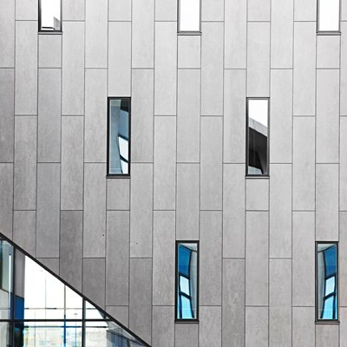
Figure 8: Examples of a building using Fibre Cement Cladding. Visionshuset or Vision House in Denmark
Regarding the integration of the building’s aesthetics and design, it is worth noting that fibre cement cladding has the capability to be manufactured in any colour as per the client's desire. By allowing customisation of the colour aesthetic according to the client's preferences, the building may be customised to meet any desired colour scheme. This not only reduces the expenses associated with painting the structure but also minimises the construction time required.

3.3. Environmental Impact

As the global impacts of climate change have become more evident, sustainability has emerged as a central topic of discussion across all industries. The materials utilised in architecture and construction have implications for both human health and the natural environment. Since the development of fibre cement cladding, recycled materials and less water are utilised compared to conventional cement. Conserving water is a significant step in the direction of environmental protection. While timber and similar materials are natural, they decompose more rapidly and are more difficult to recycle. The durability of fibre cement and its capacity to be manufactured from sustainable materials make it superior (Dalply, n.d.).

Conclusion
In conclusion, this extensive investigation clarifies the complex relationship between the superstructure and foundation, highlighting their critical significance in the construction of long-lasting, secure, and ecologically conscious structures. The examination of regional building codes, climatic and environmental variables, and soil properties revealed the necessity for a methodical approach to the foundation design. Given the lack of borehole records, a practical assessment utilising adjacent data unveiled the soil composition as comprising sand, sandy clay, clay, and gravel. As a precaution against possible subsidence and fractures, driven piles were advised. The vulnerability of the site to diverse forms of flooding emphasised the need for a sturdy foundation capable of withstanding such difficulties, with driven piles being the preferred choice. The investigation into architectural integration, material properties, fire safety, and aesthetics unveiled the importance of taking environmental impact into account. The selection of construction materials, including fibre cement cladding for the exterior and prestressed concrete supports for the foundation, was influenced by considerations such as load-bearing capacity, fire resistance, and environmental sustainability. As a result of its adaptability, resistance to fire, and reduced long-term expenses, fibre cement cladding emerged as a viable option for combining structural and aesthetic considerations.
Fundamentally, this study has furnished a comprehensive comprehension of the complex interplay between the superstructure and foundation, illustrating the critical nature of their seamless integration in the construction of environmentally sustainable structures that not only adhere to structural requirements but also fulfil ecological considerations. The study's findings and recommendations are intended to make a valuable contribution to the development of long-lasting structures that effectively integrate environmental sustainability, safety, and functionality.

References
Al-Saadi, R. and Brooks, M. (1973). A geophysical study of Pleistocene buried valleys in the Lower Swansea Valley, Vale of Neath and Swansea Bay. Proceedings of the Geologists’ Association, 84(2), pp.135-IN9. doi:https://doi.org/10.1016/s0016-7878(73)80012-4.
BuildingMaterials.co.uk. (2023). Fibre Cement Cladding: Advantages and Disadvantages. [online] Available at: https://www.buildingmaterials.co.uk/info-hub/insulation/fibre-cement-cladding-advantages-and-disadvantages.
Comodromos, E.M., Papadopoulou, M.C. and Rentzeperis, I.K. (2009). Pile foundation analysis and design using experimental data and 3-D numerical analysis. Computers and Geotechnics, 36(5), pp.819–836. doi:https://doi.org/10.1016/j.compgeo.2009.01.011.
Dalply. (n.d.). Pros and Cons of Fibre Cement Cladding. [online] Available at: https://dalply.co.uk/fibre-cement-cladding/pros-and-cons-of-fibre-cement-cladding/#:~:text=Even%20though%20the%20product%20itself [Accessed 8 Jan. 2024].
Hannigan, P.J., Rausche, F., Likins, G.E., Robinson, B. and Becker, M. (2016). Design and Construction of Driven Pile Foundations – Volume I. [online] ROSA P. Available at: https://rosap.ntl.bts.gov/view/dot/39220.
Lambe, T. and Whitman, R. (1976). (in progress) Fundamentals of Soil Behavior by.
mapapps2.bgs.ac.uk. (n.d.). GeoIndex - British Geological Survey. [online] Available at: https://mapapps2.bgs.ac.uk/geoindex/home.html?layer=BGSBoreholes&_ga=2.186313451.398978376.1702291625-2108598529.1702291624 [Accessed 8 Jan. 2024].
naturalresources.wales. (n.d.). Natural Resources Wales / Flood and coastal erosion risk in Wales. [online] Available at: https://naturalresources.wales/evidence-and-data/research-and-reports/flooding-reports-evidence-and-data/flood-and-coastal-erosion-risk-in-wales/?lang=en [Accessed 8 Jan. 2024].
Pilman , C. (n.d.). Flood and Coastal Erosion Risk Management in Wales, 2016- 2019 Report to the Cabinet Secretary for Environment, Energy and Rural Affairs under Section 18 of the Flood and Water Management Act 2010 Rev No: 1 Date.
Swansea Council (2010). The Building Regulations For use in Wales* Structure A. Welsh Government.
Sweeney, M. (2011). Environment Department -Transportation & Engineering Services City and County of Swansea Preliminary Flood Risk Assessment Environment Department -Transportation _1_ Drainage and Coastal Management CITY AND COUNTY OF SWANSEA DINAS A SIR ABERTAWE Preliminary Flood Risk Assessment City and County of Swansea Dinas a Sir Abertawe.
Tallon, A.R., Bromley, R.D.F. and Thomas, C.J. (2005). Swansea. Cities, 22(1), pp.65–76. doi:https://doi.org/10.1016/j.cities.2004.09.001.
Team, T.D. (2020). 5 Great Examples of Fibre Cement Cladding. [online] Dalply. Available at: https://dalply.co.uk/5-great-examples-of-fibre-cement-cladding/.
Tuula Hakkarainen (2002). Studies on fire safety assessment of construction products: Dissertation. Studies on fire safety assessment of construction products.
Welsh Journals . (1974). Cambria a Welsh Geographical Review. [online] Available at: https://journals.library.wales/browse/1186437 [Accessed 8 Jan. 2024].
Zhanabayeva, A., Sagidullina, N., Kim, J., Satyanaga, A., Lee, D. and Moon, S.-W. (2021). Comparative Analysis of Kazakhstani and European Design Specifications: Raft Foundation, Pile Foundation, and Piled Raft Foundation. Applied Sciences, 11(7), p.3099. doi:https://doi.org/10.3390/app11073099.

Annexes


