Independent Enquiry
Shawna Wright – 1802219
Course- BA Illustration (year 2)
Proposed Question For Independent Enquiry :How does trauma impact on an artist’s work, process and creative expression?
Word Count –2,579(Not Including Reference Bibliography)
Louise Burton
Question
3 Key Words
-Trauma
-Mental Health
-Creative Expression

Trauma, Process & Effect

An Independent Enquiry proposal

Artists often turn to their personal lives and experiences to find inspiration for their work. This Independent Enquiry will explore three keywords in order to create a link between them to create a question or statement that will be the starting point for this project. These keywords being Trauma, Process and Effect. With the support of three artists/ philosophers and the art that they produced influenced or inspired by their trauma and the different ways it has been used creatively and how it influenced their process, this research will support my question. By delving into the trauma of artists such as Frida Kahlo (Trauma), Tracey Emin (Mental Health) and Vincent van Gogh (Creative Expression) and researching to be able to create links between their trauma and process of their work and the outcomes influenced by their life experiences or hardship.

Trauma

“Trauma has no boundaries and can affect anyone regardless of age, race, or gender” - PsyLegal (2019)

The exploration of the word trauma in its self a broad subject with many different forms. By definition, in medical terms, trauma means a physical injury but in emotional terms, trauma is a deeply distressing or disturbing negative experience that leaves the victim overwhelmed and can cause lasting effects on their emotional and mental stability. Some of the most common events that can lead to trauma include events such as experiencing abuse as a child, rape, witnessing an act of violence but overall, they fall into 3 main forms; acute, chronic, and complex.
“Often associated with a single event that happens in an individual’s life, acute trauma could come in the form of a car accident, natural disaster, a single event of abuse or assault, theft, witnessing a violent event or an experience that threatens an individual’s physical or emotional safety. These such incidents and experiences can have a lasting negative impact on one’s psyche if left untreated, and impact the way they live their life” – PsyLegal (2019)
Different types of trauma can impact an artist and the process of their work in many ways. For some, it can be an empowering feeling to express trauma through creativity. It can be a way of “letting go “or as an outlet to try and free themselves from the negative emotions, that’s connected to them.
“They thought I was a surrealist, but I wasn’t. I never painted dreams. I painted my own reality”
– (Kahlo in Mexican Autobiography 1953)

One of the artists that support the question for this independent enquiry is Frida Kahlo. Kahlo experienced much hardship and had constant run-ins with trauma-related events that haunted Frida throughout her life she then used her trauma to fuel her creativity.

At the young age of 6, she was diagnosed with polio in her leg and at 18 was in a fatal bus crash that resulted in a rail impaling her through her back and out of her pelvis. Not only did Kahlo suffer physical trauma she also experienced the mental impact of trauma in her life. Kahlo was married in 1929 to Diego, a man who had wandering eyes and had numerous affairs (Burrus and Kahlo, 2008, A letter to Diego from Frida pp.114) and she divorced in 1939 only to remarry a year later. She had to live being bedridden for most of the life due to the repercussions of the crash and the series of surgeries to attempt to undo what the event had caused. Frida also struggled to conceive children as she had become pregnant 3 times, but the baby miscarried each time. (Burrus, C. and Kahlo, F. (2008 p.120-124) Kahlo’s pain and trauma towards the events in her life are heavily depicted within her artwork. “My painting carries within it the message of pain … painting completed my life. I lost three children … painting substituted this. I believe that work is the best thing.” -(Burrus, C. and Kahlo, F. (2008 p.120) Frida Kahlo: “I Paint My Reality.”)

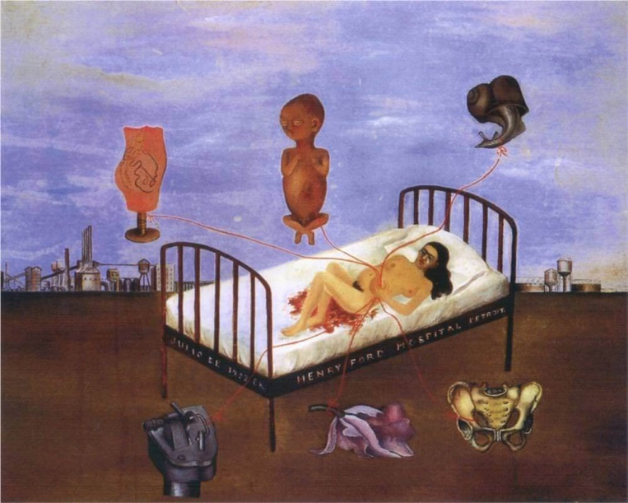
(“Henry Ford Hospital” by Frida Kahlo (1932))

Henry Ford Hospotal is an obvious choice as piece that shows Kahlo’s pain and suffering expressed through her art. The piece above shows the physical and literal representation of trauma in art. This piece depicts all of Kahlo’s worst traumas and experiences personified through creativity. The focal key points in this piece are the six main objects attached to Kahlo laying in a hospital bed, each connected by a striking red line that resembles an IV line or an umbilical cord representing the connection she feels to each of her traumas and residual link that is still between object and artist. The most striking objects in contrast within the painting are her depictions of her pelvis and the human foetus, these being an obvious representation of her bus crash and the miscarriage that she suffered.

In Kahlo’s life she was subjected to mass amounts off of trauma and had felt the hardship of the world from a young age, but regardless of the events she faced, she created masterpieces that give the viewer an undeniable feeling of understanding on the theme of trauma.

Mental Health

“Mental health includes our emotional, psychological, and social well-being. It affects how we think, feel, and act. It also helps determine how we handle stress, relate to others, and make choices. Mental health is important at every stage of life, from childhood and adolescence through adulthood.” -(MentalHealth.gov, 2000)

Mental health is defined by diction as “a person’s condition with regard to their psychological and emotional well-being.” (Collins English Dictionary, n.d.). In relation to mental health as well as trauma and the impact, it can have on an artist’s work/ thought process and their creations. This research is to support the words mental health in relation to this Independent Enquiry and to create the link between the artist, trauma and the effect it had had on their work process and outcome and how it created changes in their perception of art. Both poor mental health and psychologically sourced mental illnesses can affect the patient in many ways but through art, many people find a sense of empowerment through being in control of their feelings and being able to positively express their trauma through visual representation.

British artist Adrien Hill is known for his contribution to using art as a form of therapy. Hill served during the first world war and this caused him to experience extreme mental and physical trauma during his time as a signaller and scout during the war. His work later stemmed from him showing a companion his work who was the curator of the Imperial War Museum and the demand for real-life accounts from the front lines of WW1 in order to reduce propaganda, this led to Hill becoming the first official war artist by the museum. (Nicholls, 2013)
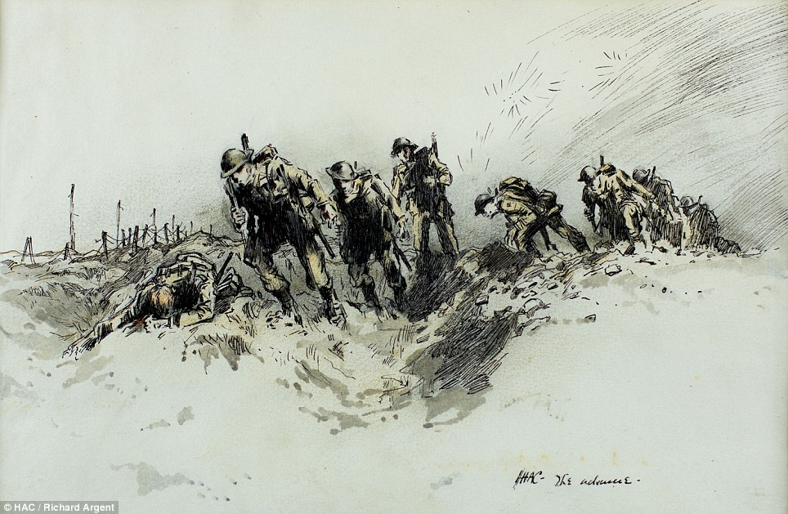
(sketch Adrian Hill - by Adrian Hill of the first battalion advancing at Gavrelle, France. (April 1917) (Duell, 2014)

Through exploration and trials of using art as a method of therapy, Hills created a book on his theories called “Art Versus Illness-A Story of Art Therapy” in 1945 (Hill, 1945) thus making him one of the lead theorists at the forefront of the art therapy movement.
“It’s this ability to channel her experiences that make Emin so extraordinary. She takes those experiences, loss, betrayal, vengefulness and abuse, and makes them available to the rest of us. She transforms them into something incredibly powerful.”- Paul Hobson d

Another British artist, Tracey Emin is known for her loud expressions of her own traumatic experiences. her depictions of her abortion, rape and sex that started from the age of 13 and the effect it has had on her both mentally and physically captured within her art as a form of self-acceptance, and reclamation of what she has experienced, taking the power away from those who have caused her heartache and holding it withing her own palms, taking control on how It is used and also her realistic take on the world from a first-hand perspective who has experienced hardship in its purest form is nothing less than captivating. (T. Emin, Strangeland, 2006)
“I had become conscious of my physicality, aware of my presence and open to the ugly truths of the world. At the age of thirteen, I realised that there was a danger in innocence and beauty, and I could not live with both.”
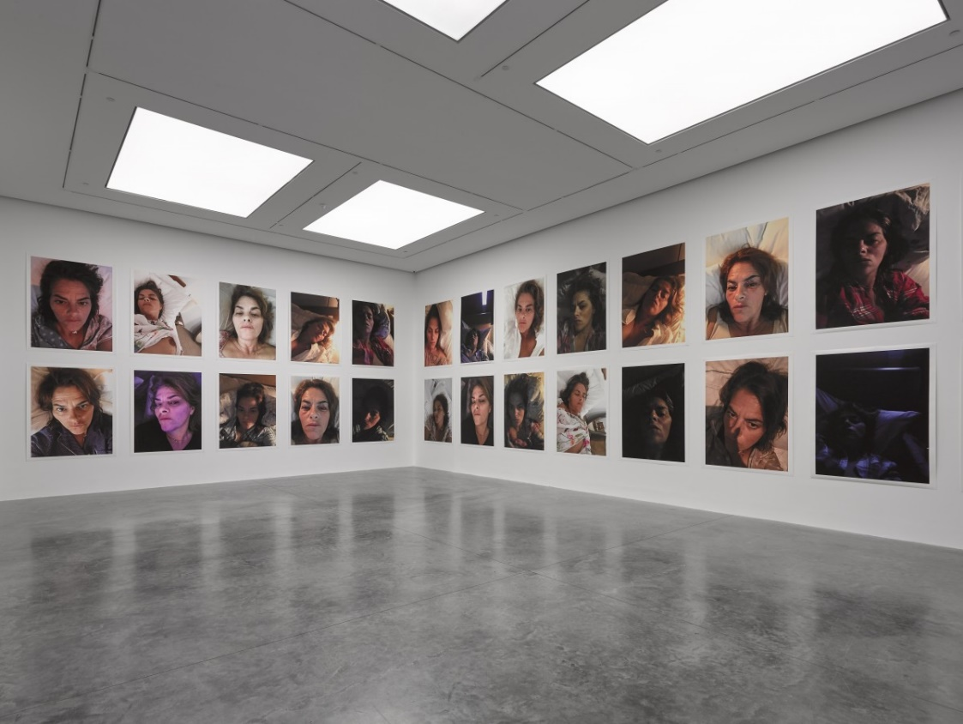
― (T. Emin, Strangeland, 2006)
(T. Christelis photography courtesy of White Cube, T. Emin – “A Fortnight of Tears” exhibition (2019))

Emin also opened a major exhibition in the White Cube Bermondsey between the dates of the 6th of February – the 7th of April 2019 titled “ A Fortnight Of Tears” (White Cube & T.Emin, 2019) This exhibition was a visual representation of her own traumatic experiences including the death of her mother and the griefs she suffered. Along with the mix of multi-media pieces, there are 50 self-portraits of Emin within the exhibition. these photos were taken late at night during the peak of Tracey’s relentless insomnia giving a raw insight into the aftermath left behind after suffering from trauma or a traumatic event and how it can have a lasting impression.

Emin went the extent of writing a book (Strangeland, 2006) filled with some of her innermost secrets and thoughts that caused major influence in her life and in her ways of perceiving the world published for all to see and feel on a personal, emotional level, captivating her audience with her hard-hitting sense of freedom and retaliation in the face of trauma.

Creative Expression

“The view that “art is imitation (representation)” has not only been challenged, but it has also been moribund in at least some of the arts since the 19th century. It was subsequently replaced by the theory that art is expression. Instead of reflecting states of the external world, art is held to reflect the inner state of the artist. This, at least, seems to be implicit in the core meaning of the expression: the outer manifestation of an inner state. Art as a representation of outer existence (admittedly “seen through a temperament”) has been replaced by art as an expression of humans’ inner life.” -(J. Hospers, 2019)

The term Creative expression can be defined as expression portrayed trough the source of creativity. The main elements necessary for creative expression are a medium or an idea. the medium of choice is defined by the maker, this can be any form of art that emmets the feeling of happiness or relief to the creator ranging anything from sculpting, printmaking to drawing or instillations, but obviously not limited to these examples as dance, theatre and anything else that can be defined under the word creativity can be a source.

Creative expression can also be portrayed through the technique, colour, process or outcome of the piece through analysis. One form of expression is through the physical marks made by the brush by the artist and then through analysing and interpretation deciphering the emotions and intent behind the results. an example of expression through the technique of can be shown through Vincent van Gogh’s art.
“Sometimes the subject calls for less paint, sometimes the material, the nature of the subjects themselves demands impasto.”- (Vincent van Gogh letter to Theo.Van Gogh,1882)
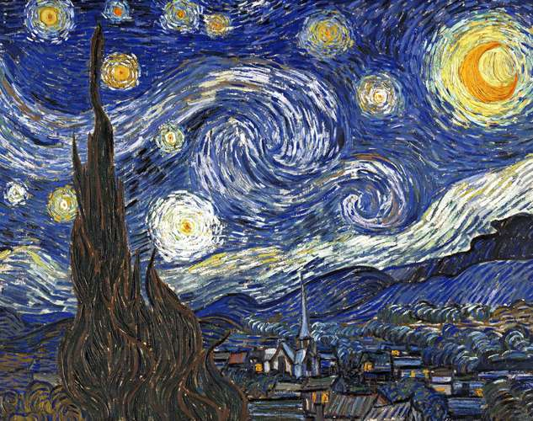
Van Gogh’s technique of choice within his painting was impasto, after experimentation within his practice, he soon adopted the impasto technique for most of his works. The Impasto technique is a thick application of paint to a canvas in order to create texture and depth within the layers, by using tools such as pallet knives and a variety of sized brushes to create the elevated effect and details. (Esaak, 2019)A notable work of Vincent’s that is an example of both his passion for the impasto technique and his own creative expression is the iconic piece “The Starry Night”.
(“The Starry Night”, Oil on canvas, Vincent van Gogh, 1889)
“The Starry Night “ was produced by Vincent during his stay at the asylum of Saint -Paul- de – Mausole in a period when his mental health appeared to be recovering before his decline that led to his suicide only 13 months later on the 29th of July 1890. (The Editors of Encyclopaedia Britannica, 2019). There is a wide variety of types of brush strokes, each can be interpreted and can reveal a lot about its creator as well as the emotion or intent behind each stroke and how the outcome may be influenced by real-life events surrounding the artist. The suffering of Vincent’s life is not visually depicted through his masterpieces in a literal sense but through interpretations, the marks he made on the canvas how he made them and what they represent, a whole new personal level of understanding can be reached.
Taking Vincent’s “The Starry Night “for example, there is a prominent brush stroke used often through this piece in order to create the iconic swirls of the piece or “starts”. this brush stroke is a blend between a fluid brush stroke and a harsh brush stroke. The fluid bush stroke is made of smooth motion and can be interpreted as “exhibiting the feeling of calmness” (Create And Release, 2013), while the harsh brush stroke uses thick paint to give dimension also leaving visible brush marks representing “something prominent in your life( whether good or bad )). (Create And Release, 2013) Giving the notion that when creating this piece Vincent mentally was in a place of calm yet had something large in his life that could, by all means, be the metaphorical persona of his experiences and the effect they had on him being expressed through his art.

Through the exploration of the three keywords for this proposal with the support of 3 artists the links between them are undeniable, from Van Gogh’s meaningful brush strokes, Kahlo’s abrasive portrayal of her own reality through painting to Tracey Emin’s declarations of her innermost thoughts, secrets and emotions through her creation and writings. The link between them is the trauma and negative emotions they have experienced throughout their lives and how it had influenced their work process and opted to use the negative emotion as a source of creative expression.

Conclusion

After research and development on the three keywords with the support of the artists, the results have led to more questions as well as other related topics that should be explored and taken into consideration for future research in this independent enquiry. There are undeniable correlations and links between the word’s Trauma, Mental Health and Creative Expression that deserves further exploration. The research collected for the independent enquiry only created more questions that seem relevant to this proposal such as, “ can mental health disorders influence the artist and their work ?” ,” can the mental impact childhood trauma leaves on the artist be reduced through creativity ?”’can the creator feel the sense of overcoming their trauma through art ?” , “can trauma be a source of creativity ?” , “can personal trauma be explored and understood through creativity?” These questions have prompted further research into other topics such as Art Therapy, Mental Health Disorders, Therapy, Understanding, Paint, Colour, Colour theory, Energy, Colour Meanings, Metaphorical Art, Empowerment, Artistic Expression, Fear, Emotion, Terror, Identity, Creativity to support my independent enquiry for next year.

Bibliography

Burrus, C. and Kahlo, F. (2008). Frida Kahlo: “I Paint My Reality.” [online] Google Books, Thames & Hudson, pp.115 ,120-121. Available at: https://books.google.co.uk/books/about/Frida_Kahlo.html?id=1AA3AQAAIAAJ.
Collins English Dictionary (n.d.). Mental health definition and meaning | Collins English Dictionary. [online] www.collinsdictionary.com. Available at: https://www.collinsdictionary.com/dictionary/english/mental-health [Accessed 11 May 2020].
Collinsdictionary.com. (2019). Trauma definition and meaning | Collins English Dictionary. [online] Available at: https://www.collinsdictionary.com/dictionary/english/trauma.
Create And Release (2013). Interpreting Brushstrokes. [online] Create and Release. Available at: https://christineloughery.wordpress.com/2013/10/21/interpreting-brushstrokes/?fbclid=IwAR2HckUrT8UL6D3YAkHcbmKscOdxhiBgConHRc7GixLzhWsz9zUrxV1Mynw [Accessed 13 May 2020].
cube, W. (2019). White Cube - Exhibitions - Tracey Emin -A Fortnight of Tears. [online] Whitecube.com. Available at: https://whitecube.com/exhibitions/exhibition/tracey_emin_bermondsey_2019.
Duell, M. (2014). Previously unseen WWI photos and records of the Army’s oldest regiment. [online] Mail Online. Available at: https://www.dailymail.co.uk/news/article-2665466/Previously-unseen-First-World-War-photos-records-Armys-oldest-regiment-Honourable-Artillery-Company.html [Accessed 14 May 2020].
Emin, T. (2006). Strangeland. London: Sceptre.
Esaak, S. (2019). Why Is Impasto Paint so Thick? [online] ThoughtCo. Available at: https://www.thoughtco.com/impasto-definition-in-art-182443.
Gogh, V.V. (1889). The Starry Night. [Oil on Canvas] Available at: https://www.britannica.com/art/oil-painting.
Goodreads.com. (2011). Tracey Emin Quotes (Author of Strangeland). [online] Available at: https://www.goodreads.com/author/quotes/83691.Tracey_Emin.
Hill, A.K.G. (1945). Art versus illness: a story of art therapy. [online] The Open Library. London: G. Allen and Unwin. Available at: https://openlibrary.org/books/OL6497039M/Art_versus_illness [Accessed 11 May 2020].
Hospers, J. (2019). Philosophy of art - Art as expression. In: Encyclopædia Britannica. [online] Available at: https://www.britannica.com/topic/philosophy-of-art/Art-as-expression.
Kahlo, F. (1932). Henry Ford Hospital. Kahlo.org. Available at: http://www.kahlo.org/henry-ford-hospital/.
Kahlo, F. (2008). Documents - Correspondence. In: Frida Kahlo ’ I Paint My Reality ’. London: Thames & Hudson Ltd, p.115.
MentalHealth.gov (2000). What Is Mental Health? | MentalHealth.gov. [online] Mentalhealth.gov. Available at: https://www.mentalhealth.gov/basics/what-is-mental-health.
Murphy, B. (2017). Van Gogh’s Ear. [online] Vintage. Available at: https://www.goodreads.com/book/show/31054313-van-gogh-s-ear [Accessed 11 May 2020].
Nicholls, O. (2013). Artist Spotlight: Adrian Hill, War Artist and Pioneer of Art Therapy - Blog. [online] www.sulisfineart.com. Available at: https://www.sulisfineart.com/blog/post/artist-spotlight-adrian-hill-war-artist-pioneer-art-therapy?fbclid=IwAR0W5L91S9ye9o-CX70lDodN9N6v0nV5QgpZomI1fAL-F0efMXAmFyUehfg [Accessed 11 May 2020].
PsyLegal (2019). What Are the 3 Main Types of Trauma? [online] Psylegal. Available at: https://www.psylegal.com.au/3-main-types-trauma/ [Accessed 8 May 2020].
Quien, R. (n.d.). About Creative Expression Art. [online] Rhea Quien Art. Available at: http://rq-art.com/cea/about-cea/?fbclid=IwAR0mFJWBT2X_dwiBB1jvQj_8U3EDQWBZFyP9He7468ofzsN1MO95wMl-Xck.
Sonya (n.d.). Van Gogh’s Painting Technique: Impasto. [online] Available at: http://blog.vangoghgallery.com/index.php/en/2012/12/17/van-goghs-painting-technique-impasto/.
Tate (2017). Tracey Emin in Conversation – Interview | Tate. [online] Tate. Available at: https://www.tate.org.uk/art/artists/tracey-emin-2590/tracey-emin-conversation.
Team, S. (2011). A Mind Of Their Own: The Psychology Of The Artist. [online] Stylist. Available at: https://www.stylist.co.uk/people/a-mind-of-their-own/11777 [Accessed 14 May 2020].
The Editors of Encyclopaedia Britannica (2019). Vincent van Gogh | Biography, Art, & Facts. In: Encyclopædia Britannica. [online] Available at: https://www.britannica.com/biography/Vincent-van-Gogh.
Van Gogh, V. (1889). The Starry Night painting by van Gogh Written By: Alicja Zelazko. [online] Britannica.com. Available at: https://cdn.britannica.com/78/43678-050-F4DC8D93/Starry-Night-canvas-Vincent-van-Gogh-New-1889.jpg reference of starry night.
www.sulisfineart.com. (n.d.). Adrian Hill - 1969 Charcoal Drawing, King Edward VII Hospital, Midhurst, Sussex. [online] Available at: https://www.sulisfineart.com/adrian-hill-1969-charcoal-drawing-king-edward-vii-hospital-midhurst-sussex-9389.html [Accessed 11 May 2020].
www.vangoghgallery.com. (n.d.). Van Gogh Starry Night | Van Gogh Gallery. [online] Available at: https://www.vangoghgallery.com/painting/starry-night.html?fbclid=IwAR2mKhruExBEU2VYfS_RdHiMoXFLTVF8X5Vc-TnXGFAWYP6barZVI7u5BZg [Accessed 14 May 2020].
www.webexhibits.org. (n.d.). Vincent van Gogh to Theo van Gogh : 3 September 1882. [online] Available at: http://www.webexhibits.org/vangogh/letter/11/228.htm.

