Drive-Cycle Requirement Specifications
Iriney Georgiev
Iriney Georgiev, MSc Motorcycle Engineering, University of Wales Trinity Saint David, Swansea, SA1 8PH

Abstract – This study aims to improve the current FIM land speed record for electric sidecars over a one-mile distance [1]. As part of this project, customer's needs and requirements were taken into consideration. It was necessary to size an appropriate energy storage system and develop a battery management system (BMS) specifically for this application. It was estimated that the total weight of the car would be 420 kg, and the whole project would cost £ 8000 in parts alone.
1. Introduction
As of today, the FIM land speed record for electric sidecars over 350kg stands at 174.61 km/h over a distance of one mile (1.61 km) [1]. According to a previous study conducted by I. Georgiev [2], a theoretical attempt was made to beat the FIM's speed record by approximately 5.39 km/h. For that study, an Emrax 268 medium voltage electric motor and a Sevcon Gen4 Size10 AC motor controller were fitted to an F1 sidecar [3,4]. Different types and configurations of energy storage systems were evaluated to meet the motor's electrical requirements. Based on the calculations, 1312 Maxwell BCAP1200 ultracapacitors were required to accelerate the vehicle and 3856 Samsung INR18650-35E batteries were required to maintain its speed [5,6]. In terms of weight, this was equivalent to approximately 220 kg of cells. Considering the weight of a Tesla Model S's energy system is 318 kg, and the fact that it is estimated to last for 405 miles with a motor demanding four times more energy than that of the Emrax 268 motor [7], Georgiev's study estimate does not appear appropriate. Regardless, the theoretical attempt failed because the sidecar ran out of energy after 40 sec, despite being designed to last 70 sec.
The objective of this report is to surpass the existing sidecar electric land speed record within the same vehicle category by 5.39 km/h. To achieve this goal, I. Georgiev's research [2] was carefully examined and reevaluated, leading to the development of an advanced drive-cycle calculator. An optimized energy storage system configuration was determined while still using the same F1 sidecar equipped with an Emrax 268 electric motor and Sevcon Gen4 AC motor controller. Additionally, a comprehensive analysis of the battery management system (BMS) was conducted. All decisions were based on evidence that the design, if procured, would meet the customer's requirements.
2. Drive-Cycle
According to the FIM regulations, short distance world records are achieved when the selected vehicle accelerates to the previous record speed, exceeds it by as much as specified by the team, and maintains that speed for a distance of one mile. In the same manner, a second run must be conducted in the opposite direction. A speed record was set based on the average speed of both runs over a mile at top speed. Within two hours, the entire procedure must be completed. In the interval between the first and second runs, batteries can be charged or replaced as long as they remain the same type and quantity. Fuel cell batteries are not permitted [8].
In this case, the customer's main priority was to achieve a speed of 180 km/h while keeping the project budget as low as possible.
2.1. Operating Conditions
It is also stated in the FIM regulations [8] that a vehicle traveling at a speed below or equal to 250 km/h must have a braking distance of at least 700 m. In light of the fact that the braking system was not the subject of this report, it was assumed that they would be sufficient enough to stop the side car from 180 km/h to 0 km/h for a distance of 700 m.
$$t=\frac{2×s}{v+u} \text{(Equation 1: }\text{Time}\text{ during }\text{Acceleration}\text{ [}\text{9}\text{]}\text{)}$$
Assuming constant acceleration, the time taken for the vehicle to reach the desired speed from a still start was calculated by using equation 1, where:
$t$ = Time (sec)
$s$ = Distance (m)
$u$ = Initial Velocity (m/s)
$v$ = Final Velocity (m/s)
All speed records have been set on the Bonneville salt flats with a run distance of 8.05 km [10]. Roughly, the sidecar would need 31.87 sec to achieve 180 km/h for a distance of approximately 5.74 km. According to the equation of motion [11], the sidecar must maintain its top speed for 8.94 sec for one mile. Assuming that the vehicle would utilize all 700 m of braking distance, the braking time could be estimated to be 7.78 seconds by applying equation 1 again. As a result, the motor would have a total operating time of 1 min and 21 sec. Due to the limited budget of the project, the batteries must be recharged between runs, which will take approximately 1 h and 58 min in this case.
2.2. Sidecar
Summary of the sidecar characteristics is provided in the table below, taken from I. Georgiev's report.
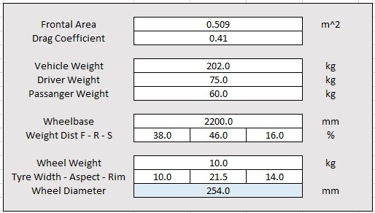
Table 1: F1 Sidecar Characteristics [2]
The vehicle weight pf the vehicle in table 1 does not include the electric motor, the AC controller and the energy storage system. However, using the weight distribution and wheelbase parameters provided, the horizontal center of gravity (CG) can be determined as follows:
$$b=\frac{m\text{f}×p}{m\text{total}} \text{(Equation }\text{2}\text{: Horizontal CG}\text{ [1}\text{2}\text{]}\text{)}$$
The sidecar had a horizontal CG located approximately 0.84 m away from its rear wheel, based on equation 2 where:
$p$ = Wheelbase (mm)
$m\text{f}$ = Mass of the Front End (kg)
$m\text{total}$ = Total Mass (kg)
Since the sidecar's CG was located near the vehicle's rear end, handling issues may arise at high speeds [13]. This could be mitigated by placing the electric motor and energy storage system closer to the front end of the vehicle. Meanwhile, the vertical CG of the vehicle was assumed to be two-thirds the sidecar's wheel height due to the lack of physical tests in this report.
2.3. Powertrain
Three versions of the Emrax 268 electric motor were available: air-cooled (AC), liquid-cooled (LC) and combined (CC). In Georgiev's report, a CC motor with a heat exchanger and pump cooling system was selected [2].
The F1 sidecar design provides access to air flow for the motor. In the worst-case scenario, 50% of the airflow reaches the motor at full speed, which translates to 25 m/s of airflow cooling the motor. The Emrax manual suggests that an airflow of 20 m/s would be sufficient to maintain a temperature optimum for the motor [3]. In theory, this study did not require a cooling system, which helped reduce expenses and led to the use of an Emrax AC motor.
$$Velocity=\frac{D\text{rw}×π×60×RPM}{FD×1000} \text{(Equation }\text{3}\text{ [1}\text{2}\text{]}\text{)}$$
For the purpose of calculating the theoretical speed of a vehicle, equation 3 was used, where:
$D\text{rw}$ = Rear Wheel Diameter (m)
$RPM$ = Motor Rotational Speed (rpm)
$FD$ = Final Drive Ratio
There was a maximum motor rotational speed of 4500 without weakening the magnetic field. After attempting to attain a speed of 180 km/h, the final drive ratio was calculated to be either 1.0 at 3900 rpm or 1.2 at 4500 rpm. In this particular scenario, 1.2 was chosen because it would provide smooth acceleration helping with wheel slippage.
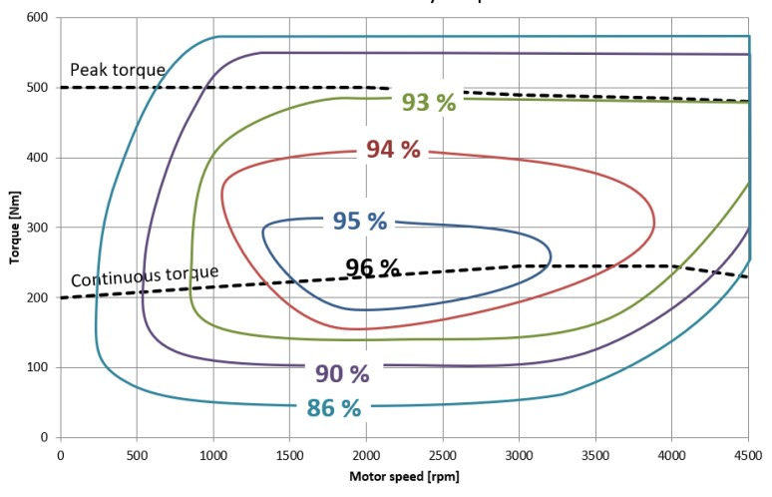
Figure 1: Emrax 268 Efficiency Map [3]
With the selected gear ratio, the motor would have a higher amortization rate and poorer thermal efficiency. In this scenario, the efficiency difference was only 3% based on figure 1. Additionally, the motor would only operate at peak rpm for approximately 18 sec in both directions, resulting in minimal wear.
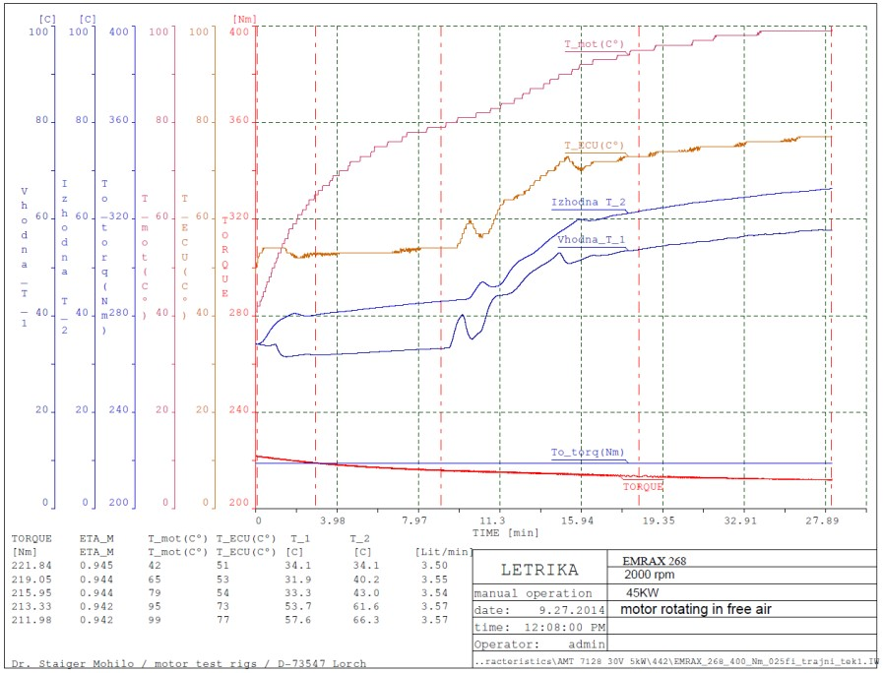
Figure 2: Emrax 268 Characteristics at 2000RPM [3]
It was assumed that the conditions under which the land speed record would be broken would be 25 deg [10]. An illustration of the increase in temperature of the motor at 2000 rpm over time is shown in figure 2. A worst-case scenario would be that if the motor is running for 40.81 sec at full rotational speed, its temperature would reach 90 deg according to figure 2. As 120 deg is the maximum temperature at which the motor can operate without degrading [3], an Emrax 268 AC electric motor was confirmed to be comfortable to operate in the conditions estimated for this study.
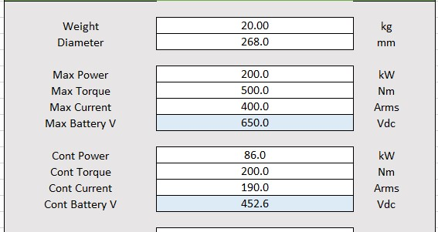
Table 2: Emrax 268 AC Motor Characteristics [3]

In table 2, the electrical requirements for the selected AC type Emrax 268 motor are listed for maximum and continuous power and torque.
2.3. Control
The AC motor controller Gen4, also known as the variable frequency drive (VFD), was used to regulate the motor's speed and power output [4]. An Excel spreadsheet was used to record the continuous and maximum power curves for the Emrax motor at every rpm. Based on the calculations performed by I. Georgiev [2], the following tables were developed:
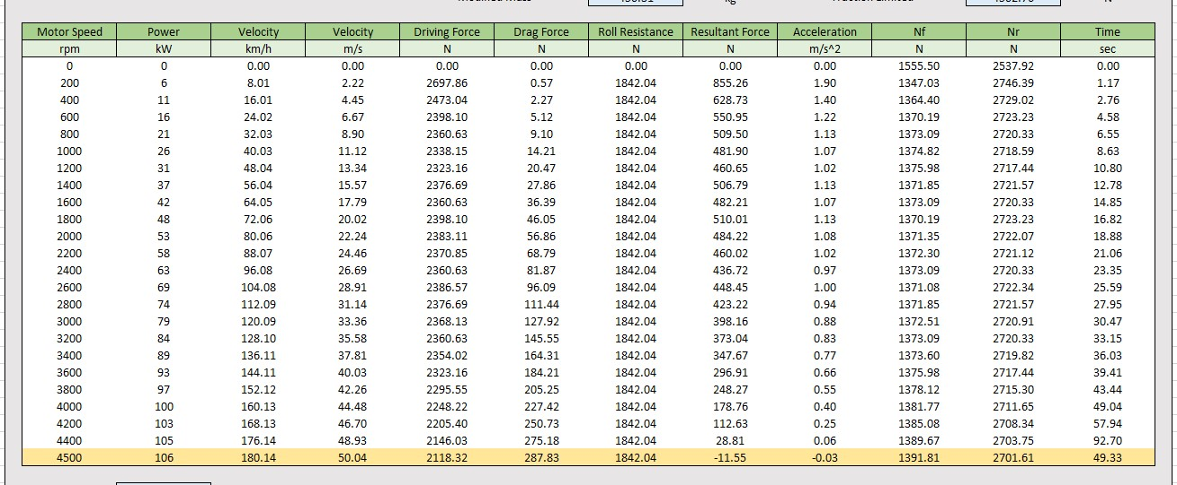
Table 3: Emrax Motor Continuous Power Control

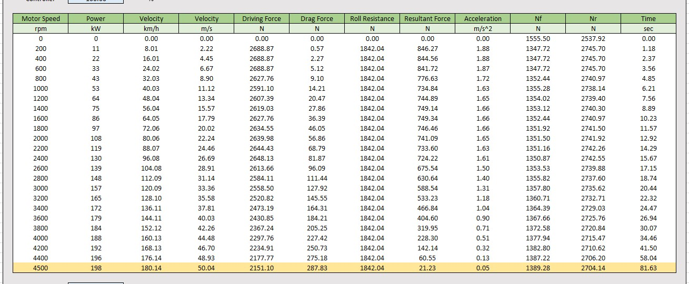
Table 4: Emrax Motor Maximum Power Control

In table 3, a theoretical drive cycle for the sidecar based on the continuous flow of power from the motor is illustrated. According to the data, prior to reaching 180 km/h, the vehicle's acceleration became negative indicating that there was not enough power to overcome the opposing forces acting on the vehicle. As an alternative, table 4 utilizes the maximum motor power. Using Excel's goal seek function, it was estimated that the sidecar would reach top speed in around 82 sec when the motor was restricted by approximately 45% of its maximum power.
The controller could be programmed to maintain the motor at its maximum RPM by adjusting the input power frequency to match the motor's rated frequency [13]. Simultaneously, the power output would be controlled at 55% of the motor's maximum capacity by modulating the input voltage. To operate at desired conditions, it was calculated that the motor would require a maximum of voltage (V) of 350 V and current (I) of 215 A.
2.4. Energy Storage
To design an energy storage system for the sidecar, the total energy required by the motor for the entire 82 sec in one direction was calculated using the following equation:
$$E =P×t \text{(Equation 4: Energy Required [1}\text{3}\text{])}$$
It was estimated that the motor would require around 107 kW of power (P). Consequently, 8681.8 kJ of energy would need to be available in the storage system. As the motor was assumed to use 107 kW at all times, the actual consumption during acceleration would be lower, thereby providing a safe margin for the energy storage system.
For this study, based on consultation with the customer, only lithium-ion batteries were chosen to be used for construction of an energy storage system since I. Georgev's method of combining ultracapacitors with lithium-ion batteries did not achieve success [2]. The most commonly used lithium-ion batteries with the highest density-to-weight ratio by electric vehicle manufacturers were selected and assessed.
$$Series =\frac{V\text{total}}{V\text{nomina}l} \text{(Equation }\text{5}\text{: }\text{Cells in Series [1}\text{3}\text{]}\text{)}$$
$$Parallel =\frac{I\text{required}}{I\text{discharge}} \text{(Equation }\text{6}\text{: }\text{Cells in Parallel [1}\text{3}\text{]}\text{)}$$
According to equations 5 and 6, different configurations of an energy storage system were calculated for each of the seven cells selected for this analysis. Due to the fact that charging time played an important role, the following equation was used to determine how long it would take for an energy pack to charge sufficiently so that the user would have 5% more energy after the second run.
$$Charge Time =\frac{E\text{required}}{Series×Parallel×V\text{charging} ×I\text{charging}}$$
$$\text{(Equation }\text{7}\text{: }\text{Chargin}\text{g}\text{ Time}\text{ [1}\text{3}\text{]}\text{)}$$
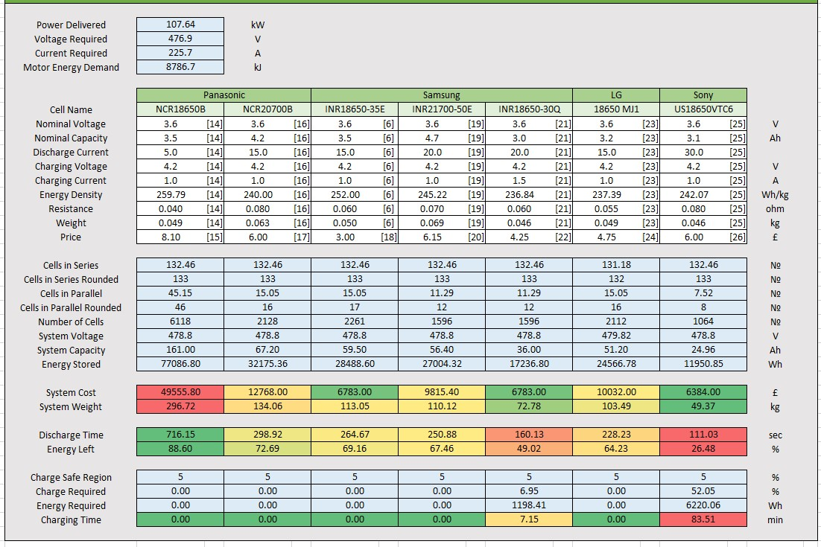
Table 5: Energy Storage System Analysis

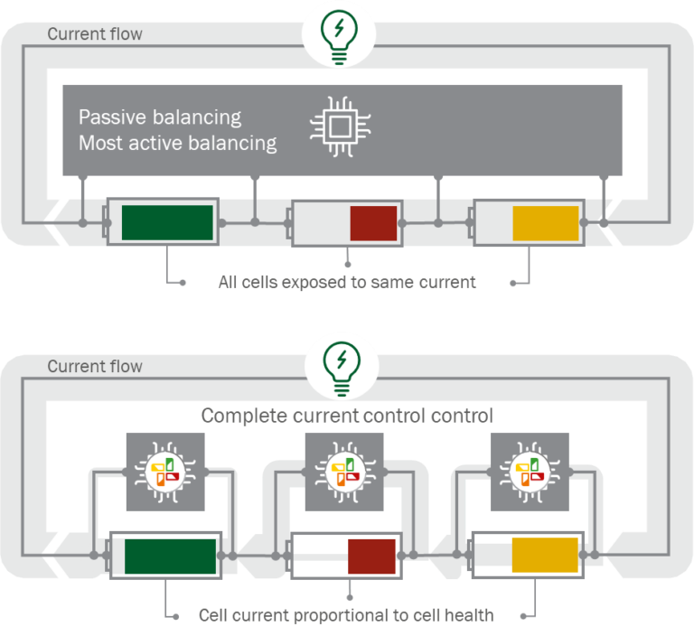
As shown in table 5, most of the cells available on the market have a limited discharge current capability. Consequently, a large number of cells are required, which invariably increases the weight and cost of the overall energy system. For instance, the INR 18650-30Q cell ranked second in terms of price and weight. However, it was more than adequate to conduct the second run without recharging, allowing sufficient time for the battery pack to cool down between runs. The Sony version, on the other hand, was slightly cheaper and considerably lighter, making it an ideal option for the intended application. Moreover, the charging time would be around 84 min, while the cooling time would be around 32 min between sessions, resulting in no additional weight being carried. Therefore, it was decided to construct the sidecar energy system using 133 series cells and 8 parallel cells (133S8), which required only 1064 US18650VTC6 batteries, significantly less than other alternatives. This would not only reduce the weight and cost of the energy system but also minimize heat generation due to lower resistance between the cells.
For reference, the Tesla Model S has 14 energy storage systems, each containing 444 cells in a configuration 74S6 and weighing 25 kg. With a second-hand price of approximately £ 822, these systems provide 22.8V of voltage and 232 Ah of capacity [27]. In light of these factors, an urban automobile battery pack proves unsuitable for this study in terms of both cost and performance.
As previously mentioned, the battery pack weight was roughly estimated to be 50 kg. Since the battery pack's weight was calculated to be 49.37 kg, the goal seek method described in section 2.3 was used again. In total, the vehicle was estimated to weigh 417.3 kg. Consequently, the AC motor control was adjusted to limit the maximum power of the Emrax motor to 54.36%.
3. Battery Management
The battery management system (BMS) monitors and controls the charging and discharging process of rechargeable batteries. In this way, the battery is protected from overcharging, overdischarging and overheating conditions that can damage the battery and pose a safety risk. Furthermore, the BMS provides important information about the battery, such as its capacity, voltage and temperature, which can be used to optimize its performance and extend its lifespan [28].
Upon discussion with the customer, it was determined that the batteries used in the vehicle were expensive. It would therefore be reasonable to attempt to save the energy storage system for at least another year in order to conduct the same land speed attempt. To achieve this, several types of BMS were assessed, energy storage system requirements were evaluated and special BMS components were selected. There are no rules regarding BMS in the FIM regulations [8].
Figure 3: BMS Types Comparison [29]
In a battery pack, there are two different approaches to balancing the cells. A passive balancing method uses resistors to balance the voltage of cells within a battery pack in a simpler and less expensive manner. It utilizes the natural voltage difference between cells as a method of balancing them and is suitable for applications with similar cells under stable conditions. Alternatively, a complete current control BMS actively regulates the charging and discharging of individual cells in order to maintain a balanced state of charge. According to C. Birkl et al. [30], complete current control technology is more effective when used in larger battery packs, but it is also more expensive and complex. Since the land speed record system contained 1064 cells, it was categorized as a large battery pack, leading to the choice of a complete current control BMS regardless of its higher cost.
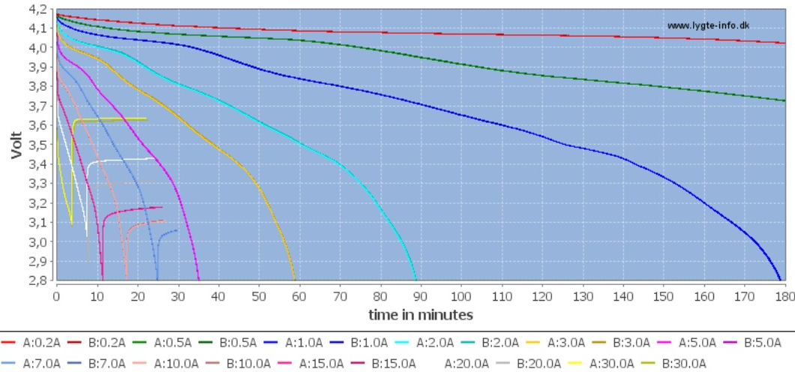
Figure 4: Current Increase Discharge Characteristics of US18650VTC6 3000mAh [25]
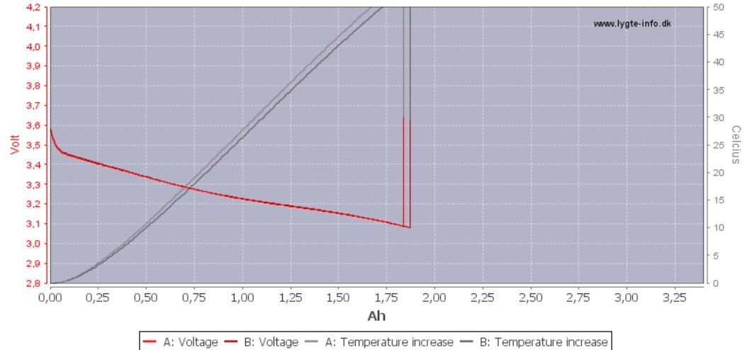
It can be seen in figure 4 that one US18650VTC6 cell can be discharged at a maximum current of 30 A, which corresponds to a maximum operational time of 5 min before a cut-out occurs. Therefore, the BMS must be able to handle a continuous discharge current of at least 240 A (30 A x 8 cells in parallel) and charging current of at least 25.2 A (4.2 A x 6 cells in parallel) [13].
Figure 5: Temperature Increase Discharge Characteristics of US18650VTC6 3000mAh [25]
As illustrated in figure 5, when a single cell is discharged at 30 A, the temperature of the cell rises rapidly. The temperature cut-out occurs at 80 deg, however, the optimal working temperature ranges between -20 and 60 deg. During charging, the Sony batteries are most effective when their temperature is between 0 and 45 deg according to [25]. It is therefore essential that the BMS be programmed to monitor the voltage and temperature of each cell. In the event that any cell's voltage or temperature exceeds safe limits, the BMS may cut off the charge or discharge.
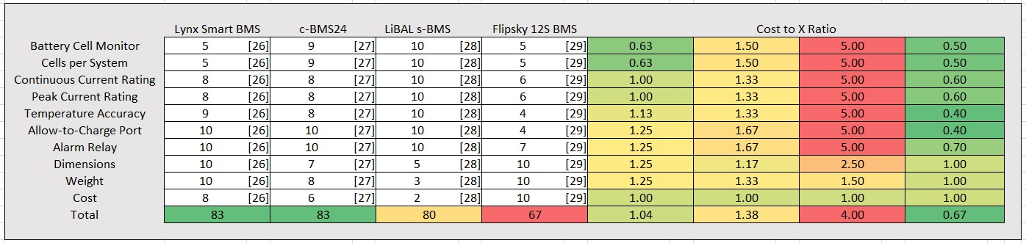
Table 6: BMS Decision Matrix

The analysis of four BMS systems was conducted by using decision matrixes, as shown in table 6. For the energy storage system, all four components listed above meet the required electrical standards. It is important to note that their tolerances above these requirements, as well as the number of cells that they can manage at any given time, differ from one another. As an example, the LiBAL s-BMS system accommodated 256 cells in series and 3 in parallel at once, which means that two of those units would be sufficient for the sidecar storage system.
However, the cost of the product was extremely high, leading to a ratio score of 4 where the client would not be able to afford it. There was a compromise offered by the c-BMS24, which had margin of 20% over the calculated charging/discharging limit. Despite its slightly higher cost to performance ratio, this system comes with its own software, making setup and operation easier.
In the end, the c-BMS24 module was selected for this project. To manage all 1064 US18650VTC6 with configuration 133S8, six BMS modules would be required since each one had limit of 24 cells. To distribute the 133 series cells equally among the six BMS modules, the cells could be divided into five groups of 22 cells and one group of 23 cells. By connecting each BMS module to its respective group of series cells, the outputs of these BMS modules can be combined in parallel while maintaining consistent output voltage and current. BMS was estimated to cost approximately £580, which was the second-best option among the three.
4. Conclusion
Based on the results of this study, the current FIM land speed for electric sidecars has been successfully improved for a one-mile distance. I Georgiev's report [2] was evaluated and its positive features were applied in this study to conduct a theoretical drive cycle analysis of the UWTSD's F1 sidecar. It was calculated that the AC motor controller would have to reduce motor power by 45.64 %. An electric storage system consisting of 1064 US18650VTC6 batteries in a configuration of 33S8 with a total weight of 49.37 kg and a cost of £6384 was developed as a result.
In collaboration with the customer throughout this project, it was decided to minimize expenses as much as possible without compromising on the quality of the output. In addition, it was necessary to manage the energy storage system appropriately in order to repurpose it for future use. After in-depth analysis of various BMS systems, six c-BMS24 modules were selected, which would cost a total of $580 and add an additional 403 g of weight without taking account of wiring.
Due to the primary concern of safety, all calculations performed in this study were based on the worst-case scenario. According to the simulation, the motor would draw 107.64 kJ per sec at full rotational speed and 54.36 %
of its maximum power, while in reality the motor would require less energy at low speed while accelerating as well as having a lower wear factor. Thus, the energy storage system will also have a little more energy left than expected, as well as a lower operational temperature.

References

[1] | FIM, "Current records," 2023. [Online]. Available: https://results.fim.ch/wrecord/wrframe.
[2] | I. Georgiev, "Sidecar Speed Record Attempt," UWTSD, Swansea, 2022.
[3] | EMRAX, "Manual for EMRAX Motors / Generators," EMRAX, 2020.
[4] | BorgWarner, "AC Motor Controller Gen4 Size10," BorgWarner, 2020.
[5] | Maxwell, "K2 SERIES 650 F - 3,000 F ULTRACAPACITORS," Maxwell.
[6] | Relectro, "Samsung INR18650-35E 3500mAh (Pink)," [Online]. Available: http://www.relectro.co.za/uploads/5/7/3/6/5736561/samsung_35e_datasheet.pdf.
[7] | Tesla, "Model S," 2023. [Online]. Available: https://www.tesla.com/en_gb/models.
[8] | FIM, "FIM LAND SPEED WORLD RECORDS REGULATIONS," FIM, 2023.
[9] | OCR, "A LEVEL," OCR.
[10] | physicstutoronlin, "Equations of Motion," physicstutoronlin.
[11] | V. Cossalter, Motorcycle Dynamics, Padova, 2007.
[12] | E. Hakansson and B. Dube, "Racing at Bonneville: Determining the “center of pressure” and center of gravity of your vehicle," 2014.
[13] | Hot Rods Down Under , "Bonneville," HRDU, 2023. [Online]. Available: https://www.gregwapling.com/hotrod/land-speed-racing-history/land-speed-racing-bonneville.html.
[14] | M. Ehsani, Y. Gao, S. Longo and K. Ebrahimi, Modern Electric, Hybrid Electric, and Fuel Cell Vehicles, CRC Press, 2023.
[15] | shoptronica, "Panasonic NCR18650B 3400mAh (Green)," shoptronica, 2023.
[16] | BatteryJunction, "Panasonic NCR 18650 3400mAh 3.7V Unprotected High-Drain 4.87A Lithium Ion (Li-ion) Flat Top Battery - Boxed," BatteryJunction, 2023. [Online]. Available: https://www.batteryjunction.com/panasonic-ncr18650b-3400.html.
[17] | Panasonic, "NCR20700B data sheet," Panasonic, 2023.
[18] | Voltaplex, "Panasonic B 20700 Battery, 4250mAh, 20A, 3.6V, Grade A Lithium-ion (NCR20700B)," Voltaplex, 2023. [Online]. Available: https://voltaplex.com/panasonic-b-20700-battery-ncr20700b.
[19] | Fogstar-Wholesale, "ISamsung 35E," Fogstar-Wholesale, 2023. [Online]. Available: https://www.fogstar-wholesale.co.uk/product/samsung-35e/.
[20] | Lygte-Info, "Samsung INR21700-50E 5000mAh (Cyan)," Lygte-Info.
[21] | BatteryJunction, "Samsung 50E INR 21700 5000mAh 3.7V High-Drain 10A Lithium Ion (Li-ion) Unprotected Flat Top Battery," BatteryJunction, 2023. [Online]. Available: https://www.batteryjunction.com/samsung-50e-inr-21700-li-ion-battery.html.
[22] | Samsung, "Introduction of INR18650-30Q," Samsung, 2014.
[23] | 18650BatteryStore, "Samsung 30Q 18650 3000mAh 15A Battery," 18650BatteryStore, 2023. [Online]. Available: https://www.18650batterystore.com/en-gb/products/samsung-30q.
[24] | Lygte-Info, "LG 18650 MJ1 3500mAh (Green)," Lygte-Info.
[25] | BatteryJunction, "LG MJ1 INR 18650 3500mAh 3.7V High-Drain 10A Lithium Ion (Li-ion) Unprotected Flat Top Battery - Bulk," BatteryJunction, 2023. [Online]. Available: https://www.batteryjunction.com/lg-mj1-inr-18650.html.
[26] | Lygte-Info, "Sony US18650VTC6 3000mAh," Lygte-Info, 2010.
[27] | 18650batterystore, "Sony | Murata VTC6 18650 3000mAh 15A Battery," 18650batterystore, 2023. [Online]. Available: https://www.18650batterystore.com/products/sony-vtc6.
[28] | Secondlife-Evbatteries, "Tesla Model S/X Module - 5.3kWh / 232Ah / 22.8V," Secondlife-Evbatteries, 2023. [Online]. Available: https://www.secondlife-evbatteries.com/collections/ev-battery/products/tesla-5-3-kwh-electric-vehicle-battery.
[29] | P. Deja, "Tests of BMS Battery Management System with active and passive system of balancing the battery capacity," IOP Conference Series: Materials Science and Engineering, 2019.
[30] | C. Birkl, D. Frost and A. Bizeray, "How to design a BMS, the brain of a battery storage system," 2021. [Online]. Available: https://www.energy-storage.news/how-to-design-a-bms-the-brain-of-a-battery-storage-system/.
[31] | V. Karkuzhali, "Analysis of battery management system issues in electric vehicles," IOP Conference Series: Materials Science and Engineering, 2020.
[32] | Bacancy, "Analyzing the Components of Battery Management System for EV," Bacancy, 2022. [Online]. Available: https://www.bacancytechnology.com/blog/components-of-battery-management-system.
[33] | Victron Energy, "Lynx Smart BMS," Victron Energy, 2023.
[34] | Lithium Balance, "LiBAL-c-BMS24," Lithium Balance, 2023.
[35] | Lithium Balance, "LiBAL-s-BMS," Lithium Balance, 2023.
[36] | Flipsky, "Flipsky 12S 200A Smart BMS For ESK8 / Consumer Robot / E-car/ E-board," Flipsky , 2023. [Online]. Available: https://flipsky.net/collections/bms/products/flipsky-12s-200a-smart-bms-for-esk8-consumer-robot-e-car-e-board.

