
Advanced Digital Signal

Processing Report
Theo Benjamin David Rose
2114615
L6 – Advanced Digital Signal Processing
(ACDA6018)
Embedded Electronics Degree Apprenticeship
Table of Contents
Introduction: 3
Background Research: 4
Frequency Modulation (FM): 4
Narrow Band Frequency Modulation (NBFM): 4
Wide Band Frequency Modulation: 4
Anti-Jamming Techniques: 4
Spread Spectrum (SS): 4
Direct Sequence Spread Spectrum (DSSS): 4
Frequency Hopping Spread Spectrum (FHSS): 4
Time Hopping Spread Spectrum (THSS): 4
Chirp Spread Spectrum (CSS): 4
Formulas and Expressions: 5
NBFM: 5
WBFM: 6
SDR: 6
Lowpass Filter: 8
Re-Sampler: 8
WBFM Receiver: 8
SDR: 9
Flow Graph: 9
Methodologies: 10
Narrow Band Frequency Modulation: 10
Narrow Band Frequency Modulation with Jamming: 10
Narrow Band Frequency Modulation with Frequency Hopping Spread Spectrum and Jamming: 10
Wide Band Frequency Modulation using RTL-SDR: 10
Implementations: 11
Narrow Band Frequency Modulation: 11
Narrow Band Frequency Modulation with Jamming: 12
Narrow Band Frequency Modulation with Frequency Hopping Spread Spectrum and Jamming: 13
Wide Band Frequency Modulation using RTL-SDR: 14
Screen Captures of Results: 15
Narrow Band Frequency Modulation: 15
Narrow Band Frequency Modulation with Jamming: 16
Narrow Band Frequency Modulation with Frequency Hopping Spread Spectrum and Jamming: 17
Wide Band Frequency Modulation using RTL-SDR: 18
Results and Analysis: 19
Discussion: 19
NFBM: 19
WBFM: 19
Ethical and Societal Impacts: 20
Conclusion: 20
References 21

Figure 1 – SDR block diagram [9] 8
Figure 2 – GNU Radio NBFM Flow Graph 13
Figure 3 - GNU Radio NBFM Flow Graph with Jamming 14
Figure 4 - GNU Radio NBFM Flow Graph with FHSS and Jamming 15
Figure 5 - GNU Radio WBFM Reciever Flow Graph 16
Figure 6 – NBFM Waterfall Sinks 17
Figure 7 – NBFM Time Sinks 17
Figure 8 – NBFM Frecuency Sinks 17
Figure 9 – NBFM with Jamming Waterfall Sink after modulation 18
Figure 10 - NBFM with Jamming Waterfall Sink after demodulation 18
Figure 11 – NBFM with Jamming Time Sinks 18
Figure 12 – NBFM with Jamming Frequency Sinks 18
Figure 13 – NBFM FHSS Waterfall Sink 19
Figure 14 – NBFM using FHSS Avoid Noise Waterfall Sink 19
Figure 15 – NBFM FHSS Time Sinks 19
Figure 16 – NBFM FHSS Frequency Sinks 19
Figure 17 – RTL-SDR Waterfall Sinks 20
Figure 18 – RTL-SDR Time Sink after Demodulation 20
Figure 19 – RTL-SDR Frequency Sinks 20
Figure 20 – RTL-SDR Constelation 20

Equation 1 – Message Signal [8] 8
Equation 2 – Phase Angle [8] 8
Equation 3 – Substituting Message Signal into Phase Angle [8] 8
Equation 4 – Standard Equation of the standard angle modulated wave [8] 8
Equation 5 – Applying Message and Phase angle to the standard angle modulated wave equation [8] 8
Equation 6 [8] 8
Equation 7 – Substitute Equation 6 into Equation 4 [8] 8
Equation 8 – Complete equation for NBFM [8] 8
Equation 9 – Equation for Modulation Index [8] 8
Equation 10 – Equation for received RF signal [9] 9
Equation 11 – Equation for in-phase local oscillator [9] 9
Equation 12 – Equation for quadrature-phase local oscillator [9] 9
Equation 13 – Equation for I(t) signal [9] 9
Equation 14 – Substituted equation for I(t) [9] 9
Equation 15 – Cosine multiplication formula [9] 9
Equation 16 – Applying Cosine multiplication formula to I(t) [9] 9
Equation 17 – Final formula for I(t) [9] 9
Equation 18 – Equation for Q(t) [9] 10
Equation 19 – Calculations for Q(t) [9] 10
Equation 20 – I(t) and Q(t) after low pass filter [9] 10
Equation 21 – Equation and calculation of Z(t) [9] 10
Equation 22 – Equations and calculations for low pass filter parameters [9] 11
Equation 23 - Equations and calculations for re-sampler [9] 11
Equation 24 – Equations and calculations for WBFM Receiver block [9] 11

Introduction:
This assignment will be exploring frequency modulation techniques including narrow band frequency modulation and wide band frequency modulation. It looks at how to design and create a GNU radio flow graph for both modulation schemes and then to simulate its performance. For NBFM it looks at the effect of introducing interference to the system and how anti-jamming techniques can be utilised to avoid it. For this assignment FHSS is being tested and simulated but background research on other methods are included. The effectiveness of FHSS is tested, analysed and discussed to see if it is a suitable method to avoid interference.
The WBFM task of this assignment explores how to design and implement a receiver using GNU radio and an RTL-SDR to successfully demodulate FM radio stations in the local area. This requires some initial tuning and adjustments to the flow graph to ensure a clear message is obtained. The results of this are then discussed with why the parameters used to achieve this are used.

Background Research:

Frequency Modulation (FM):
Frequency modulation is a common technique used to broadcast data in the UK. FM is used to broadcast radio stations, radar applications, analogue two-way radios and for some older TV video and audio broadcasting. This technique works by altering the phase of the carrier wave depending on the values of the audio source. This results in differing frequencies depending on amplitude values of the original audio capture. This can therefore result in a wide frequency range to transmit the original audio capture. [1]

Narrow Band Frequency Modulation (NBFM):
In the UK NBFM is commonly limited to around 25KHz bandwidth meaning that the range of frequencies used to encode the audio signal cannot exceed that bandwidth. This is an important consideration when designing these systems. Common use cases of NBFM are two-way radios and radio station broadcasts. [2]

Wide Band Frequency Modulation:
WBFM on the other hand has a bandwidth of approximately 200KHz allowing a much wider range of different frequencies to encode the audio signal but as a result will occupy a much larger part of the spectrum. The most common use case of WBFM is for radio stations.

Anti-Jamming Techniques:
FM as it stands is quite resilient to interference and jamming as the message is spread across a wide range of frequencies. However, there are further techniques that can be used to reduce interference further as discussed below:

Spread Spectrum (SS):
Spread Spectrum is a technique used to send multiple carrier signals at once across multiple frequencies/channels to increase the chances of the receiving device to demodulate a clear message signal. This also improves the robustness of the transmission against noise/interference as the receiving end can use the multiple channels being transmitted at once to get a clear message through. [3]

Direct Sequence Spread Spectrum (DSSS):
DSSS is a technique used to split the message signal across a larger bandwidth to improve signal integrity, robustness, resilience to interference and security aspects of the transmission. [4]

Frequency Hopping Spread Spectrum (FHSS):
FHSS is a technique used to send the message signal across multiple different channels in a pseudorandom sequence established on both the transmitting and receiving end. The signal is therefore constantly hopping between channels as it transmits/receives. [5]

Time Hopping Spread Spectrum (THSS):
THSS is a technique used to send the message in a sequence of pulses in respect to time. Both the transmitter and receiver will have a pseudorandom sequence to determine how the audio source will be split into pulses and then how the receiver will demodulate the pulses back into the original signal. [6]

Chirp Spread Spectrum (CSS):
CSS is a technique that uses chirp pulses to encode information this is done by varying frequency to achieve chirp pulses of differing slopes which relate to specific values. Positive slopes indicate a 1 and negative slopes indicate a 0 which is the foundation used to convert message signals to this form of modulation. This modulation benefits by being very resilient to interference, good for long range communication and uses considerably less power than other methods. [7]

Formulas and Expressions:

NBFM:
$$m\left(t\right)= A_{m}\cos{2πf_{m}}t$$
Equation 1 – Message Signal [8]
$$θ_{i}\left(t\right)=2π\int{{[f}_{c}+k_{f}m\left(t\right)}]dt$$
Equation 2 – Phase Angle [8]
$$θ_{i}\left(t\right)=2π\int{{[f}_{c}+k_{f}(A_{m}\cos{2πf_{m}}t )}]dt$$
Equation 3 – Substituting Message Signal into Phase Angle [8]
$$s(t)=A_{C}\cos{θ_{i}}(t)$$
Equation 4 – Standard Equation of the standard angle modulated wave [8]
$$s(t)=A_{C}Cos[ 2πf_{c}t+2π k_{f}\int{A_{m}\cos{2πf_{m}}t dt}]$$
Equation 5 – Applying Message and Phase angle to the standard angle modulated wave equation [8]
$\int{cos({2πf_{m}}t) dt}$ = $\frac{1}{{2π f}_{m}}\sin{2πf_{m}}t$
Equation 6 [8]
$s(t)$=$A_{C}Cos [2πf_{c}t+2π \frac{A_{m}k_{f}}{{2π f}_{m}}\sin{2πf_{m}}t]$
Equation 7 – Substitute Equation 6 into Equation 4 [8]
$s(t)$=$A_{C}Cos [2πf_{c}t+β\sin{2πf_{m}}t]$
Equation 8 – Complete equation for NBFM [8]
$$β=\frac{A_{m}k_{f}}{f_{m}}= \frac{∆f}{f_{m}}$$Where $β$ is the Modulation Index of FM and ∆𝒇 𝑖𝑠 𝑡ℎ𝑒 𝒇𝒓𝒆𝒒u𝒆𝒏𝒄𝒚 𝒅𝒆𝒗𝒊𝒂𝒕𝒊𝒐𝒏
Equation 9 – Equation for Modulation Index [8]
The equations shown above, Equations 1 through 9, show the calculations of NBFM for a cosine message signal. Which when implemented into the flow graph will be the audio WAV file and the calculations will aid in designing the flow graphs within GNU radio to achieve frequency modulation.

WBFM:

SDR:
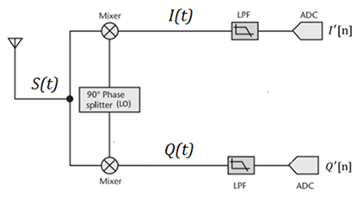
Figure 1 – SDR block diagram [9]
Equation 10 – Equation for received RF signal [9]
Equation 11 – Equation for in-phase local oscillator [9]
Equation 12 – Equation for quadrature-phase local oscillator [9]
Equation 13 – Equation for I(t) signal [9]
Equation 14 – Substituted equation for I(t) [9]
Equation 15 – Cosine multiplication formula [9]
Equation 16 – Applying Cosine multiplication formula to I(t) [9]
Equation 17 – Final formula for I(t) [9]

Equation 18 – Equation for Q(t) [9]
Equation 19 – Calculations for Q(t) [9]
Equation 20 – I(t) and Q(t) after low pass filter [9]
Equation 21 – Equation and calculation of Z(t) [9]

Lowpass Filter:
Equation 22 – Equations and calculations for low pass filter parameters [9]

Re-Sampler:
Equation 23 - Equations and calculations for re-sampler [9]

WBFM Receiver:
Equation 24 – Equations and calculations for WBFM Receiver block [9]

SDR:
The calculations, shown above in Equations 10 through 21, show the internal process of the SDR processing the signal. It starts by taking the input signal S(t) and mixing it with the local oscillator in-phase and quadrature phase to achieve the two I(t) and Q(t) signals. These signals are then passed through a lowpass filter and ADC which results in I’(t) and Q’(t). This represents both of the signals with the high frequency component (carrier) removed. Both these signals are then added together to achieve Z(t), as seen in equation 21, which represents the IQ signal to be passed to GNU radio for manipulation.

Flow Graph:
The calculations shown above walk through how the parameters of the blocks are worked out. Starting with the low pass filter, as seen in Equations 22 through 24, a sample rate of 2.4MHz is passed from the osmocom source from the SDR and is decimated by 12 to achieve a sample rate 200KHz. The cut-off frequency must then be less than or equal to the resulting sample rate as seen in equation 22 which results in a maximum value of 100KHz.
The next block is the rational re-sampler which will increase the sample rate by a factor of 12 over 5, shown in equation 23, which results in a sample rate of 480KHz.
The WBFM block with an audio decimation value of 10, as seen in equation 24, will then decrease the sample rate to 48KHz so that the audio sink can playback the message.

Methodologies:

Narrow Band Frequency Modulation:
The design of the NBFM flow diagram, shown in figure 2, consists of an audio WAV file which will be used as the message signal. It is then passed through a multiply constant block that will be used to adjust the modulation index. The next stage will pass the message audio through a throttle block to limit the number of samples and then a phase mod block which will apply the frequency modulation technique to the message signal. The bandwidth is the total span of frequency that the signal uses this is determined by beta in the equation 9. This signal is then multiplied by the carrier wave, with a frequency of 20KHz, to achieve the modulated signal. After that the signal is multiplied by the same carrier frequency to demodulate it and is then passed through a low-pass filter to remove the high frequency (carrier component) of the received signal. This leaves the demodulated message signal which is then connected to a waterfall, time and frequency sink to display a graphical representation of the demodulated signal. An audio sink is also attached so that the message can be played through the computers speakers to validate the demodulated message.

Narrow Band Frequency Modulation with Jamming:
The same procedures discussed above are utilised in this version of the flow graph, but interference/jamming is introduced in this section to see the effects on the signal integrity when noise is added to the spectrum as seen in figure 3. To do this an adder block was placed before the demodulation stage where it will add the modulated signal to a Gaussian source block modulated on the same carrier frequency. This will be used to simulate jamming/interference on the same channel being used to send the audio message. The Gaussian source block will produce random noise that will add interference to the system.

Narrow Band Frequency Modulation with Frequency Hopping Spread Spectrum and Jamming:
The following two procedures discussed above are used in the final iteration of flow graph seen in figure 4. But for this version a channel hopping functionality is added. To achieve these two changes to the previous design need to implemented. The first change is on the transmit side as another signal source and multiply block need to be added to achieve a channel hopping functionality. The same needs to be applied on the receive end and therefore the demodulation side needs to change the frequency depending on the end result of the transmit side (carrier + (carrier*channel).

Wide Band Frequency Modulation using RTL-SDR:
The design of the WBFM flow graph, shown in Figure 5, shows the process of demodulating WBFM messages from radio stations in the local area. It requires some initial tuning to find the correct frequency of an FM broadcast but after finding that value it can be set as the default value of the carrier variable. The flow graph starts with the osmocom source block which is responsible for communicating with the software defined radio over USB. The variable within the block determines how the SDR behaves and is therefore important to configure correctly. For this setup only 1 channel is required, a sample rate of 2.4 MHz is used, the default value for the carrier frequency is 90 MHz, RF gain is 60dB and the IF gain is 50dB. All these parameters are used, on start-up, to configure the SDR and then any received signal is passed through to the rest of the flow graph. The calculations behind the parameters of each block are discussed in the previous section using equations 22 through 24.

Implementations:

Narrow Band Frequency Modulation:

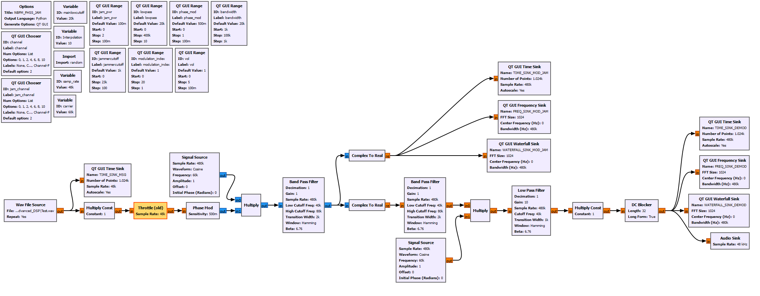
Figure 2 – GNU Radio NBFM Flow Graph

Narrow Band Frequency Modulation with Jamming:

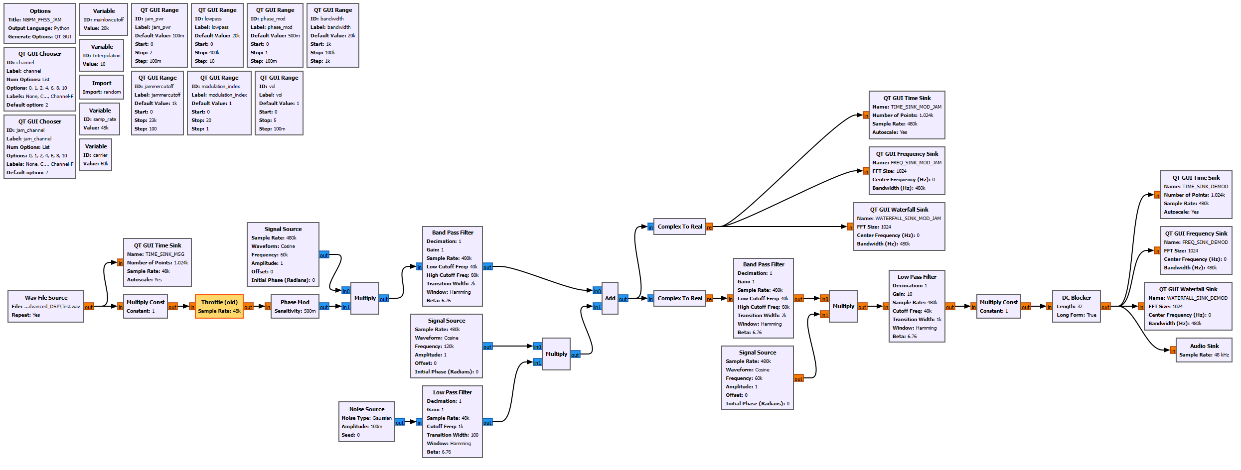
Figure 3 - GNU Radio NBFM Flow Graph with Jamming

Narrow Band Frequency Modulation with Frequency Hopping Spread Spectrum and Jamming:

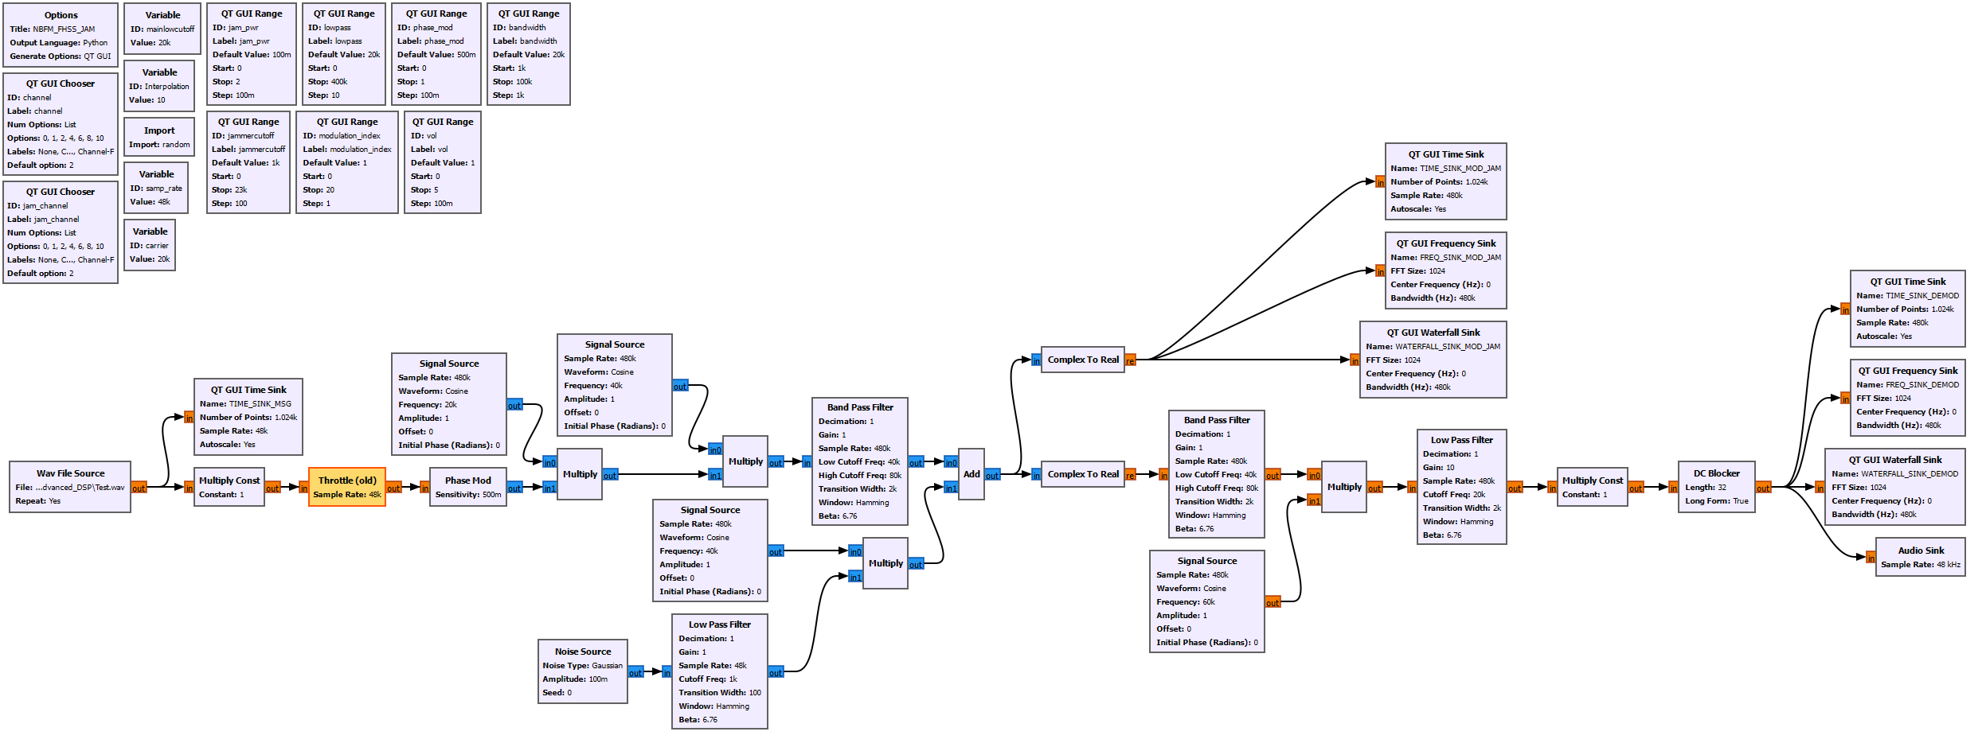
Figure 4 - GNU Radio NBFM Flow Graph with FHSS and Jamming

Wide Band Frequency Modulation using RTL-SDR:

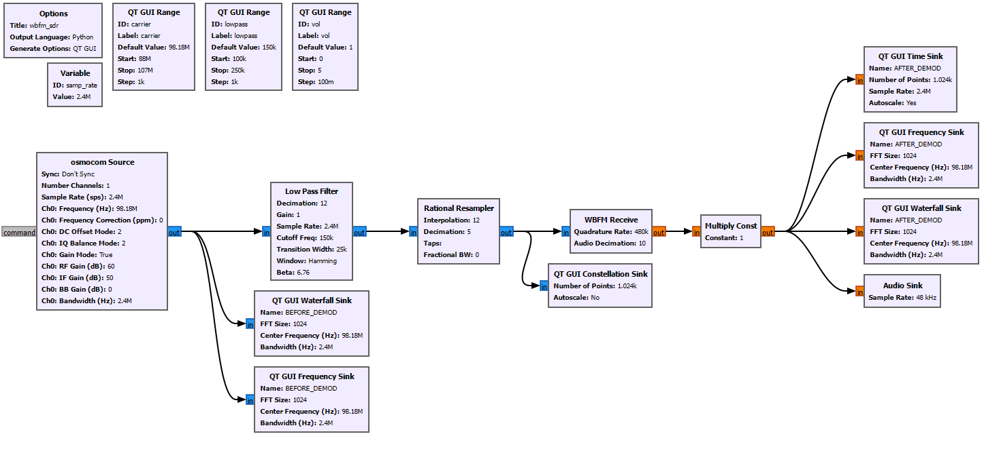
Figure 5 - GNU Radio WBFM Reciever Flow Graph

Screen Captures of Results:

Narrow Band Frequency Modulation:
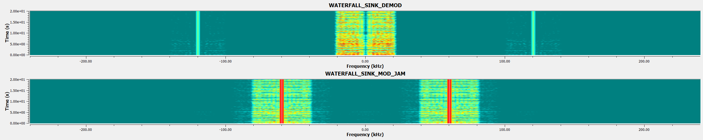
Figure 6 – NBFM Waterfall Sinks
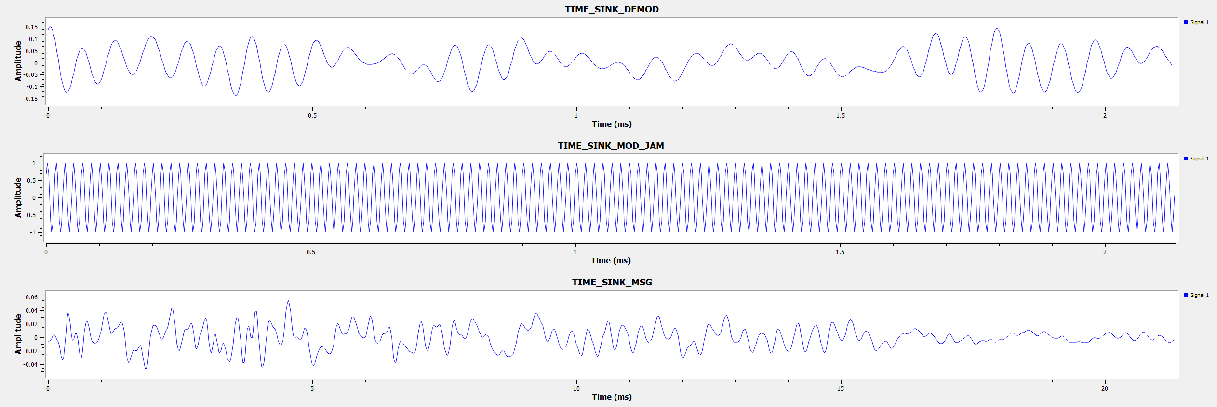
Figure 7 – NBFM Time Sinks
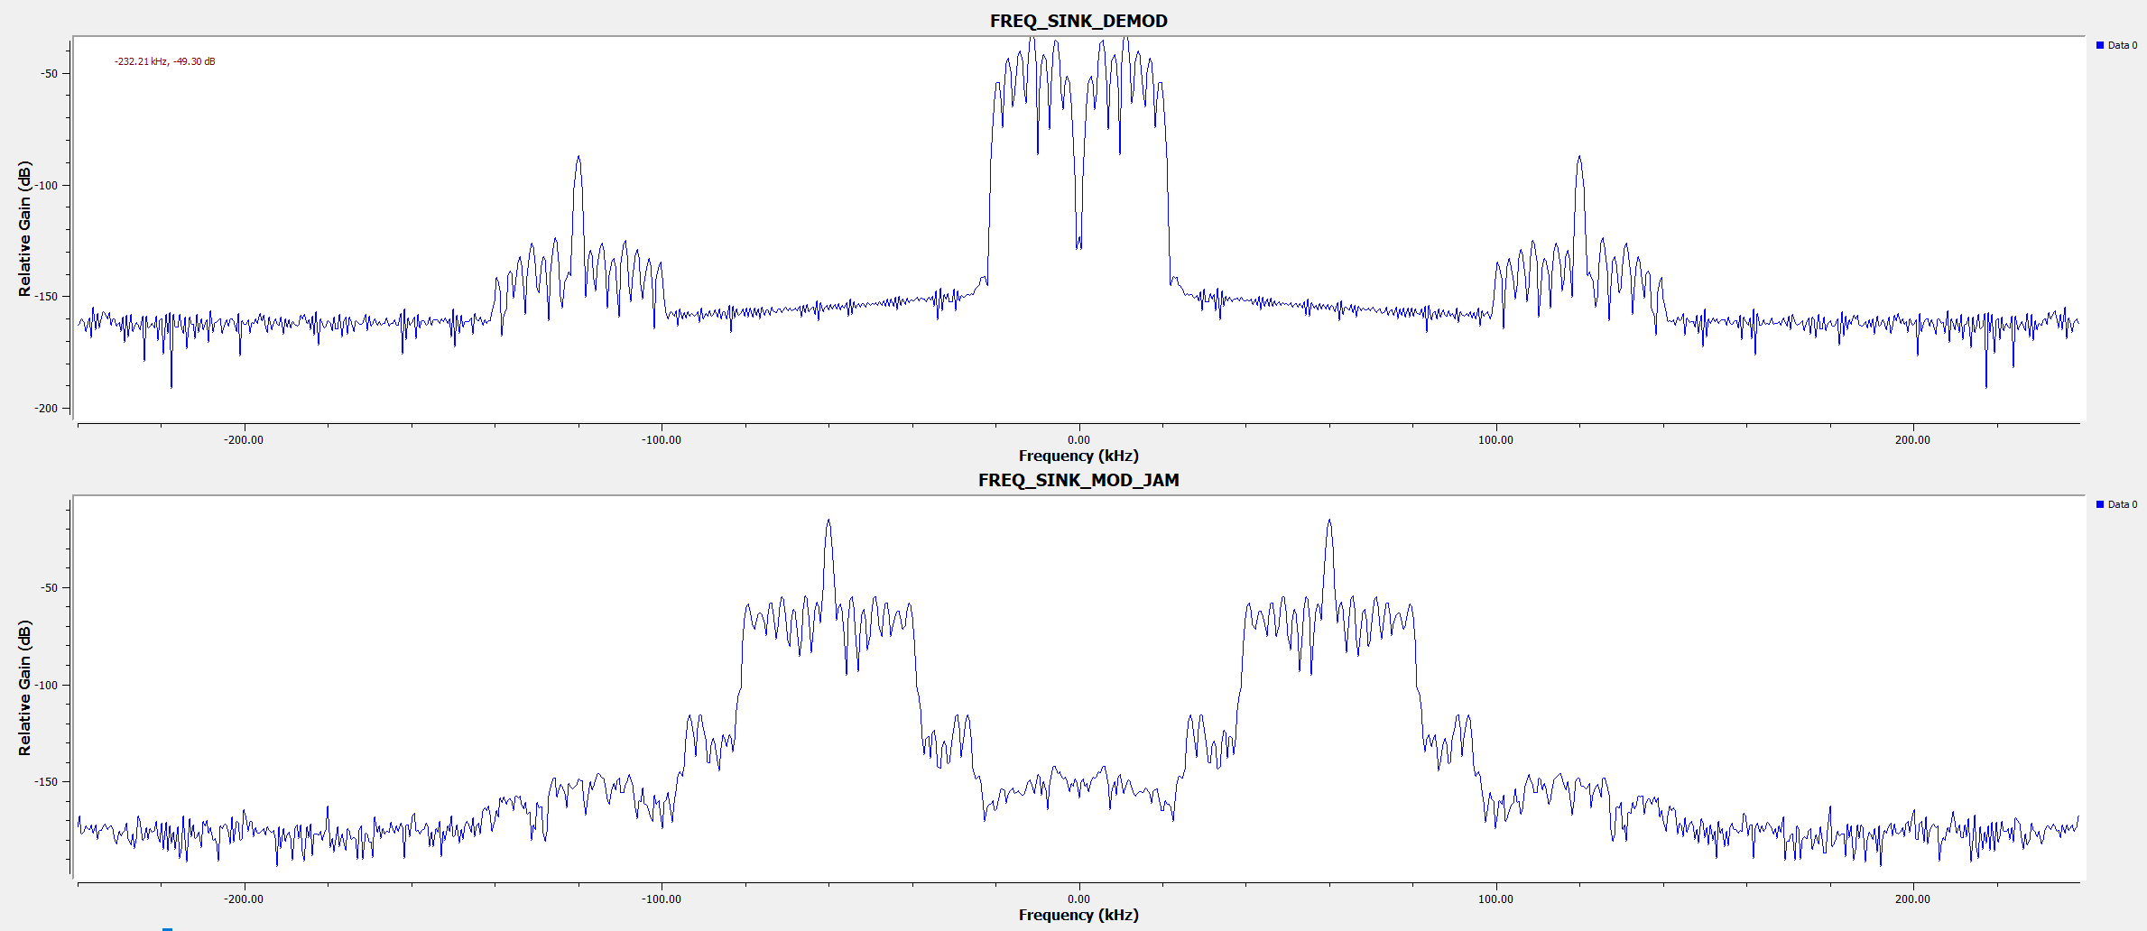
Figure 8 – NBFM Frecuency Sinks

Narrow Band Frequency Modulation with Jamming:
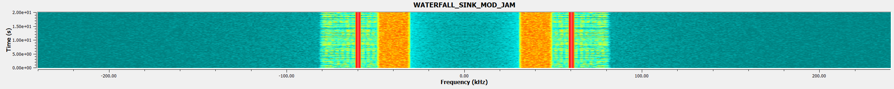
Figure 9 – NBFM with Jamming Waterfall Sink after modulation
Figure 10 - NBFM with Jamming Waterfall Sink after demodulation
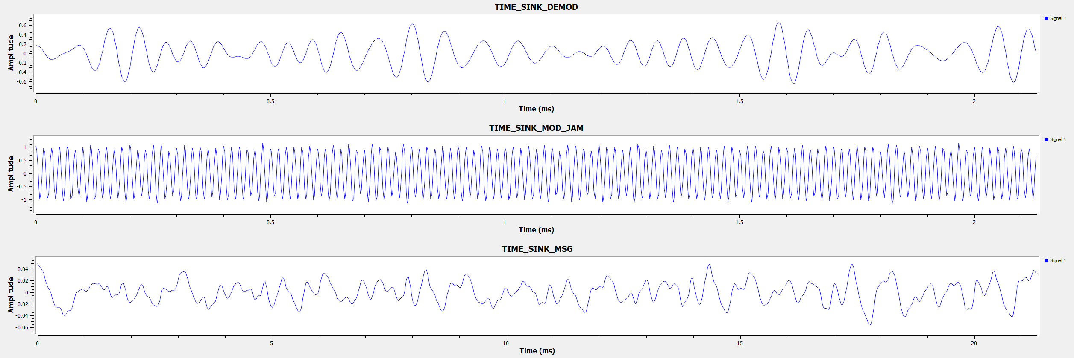
Figure 11 – NBFM with Jamming Time Sinks
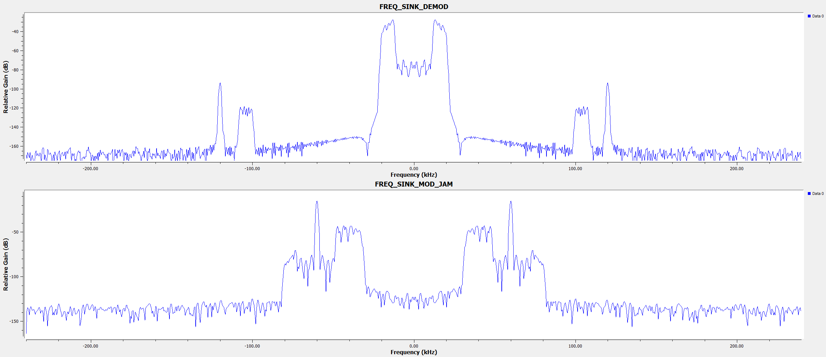
Figure 12 – NBFM with Jamming Frequency Sinks

Narrow Band Frequency Modulation with Frequency Hopping Spread Spectrum and Jamming:
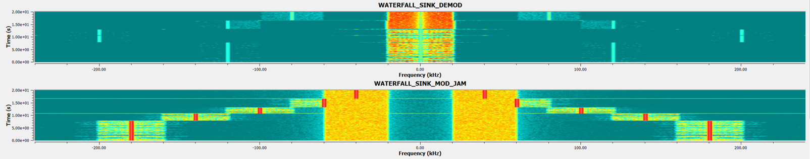
Figure 13 – NBFM FHSS Waterfall Sink
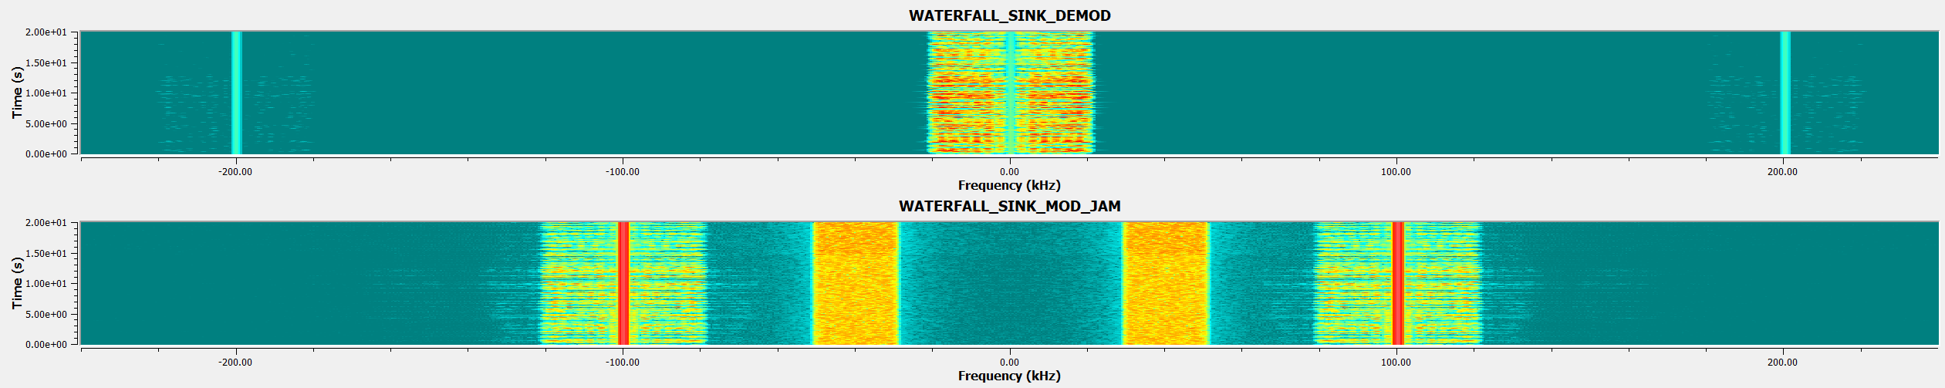
Figure 14 – NBFM using FHSS Avoid Noise Waterfall Sink
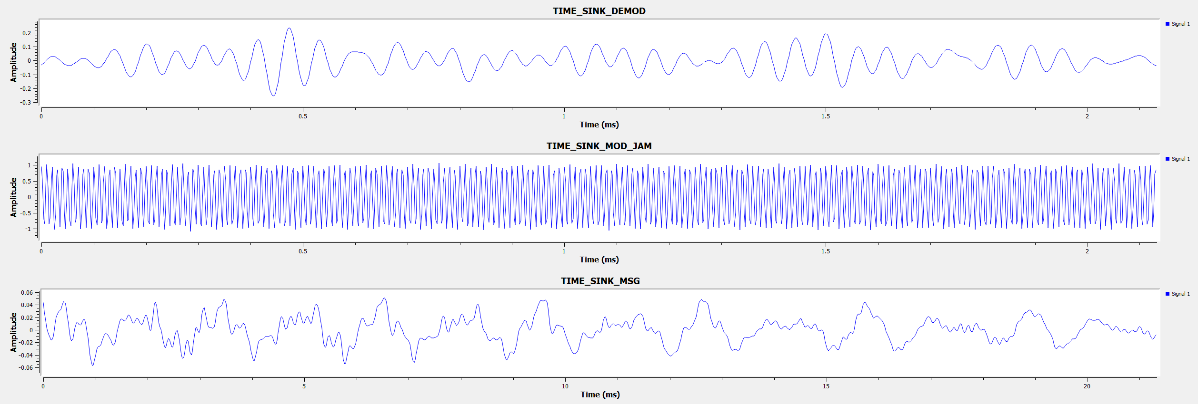
Figure 15 – NBFM FHSS Time Sinks
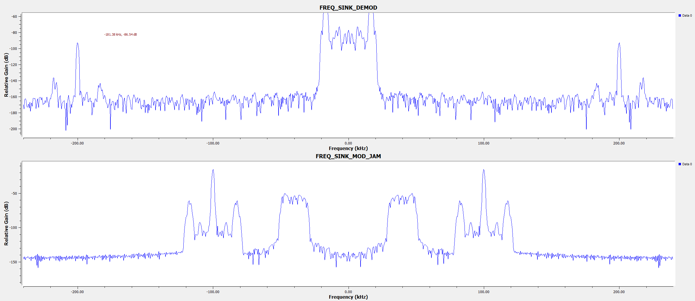
Figure 16 – NBFM FHSS Frequency Sinks

Wide Band Frequency Modulation using RTL-SDR:
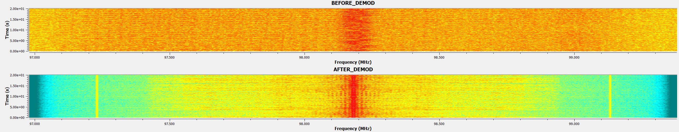
Figure 17 – RTL-SDR Waterfall Sinks
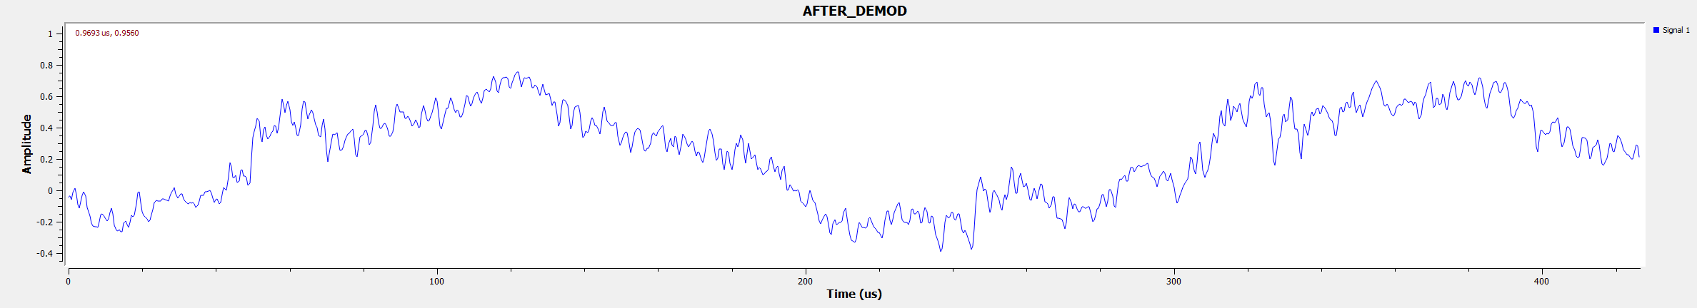
Figure 18 – RTL-SDR Time Sink after Demodulation
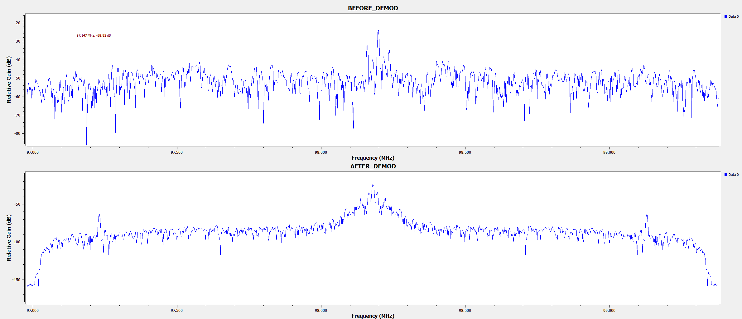
Figure 19 – RTL-SDR Frequency Sinks
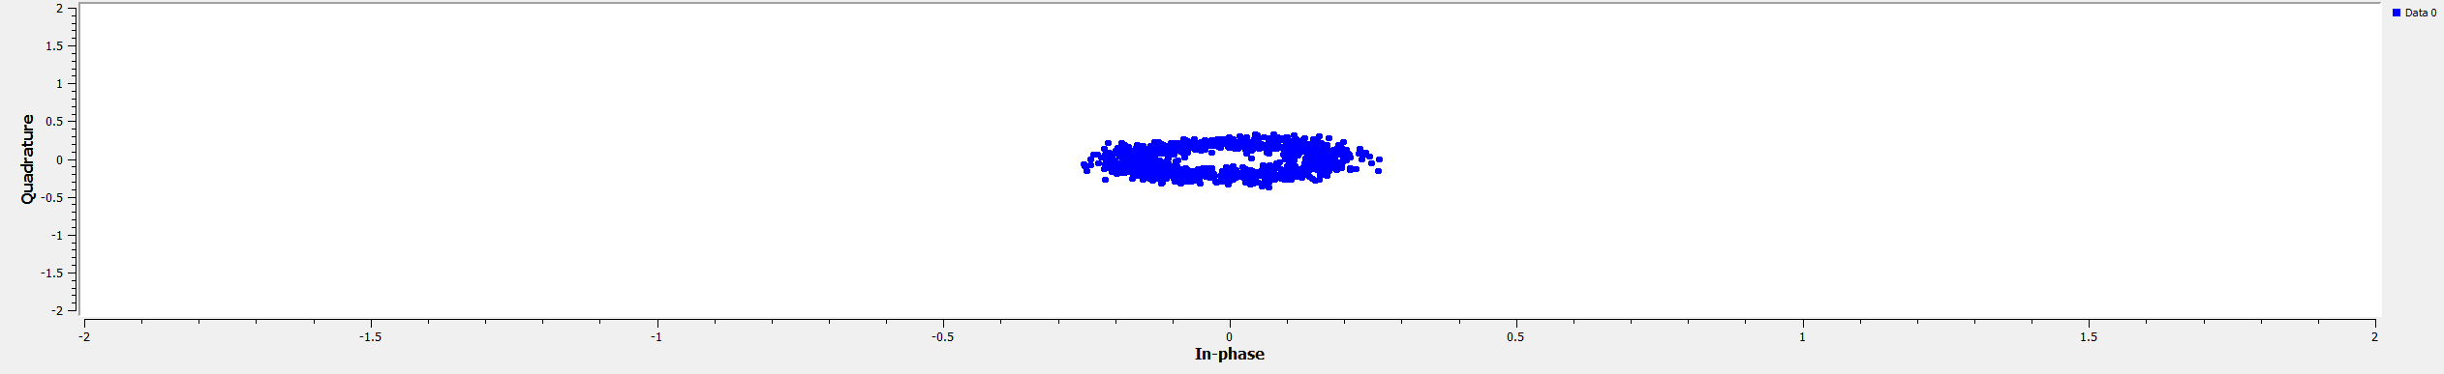
Figure 20 – RTL-SDR Constelation

Results and Analysis:

Discussion:

NFBM:
This task explored the effect of applying an interference source to NBFM communication and how FHSS can be applied to counteract this. The NBFM system is designed and simulated within a python base software called GNU radio which will be used to represent the effect of jamming the signal and how you can bypass it.
The original signal, as seen in figure 6, with no interference maintains signal integrity and when demodulated produces a very clear audio output. The carrier frequency is clearly seen in figure 6 waterfall sink and is separated from the audio message that has undergone NBFM allowing the system to remove the high frequency component by using a low pass filter as seen in the frequency sink in figure 8.
When interference is introduced to the system on the same channel as the transmitter signal degradation and distortion is noticed. The bandwidth of the jamming signal and the power need to be at a sufficient level to completely stop the receiver from demodulating the message completely. Because of this it is possible to still hear and see some of the audio message after demodulation because frequency modulation is quite resilient to interference on its own. When the jammer completely covers one half of the message signal the audio is completely distorted and little of the original message is audible. This can be seen in figure 12 as the frequency sink shows most of the message overpowered by the interference. This is also seen in figure 10 as the waterfall shows how the bandwidth overpowers the message signal.
With FHSS you can see in figure 13 how the transmitter is capable of changes frequencies/channels to actively avoid any interference in the simulation. Figure 14 shows an effective channel change in the waterfall sink which can also be seen in figure 16 of the frequency sink.
The demodulated audio time sink shows the audio signal after demodulation, and it is evident that data is lost across all three flow graphs which likely indicates that a higher sample rate is needed to retain more of the audio data.
Signal to noise ratio or SNR is the ratio between the power of the received signal and the noise in the system. The higher the value of SNR the better the signal integrity/clarity. Therefore, FHSS is being implemented in this system to improve SNR when interference is introduced. [10]
FHSS performs very well against this type of interference source with a small bandwidth remaining on one channel as it can switch channels where there is little to no noise and can therefore retain the signal integrity better as seen in the figures 12 and 16 which shows the demodulation with jamming and without. This wouldn’t be as effective in a real-world simulation as there will be other noise present and the interference may not be localised to one of the frequency channels used.
The limitations of this design are mainly the number of channels available to change to, the simulation requires manual switching between channels, it doesn’t automatically hop between channel based on a pseudorandom sequence as per the real-world implementation and that the interference is very localised and doesn’t emulate what would be experienced if deployed.

WBFM:
The waterfall sink, seen in figure 17, shows the waterfall sink before demodulation and is very difficult to identify any signal because of the background noise. Figure 17 shows the waterfall sink after the low pass filter and demodulation where there is clear carrier waves present on either side of the waterfall and the audio message is seen between. Figure 19 shows the before and after of the frequency sink which shows the successful demodulation as seen in the waterfall sinks. Finally, figure 20, shows the constellation diagram of the received signal which shows some distortion of the message but overall provides good signal clarity.

Ethical and Societal Impacts:
OFCOM is the regulatory body for communication services in the UK and decides how the radio frequency spectrum is managed and decides what limitations are enforced [11]. The main areas of significance regarding OFCOM regulations are the frequencies being used and the power limitations that apply [11]. It is not legal or ethical to intentionally interfere or disrupt any communication without prior approval from the governing body. The spectrum is split up into areas that include license and license-free operation in that band, the latter allowing people transmit within that band as long as they stay within the stated power limitations.
Jamming or interfering with any communication system is considered illegal and very unethical as the communication system could be essential for emergency services and will likely cause harm without them. This is also why anti-interference techniques are often implemented as an extra layer of robustness against any people looking to cause disruption.
Secure communication is another key factor to consider when creating these communication systems as sensitive personal information will likely be shared, and it is therefore important for that these systems are constantly kept up to date to reduce the chance of any vulnerabilities being exploited. The benefits of having secure communication methods adds an extra layer of redundancy which is especially important for emergency services.
SDR technology is extremely powerful and can enable users to explore faster and more adaptable use cases compared to fixed hardware by allowing them to adjust how the radio behaves through software. However, there are drawback to this technology as it can be used to illegally and unintentionally inhibit communication services. The technology is very easy to use and can therefore be just as easy to apply maliciously.

Conclusion:
From the background research and simulations in this assignment it is clear that FHSS is a suitable anti-jamming technique to avoid localised interference as seen in figures 14 and 16. This method of anti-jamming is ideal for this specific scenario as it capable of changing channel when interference is present on the desired channel. The flow graph itself is capable modulating and demodulating depending on the channel input in the GUI which is used to actively avoid any jamming.
However, this method may not be a perfect solution when implementing it in a real-world scenario as background interference will be present no matter what frequency is chosen and there is restrictions and regulations that need to be adhered to. These restricts limit the bandwidth, power and frequency that you can use and it must be followed to legally transmit in the UK. It is therefore worth exploring alterative techniques, such as CSS, SS and DSSS to ensure signal integrity is maintained but the technique used will be entirely dependant on the requirement of the transmission system as each one comes with its own benefits as well as limitations.

References

[1] | N. Abramson, “Bandwidth and Spectra of Phase-and-Frequency-Modulated Waves,” IEEE Transactions on Communications Systems, vol. 11, no. 4, pp. 407-414, 1963.
[2] | S. S. R.S.Goswami, “Audio Transmission through NBFM using GNU Radio,” in International Conference on Advancements in Engineering and Technology (ICAET 2017), 2017.
[3] | T. C. R. a. M. Y. T. M. B. Pursley, “High-rate direct-sequence spread spectrum,” IEEE Military Communications Conference, vol. 2, no. 1, pp. 1101-1106, 2003.
[4] | L. F. Chaparro, “Applications of Discrete-Time Signals and Systems,” Signals and Systems using MATLAB, 2011.
[5] | N. H. Motlagh, “Frequency Hopping Spread Spectrum: An Effective Way to Improve Wireless Communication Performance,” in Advanced Trends in Wireless Communications, 2011.
[6] | B. V. N. I. S. a. K. K. H. Jung, “Design of Anti-Jamming Waveforms for Time-Hopping Spread Spectrum Systems in Tone Jamming Environments,” IEEE Transactions on Vehicular Technology, vol. 69, no. 1, pp. 728-737, 2020.
[7] | A. T. o. C. S. S. M. f. L. B. a. K. Advances, “A Tutorial on Chirp Spread Spectrum Modulation for LoRaWAN: Basics and Key Advances,” IEEE Open Journal of the Communications Society, vol. 5, no. 1, pp. 4578-4612, 2024.
[8] | J. P. Devaraj, “GNU Radio Intro,” UWTSD, 2024.
[9] | J. P. Devaraj, “Software Defined Radio,” UWTSD, 2024.
[10] | Cadence, “What is Signal to Noise Ratio and How to calculate it?,” Cadence, [Online]. Available: https://resources.pcb.cadence.com/blog/2020-what-is-signal-to-noise-ratio-and-how-to-calculate-it. [Accessed 11 12 2024].
[11] | Ofcom, “Frequency and technical information,” Ofcom, 14 01 2025. [Online]. Available: https://www.ofcom.org.uk/spectrum/frequencies/technical-information/. [Accessed 14 01 2025].
[12] | O. L. a. A. E. B. F. du Burck, “Narrow-band correction of the residual amplitude modulation in frequency-modulation spectroscopy,” IEEE Transactions on Instrumentation and Measurement, vol. 52, no. 2, pp. 288-291, 2003.
[13] | Wray Castle, “Understanding Direct Sequence Spread Spectrum: A Simple Guide for Beginners,” 12 2024. [Online]. Available: https://wraycastle.com/blogs/knowledge-base/direct-sequence-spread-spectrum#:~:text=Direct%20Sequence%20Spread%20Spectrum%20(DSSS,choice%20for%20various%20communication%20systems.. [Accessed 14 01 2025].

