An Analysis of Front Office Service Quality Improvement Opportunities in a Budget Hotel:
A Case Study of Ibis London Stratford

Placement Research Project
BA (Hons) International Hotel Management
Level 6 | Module Code: BMIH6008

University of Wales Trinity Saint David
Swansea Campus

Student: Aniko Takacsne Feher
Student Number: 2245369
Lecturer’s name: Kathryn E Flynn
Word count: 8123

AI Acknowledgement
I confirm that I have not used any AI tools in the research and creation of this assignment. I confirm that I have not presented any AI-generated materials as my own work. I confirm I have copies of my drafts, notes, and other resources I used, which I may be asked to provide in evidence.

Signed:
Date: 26 February 2026

Acknowledgements
I would like to express my sincere gratitude to my project supervisor for her invaluable guidance, constructive feedback and continued support throughout this research project. I am also grateful to the University of Wales Trinity Saint David for providing access to academic resources and library databases that were essential to completing this study.
I would like to thank the management team at Ibis London Stratford for the opportunity to undertake my professional placement at the hotel, which provided the practical context and inspiration for this research. The experience gained during the placement was instrumental in identifying the research topic and shaping the direction of this project.
Finally, I wish to thank my family and friends for their patience, encouragement and constant support throughout my studies.

Abstract
The placement experience at Ibis London Stratford included long queues during busy periods at check-in, understaffing during the weekend and inconsistent complaint handling. These patterns will be analysed throughout this dissertation through secondary research to identify evidence-based improvement strategies to improve service quality within the budget hotel sector.
Service quality research has been prevalent within the luxury hotel verticals and full-service hotels categories whereas economy and budget hotels have not seen as significant research interest academically. Therefore, this dissertation addresses three research questions: existing approaches to measuring service quality, the comparison between secondary research and placement-based patterns, and realistic improvements to increase service quality.
To complete this dissertation, secondary desk-based research was conducted. Thematic analysis was completed through Braun and Clarke’s (2021) six-phase approach to analyse academic journals, industry articles and customer review data. Recent journal articles related to service quality in hospitality were used to establish topic relevance. Industry articles were then used to supplement this and included articles from J.D Power (2024) and Mordor Intelligence (2025). Review data was anonymised in table form from publicly available review platforms and analysed following Bi, Zhu and Han (2024) and Mehraliyev, Chan and Kirilenko (2022).
The following themes were identified as most present: speed of service during check-in/check-out, staff availability, recovery, communication and value. Check-in queues during busy periods were a significant theme during placement observations. After further research, hospitality staff availability is recognised as a labour concern (UKHospitality, 2024). Some staff members were praised by guests following service recovery; however, employees had limited authority during these situations. Communication differed by shift and guests felt they received value as long as basic services functioned.
Empathy was established as being significant with regard to satisfaction levels. Ali et al. (2021) concluded that when guests are approached with empathy, many positive correlations occur. Mouzaek et al. (2021) found similar results. Technology can aid hospitality businesses by facilitating mobile check-ins and installing self-service technology which can decrease wait times and free up employees to work on building relationships with guests (Oracle Hospitality and Skift, 2022; Guestara, 2024). Satisfaction can increase when businesses resolve complaints if the service recovery paradox occurs (Kim and So, 2023; Rao, Pai and Sethumadhavan, 2024). Recommendations from this research include adopting a hybrid approach to service, empathy training, empowering employees to improve responsiveness during service recovery, introducing structured complaint management and career development initiatives.

Table of contents
Acknowledgements 3
Abstract 4
Chapter 1: Introduction 8
1.1 Background and Context 8
1.2 Research Problem and Rationale 9
1.3 Aim and Objectives 10
1.4 Structure of the Report 11
Chapter 2: Literature Review 12
2.1 Conceptualising Service Quality in Hospitality 12
2.2 The SERVQUAL Framework and Its Hospitality Adaptations 13
2.3 Service Quality in Budget Hotel Contexts 14
2.4 The Front Office as a Service Quality Nexus 15
2.5 Online Reviews and Service Quality Assessment 16
2.6 Service Recovery and the Recovery Paradox 17
Chapter 3: Research Methodology 19
3.1 Research Philosophy and Approach 19
3.2 Research Design: Qualitative Case Study 19
3.3 Secondary Data Sources 20
3.4 Thematic Analysis Procedures 21
3.5 Trustworthiness and Limitations 21
Chapter 4: Findings and Discussion 23
4.1 Findings 23
4.1.1 Theme One: Check-in and Check-out Efficiency 23
4.1.2 Theme Two: Staff Availability and Service Responsiveness 25
4.1.3 Theme Three: Service Recovery and Complaint Handling 27
4.1.4 Theme Four: Communication and Information Quality 28
4.1.5 Theme Five: Value Perception and Service Consistency 29
4.2 Discussion 30
4.2.1 Synthesised Perspective 30
4.2.2 Theoretical Implications 31
4.2.3 Practical Implications for Ibis London Stratford 32
Chapter 5: Conclusion and Recommendations 34
5.1 Summary of Key Findings 34
5.2 Recommendations 35
5.2.1 Recommendation One: Implement a Hybrid Service Delivery Model 35
5.2.2 Recommendation Two: Develop an Empathy-Focused Training Programme 35
5.2.3 Recommendation Three: Establish a Service Recovery Empowerment Framework 36
5.2.4 Recommendation Four: Introduce Systematic Guest Feedback Analysis 37
5.2.5 Recommendation Five: Address Staff Retention Through Career Development 38
5.3 Directions for Future Research 38
5.4 Concluding Remarks 39
Reference List 40

Chapter 1: Introduction

1.1 Background and Context
Hospitality and leisure is a major industry in the UK economy. According to UK Hospitality (2024), it contributes £93 billion to the UK economy per year and provides 3.5 million jobs. WTTC (2024) and Ignite Economics (2023) also provide similar estimates. There are around 176,685 businesses across Britain in the hospitality sector according to the House of Commons Library (2025), most of which are SMEs. Budget hotels are a growing segment within the hospitality industry known for being resilient and flexible. They deliver consistent quality at affordable prices catering to the changing demands of guests and travellers. According to World Tourism Forum Lucerne (2024), the budget hotel market is worth USD 276.3 billion worldwide. It is expected to grow to USD 430.9 billion by 2032.
In 2024 Ibis celebrated its 50th anniversary having become one of the largest economy hotel brands in the world (Hospitality Investor, 2024; CoStar, 2024; Campaign India, 2024). Today, the Ibis brand has over 2,600 hotels in 79 countries with about seventy-two million room nights sold annually. Accor (2025) also stated that ALL has had over 100 million members. The Ibis London Stratford hotel, which was the case hotel reviewed in this study, is based in East London and had occupancy rates of approximately 82 per cent with room rates averaging at £228 per night, showing promising figures for business (Knight Frank, 2025; STR, 2024; Cushman and Wakefield, 2024; VisitEngland, 2025). Hotel occupancy rates in London have also bounced back past pre-pandemic levels. ONS figures from RSM UK (2024) show that occupancy hit 80 per cent in December 2023 up from the previous figure of 78.3 per cent.

The hospitality sector looks set to continue to grow with Mordor Intelligence’s (2025) prediction that the UK hospitality market will be worth USD 72.76 billion by 2030. Other similar estimates have been published by Deloitte (2024) and Statista (2024). Although the market is growing, many hoteliers continue to face rising costs and pressure on their businesses. According to PwC (2025), labour costs per room have risen 15 per cent since before the pandemic. Energy costs have also risen and now account for “around 5 to 10 per cent of turnover annually” which is significantly higher when compared with 2019 (Hotel Management Network, 2024: 6). For budget hotels, this is significant as margins are often slimmer than other hotels, so being efficient and effective is crucial.

1.2 Research Problem and Rationale
Challenges experienced during the placement at Ibis London Stratford, such as long queues at check-in times around late afternoon, staff shortages during evenings and weekends and inconsistent service when dealing with guest complaints across different shifts, were persistent problems observed throughout the placement. These problems appeared consistently in daily operations and may have managerial and organisational implications.
The study concentrates on the front office as reception is widely recognised as the heartbeat of hotel operations (Jawabreh et al., 2022) and Mataram et al.’s (2022) study showed a positive correlation between front office e-service quality and guest satisfaction within the industry. Furthermore, labour shortages appear to be an industry-wide problem within the hospitality sector. UK Hospitality (2024) found there to be around 132,000 job vacancies across the hospitality industry with 84 per cent of hospitality businesses struggling to recruit frontline staff members (CIPD, 2024; Office for National Statistics, 2025). Moreover, articles have been published relating to how staffing shortages are impacting hotels on a day-to-day basis (Infraspeak Blog, 2024; Nory, 2024) and employee turnover continues to soar with it currently at 73.8 per cent annually in the UK hospitality sector (Lingio, 2024).
Due to the above challenges faced within the industry, the research problem is centred around identifying areas of poor service quality and opportunities for improvement within the front office department of a budget hotel. Many studies focus on service quality within the luxury and full-service segment of hotels leading to limited research around budget hotels which make up a large proportion of hotels. To gain further understanding of service quality in budget hotels, the study considers relevant literature alongside placement observations through the lens of one hotel.

1.3 Aim and Objectives
The aim of this project is to carry out secondary research into areas of service quality and service improvement potential within the front office department at Ibis London Stratford, identifying practical recommendations which can be employed to enhance service quality. Research topics were derived from issues encountered during the placement.
This project has three specific objectives:
- To conduct a review of literature into front office service quality and guest satisfaction in economy and midscale hotels, including current models such as SERVQUAL and their applicability to hospitality.
- To assess secondary research material including brand standards, online customer reviews and industry publications to establish common themes in front office service failures at Ibis London Stratford.
- To put forward actionable recommendations to increase the effectiveness and productivity of front office service while maintaining alignment with Accor’s brand standards.

1.4 Structure of the Report
This report consists of five chapters. Chapter 2 offers a review of relevant literature on service quality theory, with a focus on its conceptualisation for budget hotels specifically. Chapter 3 describes the research methods utilised for this study and justifies the desk-based qualitative case study design. Chapter 4 discusses the results of secondary data analysis and interprets their practical and theoretical significance. Chapter 5 summarises the main takeaways and proposes practical implications for hotel management.

Chapter 2: Literature Review

2.1 Conceptualising Service Quality in Hospitality
Conceptualising and measuring service quality within the hospitality industry has been a key area of focus in hospitality research and remains debated among academics and industry experts. Grönroos (1984) developed one of the first conceptualisations of service quality, differentiating between technical quality and functional quality. Since then, most conceptualisations have been defined as how well the level of service delivered matches or surpasses guest expectations (Ali et al., 2021; Zeithaml, Parasuraman and Berry, 1990). However, Parasuraman, Zeithaml and Berry’s original conceptualisation from 1988 remains the basis for many contemporary studies.
Measuring service quality can be challenging, as hotel services are simultaneously produced and consumed, are highly people-oriented and heterogeneous, making them difficult to assess consistently (Ali et al., 2021). This, combined with the intangible and perishable nature of services, results in customers having limited opportunities to assess hotel quality before purchase and consumption. Shyju et al. (2023) recently conducted a Web of Science review of hospitality service quality literature and noted that studies have been dispersed across several themes, using a variety of methodological approaches. This corresponds with similar recent bibliometric studies of hospitality service quality literature by António and Rita (2023).
A more recent study by Olawuyi and Kleynhans (2025) analysed 876 scholarly articles on service quality and found that SERVQUAL is the most commonly used tool for measuring service quality. SERVQUAL measures five dimensions which are tangibles, reliability, assurance, empathy and responsiveness. Despite SERVQUAL being the most popular framework used when measuring service quality within the hospitality industry, several hospitality service-quality adapted models have been used, such as HOLSERV, LODGSERV and LODGEQUAL (Rauch et al., 2015). Asgeirsson, Gudlaugsson and Jóhannesson (2024) analysed survey responses from 1,487 hotel customers and differentiated between tangible service quality cues and service quality performance. Both were found to have significant relationships with customer satisfaction and loyalty.

2.2 The SERVQUAL Framework and Its Hospitality Adaptations
Five dimensions of service quality were identified through SERVQUAL. These were tangibles, reliability, responsiveness, assurance and empathy. Tangibles cover the physical appearance of facilities and staff; reliability is the ability to perform the promised service dependably and accurately; responsiveness reflects willingness to assist guests; assurance refers to staff knowledge, courtesy and their ability to inspire trust; and empathy covers the provision of caring and individualised attention to guests. The application of these five dimensions to service industries such as hospitality remains popular for assessing customer perceptions.
The literature is consistent on the prominence of empathy. Ali et al. (2021) found a very high correlation between empathy and guest satisfaction (0.812) which is higher than that of tangibles or reliability. Mouzaek et al. (2021) found that empathy and responsiveness had the most significant impact on guest satisfaction in hotel services. This finding corroborates that of Choi and Chu (2001) and Lee, Lee and Yoo (2000), who found that interpersonal delivery was the most significant contributor to customer perceptions of hotel service quality among managers of budget hotels. Other studies have demonstrated the importance of the SERVQUAL dimensions in different ways. Kalnaovakul and Promsivapallop (2023) used topic modelling on 25,267 reviews from TripAdvisor and found five themes comparable to HOLSERV categories. This shows support for both SERVQUAL-based research and the use of text mining as a supplement to surveys. Wong et al. (2022) argue that technological advancements are shifting hotel service encounters from high-touch to high-tech, highlighting the need for service quality measures that account for digitalised interactions.

2.3 Service Quality in Budget Hotel Contexts
Budget hotels tend to operate to different rules. Mintel (2024) highlights this distinction and J.D. Power (2024) reports that for economy guests value for money is the most influential purchasing factor. This can be understood from the guest perspective. A guest selecting a £60 room rather than a higher-priced alternative reflects differing priorities. Ali et al. (2021) also confirms that when it comes to predicting satisfaction in economy settings empathy and responsiveness in service delivery are vital. Guest trust is influenced by word-of-mouth communication and negative service experiences. Expectations may be lower in low-price segments, yet dissatisfaction can still arise quickly when core services fail.
J.D. Power’s (2024) survey of 39,468 guests revealed a disturbing trend for budget operators. Despite an industry uptick satisfaction in the economic segments continued to decline year on year. While other segments improved, the economy segment experienced declining satisfaction. Staff service remains though the number one score across all categories indicating where value is most strongly perceived. American Customer Satisfaction Index (2024) discovered that whilst budget guests are willing to forgo luxury in exchange for low prices they will absolutely not tolerate staying in a room that isn’t clean or receiving unreliable basic service. Mashita et al. (2025) surveyed 233 guests at budget hotels in Malaysia and their findings confirmed that satisfaction is raised in economy hotels by delivering on SERVQUAL dimensions such as responsiveness, assurance, empathy.
Brand reputation is highly influential in this sector. Savanta (2022) concluded it was the one thing separating the good budget hotel brands from less recognisable brands. Within this context, Ibis represents a leading economy brand. Hospitality Investor (2024) quotes Ibis Global Brand President Jean-Yves Minet saying his brand “democratised travel by pioneering economy hospitality” half a century ago. CoStar (2024) says that from the beginning Ibis has competed on brand consistency not luxury. BW Hotelier (2024) recently reported that Accor has plans to open 143 new hotels with 17,474 rooms by the year 2027 courting business travellers and millennial and Gen Z tech customers. Such expansion plans require consistent front office standards to be maintained across properties.

2.4 The Front Office as a Service Quality Nexus
The hotel front office is a major service delivery point and primary contact area for customers. Jawabreh (2022) defines reception as a “central operations point” within hotel operations, incorporating services such as check-in, enquiry handling, complaint resolution and the checkout process. All of these sub-processes therefore help build guest perception, with previous research showing that hotel front office e-service quality predicts guest satisfaction (Mataram et al., 2022).
Cost cutting and restructuring during COVID-19 have also placed increased strain on front office operations as Hemmington and Neill (2022) recognise “leaner operating models mean there are fewer people and less flexibility”. This challenge was particularly evident within the budget hotel placement context due to limited back-of-house support services. As a result of this front desk agents were involved in many operational tasks from contacting guests, liaising with housekeeping and following up on any service failures. Placement observations supported this, indicating that front office staff frequently performed multiple services simultaneously with limited staffing.
Supporting the importance of front office in guest satisfaction, Davras and Caber (2019) found that negative experiences at reception have a more powerful impact on guest satisfaction levels within economy hotels than positive ones. Therefore, reliable front office operations are critical in determining overall service quality.

2.5 Online Reviews and Service Quality Assessment
Online reviews have become an important source of hospitality-related service quality research data. Mehraliyev, Chan and Kirilenko (2022) provide evidence that sentiment analysis, defined as “the automated process of identifying positive, negative or neutral opinions from text materials,” is now frequently used to assess service quality and that sometimes the analysis of reviews can be used to supplement survey results. Text mining extracts recurring patterns in guest comments from platforms such as TripAdvisor and Google Reviews that may not be captured through traditional service quality audits (Bi, Zhu and Han, 2024). Guo, Barnes and Jia (2017) and Xu and Li (2016) also acknowledge the benefits of analysing content created by customers.
Ounacer et al. (2023) show through sentiment analysis that properties can suffer from issues which are not identified through the normal quality assessment process. Other researchers show that guests who are satisfied highlight different factors to guests who are not satisfied. Berezina et al. (2016) show that satisfied and dissatisfied guests regularly highlight different service attributes. This is consistent with Herzberg's (1959) two-factor theory and Maslow's (1943) hierarchy of needs, which suggest that basic expectations must be met before higher-level satisfaction can occur. Reviews are becoming increasingly influential as their volume continues to rise on platforms such as Booking.com (2024). The study gathered publicly available reviews for Ibis London Stratford, which were thematically analysed without the use of personal data, consistent with ethical guidance noted by Kim and So (2023).

2.6 Service Recovery and the Recovery Paradox
Service failures occur periodically during service delivery. A phenomenon known as the service recovery paradox exists within the hospitality industry which means that customers who experience failures may develop higher levels of loyalty when the failure is well managed (Kim and So, 2023; Rao, Pai and Sethumadhavan, 2024). A meta-analysis found that when customers perceive recovery to be sincere, prompt, and appropriate to the situation, service recovery paradox may occur, with recovery efforts having a more positive effect on satisfaction than the original failure (Rao, Pai and Sethumadhavan, 2024). Effective service recovery often involves empowering frontline employees who engage directly with customers. Al-Ababneh (2021) found that when employees are empowered to make decisions affecting customers it can increase customer satisfaction and positively impact employee well-being and self-efficacy. As front office associates represent the primary employee contact point for economy hotel guests, empowering these employees is important.
Customer service recovery has been linked to service quality. SERVQUAL dimensions of reliability, responsiveness, assurance, empathy, and tangibles have been used to measure customers’ expectations of recovery (Parasuraman, Zeithaml and Berry, 1988) and their perceptions of the actual recovery received. Herzberg’s (1959) motivator-hygiene theory and Maslow’s (1943) hierarchy of needs help explain why customers in economy hotels may be more concerned with hotels getting the basics right each time than with extra perks offered by hotels.
Research has shown that empathy was a key driver of satisfaction (Ali et al., 2021; Mouzaek et al., 2021). Evidence of service recovery paradox also shows the importance of customer complaint handling in building customer loyalty (Kim and So, 2023). Review-based analyses can also allow hotels to see what problems keep occurring in the front office department (Bi, Zhu and Han, 2024; Mehraliyev, Chan and Kirilenko, 2022). These studies informed the methodological approach and recommendation development within this research.
Figure 1 summarises the conceptual relationships between service quality dimensions, front office operations, online review insights and service recovery processes that inform the analytical framework of this study.
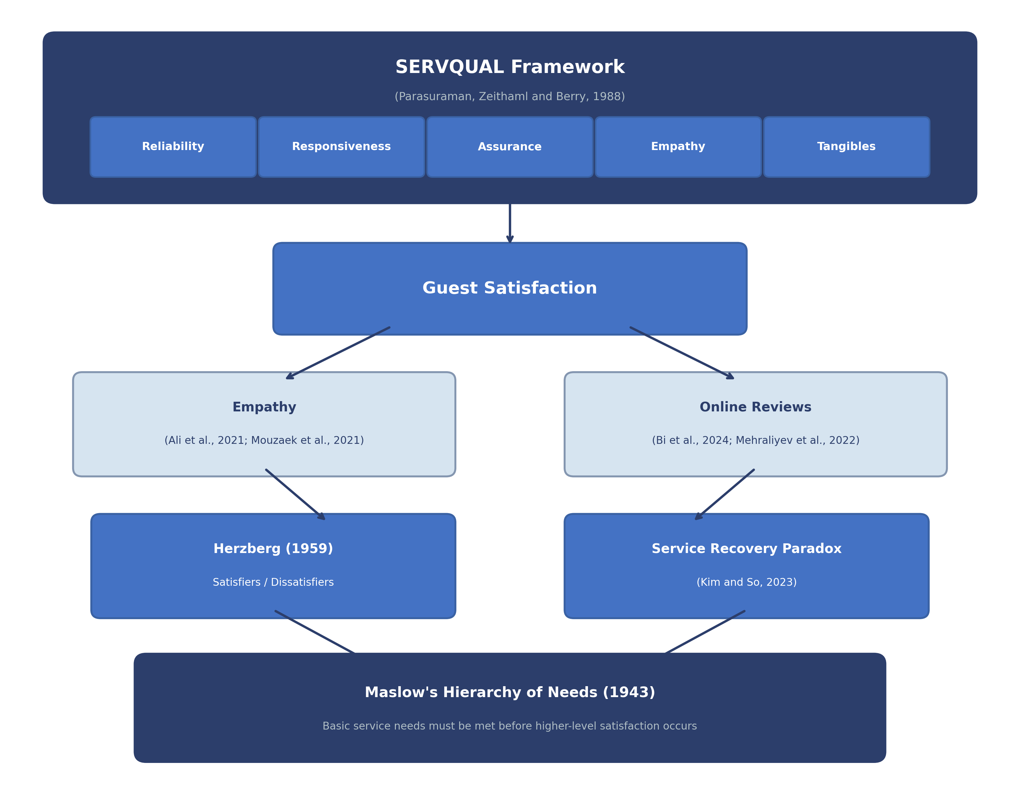
Figure 1: Conceptual Framework for Analysing Front Office Service Quality at Ibis London Stratford

Chapter 3: Research Methodology

3.1 Research Philosophy and Approach
Saunders, Lewis and Thornhill (2019) describe several philosophical approaches to business and management research. An interpretivist philosophy was selected for this study as the research seeks to interpret and understand experiences rather than explain causal relationships. Within the hospitality industry, customer feedback and reviews are subjective; therefore qualitative research can be utilised to understand how guests experience front office operations. Additionally, Creswell and Creswell (2023) explain that the interpretivist philosophy can be combined with an inductive approach. This approach allows patterns to emerge from the data rather than forcing data into predetermined conceptual models.

3.2 Research Design: Qualitative Case Study
The methodological approach used in this study is qualitative case study. According to Yin (2018), the case study method is ideal for answering questions about modern-day events in their natural context; therefore, it is appropriate for researching the issues in one hotel environment. Consequently, Ibis London Stratford was selected as the case, and multiple secondary data sources were used to build a case study around front office procedures and themes that arise.
As this study relies solely on secondary data, no primary data collection was undertaken. This is because of several pragmatic reasons given the period of the placement. Ethical considerations related to collecting data from staff or customers were also acknowledged as potentially compromising personal data. Desk research is known to be just as valid as collecting primary data when using qualitative methods (Bowen, 2009). Documents and their analysis can be used to create context around an issue. Lu et al. (2015) demonstrate the use of documentary analysis in examining hotel service quality when analysing service quality in hotels. Throughout the project, knowledge gained from placement experience helped shape the research questions. However, all evidence was derived from publicly available documents or academic sources.

3.3 Secondary Data Sources
Three types of secondary data were used in this study. The first consisted of published academic material from various sources available through UWTSD resources, including EBSCO, Emerald Insight and Google Scholar. These included journal articles, textbooks and conference papers. There was a focus on literature published since 2021 in an effort to take account of how the sector had changed following the COVID-19 pandemic; however, foundational frameworks such as SERVQUAL have remained relevant, and so literature referencing this was still used (Parasuraman, Zeithaml and Berry, 1988).
Secondary data also came from publicly available hotel data and industry reports. Hotel brand reports were used from Accor (2023, 2024) as well as industry reports from Knight Frank (2025), PwC (2025), Savills (2024, 2025), Mordor Intelligence (2025), J.D. Power (2024) and the American Customer Satisfaction Index (2024). Industry data was used to give background to the current state of the market and how the hotel brand fits into this. Lastly, reviews were used for Ibis London Stratford from various booking sites. These reviews were analysed at an aggregated level and no usernames were recorded. No personally identifiable information was retained. The PG2 UWTSD Ethics Form was completed prior to data collection.

3.4 Thematic Analysis Procedures
A thematic analysis framework adapted from Braun and Clarke’s (2021) guidelines was used to analyse the secondary data collected. Phase one, familiarisation with data, involved reading and re-reading guest reviews and crosschecking with industry reports and academic articles to become familiar with the information gathered. Coding was conducted in phase two by organising data into sections related to front office service quality.
Phase three consisted of searching for themes by grouping the first level of codes into potential themes. Phase four involved reviewing themes and developing a thematic map to ensure coherence and alignment with coded extracts. Phase five involved defining the themes presented in Chapter 4, while phase six consisted of producing the analytical narrative. The themes generated were mapped against existing service quality models such as SERVQUAL.

3.5 Trustworthiness and Limitations
To increase credibility, a triangulation approach was used. The sources used included academic literature, secondary industry sources, brand documentation, and online guest reviews. Themes supported by multiple independent sources enabled more confident interpretation and conclusion development. Detailing how the analysis was undertaken also helped improve dependability.
Analysing secondary data also required ethics to be considered. Reviews were analysed at an aggregated level rather than having individual responses recorded or stored. No data enabled the identification of individuals (e.g. names or email addresses), ensuring adherence to institutional ethical guidelines. This reduces risk to participants and keeps it anonymised.

A key limitation is that secondary data may provide less contextual depth than primary data if surveys or conversations were held with staff or guests. Reviews are self-selecting and may reflect more extreme guest experiences (Mehraliyev, Chan and Kirilenko, 2022). As this was a single case study, the findings cannot be confidently generalised to other hotels. However, given the placement-based context of the study, the chosen methods were suitable.

Chapter 4: Findings and Discussion
Five themes emerged from the secondary data analysis, each addressing a distinct altough interconnected aspect of front office service quality at Ibis London Stratford. The findings are presented first, followed by a discussion interpreting their significance.

4.1 Findings

4.1.1 Theme One: Check-in and Check-out Efficiency
Efficiency during check-in and check-out emerged as the dominant theme across the datasets. Customer reviews talked about waiting times when arriving between 16:00–18:00, where business and leisure travellers arrive. Evidence from three booking platforms demonstrated consistent themes around queuing and bottlenecks at reception desk outlining efficiency as a crucial factor in perceived service quality early on in the stay journey (Figure 2).
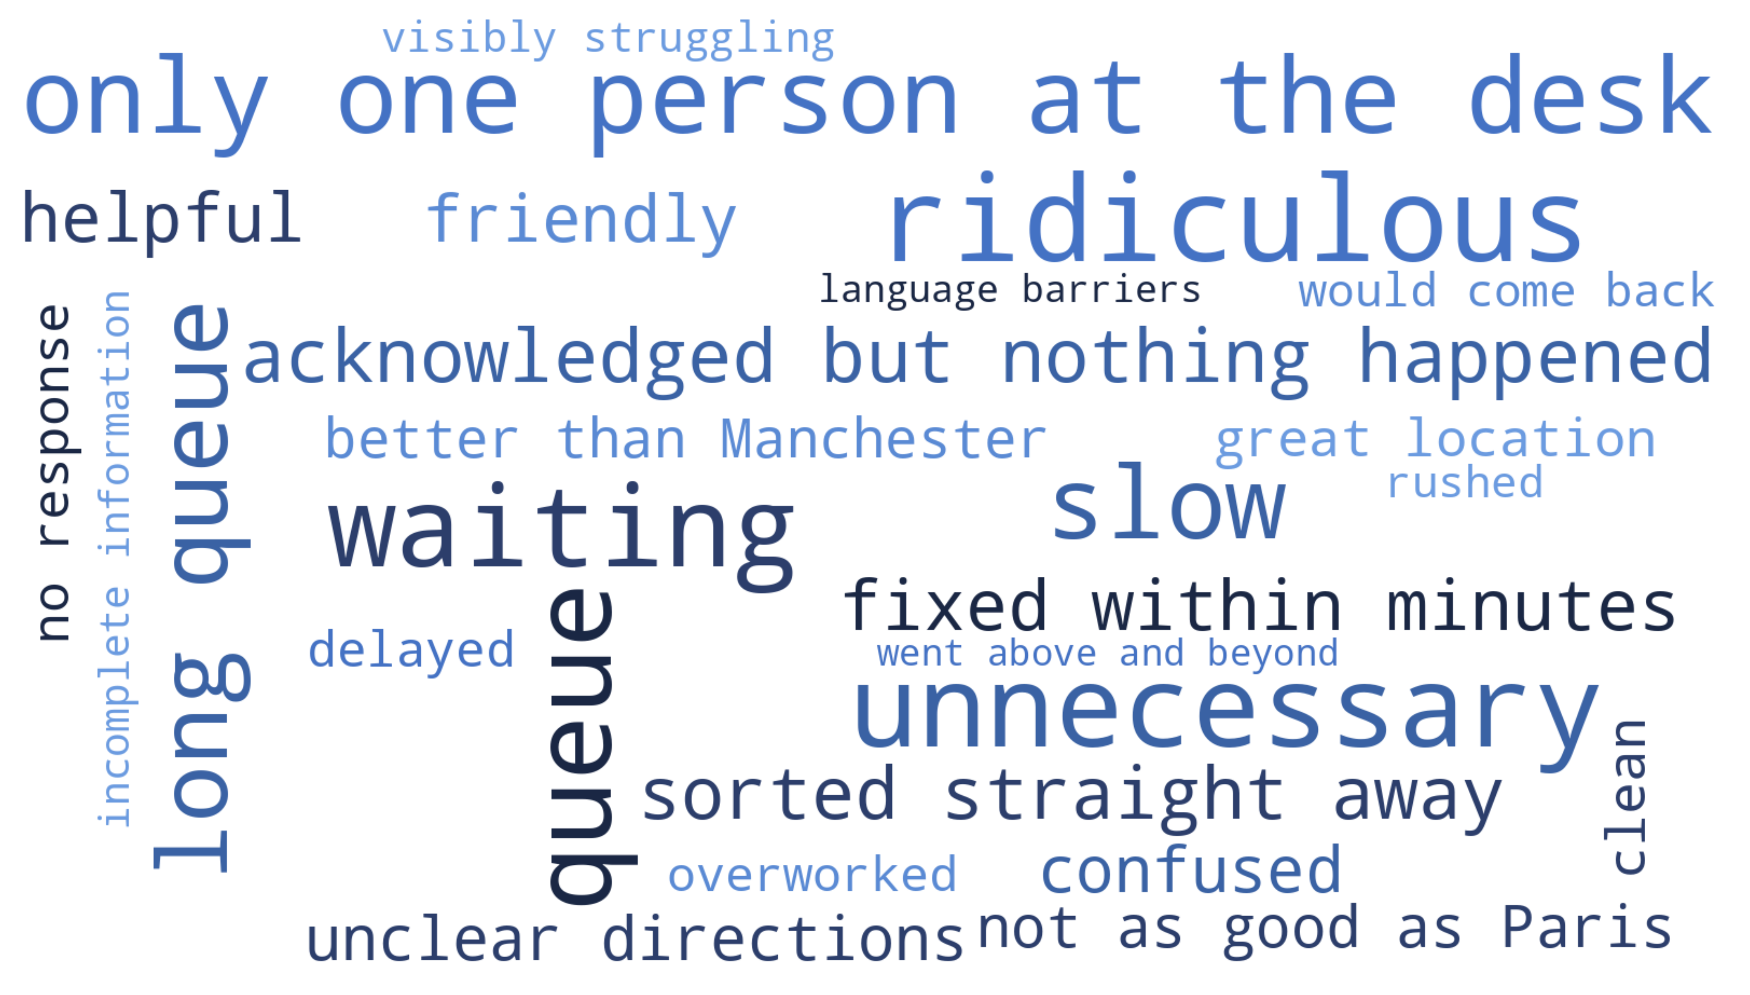
Figure 2: Word Cloud of Recurring Terms in Ibis London Stratford Guest Reviews
One potential solution to reduce pressure at reception desks is the utilisation of technology. According to Oracle Hospitality and Skift (2022), “73 per cent of travellers around the world would prefer hotels to offer self-service check-in” while Guestara (2024) found that automated check-in technology could improve processing times by up to 60 per cent. Previous literature demonstrates technology aided check-ins allow for better perceived efficiency while still allowing time for face-to-face interaction should guests desire it when using hybrid models, where technology complements rather than replaces human interaction. (Figure 3).
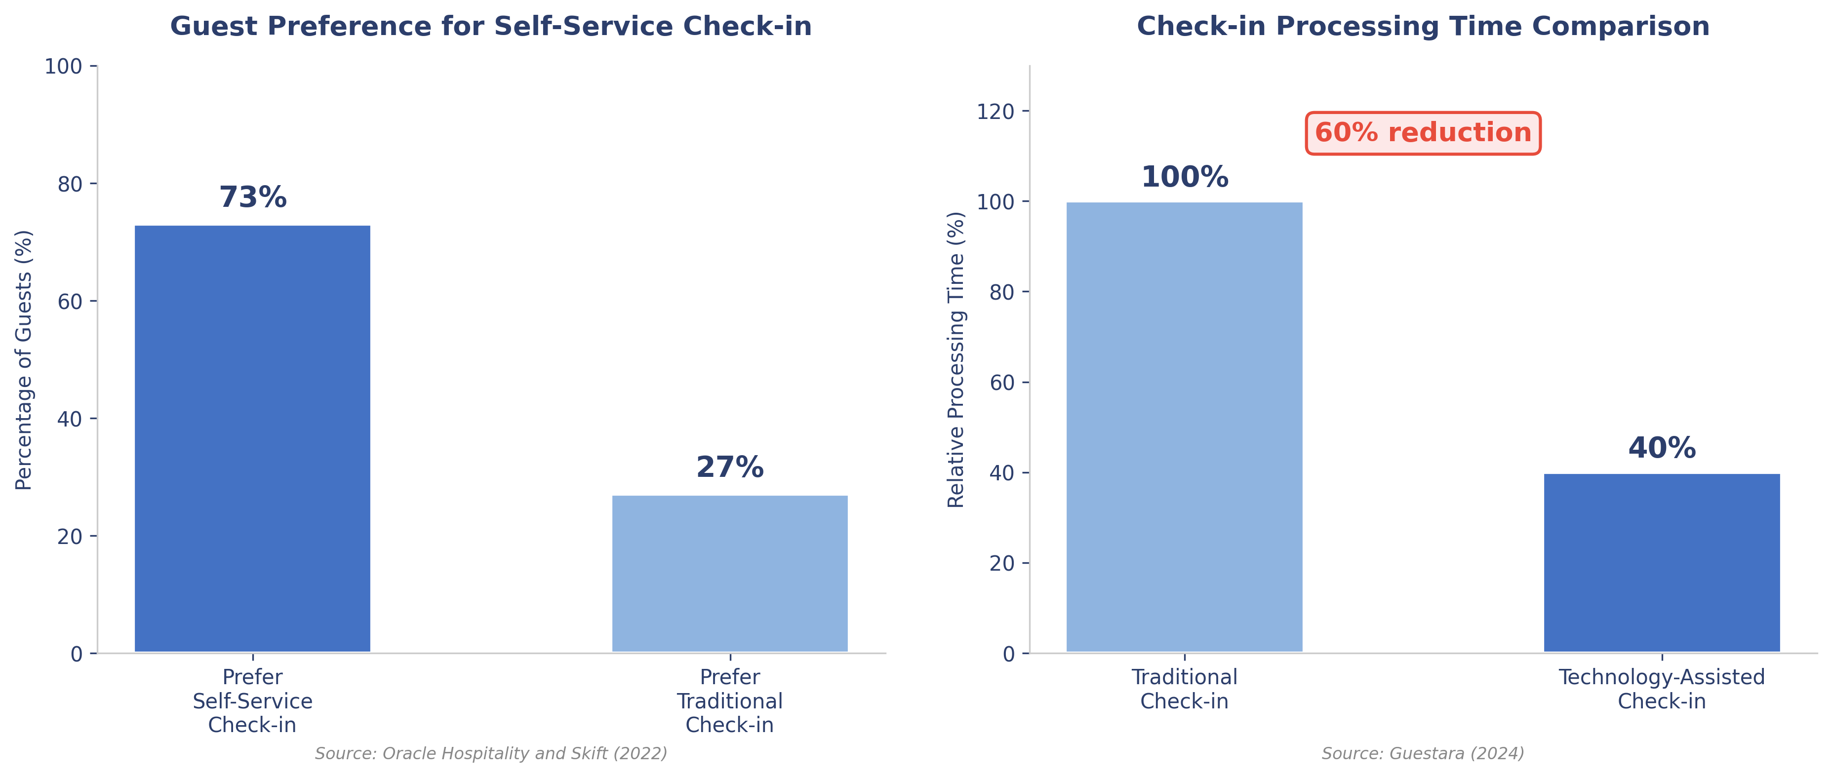
Figure 3: Self-Service Check-in: Guest Preferences and Processing Time Reduction
Placement observations supported review findings about rush hour at reception desk when staffing is low. Self-service check-in kiosks were placed conveniently around the lobby but they appeared difficult to locate due to poor visibility, lack of signage and no staff recommending this service to guests. Consequently, guests continued to queue at the reception desk despite available technology.
Similar trends around check-in/check-out could be observed within the marketplace. Savills (2024) reported hotel occupancy rates spike during school holidays/bank holidays in London causing heavy traffic of arrivals. This busy timeframe aligned with patterns identified in review data during the weekend where leisure guests arrive in bulk. On the brand-level, Accor (2023) found efficiency throughout the check-in process was important. One way they try to tackle this is through the use of technology such as mobile check-in and contactless kiosks. Overall, these findings indicate that front office performance during peak capacity is critical to perceived service quality.

4.1.2 Theme Two: Staff Availability and Service Responsiveness
In multiple instances within the collated review data, comments were made about reduced staffing capacity at the front desk during night shifts, mornings and weekends. Similar complaints were found throughout Booking.com, Google Reviews and TripAdvisor, showing consistency across different channels (Figure 4). The repetition of these comments strengthens the credibility of this theme.

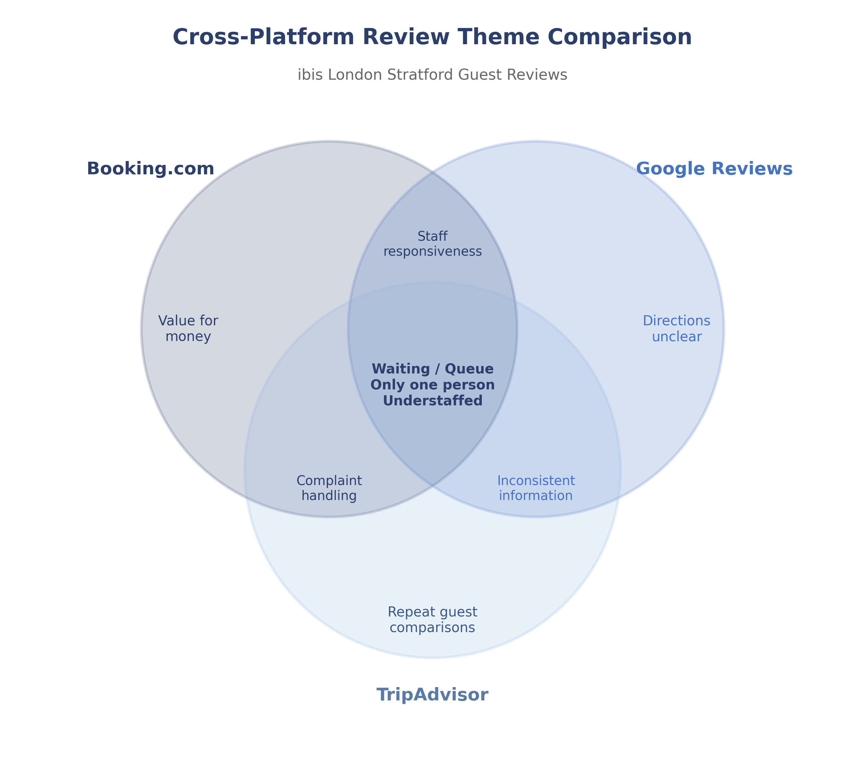
Figure 4: Platform comparison

Data from industry sources help to substantiate this theme. UKHospitality (2024) estimates that there are around 132,000 vacancies throughout the UK hospitality industry; with 84 per cent of firms within this sector currently facing difficulty hiring for front of house roles. Workforce shortages are intensified further by high rates of turnover; Lingio (2024) notes that staff turnover sits at 73.8 per cent on a yearly basis. Infraspeak Blog (2024) and Nory (2024) discuss how these vacancies result in heightened pressure on those who are employed within these front-of-house roles. Baum et al. (2020) note how employee turnover in hospitality should be viewed as an industry norm rather than an anomaly.
Placement observations indicated that reception was sometimes staffed by only two employees. This resulted in employees managing multiple tasks simultaneously, including check-in, check-out, answering phone calls, replying to emails and other operational duties. When staff are responsible for so many duties at once, there is the potential for them to focus less on the guest experience and rush through SERVQUAL dimensions in order to complete these tasks. This issue can be amplified in economy hotels as the front desk often represents the primary point of guest interaction.
There is support for how staffing capacity can impact service performance. A study by Mashita et al. (2025) found that reducing service capacity had a negative impact on multiple SERVQUAL dimensions such as responsiveness and reliability. Furthermore, Savills (2025) predicts that this issue will continue to affect the industry moving forwards. Additional sources have noted how customer satisfaction scores are decreasing within the economy sector (J.D. Power, 2024), despite staying consistent or increasing in other areas of the hotel industry. The American Customer Satisfaction Index (2024) survey showed that there are other economy hotels with similar scores to other economy brands who experience similar front-of-house inconsistencies like Premier Inn and Travelodge. Staff shortages and limited employee capacity on the front desk is therefore likely contributing to the lower scores identified within this case study.

4.1.3 Theme Three: Service Recovery and Complaint Handling
The third theme noted was service recovery and complaint handling. Some guests reported positive recovery experiences where the front desk agent was caring and went above and beyond to solve their problem. Positive recovery experiences appeared particularly salient in guest reviews to guests more than when they had no problems during their stay. This is constistent with the concept of the service recovery paradox discussed in the literature. However, there were some negative reviews talking about slow recovery times and not having their problems solved. Many times guests said that the front desk staff lacked authority to provide immediate compensation and they needed to contact a manager. Given how some reviews had both good and bad recoveries from the same hotel, there is inconsistency on how to recover from service failures and depending on the capability of staff on duty.
The literature highlights the benefits of employee empowerment in service recovery. By empowering employees, Al-Ababneh (2021) found that not only did guest satisfaction increase, but the effectiveness of the service also increased. Kim and So (2023) and Rao, Pai and Sethumadhavan (2024) found that there is a service recovery paradox, but only if the response given to the guest is quick and fits the problem. Review evidence suggests that complaints were often escalated to management, resulting in delayed resolution and negative guest perceptions. Empowering employees can help with this problem.
Torres and Kline (2013) looked into what created not only a satisfied recovery but created a positive emotional response with the customer. The author found that recovery responses delivered promptly led to a positive emotional response while delayed recovery announcements and being transferred around led to dissatisfaction. Some reviews stated that either the problem was solved right away or they experienced delayed or repeated escalation and were told things that did not happen. Placement observations indicated variability in recovery performance among employees which could create an inconsistency. This is where training can come into play. Accor (2024) has group-wide training sessions reinforcing training through daily operational routines may support more consistent implementation across properties (BW Hotelier, 2024).

4.1.4 Theme Four: Communication and Information Quality
This theme emerged from communication-related issues identified within the review data. Examples of this include inconsistencies with information regarding breakfast hours, room directions, transportation information and late checkout policies. The information communicated during check-in also lacked consistency with some reviewers stating that they were not provided with all of the essential information. Although there were some mentions of language barriers by international reviewers, this was not a predominant theme in the data.
Front office communication appears important to guests. Asgeirsson, Gudlaugsson and Jóhannesson (2024) surveyed 1,487 hotel guests and found that communication was a predictor of both perceived service quality and hotel reputation. Due to the amount of international customers that stay at hotels near Stratford, communication consistency is particularly relevant to the case study.
Placement observations indicated that communication quality varied across shifts. Busier shifts and less experienced staff seemed to impact the quality of communications. Due to there not being a checklist for the information that is given to guests during check-in, information delivery depended on individual front desk agent discretion. Review data showed that guests took notice when they were not given certain pieces of information.
Through Fuzzy-set qualitative analysis (fsQCA), Perdomo-Verdecia, Garrido-Vega and Sacristán-Díaz (2024) found that inconsistent satisfaction (occasional poor communication) can hurt satisfaction more than consistent non-satisfaction. Communication was found to be a condition that was necessary to have guest satisfaction but was not sufficient alone to differentiate overall satisfaction. In the case study, guests rarely mentioned when they received great communication but did mention when they were not provided with certain information. This suggests that standardising check-in information may improve communication consistency.

4.1.5 Theme Five: Value Perception and Service Consistency
Value is widely regarded as the most influential factor in budget hotel choice. J.D. Power (2024) reports that the ‘price–value trade-off’ is ranked as the most influential factor when booking in the economy category. Customers selecting lower-priced hotels generally accept simplified service offerings; however, research showed that inconsistency of core services was not tolerated. Clean rooms, speedy check-in/out and front office responsiveness were seen to be fundamentals that customers expect (American Customer Satisfaction Index, 2024; J.D. Power, 2024).
Data also showed that consistent service experience influenced value perceptions. According to American Customer Satisfaction Index (2024), having ‘reliable experiences over time’ had more impact on customer satisfaction than one positive experience. Similarly, within the case study data, guests had praised location, rooms and facilities; however, there were inconsistencies in front office staff friendliness across different days and times. This could be costly as it may decrease the perceived value and damage hotel credibility.

Ibis promotes itself as consistent economy hospitality (Hospitality Investor, 2024). From the reviews, it seemed that some customers visited more than one Ibis property and compared them – consistency was being measured to determine if Ibis was trustworthy. Some reviewers were comparing ibis to other types of accommodation as it was their first time visiting an Ibis property. Changes in the quality of service provided by front office staff could be affecting the Ibis brand. Consistent with these findings, J.D. Power (2024) states that ‘consistency’ is ranked the second highest driver of satisfaction in the economy category (after price–value trade-off) and Savanta (2022) found that budget hotel customers associated consistency with trusting the hotel brand. Therefore, based on the research evidence, the findings suggest that consistent core service is an important factor that influences value perception at our case study hotel.

4.2 Discussion

4.2.1 Synthesised Perspective
Overall, the five themes appear interconnected rather than separate issues within the service operation. Data show a reliance on staffing levels, as limited staff affected wait times at check-in and created less staff members available to handle service recovery. Moreover, communication challenges appeared to create inconsistencies within the delivery of the primary service. For example, if a hotel does well in one of these categories, performance in one area may influence outcomes in another. Despite Accor (2024) having self-check-in kiosks and training at a group level, these resources were not utilised consistently enough to have a noticeable impact.
Due to staff capacity affecting wait times, staff availability for service recovery, and potential decrease in guest interactions, communication, and complaint management, Theme 1 appeared to generate a ripple effect across the remaining themes. If there is not enough staff to support the lobby, there will be less time for employees to connect with guests, communicate with them, and address any complaints that they may have. This may spill over into how guests may decide to review the hotel. Placement observations during well-staffed versus low-staffed shifts also showcased noticeable differences in the lobby and quality of recovery.
Furthermore, UKHospitality (2024) mentions there is a shortage of workers within the hospitality industry. Lingio (2024) echoes this by stating there is a high turnover of employees in hotel businesses. Baum et al. (2020) refer to this as an institutional characteristic of hospitality work. These findings suggest that staff shortages are likely to remain an ongoing structural challenge within the sector. Thus, making Theme 1 a constant within the case study that affected check-in times, communication, complaints, and inconsistencies within service. This finding supports previous literature identifying staffing constraints as a structural driver of service quality variability within hospitality operations (Baum et al., 2020).

4.2.2 Theoretical Implications
Ali et al. (2021) and Mouzaek et al. (2021) identify empathy as a key predictor of guest satisfaction and similarly, review evidence indicates that when guests felt that the hotel staff cared and listened to their needs they rated their stay highly. On the other hand, those who felt staff were indifferent or rushing them while communicating left negative reviews. These findings reinforce existing SERVQUAL research emphasising the dominant role of empathy and responsiveness in shaping guest satisfaction within front office encounters (Ali et al., 2021; Mouzaek et al., 2021).
Regarding tangibles, staff seem to deliver on what was promised in terms of hotel facilities and location. Adhikari, Wagley and Dahal (2023) found tangibles in the modern hotel setting to be a given and not an outstanding feature. Asgeirsson, Gudlaugsson and Jóhannesson (2024) also show that performance has a greater impact on guest satisfaction and loyalty than Tangibles. Therefore, employee skill and behaviour during guest interactions appear to exert greater influence on satisfaction.
Interestingly, Wong et al. (2022) indicate that hotels are becoming hybrid-service businesses. Check-in kiosks allow for staff to focus on other guest requests while they check-in themselves suggesting that both technical (digital check-in kiosks) and functional (efficient staff interactions) aspects can live in harmony if managed correctly, even in smaller hotels with limited staff. This observation is consistent with prior research suggesting that technology enhances rather than replaces interpersonal service interactions in hospitality contexts (Wong et al., 2022).
Al-Ababneh (2021) shows that empowering front desk employees to solve guest issues not only benefits recovery but guest satisfaction as well. Although some guests reported resolved complaints, other reviews indicated delays or unresolved issues. Helping front desk employees be more empowered when solving guest issues may reduce such occurrences and strengthen guest loyalty.

4.2.3 Practical Implications for Ibis London Stratford
The overall analysis shows that the service delivery of the front office team at Ibis London Stratford suggests overall operational effectiveness based on positive guest feedback and occupancy indicators. Furthermore, data analytics has shown there are areas of improvement which can be addressed to increase guest satisfaction ratings and online reviews. Themes identified during this research show that improvements can be made by targeted process improvements as opposed to overhauling the system.
Naturalistic observations conducted during regular business hours contextualised front desk operations. As a qualitative strategy, observation is an accepted data collection method (Saunders, Lewis and Thornhill, 2019). Observations indicated that front desk operations require multitasking and being able to manage limited resources while assisting guests with their needs. Observation findings suggest that constraints in current front office service delivery are not primarily attributable to employee inefficiency. Based on reviews and observations made during this research project, staffing shortages, inconsistencies in training, empowering associates and technology are variables that play a role in this topic.
Employee schedules and knowledge of employees were also points of consideration. Baum et al. (2020) state that when composing a team, there are many factors to consider aside from the number of staff on shift. Placement observations indicated that when there was a mix of new and experienced employees on shift, service appeared to run more smoothly and newcomers were able to ask questions when needed. However, when limited experience was present on shift during busy times, operational pressure appeared to increase. Utilising employee schedules and allowing new employees to learn from others may support improved service consistency. This observation supports workforce research highlighting skill mix as a determinant of service dependability in hospitality operations (Baum et al., 2020).

Chapter 5: Conclusion and Recommendations

5.1 Summary of Key Findings
The primary purpose of this study was to examine front office service quality at Ibis London Stratford. The approach involved secondary research synthesised with placement observations focusing on rush hour queuing, understaffing and inconsistent complaint management.
The results in addressing Objective One revealed that foundational research remains relevant today. Academic articles by Ali et al. (2021) and Mouzaek et al. (2021) support empathy and responsiveness as the most substantial contributors to satisfaction. Although physical aspects of the hotel were tangible attributes influencing satisfaction, guests rated human interactions with higher importance. Review validity was also supported through literature where articles by Kalnaovakul and Promsivapallop (2023) and Mehraliyev, Chan and Kirilenko (2022) concluded that online guest reviews were valid methods for understanding guest perceptions.
Five themes arose when addressing Objective Two: queuing at check-in, staffing shortages, service recovery, communication inconsistencies and value perception linked to reliability. Understaffing can be linked to all themes as there is a lack of employees to perform hotel operations. This supports the hospitality industry having a shortage of employees and structural issues as stated by UKHospitality (2024) and Baum et al. (2020). Validity is strengthened through triangulation across multiple sources to develop the themes.
Objective Three identified practical opportunities for improvement to the hotel case study. From the data provided by guest reviews, the hotel seems to be operating effectively with a decent amount of room occupancy and guests mentioning how great the location, cleanliness and physical aspects of the hotel were. Yet, targeted improvements within the front office may enhance reliability and overall satisfaction.

5.2 Recommendations

5.2.1 Recommendation One: Implement a Hybrid Service Delivery Model
There seems to be demand from guests to use automated check-in as Oracle Hospitality and Skift (2022) found that 73 per cent of guests would prefer to use automated check-in when offered. As self-service kiosks are already provided by the company in the case study, the main issue appears to be encouraging guests to use them. These kiosks can be better advertised by being placed in convenient areas with clear signage in multiple languages. If guests have simple reservations, staff can also aid guests to use the technology.
Using automated check-in will result in fewer visitors at the front desk so staff can dedicate time to other tasks like guest inquiries, service recovery, and fostering personal guest connections. This solution correlates with Accor’s (2023) research that hotel guest satisfaction increased when hotels offered combined digital and face-to-face check-in. Hybrid check-in can satisfy guests when they are given the choice whether to use it. The solution I provided meets the issues of decreased check-in time and supporting front desk agents by lightening the workload at the front desk. This recommendation is low-cost, operationally feasible and likely to reduce queueing while improving staff task allocation.

5.2.2 Recommendation Two: Develop an Empathy-Focused Training Programme
Multiple sources have cited empathy as a contributing factor in guest happiness during their front office experience (Ali et al., 2021; Mouzaek et al., 2021). If empathy can be improved through training, people skills may be developed rather than treated as purely inherent traits. Observations indicated that existing training primarily focuses on procedure.
The hotel could institute training that focuses on emotional intelligence when dealing with guests, active listening, and delivering more personalised guest interactions. Lingio (2024) and EHL Hospitality Insights (2024) discussed ways to implement soft skills training. Short scenario discussions during team meetings could allow staff to reflect on real front desk situations. For example, complaints or reservation confusion could help employees learn how to deal with these types of situations.
While it will take an initial investment of time to train employees, it may contribute to reduced turnover. According to Accor (2024), there is a correlation between training and employee retention. If an employee knows how to properly interact with guests, it may lead to them staying longer at the hotel. Additionally, one of the motivators in Herzberg’s two-factor theory is recognition (1959). By allowing employees to properly deal with guests, they may gain recognition from managers and guests, possibly increasing employee satisfaction. This recommendation is low-cost, feasible to implement and likely to enhance guest satisfaction while supporting employee confidence and retention.

5.2.3 Recommendation Three: Establish a Service Recovery Empowerment Framework
Allowing frontline staff to deal with complaints is shown to be effective in complaint handling and recovery. Al-Ababneh (2021) provides evidence that guests prefer receptionists to deal with service failures rather than escalate them up a chain of command as this not only improves recovery outcomes as well as boosts employee morale. Observations and review data indicated that waiting for manager involvement may frustrate guests when issues can be resolved immediately.
Providing employees with a menu of predetermined solutions can expedite complaint resolution and standardize recovery. Examples of this may be complimentary breakfast/ drinks, late check-out, room upgrades (where available), complimentary refreshments, and a guaranteed apology with appropriate gestures. Clearly defining when these solutions may be applied can support frontline resolution of routine complaints while allowing escalation in line with SOPs.
Faster complaint recovery may increase repeat patronage due to the service recovery paradox. Kim and So (2023) as well as Rao, Pai and Sethumadhavan (2024) show that guests are likely to increase their loyalty to a brand if they view recovery efforts as immediate and adequate. Recommendation three requires minimal financial investment and can help to establish uniformity in recovery efforts. As a policy-based intervention, this recommendation is highly feasible and has potential to deliver immediate improvements in recovery speed and guest loyalty.

5.2.4 Recommendation Four: Introduce Systematic Guest Feedback Analysis
Reviews posted online are another place to discover service failures before they are reported in an official audit (Ounacer et al., 2023; Bi, Zhu and Han, 2024). Regular reviews of recent comments could be scheduled and take notes on any themes identified across major review platforms to identify emerging front office issues in a timely manner.
For one property, scheduling occasional manual review of guest comments can be an effective low-tech solution. Review analysis could be incorporated into staff meetings to maintain awareness of guest feedback. This approach is resource-light and easily implementable, providing ongoing insight into guest perceptions without requiring specialised technology.

5.2.5 Recommendation Five: Address Staff Retention Through Career Development
Hospitality continues to be plagued with high employee turnover which Lingio (2024) estimates to be at 73.8 per cent annually. Improved retention could help address several issues identified in this study. Providing development pathways beyond the receptionist role could improve service consistency while creating internal progression opportunities. Paths could include competencies that need to be met with raises to progress to the next level.
While Accor (2024) offers group-level development programmes, clearer property-level implementation would be beneficial. This could take the form of shadowing, training others in different roles, and promoting from within. Baum et al. (2020) speak about the need to be agile with human resource initiatives as we continue to recover from the pandemic. A contributing factor to employee turnover was limited visibility of career progression within the property. Improving awareness of these pathways may support employee retention. This recommendation is moderately resource-intensive but strategically feasible and likely to improve retention, knowledge continuity and service consistency.

5.3 Directions for Future Research
There are some limitations with this research. As only secondary data was used, it was not possible to speak directly with staff members or guests. The study focused on a single property, Ibis London Stratford, so it may not be possible to apply any themes found throughout the analysis to other Ibis properties. Finally, online reviews are only given by people who choose to write them, which may result in more polarised perspectives.
Future research could include primary data collected through interviews or surveys with employees and guests on their opinions of the front office. Another idea for future research can include analysing other Ibis properties or different budget hotels, such as Premier Inn and Travelodge. This could help determine whether the themes identified are unique to the London Stratford location. Following implementation of the recommended changes, a follow-up study could assess service quality over time. Finally, future research may explore how the introduction of new technologies at budget hotels, such as chatbots and keyless check-in, affect guests’ experiences. As this research applied online review analysis, it can be replicated at other hotels to help with theme development.

5.4 Concluding Remarks
Results have shown that Ibis London Stratford is faced with front office issues that relate mostly to structural elements – staffing levels, frontline employee empowerment and optimisation of existing technology. Observed challenges appear symptomatic of wider process issues rather than individual employee performance. Placement experience enabled awareness of these issues and secondary research allowed affirmation of these concepts through scholarly context.
The recommendations encourage process improvements that align with company policies already in place. Recommendations prioritise streamlining of operations, personnel training where necessary and more effective use of existing resources to support consistent service delivery without adding pressure on frontline staff. Improvements such as these have potential to increase guest satisfaction and strengthen brand consistency as well as ensuring the maintenance of front office positions at the economy hotel level.
The front office is where guests form initial perceptions of brand standards. Each service encounter contributes to perceptions of dependability and predictability that the Ibis brand aims to continue to provide to their customers worldwide. For this reason, front office performance remains central to perceived service quality.

Reference List
Accor (2023) Impact Report 2023. Paris: Accor Group.
Accor (2024) Integrated Report 2024. Paris: Accor Group.
Accor (2025) ALL, Accor's award-winning loyalty programme reaches 100 million global members. Available at: https://group.accor.com (Accessed: 25 February 2026).
Adhikari, Y., Wagley, M.P. and Dahal, N. (2023) ‘Developing the contextualized SERVQUAL instrument for measuring the service quality of Nepali resorts’, SAGE Open, 13(3), 21582440231195952.
Al-Ababneh, M. (2021) ‘Achieving service recovery through service innovation in the hotel industry: the critical role of employee empowerment’, Enlightening Tourism, 11(1), pp. 40–88.
Ali, B.J. et al. (2021) ‘Hotel service quality: the impact of service quality on customer satisfaction in hospitality’, International Journal of Engineering, Business and Management, 5(3), pp. 14–28.
American Customer Satisfaction Index (2024) ACSI Travel Study 2023–2024. Ann Arbor: ACSI LLC.
António, N. and Rita, P. (2023) ‘Twenty-two years of International Journal of Hospitality Management: a bibliometric analysis’, International Journal of Hospitality Management, 114, 103578.
Asgeirsson, M., Gudlaugsson, T. and Jóhannesson, G. (2024) ‘The relationships between service quality, reputation, and performance in hospitality’, Tourism and Hospitality, 5(3), pp. 736–752.
Baum, T., Mooney, S.K.G., Robinson, R.N.S. and Solnet, D. (2020) ‘COVID-19’s impact on the hospitality workforce – new crisis or amplification of the norm?’, International Journal of Contemporary Hospitality Management, 32(9), pp. 2813–2829.
Berezina, K. et al. (2016) ‘Understanding satisfied and dissatisfied hotel customers: text mining of online hotel reviews’, Journal of Hospitality Marketing and Management, 25(1), pp. 1–24.
Bi, J.-W., Zhu, X.-E. and Han, T.-Y. (2024) ‘Text analysis in tourism and hospitality: a comprehensive review’, Journal of Hospitality and Tourism Research. https://doi.org/10.1177/00472875241247318.
Booking.com (2024) Traveller Review Awards 2024. Amsterdam: Booking Holdings.
Bowen, G.A. (2009) ‘Document analysis as a qualitative research method’, Qualitative Research Journal, 9(2), pp. 27–40.
Braun, V. and Clarke, V. (2021) Thematic Analysis: A Practical Guide. London: SAGE.
BW Hotelier (2024) There’s something for everyone at Ibis. Available at: https://bwhotelier.com (Accessed: 25 February 2026).
Campaign India (2024) Can “Go Get It” entrench Ibis strongly on India’s hospitality map? Available at: https://campaignindia.in (Accessed: 25 February 2026).
Choi, T.Y. and Chu, R. (2001) ‘Determinants of hotel guests’ satisfaction and repeat patronage in the Hong Kong hotel industry’, International Journal of Hospitality Management, 20(3), pp. 277–297.
CIPD (2024) Labour Market Outlook: Autumn 2024. London: Chartered Institute of Personnel and Development.
CoStar (2024) Accor celebrates 50th anniversary of Ibis brand family. Available at: https://costar.com (Accessed: 25 February 2026).
Creswell, J.W. and Creswell, J.D. (2023) Research Design: Qualitative, Quantitative, and Mixed Methods Approaches. 6th edn. Thousand Oaks, CA: SAGE.
Cushman and Wakefield (2024) UK Hospitality Marketbeat Q2 2024. London: Cushman and Wakefield.
Davras, Ö. and Caber, M. (2019) ‘Analysis of hotel services by their symmetric and asymmetric effects on overall customer satisfaction’, International Journal of Hospitality Management, 81, pp. 83–93.
Deloitte (2024) European Hotel Industry Survey 2024. London: Deloitte LLP.
EHL Hospitality Insights (2024) Why emotional intelligence is the hospitality skill of the future? Available at: https://hospitalityinsights.ehl.edu/hospitality-skills-emotional-intelligence (Accessed: 25 February 2026).
Grönroos, C. (1984) ‘A service quality model and its marketing implications’, European Journal of Marketing, 18(4), pp. 36–44.
Guestara (2024) Self check-in hotel: benefits, technology and implementation guide. Available at: https://guestara.com (Accessed: 25 February 2026).
Guo, Y., Barnes, S.J. and Jia, Q. (2017) ‘Mining meaning from online ratings and reviews’, Tourism Management, 59, pp. 467–483.
Hemmington, N. and Neill, L. (2022) ‘Hospitality business longevity under COVID-19’, Tourism and Hospitality Research, 22(1), pp. 103–114.
Herzberg, F. (1959) The Motivation to Work. New York: Wiley.
Hospitality Investor (2024) Ibis celebrates 50 years. May. Available at: https://hospitalityinvestor.com (Accessed: 25 February 2026).
Hotel Management Network (2024) UK hotel investment market set to prosper in 2024. Available at: https://hotelmanagement-network.com (Accessed: 25 February 2026).
House of Commons Library (2025) Hospitality: Statistics and Policy. London: House of Commons Library.
Ignite Economics (2023) The Economic Contribution of the UK Hospitality Industry. London: UKHospitality.
Jawabreh, O. et al. (2022) ‘Customer satisfaction towards communication skills of front office staff at the hotel’, GeoJournal of Tourism and Geosites, 44(4), pp. 1312–1318.
J.D. Power (2024) North America Hotel Guest Satisfaction Index Study 2024. Troy: J.D. Power.
Kalnaovakul, K. and Promsivapallop, P. (2023) ‘Hotel service quality dimensions and attributes’, Tourism and Hospitality Research, 23(3), pp. 420–440.
Kim, H. and So, K.K.F. (2023) ‘The evolution of service failure and recovery research’, International Journal of Hospitality Management, 108, 103457.
Knight Frank (2025) UK Hotels Trading Performance Review 2025. London: Knight Frank.
Lee, H., Lee, Y. and Yoo, D. (2000) ‘The determinants of perceived service quality’, Journal of Services Marketing, 14(3), pp. 217–231.
Infraspeak Blog (2024) Hospitality labour shortage in the UK explained. Available at: https://infraspeak.com (Accessed: 25 February 2026).
Lingio (2024) Key insights on employee training and development in the hospitality industry. Available at: https://lingio.com (Accessed: 25 February 2026).
Lu, C. et al. (2015) ‘Service quality and customer satisfaction’, International Journal of Culture, Tourism and Hospitality Research, 9(2), pp. 168–182.
Maslow, A.H. (1943) ‘A theory of human motivation’, Psychological Review, 50(4), pp. 370–396.
Mashita, A.J. et al. (2025) ‘Service quality and guests’ satisfaction’, International Journal of Research and Innovation in Social Science, 9(10), pp. 252–266.
Mataram, I.G.A.B. et al. (2022) ‘Implementation of e-service quality at front office department’, International Journal of Travel, Hospitality and Events, 1(3).
Mehraliyev, F., Chan, I.C.C. and Kirilenko, A.P. (2022) ‘Sentiment analysis in hospitality and tourism’, International Journal of Contemporary Hospitality Management, 34(1), pp. 46–77.
Mintel (2024) Budget and Mid-Range Hotels UK 2024. London: Mintel.
Mordor Intelligence (2025) United Kingdom Hospitality Market (2025–2030). Hyderabad: Mordor Intelligence.
Mouzaek, E. et al. (2021) ‘Impact of service quality dimensions on guest satisfaction’, Journal of Contemporary Issues in Business and Government, 27(3), pp. 1186–1199.
Nory (2024) Technology: the answer to hospitality labour shortages. Available at: https://nory.ai (Accessed: 25 February 2026).
Office for National Statistics (2025) Business Register and Employment Survey. London: ONS.
Olawuyi, B.J. and Kleynhans, I.C. (2025) ‘Bibliometric analysis of service quality in hospitality’, Administrative Sciences, 15(6), 215.
Oracle Hospitality and Skift (2022) Hospitality in 2025: Automated, Intelligent and More Personal. Redwood City: Oracle Corporation.
Ounacer, S. et al. (2023) ‘Customer sentiment analysis in hotel reviews’, International Journal of Advanced Computer Science and Applications, 14(1).
Parasuraman, A., Zeithaml, V.A. and Berry, L.L. (1988) ‘SERVQUAL’, Journal of Retailing, 64(1), pp. 12–40.
Perdomo-Verdecia, V., Garrido-Vega, P. and Sacristán-Díaz, M. (2024) ‘An fsQCA analysis of service quality’, International Journal of Hospitality Management, 122, 103793.
PwC (2025) UK Hotels Forecast 2025. London: PricewaterhouseCoopers.
Rao, A.S., Pai, P.Y. and Sethumadhavan, L. (2024) ‘Linkages between service recovery system and customer justice perceptions’, F1000Research, 12, 947.
Rauch, D.A. et al. (2015) ‘Measuring service quality in mid-scale hotels’, International Journal of Contemporary Hospitality Management, 27(1), pp. 87–106.
RSM UK (2024) Hotels Tracker. London: RSM UK.
Saunders, M., Lewis, P. and Thornhill, A. (2019) Research Methods for Business Students. 8th edn. Harlow: Pearson.
Savanta (2022) BrandVue: Most Loved Brands 2022. London: Savanta.
Savills (2024) Spotlight: UK Hotels 2024. London: Savills.
Savills (2025) Spotlight: UK Hotel Market 2025. London: Savills.
Shyju, P.J. et al. (2023) ‘Service quality and customer satisfaction in hospitality’, Journal of Quality Assurance in Hospitality and Tourism, 24(1), pp. 24–50.
Statista (2024) Hotel Industry in the UK – Statistics and Facts. Hamburg: Statista.
STR (2024) UK Hotel Industry Performance Review 2024. Nashville: STR.
Torres, E.N. and Kline, S. (2013) ‘From customer satisfaction to customer delight’, International Journal of Contemporary Hospitality Management, 25(5), pp. 642–659.
UKHospitality (2024) UK Hospitality Workforce Indicators. London: UKHospitality.
VisitEngland (2025) England Occupancy Survey: December 2024 Results. London: VisitBritain/VisitEngland.
Wong, I.A., Huang, J., Lin, Z.C. and Jiao, H. (2022) ‘Smart dining, smart restaurant, and smart service quality’, International Journal of Contemporary Hospitality Management, 34(6), pp. 2272–2297.
WTTC (2024) Economic Impact Research: United Kingdom 2024. London: World Travel and Tourism Council.
Xu, X. and Li, Y. (2016) ‘The antecedents of customer satisfaction and dissatisfaction toward various types of hotels’, International Journal of Hospitality Management, 55, pp. 57–69.
Yin, R.K. (2018) Case Study Research and Applications: Design and Methods. 6th edn. Thousand Oaks: SAGE.
Zeithaml, V.A., Parasuraman, A. and Berry, L.L. (1990) Delivering Quality Service: Balancing Customer Perceptions and Expectations. New York: Free Press.

