

Assessment 1
Supporting Paper

Student name:​ Shalma Begum
Student ID: ​1813709
Module name: Mental Disorders and Psychopathology​
Module code: BMHP6006
Lecturer name: Bianca Sanfilippo ​
Date: 15/12/21

Table of Contents

Introduction 3
What is mental health disorder 4
A brief overview of mental health in the UK 4/5
A brief overview of the history of mental health and general treatment. 5/6
Classification…………………………………………………………………………………............7
Types……………………………………………………………………………………………….....7
Etiology…………………………………………………………………………………………..…...7
Signs/symptoms……………………………………………………………………………………..7
Historical treatments and current treatments………………………………………………………………………………………….8/9
Advantages and disadvantages…………………………………………………………………….9
Case study……………………………………………………………………………………………9
Government support……………………………………………………………………………………….………10
Conclusion……………………………………………………………………………………….…11
Reference…………………………………………………………………………..…………12/13
Appendices………………………………………………………………………………………14/15/16/17/18/19

Introduction
In this supporting paper, a general definition of mental disorders will be presented as well as a general summary of historical viewpoints and treatment about mental disorders. Next, the report will concentrate on the chosen mental health disorder which is depression. The definition of depression will be made including the classification within ICD-10 Manual, symptoms, signs, diagnosis, historical overview as well as treatments and current treatments for depression. NICE guidelines for working with individuals with depression will also be included.

What is mental health disorder?
According to WHO (2019), mental health disorders belong to a broad variety of mental health conditions. Disorders that impact a person’s mood, feeling as well as their behaviour. A few examples of mental illness are depression, anxiety, schizophrenia and bipolar.
Many individuals have mental health worries at some point in their lives. However, a mental health worry develops into a mental illness when constant signs as well as symptoms trigger repeated stress and impact a individual's capability to function.
A brief overview of mental health in the UK
There are nearly 20 million people in the UK who will encounter struggles with a common mental illness and over 792 million worldwide who suffer from a mental health issue, (MHFA, 2021). According to a study carried out by O`Connor et.al (2020), people from generally deprived environments, as well as those with present mental health difficulties, reported the highest mental health effects.
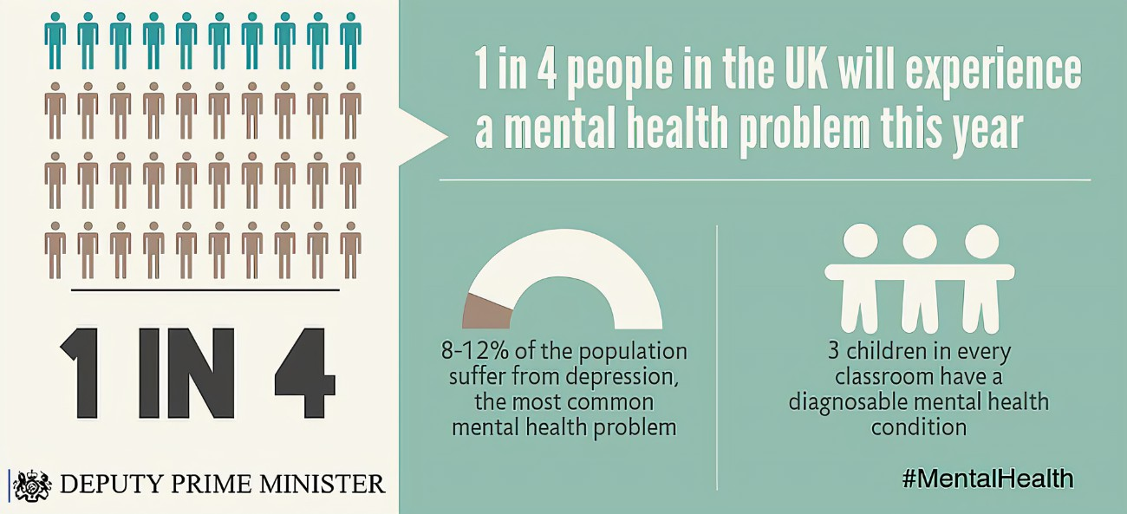
Various surveys during the pandemic have indicated a rise in the occurrence of mental health disorders particularly anxiety and depression. According to a study carried out by O’Connor et.al (2020), people from generally deprived environments, as well as those with present mental health difficulties, reported the highest mental health effects. Suicidal thoughts increased through the preliminary weeks of lockdown, where 14% of young adults reported suicidal thoughts during the third wave. This is greater than the 11% suicidal thoughts percentage conveyed by adolescents in a previous study which was taken before Covid-19, (Chandola, et.al 2020).
The graph below highlights that most individuals felt that their mental health was worse than before the pandemic.
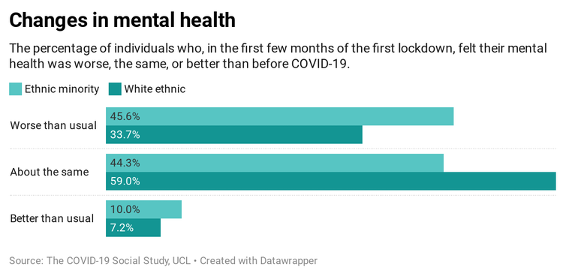
A brief overview of the history of mental health and general treatment.
Throughout history, there have been different ideas and beliefs about mental health. During Ancient times spiritualism overshadowed any type of scientific understanding. People were thought to be possessed by demons or bad spirits if they showed any signs of being mentally unwell. Trepanning was a procedure where a hole was drilled into a person’s skull to drive out the ‘bad spirits or demons’, (Wright, 2017). During this time, depression was described as melancholia.
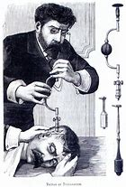
It was believed that by drilling holes in the skull a person would be cured.
Greek physicians refused paranormal reasons for mental disorders. It was around 400 BC that Hippocrates tried to divide irrational belief and religious conviction from medication by categorising the belief that there was an imbalance in body fluids- humors: blood, phlegm, black bile, yellow bile. For example, a person who was erratic was deemed as suffering from excess blood and therefore bloodletting would be needed. Bloodletting was a procedure where blood was taken out from the person’s body for therapeutic purposes, (Greenstone, 2010). Purging and stimulating puking to alter the humors were common remedies that continued until the 19th century. Separating the mentally unwell in asylums began to be common in the medieval age and beyond, which then began to develop into large institutions behind elevated borders in the 18th century. Treatments were mainly physical, like cold baths or shackles, however. People were treated inhumanely and were marginalised for showing signs of ‘mental illnesses’. (Smith, 2019). Electroconvulsive therapy became a normal treatment in the 20th century. The psychotherapy founded by Sigmund Freud and Jung in the beginning of the 20th century is one of the few persevering historical treatments.

Classification in The ICD-10 Manual
In the ICD-10 Manual depression is classified under the Mood [affective] disorders (F30-F39). Depression is defined as a low mood that persists for a long period of time affecting a person’s ability to carry out daily tasks, (WHO,2010).

Types of depression
There are various forms of depression, the common types are clinical depression which is more severe. Psychotic depression is a severe bout of depression, people hallucinate or get delusions (psychosis). Postnatal depression, feelings of intense unhappiness, unease, exhaustion, isolation, despair, suicidal thoughts, worries about harming baby, (NHS, 2021).

Aetiology of depression
There is not just one sole reason for depression, it is mainly a combination of reasons. These vary from person to person and for a lot of people, there is no obvious explanation. A few probable triggers include hormones, where a shift in natural hormones can have an impact on a person’s feelings. Lots of females become aware of these shifts for the duration of their menstrual cycle, prenatal period as well as menopause. Depression can also be inherited through a person’s genes, (Mental Health UK, 2021). Troubles throughout upbringing coupled with traumatic experiences such as grief can raise the possibility of having depression. Individuals who have suffered abuse, particularly in their childhood, can suffer from depression early in life and carry on living with it for most of their life. Some people choose a life of drug abuse to block out their past experiences, this can influence overall mental health, making it easier to encounter the symptoms of depression. Present health issues can also be a cause.

Signs and symptoms of depression
As mentioned above there is not one specific cause of depression however, there are a few frequent signs as well as symptoms that can assist a person to identify if they or even someone they know is depressed. Feelings like unhappiness, incomprehensible guilt feelings, insignificance, as well as seclusion can come together and develop a person to have a bleak view of their life, (NHS, 2021). Depression, and the way it impacts a person`s sleep patterns, can differ for everyone. Sleeping a lot more than usual can make a person feel like they have no strength and is a symptom of depression that the majority of people experience. Uncontrollable emotions, one minute a person feels fine, and the next minute they may have feelings of overwhelming sadness and fatigue. This is what depression looks like for some individuals. Having a range of emotions that are uncontrollable can make it hard to control how a person feels and seeks help, (Jokela,et al, 2016).

Historical treatments for depression
During the Enlightenment era, beliefs about depression began to alter. It was thought that turning people in chairs till they were lightheaded might assist in fixing matters in the brain and end their depression. Slowly, people began to associate melancholia with feelings, (Jackson, 2018). This was a substantial change in point of view as it assisted doctors to start to view those emotions and comprehend that the way individuals think could also affect the body.
Some individuals were so desperate for relief that they choose lobotomies, which were surgical procedures to obliterate the brain`s prefrontal lobe, however, the consequences of this were personality changes and sometimes death, (Yousaf et al, 2020). Slowly, people began to associate melancholia with feelings. Several years later, Sigmund Freud and others began to explore depression and stated that causes could be due to grief, breakdown of relationships, genetics, as well as childhood experiences.
Current treatment for depression
Treatments for depression typically entails blend of therapies and apps that can be used independently if suffering from mild depression as well as medication for more severe depression. If the doctor diagnoses mild depression they may advise delaying any form of help for a brief time to see if it gets better by itself.
Talking therapies are common, contrasting from other talking treatments, cognitive behavioural therapy (CBT) deals with a person`s existing problems, instead of concentrating on problems from their past, (NHS, 2021). The aim of CBT is to aid the individual in dealing with overpowering difficulties in a constructive approach by splitting them down into reduced elements. Contrasting from other talking treatments, CBT deals with a person`s existing problems, instead of concentrating on problems from their past.
Complementary therapies are another form of treatment for depression. Treatments might assist in improving a person`s emotional welfare, they can consist of aromatherapy, herbal medications, acupuncture, massage, as well as yoga. The aim of Psychodynamic therapy is to see how a person’s depression could be linked to early events in life. The therapist helps the person deal with these problems so that they can move on in their life. This therapy was based on Sigmund Freud’s Psychoanalysis and evolved extensively since then and is practiced widely, (Cristancho, 2011). Treatment for severe depression is usually medication like anti-depressants and maybe even being admitted to hospital.
Advantages and disadvantages
According to Riberio et.al, (2017) people who used psychodynamic therapy as treatment said they now had a better understanding of themselves and others, acknowledgment, and acceptance of emotions, and steadily beginning to look at problems and worries. Depression is widespread in older individuals, most may already be taking medication for other health difficulties, by utilising talk therapy as an alternative from drugs that may impede their other medicines is a beneficial result. However, there is not a guarantee that talk therapy will work and it depends strongly on the superiority of the connection between the therapist and the patient. Many patients who struggle with severe depression are resistant to therapy devoid of help from medication or other treatments.
The disadvantage of complementary therapy is that it takes time to work, the individual would need to commit to a block of sessions to see any result. It can also be costly, (Asher et.al, 2017). However, current treatment is far better than historical treatment. People have a choice now; treatment options have been thoroughly researched and are still being researched to this day to see their effectiveness.
Case study
Below is a case study of a new mum suffering from postnatal depression. She was reluctant to seek help as she had fears that her baby would be taken from her. The GP ensured Sarah that since she is seeking help, the aim was to provide that help and not to judge her thoughts and actions. Empathy is found to be helpful to humanise the care delivered to the patient, Sarah was first given a choice of treatments like talking therapy but as she had a severe form of postnatal depression she was also provided anti-depressants.
Sarah is a 19-year-old who recently gave birth to a healthy baby girl. She decided to breastfeed her baby and was doing well with the support of nurses while at the hospital. She was concerned about having to care for her baby alone as she has no friends and family near her who can help, and she is separated from the baby`s father. When the baby is 3 days old a home visit is made by the health visitor who then reports the home to be very cluttered and unclean. Sarah voiced her concerns that she always thinks the baby is not getting enough milk and she seems like a failure because she cannot feed her. The health visitor was very helpful. Sarah was reluctant to see the GP at first as she thought her baby would be taken away and she would be locked up in a mental health institute, however, after receiving the help she needed she said seeking help was the best decision she made. She was put on a course of anti-depressants for a month monitored regularly, (NHS, 2021).

Government support and guidelines
Individuals with mental health problems varying from severe to more common mental health issues, such as depression will gain from increased mental health services funded by £500 million from the government`s Mental Health Recovery Action Plan, GOV.UK (2021). The funding will ensure that staff receives proper training to support people with mental health issues, funding will also be provided for talking therapies to expand. Individuals residing with acute mental illnesses will similarly gain aid from improved mental services in the area and support between primary and secondary care. They will also benefit from collaborative support between primary and secondary care.
When working with people who suffer from depression or any mental health disorder we must ensure that we follow guidelines which are entailed in the Human Rights Act 1998, Equality Act 2010, Confidentiality and Data Protection Act 2018, and the Mental Health Act 1983, to name a few We must be mindful that stigma and discrimination can be linked with a judgment of depression, be mindful that the symptoms of depression and the effect of stigma can make it tough for individuals to contact mental health services or accept treatment, (NICE, 2021). We must ensure that we are culturally sensitive, some patients may come from different backgrounds and beliefs therefore we must be aware that they may have different understandings regarding depression. The stigma surrounding depression and additional mental health disorders can be elevated in a few cultural groups and frequently is a big obstacle to individuals coming from various beliefs when retrieving mental health services, (Biswas et al, 2018). Therefore, we should ensure measures are taken to diminish stigma and impediments for individuals looking for support and that discussions take place in surroundings where confidentiality, privacy, and dignity are respected.

Conclusion
Effective and valuable treatments are accessible to enhance the health and the lives of the millions of individuals experiencing some form of depression. Looking at it in a personal and public level, we should educate ourselves about depression and care for those who are experiencing issues due to this mental disorder. Depression is a mental disorder that is widespread. in the world and can affect anyone. However, currently, there are many treatments options available contrasting to the past when people were treated inhumanely if they had any signs of depression.

References
Greenstone, (2010).Bloodletting, [Online] Available at: https://bcmj.org/premise/history-bloodletting. (Accessed: 7th December 2021).
Ribeiro, et.al (2017) Ribeiro, Â., Ribeiro, J. P., & von Doellinger, O. (2018). Depression and psychodynamic psychotherapy, 40(1), 105–109. https://doi.org/10.1590/1516-4446-2016-2107.
A Brief History of Mental Illness Treatment (2017) added by Megan Wright [Online]. Available at https://www.youtube.com/watch?v=8eR3i0oT_B0 (Accessed: 29th October 2021).
Asher, G. N., Gerkin, J., & Gaynes, B. N. (2017). Complementary Therapies for Mental Health Disorders. The Medical clinics of North America, 101(5), 847–864. https://doi.org/10.1016/j.mcna.2017.04.004.
Biswas J, Gangadhar BN, Keshavan M.(2016) Cross cultural variations in psychiatrists' perception of mental illness: a tool for teaching culture in psychiatry. Asian J Psychiatry (2016) 23:1–7. 10.1016/j.ajp.2016.05.011
Byard, R.W., (2017). Frontal lobotomy. Forensic science, medicine, and pathology, 13(2), pp.259-264.
Chandola, T., Kumari, M., Booker, C. L. and Benzeval, M. (2020) The mental health impact of COVID-19 and lockdown-related stressors among adults in the UK, Psychological Medicine, Cambridge University Press, pp. 1–10.
Cristancho, M.A., O’reardon, J.P. and Thase, M.E., 2011. Atypical depression in the 21st century: diagnostic and treatment issues. Psychiatric Times, 28(1), pp.42-47.
De Young, M., (2014). Madness: An American history of mental illness and its treatment. McFarland.
Jackson, S.W., (2008) A history of melancholia and depression. In History of psychiatry and medical psychology (pp. 443-460). Springer, Boston, MA.
Jokela, M., Virtanen, M., Batty, G.D. and Kivimäki, M., 2016. Inflammation and specific symptoms of depression. JAMA psychiatry, 73(1), pp.87-88.
Mental Health UK, (2021) Causes, [Online] Available at: https://mentalhealth-uk.org/help-and-information/conditions/depression/causes/. (Accessed: 10th December 2021).
MHFA, (2021) Depression [Online] Available at: https://www.mentalhealth.org.uk/a-to-z/d/depression. (Accessed: 8th December 2021).
NHS, (2021) Symptoms for depression [Online] Available at: https://www.nhs.uk/mental-health/conditions/clinical-depression/symptoms/. (Accessed: 8th December 2021).
NHS, (2021) Types of depression,[Online] Available at: https://www.nhs.uk/mental-health/conditions/depression/types-of-depression/. (Accessed: 9th December 2021).
NHS, (2021) Post-natal depression, [Online] Available at: https://www.evidence.nhs.uk/search?om=%5B%7B%22ety%22:%5B%22Case%20Studies%22%5D%7D%5D&q=postnatal+depression. (Accessed: 11th December 2021).
NICE, (2020) Guidance [Online] Available at: https://www.nice.org.uk/guidance/cg90/chapter/Recommendations. (Accessed: 10th December 2021).
O'Connor, RC, Wetherall, K, Cleare, S, McClelland, H, Melson, AJ, Niedzwiedz, CL, O'Carroll, RE, O'Connor, DB, Platt, S, Scowcroft, E, Watson, B, Zortea, T, Ferguson, E & Robb, KA (2021), ‘Mental health and well-being during the COVID-19 pandemic: longitudinal analyses of adults in the UK COVID-19 Mental Health & Wellbeing study’, The British Journal of Psychiatry, vol. 218, Cambridge University Press, no. 6, pp. 326–333.
Stanwell-Smith, R. (2019) ‘Mad, bad and dangerous to know? History and mental health’, Perspectives in Public Health, 139(3), pp. 110–110. doi: 10.1177/1757913919838164.
WHO, (2021) Mental disorders [Online] Available at: https://www.who.int/news-room/fact-sheets/detail/mental-disorders. (Accessed: 7 December 2021).
WHO, (2021) Classifications, [Online] Available at: https://www.who.int/classifications/icd/en/bluebook.pdf. (Accessed: 9th December 2021).
Yousaf, A., Singh, K., Tavernor, V. and Baldwin, A., (2020.) Psychosurgery: A History from Prefrontal Lobotomy to Deep Brain Stimulation. Journal of Geriatric Medicine, 1(3).

Appendices: (Power point slides for debate)



