Module Title: Entrepreneurship
Module code: LCBB5013
Ervin Kis
Student ID:2331457
Task 1
“Establishing an Indoor Playground Business in Birmingham: A Strategic Business Proposal”
Table of Contents
Introduction 3
Element 1: Business Idea, Products/Services, Objectives & USP 3
Business Idea Overview 3
Products and Additional Services 4
Business Objectives and Unique Selling Point (USP) 4
Element 2: Business Environment & Competitor Analysis 5
Industry Overview 5
Porters Five Force Analysis 6
Competitor Analysis and Market Positioning 6
Element 3: 4Ps, Market Segmentation & Marketing Strategies 7
Market Segmentation and Target Customers 7
4Ps of Marketing 8
Online Marketing Strategies 9
Element 4: Legal, Management, and Financial Planning 10
Key Legal Structures in the UK 10
Chosen Legal Structure 11
Management Structure 11
Financial Planning 11
Conclusion 12
References 13

Introduction
The indoor playgrounds concept has become very popular in city environments especially in cities such as Birmingham where people are trying to provide safe and stimulating settings to their children. Free and structured play and physical activities in indoor playground allow children to engage in socialisation, cognitive and physical development. The lack of open spaces and unpredictable weather together with urban way of life make the need of these facilities even more significant. This business proposal deals with the development of a contemporary indoor playground in the city of Birmingham that will be fun, safe, and developmental. The playground will include different play areas, interactive games and event packages that will entertain the children between 1-10 years and help parents in being convenient. The report below is an estimation of the business environment, competition, marketing, legal structure, management, and financial planning that are required to make the playground successful. This business venture is expected to be a top provider of indoor recreational services in the region by combining the child development research and business strategy.
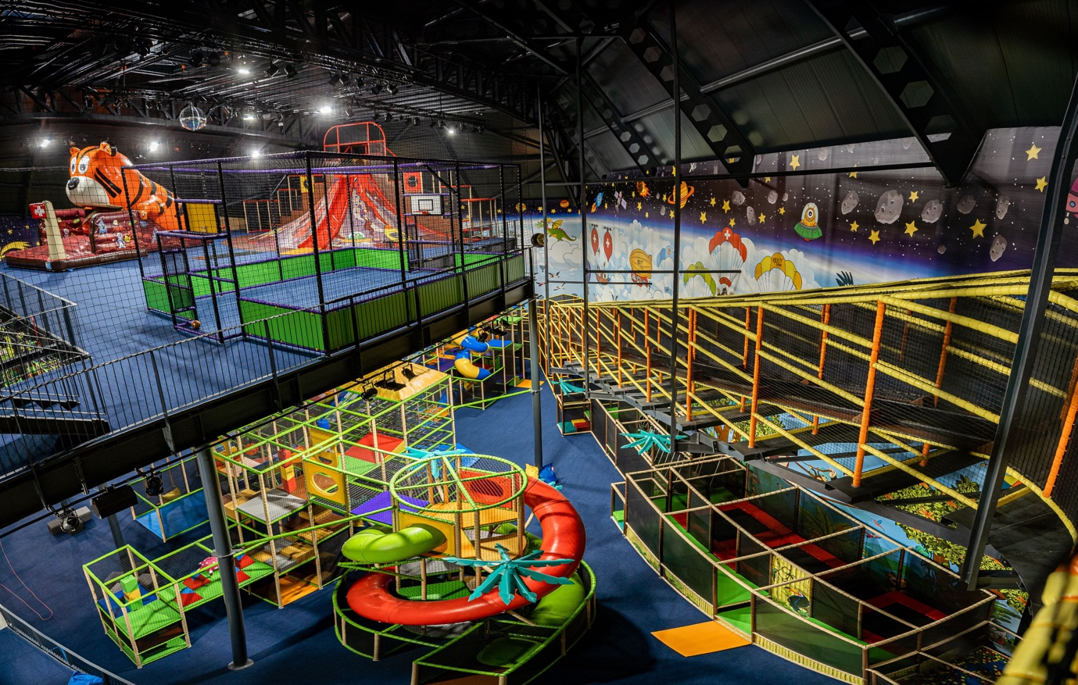
Figure 1: Indoor Playground (Playlife, 2022)

Element 1: Business Idea, Products/Services, Objectives & USP

Business Idea Overview
The proposed business would be an indoor playground within Birmingham which would enable the child to enjoy a safe, stimulating and educative environment. A lack of outdoor spaces, unpredictable weather, and urban lifestyles have augmented the necessity to have indoor play spaces where children can experience development physically, socially, and cognitively (Boz, Altunsoz and Altinisik, 2022; Creekpaum, 2019). The playground will have a mix of both structured playgrounds in the form of climbing bars, soft play zones and interactive learning stations, and open-ended plays that will allow the children to explore, imagine and play at their own speed. The guided activities aimed at the improvement of physical coordination, problem-solving, and social skills, and free play areas where children develop creativity, imagination, and cooperation skills will be provided to them to gain confidence and resilience in a safe environment (Spiegal et al., 2014). Besides this, the playground will also have special zones which cater to the various age groups. An example is that the sensory areas of toddlers can be used to facilitate early sensory and motor growth and interactive digital learning areas of older children help them in problem solving, numeracy and literacy. The playground seeks to promote the holistic child development though the fusion of physical activity and cognitive stimulation coupled with providing a fun and enjoyable experience to the families.

Products and Additional Services
In addition to regular playgrounds, the indoor playground will also have value-added services that will boost the engagement and revenues: Birthday parties - completely organised parties with thematic decorations, organised activities, as well as the opportunities to have caters. Some themed events the holiday workshops, educational programs based on the seasons, creative challenges which offer the distinctive experiences. Parent child workshops: workshops where parents are encouraged to participate in the development of the children like in the case of motor skills or creative play or team work.
They give the company various sources of revenue and enable closer communication with the community. The opportunities include birthday and themed parties as an element of marketing because the contented parents will recommend the facility to colleagues and social networks. The extra services are also related to the studies that focus on the importance of organised and creative playing in the physical, social and cognitive development (Boz et al., 2022; Creekpaum, 2019).

Figure 2: Indoor Playground Birthday Party (Uptown Jundgle, 2023)

Business Objectives and Unique Selling Point (USP)
The specialty of the indoor playground possesses both short and long-term goals. Some of the short-term goals would be the successful opening of the playground, acquiring an initial group of customers, and having in place strong safety and operational standards. Strict health and safety measures would be necessary as one of the driving forces behind customer loyalty is the establishment of trust between customers and the parent (Stevens, 2017).
Long-term goals are aimed at the sustainable development and brand building. These are the extension to other areas, the introduction of the loyalty programmes that can make people visit the playground regularly, and the establishment of the playground as a top indoor entertainment centre in Birmingham. The business focuses on innovation, safety, and child development and therefore stands out of its rivals and creates a respectable brand name in the local market (Henderson et al., 2018). The USP of the playground is the fact that it incorporates a combination of safe creative and educational play. However, it is open to developmental learning and premeditated activities that offer cognitive, social and physical development in one space unlike others that only focus on the latter by means of intense exercise. The playground will also be community-based with social enterprise principles like discounted entry to needy families or an agreement with the schools in the area. The indoor playground has a strong value proposition of providing a fun and developmental experience, thus making it the choice amongst the families in Birmingham.

Element 2: Business Environment & Competitor Analysis

Industry Overview
The UK indoor playground market is in a continuous and steady rise over the recent years due to the urbanisation, the rise in the number of households with the dual incomes, and the enhancement of the understanding of the positive impact of play on the child development. The parents in Birmingham are finding safe, accessible, and stimulating environments whereby children are able to do both physical and thinking activities with growing demands of parents. Shifting the lifestyle, the lack of outdoor activities, and the safety challenge have added to the need in the high-quality indoor recreation facilities (Farris, Horton & Lloyd, 2025; Stevens, 2017).
The indoor playground market is typified by chain and independent based restaurants. Whereas there are competitors who are more concerned with physical play, there are those ones who integrate recreation and educating or enriching activities. The parents control the market based on their expectations, the cost, location and the agreement with the safety laws. It has been reported that parents are ready to spend premium prices in an environment that is not only fun but also has developmental and safety-enhancing values (Boz, Altunsoz and Altinisik, 2022).

Porters Five Force Analysis
We can analyse the competitive environment of the indoor playground business based on the Porters Five Forces that measure the market dynamics, threats and opportunities. In summary, the analysis is as given in the table below:
Force | Assessment
Threat of New Entrants | Medium – Moderate start-up costs and safety compliance requirements, but the market is attractive for new entrants due to increasing demand.
Bargaining Power of Suppliers | Low – Play equipment, furniture, and safety materials are widely available, with multiple suppliers reducing dependence on any single provider.
Bargaining Power of Customers | High – Parents have a variety of options, including other indoor playgrounds, nurseries, and outdoor alternatives, which increases expectations and price sensitivity.
Threat of Substitutes | Medium – Outdoor playgrounds, home play setups, and digital entertainment can partially replace indoor play experiences.
Competitive Rivalry | High – Birmingham has several indoor playgrounds; differentiation through safety, educational activities, and unique services is crucial.
This discussion reveals that even though barriers to entry are not a major challenge, it needs competitive differentiation to succeed. The emphasis on the developmental play guided by a structured way of development, high-quality safety measures, and community service is the competitive edge in comparison to the existing facilities (Farris et al., 2025; Zhang, 2018; Henderson et al., 2018).

Competitor Analysis and Market Positioning
There is a combination of small and independent indoor playgrounds and large chain operators in the market of the city of Birmingham. Independent centres tend to base their operations on specific experience or local relationships, whereas chains base their operations on brand name and extended service provision. The proposed playground will offer its diversity by merging structured and free play, value added services and community approach.

The facility will be providing more revenue such as birthday celebrations, themed events, and parent-child workshops which in addition will result in customer loyalty. In addition, the consideration of the principles of social enterprise through the facilitation of the less fortunate families helps to increase the community spirit of the play ground. The quality of safety guidelines, innovative playgrounds, and specific promotional strategies will see the business gain a substantial market share of the indoor recreation in Birmingham and develop the long-term competitive edge (Stevens, 2017; Spiegal et al., 2014).
This playground has the prospects of success due to its increasing demand of recreational areas indoors, coupled by the possibility to differentiate and be unique in terms of educational and community-based services. Through the application of the market trends, parental expectations as well as industry research, the business is significantly positioned to meet the difficulties of competition, customer bargaining power, and sustainability in profits and business sustainability.

Element 3: 4Ps, Market Segmentation & Marketing Strategies

Market Segmentation and Target Customers
Knowledge of the target market is the key to success of indoor playground. The main market segmentation of the playground is done on various considerations: the age of the children, the parental income, and the lifestyle and location. The primary users include children between the age of 1-10 years since this age category is the one that benefits most in terms of structured and unstructured play that facilitates physical, social, and cognitive growth (Tilbury and Ramsay, 2018). The playground will have age specific zones that will include soft play and sensory areas used by the toddlers and climbing and interactive areas used by younger children and digital or cognitive learning areas used by older children.
The income and the style of the parent are the other key segmentation criteria. The play ground shall mainly deal with working parents who want to provide safe convenient stimulating environments to their children, particularly, on weekends or even after school. These parents put premium on quality, safety, and education advantages besides entertainment. The target customers are the urban families who may dwell in the city of Birmingham and its surroundings, so accessibility and convenience become the major components of the location and marketing strategy (Tsarakhova and Kabanov, 2020).
By targeting these segments, the business will be able to create marketing notices and offers that appeal to the concerns of the parents, including the safety of their children, the developmental advantages, and the allowable convenience. Such segmentation will guarantee the optimal allocation of resources to comply with the most appealing customer segments in order to engage the marketplace as completely as possible.

4Ps of Marketing
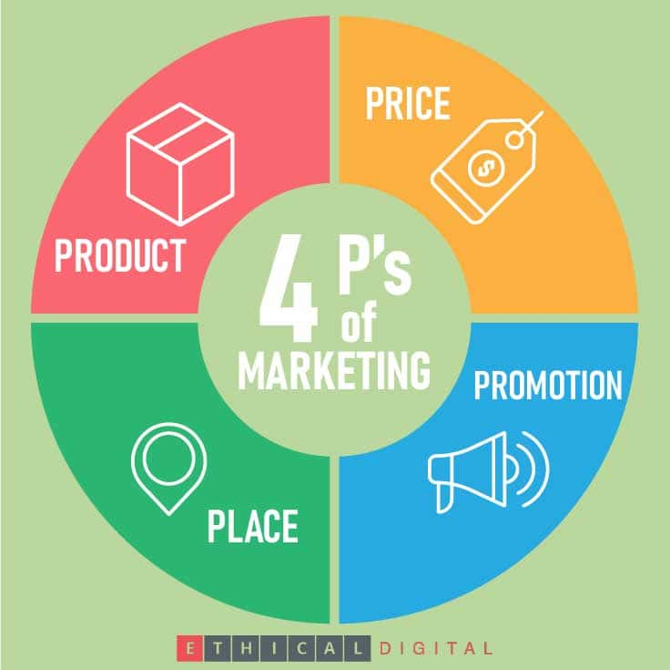
Figure 3: 4ps of marketing (Frei, 2021)
It has a product, cost, location and promotions which are known by the 4Ps of marketing and which can be utilised to factor the indoor playground favourably in the Birmingham market.
Product
The main product offered by the playground is the indoors play zone that is an amalgamation of structured playgrounds, soft playgrounds, interactive learning areas, and the unfixed playgrounds. Other services and products relate to birthday and event packages, theme workshops, parentchild sessions in order to increase the engagement and developmental advantages. These services will distinguish the playground among the competitors and will add revenue streams as well as support the USP of the business as safe, educative, and enjoyable play (Tsarakhova & Kabanov, 2020).
Price
The pricing strategies will aim at capturing and keeping the target market without making a loss. The playground will adopt the competitive prices, by providing entry passes, memberships as well as loyalty offers. These benefits may be given as memberships that include unlimited monthly schedules, discounted birthday packages and first time booking into the events. Royalty programmes will motivate returning customers, will act as a way to motivate a parent to visit regularly with their children, and will help create the long-lasting connection with the customers (Zhang, 2018).
Place
The success of the playground is located on the playground location. The location of a central facility is sitting in the middle of the city in Birmingham to serve most of the families. Football will be maximised by proximity to the transport, parking area, and the residential area in the city. The playground will also include online reservations and a virtual playground tour on the site, which will facilitate the life of parents with a tight schedule and match the current trends in consumer behaviour (Tsarakhova and Kabanov, 2020).
Promotion
The promotional strategies will aim at generating awareness, creating/creating excitement and developing loyalty amongst the target customers. Multichannel strategy will be used which will entail social media campaigns on Instagram and Facebook, collaborating with parenting groups locally, referral programmes, and content marketing that will focus on the advantage of child development. This will involve promotion of birthday and themed events packages and this will help bring new customers and keep the customers. Safety, creativity, and developmental learning will also be in the focus of marketing messages supporting the USP of the playground (Tsarakhova and Kabanov, 2020; Zhang, 2018).

Online Marketing Strategies
The online marketing is a must in the modern digital era of customer attraction and retention. The playground will have a professional webpage where one can effortlessly take the bookings of the play station, birthday parties and workshops. It will also include a virtual tour of the playground, where the design, safety, and play areas of the facility will be demonstrated and this information will ensure and assure the potential clients (Tsarakhova and Kabanov, 2020).
The main means of contacting parents will include social media like Instagram and Facebook where the promotion of events, activities of children (with their parental consent), and special offers will be presented. Social media is useful in developing a community around the brand, allowing it to build trust, attract referrals, and keep in touch with the customers on a regular basis. Videos of formal play activities, ideas of educational activities, and information regarding events of the season will be used as content.
Further, email marketing will be used to sustain long term relationships with the parents. Periodical newsletters will provide information to the subscribers on upcoming events, benefits of being a member and safety issues. These will be supplemented by the loyalty programme that will offer incentives that will include having free or discounted access after a specified number of visits. These online approaches will help the playground to become more visible to the population and foster a feeling of community, as well as drive repeat business, without compromising the overall marketing goals (Tsarakhova and Kabanov, 2020; Zhang, 2018). Incorporating the market segmentation, the 4ps, and the online marketing, the indoor playground is one of the top options of the families in Birmingham as it offers convenience, fun, safety, and developmental worth. The marketing strategy makes sure resources are guided on the most apposite customer segments, creates a long term loyalty, and maximises short term and long term profitability.

Element 4: Legal, Management, and Financial Planning

Key Legal Structures in the UK
In the context of opening a business in the UK, it is necessary to determine a suitable legal structure to match the goals of the company, liability concerns, and its flexibility. A Limited Company is an independent legal entity, which gives its owners limited liability and gives credibility to the company, the customers, suppliers and potential investors. It also supports taxation of profits at the corporate level and it is easy to access funds thus appropriate in case the business intends to expand (Henderson et al., 2018). On the contrary, a Sole Trader belongs to one person and is controlled by an individual, which allows the full control of business decisions but makes the proprietor vulnerable to indefinite personal liability, and the profits are taxed as personal income (Stevens, 2017). Partnerships are the activities of two or more individuals in sharing profits, responsibilities, and risks which could give a pool of expertise but can also lead to the possibility of conflicts. Franchises give a person the opportunity to work in an established brand with brand recognition benefits and support, but at the cost of periodic fees and a lack of operational freedom. Online business mainly takes place online, meaning that it is scalable and flexible, with high competition and logistical issues. Social enterprises are more business-like, but care more about social or community goals and also reinvest profit in their mission, usually receiving grants or socially responsible financing (Henderson et al., 2018).

Chosen Legal Structure
In the case of the proposed indoor playground in Birmingham, a Private Limited Company is the best legal structure. In this arrangement, the risk of liability is insured and the personal assets are not liable to any financial or legal risks. It also boosts its credibility among parents, suppliers, and potential investors which is very essential in the child care and recreation industry. Moreover, a small company format enables the possibility of scaling, which can be extended in the future to other places, other services like birthday packages, and possible partnership with schools or other community organisations. The professional status and versatility of the limited company is the best fit to the long-term strategic goals and expansion aspirations of the playground (Stevens, 2017; Henderson et al., 2018).

Management Structure
An effective management structure is important in achieving operational efficiency, compliance with safety and quality of service delivery. The suggested hierarchy of the organisation starts with the Owner/ Director, who carries out the strategic planning, finances and general compliance. The Operations Manager will be answering to the Director and will be in charge of the daily operations, staffing and customer service in all the play zones to ensure the smooth running of all operations. Play Supervisors will engage in the monitoring of the kids, organisation of activities, and the safety level, and Administrative Staff will be in charge of bookings and customer requests, marketing planning, and account management. The roles are essential in ensuring a high-quality experience of children and parents. Employees will also be trained on child safety, first aid, and customer care and frequent team meetings and performance appraisals will keep the operational standards at par and improving on them (Stevens, 2017).

Financial Planning
An indoor play ground must be carefully planned in terms of financial planning to make it sustainable and profitable. The start-up costs will consist of finding and refurbishing a centrally located place to host various play zones, buying play equipment like soft play structures, climbing frames and interactive learning stations and safety measures including insurance, certifications and first aid equipment. Other costs are the hiring of personnel and wages, advertisement, web development and marketing efforts to gain and maintain clients. The possible sources of funds to meet these expenses are personal savings, conventional bank loans, and investment of angel investors who have interest in childcare or educational business. In case the playground implements community-based programs, including discounts on a disadvantaged population, it can also receive social enterprise grants (Farris, Horton and Lloyd, 2025; Henderson et al., 2018).
A budgeting and break-even analysis will be included in the financial planning in order to closely track the revenue and expenditure. This helps the management team to make wise decisions on pricing strategies, marketing investments as well as future expansions. With the financial management in line with the objectives of operations and safety standards, the indoor playground can ensure the short-term stability and the long-term development. Overall, a strong basis of the indoor playground is the choice of a Private Limited Company, the use of a good management hierarchy, and effective financial strategies. This will be a sure way of maintaining legal compliance, efficiency in operations, and sustainable development besides providing safe, entertaining, and developmentally challenging environment to children in Birmingham.

Conclusion
The indoor playground proposed in Birmingham is a business opportunity that is viable since it fulfills the increasing need of safe, interactive, and informative playgrounds. The playground will help children to develop physically, socially, and cognitively by providing them with structured play areas, interactive programs, and community-based activities and will also provide the parents with convenience and peace of mind. Proper attention to the market needs, competition and proper marketing policies will see the business in good growth position. This venture can be a major player in offering indoor recreational services in the city of Birmingham that will benefit not only families but also the community in the region with proper legal establishment, proper management and proper financial planning.

References
Boz, M., Altunsöz, I.H. & Altinisik, Y. (2022) ‘Impact of teacher implemented activities and free play on preschool children's physical activity at indoor playground markings’, Southeast Asia Early Childhood, 11(1), pp. 18–34.
Creekpaum, S. (2019) Child development through play. In: The importance of play in early childhood education, pp. 11–18. Routledge.
Farris, S.R., Horton, A. & Lloyd, E. (2025) ‘Corporatisation and financialisation of social reproduction: Care homes and childcare in the United Kingdom’, Environment and Planning F, 4(3), pp. 340–356.
Frei, K. (2021) ‘The 4 Ps of Marketing’, Ethical Digital Marketing Blog. Available at: https://blog.ethicaldigital.com/4-ps-of-marketing [Accessed 26 Oct. 2025].
Gambaro, L., Stewart, K. & Waldfogel, J. (2014) ‘Equal access to early childhood education and care? The case of the UK’, in An Equal Start?, pp. 29–52. Policy Press.
Henderson, F., Reilly, C., Moyes, D. & Whittam, G. (2018) ‘From charity to social enterprise: the marketisation of social care’, International Journal of Entrepreneurial Behavior & Research, 24(3), pp. 651–666.
Playlife (2022) ‘Open and build an indoor playground [10-step guide]’. Available at: https://playlife-system.com/en/blog/start-family-entertainment-center [Accessed 26 Oct. 2025].
Spiegal, B., Gill, T.R., Harbottle, H. & Ball, D.J. (2014) ‘Children’s play space and safety management: Rethinking the role of play equipment standards’, Sage Open, 4(1), 2158244014522075.
Stevens, K.B. (2017) Workforce of today, workforce of tomorrow: The business case for high-quality childcare. United States Chamber of Commerce.
Thornton, L. & Brunton, P. (2015) Understanding the Reggio approach: Early years education in practice. Routledge.
Tilbury, C. & Ramsay, S. (2018) ‘A systematic scoping review of parental satisfaction with child protection services’, Evaluation and Program Planning, 66, pp. 141–146.
Tsarakhova, L.N. & Kabanov, S.V. (2020, March) ‘Internal marketing strategy for educational services’, in International Scientific Conference "Far East Con" (ISCFEC 2020), pp. 1619–1625. Atlantis Press.
Uptown Jungle Avondale, AZ. (2023) ‘UPTOWN JUNGLE FUN PARK | Avondale’. Available at: https://avondale.uptownjungle.com/10-benefits-indoor-playground-birthday-party/ [Accessed 26 Oct. 2025].
Zhang, K. (2018) ‘Productisation in the children playground business’.
‌

‌

‌

