Max Beasley
2304218@student.uwtsd.ac.uk
Assighnment 2: Developing an MS Access Database for Coastal Tourism Management
Introduction to Web and Database Concepts

Contents
Section A 2
Task 1 2
Task 2 4
Task 3 6
Task 4 8
Task 5 10
Section B 14
Task 6 14
References 15

Section A

Task 1
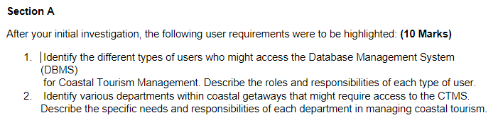

1
There are three main types of users who will have access. The highest level of user will be the database management team, they will have the ability to access and modify all aspects of the database structure and contents, this will allow them to implement any upgrades or preform maintenance to the database without running into access issues. Although it may be necessary to restrict access to some confidential data such as payment details and make such information special access only as may be required but the Data protection act 2018 [1].

The second highest level of access will be given to Coastal Getaways managers, this will allow them to access and change employee details and oversee / monitor the work of the general employees. This level of access will allow them to efficiently carry out their responsibilities as a manager and handle tasks like hiring new staff.

The third type of user would be the general Coastal Getaways employee. They would have access to all the information (previously mentioned restrictions applied) but notably they will not be able to change or modify the structure or operation of the database, they will only be capable of data manipulation. This will allow them to organise relevant events and help customers with any problems that may arise.

The final and lowest level user will be the customer, they will have the ability to enter data to make a reservation. They will also be able to edit their own information such as contact and payment details if they change.

2
The IT department who will manage and maintain the database will need access to all aspects of the CTMS in order to complete maintenance and upgrades to the system when necessary and fix problems that arise during day-to-day use.

The department with the second highest access will be the management department. They will have access to all the employee information in order to complete hiring and other HR tasks. Therefore members of the management team will be given the management access level to the database.

The department that manages the bookings will need access to customer information and booking details in order to correctly manage and create the itineraries for the customer. They will need access to this information so that they can put into place any additional requests or requirements such as disability.

The customer support team will also need access to the CTMS in order for them to effectively help the customers that require assistance with various aspects of the booking. This means they will need access to the customer details and booking details, importantly they will need to access the contact details for the customer so that they can have effective communication with the customer. for this reason, they will have the general staff access.

Task 2
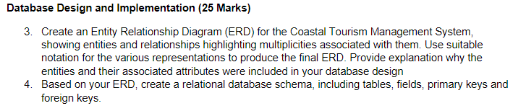
3

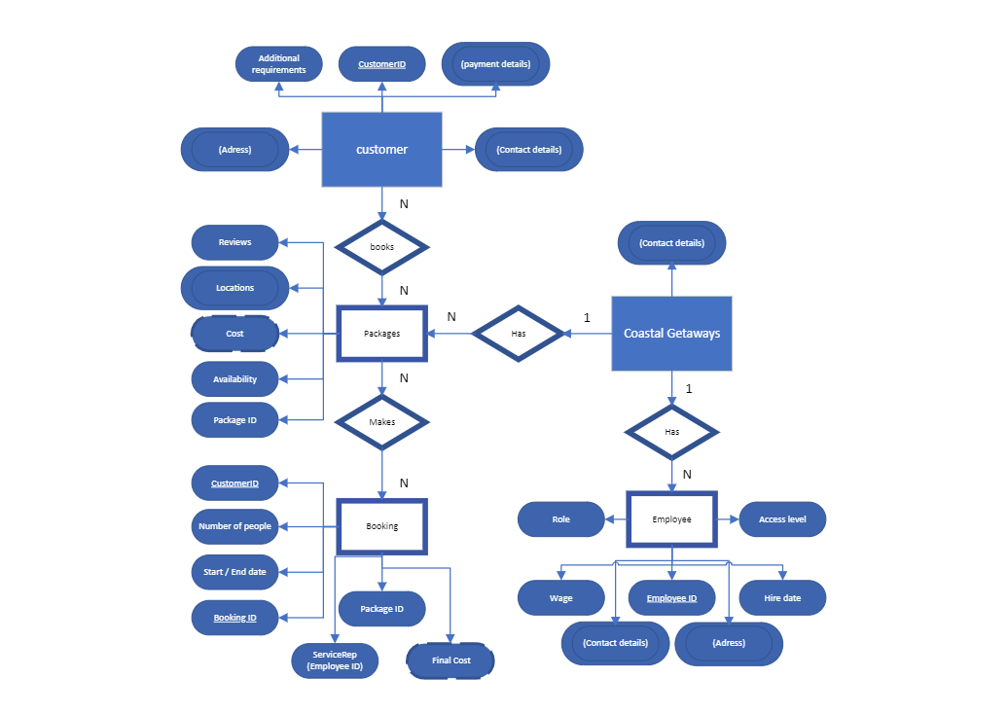
https://uowtsd-my.sharepoint.com/:u:/g/personal/2304218_student_uwtsd_ac_uk/EazveseRM15HmOIoN08o314Bte60ZVPflifnSPHlwh4lQQ?e=VFTAas

4
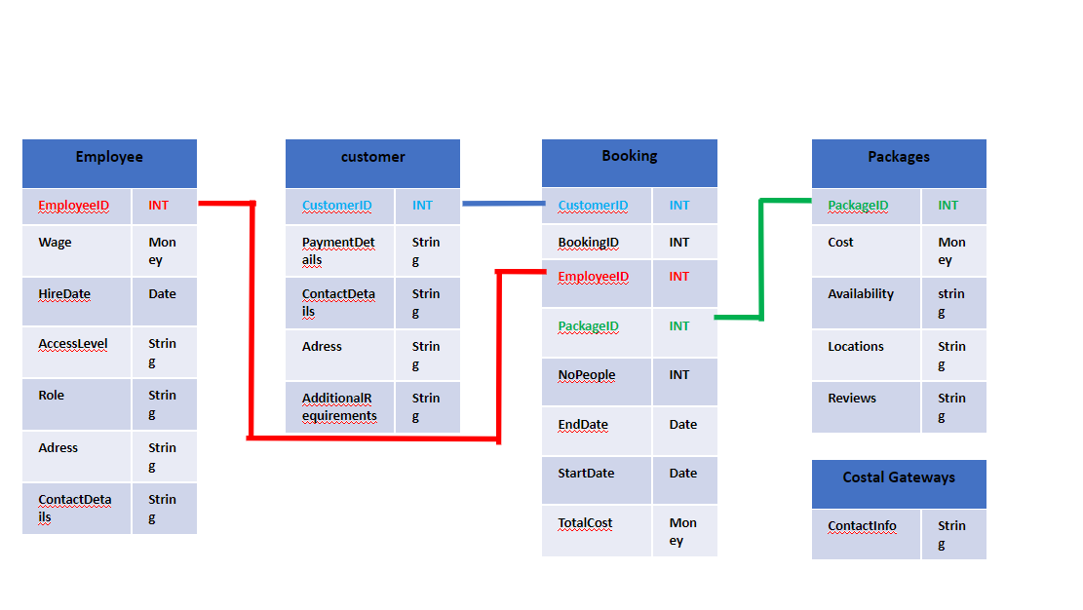
https://uowtsd-my.sharepoint.com/:p:/g/personal/2304218_student_uwtsd_ac_uk/EYSqrm2JBvxCiD4gfzCLZ9MBGP7cWgj3FbAgqMPBn8kzRQ?e=qb5KPV

Task 3
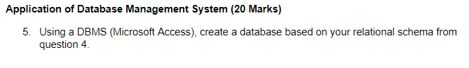
The employee table.
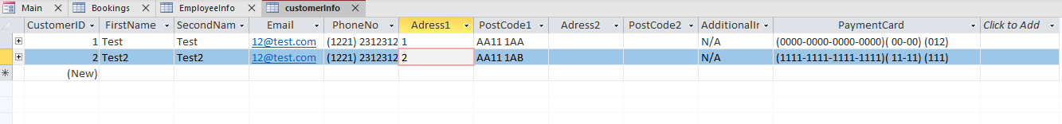
The customer information table.
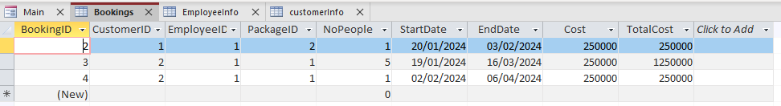
The booking information table.
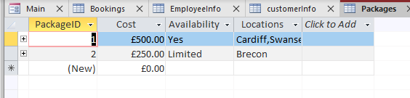
The package information table.
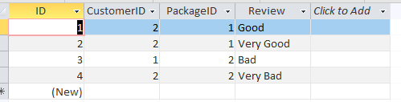
The reviews table.
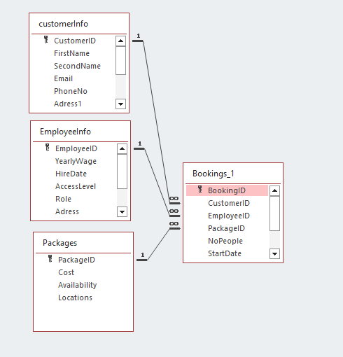
The relationship diagram.

Task 4
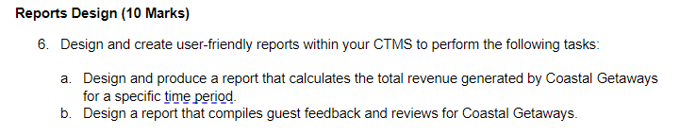
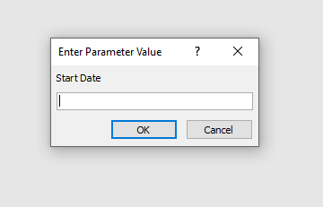
Start date for search.
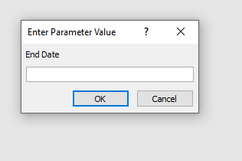
End date for search.

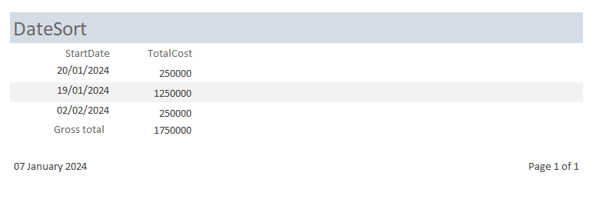
Search results

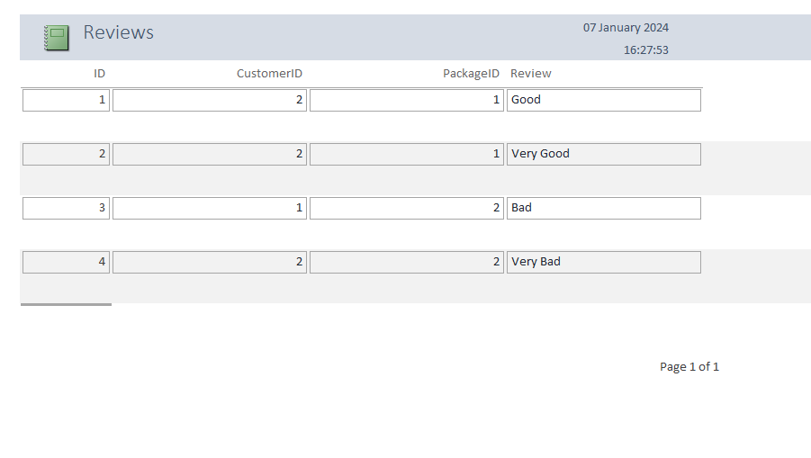
A report that displays all review left by customers.

Task 5
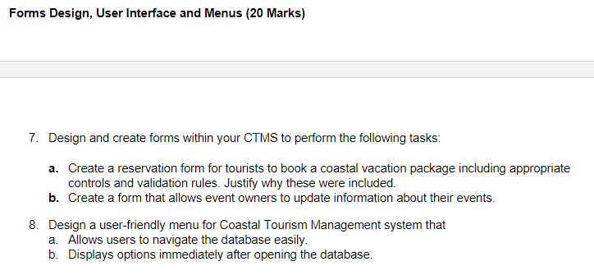
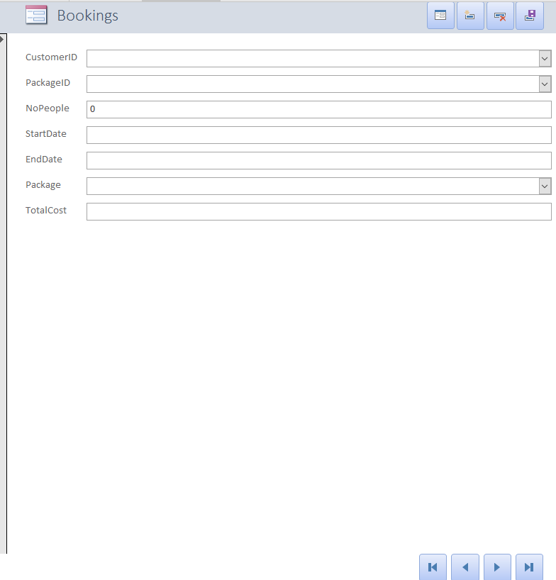
A form that users can use to create a new booking.
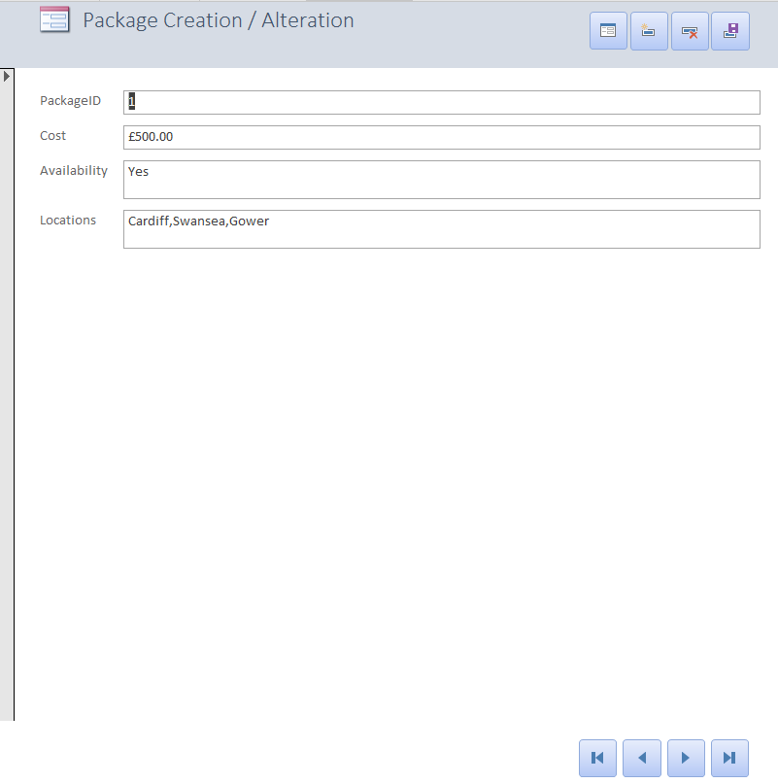
A form to edit the details in the packages table.
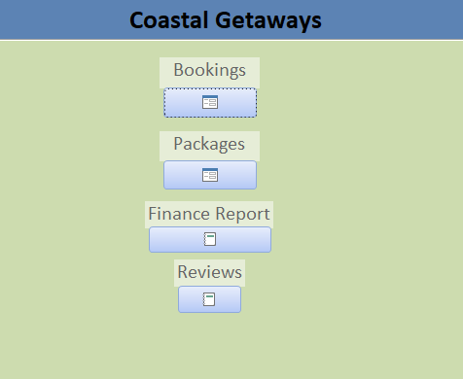
A main menu for the database so users can easily select the form or report they want.
The menu form is set to be the first thing displayed when opening the database.

Section B

Task 6
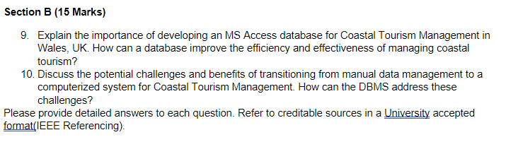
9.
Using a database can improve efficiency and effectiveness in a multitude of ways, arguably one of the most impactful ways is through the increased ease of data access and sharing, a DBMS can allow multiple people to access data quickly and simultaneously, they then also have the ability to share said data quickly and securely. This also leads into the point of data consistency and integrity, a DBMS can enforce levels of data integrity that will ensure data is not changed by different users at one time, this cuts down on time spent checking data for errors and reduces the chance of them appearing in the first place. [2]

10.
Migrating data from a physical data management system to digital one can come with many challenges, the most obvious being the time needed to digitize all physical records and data, this can be incredibly time consuming especially for a small business. Time is also a problem when it comes to training staff to use the new DBMS as some people may struggle to adapt to the new system especially as some may not be as technically minded. There will also be a large cost burden associated with switching to a digital method, this is brought about by the need to invest in a potentially large amount of network equipment and infrastructure, an example of this is if no external hosting is used data will need to be stored locally on servers. Furthermore, software licenses will need to be acquired and new devices purchased for staff to access the DBMS. [3]. However, all of the challenges mentioned are short term ones, the long-term benefits, however, far outweigh the initial challenges. As mentioned in section 9, using a DBMS can provide a multitude of benefits especially when compared to a manual data solution. These include better redundancy as data can be backed up more quickly and with a reduced cost. Using a DBMS also provides a more scalable solution as the scope of the database can be expanded without making all the old records obsolete as would happen with a physical solution.[2]. All of this points to the fact that transitioning to a DBMS will greatly improve the workflow and efficiency of the Costal Gateways business.

References

[1] Uk Government. "The Data Protection Act." GOV.UK. https://www.gov.uk/data-protection (accessed Jan 3,).
[2] Indeed Editorial Team. "What Is a Database Management System? (With 12 Benefits) | Indeed.com." indeed. https://www.indeed.com/career-advice/career-development/what-is-database-management-system (accessed Jan 7,).

[3] A. Danielkievich. "Top 10 Data Migration Challenges in 2023 (Solutions Added)." Forbytes. https://forbytes.com/blog/common-data-migration-challenges/ (accessed Jan 7,).

