  - By Jacob James-Machin ID: 2304400

TOEJAM AND EARL OVERVIEW

Large, detailed document about the SEGA Genesis game Toejam and Earl with Citations

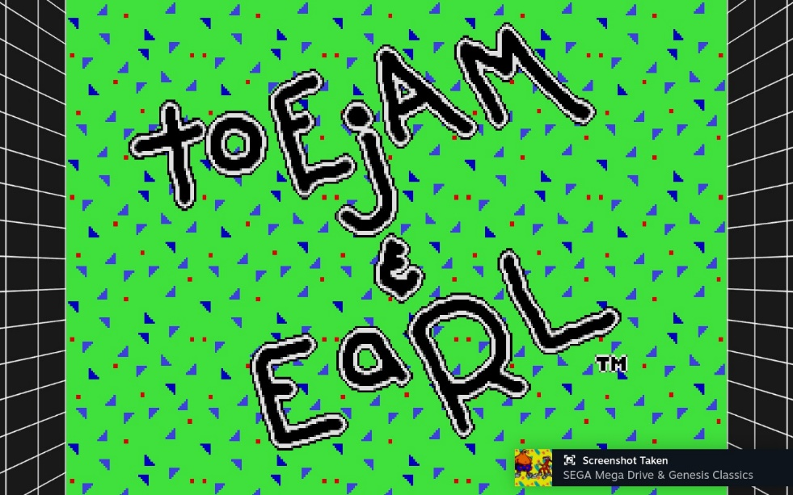
Title Screen for the game
Contents
Introduction 2
Genre 3
Visual Style 4
Intended Demographic 4
Game Structure 5
Challenges 6
Game flow 6
Replay Value 7
Positive and Negative aspects of the game 9
My Opinion 10
References 11

Introduction
“Toejam and Earl the most 90’s approach on human culture as viewed by aliens”.
This was a new game for me. A new experience and it was unlike anything I played before. As I played though this old SEGA Genesis classic a few thoughts occurred to me. As I will explain in this document but first, I would like to talk about what this game and how it came to be.
Toejam and Earl was developed by a company called “Johnson Voorsanger Productions” (now called Toejam and Earl productions however now defunct in 2003) [1] in 1991 it was first released for the SEGA Mega Drive and it's about 2 aliens named Toejam and Earl who seem to be funky rappers. The game has a ton of satire, style, and a vibe to it that perfectly matches the late 80’s and early 90’s most specifically the hip hop scene at the time. Which makes sense considering the aliens are rappers. ‘Jamin’ rappers.
The game starts off with the aliens looking for their spaceship parts. They crashed on a surrealist parody of earth consisting of islands floating in space.
Toejam and Earl must find their spaceship parts and overcome bizarre, surreal and wacky obstacles. The game is filled with a tongue in cheek and funky quirks with funky hip hop slang that the aliens can say. Stuff like “Jammin” or “Poindexter” or “Dufus”
There are 2 aliens you can select (or play as coop) named Toejam and Earl
Toejam is a red lanky bulbous eye alien who seems to be the brains of the pair. He’s also the most alien looking on or non-humanoid considering his figure consist of a red straight stringy form.
Earl is the chubby and the “dufus” of the pair. He’s more humanoid but he’s also very fat. He has a very chill vibing stride to him. Like he’s not concerned about the dangers around him.
The game has a bunch of human based enemies which makes sense considering they are facing two bizarre looking aliens. Although I would argue that the human enemies in the game also feel just as alien as Toejam and Earl. Enemies ranging from insane doctors, mothers with crying babies in their shopping trolly, rolling giant hamsters, flying cupid babies. Hula ladies etc.
However, it’s not just humans that would be an obstacle to Toejam and Earl. It seems like Earth has a monster problem like “lil crazy devils”, monster mailboxes, boogiemen, or moles.
The hazards and enemies around Toejam and Earl are very diverse and would always serve as a major threat to our hero’s journey to gather their spaceship parts. They also range in deadliness and danger with some dealing critical damage. The game wants you to keep on your toes considering you cannot attack.
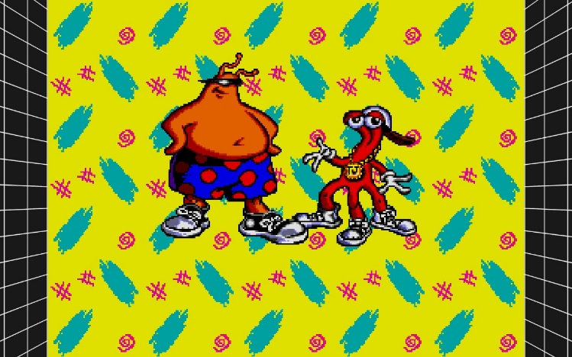

The main characters Toejam and Earl

Genre
The intended genre for Toejam and Earl seems to be a “Roguelike Game”. Initially I wasn’t familiar with the genre but after some careful research I think I got the idea on what it is. So, after careful analysis the “Roguelike” genre are typically seen as dungeon crawler type games. They are usually seen in RPG’s since they provide procedurally generated levels. Mostly fantasy based RPG’s as well.

With this kind of genre, you can see how and where Toejam and Earl utilize this with its dungeon crawler esque design with titbits of an open world element to it.

Roguelike games consists of random environment generation, permadeath, turn based movement on a grid, a gameplay model that does not require special screens like cutscenes [2] however Toejam and Earl is very different since its not an RPG. However due to its gameplay style it shares a ton in common with the roguelike genre. It’s considered a “roguelite” game taking elements from the roguelike genre while doing their own spin.
“Developers can easily bring their own themes to a roguelike and their own special twists and mechanics, while still building on a very well-understood foundation.” [3]
With this fact where I will be elaborating on further on in the “Replay Value” section it does create a sense of replay ability to the game especially with the unique and elaborate challenges Toejam and Earl presents to the player
Another thing I would like to bring up with how Toejam and Earl relates to the roguelike genre is its weird semi-isometric camera view. With other roguelike games like Hades, Dust & Neon and etc they all share a visual semi-isometric camera view which is a common trope with the roguelike genre. Toejam and Earl has this isometric view to its landscape. Working with the technology at the time where the game was released.
Toejam next to a Boombox
EarlPondering Life
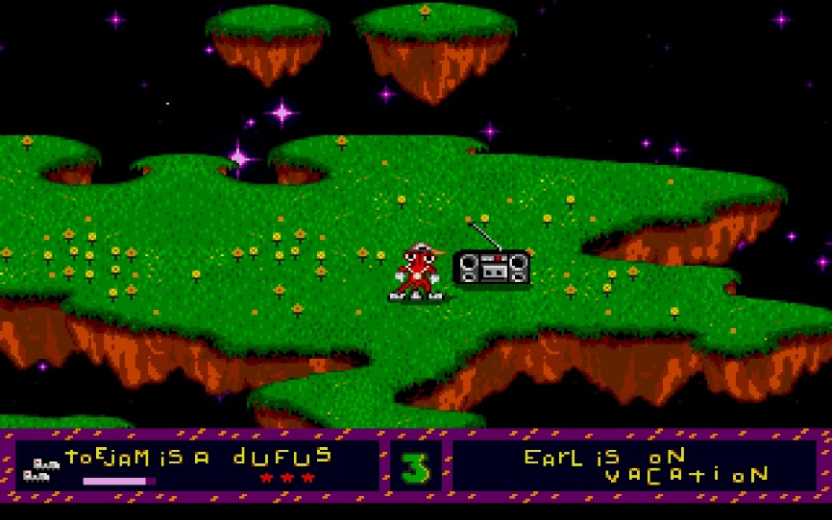
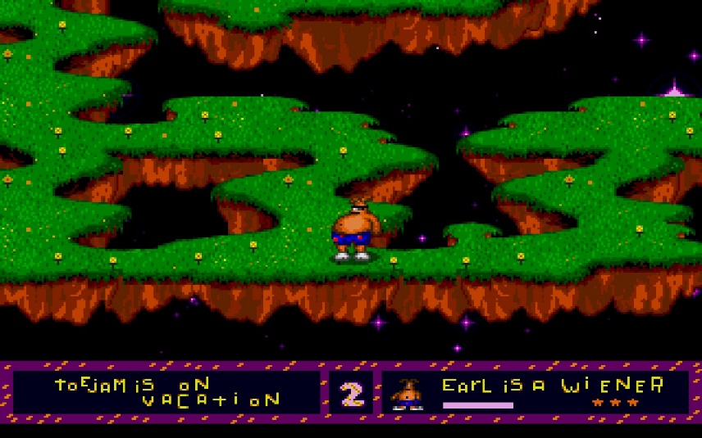

Visual Style
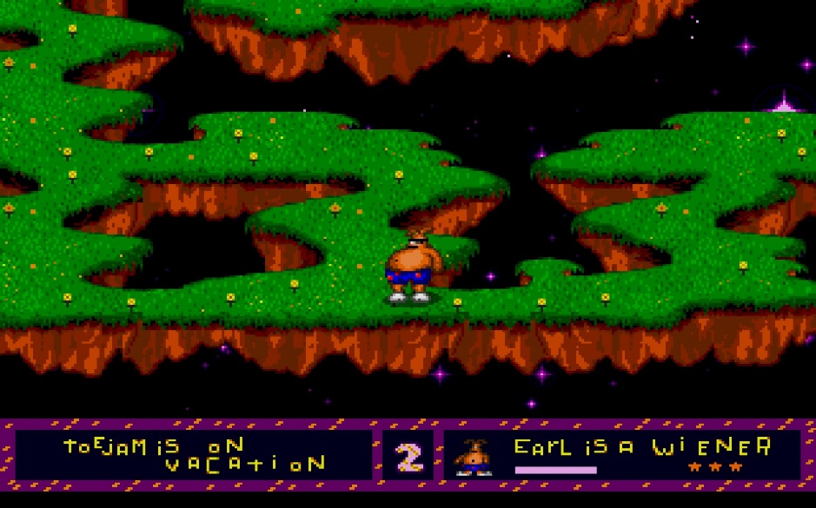
The game’s visual style is a 2D sprite based cartoony style. From the outset it seems like an average cartoony kid game however it does have a style which reflect the culture it is depicting through the aliens. The title screen and the main characters themselves has this graffiti esque style to them.

In game grapbhics

Which I believe works to the game’s advantage. It gives it its own stylized look to the characters and environments around them. Plus is very early 90’s considering the use of colourful shapes and flat coloured backgrounds. While playing this game I could tell it’s a fascinating look into the past making it an interesting time capsule to the visual style at the time.

I believe it aids the basic looking graphics with this cartoony fun visual style along with the random nature of the game [4]

Intended Demographic
The intended demographic for this game is Early teens, fans of platformers or roguelike and dungeon crawlers. Officially as it stands the ESRB rated the game “E for Everyone” [5] which would make sense for the visual style of the game and the child friendly approach. It also makes sense that teens would enjoy this game also considering it has a “hip-hop” urban vibe to it.

Plus, the platform it was mainly released on the Sega Mega Drive always tried to advertise itself as the cooler and more “hip” alternative to the Super NES. For instance, the commercials for the SEGA Mega Drive always tried to present more “realistic” or “cool” games to the fantasy cartoony style that the SNES had. It was seen as the “cool console to own” [6]
How does this relate the Toejam and Earl especially with its cartoony artsyle contradicting SEGA’s own style to present. Well, the biggest thing that Toejam and Earl contributes to SEGA’s style that they were trying to push is that is its “De la Soul” vibe. Like I mentioned above Toejam and Earl is ingrained in early 90’s hip hop culture which fits SEGA’s push to be seen as cooler and hipper than Nintendo [7]
Also, with the genre that Toejam and Earl is based on. (Semi Roguelike) I do believe that roguelike fans would also play the game however due to the game not being a proper roguelike.
Its more considered a roguelite yet its very well regarded for its time. [8]
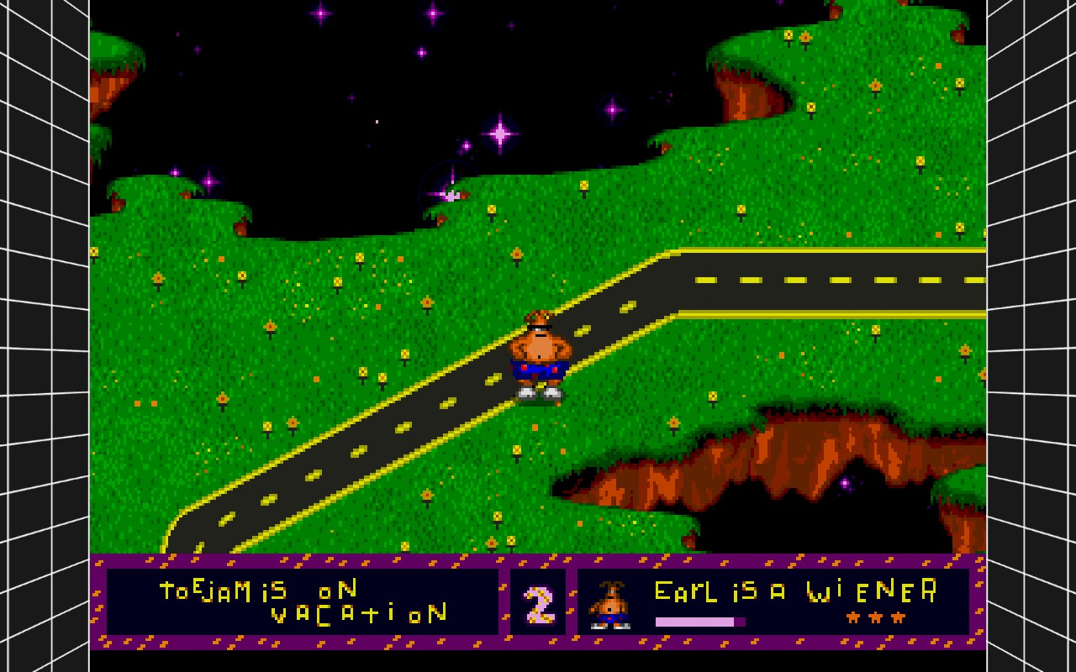

Earl walking along a road

Game Structure
The game is structured like a typical roguelike game however the biggest difference to this game compared to typical roguelike games is that its not an RPG. The game is mostly structed as a semi open world game as opposed to a roguelike game. It does share a few things in common with roguelikes. Mostly being that the game is very random in terms of enemy/item placement. When you play through this game each time it won’t be the same experience.

Like other roguelike there is a ton of randomly generated sets of items and maps. This feature is heavily highlighted in the “random world” option you can select in the menu which would heavily randomise the game with 10 differing layouts and randomised items you can use.
Another similar thing it shares in common with other roguelikes is that the game is a semi overhead view and as you explore the floating island to find certain items to let you utilize various skills or drawbacks. Which adds to the diverse challenge this game can provide.
Each level of the game is situated above each other meaning that its possible to completely reset your progress if you fall off a ledge which would take you back to the previous level.
It makes some items dangerous to use like rocket boosters and it makes traversing the game quite a challenge.

Challenges
Avoid enemies, know your environment, utilizing the presents and find spaceship parts. This makes the challenge in the game very diverse considering its randomised nature. However, the main challenge in the game centres around avoiding the various enemies you would encounter in the game. These include.
- Angry devils
- Giant Hamsters
- Monster mailboxes (the types that would blend in as normal mailboxes. The type you would need to get items)
- A mother and child
- Crazed Doctors
- Moles
- Hula Ladies (they would have your character stop and dance)
- Cupid (if you are shot by them, they would reverse your movement)
- Boogiemen
They are called earthlings within the game’s lore. There are non-hostile earthlings you can come across. Some of which would sell you items that you can use if you have a “buck” on hand. So, there is a clear economy in this game.

Game flow
Collecting pieces of the spaceship venturing through the levels. The game does indeed have a bit of a slow and careful process to it. However, with the emulator I am using I can speed up the game. But mainly the game is slow although one of the characters Toejam can walk faster and there is an item that can make you sprint (that item being the trainers or sneakers)
However, as I mentioned in the previous section you can reset your progress if you fall off the map. You would still have the items you have from other levels, but you will have to venture upwards to get back to where you left off.

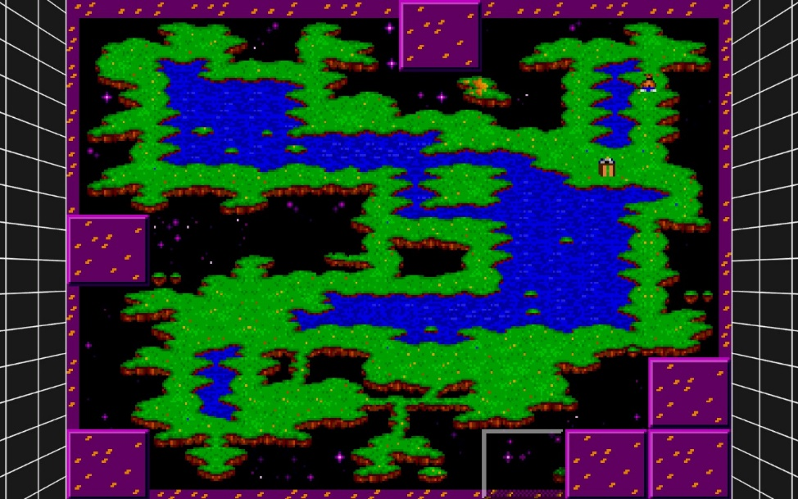

Ingame map

The in-game map can be extremely helpful to know where you are going, where the exit is and the layout of the map. Considering the game consists of floating islands you really want to make sure you know where you are stepping because another thing, I would like to mention about the game is that sometimes the map isn’t complete.

What I mean by this is that if you go to a certain area on the game world more landmasses will phase in. This is most notable in areas with tight walkways.

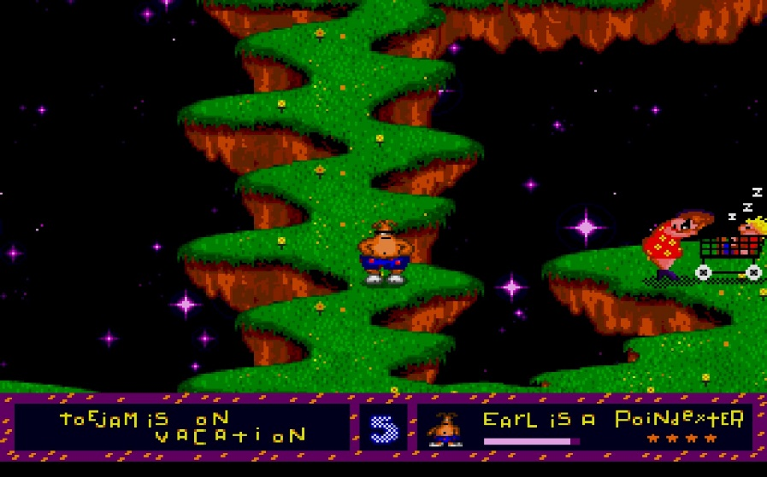

Tight walkways

This makes exploring every inch of the map rewarding in a way that there is always something new to discover as you look for spaceship parts, items, food or whatever.

Replay Value
The replay value is greatly benefited through procedurally generated levels, coop support and etc.
The biggest thing that adds to the replayability is that every time you play the game its not the exact same experience. In terms of item/enemy placement this game always tries to keep you on your toes especially when the items you get tend to be randomized. You are not going to get the same “gift” twice.
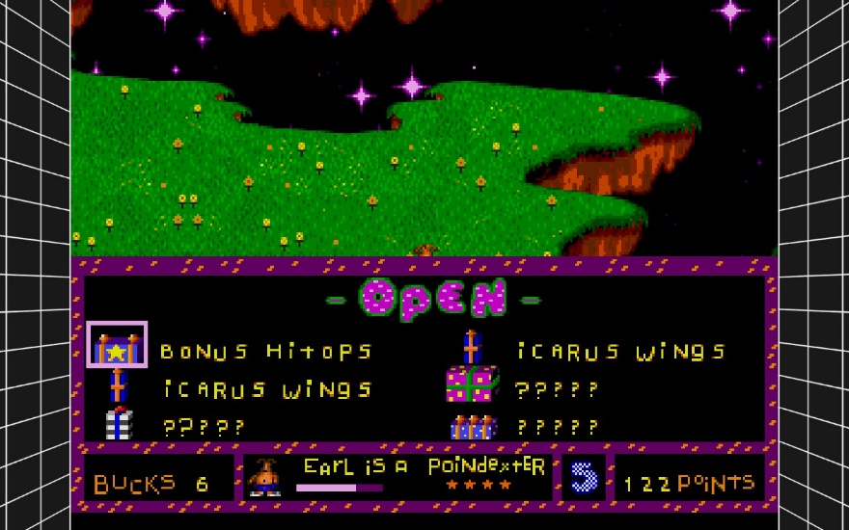

Item Menu

Along with that the game has a “random world” mode. Which would drop you into a random level with randomized items and enemy placement which again adds to the unique challenge this game holds.
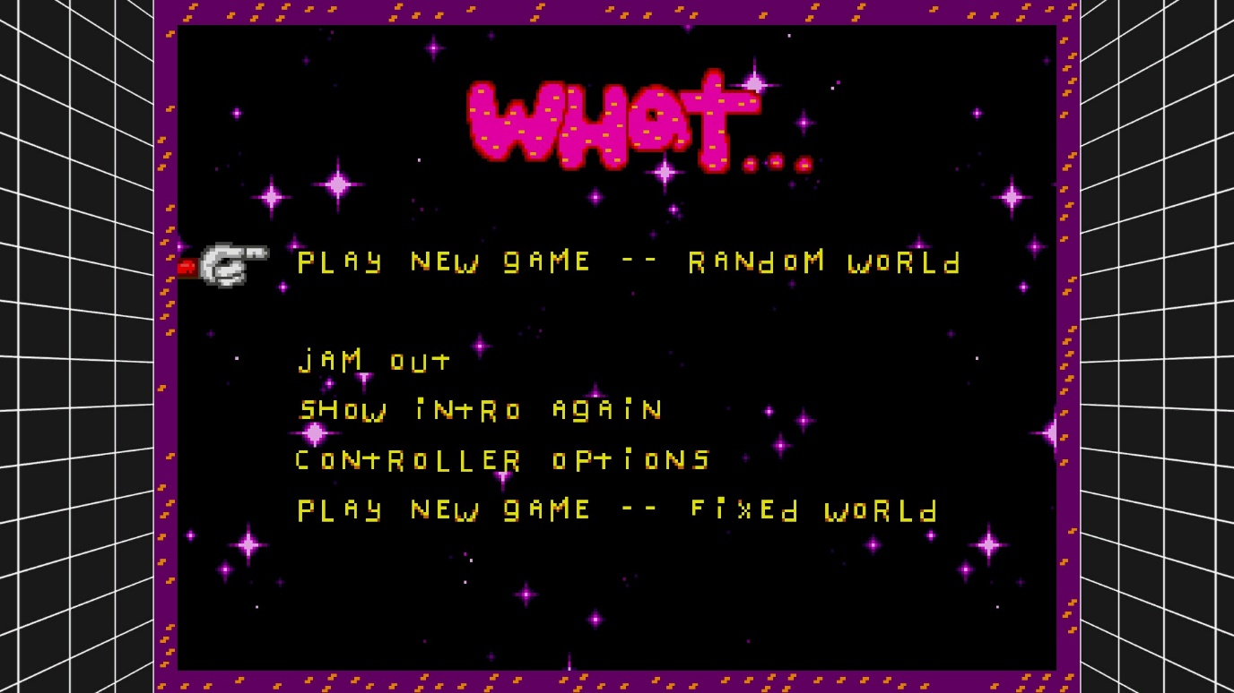
Ingame menu

Not to mention the game has Coop. You can grab a friend and play as with Toejam or Earl as you go ahead and collect spaceship parts. Coop in of itself also just adds a ton of replay value to this game since you are playing with a friend and both players trying to find new items in its randomized system it can bring a new experience each time you play.
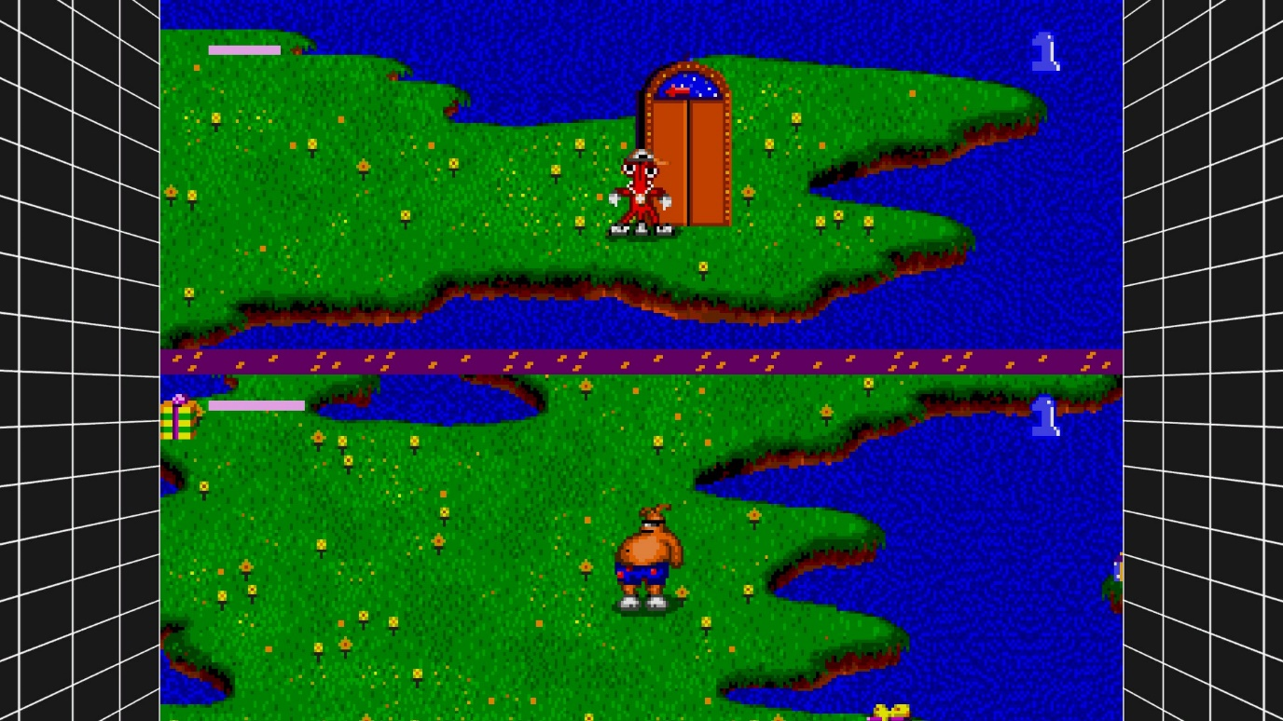
Coop support

Positive and Negative aspects of the game
The discourse around this game seems to be rather positive. Especially regarding reviews...

The Verge reviews this game and compliments the coop mode while also criticizing the “repetitive” nature of the game.
“It’s all about playing with another person. Going solo is missing the point.”-The Verge [9]
This review tells me that this person thinks playing the game with a friend is the ideal way to play.
Honest Gamers complimented Toejam and Earl’s originality and style.
“What makes Toe Jam & Earl so special?! Well, everything about it does, but if I could sum it all up in one word, it would be originality” [10]
The legacy that Toejam and Earl left behind within the SEGA mindset seems to persist with its “cool” and “hip” presentation that SEGA had at the time which the reviews reflected. Some like “The Independent” even argued it may have style over substance.[11]

My Opinion
In my honest opinion this game. It was a fun albeit frustrating experience. The music has a vibe to it which is relaxing to listen to as you play the game which I think aided the experience. However, there were moments within the game which are Irritating.
The biggest one is that the game is slow. Unless you have sprint trainers you will be strolling. While it made sense with the vibe the game has it gets frustrating when you are trying to avoid enemies that can move faster than the player and it gets annoying when you encounter those Hawaii ladies where your character would stop just to do the Hula dance
Its especially painful when those cupid babies can reverse your movement and you would have to stop a lot. If it wasn’t for the SEGA emulator “fast forward” feature, I would’ve given up.
I also didn’t like that when use rocket boots it can really mess up your flow of the game if you are sent back a couple of levels since you flew off the edges.
All in all, though despite the challenges I still had fun. I loved strolling as Earl chilling to that laidback funky beat and I did like the idea that you are playing with fire opening presents. It just adds a very fun dynamic to it which adds to the innovation Toejam and Earl gave to the SEGA library.

Overall, I would give it a 7.5/10.

References
[1] ToeJam (2007) Wikipedia. Available at: https://en.wikipedia.org/wiki/ToeJam_&_Earl (Accessed: 24 October 2023).
[2] Stegner, B. (2021) What are roguelike and roguelite video games?, MUO. Available at: https://www.makeuseof.com/what-are-roguelike-and-roguelite-video-games/ (Accessed: 24 October 2023).
[3] John HarrisContributorApril 03, 2019 (2019) ‘roguelike’ from Another planet: The big toejam &amp;amp; earl: Back in the, Game Developer. Available at: https://www.gamedeveloper.com/design/-roguelike-from-another-planet-the-big-i-toejam-earl-back-in-the-groove-i-interview (Accessed: 24 October 2023).
[4] Hogan, D. (2021) ToeJam and Earl (mega drive) review, Hogan Reviews. Available at: https://hoganreviews.co.uk/2021/02/22/toejam-and-earl-mega-drive-review/ (Accessed: 24 October 2023).
[5] Toe Jam &amp; Earl (no date a) ESRB Ratings. Available at: https://www.esrb.org/ratings/2231/toe-jam-earl/ (Accessed: 30 October 2023).
[6] Horowitz, W. by K. (no date) Marketing the Genesis: Sega’s advertising 1989-1996, Sega. Available at: https://www.sega-16.com/2006/08/marketing-the-genesis-segas-advertising-1989-1996/ (Accessed: 30 October 2023).
[7] Banks, T. (2015) The design history of the Sega Mega Drive, Design Week. Available at: https://www.designweek.co.uk/issues/november-2014/the-design-history-of-the-sega-mega-drive/ (Accessed: 30 October 2023).
[8] Mike (2022) Toejam &amp; Earl Review, Gaming Pastime. Available at: https://gamingpastime.com/toejam-and-earl-review/ (Accessed: 30 October 2023).
[9] Lowensohn, J. (2014) Does ‘Toejam and Earl’ for Sega Genesis hold&nbsp;up?, The Verge. Available at: https://www.theverge.com/2014/11/8/7174927/does-toejam-and-earl-hold-up (Accessed: 01 November 2023).
[10] Toejam &amp; Earl (Genesis) review (2003) Retro Game Reviews &amp; More. Available at: https://www.honestgamers.com/1401/genesis/toejam-earl/review.html (Accessed: 01 November 2023).
[11] Sega Vintage Collection: Toejam and Earl – Review (2012) The Independent. Available at: https://www.independent.co.uk/games/sega-vintage-collection-toejam-and-earl-review-8334665.html (Accessed: 01 November 2023).

