1.
My storyboard looks at the climate-related issue of biodiversity in local parks and roadside verges.
"The (2022) IPCC report confirms that we are not living through a single crisis – but rather a triple-threat of climate, biodiversity, and social crises worldwide.
“Biodiversity loss globally is a threat to humanity, and will make climate change even worse, creating a vicious cycle" says Henry Grub, postgraduate researcher in the Centre for Environmental Policy and Imperial's Grantham Institute - Climate Change and the Environment. (Amer, 2022)
"If all of the road verges in the United Kingdom were managed for nature there would be a spectacular 418.88 billion more flowers, or 6,300 per person in the UK." (Plantlife, n.d.)
I have looked at a few of the ways in which local roadside verges and parks could be managed for biodiversity.
Word count: 135/500
2.
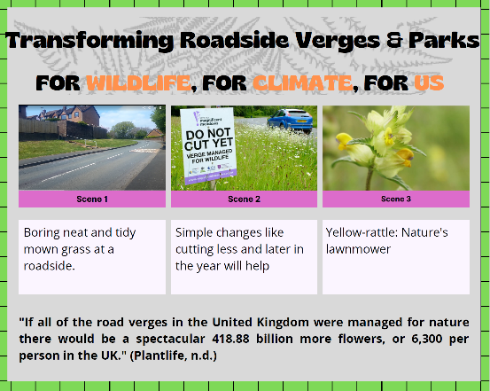
Title design (Plantlife, 2022) Scene 1 (Hill, 2022) Scene 2 (Plantlife, 2022) Scene 3 (Plantlife, 2022)
1
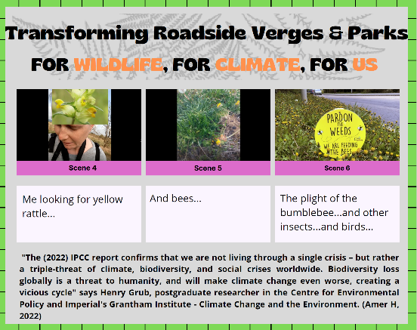
Scene 4 (Hill, 2022) Scene 5 (Hill, 2022) Scene 6 (Sarah, 2021)
2
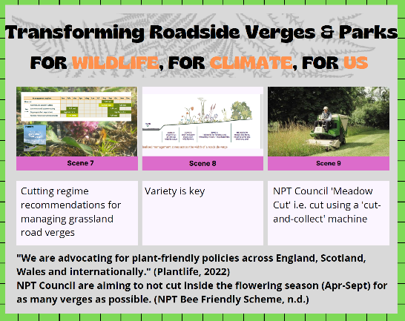
Scene 7 (Hill, 2022) (Plantlife, 2022, p. 13) Scene 8 (Plantlife, 2022, p. 17) Scene 9 (NPT, 2022)
3
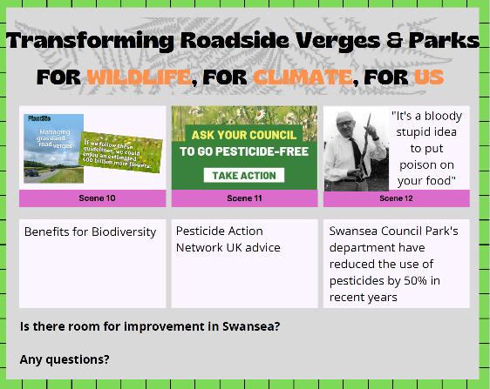
Scene 10 (Plantlife, 2022, p. 38) Scene 11 (PAN, 2022) Scene 12 (Vine, 2022)
4

‘Explanatory words’ count: 218/500

3.
I made a short (1:55 minutes) video to accompany two of the scenes from my storyboard. I have shared this video to my Twitter and Instagram account and the screenshots below show how successful this has been so far (up until todays date: 24 April 2022).

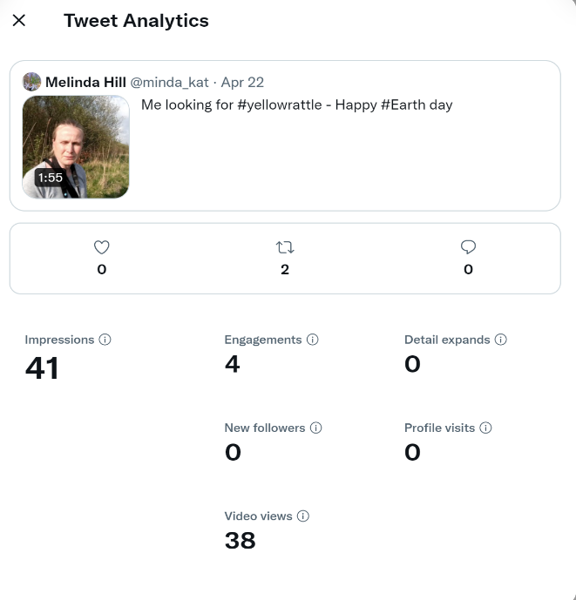
Figure 1. Twitter analytics for my first tweet of my video

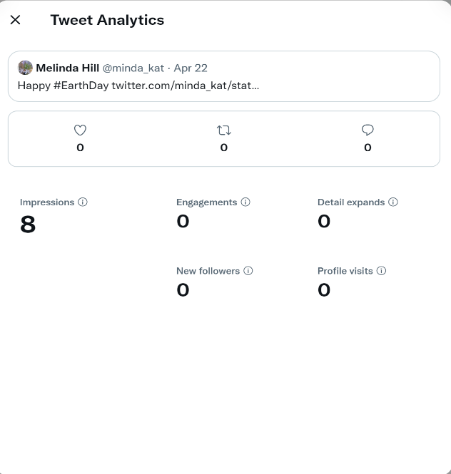
Figure 2. Twitter analytics for my second attempt at tweeting my video (this time with the correct hashtag: #EarthDay (instead of #Earth day) trending on Twitter at the time of posting my video

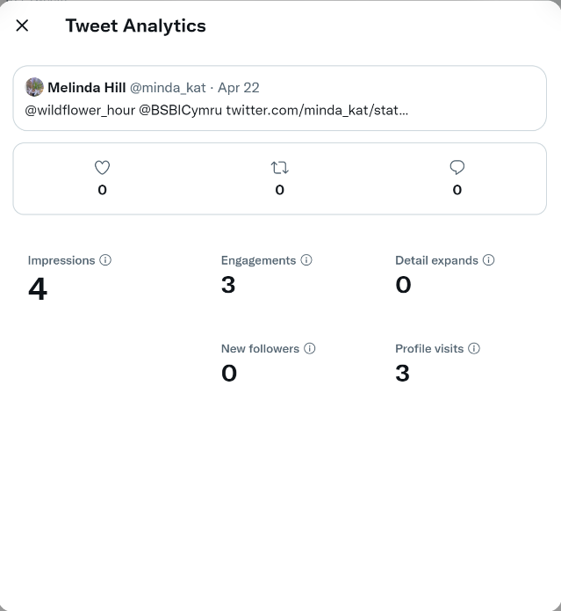
Figure 3. Twitter analytics for my attempt at retweeting my original tweet this time with @'s to share it with relevant Twitter groups. In hindsight I should have included these in my original tweet, which may have disseminated my video more widely.

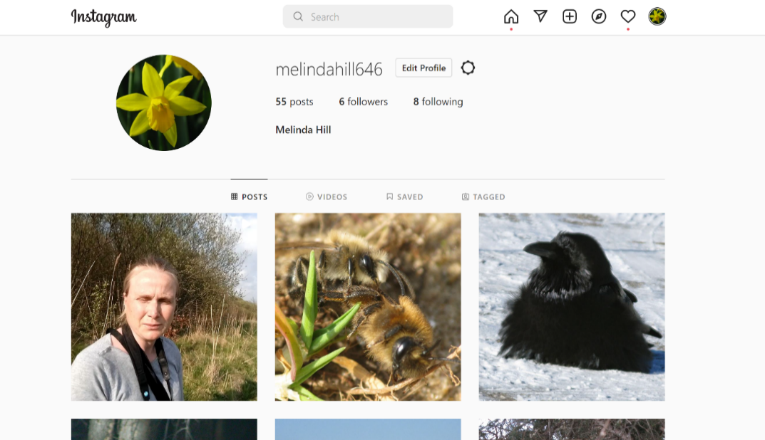
Figure 4. My Instagram. No-one has liked my video since posting on 22 April 2022.

Word count: 147/500
Total word count: 500

Bibliography
Amer, H., 2022. New IPCC report "the starkest warning yet" on the dangers of climate change. [Online]
Available at: https://www.imperial.ac.uk/news/234374/new-ipcc-report-starkest-warning-dangers/
[Accessed 24 April 2022].
Hill, M., 2022. Bee on red clover. Swansea: s.n.
Hill, M., 2022. Boring roadside verge. Swansea: s.n.
Hill, M., 2022. Me looking for bees. Swansea: s.n.
Hill, M., 2022. Me looking for yellow rattle. Swansea: s.n.
NPT, B. F. S., 2022. How our management is changing.... s.l.:https://www.npt.gov.uk/29554.
PAN, U., 2022. Pesticide Free Towns Campaign. s.l.:https://www.pan-uk.org/pesticide-free/.
Plantlife, 2022. How to grow Yellow Rattle (Rhinanthus minor). s.l.:https://www.plantlife.org.uk/uk/discover-wild-plants-nature/how-to-grow-yellow-rattle-rhinanthus-minor.
Plantlife, 2022. Managing grassland verges. s.l.:https://www.plantlife.org.uk/application/files/3315/7063/5411/Managing_grassland_road_verges_Singles.pdf.
Plantlife, 2022. The Road Verge Campaign Blossoms.... s.l.:https://www.plantlife.org.uk/uk/blog/the-road-verge-campaign.
Plantlife, 2022. Transforming road verges. s.l.:https://roadverges.plantlife.org.uk/.
Plantlife, n.d.. Road verges: 20% drop in diversity of wild flowers puts bees at risk as plant 'marauders' take over. [Online]
Available at: https://www.plantlife.org.uk/uk/about-us/news/road-verge-marauders
[Accessed 24 April 2022].
Sarah, [., 2021. Pardon the weeds.... s.l.:https://mobile.twitter.com/SarahPa80038805/status/1380463867193659394/photo/1.
Vine, J., 2022. Putting pesticides on your food. Swansea: http://www.aberford.net/2003/09/fred-hayton-and-his-longest-runner.html?fbclid=IwAR0Z5YqrojYooH8BomF22jpCE9Tvmpri0BNmRSuphXGhibejtEzKmwhBffw.

