Network and Cyber security essentials Coursework.

Author: Jack Miller (2006843)

Networks and Cyber Security Essentials ACCA4024

School of Applied Computing

Wales Institute of Science and Art

Date and Time of submission:

Abstract

Table of Contents

Contents

1. Introduction

2. Related Work / Review of Literature

3. Design and Implementation

4. Mitigation Strategies and Recommendation

5. Conclusion

6. References

Abstract

In this work I will discuss the various networks that are most commonly used in both the workplace and in private life. I will evaluate some of the key flaws with these methods and demonstrate a practical attack in the form of ARP poisoning to intercept FTP traffic. I will then evaluate some of the most effective policies to combat this attack and others like it and to better secure the network.

1. Introduction

Networks are an integral part of all communication devices in the modern world. A network is defined as “… two or more computing devices that are connected in order to share the components of your network and the information you store there …”[1]. Because of the growing prevalence of networks in all facets of life security is more important than ever. This means that a good understanding of the vulnerabilities of networks is crucial in understanding how best to defend against malicious attacks. In this report I will be examining the flaws in Che-Si’s security policies and suggesting how they could be improved.

Related works

Types of networks

There are a number of different types of networks which utilise different mechanisms to transmit data and therefore have different vulnerabilities and securities. The first and most common type of network used by most consumer devices is the wireless network. Wireless networks are clearly more convenient than wired networks as devices are not physically connected to any other devices and are therefore far more portable.
Another type of network commonly encountered by people , especially in the work place, are wired networks. Wired networks rely on computers and other networked devices being physically connected to network infrastructure by ethernet or other network media. These can be more secure as information is not broadcast over the air but is instead sent directly to network infrastructure such as routers and switches. Wired networks also allow for far greater network speeds and much lower latency

Attacks and threats

There are a number of common encryption and security mechanisms for wireless networks such as WEP(wired equivalent privacy), WPA(wifi protected access) and WPA2(wifi protected access2)[2]. These mechanisms are not entirely secure and do leave room for exploitation. WEP is the original standard for wireless security and was originally adopted in 1999. It uses the RC4 algorithm for its encryption. WEP was superseded by WPA in 2003 and by WPA2 in 2004. Kumkar et al show in their paper some of the major vulnerabilities found in all three of these security mechanisms. In networks using WEP the researchers were able to crack the keys in only a few minutes. This is down to a number of factors including improper use of the RC4 algorithm and the reuse of initialisation vectors. WPA and WPA2 fix many of the security flaws ignored or created by WEP. WPA continues to use the RC4 algorithm whereas WPA2 uses CCMP (Counter Mode with CBC-MAC Protocol) which employs AES (Advanced Encryption Standard) as its encryption algorithm[3]. In practice this means that the statistical analysis which was effective in cracking WEP keys is no longer feasible for WPA as the keys used are not static. The method used in this paper [2] is a dictionary attack in which a pre compiled list of keys is used to crack the key. This can be achieved by packet capturing during the handshake phase of the WPA2 mechanism.

By allowing all staff to access the network from any location and on any device is a massive security risk and compromises the entire networks integrity. Allowing any device to be used makes it incredibly difficult for the security team to know whether the connection is legitimate and initiated by a staff member or if it is an attempt to infiltrate the network by unauthorised people.

This also makes it relatively easy to perform man-in-the-middle (MITM) attacks. MITM attacks are difficult to notice and are easy to execute. They work by routing either all, or a specific target computers network traffic through another computer. This allows all packets sent from the target to be opened, inspected and modified before being sent on to the gateway and allows the same to happen to packets intended for the target. One way in which this attack can be accomplished is through ARP (Address resolution protocol) poisoning[4]. This particular attack is achieved by exploiting a feature in the “Hot Standby Router Protocol” (HSRP) [5]. This protocol is designed to allow two routers to act as a default gateway, the two routers agree on a primary and failover device and create a virtual IP address. As this virtual IP address needs to be able to move between the two devices with minimal lag time they cannot wait for the ARP cache entries to time out as this can take up to 20 minutes. Instead they use a mechanism called “Gratuitous ARP response”. This allows routers to immediately update ARP caches on local systems without first being queried[6]. This is obviously useful when a router uses it, however when used maliciously it can have devastating effects.

Design and Implementation

There are a number of flaws in the security policy of this company. Firstly that the company allows any one to connect using their own devices. This leaves room for malware such as key loggers to intercept confidential login credentials if they are installed onto an employees personal devices. And secondly that employees and clients are allowed to connect from any network in the world. This makes it far more difficult to ascertain whether or not any connection is legitimate or an attempt to break into the system. This also means that you cannot be sure of who else is using the network at the same time or even if the network itself is not monitoring the traffic flowing through it.

Implementation

I am going to demonstrate a man-in-the-middle attack using a piece of open source software called Ettercap[7]. Ettercap allows easy execution of MITM attacks by automating the ARP poisoning process. It also provides functionality for the modification of intercepted packets. I will use an Ubuntu Server virtual machine and a Debian virtual machine as well as my MacBook for this demonstration. I will first set up an FTP server on the Ubuntu server VM. I will use Ettercap to initiate a MITM arp poisoning attack and will intercept all traffic between the server and the Debian VM. I will then attempt to connect to this FTP server from the Debian VM. This will allow me to view the intercepted FTP packets in Wireshark.
Wireshark is a powerful packet sniffing tool which will allow me to filter out packets which are not important and allow me to analyse the FTP packets and retrieve information such as the username and password.

Firstly I will start Ettercap and initiate the ARP poisoning by opening the terminal and running the command
“sudo ettercap -T -q -M arp:remote /192.168.1.98// /192.168.1.206//”
This command launches Ettercap with the options “-T” which tells it to run in text mode, “-q” which tells it to be quiet and “-M” which tells it to initiate a MITM attack. The IP addresses are parsed into Ettercap in the format Mac/IP/IPv6/Port. In this example I have left all options empty apart from the IP addresses. The first IP address inputted is the FTP server and the second is the client. The reason that I have specified the IP addresses of both VM’s, is because they are connected via a virtual switch and so the traffic between the two is not handled by the default gateway.

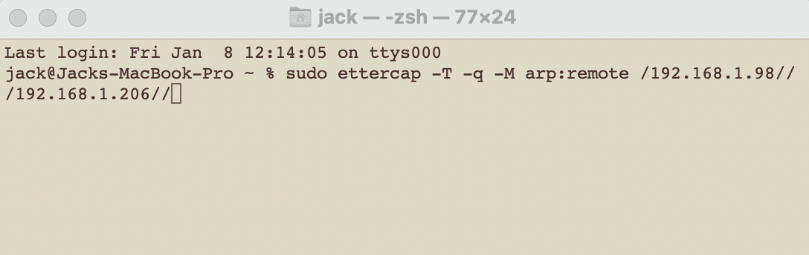

The output of this command shows that the ARP poisoning was successful. There is no traffic shown in the terminal at this point because of the “-q” option I used earlier. This is fine as I am going to use Wireshark to view the captured packets later.

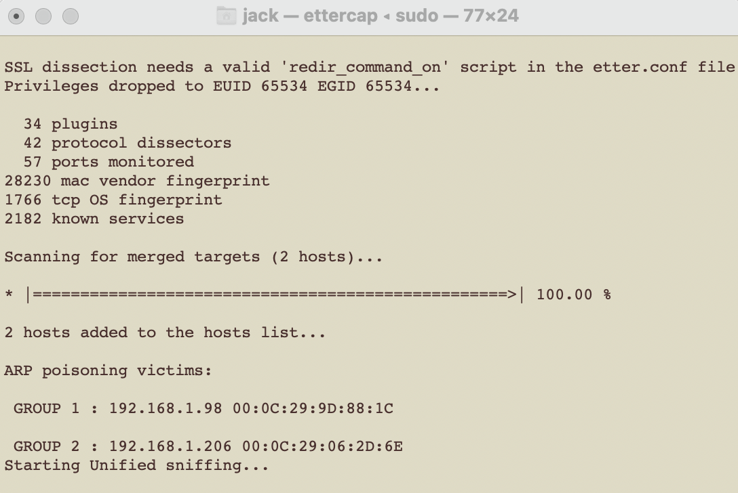

Now that the MITM attack has been executed I can begin looking out for packets. In this demonstration I am looking for FTP packets, specifically to try and find the login credentials to the file server. To do this I am going to launch Wireshark.
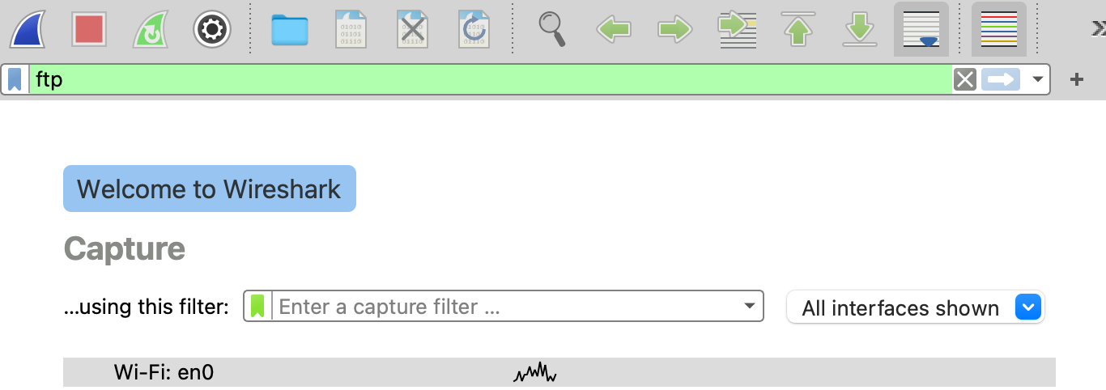

As you can see I have selected the wifi adapter on my computer to be the interface I am listening on and have applied a filter so that I only see FTP packets. I am then going to start the process of sniffing packets. I won’t see any packets come up until I begin making requests to the FTP server.

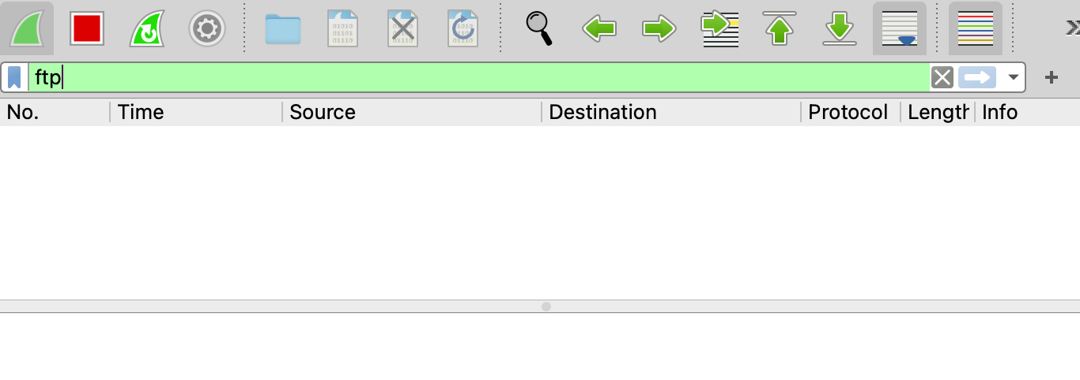

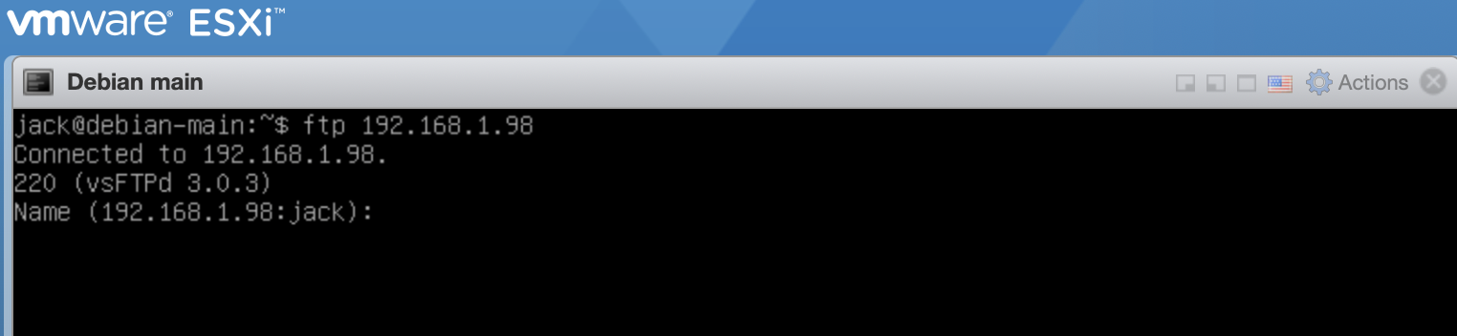
I am now going to switch over to the Debian virtual machine and initiate a connection with the file server.

Now that I have begun communicating using ftp Wireshark is picking up packets.
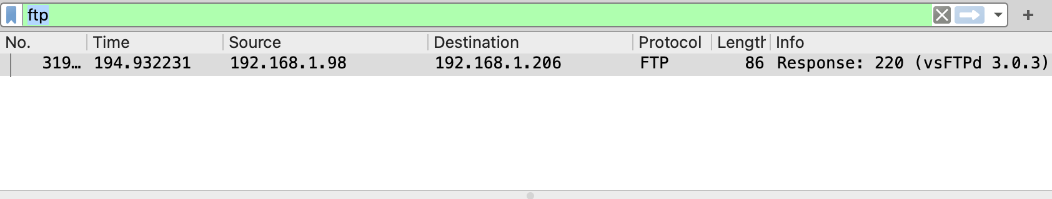

Now that we can see that a connection has been initiated we will also be able to see the contents of any other ftp packets sent between the target and the server. This includes not only the username and password used to login to the server but also every command issued once the user has logged on, and the output of those commands.

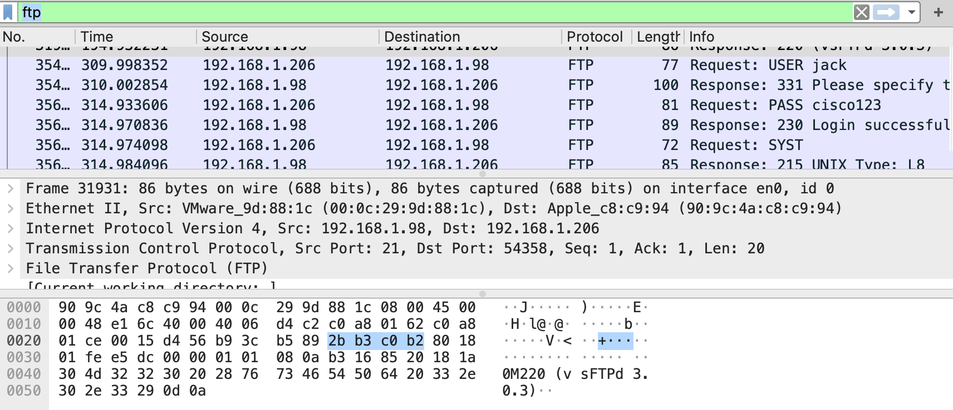
As you can see, both the username and password were transmitted in plain text. I can now logon to the server using those credentials. This means that I have access to everything that the user “jack” had access to, this could be anything from inventory for the company to confidential employee information like addresses and payslips and the companies financial details. This is clearly a highly effective attack that is easy to execute and could have devastating consequences for the company.

Mitigation strategies

Attacks such as these can be mitigated relatively easily with a few simple techniques. Firstly staff should be encouraged only to use trusted networks when handling sensitive information like business plans or financial information. This would help to minimise the risk of malicious actors being present. Examples of these types of networks would be workplace networks which are monitored and where any unwanted or unrecognised devices could be removed. Other precautions which can be taken to minimise the risks of attack are using secure protocols. For example WPA3 is now becoming more commonplace and is more secure than its antecedents[8]. Using strong passwords on all wifi networks would also help to filter out malicious actors and make it less likely for dictionary attacks to be successful. Using encrypted protocols like https or ftps mean that even if your traffic is intercepted, it is less likely that any one is going to be able to read the potentially sensitive information contained within.

There are of course a number of far more complex exploits and attacks available to the determined attacker such as making use of buffer overflows in poorly written code, using “heap spray” techniques to exploit browsers and using custom malware.[5] These types of attacks are much more difficult to guard against as they often make use of zero day exploits (which are vulnerabilities which the developer may not be aware of, or have only just found). The basic steps to protect against these types of attacks mainly resolve around keeping all of your software up to date and installing all new security patches. However it must be said that understanding your threat model is important here as there is no point in spending huge amounts of time and money building a network defence that could stand up against nation state level attacks if your main threats are script kiddies.

It is critical for the security of any network to have effective, enforceable policies regarding the use of the network. Firstly it is important to note that an information security policy should not be static and should instead be continually evolving as our understanding of the threats that we face evolve. For this reason it is suggested that the policy document should be reviewed at least once per year and updated [9].
Perhaps the most relevant set of policies to implement in this case would be access control policies. This would involve allowing users to only access files relevant to their position, for example a client does not need to be able to access your accounting files. This would mean that in the event of a data breach the damage done should be limited.
It would also include utilising a monitoring system to record every login and logoff[10], both successful and unsuccessful including the times and dates, and the ip addresses of those attempting to login. This would help in being able to pinpoint which accounts accessed what services at any given time. It would also be worth using multi-factor authentication so that multiple, disparate forms of identification must be used to logon, such as receiving a text with a unique number which is needed to login to the server [11].
All staff should receive training in the new policies to make sure that they are understood by everyone. It would also be a good idea to virtualise a server for each client so that if they choose not to comply with the new security policy no-one else’s data or information is lost. This would also make managing accounts easier as when a contract with a client ends the server allocated to them could be spun down without effecting any of the others.

Conclusion

In conclusion, it is crucially important to understand the threats faced by companies in the modern world if you are to protect yourself from them. This includes knowing the signs that an attack is happening, keeping backups of all of your data (obeying the rule of 3[12]) and reviewing your policies in line with modern threats. If all of the above is done then the risk of significant data breaches is vastly diminished.

References
[1] mike Meyers, “‘In the beginning, there were no networks. Life was bad.,’” Www3.nd.edu. [Online]. Available: https://www3.nd.edu/~cpoellab/teaching/cse40814_fall14/networks.pdf. [Accessed: 02-Jan-2021].

[2] V. Kumkar, A. Tiwari, P. Tiwari, A. Gupta, and S. Shrawne, “Vulnerabilities of Wireless Security protocols (WEP and WPA2),” Irstu.com. [Online]. Available: https://dl.irstu.com/wp-content/uploads/Download/Education/Book/Network/Network%20Security/WEP-WPA-Article/Vulnerabilities%20of%20Wireless%20Security%20protocols.pdf. [Accessed: 02-Jan-2021].

[3] P. Arana, “Benefits and vulnerabilities of WI-fi protected access 2 (WPA2),” Irstu.com. [Online]. Available: https://dl.irstu.com/wp-content/uploads/Download/Education/Book/Network/Network%20Security/WEP-WPA-Article/Benefits%20and%20Vulnerabilities%20of%20Wi-Fi%20Protected%20Access%202%20(WPA2).pdf. [Accessed: 02-Jan-2021].

[4] C. Nachreiner, “Anatomy of an ARP poisoning attack,” Csci6433.org. [Online]. Available: http://csci6433.org/Papers/Anatomy%20of%20an%20ARP%20Poisoning%20Attack%20_%20WatchGuard.pdf. [Accessed: 02-Jan-2021].

[5] D. Regalado et al., Gray hat hacking the ethical hacker’s handbook, fourth edition, 4th ed. New York, NY: McGraw-Hill Professional, 2014.

[6] Libero.it. [Online]. Available: https://digilander.libero.it/SNHYPER/files/arppoison.pdf. [Accessed: 02-Jan-2021].

[7] “Ettercap Home Page,” Ettercap-project.org. [Online]. Available: https://www.ettercap-project.org. [Accessed: 02-Jan-2021].

[8] A. Price, “WPA3 Wi-Fi Security,” Infosecwriters.com. [Online]. Available: http://www.infosecwriters.com/Papers/aprice_WPA3Security.pdf. [Accessed: 02-Jan-2021].

[9] S. Barman, Writing information security policies. Upper Saddle River, NJ: New Riders Publishing, 2001.

[10] D. Kostadinov, “Key elements of an information security policy,” Infosecinstitute.com. [Online]. Available: https://resources.infosecinstitute.com/topic/key-elements-information-security-policy/. [Accessed: 02-Jan-2021].

[11]Sophos.com. [Online]. Available: https://www.sophos.com/en-us/legal/sophoslabs-information-security-policy.aspx. [Accessed: 02-Jan-2021].

[12]V. Rausch, “Data backup: The rule of three,” Davikinc.net, 20-Aug-2014. [Online]. Available: https://davikinc.net/data-backup-the-rule-of-three/. [Accessed: 02-Jan-2021].

