Academic and Employability Skills
BMSW4001

Student Name:Ramona-Iulia Ungureanu
Student ID:2028821

Table of Contents
Introduction 3
Academic Writing 3
Time management 4
Online Learning Experience 5
Public Speaking and giving presentations 6
Conclusion 7
References 8

Introduction
Employability Know-how can be described as the transferrable talents that a person needs to be hired by an organization or corporation. In addition to outstanding technical comprehension and expertise of subjects, companies generally describe a number of talents from employees that they require. Employability skills generally grow during the academic session of an individual’s life. Through passing several academic procedures, an individual learns various skills such as time management skills, presentation skills, public speaking, problem-solving skills, and many more. All those skills make the individual employable (Small, et al, 2018). In response to this reflective report, I explain essential employability skills, including public speaking and presentations, time management skills, academic writing, and online learning experiences, to ensure better working conditions in the current employment market. In 1988 Graham Gibbs introduced Gibbs' Reflective Cycle to provide a framework for learning through events. One of the most famed cycle frameworks for reflecting and analyzing six stages: description, feelings, assessment, analysis, conclusion, and action plan (Parkinson, et el, 2018). This model is an excellent technique to generate an overview of an experience. Throughout this module, I will entitle the significant advantages of those employability abilities, such as time management, presentation, academic writing, and virtual education in the contemporary working population, with Gibb's famous reflective model.

Academic Writing
Academic or scientific writing is non-fiction created as an academic activity, such as empirical fieldwork reports or research in natural and social-scientific institutions. The most specific goal in university writing is to describe a particular concept or finding study and convince readers that the writer has the correct interpretation or concept (Chin, et al, 2013). The accurate writing method used at universities and colleges is academic writing. This is what learners have to submit to courses and what professors and educational researchers use to write cultural aspects. Its key aspects include the formal tone, accurate language, perspective, focus, organization, and quotes from the source. Academic writing will typically be prepared for the third individual because instead of promoting an idea or providing instruction, the center is to present evidence. Since most academic work involves summary examination results, it can emphasize specific examination questions. Academic writing in a focused and feasible style should be structured systematically (Swales, et al, 2004).

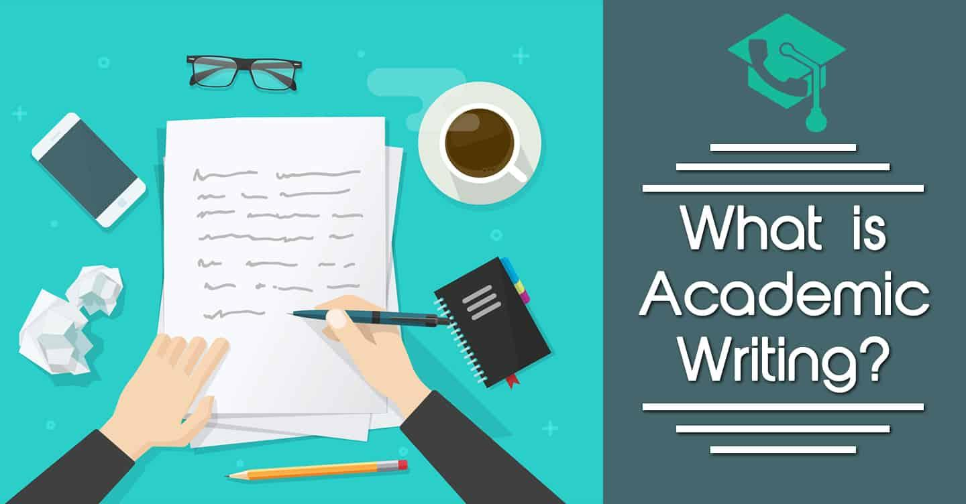
Fig 1: Academic Writing
In academics around the world, academic writing plays an important role. Learning how to write professionally takes a maximum time of instructors. In the context of my experience, academic writing will enable me to assess the work or ideas of someone else and develop a point of view. I have to consider how to write apart from explaining the work. This style of writing also teaches us how to do a thorough assessment of how to convey material in the best way to keep the reader's attention to the finish. I have to study topics and carry out a thorough investigation to make my articles successful during the composition of academic documents. This style of writing will help me build a different perspective by assessing what I understood and making declarations. This talent enhances my critical thinking and evaluation skills, which improve my potential for employability (Borglin, 2012). In addition, in answering questions, we are becoming innovative. This is because academic work on different subjects will particularly strengthen my vocabulary and use of the terminology. On the basis of the study and insights acquired, I may utilize academic writing as a tool for communicating with knowledgeable readers in a formal language.

Time management

The capacity to control time successfully refers to time management skills. This is an ability that helps living creatures. Time management can be used almost at every point of life as an instrument for advancement and enjoyment because success can only be achieved if we make optimum use of our time. Time management allows a person to improve production, which benefits the individual and the company alike (Sainz, et al, 2019). In a person performing at work, it offers a Jogging performance of various objectives. Time Management allows a person to improve effectiveness, which benefits both employees and companies. Maintaining superior time management capabilities within their employees is driven by the company's management. The methodology of time management is an outlined chain of ways. A variety of abilities, tools, and strategies used to preserve the time required to execute diverse tasks, programs, and objectives can support time management capability. The correct time flow should be maintained to pursue a secured career in this present competitive job market (McFadden, et al, 1992). Time management is usually a requirement in the administration of any program as it specifies the timeframe and extent of the program. It is also vibrant to distinguish that there are both primary and professional variances in time management because of developments in cultural time theory (Wagner, et al, 2008).
Fig 2: Time management Skill
Time management skill is denoted as one of the most demandable employability skills. Inconceivable time-setting allows a person to accomplish more, reducing anxiety and leading to career satisfaction in less timeframe (Hosseini, 2017). Efficient time management makes it possible for students to do more in a shorter period. Furthermore, Gibbs’ reflective framework help to analyze my experience regarding time management skills (Adeani, et al, 2020). In context to my experiences, time management skills enhance my productivity and effectiveness throughout the academic journey. Time management abilities help prevent stress and provide sufficient space in order to improve my work capability. Due to effective time management, the caliber of my choices significantly affects and influences virtually everything in my life, from my work growth to my connections, relationships, and social interactions. The skills help me bring effectiveness to my working potential and make me aware of the benefits of doing jobs in time. Additionally, practical time management skills help me reduce mental stress by doing my job on time and bringing more credibility in a personal development setting.

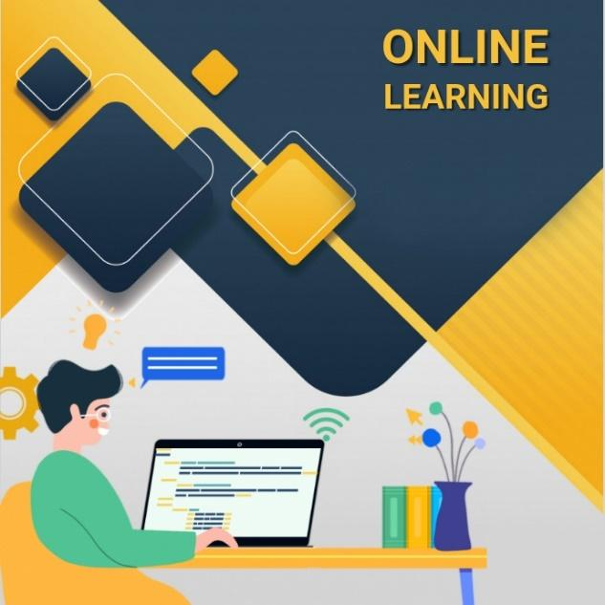
Online Learning Experience
Fig 3: Online Learning Experience
Due to the increase in demand, online learning is becoming increasingly popular. It is also an effective method of distributing knowledge through learning platforms to distance learners (Anderson, et al, 2008). E-learning is a systematic education technique that involves digital resources, however. Our traditional instructional system was transformed into a digital system where the entire learning procedure was performed online because of the ongoing Covid-19 problems. During the Covid-19 pandemic, universities worldwide were forced to alter their curricula to now be accessed online (Verawardina, et al, 2020). As far as the online learning system is concerned, my group work has improved my performance in a collaborative setting in which I can share my thinking and talents to achieve achievements. This technique also develops my sense and team skills. Working in a group can also develop peer-to-peer reviews where fellow students also provide input on challenges. The peer-to-peer review can help improve our understanding and profound knowledge of specific problems. We can also discover the experimental setup and standards that enhance our productivity and effectiveness (Du, et al, 2019). The system of online learning provides flexibility in everyday living. The scheduling method depends on the choice of students and allows them to attend the classes with ease. I have flexibility in my everyday schedules when it comes to my online learning experience. In addition, employers notice this and appreciate the time management abilities that all three have to balance. Since there are no defined periods in an online graduate school and learners can design their preferred schedules, they need to reach the teaching staff proactively, finish tasks on time and plan appropriately (Mukhtar, et al, 2020).

Fig 4: Learning in a digital approach (Online Learning system)
Universities worldwide had to adjust education to the epidemic of Covid-19, such that it was now available online (Liu, et al, 2020). However, my student participation in online learning is somewhat stressful. I must use the main items to enjoy online learning. Now, as usual, I spend much time online and on technology. I tried to negotiate several speeches one thing. Although it pushed me favorably to continue to learn online, I did not create too many fast-starting. I participated in the online courses, and typically that was beneficial.

Public Speaking and giving presentations

The presentation involves addressing a particular goal and coordinating this speech with several graphics or slides to strengthen that goal and measure the result. A more widespread range of speech effective communication is public speaking. Public speaking with presentation is mixed up to generate a more comprehensive communication to reach the audience's interest.

Fig 5: Public Speaking
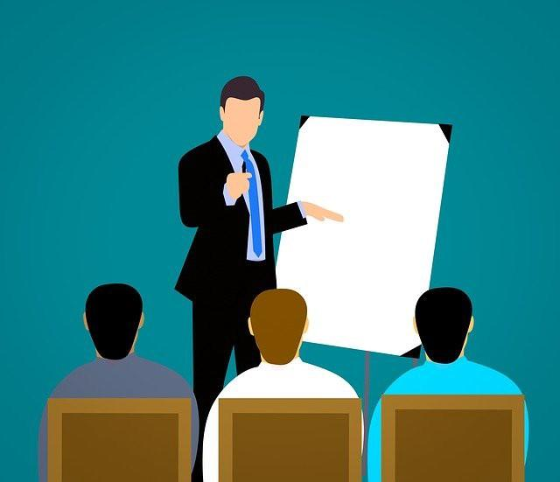
Public speakers are a terrific way to create self-improvement in several aspects since the improvement of effective communication in practically every area of life is essential. Employment progress can be helped by the practical public-speaking skills that reflect innovation, critical analysis, authority, balance, and professionalism that are very desirable to the employment market (Casteleyn, 2019). It is a fantastic method to gain credibility to speak at conferences and seminars. The more well-known the event, the greater it can contribute to the curriculum. In addition, speaking publicly with the presentation can increase my confidence tremendously. It is exhilarating to overcome the uncertainties and uncertainties that accompany public speech (Ayesha, 2021). In addition, it might be strongly remembered that someone has significant thoughts and opinions to offer to the community. The public speaking and presentation skill has played an essential role in learning, management, and professionalism throughout the ages. Speaking may inform, influence, educate and appreciate. The spoken declaration can be even more substantial than the printed thought in the fingertips of the actual presenter. Speaking in public promotes concentration, better research skills, increased capacity for the deduction, and much more (Murillo-Zamorano, et al, 2018).
Fig 6: Public Speaking with giving
Preparing for a speech requires presenters to consider the bigger picture and think deeply about effective communication methods (M.I., 2021). The communication patterns we established several years ago are easy to count on in ordinary living. However, to stand out among the crowd, we need to develop practical communication skills such as public speaking and presentation. Regarding my experiences, public speaking is a pretty effective way to interact with the audience. It helps to develop efficient communication potential, which will help to pursue a secured career. Additionally, the skill of public speaking and giving presentations helps me expand my social connections and enhance professional relations. Through giving presentations in academic sessions with public speaking develops my vocabulary and fluency to the next edge.

Conclusion
Academic learning and employability is a closely related term commonly used in the present competitive job market. In order to enhance an organization’s productivity and profitability, business owners are highly encouraged to employ people with excellent soft skills and practical knowledge. Through this entire report, I have discussed the four critical employability skills based on my personal experience using Gibbs’ reflective model to entitle the benefits of those skills. At the beginning of the report, I have discussed the skill regarding academic writing. Academic writing is a pretty common term for university students that we used in various research projects or formal writing. The efficient skill in academic writing enhances my potentialities of critical thinking and evaluation to generate a point of view on particular research topics. Then, I have entitled the time management skill. Time management is regarded as the strategy of planning and scheduling used for exact activities. Time management is essential to accomplish each assignment on time. In addition, excellent time management gives students and all types of individuals the most advantages. In the next part, I have discussed my experience regarding the online learning system. Due to the breakdown of Covid-19, most of the educational intuitions had to shift their teaching system from a conversational approach to a digital method. Online learning is quite a satisfactory term that establishes a collaborative environment where we can directly collaborate with distant learners and renewed teachers. Moreover, online learning brings flexibility in daily life which also reduces the stress of the learners. Finally, I have talked about public speaking and giving presentations. Public speaking is a speech given to an audience that helps me broaden my connections with society and the workforce to improve my future career.

References
Adeani, I.S., Febriani, R.B. and Syafryadin, S., 2020. USING GIBBS’REFLECTIVE CYCLE IN MAKING REFLECTIONS OF LITERARY ANALYSIS. Indonesian EFL Journal, 6(2), pp.139-148.
Anderson, T. ed., 2008. The theory and practice of online learning. Athabasca University Press.
Ayesha, M.I., 2021. Training Public Speaking and Presentation Skills for Rural Students on Online Platform: An Experimental Study.
Borglin, G., 2012. Promoting critical thinking and academic writing skills in nurse education. Nurse education today, 32(5), pp.611-613.
Casteleyn, J., 2019. Improving public speaking in secondary education―Exploring the potential of an improvisation training. L1 Educational Studies in Language and Literature, (Assessing Oracy).
Chin, P., Reid, S., Wray, S. and Yamazaki, Y., 2013. Academic Writing Skills 3 Student's Book (Vol. 3). Cambridge University Press.
Du, J., Fan, X., Xu, J., Wang, C., Sun, L. and Liu, F., 2019. Predictors for students’ self-efficacy in online collaborative groupwork. Educational Technology Research and Development, 67(4), pp.767-791.
Ghiasvand, A.M., Naderi, M., Tafreshi, M.Z., Ahmadi, F. and Hosseini, M., 2017. Relationship between time management skills and anxiety and academic motivation of nursing students in Tehran. Electronic physician, 9(1), p.3678.
He, K.N., Parkinson, L. and Doyle, A.K., 2018. Gibbs’ Reflective Cycle.
Liu, Z.Y., Lomovtseva, N. and Korobeynikova, E., 2020. Online learning platforms: Reconstructing modern higher education. International Journal of Emerging Technologies in Learning (iJET), 15(13), pp.4-21.
McFadden, K. and Dart, J., 1992. Time management skills of undergraduate business students. Journal of Education for Business, 68(2), pp.84-88.
Mukhtar, K., Javed, K., Arooj, M. and Sethi, A., 2020. Advantages, Limitations and Recommendations for online learning during COVID-19 pandemic era. Pakistan journal of medical sciences, 36(COVID19-S4), p.S27.
Murillo-Zamorano, L.R. and Montanero, M., 2018. Oral presentations in higher education: A comparison of the impact of peer and teacher feedback. Assessment & Evaluation in Higher Education, 43(1), pp.138-150.
Sainz, M.A., Ferrero, A.M. and Ugidos, A., 2019. Time management: skills to learn and put into practice. Education+ Training.
Small, L., Shacklock, K. and Marchant, T., 2018. Employability: A contemporary review for higher education stakeholders. Journal of Vocational Education & Training, 70(1), pp.148-166.
Swales, J.M. and Feak, C.B., 2004. Academic writing for graduate students: Essential tasks and skills (Vol. 1). Ann Arbor, MI: University of Michigan Press.
Verawardina, U., Asnur, L., Lubis, A.L., Hendriyani, Y., Ramadhani, D., Dewi, I.P., Darni, R., Betri, T.J., Susanti, W. and Sriwahyuni, T., 2020. Reviewing online learning facing the Covid-19 outbreak. Talent Development & Excellence, 12.
Wagner, P., Schober, B. and Spiel, C., 2008. Time investment and time management: An analysis of time students spend working at home for school. Educational research and evaluation, 14(2), pp.139

