University of Wales Trinity Saint David
Wales Institute of Science and Art


Academic Skills ACHA4008
Technical Report Soapbox

James Minton 2204900

Biagio Gallo (2200506)

Charlie Jones (2103718)

Jak Kamphenkel (2205180)

Shaun Elias (2201130)

Abstract
This report was written to find out the challenges and time it would take to engineering, source and create a soapbox cart for a race from scratch the following topics in this report include the cost, engineering and the time taken.
The main topics that were focused on when creating this soapbox cart were cost effectiveness, simplicity when engineering and the weight of the vehicle.

Contents
Introduction 3
Literature Review 4
Methodology 6
Analysis……………………………………………………………………………………………………………………………….8
Conclusion 9
References 10

Introduction
This report has been made to show the different sections and challenges it takes to engineer a soapbox cart for the summer soapbox race.
Included in this report is the materials used for the soapbox as well as steering, braking system, body design, time chart and cost analysis if the project.

Literature Review
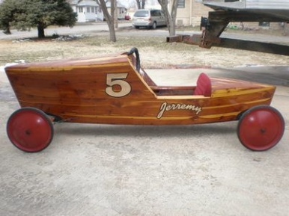
Fist challenge was to select the type of materiel to used.
Plywood- Good cheap material to make the body of the soap box out of easy to cut to shape and design that you want for your soap box to look like. Can become heavy when trying to get the plywood to be stronger as more layers are needed, thinner the plywood the more you can bend it.
This would make for a good, cheap and easy way of making a soapbox as it wouldn’t take a lot of money or skill to be put together. (COST EFFECTIVE/LIGHT WEIGHT)
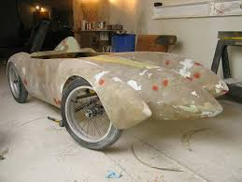
Fiberglass- Strong and lightweight and can be easily moulded into shape. However, doing this does require to have some form of mould to put the fiberglass onto to get the shape you want and then replace the mould with just the fiberglass.
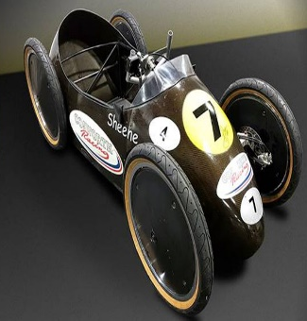
Fiberglass is a good light weight material that would allow you to make the body of the car more intricate as it wouldn’t be too heavy, it would break just under the weight of itself. ( DIFFICULT TO ENGINEER)
CFRP- Strong and lightweight is made up of two different materials a matrix and a reinforcement in CFRP the reinforcement is carbon fibre, which provides its strength. The matrix is usually a polymer resin, such as epoxy, to bind the reinforcements together. Making sure they stay together and don’t come apart. This would be a great material to use for a soap box as it wouldn’t break and has the durability to make it down the hill in one piece. However, the price of this material would be too high and wouldn't be affordable to make the whole car out of it. (HIGH COST)
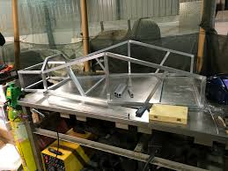
Aluminium- For the structure of the build as it is flexible and lightweight this makes for a good soap box frame as it won’t be too heavy on itself. And more likely make it to the bottom of the hill intake. Hopeful using aluminium because it flexible it will flex on the road and not brake when going over jumps as we have seen happen before. This also means you can bend and shape the tubes how you want the car to look. (FLEXIBLE/LIGHT WEIGHT LESS EXPENSIVE COMPARED TO OTHER MATEIALS)
As seen above aluminium has been chosen for the frame and plywood for the body. It was found early on that the use of the other material listed above were far too expensive and difficult engineer/source.

Steering
Second task was to select a type of steering system, for this the Ackermann steering design was chosen.
As well as selecting the Ackermann system as the steering it was decided that the soap box should be of a 3 wheeled design rather than 4 wheeled design to decrease weight and cost.

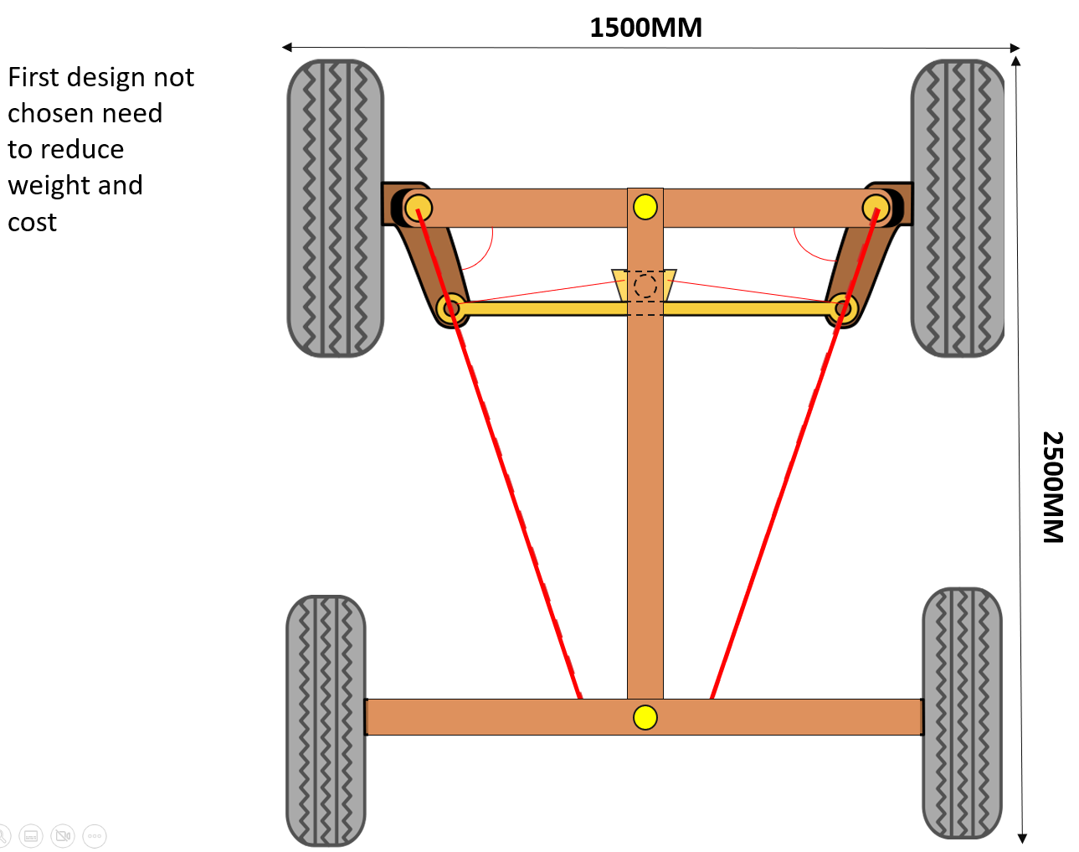Methodology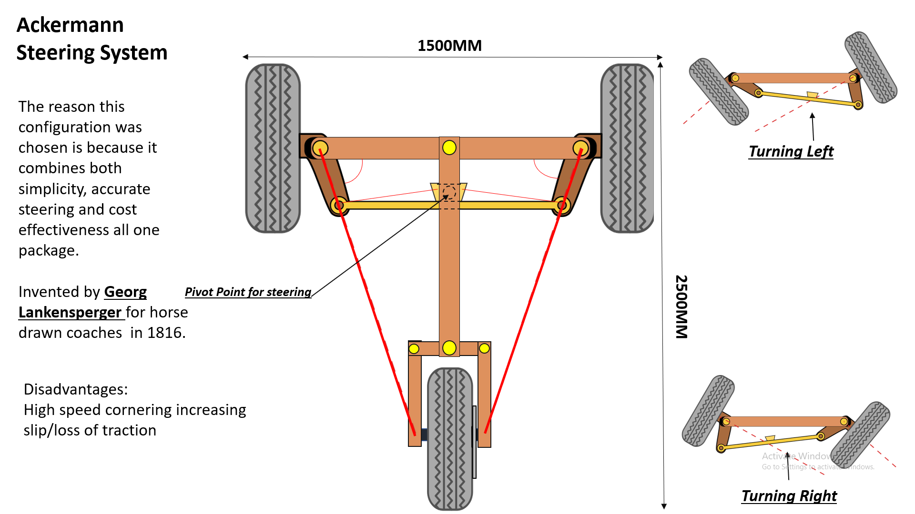Braking
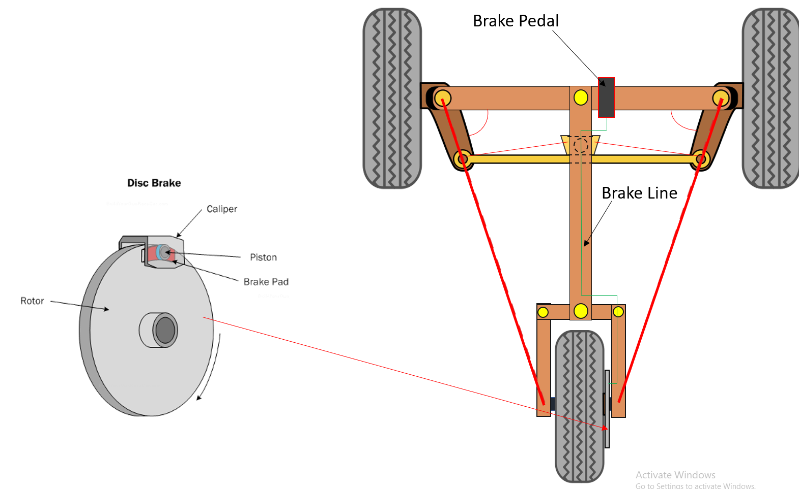
To keep cost and engineering simple it was chosen to only have braking on the rear wheel. It was also found early on that having brakes on the front wheels would send the weight of the cart to the front wheels causing unstable characteristics for the driver and possibly flipping the cart over.

Body Design
For the body of the cart, it was decided that it would consist of an angled nose with a low angle of attack increasing the amount of air flow over the vehicle at the front increasing air pressure over the cart in turn creating more stability as well as having a tear drop styled rear to reduce the amount of air resistance on the rear body.

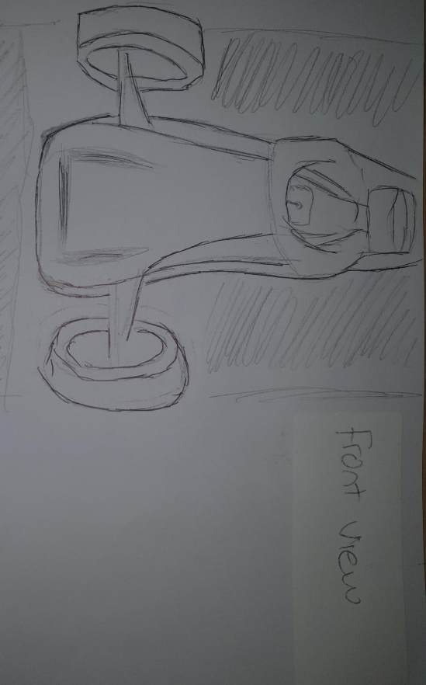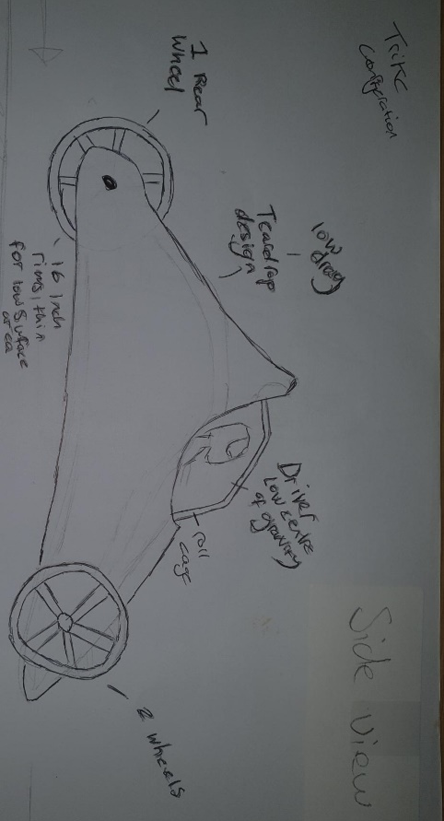

Methodology
To achieve the desired soapbox cart for this race the team separated into smaller divisions to specialise in certain aspects of the carts design, researching previous races and different prototype designs used in soapbox rallies.
With the end goal of creating a soapbox that is light weight, fast, simple to engineer and cost effective.

Analysis
Cost
To find the most cost-effective way of building a soapbox the team research and planed out different materials in which the soapbox could be made from. The graph below is the material that the teams researched, and price matched accordingly.
The team decided the most sensible choice was to have an aluminum frame with a wooded body to balance out the cost of the aluminum as well as being lighter than a traditional steel frame, 16-inch wheels were also chosen for the low cost and size to increase stability.
Materials |  | Dimensions |  | Amount of material (Sheets) |  | Cost for one sheet (£) |  | Cost for Multiple sheets (£)
Plywood (Hardwood Eucaplus plywood Poplar cord fsc) 5.5mm |  | 2440x1220mm |  | 3 |  | 26.51 |  | 79.53
Aluminium (0.9 thick mill finish) |  | 2x1 metre |  | 3 |  | 59.94 |  | 179.82
Rims |  | 16 inches |  | 4 wheels |  | 21.60 |  | 86.40
 | Rim size |  | Amount |  | Cost per wheel (£) |  | type
 | 12 inch |  | 3 |  | 34.20 |  | Bicycle
 | 14 inch |  | 3 |  | 61.60 |  | Pit bike
 | 16 inch |  | 3 |  | 21.60 |  | Bicycle
Time Chart
Showing what tasks were performed at what time and date.
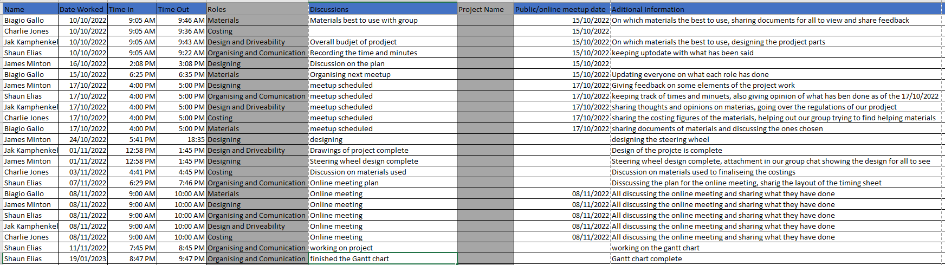
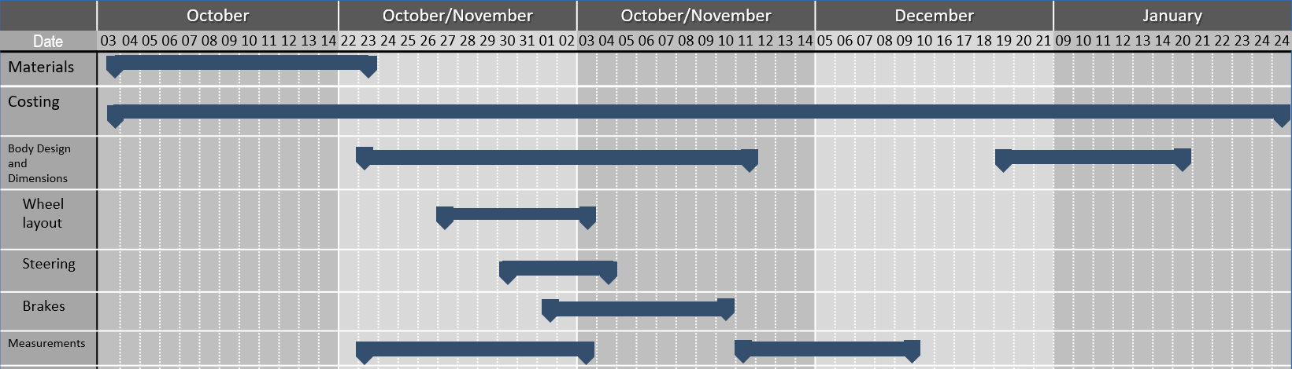

Conclusion
To conclude the findings in this report, it was found that to create and engineering an optimal soapbox for this race it came down to three major factor simplicity in engineering the soapbox, the weight of the vehicle to allow for a higher velocity when going through the race and the cost of the vehicle itself as having an expensive cart with exotic material would have certainly go over the budget required.

References
Joe Walter, JW & (2021). The story of Ackermann steering. [online] Tire Technology International. Available at: https://www.tiretechnologyinternational.com/opinion/the-story-of-ackermann-steering.html. Accessed (28/01/2023)

Triton Cycles. Available at: Burley MyKick Wheel, 12? Spoked | Triton Cycles (Accessed: 05/01/2023).

Fun Bikes. Available at: Pit Bike 14" Rear Wheel and Tyre Black (funbikes.co.uk) (Accessed: 12/01/2023).

Metal4U. Available at: Aluminium Sheeting, Aluminium Plates & Sheet Metal | metals4U (Accessed: 25/01/2023).

Science Learning Hub (2011). Wings and lift. [online] Science Learning Hub. Available at: https://www.sciencelearn.org.nz/resources/300-wings-and-lift.

‌

