Name | Student Number | Date | Lecturer’s Name | Your score
Foad Rabia Abdulaziz Fayyad | 2432992 | 20/072025 | Akash | To be filled by the marker  ___/40
You will have 90 minutes to complete this assessment. It is divided into three sections: note-taking, paraphrasing and writing a paragraph.
---------------------------------------------------------------------------------------------------------------------
1. Take diagrammatic notes from the passage below using the space provided:

The university experience is not just about subject knowledge, but also about developing skills that will equip you for your future life. For starters, it's impossible to graduate without a range of people skills under your belt. You'll meet new people from different backgrounds. You'll also interact with lecturers, tutors and university staff almost daily. Another life lesson that university teaches you is taking responsibility for yourself, your own schedule and learning. A lot of university study is self-directed - it's up to you to plan and organise your work, juggle multiple projects and manage deadlines – you will need to develop self-motivation if you want to succeed. Let’s not forget learning how to overcome obstacles; whether academic, work-related or personal, you'll face your fair share of hurdles as a student, but you will develop resourcefulness and resilience in the process. If you were a bit unorganised before you went to university, you won't be by the time you leave. To successfully navigate student life you'll need to handle a variety of study, work, social and personal commitments and the only way to do this is with organisation and time management. Finally, university provides plenty of opportunities to work on and boost your confidence: you'll work in groups, deliver presentations, complete assessments and maybe even become a class representative.
Adapted from: https://www.prospects.ac.uk/applying-for-university/university-life/7-life-skills-youll-learn-at-university

Space for your notes (max 12 marks):
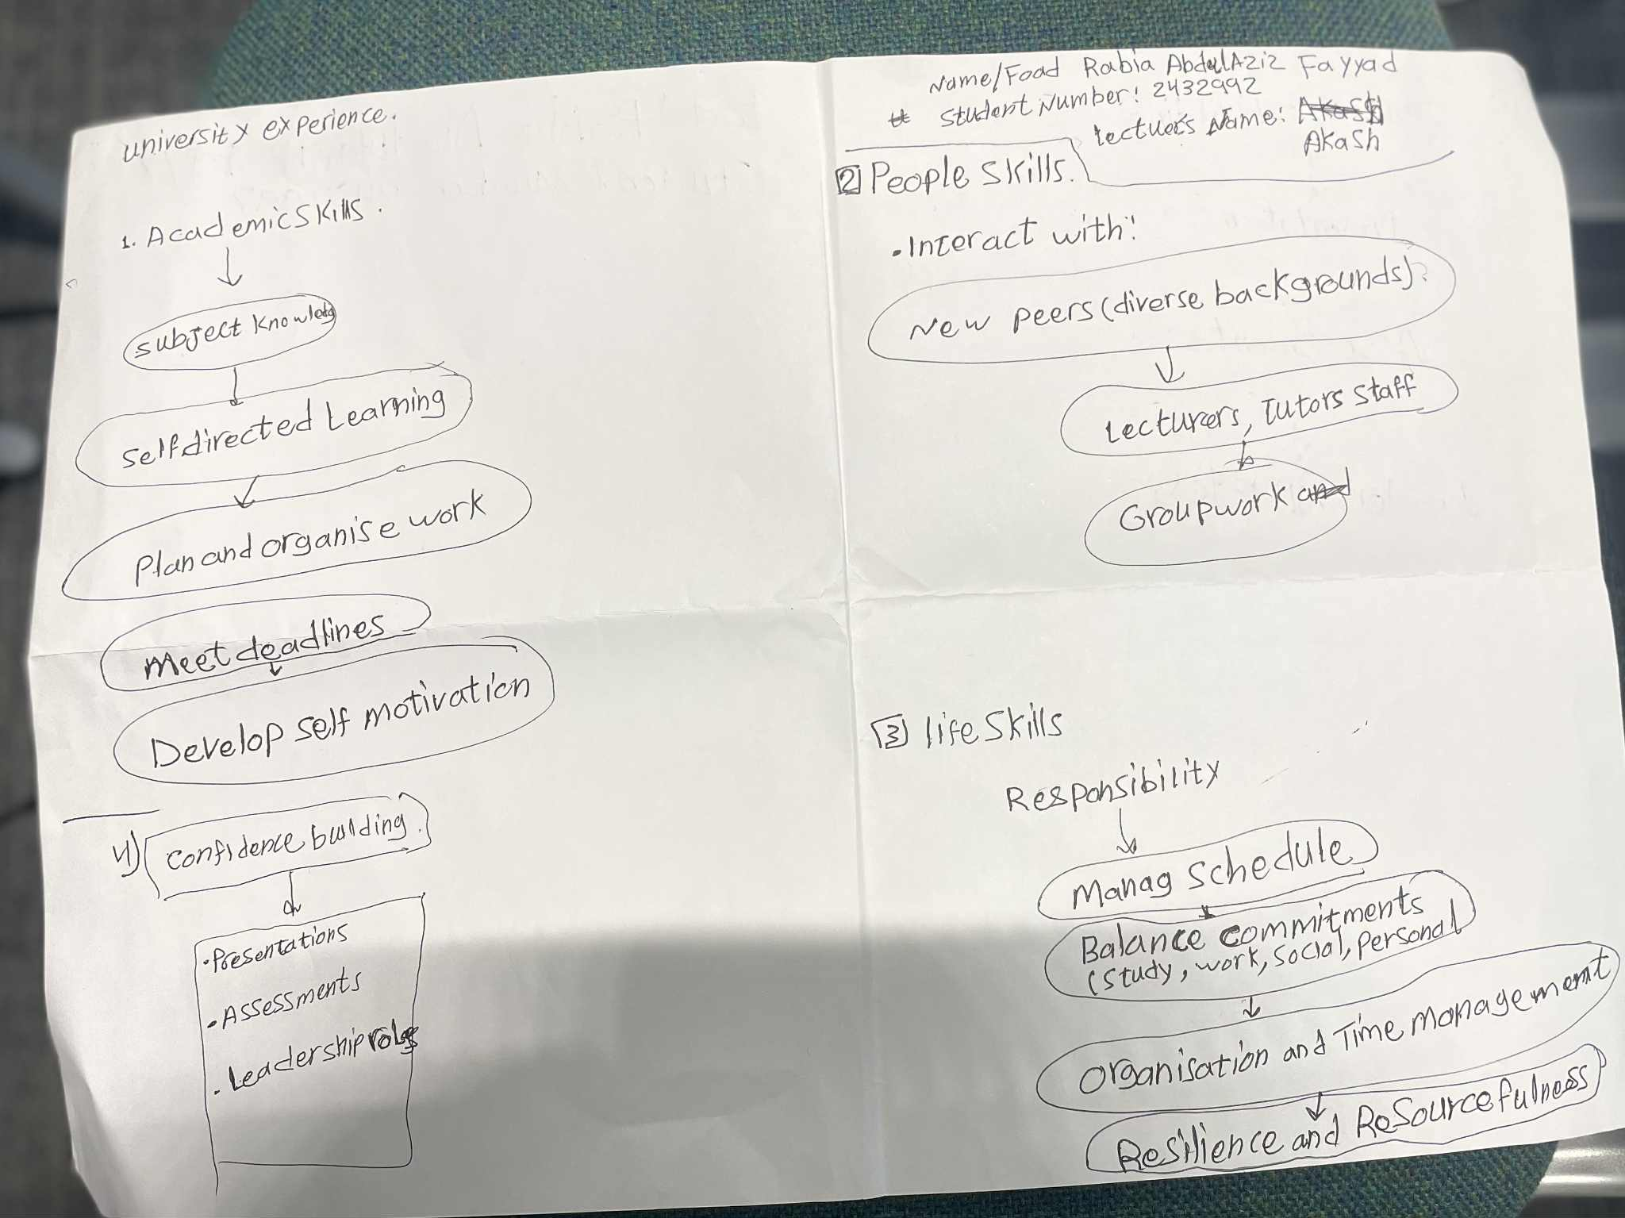

2. Paraphrase the following sentences (max 3 marks for each, max 12 marks in total):

a) To successfully navigate student life, you will need to handle a variety commitment.

To effectively manage student life, you'll need to juggle various commitments.

b) You will need to develop self-motivation if you want to succeed at university.
If you aim to succeed in university, it's essential to cultivate self-motivation.

c) Many students find it challenging to manage stress during assessment periods.
A lot of students struggle to cope with stress during exam times.

d) Frequent reading can help you become a more effective communicator.

Regular reading can enhance your communication skills.

3. Write a well-structured paragraph (8 sentences) on the following topic:

Effective time management techniques for university students

Your paragraph must be written in full sentences (no bullet points) and in an academic style.

(max 16 marks in total)

Effective time management is crucial for university students who want to balance school and personal life. Tools like weekly planners and digital calendars help schedule study sessions, deadlines, and extracurricular activities. Prioritization methods, such as the Eisenhower Matrix, allow students to distinguish between urgent and important tasks, which improves productivity. Additionally, breaking complex assignments into smaller parts helps reduce procrastination and supports a steady workflow. Regularly reviewing plans keeps students flexible and ready to respond to changing demands. Including short breaks in study routines boosts focus and reduces mental fatigue. Setting clear goals and aligning daily habits with long-term aims creates a sense of purpose, which increases motivation and academic success. Overall, mastering time management leads to success in higher education and encourages resilience and personal growth.

