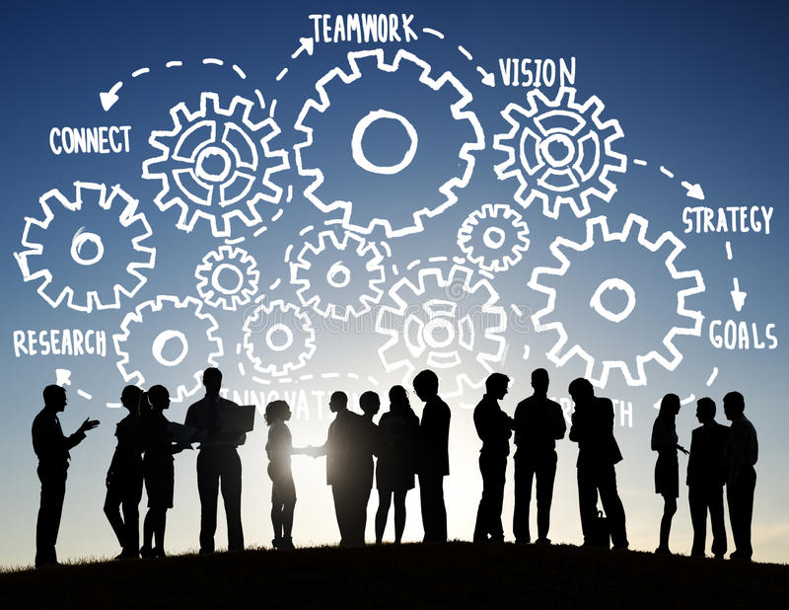

Name: Maiyara Mabel Florian Santana (2113112)
Module: Effective Team Work and Communication (BMSW4002)
Lecture Name: Akash Puranik

Table of Content page number
Abstract…………………………………………………………………………….. 3
Introduction………………………………………………………………………….. 3
Overview of Team Work……………………………………………………………..4
Models of team development……………………………………………………….. 5-6
Team Roles………………………………………………………………………….. 7
Discussion……………………………………………………………………………7-8
Conclusion and Recommendation………………………………………………. 9
Reference List…………………………………………………………………….10

Report
To: Vodaphone Management
From: Maiyara Santana
Date: March 6th, 2022

Abstract
This report highlights the impact of effective team-working and communication on team success. The discussion is based on the case scenario, which presents the impact of ineffective teams on project outcomes. The report is based on Tuckman's model of team development and Belbin's theory of team roles to identify factors affecting team performance. The discussion reveals that successful teams must go through the successive stages outlined in Tuckman's model, including forming, norming, storming and performing. Moreover, it indicates that members must simultaneously perform all Belbin's roles to ensure the successful performance of the team. The impacts of ineffective team-working include, breakdown of communication, decreased productivity and efficiency and increased conflicts. Conversely, the main advantages of team-working include increased co-operation, optimal human resource utilisation, organisational learning and increased job satisfaction, motivation and creativity. Therefore, Abdul should ensure that the team goes through the Tuckman's model and members play the nine teams outlined in Belbin's theory of team roles to create effective teams.

Introduction
The report highlights the concept of effective team-working and communication in the organisation based on the provided scenario. The case indicates that the project started on a negative note due to a lack of effective communication within the team. Khan et al. (2017) indicates that teams bring together individuals with diverse abilities, making effective communication among members vital to achieving the team’s goals. Driskell et al. (2018) indicates that inclusive communication is crucial to a team's success since it enables members to make equal contributions towards achieving particular team goals. The report relies on Tuckman's theory to outline the five phases of team development, and Belbin's theory to address various team roles. The above theories significantly promote understanding of the challenges affecting team performance as provided in the scenario. The report is divided into an overview of team-working, models of team development, team roles, discussion, and conclusion and recommendations. The arrangement will ensure that the report exhaustively addresses the concept of team-working and communication for the team's success, based on the provided scenario.

Overview of teamwork
Teamwork is a vital aspect of contemporary organisations due to its capacity to promote creativity and innovation required for the completion of complex tasks within relatively shorter timelines. Mullins (2016) describes a team as a group of individuals with diverse abilities, working towards achieving particular goals while sharing responsibility for the team outcome. Notably, this implies that teams bring together individuals with diverse abilities, promoting the accomplishment of different tasks. Driskell et al. (2018) argues that all members of a team must make equal contributions towards the achievement of particular goals and objectives within the teams.
The success of any organisation in the contemporary business landscape largely depends on the success of its teams. Notably, teamwork enables organisations to break down complex tasks into smaller workable components, facilitating their completion. Mullins (2016) argues that teams consist of individuals with diverse abilities and personalities that promote the creation of unique solutions to complex challenges facing an organisation; thus, helping contemporary organisations respond adequately to changes in market demands. Since teams bring together individuals with diverse abilities and personalities, effective team communication is critical to successful team performance. Driskell et al. (2018) observe that successful team performance is mainly hinged on effective communication among team members. Notably, effective communication promotes sharing of ideas and opinions among team members, promoting solutions to complex problems at relatively shorter timeframes and reduced budgets. Kim et al. (2019) indicate that inclusive and transparent communication among team members promote knowledge sharing and situational awareness. Therefore, effective communication is vital to successful team outcomes.
The scenario indicates that lack of effective communication negatively impacted the outcome of the group, which was under Abdul's management. The group aimed to deliver a community event with Vodafones UK's local stakeholders, commercial businesses, and voluntary organisations. Abdul discussed with team members their respective roles and responsibility to ensure that they contribute adequately towards the success of the project. However, the project failed to start due to poor communication among members. Mathieu et al. (2015:5) indicate that Belbin’s theory outlines different roles that members of a team must play to ensure its success. In this regard, effective communication ensures that every member of a team understands their role; thus, reducing potential confusion and potential team failures.

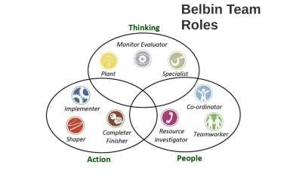

Figure 1: Belbin’s Team Roles

Models of team development
Teams develop through various stages to achieve successful outcomes. Tuckman’s model identifies four successive stages that teams must go through to achieve successful outcomes. Tuckman and Jensen (1977) indicate that these stages include, forming, norming, and performing. Teams must go through the above stages to ensure that achieve the desired outcomes. Tuckman's model is critical to the understanding of various stages through which successful teams develop the within-group project. Therefore. The analysis of Tuckman's successive stages of team development is critical to addressing the challenges facing Abdul’s group as highlighted in the scenario.
Forming constitutes the first stage of team development and relationships and involves the initial formation of the group and bringing together members of the group. According to Mullins (2016), the stage involves bringing the team together and communicating the purpose of the team to the members. As mentioned earlier, organisations form teams to accomplish various goals and objectives. The main considerations at this stage include the team’s hierarchical structure, leadership pattern, responsibilities, and codes of conduct. Therefore, this stage is critical to a team's future success since it involves laying down the team's purpose, communicating members' roles and responsibilities, and allowing members to create personal identity and commitment to the stated purpose.
Storming is the second stage of team development under Tuckman's model. According to Martinet al. (2017), at this stage, team members get to understand each other and freely and forcefully set forth their views. Notably, this stage involves conflicts and hostility, calling for effective leadership to ensure that they do not affect the team’s outcomes positively. The nature of roles and responsibilities assigned to members at the forming stage may cause significant challenges. Therefore, this stage is critical to ensuring that the team addresses challenges emerging from the decisions made at the forming stage; thus, ensuring that the team develops meaningful structures and procedures to enhance the team’s success.
Norming and performing stages largely depends on the previous stages. Mullins (2016) indicates that norming stage involves the establishment of guidelines and standards to help the group develops the team norms to guide members' behaviour. It is a crucial stage for a team's success since it enables members to cooperate with one another to work towards achieving the project's goals. Conversely, at the performing stage, members successfully achieve the team's purpose (Martinet al. 2017). Notably, this stage largely depends on the success of the other three stages. Notably, team managers should focus on the first three stages to ensure that the team achieves its central purpose at this final stage of team development. Therefore, this model is appropriate to resolving the challenges facing Abdul's team as indicated in the scenario, since it provides a successive approach to resolving the challenges that emanate from every stage of team development, ensuring a successful outcome.
Team Roles
Team members must simultaneously perform various roles to create cohesive and effective teams. According to Mathieu et al. (2015:5), Belbin’s theory outlines nine specific team roles, including “plant, resource investigator, coordinator, shaper, monitor-evaluator, team-worker, implementer, completer-finisher, and specialists”. Notably, the above roles must be performed simultaneously to ensure that the team functions properly. Mullins (2016) argues that the constitution of a team is a critical determinant of its success since it brings together individuals with diverse personalities, which enable them to perform various roles in the team. Team role in this context refers to the pattern of behaviour and interaction between members to facilitate the team’s progress. Therefore, analysis of these roles is vital to building successful teams.
The roles are grouped into three broad categories, including thinking, people, and action as highlighted in Figure 1. The thinking category includes roles such as plant, mentor-evaluator, and specialist. First, members playing the plant role must be free-thinking, creative, and imaginative to enable them to generate ideas required to solve complex challenges in a team. Second, members playing the role of mentor-evaluator must be sober, strategic and discerning to help them arrive at accurate options. Finally, those playing the role of specialists must be dedicated, self-sharing, and single-minded to provide rare knowledge and skills to the team (Mullins 2016).
The people category includes roles such as co-ordinator, team-worker, and resource investigator, which ensure harmonious working among team members. First, members playing the co-ordinator role must be mature, confident, and identify talent to promote clarification of goals and effective delegation critical to successful team performance. Second, members playing the role of team-worker must be cooperative, perceptive, and diplomatic to enable them to identify and resolve problems that emerge in the teams. Finally, those playing Belbin's resource investigator role must be outgoing, communicative, and enthusiastic to help explore existing opportunities and develop contacts (Mullins 2016).
The final category of Belbin’s role is the action, which includes the implementer, shaper, and completer-finisher roles. First, members playing the implementer role must be practical, efficient, and reliable to enhance the conversion of abstract ideas into actions to be undertaken by the teams. Second, members playing the shaper must be dynamic, dynamic, and works well under pressure, which enables them to overcome obstacles. Lastly, the completer-finisher role requires members to be anxious, conscientious, and painstaking to help them search for errors, polish, and achieve perfection in the group (Isaac and Carson 2012). Therefore, it is critical to apply the theory when employing new staff to ensure that teams have individuals with the right abilities and personalities to enable them to perform various teams; thus, promoting the creation of cohesive and successful teams.

Discussion
The increased competition in the current business landscape has increased teamwork in most corporations. The analysis indicates that team-working can be advantageous and disadvantageous to corporations depending on their management. Tuckman's model indicates that team development follows four successive stages that enable group managers to address challenges emerging in the team ensuring successful performance (Mullins 2016; Tuckman and Jensen 1977). Moreover, Belbin's theory indicates that teams can only be successful if members simultaneously perform various roles (Mullins 2016). Therefore, efficient teams must go through all the stages of group development and their members must perform the nine-team roles to ensure successful performance
Effective team-working has several benefits to organisations. First, Mullins (2016) indicates that effective team-working increases cooperation between members, ensuring that organisations solve complex problems, or complete complex projects within a relatively short time and low budget. Second, Fapohunda (2013) indicates that effective team-working optimises the use of human resources in an organisation since it enables them to gain access to individual knowledge and skills. Notably, teams bring together individuals with different abilities and personalities, which enable organisations to solve complex problems in a relatively short time. Third, effective team-working promotes organisational learning since it allows employees belonging to particular teams to share their opinions and skills towards addressing various problems and completing various projects. Mullins (2016) indicates that teams bring together individuals with diverse abilities, creating a synergy that promotes individual productivity and efficiency. Finally, effective team-working improves job satisfaction, motivation, and creativity among team members since they feel directly involved in performing various tasks and taking responsibility for the outcome of the team outcomes (Fapohunda 2013). Therefore, team-working is critical to the success of organisations operating in the current dynamic and competitive business environments.
Ineffective team-working has several impacts on the overall organisational performance since most contemporary organisations largely depend on teams to solve complex problems in the market. The first impact of ineffective team-working, according to Jelphs and Dickinson (2016), is a breakdown in communication, which increases suspicion among the team members. For instance, communication breakdown is responsible for the negative start of Abdul's team provided in the case scenario. The second impact of ineffective team-working is decreased efficiency and productivity. Mullins (2016) indicates that teams bring together individuals with diverse abilities and personalities committed to achieving a particular goal. In this regard, ineffective team-working results in a sharp decline in employee creativity and innovation, leading to decreased efficiency and productivity in the organisation. Finally, ineffective team-working results in increased conflicts within the organisation. Mathieu et al. (2015) argue that members of a team must perform various roles in the team to reduce potential conflicts. For instance, a member must play the team-working role to identify and resolve various conflicts that emerge in the organisation. Therefore, ineffective team-working is detrimental to organisational success.

Recommendation and Conclusion
The report reveals that effective team-working and communication are critical to successful performance in the current business landscape. Teams consist of individuals with diverse abilities and personalities that enable organisations to successfully undertake complex projects within a relatively short time and low budget. Effective teams must follow Tuckman's model of team development since it enables team managers to identify and address various challenges that emerge within the team. Moreover, the discussion indicates that team members must simultaneously play Belbin's team roles to ensure that teams achieve their intended goals and objectives. Failure to follow Tuckman's model and Belbin's theory results in ineffective teams, which results in communication breakdown, a decline in productivity and efficiency, and increased conflicts within teams. Conversely, effective teams are those that go through all of Tuckman's model and follows Belbin's roles, leading to increased cooperation among employees, optimal human resource utilisation, and increased job satisfaction, employee motivation, and creativity. Therefore, Abdul should ensure that his team follows the Tuckman's models and team play the nine-team roles outlined in Belbin's theory to ensure effective team-working and communication, required for the successful completion of the project.

Reference List
- Driskell, J.E., Salas, E. and Driskell, T., 2018. Foundations of teamwork and collaboration. American Psychologist, 73(4), pp.334-338.
- Fapohunda, T.M., 2013. Towards effective team building in the workplace. International Journal of Education and Research, 1(4), pp.1-12.
- Isaac, M., and Carson, K., 2012. A guide to Belbin team roles: How to increase personal and team performance. Marysville, OH: Bridge Publishing.
- Jelphs, K., and Dickinson, H., 2016. Working in teams, 2nd Ed. Bristol: Policy Press.
- Khan, A., Khan, S., Zia-Ul-Islam, S. and Khan, M., 2017. Communication Skills of a Teacher and Its Role in the Development of the Students' Academic Success. Journal of Education and Practice, 8(1), pp.18-21.
- Kim, L.Y., Giannitrapani, K.F., Huynh, A.K., Ganz, D.A., Hamilton, A.B., Yano, E.M., Rubenstein, L.V. and Stockdale, S.E., 2019. What makes team communication effective: a qualitative analysis of Interprofessional primary care team members’ perspectives. Journal of Interprofessional Care, 33(6), pp. 836-838.
- Martin, B., Breunig, M., Wagstaff, M., and Goldenberg, M., 2017. Outdoor leadership: Theory and practice. Champaign, IL: Human Kinetics.
- Mathieu, J.E., Tannenbaum, S.I., Kukenberger, M.R., Donsbach, J.S. and Alliger, G.M., 2015. Team role experience and orientation: A measure and tests of construct validity. Group & Organization Management, 40(1), pp.6-34.
- Mullins, L.J., 2016. Management and organisational behaviour.11th ed. New York, US: Pearson Education Limited.
- Tuckman, B.W. and Jensen, M.A.C., 1977. Stages of small-group development revisited. Group & Organization Studies, 2(4), pp.419-427.

