BMIH5007

Financial Management for the Hotel Industry

Module Lecturer:
Tristan Hawkins

Student:
Lucian Stefan Mihaita
2234126

Executive Summary
Urban Heights Hotel, a prominent restaurant, bar, and event venue in the city, is facing significant financial decline. Over the past three years, the hotel has experienced a steady decrease in revenue, a surge in operational costs, and a series of net income deficits. This report meticulously identifies the internal and external factors contributing to these financial issues and proposes comprehensive solutions.
Operational inefficiencies within the hotel, particularly in housekeeping, maintenance, and check-in/check-out processes, have significantly impacted on its financial performance. These inefficiencies have led to increased operating costs and decreased consumer satisfaction. Furthermore, staff performance and facility hygiene issues have further dampened consumer satisfaction and retention. The combination of operator inefficiencies, poor service performance, high personnel turnover, and insufficient training has created a detrimental cycle.
Changes in government policies and laws have raised operational expenses and complexity. Revenue streams have suffered due to economic downturns, inflation, and Airbnb competition. Traditional hotels are struggling with social developments and consumer preferences for personalised experiences. Market share has declined due to missed digital marketing and online reservation opportunities. Employment laws and health and safety standards are expensive, and the demand for sustainable practices has prompted investments in green operations.
The hotel's financial performance study shows a drop in revenue, growing operational expenses, and significant net income losses. Financial hardship emphasises the necessity for immediate problem-solving. Analysing gross profit margin, operational profit margin, and current ratios reveals financial limits.
The report suggests a thorough turnaround approach to reduce financial risks. This risk-avoidance method streamlines operations and improves service quality to cut costs and boost customer satisfaction. Strong operational controls and detailed financial plans minimise risk, including budgeting and forecasting. The approach also includes purchasing insurance and managing reserve cash to protect liquidity and manage unforeseen expenses.
This method demands constant monitoring and reporting. Reviewing financial performance and risk management methods regularly assures their efficacy and allows for market and operational modifications. Building a thorough reporting system to measure financial KPIs and operational performance helps make educated decisions and handle concerns quickly.
Urban Heights Hotel can boost its financial stability by managing risk and addressing internal inefficiencies and external market conditions. The proposed measures reduce financial risks, improve operational efficiency, and increase profitability to safeguard the hotel's financial future. Urban Heights Hotel can significantly improve its financial stability by addressing internal inefficiencies and external market conditions through a comprehensive risk management strategy. The proposed strategies aim to mitigate financial risks, enhance operational efficiency, and achieve profitability, ensuring a more secure financial future for the hotel.

Introduction
Urban Heights Hotel is a restaurant, bar, and event space in a busy city. However, income, occupancy, and customer happiness have dropped in recent years, raising questions about the hotel's viability. This study will assess the hotel's financial performance over the past three years, determine the primary causes of its decline, and create a thorough plan to reverse it.
This report analyses Urban Heights Hotel's financial patterns, identifies internal and external causes of the decline, and makes solutions to improve the hotel's finances. Internal operational inefficiencies, customer satisfaction, and excessive staff turnover are examined in the study. Economic conditions, regulatory changes, and Airbnb competition are all discussed. The report offers realistic ways to improve revenue, operational efficiency, financial stability and profitability for Urban Heights Hotel by addressing these concerns.

Financial Performance Analysis
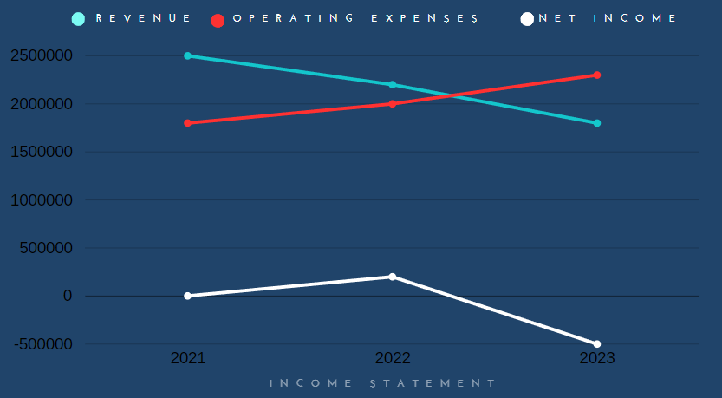
Trend Analysis: Evaluation of Financial Performance Over the Past Three Years
Urban Heights Hotel's financial performance has fluctuated over the past three years due to management concerns and market conditions. The hotel's financial health can be assessed by analysing revenue, operating expenses, net income, and essential financial parameters.
Revenue Trends
Urban Heights Hotel's revenue fell from £2,500,000 in 2021 to £1,800,000 in 2023. This 28% dip over three years suggests that growing competition and shifting market dynamics have hurt the hotel's ability to recruit and retain guests. Wadesango et al. (2017) suggest that a sustained decline in revenue may signal deeper concerns with customer satisfaction and market positioning, requiring the hotel to rethink its marketing and service initiatives.
Operating Expenses Trends
Urban Heights Hotel's operating costs rose from £1,800,000 in 2021 to £2,300,000 in 2023. Operating costs rose 28%, indicating cost control inefficiencies. The hotel's rising expenses while dropping revenues indicate poor resource management. Franco et al. (2020) warn that rising operating costs without revenue growth can affect sustainability and profitability. This disparity highlights the necessity to analyse operational processes to find and reduce inefficiencies.
Net Income Trends
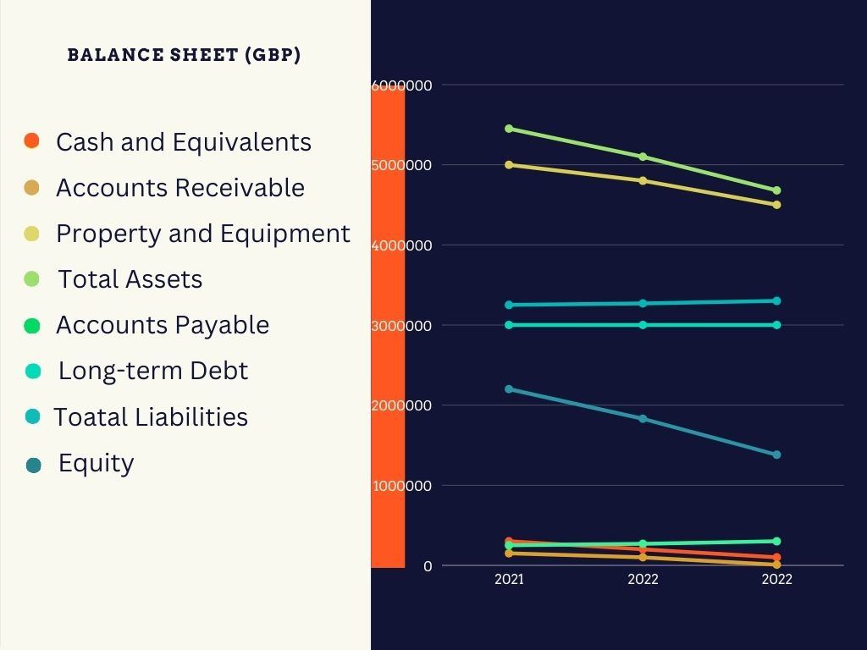
Urban Heights Hotel lost £500,000 in 2023 after earning £700,000 in 2021. This steep fall indicates a serious financial collapse and emphasises the need to address underlying concerns. According to García-Gómez et al. (2021), negative net income can impact long-term viability and require innovative financial restructuring. The net income pattern implies prompt action is needed to stop the financial deterioration and restore profitability.
Financial Ratios Analysis
We use essential financial ratios to analyse the hotel's financial constraints:
Gross Profit Margin: This ratio demonstrates how well the hotel can make money above its cost of goods sold (COGS). The drop from 28% in 2021 to -28% in 2023 indicates serious problems with pricing and operational inefficiency.
Operating Profit Margin: This ratio highlights operational efficiency by showing the portion of income that remains after operating expenses are paid. The downward trajectory from 28% in 2021 to -27.8% in 2023 signifies a decline in cost control.
Current Ratio: This liquidity ratio gauges the hotel's capacity to meet short-term obligations with current assets. When the current ratio drops from 2.5 in 2021 to 1.2 in 2023, there is a greater chance of liquidity concern.

Identifying the Causes of the Decline
Internal Factors
Operational Inefficiencies
Operational inefficiencies are core to Urban Heights Hotel's problems. Housekeeping, maintenance, and check-in/check-out can be inefficient, increasing costs and decreasing customer satisfaction. Franco et al. (2020) claim that quality management principles streamlined processes increase performance and eliminate wasted spending. Inefficiencies in operations may increase worker costs, lowering profitability. García-Gómez et al. (2021) state that the hospitality industry's capital-intensive and labour-intensive structure might lead to financial hardship due to inefficient operational management.
Customer Satisfaction and Service Quality Issues
Service quality and customer satisfaction are linked. Staff demeanour, competence, facility cleanliness, and client experience affect service quality. According to Li (2020), customer happiness can boost financial success because satisfied guests are more likely to return and recommend the hotel. Quality characteristics, including physical appearance, certainty, empathy, and responsiveness, increase customer pleasure. Sun and Kim (2013) also found that strong profit margins, ROE, and ROA are linked to customer happiness.
Staff Turnover and Training Inadequacies
Insufficient training and high employee turnover cause operational issues and poor service. Training programmes that boost client loyalty and satisfaction require high service standards. Vidyanata (2022) states that service quality greatly affects customer happiness and loyalty. High turnover rates can increase hiring and training costs and disrupt operations, hurting a hotel's finances. According to Harjanti (2019), effective leadership can reduce attrition and increase service quality by reducing burnout and enhancing job satisfaction.

External Factors (PESTLE Analysis)
Political
Government laws greatly impact the hotel industry. Modifying urban development, health and safety, and labour legislation may raise operational expenses and lower profits. Political upheaval and regulation changes may deter tourists, affecting hotels' finances, according to Kazakova and Kim (2021). Staff training and infrastructure upgrades may be needed to meet new requirements.
Economic
Recession, inflation, and consumer spending habits affect hotel performance. Airbnb has increased competition, making it harder for established hotels to maintain price power and occupancy rates. Dunham and Grandstaff (2022) claim that economic downturns can dramatically reduce discretionary hospitality and travel spending, affecting income streams. Inflation raises prices, lowering business margins.
Social
Demographics and social changes affect travel and lodging preferences. Conventional hotels struggle to provide unique, tailored experiences for modern travellers. Ritzer (2015) noted the rise of the "prosumer," who consumes and creates value through social media and reviews, changing hospitality dynamics. Hotels must adapt to these changes to compete.

Technological
Digital marketing and online reservations have transformed the hotel industry. Hotels that don't employ technology or have poor internet can lose customers. Backman et al. (2017) state that hospitality companies must innovate to compete. Modern technology can improve customer satisfaction and operational efficiency.
Legal
Compliance with employment, health, and safety laws is essential but may be costly. Non-compliance may lead to legal challenges, sanctions, and reputation damage. Chou (2014) says compliance with environmental regulations and sustainability standards is becoming more critical as customers seek greener alternatives.
Environmental
Hospitality relies on environmental legislation and sustainable business practices. Hotels must adopt sustainable procedures to satisfy environmentally sensitive guests. According to Rodríguez et al. (2020), modern hospitality companies must use sustainable resources, reduce waste, and save energy. Sustainability decreases long-term running costs and attracts eco-conscious customers.

Comparative Analysis: Chains Hotels vs. Single Hotel Brand
Advantages and Disadvantages of Chain Hotels
Chain hotels can save money and enhance efficiency by using economies of scale. Hollenbeck (2017) found a 20% revenue premium for chain hotels versus independent hotels. Their strong brand and market domination are the main reasons. Due to their more significant financial resources, chain hotels can invest more in staff training, technology, and marketing. Ivanova and Ivanov (2015) say chain hotels can standardise services to maintain quality. However, chain hotels may have trouble adapting to local markets and higher operational costs due to management or franchise fees.

Challenges Faced by Single-Brand Hotels in Urban Areas
Single-brand hotels may lack cash and marketing capabilities, making competing with chain hotels in densely populated cities harder for businesses. According to Su and Reynolds (2017), independent hotels must overcome brand identity and client retention challenges. Single-brand hotels may struggle to improve their products and decrease costs because they lack chain hotel operational efficiencies and technical advances. Independent hotels sometimes struggle to commit resources to better amenities and services due to economies of scale, according to Ivanova et al. (2020).

Impact on Occupancy Rates, Pricing Strategies, and Brand Loyalty
Chain hotels have excellent occupancy rates due to their brand familiarity and extensive marketing. Becerra et al. (2013) found that branded hotels can maintain profitability by charging more and offering fewer discounts than independent hotels. To boost repeat business and occupancy, chain hotels often offer reward programmes. Single-brand hotels may employ aggressive pricing to attract guests, lowering profit margins. Independent hotels employ positive electronic word-of-mouth (e-WOM) to attract tourists, according to Raguseo and Vitari (2017).
Single-brand hotels suffer from resource allocation and market rivalry, while chain hotels enjoy brand awareness, economies of scale, and powerful marketing. Variations impact occupancy, pricing, and brand loyalty.

Conclusion
Over the previous three years, the Urban Heights Hotel has experienced severe financial difficulties, including diminishing revenues, growing operating costs, and negative net profitability. High employee turnover, low customer satisfaction, and operational inefficiencies are some of the internal factors causing this drop. These problems have been made worse by external political, economic, social, technical, legal, and environmental variables. Comparative research reveals that single-brand hotels face severe competition and resource constraints, while chain hotels enjoy the advantages of economies of scale and strong brand loyalty. Restoring financial stability and profitability requires a thorough turnaround plan prioritising cost control, increasing revenue, and using hotel facilities.

Turnaround Strategy: Financial Risk Management for Urban Heights Hotel
Financial Risk Analysis
Urban Heights Hotel has diminishing revenues, rising operating expenses, and negative net profitability. Reversing these trends and recovering profitability requires effective financial risk management. Market, operational, economic, and regulatory & compliance risks comprise the hotel's financial risk.
Identifying Financial Risks
- Market Risks: These include modifications to the market environment, heightened competition from online lodging services like Airbnb, and recessions that affect consumer expenditure (Hossain, 2021).
- Operational Risks: Inadequate maintenance, cleaning, and check-in/check-out procedures increase operating expenses and decrease client satisfaction (Franco et al., 2020).
- Financial Risks: challenges with the hotel's debt obligations and financial structure, such as significant debt levels and liquidity issues (García-Gómez et al., 2021).
- Regulatory & Compliance Risks: compliance with state and federal laws may raise the complexity and expense of operations (Kazakova and Kim, 2021).

Strategies to Mitigate Financial Risks
1. Risk Avoidance
- Eliminate Inefficiencies: Simplify the maintenance, cleaning, and check-in/check-out procedures to save money on operations and raise client happiness. Quality management systems can be beneficial (Franco et al., 2020).
- Improve Customer Satisfaction: To attract new customers and retain existing ones, improve the quality of your services by training your employees and enhancing facility management (Li, 2020).
2. Risk Reduction
- Operational Controls: Implement strict operational guidelines and procedures to reduce the risks arising from internal procedures and human error. This includes regular audits and process evaluations (Franco et al., 2020).
- Financial Planning: Create a thorough financial plan that includes methods for risk avoidance, forecasting, and budgeting. This aids in predicting financial requirements and getting ready for unanticipated costs (García-Gómez et al., 2021).
3. Risk Transfer
- Insurance: Invest in insurance policies to shift the financial risk of possible losses or unanticipated circumstances. According to the Corporate Finance Institute (2023), this comprises business interruption, liability, and property insurance.
4. Risk Retention
- Reserve Funds: Maintain a reserve account in case of unforeseen expenses. This ensures liquidity and allows handling unforeseen costs without resorting to high-interest loans (Corporate Finance Institute, 2023).
Implementing the Strategy
- Continuous Monitoring: Review risk management techniques and financial performance frequently to ensure they are still working. Modify strategies depending on operational performance and market conditions (Corporate Finance Institute, 2023).
- Effective Reporting: Establish a comprehensive reporting system to monitor operational effectiveness, financial metrics, and risk management results. This will facilitate making well-informed decisions and promptly resolving problems as they emerge (Corporate Finance Institute, 2023).
Linking Strategy to Identified Issues
- Addressing Revenue Decline: Urban Heights Hotel can reduce market risks and draw in a more extensive clientele by expanding its revenue streams through alliances and partnerships (Douvrou, 2019). According to Vives et al. (2018), listing rooms on Airbnb can also aid in raising revenue and occupancy rates.
- Reducing Operating Expenses: Costs can be decreased by reducing operational inefficiencies, implementing quality management systems, and streamlining operational processes (Franco et al., 2020).
- Improving Financial Health: Long-term hotel viability is ensured by comprehensive financial planning, which includes forecasting and budgeting and helps manage debt and liquidity more effectively (García-Gómez et al., 2021).
Urban Heights Hotel's financial stability can be significantly enhanced by implementing a thorough risk management plan considering external market conditions and internal inefficiencies. The hotel can reduce financial risks and improve its operational efficiency and profitability by implementing risk avoidance, reduction, transfer, and retention measures.

References
- Li, S., 2020. The impact of service quality, self-service technology, and the corporate image on customer satisfaction and customer revisit intention among luxury hotels in Kuala Lumpur, Malaysia. International Journal of Services, Economics and Management, 11(1), pp.48-70. https://doi.org/10.1504/IJSEM.2020.107794
- Backman, M., Klaesson, J., & Öner, Ö., 2017. Innovation in the hospitality industry. Tourism Economics, 23, pp. 1591 - 1614. https://doi.org/10.1177/1354816617715159.
- Becerra, M., Santaló, J., & Silva, R., 2013. Being better vs being different: differentiation, competition, and pricing strategies in the Spanish hotel industry. Tourism Management, 34, pp. 71-79. https://doi.org/10.1016/J.TOURMAN.2012.03.014.
- Rodríguez, C., Florido, C. and Jacob, M., 2020. Circular economy contributions to the tourism sector: A critical literature review. Sustainability, 12(11), p.4338. https://doi.org/10.3390/su12114338
- Chou, C.J., 2014. Hotels' environmental policies and employee personal environmental beliefs: Interactions and outcomes. Tourism management, 40, pp.436-446. https://doi.org/10.1016/j.tourman.2013.08.001
- Corporate Finance Institute, 2023. Financial Risk Management. https://corporatefinanceinstitute.com
- Dunham, L.M. and Grandstaff, J.L., 2022. The value relevance of earnings, book values, and other accounting information and the role of economic conditions in value relevance: a literature review. Accounting Perspectives, 21(2), pp.237-272. https://doi.org/10.1111/1911-3838.12280
- Franco, S., Caroli, M., Cappa, F., & Chiappa, G., 2020. Are you good enough? CSR, quality management and corporate financial performance in the hospitality industry. International Journal of Hospitality Management, 88, pp. 102395. https://doi.org/10.1016/j.ijhm.2019.102395.
- García-Gómez, C.D., Bilgin, M.H., Demir, E., Díez-Esteban, J.M., García-Gómez, C.D., Bilgin, M.H., Demir, E. and Díez-Esteban, J.M., 2021. Leverage and performance: The case of the US hospitality industry. Quantitative Finance and Economics, 5(2), pp.228-246. http://www.aimspress.com/aimspress-data/qfe/2021/2/PDF/QFE-05-02-010.pdf
- Hossain, M., 2021. The effect of the Covid-19 on sharing economy activities. Journal of Cleaner Production, 280, p.124782. https://doi.org/10.1016/j.jclepro.2020.124782
- Harjanti, D., 2019. Burnout and Employee Performance in Hospitality Industry: The Role of Social Capital. Jurnal Teknik Industri. https://doi.org/10.9744/JTI.21.1.15-24.
- Hollenbeck, B., 2017. The Economic Advantages of Chain Organization. ERN: Firm Behavior (IO: Empirical) (Topic). https://doi.org/10.2139/ssrn.2621840.
- Ivanova, M., & Ivanov, S., 2015. Affiliation to Hotel Chains: Hotels’ Perspective. https://doi.org/10.1016/J.TMP.2015.08.001.
- Ivanova, M., Petrov, H., & Ivanov, S., 2020. INDEPENDENT OR BRANDED: THE DILEMMA OF BULGARIAN HOTELIERS. https://doi.org/10.36997/TC2020.289.
- Kavoura, A., Kefallonitis, E. and Theodoridis, P., 2019. Strategic, innovative marketing and tourism. Business and Economics. https://doi.org/13/2204/132154323154644
- Kazakova, A. and Kim, I., 2021. Geopolitical-risk and economic policy—uncertainty impacts on tourist flows from neighboring countries: A wavelet analysis. Sustainability, 13(24), p.13751. https://doi.org/10.3390/su132413751
- Newman, W., Mhaka, C., Katiyo, E.M., Ongayi, W. and Milondzo, K., 2017. An evaluation of the effectiveness of Financial Statements in disclosing true business performance to stakeholders in the hospitality industry (A case of Lester-Lesley Limited). Academy of Accounting and Financial Studies Journal, 21(3), pp.1-22.
- Ozdemir, O., Kizildag, M., Dogru, T. and Madanoglu, M., 2022. Measuring the effect of infectious disease-induced uncertainty on hotel room demand: a longitudinal analysis of US hotel industry. International Journal of Hospitality Management, 103, p.103189. https://doi.org/10.1016/j.ijhm.2022.103189
- Raguseo, E., & Vitari, C., 2017. The Effect of Brand on the Impact of e-WOM on Hotels’ Financial Performance. International Journal of Electronic Commerce, 21, pp. 249 - 269. https://doi.org/10.1080/10864415.2016.1234287.
- Ritzer, G., 2015. Hospitality and presumption. Research in Hospitality Management, 5, pp. 17 - 9. https://doi.org/10.1080/22243534.2015.11828323.
- Su, N. and Reynolds, D., 2017. Effects of brand personality dimensions on consumers’ perceived self-image congruity and functional congruity with hotel brands. International Journal of Hospitality Management, 66, pp.1-12. https://doi.org/10.1016/j.ijhm.2017.06.006
- Vidyanata, D., 2022. The Mediating Role of Customer Satisfaction on the Relationship between Service Quality and Consumer Loyalty in the Hospitality Industry. E-Bisnis : Jurnal Ilmiah Ekonomi dan Bisnis. https://doi.org/10.51903/e-bisnis.v15i1.768.
- Vives, A., Jacob, M. and Nicolau, J.L., 2018. The influence of Airbnb on hotel revenues. Tourism Management, 67, pp.284-289. Available at: https://doi.org/10.1016/j.tourman.2018.02.015

