NAME - VIJAY KUMAR

STUDENT NUMBER- 1918986

MODULE TITLE- LCMB7013

ASSIGNMENT TITLE- MANAGING PERFORMANCE

Executive Summary
This report has focused on the performance management and the performance development programmes. The managing of the performance helps in achieving the objectives and the goal of the organisations. Various theories and the appraisal schemes were discussed which help in enhancing the performance of the organisation. The organisation chosen is a whole sale organisation. The report has also focussed on the organisational concerns which have risen from the various aspects of organisational means. This also analyses the employee concerns and the implementation of employee contribution in the enhancement of organisational performance. The factors of employee involvement and employee engagement have also been discussed. The recommendations have also been discussed relevant to the aspect of management of performance of employees. The recommendation has been given for both short and long terms.
Table of Contents
Introduction 4
Performance Development Planning 4
Performance Management 6
Performance development 9
Trust, Manageability and Control 12
International, Environmental, Ethical and Sustainability issues 14
Organizational and Employee Concerns 15
Employee Engagement and Employee Involvement 17
Recommendations short term 19
Recommendations longer term 21
Conclusion 23
Reference List 24
Appendix 1: Broad-build-theory 28

Introduction
Managing the performance of the employees is considered as the continuous process which helps in monitoring the performance of the employees. This is considered as the continuous process related to the communication between the high authorities and the employees which help in getting an annual review of the employees. This also helps in understanding the abilities and the efficiency of the work of the employees. The managing of the performance helps in achieving the objectives and the goal of the organisations.
The wholesaler company includes 1500 staff to help in running the business successfully. The company is run by the family members which follows the autocratic management styles. In recent times due to the increase of the level of the competition, the company is trying to incorporate some of the strategies of the performance management that will help in enhancing the level of the performance of the employees working there. The owners of the company in the recent board meeting have given direction to incorporate the new stargazes of the performance management that help in enhancing the productivity of the company. In this report, the various strategies of the performance management, and the planning for the performance development and the incorporation of the various sustainable issues will be discussed that will help in enhancing the performance management and the productivity of the wholesaler company.

Performance Development Planning
The performance development planed is considered as the analytical tool that helps in improving the performance level of the employees within the organisation. The planning of the performance development helps in better understanding of the abilities and the weaknesses of the employees and planning of the strategies and setting of the goals and objectives based on that. The initiative to improve the performance of the employs will help in achieving the goals and the objectives of the organisation.
The planning of the performance development is done on the quarterly basis that has helped in tracking the oranges and monitoring the work efficiency of the employees by the high authorities (Kamensky, 2018). The plan includes the activity and the planning of the goals and the incorporation of the skills and the knowledge that needs to be improved which help in achieving the goals and the objectives of the organisation. This helps in the continuous development and the improvement in the career. The performance development plan helps in creating a strong bond among the managers and the staff as the employees gets a chance to work with the managers in close proximity. This supports the manager in identifying the skills and the areas of improvement which help in achieving the needs of the business (Medvecká et al. 2017)
The major work of the wholesale business is the forecasting of the future risk and planning of the satyrs based on the risk management that will help in overcoming the risk. The wholesaler company needs to have a clear idea of the market structure which helps in planning of their manufactured goods. The performance development plan is considered as one of the important factors that help in the growth and the development of the organisation. The performance development plan helps in understanding and monitoring the performance level of the employees which helps in changing the strategies and adopting the new changes in the planning or the growth and development of the business (Baron and Armstrong, 2007).
The wholesale business has to follow certain steps to formulate a strategic and a well development performance development plan.
- Self assessment of the staff members: the employees of the business had to plan and arrange a self assessment plan based on their interest, skills, values and the personality of that particular individual which helped in planning the strategies for its growth and development.
- Assessment of the skill of the staff members: the organisation has to plan and conduct the training session based on the skills and the abilities of the staff members. This helps in increasing the job satisfaction among the employees and increases their work efficiency (Juevesa et al. 2020)
- Assessing the need of the organisation: in order to get a successful performance development plan the employee of the organisation has to plan the self assessment keeping in mind about the goals and the objectives of the organisation which help in its growth and development.
- Creating development opportunities for the employees: the wholesale company will have to arrange various technical training sessions, workshops and the seminars that help in increasing the motivation of the employees. The seeking employees may also be given the opportunity to work under the supervision of the mentors which help in enhancing their work efficiency.
- Analysis of the staff member’s progress: the company has to maintain the record and monitoring the work progress of the employees which help in planning of the strategies by using various performance logs and the record for giving of the rewards.

Figure 1: Steps of Performance Development Planning

Performance Management
Performance management is considered as the corporate tool that helps in maintaining and monitoring the performance level of the employees working in the wholesale industry which help in increasing the productivity of the orientation. This helps in creating a better environment for the employee where they can work effectively and efficiently which will help to produce quality products. The main aim of the wholesaler business is to develop the performance management strategies (Tsangas et al. 2020). The basic agenda of the conference where the owner has nitrate the hr department for the development of the strategic performance management. This planning will help the organisation make competitive advantage and compete with the other modern technology use industry. They have to set a talent management sector where the main work will be to attract the skill and the talented employees towards their organisation and increasing the productivity and boosting the annual revenue of the firm. The organisation has also planned the various coaching and mentoring styles that will help in giving training to the employees and the staff members and enhancing their abilities to work (Armstrong, 2012).
The wholesale business has followed the performance development and the management cycle for better understanding of the level of the performance and monitoring the work flow of employees. The cycle consists of 4 stages. The planning stages constitute the planning of the strategic goals that help in understanding the abilities of the employees and achieving the goals and the objectives of the organisation. The second stage includes the development stage where the tasks were prepared as help in monitoring the workflow and incorporating the abilities of employees. The third stage is the performing sage. In this stage the managers or the high authorities keep record of the output and the work efficiency the employees help in increasing the productivity of the organisation. The main emphasis is on the contribution of the employees which help in achieving the objectives of the urbanisation thereto behaviours and the capability of the organisation. The final stage deals with the reviews that are gained after the monitoring of the achievement and the skills of the employees (Shojaei et al. 2019).
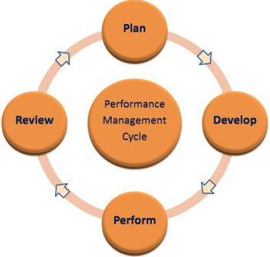
Figure 2: performance management cycle
The principle of the performance management includes the monitor and the evaluation of the skill and talent of the employees that creates benefit for the organisation. The managers can have complete control over the progress and the weakness of the employees and also can understand the abilities of the workers. This helps the leaders in distributing the work among the employees. The adaptation of the new technologies help in enhancing the skill of the employees, and also help in adapting new skill base in the up gradation of the skill. This helps in maintaining the flexibility within the organisation and boosting this thee girth and development (Schleicher et al. 2018)
The aim of the performance management that helps in growth and development of the organisation include the following.
- The use of the strategic communication between the employees and the managers that help in conveying the ideas and the strategic decision making changes to the employees and also help in boosting the confidence.
- The building of the personalised relationship among the employees and the higher authorities held in close monitoring of the progress and the working structure can also help in understanding the abilities of the staff and distributing work based on that (Lasserre, 2017).
- The wholesale company can also arrange the various employee development plans and the strategies that help in boosting the work efficiency of the employees and personal development plan that help in getting the employees scan increase their job satisfaction.
- The arrangement of the evaluation procedure and the action the tack of the achievement and the abilities c of the employees help in planning of the strategies and the process of the giving of rewards and incentive and also the process of the promotion. The organization can also arrange for the 360 degree feedback system (Shojaei et al. 2019).

Performance development
Performance development is considered as an ongoing and continuous process which help in the development of the effective communication between the employees Andrew manners within the wholesale organisation which help in clarifying the position, the responsibilities and the performance priorities which help in achieving the goals and the objectives of the organisation and maintaining the effectiveness and the productivity of the organisation. The performance development help in improving the performance, skill and the knowledge of the employees that help innate consideration and promotion of the employees and help in the development of the organisation by increasing its productivity level (Leyhr et al. 2018) The performance development also helps in understanding the performance and the duties based on the position specific and giving a clear instruction in achieving the mission and the goals. The major purpose behind the formulation and conduction of the performance development goal is to develop the structure and the process which help in the effective communication between the managers and the employees.
There are mainly 3 factors that are considered in the performance development which includes the skill and the knowledge about these certain facts and the ideas which help in formulating plans. The employees must have the knowledge of the princess and how the procedures are being followed and the requirement of the skills that help in conducting this process. The level of the motivation and job satisfaction help in increasing the work efficiency of the employees and boosting the productivity of the wholesale industry (Skorobogatova and Kuzmina-Merlino, 2017).
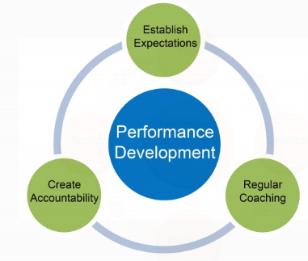
Figure 3: performance development
“Goal theory” by “Locke and Latham '' help in understanding the importance of the motivation level and the rewards and incentives help in increasing the work efficiency among the employees which help in achieving the goals and the objectives of the organisation. There are major 5 principles which include the clarity of the work which helps in stimulating the effort, the challenges that we face during the completion of the work and help in enhancing the skill and the knowledge of the employees, the commitment and the feedback process the help in motivating the employees. The planning of the states must be based on the commodities of the task and the procedure that is to be followed (Yurtkoru et al. 2017)
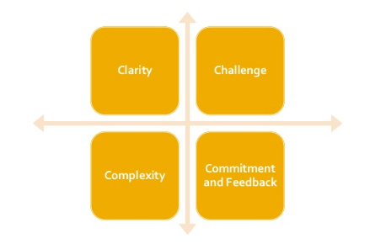
Figure 4: goal setting theory
“Control Theory by Barrows & Neely, 2012” helps in managing and controlling the performance employees which help in achieving the pre-defined goals and the objectives of the organisation. This helps in shaping the behaviour of employees by focusing their attention on the feedback. Therefore feedback is considered as the most important part of the performance management. This helps in generating faster and the quality output by following the process of the regular monitoring and giving of the feedback (Bwire, 2019).
“Social Cognitive Theory by Bandura 1986” help in influencing the social influences the help in incorporating the internal and the external factors that affect the performance of the employees and the abilities to perceive the changes. The increasing and building of the efficiency of the employees and the performance management of the employees of the wholesale employees and meeting the objectives of the organisation. This helps in formulating the strategies by gaining the idea of the past experiences (Beauchamp et al. 2019)
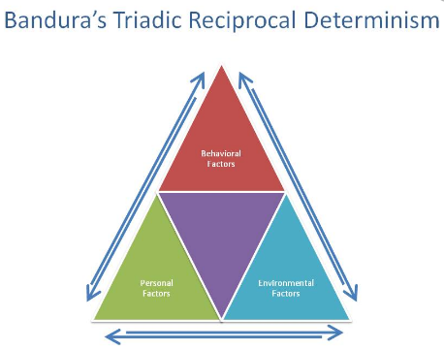
Figure 6: Social Cognitive Theory
Performance Appraisal
Performance appraisal is considered as the regular review of the work efficiency and the progress of the employees based on which the job performance of the employees are evaluated and the contribution with the organisation. The appraisal is based on the skill and the knowledge of the employees and which help in getting motivation to work efficiently and help in the gout and the development of the organisation. There are various systems of giving appraisal to the employees (DeNisi and Murphy, 2017). The wholesale company uses the “trait system” and the “result based system” to give feedback to their employees. The performance appraisal of that is being used in the trait system mainly depends on the quality and the dependability of the employees which help in giving the feedback based on the characteristics. The characteristics that have been used by the trait factors are the quality of the employees, the behaviours, decision making strategies, the responsibilities and the initiatives that help in giving away appraisal to the employees of the organisation. The result based appraisal helps in giving the feedback to the employees based on the output and the work progress of the employee. In this process the selection process is mainly based on the two factors like the relevance of the result and the reliability on the basis of which the appraisal and the results based on which the results are measured (Idowu, 2017).
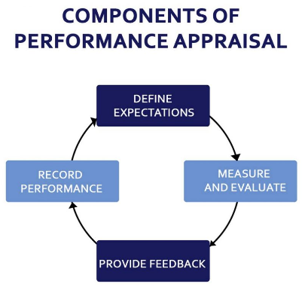
Figure 7: Components of Performance Appraisal

Trust, Manageability and Control
There are other 3 components of the organisation management of the employees rat help in controlling and managing the performance level and the work efficiency of the employees. Trust is considered the most important issue the help in building a personalised relation with the employees and the sharing of type strong bond with the staff members this help in close monitoring on the work of the employees. The major work of the HR department is to control and monitor the work of the employees of the crater sector that help in building of the trust relationship. The success rate of the organization and smooth running of the manufacturing process depends upon the manageability and the organization management procedures. This helps in increasing the productivity of the organisation by boosting the work efficiency of the employees and the success rate of the organisation also increases. There are certain features that has to include goby te world sake organisation to get a control over the organisational management which includes the planning of the effective strategies and organising the resources that are required during the procedure to help in successful running of the business. The third stage includes the recruitment of the skilled employees to help in enhancing the work capacity in the organisation. The presence of the efficiency leader with a good control over thee employees the business environment is clear and most important factor for running of the business. The time management and the planning of the strategies that helps in increasing the motivation of the employees. This ultimately helps in increasing the productivity of the organisation and boosting the annual revenue (Zhen et al. 2019).
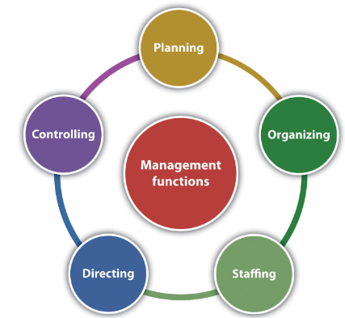
Figure 8: management functions

Another important factor that helps in increasing the performance management of the organisation is having good control over the employees and monitoring the progress rate of the employees within the organisation. This control helps in managing the employees abilities and the weaknesses. This also helps in planning of the technical training session and the arrangement of the workshops and the seminars they help in enhancing the working capacity. These fall under the major work role of the HR department of the wholesale organisation which help in enhancing the productivity of the organisation and also the profitability.

International, Environmental, Ethical and Sustainability issues
The wholesale organisation of the UK has been facing the certain issues while the running of the business and enhancing the performance level of the employees which help in increasing the productivity of the organisation. The various sustainable and the environmental issues that are been faced by the organisation are the excessive use of the plastic in the organisation leads to the increase of the plastic pollution in the UK which hampers the environmental balance and disturbs the sustainable environment of the UK (Cross et al. 2021). The use of the various innovations and technological modifications in the manufacturing procedure increases the rate of the air pollution in the UK. The wholesale manufacturing process uses the faster rate which leads to the increased amount of the toxic material in the environment and increases the rate of the air pollution. The excessive use of nitrogen oxide in the air of the UK enhances the rate of air pollution.
The various ethical issues that have been faced by the organisation is the maintenance of the information security and the maintenance of the copyright can help in maintaining the ethical issue and the protect act of the company. This helps in smooth running of the business and maintaining the performance management and the development by the through process of the performance management cycle. The maintaining of human rights is also considered as an important ethical issue that is being faced by the wholesale organization. The maintaining of human rights helps in increasing the motivation level of the employees and increasing their job satisfaction (Mårtensson, 2018). So the wholesale organisation also has to keep in mind the maintenance of the various issues referring to the ethics, environment and sustainability which will help in easy running of the business and gaining the performance management and their performance development. This helps in increasing the productivity of the organisation and boosting the annual revenue. This also helps in developing effective communication and building their personalised relationship between the members and the staff of the organisation.

Organizational and Employee Concerns
The business consists of 1500 employees with a legacy of long term business activities. The main issue in this wholesaler company lies in the placement of all the employees at only one location and also the leadership style of autocracy. As the autocratic leadership style had been implemented in the organisation over a long period of time thus the concerns are both at organisational and employee level (Pettinger, 2013). The autocratic leadership style implies a set of rules which makes their way through the decision making form only a selected set of people and in this case the family members meaning the company. Due to change in the motive of owner in employee management there is the need of imminent change in business aspects which has to be met at the following concerns:
- Strategic planning- The aspect of strategic planning concentrates on the variability of talent management and effective appraisal system. The company has focussed on the straightway of appraising the employees for performance and talent management. But the changed scenario this would become ineffective as the employee would get habituated of pay enhancement in case of any disputes. But the main peripherals to be taken into concentration would focus on a holistic approach through “ability, motivation and opportunity” (Dahshan et al. 2018)
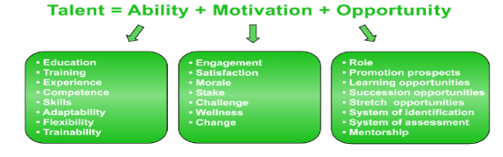
Figure 9: Strategic planning aspect of employee concern
(Source- Influenced by Dahshan et al. 2018)
- Business Planning- The business planning peripheral is the other most important organisational concern which would arise in the application of a new system in the company. The employees are already in a set of rules and regulations and they would always expect pay increase as a part of employee motivation. But the new system would imply the aspects of overall performance management in terms of a holistic approach. This would give rise to new concerns like the setting up of goals and objectives of the company, budget concerns and so on
- Employee Performance Management- This is another concern over the control and management of employees. This employee concern would be the cradle of clash of conflicts among the employees over misunderstanding of the strategic goals of the management. The “pay for performance” system would be the next problem that would always revolve around the psychology of the employees (Basterretxea et al. 2019). The other aspects would be the regular complaints and irregularities of performance from the employees.
- Management Concern- This is the concern of the applicability of various aspects by the management of the company. The management of the company had been in the line of autocratic implementation of power and controlling. The concern would arise in the case of change in the motive of the owner in implementing a new set of rules in the management. The management would be in a sense of lack of objectives. The political factors would arise if they had the compilation of employees and they differ with the new set of rules in the new transition of organisational change (Sadiq et al. 2019).
- Employee Resistance- This is the most important concern in terms of the applicability of a new set of rules and regulations in the organisation. The company had been habituated in working in a sense of working in the autocratic style of leadership and tendency of getting the pay upgrades through appraisals. But the performance management would include a huge array of applicability like “coaching, corrective action and termination (dismissals)”. This would give rise to resistance from the employees in respect to the prospect of career development, security of jobs, studying of new skills and ideas and so on (Singh and Sharma, 2018).

Figure 10: Organisational and Employee concern

Employee Engagement and Employee Involvement
The company has been following the autocratic leadership style and this includes the peripherals of passage of orders in strategic planning through only one lead. Thus in the transition the most important aspect for the development of the company would be of the involvement of the employees or employee engagement. The attribute of employee involvement is the way through which a collaborative motive of implementation of strategy is being used by which the mission and vision of the company could be achieved in a very easy way of implementation. This would include the traits of allowing employees to implement their own ideas and find the innovative way of development of strategies through which the enhancement of profitability of organisation could be done.
- Motivation- This is the most important part of applicability for the employee engagement aspect through maintenance of the relationship between the intrinsic value of an employee and motivating them to engage in the enhancement of the company. The attribute also includes the peripherals of “psychological needs for autonomy” to meet their goals and objectives in the designated job peripherals (Osborne and Hammoud, 2017).
- Field theory of employee involvement- This is the aspect which is applicable when the participation of the family in their family run businesses are very prominent. In this aspect the participation of the family members along with the participation of the employees enhance the performance of the employees. The independent variables of this theory are the “family/owner involvement” along with the “engagement of employee” which results in the enhancement of dependent variable which is employee performance (Kuruppuge and Gregar, 2017).
- Enhancement of communication- The trait of communication in respect to employee involvement is very important in the peripheral that this helps the leadership to convey management objectives and goals to emp[loyees in an effective manner. The applicability of “symmetrical internal communication” includes the process of integrated communication action (Kang and Sung, 2017).
- Effective training and learning- The aspect of training would be the most effective way for making the employees involved in the daily activities of employees. This would also help in making the employees to learn about the new set of objectives of the organisation. The most efficient way of assessment of learning methods would be the “Honey and Mumford style of learning” which includes the four distinct styles namely “Activist, Theorist; Pragmatist and Reflector”. The aspect of vast experimentation and conceptualisation of the learning styles to be most effective for the employees could be assessed by which the enhancement of logical reasoning, active involvement, innovative process of application of new ideas, analysis of situations rationally and sop on could be done (Baharaudin et al. 2017).
- Encouragement of creativity- The encouragement of the aspect of creativity is the other most important peripheral which would enhance the employee involvement and engagement in the new set of rules and regulations (Stoyanova and Iliev, 2017). The trait of creativity is related with engagement of employees in the prospect that this allows employees in “flexible reasoning” towards their job profile which they intend to do in a self mannered, self structured innovative way. Through this employees enjoy their job profile and task. The factor creativity is also backed by the “broad-build-theory” which ensures that the employees find the involvement more responsible towards their commitment in the success of the company (Ismail et al. 2019).

Figure 11: Employee engagement and involvement

Recommendations short term
Recommendation 1: Implementing the skill development classes after every business quarters
Specific | The main aim of this recommendation is to develop the skills of the employees which will include the learning of effective communication, management skills, skills according to the job profile and understanding the variables of changes that are going on in the organisation.
Measurable | This will be measured by the terms of development in the efficiency of the employees and the direct impact will be only the affectivity of services rendered by the company
Achievable | The recommendation is easily achievable by means of organising special skill development classes after every quarters and enhancing the employees along with the contemporary development of both internal and external factors
Relevant | The recommendation is relevant with the topic in respect to the management of people by mean of enhancement of affectivity of employees
Timeframe | The time frame of the recommendation aspect will have to be done after every business quarters that is three months (3 months)
Table 1: Short term smart recommendation 1
Recommendation 2: Rendering the importance of changes in the management and business strategy to the employees after every six months
Specific | The specified aim of this recommendation is to imply sessions with the employee to render them the message of co operation from the management and making them understand the benefits that the organisation and the employees are getting from the change
Measurable | This is measurable by the reduction of employee resistance and other issues with the employee management and reduction of attrition rate in the company
Achievable | The recommended aspect is easily achievable by the means of organising a session after every six months to show the success of the organisation due to the organizational changes and the contribution of the employees
Relevant | The relevance of this recommendation finds the way from the way that this is directly involved in the management of performance of the employees
Timeframe | The time in consideration will be six months (6 months)
Table 2: Short term smart recommendation 2

Recommendations longer term
Recommendation 1: Introduction of 360-degree feedback system and assessing them after every financial year
Specific | The main aim of this recommendation is to implement the 360 degree feedback system by maintenance of confidentiality
Measurable | This is measurable by the means of development of performance of the employees as this gives a holistic approach towards knowing the work environment and culture of the office place
Achievable | The recommendation is achievable by a single data entry system in the network of the organisation that could only be accessed by the employees by using dedicated username and software
Relevant | This is relevant with the performance management on the variables that this is beneficiary in knowing about the work environment of workplace and relevant applications could be taken in case of any discrepancies
Timeframe | The time frame for the assessment will be 12 months
Table 3: Long term smart recommendation 1

Recommendation 2: Application of performance management software to assess the performance of employees in a single base of operation
Specific | The recommendation is to utilise performance management software like staff circle, workforce hub and so on.
Measurable | This is measurable by the quick assessment of the employees and taking immediate actions for any rectifications if needed
Achievable | This is achievable by installation of such software in the systems of the company
Relevant | The relevant is justified by the attribution of employee performance management
Timeframe | The time frame is 18 months as employee performance management is a continuous process to be evaluated over a longer period of time for deducing any action
Table 4: Short term smart recommendation 1

Conclusion
This could be concluded for this scenario that the company has been following the autocratic style of leadership and made their basis of employee management through appraisal system. But the technique of appraisal system has not been effective in respect to the performance of the company. Thus this has given rise to the need of a very conclusive way of performance management to get over the productivity of services rendered by the organisation. The main concerns that had been identified in the company have been the aspects of issues to be in effect after implementation of the new set of rules. The main issues are the miscommunication of employees, misinterpretation of the new set of rules and rise of employee dissatisfaction.
The main array of eradication of such concerns would make their way through the implementation of an efficient performance management cycle, involvement of employees, employee engagement and opening up various avenues of talent management. This also includes the attributes of an efficient way of management through increasing the efficiency of employees by skill development, motivation and so on. The aspect of understanding the culture of the employees along with their backgrounds and training them as per the requirements of the job portfolio is the most efficient way of implementation in proper employee management by actionable performance management. The modification of the appraisal system has also found the way in performance management as this is the most effective way of managing the employees along with motivation. Thus the total approach has been holistic comprising all the peripherals for the effective performance management.

Reference List
Armstrong, M., 2012. Armstrong's handbook of management and leadership: developing effective people skills for better leadership and management. Kogan Page Publishers.
Baharudin, A.F., Sahabudin, N.A. and Kamaludin, A., 2017. Behavioral tracking in E-learning by using Learning styles approach. Indonesian Journal of Electrical Engineering and Computer Science, 8(1), pp.17-26.
Baron, A. and Armstrong, M., 2007. Human capital management: achieving added value through people. Kogan Page Publishers.
Basterretxea, I., Heras‐Saizarbitoria, I. and Lertxundi, A., 2019. Can employee ownership and human resource management policies clash in worker cooperatives? Lessons from a defunct cooperative. Human Resource Management, 58(6), pp.585-601.
Beauchamp, M.R., Crawford, K.L. and Jackson, B., 2019. Social cognitive theory and physical activity: Mechanisms of behavior change, critique, and legacy. Psychology of Sport and Exercise, 42, pp.110-117.
Bwire, E., 2019. Project Monitoring, innovation and performance of non-governmental organisations (NGO) (Doctoral dissertation, Busitema University).
Cross, S., Welfle, A.J., Thornley, P., Syri, S. and Mikaelsson, M., 2021. Bioenergy development in the UK & Nordic countries: A comparison of effectiveness of support policies for sustainable development of the bioenergy sector. Biomass and Bioenergy, 144, p.105887.
Dahshan, M., Keshk, L. and Dorgham, L.S., 2018. Talent management and its effect on organization performance among nurses at shebin el-kom hospitals. International Journal of Nursing, 5(2), pp.108-123.
DeNisi, A.S. and Murphy, K.R., 2017. Performance appraisal and performance management: 100 years of progress?. Journal of applied psychology, 102(3), p.421.
Idowu, A., 2017. Effectiveness of performance appraisal system and its effect on employee motivation. Nile Journal of Business and Economics, 3(5), pp.15-39.
Ismail, H.N., Iqbal, A. and Nasr, L., 2019. Employee engagement and job performance in Lebanon: the mediating role of creativity. International Journal of Productivity and Performance Management.
Juevesa, R.D., Castino, J.M.P. and Juevesa, C.V., Employee Commitment, Job Satisfaction and Organizational Performance among Multigenerational Workforce: Bases for Human Resource Development Plan.
Kamensky, J.M., 2018. CHAPTER FOUR Managing Performance. Government for the Future: Reflection and Vision for Tomorrow's Leaders, p.61.
Kang, M. and Sung, M., 2017. How symmetrical employee communication leads to employee engagement and positive employee communication behaviors: The mediation of employee-organization relationships. Journal of Communication Management.
Kuruppuge, R.H. and Gregar, A., 2017. Family involvement, employee engagement and employee performance in enterprising family firms. Acta Universitatis Agriculturae et Silviculturae Mendelianae Brunensis.
Lasserre, P., 2017. Global strategic management. Macmillan International Higher Education.
Leyhr, D., Kelava, A., Raabe, J. and Höner, O., 2018. Longitudinal motor performance development in early adolescence and its relationship to adult success: An 8-year prospective study of highly talented soccer players. PloS one, 13(5), p.e0196324.
Mårtensson, U., 2018. The Ethical Issue of Others. Comparative Islamic Studies, 11(2), pp.137-139.
Medvecká, I., Biňasová, V. and Kubinec, L., 2017. Planning and performance evaluation of the manufacturing organizations. Procedia engineering, 192, pp.46-51.
Osborne, S. and Hammoud, M.S., 2017. Effective employee engagement in the workplace. International Journal of Applied Management and Technology, 16(1), p.4.
Pettinger, R., 2013. Organizational behaviour: Performance management in practice. Routledge.
Sadiq, M., Othman, Z. and Ooi, C.K., 2019. A study of interaction effects of political influences and earnings management on organisational performance. Asian Economic and Financial Review, 9(5), p.642.
Schleicher, D.J., Baumann, H.M., Sullivan, D.W., Levy, P.E., Hargrove, D.C. and Barros-Rivera, B.A., 2018. Putting the system into performance management systems: A review and agenda for performance management research. Journal of Management, 44(6), pp.2209-2245.
Scullion, H. and Collings, D., 2011. Global talent management. Routledge.
Shojaei, M., Ahmadi, A. and Shojaei, P., 2019. IMPLEMENTATION PRODUCTIVITY MANAGEMENT CYCLE WITH OPERATIONAL KAIZEN APPROACH TO IMPROVE PRODUCTION PERFORMANCE (CASE STUDY: PARS KHODRO COMPANY). International Journal for Quality Research, 13(2).
Singh, R. and Sharma, T., 2018. Performance Management System and Its Impact on Performance of the Employees. methods, 3(1), pp.118-121.
Skorobogatova, O. and Kuzmina-Merlino, I., 2017. Transport infrastructure development performance. Procedia Engineering, 178, pp.319-329.
Stoyanova, T. and Iliev, I., 2017. Employee engagement factor for organizational excellence. International Journal of Business and Economic Sciences Applied Research (IJBESAR), 10(1), pp.23-29.
Tsangas, M., Gavriel, I., Doula, M., Xeni, F. and Zorpas, A.A., 2020. Life cycle analysis in the framework of agricultural strategic development planning in the Balkan region. Sustainability, 12(5), p.1813.
Yurtkoru, E.S., Bozkurt, T., Bekta, F., Ahmed, M.J. and Vehap, K.O.L.A., 2017. Application of goal setting theory. PressAcademia Procedia, 3(1), pp.796-801.
Zhen, L., Zhuge, D., Murong, L., Yan, R. and Wang, S., 2019. Operation management of green ports and shipping networks: Overview and research opportunities. Frontiers of Engineering Management, 6(2), pp.152-162.

Appendix 1: Broad-build-theory


